Connecticut Single-Family Potential Study (R15)
REVIEW DRAFT
January 22, 2016
SUBMITTED TO:
Connecticut Energy Efficiency Fund
Eversource Energy
The United Illuminating Company
SUBMITTED BY:
NMR Group, Inc.

Study Highlights
This report contains findings of a single-family residential potential savings study conducted on behalf of the Connecticut Energy Efficiency Board (EEB). The following list describes the four components of the study. See the Methodology section of this report for details on methodology, which varies for each component.
- Technical potential savings are the energy savings that are technically feasible over a ten-year period from 2016 to 2025. These estimates do not take into account the cost-effectiveness of upgrades, and assume that all upgrades are applied immediately.
- Cost-effective potential savings are the energy savings that are technically feasible and cost-effective to achieve over a ten-year period from 2016 to 2025. These estimates take into account the evolution of codes and standards, but not the likelihood of measure adoption by consumers.
- Maximum achievable potential savings are the energy savings that are technically feasible, cost-effective, and achievable over a ten-year period from 2016 to 2025. These estimates take into account the evolution of codes and standards, expected consumer adoption rates, and equipment replacement schedules based on the effective useful lifetimes of existing equipment; however, they do not take into account the potential impacts of incentive programs.
- Fuel switching potential savings are the potential impacts resulting from conversion of the heating and water heating equipment in single-family homes currently using oil, propane, biomass, or electric heating to either (a) natural gas space heating and water heating equipment, or (b) electric heat pump space heating and water heating equipment.
Figure 1 presents a summary of aggregate ten-year savings potential for each study component. As a percentage of baseline consumption, there is proportionally less technical and cost-effective potential for electric savings than for fossil fuel savings. However, maximum achievable potential savings represents 5% of baseline consumption for both electric and fossil fuels.
Figure 1: Ten-Year (2016-2025) Aggregate Savings by Fuel Type*
Base: all single-family homes (population-weighted)
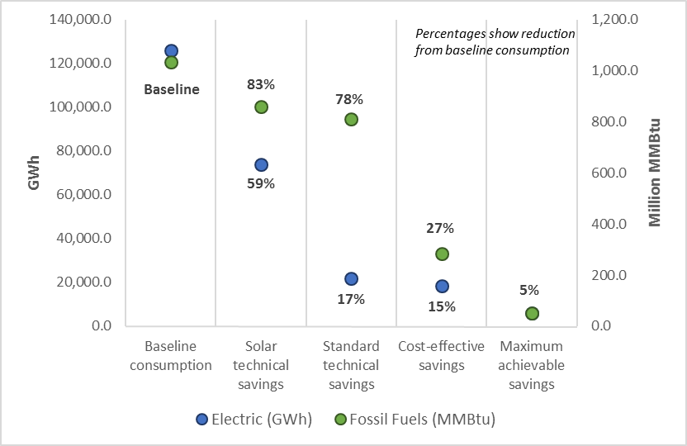
* “Solar technical” refers to technical potential savings with photovoltaic and solar hot water upgrades included, and “standard technical” refers to those savings excluding solar upgrades.
The following conclusions and associated recommendations were identified as part of this evaluation. Conclusions and recommendations from the potential savings and fuel switching analyses are listed separately as these results should be considered independent of one another.

Technical, Cost-Effective, and Achievable Potential

Conclusions
- Of the 43 measures considered in this study, ductless mini-splits have the greatest technical potential for energy savings. This is due to the high efficiency of the units, the fact that they can displace a high percentage of a home’s heating load, and the versatility of the technology.
- For 20 out of the 43 measures, cost-effectiveness screening resulted in an average total resource cost value (TRC) greater than one (Table 23 and Table 24). Four of these are not currently incentivized through the HES/HES-IE program: water heater tank wrap, foundation wall insulation, dishwashers, and efficient oil storage water heaters. These results indicate that the HES and HES-IE programs are already targeting the majority of cost-effective measures through their incentive efforts.
- Building shell measures—including air sealing and insulation improvements—all screened as cost-effective (on average) under both the utility cost test (UCT) and TRC tests. On a related note, while electric savings will drop over time due to the impact of rising minimum efficiency standards for lights and appliances, achievable potential fossil fuel savings will increase. This occurs mainly due to the gradually increasing market adoption of upgrade measures over the ten-year window, but also because as years pass, more existing equipment is replaced, leading to replace-on-failure savings opportunities.

Recommendations
- The Companies should maintain—and possibly consider raising—incentive amounts for building shell improvements in existing homes in the coming years. The analysis shows that these measures represent a proportion of achievable potential savings that will increase considerably going forward.
- The Companies should review their cost-effectiveness screening processes to ensure that benefit/cost ratios are not being overstated by failing to account for future codes and standards in the screening calculations.

Fuel Switching

Conclusion
- Under the upgrade case—which assumes that program incentives are available for high efficiency equipment—fuel switching has the potential to decrease fuel oil consumption by 21% and propane consumption by 18% if conversions take place at 25% of potential single-family homes. These percentages are only slightly higher than the 19% of savings for fuel oil and 15% of savings for propane under the base case scenario with 25% uptake in fuel switching.

Recommendations
- Potential fuel oil and propane savings from fuel switching are significant. The Companies should consider the best ways to promote fuel switching among single-family homes in Connecticut.
- Incentives designed to influence homeowners to fuel switch will have a more significant impact than incentives for high efficiency equipment once a fuel switch has already taken place. The Companies should consider offering an incentive for fuel switching if reducing oil and propane consumption becomes a priority in the future.

Table of Contents
Study Highlights I
Technical, Cost-Effective, and Achievable Potential II
Fuel Switching III
Executive Summary I
Technical, Cost-Effective, and Achievable Potential II
Energy Savings II
Peak Electric Demand Savings VII
Fuel Switching Potential VIII
Base Case Scenario IX
Upgrade Case Scenario XI
Conclusions and Recommendations XII
Technical, Cost-Effective, and Achievable Potential XII
Fuel Switching XIII
Introduction 15
Methodology 18
Technical Potential Methodology 18
Cost-Effective Potential Methodology 21
Cost-Effectiveness Tests: TRC and UCT 22
Cost-Effectiveness Screening Process 23
Achievable Potential Methodology 27
Replacement Schedules 27
Gradual Market Adoption of Upgrade Measures 27
Peak Demand and Coincidence Factors 28
Fuel Switching Methodology 29
Sampling & Weighting 34
Weighting 36
Technical Potential 37
Results 37
Comprehensive Model Results (All Applicable Upgrades) 38
Individual Measures 46
Cost-Effective Potential 53
Results of Cost-Effectiveness Screening 53
Cost-Effective Potential Savings 56
Achievable Potential 62
Comparison to Projected Program Savings 70
Fuel Switching Potential 71
Results 71
MMBtu Summary 72
Results by Fuel 75
Base Case Scenario (No Utility Incentive) 79
Upgrade Case Scenario (Program Incentive Impact) 84
Fuel Switching Impact by End Use 90
Appendix A Major Changes from Original Draft A-1
Ductless Mini-Splits A-1
Appliances A-2
Appendix B Potential Upgrade Measures B-1
Maximum R-value Achievable by Framing B-3
Appendix C Modeling Assumptions and Other Details C-1
Technical Feasibility for Advanced Measures C-1
Baseline Assessment for Measures Not Inventoried During Site Visits C-2
Appendix D Detailed Fuel Switching Impact Tables D-1
Appendix E Sources of Growth Rates E-1
Appendix F Achievable Potential Assumptions F-1
Federal Standards F-1
Market Adoption Assumptions F-3

Figures
Figure 1: Ten-Year (2016-2025) Aggregate Savings by Fuel Type* II
Figure 2: First Year (2016) and Tenth Year (2025) Potential Savings III
Figure 3: Ten-Year (2016-2025) Aggregate Savings for All Homes IV
Figure 4: Ten-Year Aggregate Savings by Fuel Type (2016 to 2025) V
Figure 5: Ten-Year Aggregate Peak Electric Demand Savings VII
Figure 6: Fuel Switching - Change in Overall Consumption Under the Base Case Scenario (MMBtu) IX
Figure 7: Fuel Switching - Percent Change in Energy Consumption by Fuel Type Under the 100% Conversion Rate Base Case Scenario X
Figure 8: Fuel Switching - Incentive Impact on Overall Consumption in Upgrade Case Scenario (MMBtu)* XI
Figure 9: Fuel Switching - Percent Change From Base Case, in Energy Consumption, by Fuel Type Under the 100% Conversion Rate XII
Figure 10: Baseline Consumption by Fuel Type and End Use* Base: all single-family homes (population-weighted) 39
Figure 11: Total Technical Potential Savings by End Use—% MMBtu Savings* 43
Figure 12: Total Technical Potential Savings by Fuel Type—% MMBtu Savings 45
Figure 13: Ten-Year (2016-2025) Aggregate Savings for Technical and Cost-Effective Potential (MMBtu) 56
Figure 14: Fuel Type Percent of Cost-Effective Savings (MMBtu) 58
Figure 15: Cost-Effective Potential Savings by End Use & Fuel Type 60
Figure 16: First Year and Tenth Year Cost-Effective and Achievable Potential Fossil Fuel Savings 62
Figure 17: First Year and Tenth Year Cost-Effective and Achievable Potential Electric Savings 63
Figure 18: Achievable Potential Savings Growth Rendered in MMBtu 64
Figure 19: Achievable Potential Savings by End Use (MMBtu) 68
Figure 20: Fuel Type Share of Achievable Potential Savings (MMBtu) 69
Figure 21: Fuel Switching—Change in Total Consumption in MMBtu, Base Case Scenario 74
Figure 22: Fuel Switching—Change in Total Consumption in MMBtu, Upgrade Case Scenario 74
Figure 23: Fuel Switching—Impact on Fuel Oil Consumption (100% Conversion Rate) 76
Figure 24: Fuel Switching—Impact on Propane Consumption (100% Conversion Rate) 77
Figure 25: Fuel Switching—Impact on Natural Gas Consumption (100% Conversion Rate) 77
Figure 26: Fuel Switching—Impact on Electricity Consumption (100% Conversion Rate) 78
Figure 27: Fuel Switching—Impact on Overall Consumption in MMBtu (100% Conversion Rate) 78
Figure 28: Fuel Switching—Change in Fuel Oil Consumption Under the Base Case Scenario 81
Figure 29: Fuel Switching—Change in Propane Consumption Under the Base Case Scenario 82
Figure 30: Fuel Switching—Change in Natural Gas Consumption Under the Base Case Scenario 83
Figure 31: Fuel Switching—Change in Electricity Consumption Under the Base Case Scenario 84
Figure 32: Fuel Switching—Change in Total Consumption in MMBtu, Base to Upgrade Comparison* 86
Figure 33: Fuel Switching—Change in Fuel Oil Consumption, Base to Upgrade Comparison* 87
Figure 34: Fuel Switching—Change in Propane Consumption, Base to Upgrade Comparison* 88
Figure 35: Fuel Switching—Change in Natural Gas Consumption, Base to Upgrade Comparison* 89
Figure 36: Fuel Switching—Change in Electricity Consumption, Base to Upgrade Comparison* 90
Figure 37: Fuel Switching—Base Case Annual Savings in MMBtu at Year Ten, by End Use* (100% Conversion Rate) 92
Figure 38: Fuel Switching—Upgrade Case Annual Savings from Base Case in MMBtu at Year Ten, by End Use (100% Conversion Rate) 93

Tables
Table 1: Savings from All Applicable Measures by Fuel—Ten-Year Aggregate VI
Table 2: Measures Included in Comprehensive Technical Potential Model Run (Most Common)* 20
Table 3: Measures Included in Comprehensive Technical Potential Model Run (Less Common)* 21
Table 4: Benefits Accounted for in Cost-Effectiveness Screening 26
Table 5: Coincidence Factors 28
Table 6: Upgrade Efficiencies 29
Table 7: Features of Fuel Switching Groups 32
Table 8: Fuel Switching Conversion Scenarios 33
Table 9: Growth Rates and Annual Consumption Change 33
Table 10: Sample Design—Planned & Actual with Sampling Error 35
Table 11: Potential Study Population Weights 36
Table 12: Savings from All Applicable Measures—Ten-Year Aggregate (2016 to 2025)* 40
Table 13: Total Technical Savings Potential by End Use—First-Year* 41
Table 14: Total Technical Savings Potential by End Use—First-Year (Percentage of Overall MMBtu Savings)* 42
Table 15: Fuel Type Share of Baseline Consumption and Savings Potential 44
Table 16: Technical Peak Electric Demand Savings Estimates (MW)* 46
Table 17: Building Shell Savings Potential—First-Year 47
Table 18: HVAC Savings Potential—First-Year 48
Table 19: Water Heating Savings Potential—First-Year^{i} 49
Table 20: Appliance Savings Potential—First-Year 50
Table 21: Heat Pumps and Solar Technologies Savings Potential—First-Year 51
Table 22: Savings from Non-REM Measures—First-Year 52
Table 23: Screening Results—Measures with Mean TRC Ratio ≥ 1.0 54
Table 24: Screening Results—Measures with Mean TRC Ratio < 1.0 55
Table 25: Cost-Effective Potential Savings— Ten-Year Aggregate Savings (2016-2025)* 58
Table 26: Cost-Effective Potential Savings by End Use—First Year 59
Table 27: Cost-Effective Savings Potential by End Use as a Percentage of Overall Savings in MMBtu —First Year 59
Table 28: Fuel Type Share of Baseline Consumption and Cost-Effective Savings Potential 61
Table 29: Cost-Effective Peak Electric Demand Savings Estimates (MW)* Base: all single-family homes (population-weighted) 61
Table 30: Achievable Potential Savings— Ten-Year Aggregate (2016-2025)* 63
Table 31: Achievable Savings as a Percent of Baseline in Year Ten 65
Table 32: Achievable Potential Savings by End Use—Year One & Year Ten* 66
Table 33: Achievable Potential Savings by End Use as a Percentage of Overall Savings in MMBtu—Year One and Year Ten 67
Table 34: Achievable Peak Electric Demand Savings Estimates (MW)* 70
Table 35: Extrapolated Costs Necessary to Achieve 2016 Maximum Achievable Potential Savings 70
Table 36: Fuel Switching—Overall Summary in MMBtu 73
Table 37: Fuel Switching—Change in Annual Consumption by Fuel at Year Ten 75
Table 38: Fuel Switching—Annual Consumption Trajectories – Base Case Scenario 80
Table 39: Fuel Switching—Annual Consumption Trajectories – Upgrade Case Scenario 85
Table 40: Fuel Switching—Maximum Impacts of Program Incentive by End Use (100% Conversion Rate) 91
Table 41: Appliance Cost-Effectiveness Screening Comparison A-2
Table 42: Building Shell Measure Upgrades B-1
Table 43: HVAC Measure Upgrades B-1
Table 44: Water Heating Measure Upgrades B-2
Table 45: Lighting & Appliance Measure Upgrades B-2
Table 46: Heat Pump & Solar Technology Measure Upgrades B-2
Table 47: Insulation Upgrade Values by Framing Type B-3
Table 48: Fuel Switching—Consumption Growth Trajectories Under the Maximum (100%) Uptake Rate D-2
Table 49: Fuel Switching—Estimated Savings Due to Program Incentive Over Ten Years D-3
Table 50: Fuel Switching—Maximum Impacts of Fuel Switching by End Use Under the 100% Conversion Rate^{i} D-4
Table 51: Federal Standards for Heating & Cooling Equipment F-2
Table 52: Federal Standards for Water Heating Equipment F-2
Table 53: Federal Standards for Appliances F-2
Table 54: Future Market Penetration Assumptions F-3

Executive Summary
ES
This report contains the findings of a single-family residential potential savings study which NMR conducted on behalf of the Connecticut Energy Efficiency Board (EEB). The study estimates the potential heating oil, natural gas, propane, and electricity savings from upgrading the efficiency of existing single-family homes in the state. It makes use of home energy data gathered over the course of 180 on-site assessments, which were conducted between September 2012 and January 2013 for the Connecticut Weatherization Baseline Assessment.
The results presented in this document describe technical, cost-effective, maximum achievable, and fuel switching potential savings results. The technical potential, cost-effective, and maximum achievable savings should be considered as three steps in the same analysis. The fuel switching results, however, should be viewed and considered independently—the savings presented in the fuel switching potential section are not meant to be additive to the savings presented in any of the other sections, as some of the measure upgrades overlap.
The following descriptions detail each of the four critical study components. See the Methodology section of this report for details on the methodology, which vary for each study component.
- Technical potential savings are the energy savings that are technically feasible over a ten-year period from 2016 to 2025. These estimates do not take into account the cost-effectiveness of upgrades, and assume that all upgrades are applied immediately.
- Cost-effective potential savings are the energy savings that are technically feasible and cost-effective to achieve over a ten-year period from 2016 to 2025. These estimates take into account the evolution of codes and standards, but not the likelihood of measure adoption by consumers.
- Maximum achievable potential savings are the energy savings that are technically feasible, cost-effective, and achievable over a ten-year period from 2016 to 2025. These estimates take into account the evolution of codes and standards, expected consumer adoption rates, and equipment replacement schedules based on the effective useful lifetimes of existing equipment; however, they do not take into account the potential impacts of incentive programs.
- Fuel switching potential savings are the potential impacts resulting from conversion of the heating and water heating equipment in single-family homes currently using oil, propane, biomass, or electric heating to either (a) natural gas space heating and water heating equipment, or (b) electric heat pump space heating and water heating equipment.
The study used REM/Rate™ home energy modeling software to calculate potential savings for each study component. The 180 home energy ratings conducted as part of the Connecticut Single-Family Weatherization Baseline Assessment were each modeled in REM/Rate. These “as-built” models were then copied and adjusted to reflect various efficiency upgrades and fuel switching opportunities. The energy consumption from the as-built model was compared to the adjusted model to calculate potential savings. More detail on the methodology can be found in the Methodology section of this report.

Technical, Cost-Effective, and Achievable Potential
This section presents high-level results of the technical, cost-effective, and achievable potential analyses.

Energy Savings
Figure 2 shows baseline consumption and potential savings from each component of the study for the first year (2016) and tenth year (2025) of the study’s ten-year window. While annual cost-effective electric savings account for 21% of baseline consumption in year one, by year ten the proportion drops to 10%. This is due largely to changes in federal minimum efficiency standards for lighting and appliances. Maximum achievable electric savings, which are derived from cost-effective savings, account for 5% of baseline consumption in the first year and 4% in the tenth.
Cost-effective fossil fuel savings—including savings in fuel oil, natural gas, and propane—account for 29% of baseline consumption in year one, and drop slightly to 26% in year ten. Maximum achievable savings increase substantially over the course of the ten years, from 1% of baseline to 7%. This occurs mainly due to the gradually increasing market adoption of upgrade measures over the course of the ten-year window, but also because as years pass, more existing equipment is replaced, leading to replace-on-failure savings opportunities.
Figure 2: First Year (2016) and Tenth Year (2025) Potential Savings
Base: all single-family homes (population-weighted)
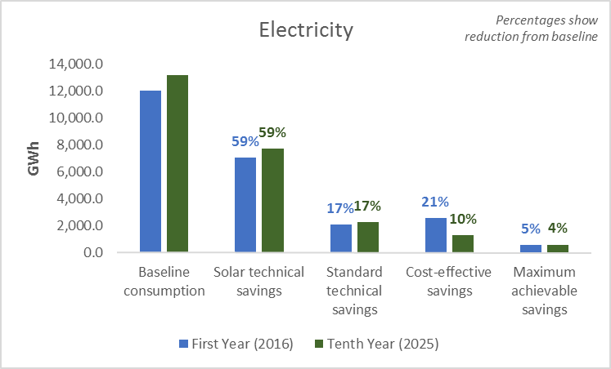
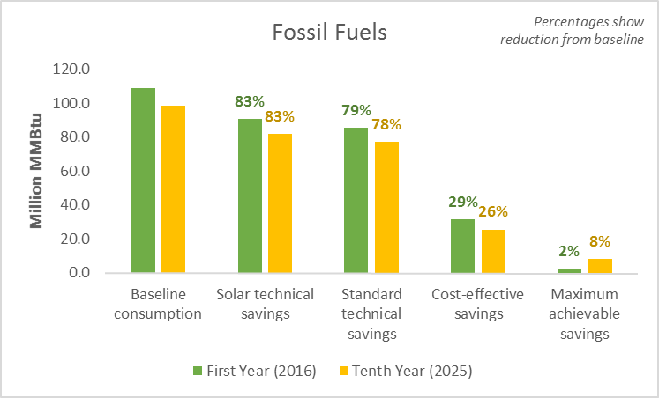

Figure 3 shows ten-year aggregate technical (with and without solar technologies included), cost-effective, and achievable potential savings. As a percentage of baseline consumption, savings are greater for electricity than for fossil fuels in each stage of the analysis except achievable potential, where savings in both fuel types account for 5% of baseline consumption. This is the case because cost-effectiveness screening excluded many fossil fuel measures from the analysis, resulting in a smaller difference in the cost-effective stage—relative to technical potential—in the percent of baseline consumption represented by fossil fuel and electric savings. Subsequently, in the achievable analysis, measures with long replacement schedules are more often fossil fuel measures, whereas measures with short replacement schedules (like lighting) and measures close to the end of their expected useful lifetimes (like appliances) are more often electric measures.
Figure 3: Ten-Year (2016-2025) Aggregate Savings for All Homes
Base: all single-family homes (population-weighted)

Figure 4 shows ten-year aggregate savings by fuel type. As shown, the majority of fossil fuel savings are in fuel oil for each of the potential analyses. This is primarily due to the fact that fuel oil is the most common heating fuel among single-family homes in Connecticut.
Figure 4: Ten-Year Aggregate Savings by Fuel Type (2016 to 2025)
Base: all single-family homes (population-weighted)
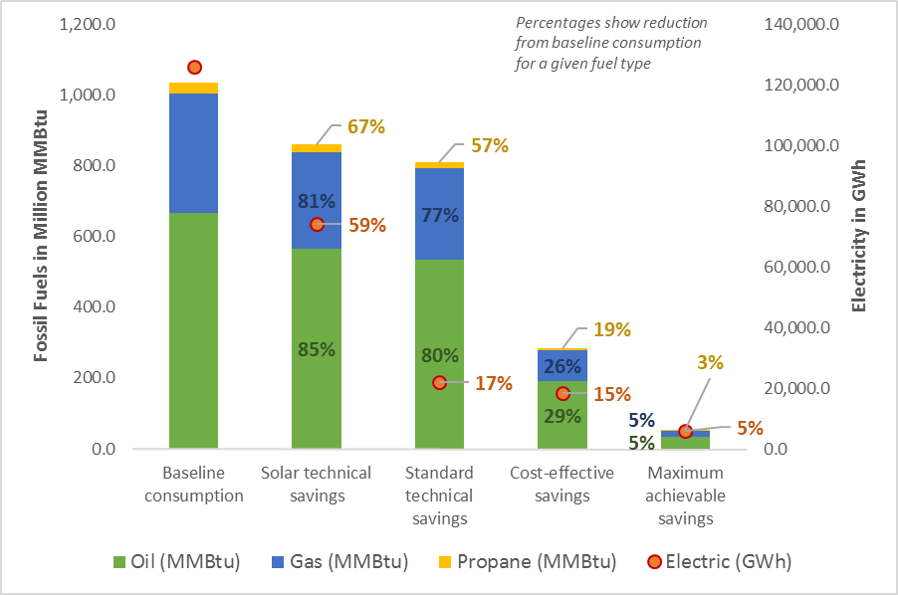

Table 1 shows the following detailed findings from the technical, cost-effective, and achievable potential analyses:
- Accounting for all applicable energy efficiency upgrades (including photovoltaics and solar hot water), single-family homes in Connecticut have the technical potential to save about 85% of baseline fuel oil usage, 81% of natural gas usage, and 59% of electric usage over the ten years from 2016 to 2025.
- Screening measures for cost-effectiveness diminishes potential savings substantially. Cost-effective fuel oil savings again account for the greatest proportion of baseline consumption, at 29%. Natural gas savings also represent a relatively high proportion of baseline usage in this stage of the study (26%). Propane (19%) and electric savings (15%) accounted for less savings relative to the baseline.
- Achievable potential, which accounts for the likelihood of energy upgrade adoption as well as codes and standards, shows that fuel oil (5%), natural gas (5%), propane (3%), and electricity (5%) all have a savings potential between 3% and 5% of baseline consumption over the ten-year period assessed in the analysis.
Table 1: Savings from All Applicable Measures by Fuel—Ten-Year Aggregate
(2016 to 2025)*
Base: all single-family homes (population-weighted)
 | Fuel Oil (gal) | Natural Gas  (ccf) | Propane (gal) | Electric (kWh) | Fossil Fuels (MMBtu) | All Fuels (MMBtu)
Ten-year baseline consumption | 4,795.2 | 3,372.9 | 350.3 | 126,040.4 | 1,034.3 | 1,464.4
Ten-Year Aggregate Savings (2016-2025)
Technical potential including solar | 4,081.7 | 2,729.2 | 234.5 | 74,022.4 | 860.4 | 1,113.0
Technical potential excluding solar | 3,847.7 | 2,590.9 | 200.9 | 21,843.2 | 811.1 | 885.6
Cost-effective potential | 1,369.6 | 880.0 | 68.1 | 18,399.2 | 284.2 | 346.9
Maximum achievable potential | 251.7 | 165.5 | 11.4 | 5,913.6 | 52.5 | 72.7
Percent Savings from Baseline (2016-2025)
Technical potential including solar | 85% | 81% | 67% | 59% | 83% | 76%
Technical potential excluding solar | 80% | 77% | 57% | 17% | 78% | 60%
Cost-effective potential | 29% | 26% | 19% | 15% | 27% | 24%
Maximum achievable potential | 5% | 5% | 3% | 5% | 5% | 5%
* Savings are in millions of units.

Peak Electric Demand Savings
Figure 5 presents aggregate ten-year peak electric demand savings estimates for each of the scenarios assessed as part of the potential study. Below is a summary of the findings:
- In aggregate over the ten years from 2016 to 2025, cost-effective (24% vs. 20%) and maximum achievable (8% vs. 7%) peak electric demand savings are greater as a percentage of baseline peak demand in the winter than they are in the summer.
- Over the same ten years, total technical potential peak electric demand savings are negative in the winter—i.e., demand increases—due to the impact of ductless mini-splits, which were modeled at all sites and result in substantial winter demand for heating. For the same reason, aggregate technical potential summer peak electric demand savings are substantial as a percentage of baseline demand; while the mini-splits result in more demand for heating, their efficiency offsets a sizable proportion of demand for cooling.
Figure 5: Ten-Year Aggregate Peak Electric Demand Savings
Base: all single-family homes (population-weighted)
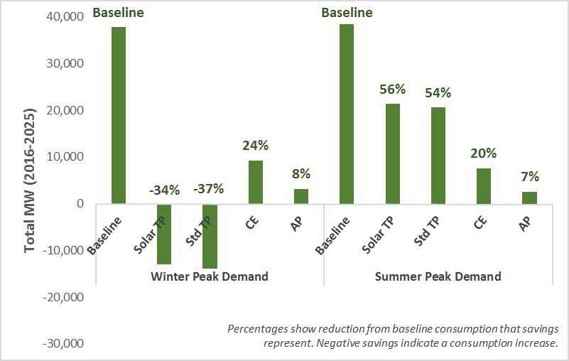

Fuel Switching Potential
For this analysis, conversions of heating and water heating equipment from oil or propane to natural gas or electricity (heat pumps) were modeled in two ways:
- A base case, where all new gas and electric equipment were modeled at baseline efficiency levels, assuming no involvement of an energy efficiency program.
- An upgrade case, where all new gas and electric equipment was modeled at the higher efficiency levels utilized in the technical potential analysis. This case describes a scenario wherein the programs incentivize efficient equipment during the fuel switching process.
The fuel switch modeling was applied—using REM/Rate™ energy modeling software—to all homes not currently heating with natural gas. This constitutes 134 (74%) of the 180 homes that were audited during the onsite assessments. A fuel switch to natural gas was modeled for 19% of the sampled homes not currently fueled by natural gas. The remaining 47% of homes were modeled with a fuel switch to electricity for heating (and water heating in the upgrade scenario).
The results of fuel switching are presented over a ten-year period with conversions increasing to the maximum 100% rate of uptake over that time as well as 25%, 50%, and 75% uptake rate scenarios.
More detail on the fuel switching methodology can be found in the Methodology section of this report.
As previously mentioned, the fuel switching results should be viewed and considered independently from the technical, cost-effective, and achievable potential findings. The fuel switching analysis results in a number of key findings.

Base Case Scenario
As Figure 6 demonstrates, total annual fuel consumption in the state is projected to decrease by 5% in the next decade (from 155.9 million MMBtu to 147.7 million MMBtu) if its current trajectory continues. Fuel switching could potentially lead to an additional 4% (base case scenario with 25% conversion rate) to 17% (base case scenario with 100% conversion rate) decrease in annual fuel consumption over the same time period. These savings are primarily due to the fact that naturally-occurring replacement with equipment that meets federal minimum standards (i.e., equipment that would be installed without any program intervention) results in more efficient equipment than what is currently present in homes.

Figure 6: Fuel Switching - Change in Overall Consumption Under the Base Case Scenario (MMBtu)
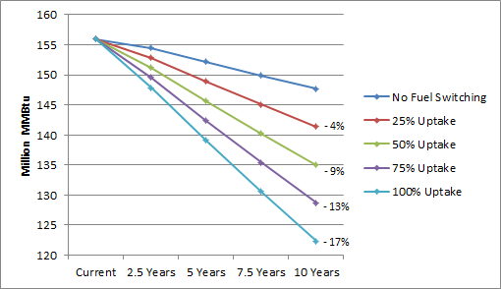

Potential maximum changes in fuel use due to base case fuel switching include a 77% decrease in annual fuel oil consumption, a 59% decrease in annual propane consumption, an 89% increase in annual consumption of natural gas, and a 13% increase in annual electric usage ten years from now (Figure 7). The analysis assumes a gradual increase in fuel switch conversions over the ten-year period. For this reason, the percent change in energy consumption in year ten is greater than the same change measured in aggregate over ten years.
Figure 7: Fuel Switching - Percent Change in Energy Consumption by Fuel Type Under the 100% Conversion Rate Base Case Scenario
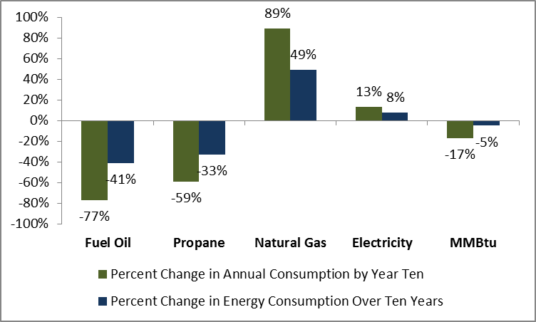

Upgrade Case Scenario
The energy savings from possible program incentives for higher-efficiency equipment (the upgrade case scenario) are substantially smaller than the energy savings from the base case scenario (fuel switching without incentives).
The analysis showed that the maximum impact of program incentives for higher-efficiency equipment would decrease overall annual consumption by about 6% relative to the expected annual consumption ten years from now under the base case fuel switching scenario (Figure 8).
Figure 8: Fuel Switching - Incentive Impact on Overall Consumption in Upgrade Case Scenario (MMBtu)*
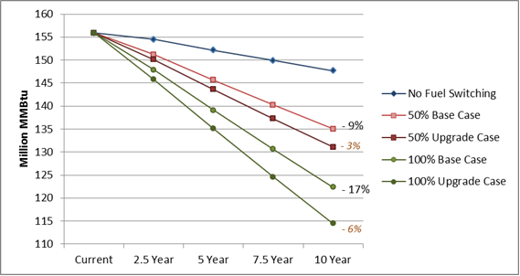
* Base case data labels show percent difference from a scenario without fuel switching at year ten. Upgrade case labels (in orange) show percent difference from the base case.

The maximum potential impacts (under the 100% conversion rate) due to program incentives include annual decreases of 30.1 million gallons of oil (30% decrease from the base case), 4.8 million gallons of propane (33% decrease), 24.3 million ccf of natural gas (4% decrease), and 188.7 million kWh (1% decrease) (Figure 9).
The percent decreases for oil and propane are higher because base case fuel switching captures most savings associated with those fuels and these numbers are presented relative to base case consumption. Fuel oil and propane savings occur entirely at the water heating end use as heating consumption for these fuels was eliminated in the base case.
Figure 9: Fuel Switching - Percent Change From Base Case,
in Energy Consumption, by Fuel Type Under the 100% Conversion Rate
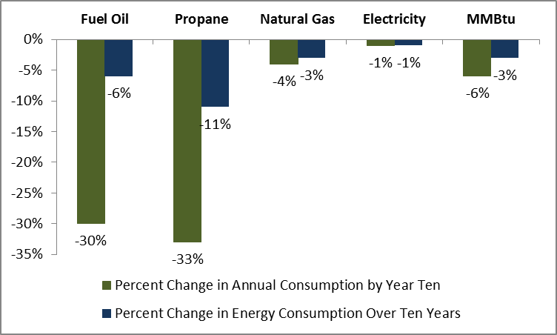

Conclusions and Recommendations
The following conclusions and associated recommendations were identified as part of this evaluation. Conclusions and recommendations from the potential savings and fuel switching analyses are listed separately as these results should be considered independent of one another.

Technical, Cost-Effective, and Achievable Potential

Conclusions
- Of the 43 measures considered in this study, ductless mini-splits have the greatest technical potential for energy savings. This is due to the high efficiency of the units, the fact that they can displace a high percentage of a home’s heating load, and the versatility of the technology.
- For 20 out of the 43 measures, cost-effectiveness screening resulted in an average total resource cost value (TRC) greater than one (Table 23 and Table 24). Four of these are not currently incentivized through the HES/HES-IE program: water heater tank wrap, foundation wall insulation, dishwashers, and efficient oil storage water heaters. These results indicate that the HES and HES-IE programs are already targeting the majority of cost-effective measures through their incentive efforts.
- Building shell measures—including air sealing and insulation improvements—all screened as cost-effective (on average) under both the utility cost test (UCT) and TRC tests. On a related note, while electric savings will drop over time due to the impact of rising minimum efficiency standards for lights and appliances, achievable potential fossil fuel savings will increase. This occurs mainly due to the gradually increasing market adoption of upgrade measures over the ten-year window, but also because as years pass, more existing equipment is replaced, leading to replace-on-failure savings opportunities.

Recommendations
- The Companies should maintain—and possibly consider raising—incentive amounts for building shell improvements in existing homes in the coming years. The analysis shows that these measures represent a proportion of achievable potential savings that will increase considerably going forward.
- The Companies should review their cost-effectiveness screening processes to ensure that benefit/cost ratios are not being overstated by failing to account for future codes and standards in the screening calculations.

Fuel Switching

Conclusion
- Under the upgrade case—which assumes that program incentives are available for high efficiency equipment—fuel switching has the potential to decrease fuel oil consumption by 21% and propane consumption by 18% if conversions take place at 25% of potential single-family homes. These percentages are only slightly higher than the 19% of savings for fuel oil and 15% of savings for propane under the base case scenario with 25% uptake in fuel switching.

Recommendations
- Potential fuel oil and propane savings from fuel switching are significant. The Companies should consider the best ways to promote fuel switching among single-family homes in Connecticut.
- Incentives designed to influence homeowners to fuel switch will have a more significant impact than incentives for high efficiency equipment once a fuel switch has already taken place. The Companies should consider offering an incentive for fuel switching if reducing oil and propane consumption becomes a priority in the future.

Introduction
1
This report contains the findings of a single-family residential potential savings study which NMR conducted on behalf of the Connecticut Energy Efficiency Board (EEB). The study estimates the potential heating oil, natural gas, propane, and electricity savings from upgrading the efficiency of existing single-family homes in the state. It makes use of home energy data gathered over the course of 180 on-site assessments, which were conducted between September 2012 and January 2013 for the Connecticut Weatherization Baseline Assessment.
The following information was collected as part of the onsite inspections:
- General information, including house type and year of construction, conditioned floor area, conditioned volume, foundation type, primary heating fuel, number of stories, number of bedrooms, thermostat type, and ownership status;
- Basement information, detailing a basement’s characteristics to aid in categorizing a space as within or outside the buildings conditioned space;
- Building shell measures that fall into two types:
  - Insulation location, area, type, R-value, and installation grade for walls, floors, ceilings, joists, foundation walls, and slabs,
  - Framing description where applicable;
- Window type, location, area, U-value, and SHGC values;
- Door type, location, area, and insulation;
- Mechanical equipment, including make, model, type, age, location, efficiency, and capacity of heating, cooling, and water heating units;
- Appliances, including make, model, age, location, energy usage in kWh/yr., and Energy Factor where applicable;
- Lighting, including number of fixtures by type and location;
- Diagnostic testing, including building envelope air leakage in cubic feet per minute at 50 Pascals (CFM50) and duct leakage, both total and to the outside of the envelope, in cubic feet per minute at 25 Pascals (CFM25);
- Duct information, including type of duct, location in the home, location on the supply or return portion of the system, insulating material, and R-value;
- Ventilation, including attic ventilation; Energy Recovery and Heat Recovery Ventilation Systems (ERV/HRV) make, model, rate, and recovery efficiency; and bathroom fan control type;
- Renewable technologies, including the size, type, and efficiency of solar thermal, photovoltaic, and wind technologies; and
- Auditor rankings, wherein auditors record the level of opportunity for improving energy efficiency in the home on a scale of one (low) to five (high) and rank the energy features of the home by greatest savings opportunity.
This document presents results from four analyses:
- Technical potential savings
- Cost-effective potential savings
- Maximum achievable potential savings
- Fuel switching potential savings
Technical, cost-effective, and achievable potential savings should be considered as various steps in the same analysis. The fuel switching results should be viewed and considered independently. The savings presented in the fuel switching potential section are not meant to be additive to the savings presented in any of the other sections, as some of the measure upgrades overlap.
The four study components are described below:
- Technical potential savings are the energy savings that are technically feasible over a ten-year period from 2016 to 2025. These estimates do not take into account the cost-effectiveness of upgrades, and assume that all upgrades are applied immediately.
- Cost-effective potential savings are the energy savings that are technically feasible and cost-effective to achieve over a ten-year period from 2016 to 2025. These estimates take into account the evolution of codes and standards, but not the likelihood of measure adoption by consumers.
- Maximum achievable potential savings are the energy savings that are technically feasible, cost-effective, and achievable over a ten-year period from 2016 to 2025. These estimates take into account the evolution of codes and standards, expected consumer adoption rates, and equipment replacement schedules based on the effective useful lifetimes of existing equipment; they do not take into account the potential impacts of incentive programs.
- Fuel switching potential savings are the potential impacts resulting from conversion of the heating and water heating equipment in single-family homes currently using oil, propane, biomass, or electric heating to either (a) natural gas space heating and water heating equipment, or (b) electric heat pump space heating and water heating equipment.
The study used REM/Rate™ home energy modeling software to calculate potential savings for each study component. The 180 home energy ratings conducted as part of the Connecticut Single-Family Weatherization Baseline Assessment were each modeled in REM/Rate. These “as-built” models were then copied and adjusted to reflect various efficiency upgrades and fuel switching opportunities. The energy consumption from the as-built model was compared to the adjusted model to calculate potential savings. More detail on the methodology can be found in Methodology.

Methodology
2
This section explains the methodology used in assessing potential savings in each of the study’s four stages.

Technical Potential Methodology
Technical potential was assessed using the following analytical steps:
- Data collected as part of the Connecticut Single-Family Weatherization Baseline Assessment was used to develop 180 “as-built” REM/Rate home energy models. REM/Rate accounts for interactive energy effects between the various facets of a house, and thereby provides a highly accurate picture of a homes’ projected annual energy use irrespective of occupant behavior.
- For each unique efficiency upgrade, the as-built model for a given site was copied and altered to reflect only a single upgrade. For example, if the flat ceiling insulation R-value upgrade was applicable to a given site, this step would entail creating a new model where everything is identical to the as-built model except flat ceiling insulation R-value. This step resulted in 3,369 separate REM/Rate models. These are referred to as “individual model runs” in this report.”
- For each site, the as-built model was copied twice; the first copy was altered to reflect all applicable energy upgrades, and the second was altered to reflect all applicable upgrades excluding solar technologies. This step resulted in an additional 360 models. These are referred to as “comprehensive model runs” in this report.
- The 3,909 models were then aggregated into one database using REM/Rate’s data export function. Analysis was then performed on the data.
The technical potential analysis presumes that all efficiency upgrades are installed immediately, which is consistent with the EPA definition of technical potential. In addition, the analysis assumes that all measures, once installed, remain installed for the 10-year window for which savings are projected. Forty-three home energy upgrades are considered, relating to the building envelope, HVAC systems, water heating equipment, lighting, appliances, and solar technologies.
Most upgrades were applied to homes that have a given feature but do not meet the efficiency level specified for the upgrade. For instance, a home featuring a gas boiler with an AFUE less than the upgrade value of 95% would qualify for a gas boiler upgrade, while the same home with a 97% efficient gas boiler would not receive that upgrade.
In determining insulation upgrade eligibility, consideration was given to the maximum R-value achievable by framing depth—while the upgrade value for above-grade wall insulation is R-20, homes built with 2x4 framing can only realistically accommodate R-12 blown-in cellulose insulation. These insulation upgrade values are presented in detail in Appendix B.
Upgrades to features not commonly found in homes—photovoltaics, solar hot water systems, heat pump products, and dehumidifiers—were applied to a sample of homes. Savings from four upgrades for which REM/Rate inputs either do not exist or are insufficient given the study’s needs and available data—clothes washers, low-flow showerheads, faucet aerators, and pipe insulation—were calculated using equations found in the 2013 Connecticut Program Savings Document., Excluding measures for which there is no REM/Rate input, an average of 19 upgrades were applicable to any one site. A full list of upgrades is provided in Appendix B.
Table 2 and Table 3 list the measures that were considered for this study and the percentage of homes for which the measure was applied for the comprehensive model runs. As shown, ductless mini-splits were included in the comprehensive model for every home. This is due to the fact that ductless mini-splits yielded the greatest overall energy savings when compared to other conflicting measures (e.g., conventional air source heat pumps, high efficiency furnaces, high efficiency central air conditioning systems, etc.).
Table 2: Measures Included in Comprehensive Technical Potential Model Run (Most Common)*
Measure | N | Percent of Sites
Upgrade windows | 180 | 100%
Install ductless mini-split | 180 | 100%
Increase socket saturation of efficient lighting | 180 | 100%
Upgrade refrigerator | 180 | 100%
Install low-flow showerheads | 180 | 100%
Install faucet aerators | 180 | 100%
Upgrade clothes washer | 177 | 98%
Add flat attic insulation | 167 | 93%
Add above grade wall insulation | 166 | 92%
Upgrade dishwasher | 164 | 91%
Add frame floor insulation | 161 | 89%
Reduce air infiltration | 143 | 79%
Increase water heater tank wrap R-value | 134 | 74%
Add rim joist insulation | 109 | 61%
Add solar hot water system | 109 | 61%
Add photovoltaic array | 108 | 60%
Add foundation wall insulation | 91 | 51%
Increase oil boiler AFUE | 83 | 46%
Add vaulted ceiling insulation | 78 | 43%
Add duct insulation | 78 | 43%
Reduce duct leakage | 74 | 41%
* Central heating systems were upgraded for a portion of the sample. While ductless mini-splits were included in every model, they were sized to meet the cooling load of each home, not the heating load. As a result, the existing heating equipment was modeled to fulfill the remainder of the heating load and was upgraded where applicable.

Table 3: Measures Included in Comprehensive Technical Potential Model Run (Less Common)*
Measure | N | Percent of Sites
Upgrade freezer | 60 | 33%
Install ECM fan motor | 53 | 29%
Upgrade dehumidifier | 49 | 27%
Replace gas storage water heater with instantaneous | 43 | 24%
Replace tankless coil with indirect water heater | 43 | 24%
Replace electric DHW with heat pump DHW | 42 | 23%
Add DHW pipe insulation | 39 | 22%
Increase oil furnace AFUE | 29 | 16%
Increase gas furnace AFUE | 26 | 14%
Increase gas boiler AFUE | 24 | 13%
Replace oil storage DHW with more efficient oil storage | 9 | 5%
Replace LP storage water heater with instantaneous | 6 | 3%
Install air source heat pump | 4 | 2%
Increase propane furnace AFUE | 2 | 1%
Increase propane boiler AFUE | 2 | 1%
Replace gas storage DHW with more efficient gas storage | 0 | 0%
Replace gas storage DHW with gas condensing | 0 | 0%
Replace LP storage DHW with more efficient LP storage | 0 | 0%
Replace LP storage water heater with LP condensing | 0 | 0%
Upgrade central air conditioner | 0 | 0%
Upgrade room air conditioners | 0 | 0%
Install ground source heat pump | 0 | 0%
* Central heating systems were upgraded for a portion of the sample. While ductless mini-splits were included in every model, they were sized to meet the cooling load of each home, not the heating load. As a result, the existing heating equipment was modeled to fulfill the remainder of the heating load and was upgraded where applicable.

Cost-Effective Potential Methodology
Each of the 43 measures considered for the potential study were screened for cost-effectiveness using both the total resource cost (TRC) test and the utility cost test (UCT). These tests were conducted at the level of the individual measure for each home. The two tests, as defined in Connecticut’s 2013-2015 Electric and Natural Gas Conservation and Load Management Plan, are described below:
- The total resource cost (TRC) test compares the present value of future utility system and other customer savings to the total of the conservation expenditures plus customer costs necessary to implement the programs.
- The utility cost test (UCT) compares the present value of utility-specific program benefits to the “utility cost”, or program cost, of the program.
These screening methods were applied at the measure level for this study, not at the program level as described above. Many of the measures considered for this study are not currently incentivized by the Companies and thus cannot be screened using the UCT method. For this reason, the TRC test was used to determine whether or not measures were cost-effective for the purposes of modeling and analysis.
All measures that screened as cost-effective for a given site were modeled simultaneously in an “all cost-effective” REM/Rate model similar to the comprehensive model run described in the Technical Potential Methodology section above. These models were then compared to the as-built models in order to estimate cost-effective potential savings. The results of cost-effectiveness screening can be found in Table 24 and Table 25; the results of the cost-effective potential analysis can be found in the Cost-Effective Potential Savings section.

Cost-Effectiveness Tests: TRC and UCT
Benefit/cost ratios were calculated using both the TRC test and the UCT. Cost-effectiveness testing tools developed for use in this study were based on a reference model provided by Eversource. The methodology used in the Eversource tool and the methodology used for this study are consistent with one another. All benefits from the 2016 Avoided Energy Supply Costs study were included as benefits for the TRC test. For the UCT, all benefits except emissions, water, and non-resource benefits were included.
The algorithms used for each test are below:
Total Resource Cost Test
$${BC}_{TRC}=\frac{Sum of Utility and Customer Benefits}{Total Resource Cost}$$
where:
$$Total Resource Cost=Program Cost+Participant Cost$$
$$Program Cost=Incentive Cost+Administrative Cost$$

Utility Cost Test
$${BC}_{UCT}=\frac{Sum of Utility Benefits}{Program Cost}$$

Cost-Effectiveness Screening Process
As noted earlier, this study made use of REM/Rate models for 180 existing single-family homes in Connecticut. As part of the technical potential assessment, each of the 43 measures under consideration was modeled individually to show the potential savings of individual measures. The savings associated with these individual model runs were used as the savings inputs for cost-effectiveness screening. Given that the savings for each measure varied by household, the cost-effectiveness of each measure was screened at the measure level for each of the 180 sites in the sample. For example, an R-13 wall insulation upgrade might pass cost-effectiveness screening at a home that previously had uninsulated walls, while the same upgrade may not pass cost-effectiveness screening at a home that previously had R-11 insulation.

Full Cost & Net Measure Cost
One of two types of costs were included in the TRC ratio for the purposes of screening measures for cost-effectiveness. For measures that are not subject to federal minimum efficiency standards—e.g. insulation, air sealing, pipe insulation, or photovoltaics—the full cost of the upgrade was used to calculate the ratio.
For measures that are subject to changing federal minimum efficiency standards—e.g. HVAC equipment or appliances—a net measure cost (NMC) was calculated for use in the benefit/cost equation. This NMC is equal to the full cost of the efficient upgrade measure minus a deferred replacement credit. The deferred replacement credit is calculated using this equation:
$$DRC=\frac{PV\left[R,BA,PMT\left(R,BL,BC\right)\right]}{{\left(1+R\right)}^{BL-BA}}$$
where:
R = real discount rate
BA = baseline measure age
BL = baseline measure lifetime
BC = baseline measure cost
PV = the present value at discount rate R of BA number of payments
PMT = the payment for an annuity of BL number of years that yields a present value BC given discount rate R

Adjusted Savings
The dollar benefits that comprise the numerator of the benefit/cost equation were calculated using measure-level savings modeled in the technical potential stage. However, these savings had to be revised for 25 of the 43 measures in order to take into account the baseline shift resulting from changes in codes and standards. For each of these 25 measures, three types of savings were calculated:
- Early retirement savings, which reflect the difference in consumption between a high-efficiency upgrade unit and the existing unit;
- Lost opportunity savings under the current federal standard, which reflect the difference in consumption between a high-efficiency upgrade unit and a replacement unit meeting the federal minimum efficiency standard in place in 2016, the first year of the study window; and
- Lost opportunity savings under a future federal standard, which reflect the difference in consumption between a high-efficiency upgrade unit and a replacement unit meeting a future standard. For clothes washers, there are two future federal standards; for the other 24 measures, there is only one.
Early retirement savings were derived directly from the REM/Rate models developed in the technical potential stage of the study. Both varieties of lost opportunity savings were calculated using the following basic formula (some variations exist between measures):
$$L=B*\left(\frac{E}{F}\right)-T$$
where:
L = lost opportunity savings
B = baseline consumption at end use corresponding to measure in question
E = existing efficiency of unit
F = federal minimum efficiency standard for unit
T = technical potential consumption at end use corresponding to measure in question

Depending on the remaining useful life of the existing equipment, the efficiency of the existing equipment, and the federal standard in effect at the time of replacement, either early retirement or lost opportunity savings were applied to avoided costs for a given year for the purposes of calculating benefits. Benefits were counted for a number of years into the future equal to the relevant measure’s lifetime, not just within the ten-year study window.
For example, say a furnace, which has a lifetime of 20 years according to Connecticut’s 2013 PSD, is due to expire in 2019, based on its age when found on-site during data collection for the Weatherization Baseline Assessment. The screening tool would count early retirement savings in the years from 2016 to 2019, then the lost opportunity savings associated with the federal standard applicable in 2019 from the years 2020 to 2035. Savings are counted in the 20 years from 2016 to 2035 in order to correspond to the 20-year lifetime of a furnace.

Data Sources
A variety of data sources were used in defining cost-effectiveness screening model inputs. They are described below.

Program Incentives
Eversource and the United Illuminating Company (UI) provided a list of the incentive levels for the measures currently incentivized through the HES and HES-IE programs. The Companies do not incentivize all of the measures examined in this study. Measures that are not currently incentivized by the Companies were screened for cost-effectiveness using only the TRC test.

Cost of Measure Upgrades
Most of the cost data for the cost-effectiveness screening came from two incremental cost studies conducted by the Northeast Energy Efficiency Partnerships (NEEP).
- Navigant, “Incremental Cost Study Report, Final” Submitted to NEEP, September 23, 2011
- Navigant, “Incremental Cost Study Phase Two, Final Report” Submitted to NEEP, January 16, 2013
Specifically, these studies were used to assess costs for the majority of shell measures and for mechanical equipment. NEEP provides the raw data for these studies along with final published reports on their website. The raw data from these studies was leveraged to develop Connecticut-specific cost estimates.
In addition to the NEEP studies, the following sources were used to assess the costs associated with various measure upgrades:
- NMR Group, “MA RNC Program, Incremental Cost Report” Submitted to Berkshire Gas, Cape Light Compact, Columbia Gas of Massachusetts, National Grid, New England Gas Company, NSTAR Electric & Gas, Unitil, and the Western Massachusetts Electric Company, June 11, 2013
- NMR Group, “Connecticut Ground Source Heat Pump Impact Evaluation & Market Assessment-Final, Study R7” Submitted to the Connecticut Energy Efficiency Board and the Connecticut Clean Energy Finance and Investment Authority, June 3, 2014
- Database for Energy Efficient Resources (DEER)
- Standards and supporting documentation from the Department of Energy’s Energy Efficiency and Renewable Energy Office
- Internet-based market research

Avoided Energy Costs
Data from the following report and its supporting documentation were used to calculate avoided energy costs for the cost-effectiveness screening:
- Synapse Energy Economics, Inc. “Avoided Energy Supply Costs in New England”, Prepared for the Avoided-Energy-Supply-Component (AESC) Study Group, March 27, 2015
Table 4 lists the benefits that were included in the cost-effectiveness screening. Each of these benefits was calculated independently so that the benefit/cost ratios can be easily re-calculated to include any combination of benefits. For more detail on the benefit definitions and values please refer to the Synapse study cited above.
Table 4: Benefits Accounted for in Cost-Effectiveness Screening
Benefit description | Unit
Gross electric energy | $/kWh
Electric capacity | $/kW
Transmission & distribution | $/kW
Intrastate DRIPE | $/kWh
Rest-of-pool DRIPE | $/kWh
Capacity DRIPE | $/kW
Cross-fuel DRIPE | $/kWh
Electric emissions | $/kWh
Residential heating gas | $/MMBtu
Residential hot water gas | $/MMBtu
Residential oil | $/MMBtu
Residential propane | $/MMBtu
Gas DRIPE | $/MMBtu
Gas cross-fuel DRIPE | $/MMBtu
Gas emissions | $/MMBtu
Oil & propane emissions | $/MMBtu
Water ($/gal) | $/gallon

Achievable Potential Methodology
Achievable potential savings were derived by adjusting cost-effective savings to account for increases in federal minimum efficiency standards, gradual adoption of upgrade measures, and the replacement schedules of existing equipment.

Replacement Schedules
The cost-effective potential stage of the study does not take the replacement schedules of existing equipment into account. In that part of the analysis, it is possible for an upgrade to screen as cost-effective even if the existing measure has not reached the end of its lifetime. In reality, it is rare for consumers to make the decision to upgrade the efficiency of their equipment before it becomes necessary to replace the equipment. For this reason, the achievable analysis only counts savings that are achieved after a given piece of equipment has reached the end of its effective useful life (EUL). These lifetimes were derived from Connecticut’s 2013 Program Savings Documentation.

Gradual Market Adoption of Upgrade Measures
Achievable potential savings reflect the gradual market adoption of upgrade measures over the course of the ten-year study window. Truly reliable estimates of what the market penetration of various products and services will be in 2025 are difficult to come by; projecting the characteristics of the market so far into the future necessarily entails some guesswork.
In developing market penetration estimates, a 2009 potential study by the Electric Power Research Institute (EPRI) was utilized. This study calculated achievable potential savings nationwide and by region for the years 2010 to 2030. Its methodology included developing market acceptance ratios for each of the products and services it considered. These ratios describe the share of the homes replacing equipment that will install above-minimum efficiency equipment.
By this point in the analysis, the savings have already been adjusted to reflect changes in codes and standards. For this reason, the estimates taken from the EPRI study were revised down by half. For instance, EPRI estimates that in 2025, 100% of refrigerators being replaced will be more efficient than the current federal minimum. However, the savings which these market adoption percentages are meant to adjust already reflect changes in federal standards. The analysis estimates that while 100% of refrigerators sold in 2025 may be more efficient than the current standard, 50% may be more efficient than the standard applicable in that year.
Market penetration in year one (derived from Weatherization Baseline Assessment data for each measure except lighting) and estimated market penetration in year ten (derived from the EPRI study) were used in developing an adoption curve, which was subsequently used to adjust annual savings in each year from 2016 to 2025 to account for gradual market adoption.

Peak Demand and Coincidence Factors
The evaluation team used REM/Rate demand estimates as a starting point in assessing peak demand savings. NORESCO, the developers of REM/Rate, confirmed that the software assumes coincidence factors when assessing peak demand. In order to provide a more accurate estimate of peak demand for single-family homes in Connecticut, these default coincidence factors were removed and Connecticut-specific factors applied.
Table 5 displays the coincidence factors that were used in this study. All of the factors, with the exception of those used for lighting, appliances, and plug loads, are from the 2013 Connecticut Program Savings Documentation. The coincidence factors for lighting are based on the recent Northeast Residential Lighting Hours-of-Use Study. The coincidence factors for appliances and plug loads are based on load profiles for these measures as estimated by the Department of Energy in their Building American Research Benchmark Definition.
Table 5: Coincidence Factors
End Use | Summer Coincidence Factor | Winter Coincidence Factor
Heating | 0.00 | 0.50
Cooling | 0.59 | 0.00
Water heating | 0.10 | 0.15
Lights | 0.13 | 0.20
Appliances & plug loads | 0.05 | 0.06
Refrigerators & freezers | 0.30 | 0.21

REM/Rate does not include photovoltaics, one of the upgrades in the potential study, in estimates of demand savings. However, it is unlikely that photovoltaics would influence winter peak demand savings as the winter peak in New England is from 5-7 PM during the months of December and January. It should also be noted that photovoltaics were not cost-effective at any of the 180 sites and as a result the exclusion of photovoltaics from demand estimates does not impact cost-effective or achievable demand savings estimates.

Fuel Switching Methodology
This section details the methodology used to assess potential savings from fuel switching. Conversions of heating and water heating equipment from oil or propane to natural gas or heat pumps were modeled in two ways:
- In the base case, all new gas and electric equipment was modeled at the efficiency levels specified in the User Defined Reference Home (UDRH) currently utilized by the Connecticut Residential New Construction (RNC) Program. The UDRH values were used rather than federal minimum efficiencies because they are more representative of typical replacement equipment efficiencies. This case provides a baseline scenario, with no involvement of an energy efficiency program.
- In the upgrade case, all new gas and electric equipment was modeled at the higher efficiency levels utilized in the technical potential study. This case describes a scenario wherein the programs incentivize efficient equipment during the fuel switching process.

Table 6 details the upgrade efficiencies approved by the EEB for use in this study.
Table 6: Upgrade Efficiencies
Equipment | Base Case^{i} | Upgrade Case^{ii}
Gas boiler | 92.4% AFUE | 95% AFUE
Gas furnace | 92.4% AFUE | 97% AFUE
Conventional gas storage water heater | 0.62 EF 0.79 RE | N/A^{iv}
On-demand tankless water heater | N/A^{iii} | 0.93 EF
Heat pump water heater | N/A^{iii} | 2.3 EF
Ductless mini-split^{v} | 13.4 SEER 8.9 HSPF | 19.2 SEER 10.3 HSPF
^{i} Connecticut RNC program UDRH values
^{ii} Technical potential efficiency levels
_{iii} NA because measure is only modeled in the upgrade case.
^{iv} NA because measure is only modeled in the base case.
^{v} Modeled in the same manner for both the technical potential and fuel switching analyses. See Fuel Switching Methodology for details.

The differences in natural gas, electricity, fuel oil, and propane consumption between the two scenarios provide an estimate of potential savings attributable to the programs incentivizing of high-efficiency equipment. In addition to potential savings from utility incentives, the following impacts are assessed in this study:
- Reduced oil and propane consumption from fuel switching, in both cases;
- Increased natural gas consumption from fuel switching, in both cases;
- Increased electric consumption from fuel switching, in both cases.
The monetary savings associated with switching from fuel oil or propane to natural gas or electricity as the primary heating fuel are not assessed in this report. It should be noted that such a fuel switch often results in significant upfront costs to homeowners, but is likely to result in substantial monetary savings from reduced fuel costs for homeowners.
The fuel switch modeling was applied—using REM/Rate™ energy modeling software—to all homes not currently heating with natural gas. This constitutes 134 (74%) of the 180 homes that were audited during the Weatherization Baseline Study. Connecticut’s Comprehensive Energy Strategy (CES) posits that 34% of residential buildings in the state currently heat with gas, and an additional 19% might be expected to convert under various conditions. In all, the CES indicates that the proportion of Connecticut residences for which natural gas is either currently in use for heating or could feasibly be in the near-term is 53%. Therefore, the 134 homes not currently heating with natural gas were grouped in the following manner for modeling:
- Group A (non-gas homes in gas-served towns, switched to gas) consisted of a randomly-selected 49 of the 97 homes in the Weatherization Baseline sample which are located in a town served by a natural gas pipeline but are currently heating with either oil or propane. These homes were modeled with gas space heating and water heating equipment. These 49 homes represent 27.2% of the 180 sites in the Weatherization Baseline sample. When added to the 46 sites (25.6% of the 180 sites) in the sample that already heat with gas, these sites represent 53% of the Weatherization sample, which is consistent with the forecast information in the CES.
- Group B (non-gas homes in gas-served towns, switched to heat pump) consisted of the remaining 48 of the 97 homes described above, as well as 17 homes in towns with natural gas service that heat with electricity, wood pellets, or cord wood—65 in all. These homes were modeled with ductless mini-splits, which is the heat pump technology that resulted in the greatest energy savings in the technical potential savings analysis. In these models, existing space heating equipment remained in a backup capacity. Existing water heating equipment remained the same in the base case and was upgraded to a heat pump water heater in the upgrade case.
- Group C (non-gas homes in non-gas towns, switched to heat pump) consisted of the 20 homes in the Weatherization Baseline sample that are located in a town not currently served by any of Connecticut’s three natural gas companies. These homes were modeled with ductless mini-splits and heat pump water heaters in the same manner as those in Group B.
Table 7, on the next page, details the features of each fuel switching group.

Table 7: Features of Fuel Switching Groups
Group | n | % | Location | Heating Fuel |  | Heating Equipment |  | Water Heating
 |  |  |  | Existing | After Switch | Existing | After Switch | Base Case | Upgrade Case
Group A | 49 | 27% | Towns with gas service | Oil or propane | Gas | Oil or propane boiler | Gas boiler | Conventional gas storage water heater | On-demand gas water heater
 |  |  |  |  |  | Oil or propane furnace | Gas furnace
Group B | 65 | 36% | Towns with gas service | Oil, propane, electricity, or biomass | Electric with existing system backup | Oil, propane, or biomass boiler | DHP* with existing boiler backup | Existing water heater | Heat pump water heater
 |  |  |  |  |  | Oil, propane, or biomass furnace | DHP* with existing furnace backup
 |  |  |  |  |  | Electric resistance | DHP* with electric resistance backup
Group C | 20 | 11% | Towns with no gas service | Oil, propane, electricity, or biomass | Electric with existing system backup | Oil, propane, or biomass boiler | DHP* with existing boiler backup | Existing water heater | Heat pump water heater
 |  |  |  |  |  | Oil, propane, or biomass furnace | DHP* with existing furnace backup
 |  |  |  |  |  | Electric resistance | DHP* with electric resistance backup
Gas Sites | 46 | 26% | Towns with gas service | No switch |  | No switch |  | No switch
* “DHP” stands for “ductless heat pump,” or ductless mini-split.

Additionally, this report presents the results of the fuel switching analysis over a ten-year conversion period, with conversions increasing to the maximum 100% rate of uptake over that time as well as 25%, 50%, and 75% uptake rates. Table 8 details the four conversion rates.
Table 8: Fuel Switching Conversion Scenarios
Overall Conversion Rate | Rates of Uptake |  |  |  | Percent of Homes with Primary Heating Fuel in Year 10
 | Year 2.5 | Year 5 | Year 7.5 | Year 10 | Natural Gas^{i} | Electric^{ii} | Other Fuels
25% | 6.25% | 12.5% | 18.75% | 25% | 32% | 18% | 50%
50% | 12.5% | 25% | 37.5% | 50% | 39% | 28% | 33%
75% | 18.75% | 37.5% | 56.25% | 75% | 46% | 37% | 17%
100% | 25% | 50% | 75% | 100% | 53% | 47% | 0%
^{i} These values include the 25.6% of homes that already use gas as their primary heating fuel.
^{ii} These values include the 8.8% of homes that already use electricity as their primary heating fuel.

All of the impacts detailed in this report are presented relative to what the annual consumption of a given fuel is expected to be ten years from now. The growth rates for these projections along with current fuel consumption and expected fuel consumption ten years from now are detailed in Table 9.
Table 9: Growth Rates and Annual Consumption Change
Fuel type | Annual Growth Rate | Current Annual Consumption | Annual Consumption at Year Ten, No Fuel Switching
Fuel oil (million gallons) | - 2.1% | 527.6 | 435.9
Propane (million gallons) | 0.4% | 34.4 | 35.7
Natural gas (million ccf) | 0.7% | 326.8 | 348.0
Electricity (million kWh) | 1.0% | 12,048.2 | 13,177.0

Sampling & Weighting
3
The same 180 single-family homes which were audited for the Connecticut Weatherization Baseline Assessment were used to model savings potential for this study. The Weatherization study focused exclusively on single-family homes, both detached (stand-alone homes) and attached (side-by-side duplexes and townhouses that have a wall dividing them from attic to basement and that pay utilities separately).
Multifamily units—even smaller ones with two to four units—were excluded from the study due to the complexity and concomitant added costs of including them in the evaluation. Specifically, multifamily units would be difficult to recruit for this study as these units have a higher proportion of renters; the need to secure landlord permission—and the difficulties in doing so—reduced the likelihood that auditors would have permission to enter such buildings to perform a weatherization assessment. Additionally, it can be challenging to assess the efficiency of the buildings without having access to all of the units. From a logistics perspective, it would be quite difficult to coordinate participation of multiple tenants (renters or condominium owners) within the same building in order to achieve the most reliable study results. All of these factors lend themselves to a more expensive study, and the EEB and DEEP decided to exclude them for this reason.
The evaluators relied on a disproportionately stratified design that aimed to achieve 10% sampling error or better at the 90% confidence level across all of Connecticut and also for several subgroups of interest (Table 10). This level of precision means that one can be 90% confident that the results are a reasonably (±10% or less) accurate description of all the single-family homes in Connecticut. All precisions are based on a coefficient of variation of 0.5.
Table 10: Sample Design—Planned & Actual with Sampling Error
Single-family Segment | Planned Sample Size | Actual Sample Size | Precision
Overall | 180 | 180 | 6%
Low-income | 68 | 34 | 14%
Non-low-income | 76 | 146 | 7%
Income eligibility not identified | 36* | 0* | n/a
Fuel oil heat | 109 | 111 | 8%
All other heating fuels | 71** | 69** | 10%
Own | 159 | 177 | 6%
Rent | 21 | 3 | 47%
* The survey approach for identifying household income asked respondents if their income was above or below a certain amount based on their family size. This unobtrusive approach meant that the evaluators were able to identify the income status for all participants in the onsite study.
** The evaluators planned for 47 of these homes to heat with natural gas, and 46 of the homes in the final sample actually did so.

The final sample, however, did not achieve 90/10 precision for low-income households—although the sampling error of 14% is close to the desired 10%—and sampled fewer than expected renters (although the evaluators had not expected to achieve 90/10 precision for renters). These are traditionally difficult groups to sample, but three factors directly related to this study further limited the evaluators’ ability to achieve 90/10 precision for the low-income households and to visit the expected number of rental households. Two of these factors stem from the HES requirement that renters receive permission from their landlords before receiving HES services.
First, when recruiting for the study, the evaluators informed possible participants that they would have to get landlord approval before taking part in the study; at that point, many renters indicated they did not want to take part in the study. Second, renters that did originally express interest in the study were ultimately unable or unwilling to secure landlord permission prior to the onsite visit. Because a disproportionately high number of households that rent single-family homes also qualify as low-income, the difficulty in securing participants who rent also limited the evaluators’ ability to sample as many low-income households as designed.
A third reason for the lower than expected renter and low-income participation relates to the structure of buildings: When scheduling onsite visits, the evaluators discovered that many interested survey respondents who had originally indicated that they lived in single-family attached homes actually lived in multifamily homes or attached homes that were not completely separate units (i.e., they were not separated from attic to basement or they shared utilities).
The sample achieved 90/10 precision for oil-heated households and for households of all other fuel types combined. This reflects the fact that about 62% of single-family homes in Connecticut are heated with oil. The sample did not achieve 90/10 precision for any other single heating fuel type with a sample size of 180 (the size chosen by the EEB and DEEP from a list of options provided by the evaluators).

Weighting
The weighting scheme utilized in this study is consistent with that of the Weatherization Baseline study. The consumption data exported from REM/rate were weighted to the population based on each homes primary heating fuel type and income status. A count of Connecticut single-family households gathered from the American Community Survey 2008-2010 three-year estimates was used to determine the count within each weighting stratum. Two primary heating fuel type categories—one for gas and electricity and one for oil, propane, and other—were combined with income categories in order to establish the following four weighting categories:
- Low-income with oil, propane, or other heating fuel;
- Low-income with gas or electric heating fuel;
- Not low-income with oil, propane, or other heating fuel;
- Not low-income with gas or electric heating fuel.
Table 11 presents the population weights for these four categories.
Table 11: Potential Study Population Weights
Weighting Category  (Income Level: Primary Heating Fuel) | Connecticut Population (ACS) | Sample | Population Weight
Low Income: Oil, Propane, or Miscellaneous | 128,495 | 20 | 6,425
Low Income: Gas or Electric | 72,766 | 14 | 5,198
Not Low Income: Oil, Propane, or Miscellaneous | 475,295 | 98 | 4,850
Not Low Income: Gas or Electric | 216,042 | 48 | 4,501

Technical Potential
4
Technical potential, as defined by the United States Environmental Protection Agency, is an estimate of what energy and capacity savings would be achieved if all technically feasible measures were implemented immediately for all customers. The term “all customers” is limited to single-family homes in Connecticut in this study.
The upgrade measures included as part of the technical potential study component were reviewed by the EEB consultants prior to the analysis. These upgrades consist of the following measure categories:
- Building shell upgrades
- Heating, cooling, and water heating upgrades
- Solar technology upgrades
- Heat pump upgrades
- Lighting upgrades
- Appliance upgrades
This study excludes plug load measure upgrades.

Results
This section first details the results derived from analyses of the comprehensive models that include all applicable upgrades, then provides context by examining potential savings from individual measure upgrades. Overall, the analyses reveal that there is substantial technical potential for energy savings among single-family homes in Connecticut.
To put the results of this section into perspective, the analysis assessed the share of overall energy consumption by fuel type that is attributable to single-family homes in the Connecticut. According to the 2009 Residential Energy Consumption Survey (RECS) data, single-family homes in the northeast represent the following shares of residential energy consumption:
- 75% of electric consumption
- 67% of natural gas consumption
- 79% of fuel oil consumption
Additionally, according to Energy Information Administration (EIA), in 2011 the residential sector was responsible for the following shares of energy consumption in Connecticut:
- 43% of all electric consumption statewide
- 20% of all natural gas consumption statewide
- 51% of all distillate fuel oil consumption
Combining these two sets of data, the study captures the following proportion of baseline energy consumption in Connecticut:
- 32% of all electric consumption statewide
- 13% of natural gas consumption statewide
- 43% of all distillate fuel oil consumption statewide
Throughout this section some tables indicate negative savings. Some measures may offer savings opportunities for one fuel type, but actually increase consumption of another fuel. For example, a ductless heat pump that is used for heating may decrease fossil fuel consumption, but it will simultaneously increase electric consumption; however, it will result in a net decrease in energy consumption.
Unless a table indicates otherwise, all of the results in this section present first-year savings opportunities, not accounting for growth rates.

Comprehensive Model Results (All Applicable Upgrades)
The consumption figures in this section were calculated by subtracting the consumption of the home when modeled with all applicable energy upgrades (the comprehensive model) from the consumption of the home as it was found on-site (the baseline model). These results provide an estimate of total technical potential savings in MMBtus, as well as by fuel type. For reference, Figure 10 shows overall baseline consumption, in MMBtus, by fuel type and end use.
Figure 10: Baseline Consumption by Fuel Type and End Use*
Base: all single-family homes (population-weighted)
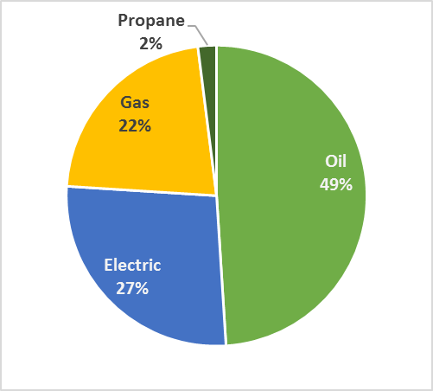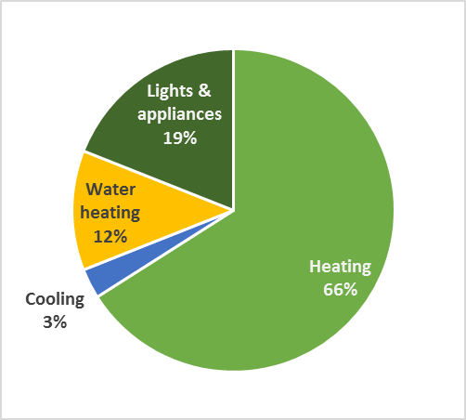
* Rendered in MMBtu to facilitate direct comparison.
A substantial portion of the overall technical potential savings can be attributed to photovoltaics and solar hot water, which were each modeled at 60% of the sites in the sample. Specifically, these technologies account for 13% of overall savings in MMBtus and 42% of the overall savings for electricity over the ten-year period (2016 to 2025) assessed in this report. Table 12 provides aggregate technical potential savings, from 2016 to 2025, both with and without the inclusion of solar technologies (photovoltaics and solar hot water) in the models. As shown:
- Technical potential savings in fuel oil exceed 4 billion gallons of fuel oil when including solar technologies.
- Savings in natural gas exceed 2.7 billion ccf of natural gas when including solar technologies.
- Removing the photovoltaics upgrade decreases the technical potential for electric savings considerably, from 59% of baseline consumption to 17%.
Table 12: Savings from All Applicable Measures—Ten-Year Aggregate
(2016 to 2025)*
Base: all single-family homes (population-weighted)
 | Fuel Oil (gal) | Nat. Gas (ccf) | Propane (gal) | Electric (kWh) | Fossil Fuels (MMBtu) | All Fuels (MMBtu)
Technical Potential Including Solar Technologies
Baseline aggregate consumption (2016-2025) | 4,795.2 | 3,372.9 | 350.3 | 126,040.4 | 1,034.3 | 1,464.4
Ten-year aggregate savings (2016-2025) | 4,081.7 | 2,729.2 | 234.5 | 74,022.4 | 860.4 | 1,113.0
Percent savings from baseline | 84% | 81% | 70% | 59% | 83% | 76%
Technical Potential Excluding Solar Technologies
Baseline aggregate consumption (2016-2025) | 4,795.2 | 3,372.9 | 350.3 | 126,040.4 | 1,034.3 | 1,464.4
Ten-year aggregate savings (2016-2025) | 3,847.7 | 2,590.9 | 200.9 | 21,843.2 | 811.1 | 885.6
Percent savings from baseline | 80% | 77% | 57% | 17% | 78% | 60%
* Savings are in millions of units.

All of the technical potential savings in fossil fuel consumption occur at the home heating and water heating end uses, while the bulk of total technical potential savings in electricity consumption occur in lighting and appliances. The presence of ductless mini-splits in each comprehensive model run results in a substantial increase in electric usage for heating.
Table 13: Total Technical Savings Potential by End Use—First-Year*
Base: all single-family homes (population-weighted)
End Use | Fuel Oil (gal) | Nat. Gas (ccf) | Propane (gal) | Electric (kWh)
Model Runs Including Solar Technologies
Heating | 409.8 | 243.3 | 18.4 | - 1,492.6
Cooling | -- | -- | -- | 849.3
Water heating | 38.4 | 21.1 | 4.6 | 646.3
Lights & appliances | -- | -- | -- | 2,439.3
Photovoltaics | -- | -- | -- | 4,632.9
Total | 448.2 | 264.4 | 23.0 | 7,075.2
Model Runs Excluding Solar Technologies
Heating | 409.8 | 243.3 | 18.4 | - 1,495.7
Cooling | -- | -- | -- | 849.4
Water heating | 12.8 | 7.7 | 1.4 | 431.1
Lights & appliances | -- | -- | -- | 2,303.0
Total | 422.6 | 251.0 | 19.8 | 2,087.8
* In millions. Negative savings indicate a consumption increase.

Table 14 is based off of the same information that is presented in Table 13 and displays the percentage of overall saving potential (in MMBtu) by end use.
Table 14: Total Technical Savings Potential by End Use—First-Year (Percentage of Overall MMBtu Savings)*
Base: all single-family homes (population-weighted)
End Use | Fuel Oil | Natural Gas | Propane | Electric
Model Runs Including Solar Technologies
Heating | 49% | 22% | 1% | - 4%
Cooling | -- | -- | -- | 3%
Water heating | 5% | 2% | 0% | 2%
Lights & appliances | -- | -- | -- | 7%
Photovoltaics | -- | -- | -- | 14%
Total | 54% | 24% | 2% | 21%
Model Runs Excluding Solar Technologies
Heating | 61% | 27% | 2% | - 5%
Cooling | -- | -- | -- | 3%
Water heating | 2% | 1% | 0% | 2%
Lights & appliances | -- | -- | -- | 8%
Total | 63% | 28% | 2% | 8%
* Negative savings indicate a consumption increase.

Figure 11 presents the percentage of first-year savings (in MMBtus) associated with key end uses. Heating accounts for the majority of potential savings among all end uses.
Figure 11: Total Technical Potential Savings by End Use—% MMBtu Savings*
Base: all single-family homes (population-weighted)
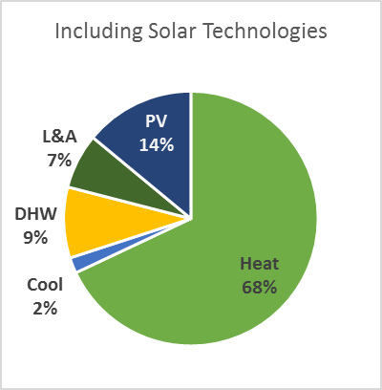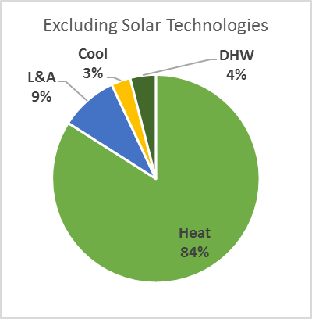
* DHW = domestic hot water. L&A = lights and appliances. PV = photovoltaics.

There is a larger relative savings opportunity for fuel oil and natural gas as they have greater shares of potential savings than they do of baseline consumption, while the opposite is true for electricity and propane (Table 15). This is because consumption in MMBtus is greatest for the heating end use and nearly 90% of homes in the sample heat with either oil or gas. Individual measure upgrades serve to shed some light on where the greatest technical potential for heat loss reduction lies.
Table 15: Fuel Type Share of Baseline Consumption and Savings Potential
Base: all single-family homes (population-weighted)
Fuel type | Share of Baseline Consumption (MMBtu) | Share of Savings Potential*
 |  | Including Solar | Excluding Solar
Fuel oil | 49% | 54% | 63%
Natural gas | 22% | 24% | 28%
Propane | 2% | 2% | 2%
Electricity | 27% | 21% | 8%
* Excluding ductless mini-splits raises the electric share of savings potential from 20.9% to roughly 29.5% when solar technologies are included, and from 7.6% to roughly 19.8% when solar technologies are excluded.

Figure 12 shows the same information presented in Table 15, but in pie charts.
Figure 12: Total Technical Potential Savings by Fuel Type—% MMBtu Savings
Base: all single-family homes (population-weighted)
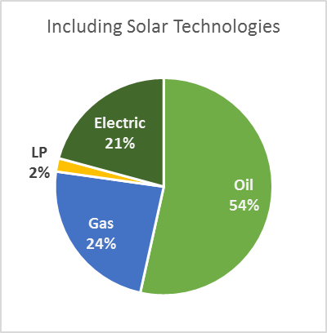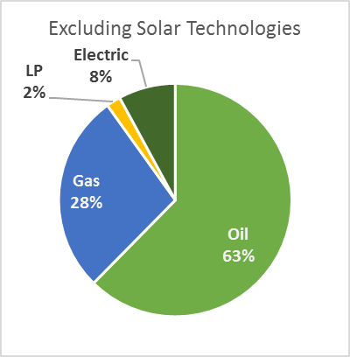

Table 16 shows the peak demand savings estimates associated with technical potential efficiency upgrades for 2016 and 2025. These estimates do not account for the impact of photovoltaics as REM/Rate does not include photovoltaics in demand calculations. It is unlikely that photovoltaics would influence winter peak demand savings as the winter peak in New England is from 5-7 PM during the months of December and January. Table 16 shows the following:
- The technical potential summer peak demand savings (including solar technologies) are 2,038 MW in 2016 and 2,229 MW in 2025.
- Savings associated with winter peak demand are negative (i.e., winter peak demand increases by 23% to 25%) because ductless mini-splits were modeled at all homes.
The estimated baseline summer and winter peak demand levels are similar. Connecticut, as a whole, is a summer peaking state where the maximum demand for electricity occurs during the summer peak hours. Both the commercial and industrial sectors are significant contributors to the summer peak demand. Because this study only analyzes single-family homes, it is not surprising to see similar baseline summer and winter peak demand estimates. While cooling is typically the primary driver of summer peak demand, some homeowners will be at work during summer peak hours with their air-conditioning turned off.
Table 16: Technical Peak Electric Demand Savings Estimates (MW)*
Base: all single-family homes (population-weighted)
 | Baseline | 2016 Savings | 2025 Savings
Summer Peak Demand
Technical potential including solar | 3,663 | 2,038 | 2,229
Technical potential excluding solar |  | 1,966 | 2,150
Winter Peak Demand
Technical potential including solar | 3,613 | -1,238 | -1,354
Technical potential excluding solar |  | -1,326 | -1,450
* See the Methodology section of this report for details on coincidence factors.

Individual Measures
The individually-modeled upgrade measures provide some context to the overall technical savings potential figures. All savings figures presented in this section are first-year savings, not accounting for growth rates. The savings from these figures are not additive as the measures in this section were modeled individually, not accounting for interactive effects with other measure upgrades, and some measures overlap for the same end use.
Throughout this section of the report, the sample sizes for individual measure upgrades represent the number of homes (out of a 180 home sample) where a particular upgrade applied. For example, Table 17 shows that reduced air infiltration has a sample size of 143 homes. This means that 143 out of the 180 homes in the sample had air leakage levels that required reduction to achieve the technical potential efficiency level.

Building Shell
Reducing air infiltration in the models saves 7.1% of baseline MMBtu consumption; the only other upgrades which resulted in greater savings were the three varieties of heat pumps and photovoltaics (Table 21). Other building shell upgrades also led to substantial savings, notably windows and above-grade wall, flat attic, and frame floor insulation. The absence of a similar level of savings from HVAC upgrades suggests that potential savings in heating and cooling are attributable mostly to upgrades in the building shell.
Table 17: Building Shell Savings Potential—First-Year
Base: all single-family homes (population-weighted)
 | N | Percent Savings^{i} | Fuel Oil (gal)^{ii} | Nat. Gas (ccf)^{ii} | Propane (gal)^{ii} | Electric (kWh)^{ii} | Total MMBtu^{ii}
Baseline consumption | 180 | - | 531.0 | 328.9 | 34.7 | 12,034.2 | 156.6
Reduce air infiltration | 142 | 7.1% | 51.8 | 29.7 | 1.4 | 142.0 | 11.1
Upgrade windows | 180 | 6.0% | 35.0 | 21.1 | 2.1 | 535.0 | 9.4
Add above grade wall insulation | 165 | 4.9% | 32.1 | 26.0 | 1.0 | 68.7 | 7.7
Add flat attic insulation | 166 | 4.0% | 29.5 | 15.6 | 1.0 | 70.8 | 6.3
Add frame floor insulation | 161 | 3.6% | 24.0 | 17.9 | 0.8 | 17.5 | 5.7
Add foundation wall insulation | 91 | 2.4% | 18.6 | 7.4 | 0.3 | 36.9 | 3.7
Reduce duct leakage | 50 | 1.9% | 10.5 | 10.5 | 0.4 | 125.4 | 3.0
Add vaulted ceiling insulation | 75 | 1.1% | 6.7 | 5.7 | 0.1 | 30.2 | 1.7
Add rim joist insulation | 109 | 0.4% | 2.4 | 1.7 | 0.1 | 1.9 | 0.6
Add duct insulation | 78 | 0.3% | 1.5 | 2.0 | 0.2 | 12.6 | 0.5
^{i} Percent savings over baseline consumption in MMBtus.
^{ii} In millions.

HVAC
Oil boilers are the most common heating equipment type in the sample, and also lead to the greatest potential savings among HVAC measures; gas furnaces are the second most common heating equipment, and lead to the second most savings (Table 18). As a percentage of baseline MMBtu consumption, however, no HVAC system upgrade resulted in as much savings in the models as any of the top five building shell measure upgrades.
Table 18: HVAC Savings Potential—First-Year
Base: all single-family homes (population-weighted)
 | N | Percent Savings^{i} | Fuel Oil (gal)^{ii} | Nat. Gas (ccf)^{ii} | Propane (gal)^{ii} | Electric (kWh)^{ii} | Total MMBtu^{ii}
Baseline consumption | 180 | -- | 531.0 | 328.9 | 34.7 | 12,034.2 | 156.6
Increase oil boiler AFUE | 81 | 2.5% | 29.1 | -- | - 0.1 | 12.2 | 3.9
Increase gas furnace AFUE | 25 | 1.3% | -- | 19.6 | -- | 32.6 | 2.1
Increase gas boiler AFUE | 24 | 1.2% | -- | 18.9 | -- | - 0.3 | 1.9
Increase oil furnace AFUE | 31 | 1.2% | 12.1 | -- | - <0.1 | 5.4 | 1.8
Upgrade central air conditioner | 76 | 0.5% | - <0.1 | 0.6 | -- | 203.0 | 0.7
Upgrade room air conditioners | 66 | 0.1% | - <0.1 | -- | -- | 62.4 | 0.2
Install ECM fan motor | 54 | 0.1% | -- | 1.7 | -- | 16.5 | 0.2
Increase propane boiler AFUE | 2 | 0.1% | - 0.02 | -- | 1.0 | - <0.1 | 0.1
Increase propane furnace AFUE | 2 | <0.1% | -- | -- | 0.4 | 0.35 | <0.1
^{i} Percent savings over baseline consumption in MMBtus.
^{ii} In millions

Water Heating
Technical potential savings attributable to water heater upgrades are comparatively modest. No single domestic hot water system upgrade exceeds savings of 1% MMBtu (Table 19). Nonetheless, technical potential savings of 11.2 million gallons of oil are available by replacing tankless coil water heating with an indirect (or integrated) system off of the boiler.

Table 19: Water Heating Savings Potential—First-Year^{i}
Base: all single-family homes (population-weighted)
 | N | Percent Savings^{ii} | Fuel Oil (gal)^{iii} | Nat. Gas (ccf)^{iii} | Propane (gal)^{iii} | Electric (kWh)^{iii} | Total MMBtu^{iii}
Baseline consumption | 180 | - | 531.0 | 328.9 | 34.7 | 12,034.2 | 156.6
Replace tankless coil on oil boiler with indirect water heater | 42 | 0.9% | 11.2 | - 0.9 | - 0.2 | 8.2 | 1.4
Replace gas storage water heater with instantaneous | 43 | 0.9% | -- | 13.5 | -- | 3.8 | 1.4
Replace electric water heater with heat pump water heater | 42 | 0.9% | - 1.4 | - 0.4 | -- | 490.0 | 1.4
Replace gas storage water heater with condensing gas water heater | 39 | 0.9% | -- | 14.6 | -- | 2.9 | 1.5
Replace gas storage water heater with more efficient gas storage heater | 39 | 0.6% | -- | 10.1 | -- | 1.2 | 1.0
Increase water heater tank wrap R-value | 102 | 0.2% | 0.3 | 1.3 | 0.1 | 41.5 | 0.3
Replace oil storage water heater with more efficient oil storage water heater | 9 | 0.1% | 1.3 | -- | 0.03 | - 0.2 | 0.2
Replace propane storage water heater with instantaneous | 6 | 0.1% | -- | -- | 1.6 | 0.3 | 0.1
Replace propane storage water heater with more efficient propane storage heater | 4 | 0.1% | <0.1 | -- | 1.0 | - <0.1 | 0.1
Replace propane storage water heater with condensing propane water heater | 4 | 0.1% | -- | -- | 1.3 | 0.3 | 0.1
^{i} Negative savings indicate a consumption increase.
^{ii} Percent savings over baseline consumption in MMBtus.
^{iii} In millions.

Appliances and Lighting
The potential for electric savings achievable by increasing homes’ saturation of efficient lighting is considerable (Table 20). However, lighting upgrades—along with refrigerator and freezer upgrades, to a lesser degree—also result in more fossil fuel consumption due to reduced internal heat gains.
Table 20: Appliance Savings Potential—First-Year
Base: all single-family homes (population-weighted)
 | N | Percent Savings^{i} | Fuel Oil (gal)^{ii} | Nat. Gas (ccf)^{ii} | Propane (gal)^{ii} | Electric (kWh)^{ii} | Total MMBtu^{ii}
Baseline consumption | 180 | -- | 531.0 | 328.9 | 34.7 | 12,034.2 | 156.6
Increase socket saturation of efficient lighting | 180 | 2.6% | - 11.0 | - 5.9 | - 0.7 | 1,900.0 | 4.1
Upgrade clothes washer | 177 | 1.2% | 3.8 | 3.3 | 0.5 | 323.6 | 2.0
Upgrade refrigerator | 180 | 0.6% | - 2.9 | - 1.6 | - 0.2 | 439.0 | 0.9
Upgrade dishwasher | 164 | 0.4% | 1.9 | 0.9 | 0.3 | 69.7 | 0.6
Upgrade freezer | 60 | 0.3% | - 0.6 | - 0.1 | -- | 174.0 | 0.5
Upgrade dehumidifier | 49 | 0.1% | - <0.1 | - <0.1 | - <0.1 | 39.3 | 0.1
^{i} Percent savings over baseline consumption in MMBtus.
^{ii} In millions. Negative savings indicate a consumption increase.

Heat Pumps and Solar Technologies
By far the most substantial savings among all the individual measures occur with heat pumps and solar technologies (Table 21). While each of the three heat pump upgrades—ground source, air source, and ductless—by themselves result in a great deal more electric consumption because of the change in heating fuel, each leads to a sizable net reduction in total MMBtu consumption. Ductless mini-splits exhibit the greatest potential savings as a result of their high efficiency, the high percentage of a home’s heating load displaced, and being applied at all 180 homes.
Table 21: Heat Pumps and Solar Technologies Savings Potential—First-Year
Base: all single-family homes (population-weighted)
 | N | Percent Savings^{i} | Fuel Oil (gal)^{ii} | Nat. Gas (ccf)^{ii} | Propane (gal)^{ii} | Electric (kWh)^{ii} | Total MMBtu^{ii}
Baseline consumption | 180 | - | 531.0 | 328.9 | 34.7 | 12,034.2 | 156.6
Install ductless mini-split^{iii} | 180 | 32.8% | 310.0 | 178.0 | 14.1 | - 4,140.0 | 51.3
Install air source heat pump | 104 | 14.7% | 165.0 | 107.0 | 8.4 | - 3,660.0 | 23.1
Add photovoltaic array | 108 | 11.8% | - 0.1 | <0.1 | -- | 5,430.0 | 18.5
Install ground source heat pump | 103 | 9.2% | 111.0 | 74.0 | 5.8 | - 2,750.0 | 14.5
Add solar hot water system | 109 | 5.7% | 36.7 | 19.6 | 4.0 | 466.0 | 9.0
^{i} Percent savings over baseline consumption in MMBtus.
^{ii} In millions. Negative savings indicate a consumption increase.
^{iii} See Appendix C for details on ductless mini-split modeling assumptions.

Similarly, the addition of photovoltaic arrays to 108 of the 180 models (60%) leads to over five Gigawatt hours (GWh) in first-year technical potential electric savings. Adding solar hot water systems to the same number of homes results in 9 MMBtus in technical savings potential, spread relatively evenly across fuel types.

Measures Assessed Outside of REM/Rate
Four of the upgrade measures could not be modeled using REM/Rate. Savings from low-flow showerheads, faucet aerators, and pipe insulation were calculated using equations found in the 2013 Connecticut HES Program Savings Document (PSD). Clothes washer upgrade calculations were also performed outside of REM/Rate because the software’s model for clothes washers requires complete data on the machine from the Energy Guide label, which was not available for all models. Savings attributable to all four non-REM/Rate upgrade measures are integrated into the comprehensive model savings in Table 12 and Table 13. The comprehensive savings values are de-rated to account for the interactive effects of water heater upgrades and water savings measures.
Auditors did not gather information regarding the presence or absence of low-flow showerheads and faucet aerators during the Connecticut Weatherization Baseline on-site inspections. Instead, data from a residential baseline study which NMR Group conducted in 2011 and 2012 on behalf of the Vermont Department of Public Service were used to estimate the number of low-flow showerheads and faucet aerators per home, which then provided context for calculations. For example, the Vermont data revealed that the mean number of low-flow showerheads in homes with one bathroom is 0.45. Similar “opportunity levels” were calculated for low-flow showerheads and faucet aerators based on number of bathrooms and subsequently used to calculate savings.
Potential savings attributable to the installation of low-flow showerheads and faucet aerators are substantial in both fossil fuels and kWh, according to equations provided in the PSD (Table 22).
Table 22: Savings from Non-REM Measures—First-Year
Base: all single-family homes (population-weighted)
 | N | Percent Savings | Fuel Oil (gal)^{ii} | Nat. Gas (ccf)^{ii} | Propane (gal)^{ii} | Electric (kWh)^{ii} | Total MMBtu^{ii}
Baseline DHW Energy Factors
DHW Pipe insulation | 138 | 0.3% | 1.4 | 1.4 | 0.3 | 24.2 | 0.5
Low-flow showerheads | 180 | 0.4% | 2.6 | 1.5 | 0.3 | 24.7 | 0.6
Faucet aerators | 180 | 0.3% | 2.0 | 1.2 | 0.2 | 20.0 | 0.5
Upgrade DHW Energy Factors
DHW Pipe insulation | 138 | 0.2% | 1.1 | 0.8 | 0.3 | 10.0 | 0.3
Low-flow showerheads | 180 | 0.3% | 2.0 | 0.9 | 0.2 | 10.2 | 0.4
Faucet aerators | 180 | 0.2% | 1.6 | 0.7 | 0.2 | 8.3 | 0.3
^{i} The 2013 Program Savings Document provides no equations which could be used to de-rate pipe insulation savings consistent with the increased mechanical efficiencies in the comprehensive model runs.
^{ii} In millions.

Cost-Effective Potential
4
This section details potential savings due to cost-effective efficiency measures. Savings used in cost-effectiveness screening were derived from the individual models developed in the technical potential stage of the study, then adjusted to reflect the evolution of codes and standards.
The varied characteristics of each of the 180 homes in the sample—for instance, building shell configurations and the capacity of existing HVAC equipment—resulted in varied savings and costs for any one measure between sites. Measures were screened at the site level, and all measures that screened as cost-effective were modeled simultaneously for each site. Savings were assessed by subtracting the consumption of the cost-effective site model from the consumption of the baseline (as-built) model.

Results of Cost-Effectiveness Screening
Table 23 and Table 24 present the results of the cost-effectiveness screening. The efficiency levels associated with each of these measures can be found in Appendix B. As shown, 20 out of the 43 measures have an average TRC benefit/cost ratio greater than one.
Some measures—especially windows—show high benefit/cost ratios using the UCT screening results, while the same measures show benefit/cost ratios of less than one when using the TRC screening results. This is because the program incentives for these measures cover just a small portion of their overall cost, leading to high participant costs. Because these measures offer substantial savings, benefits are significant when compared to program costs alone; however, high participant costs cancel out those benefits in the TRC test.
Table 23: Screening Results—Measures with Mean TRC Ratio ≥ 1.0
Base: all single-family homes (population-weighted)
Measure | # of Sites Measure Applied | UCT |  | TRC
 |  | Pass % | Mean Ratio | Pass % | Mean Ratio
Dishwasher | 153 | -- | -- | 55% | 8.5
Faucet aerators | 180 | 98% | 4.4 | 100% | 6.3
Water heater tank wrap | 102 | -- | -- | 90% | 6.2
Heat pump water heater | 42 | 100% | 9.6 | 98% | 4.7
Freezer | 60 | 72% | 7.8 | 82% | 3.9
Duct sealing | 50 | 92% | 3.1 | 84% | 2.7
Oil furnace | 28 | 94% | 12.3 | 89% | 2.5
Air sealing | 142 | 94% | 2.2 | 96% | 2.5
Low-flow showerheads | 180 | 83% | 2.1 | 99% | 2.2
Efficient lighting | 180 | 87% | 1.7 | 100% | 2.2
Clothes washer | 177 | 100% | 14.5 | 98% | 2.1
Flat attic insulation | 166 | 69% | 2.5 | 54% | 1.9
Efficient oil storage water heater | 9 | -- | -- | 44% | 1.9
HVAC pipe insulation | 138 | 100% | 2.9 | 100% | 1.8
Refrigerator | 180 | 91% | 9.8 | 78% | 1.8
Foundation wall insulation | 91 | -- | -- | 49% | 1.5
Above-grade wall insulation | 165 | 38% | 1.8 | 33% | 1.3
Frame floor insulation | 161 | 61% | 2.7 | 44% | 1.2
Vaulted ceiling insulation | 75 | 43% | 1.8 | 31% | 1.1
Integrated tank water heater | 41 | 88% | 7.8 | 39% | 1.0

Table 24: Screening Results—Measures with Mean TRC Ratio < 1.0
Base: all single-family homes (population-weighted)
Measure | # of Sites Measure Applied | UCT |  | TRC
 |  | Pass % | Mean Ratio | Pass % | Mean Ratio
Gas furnace | 25 | 72% | 2.7 | 40% | 0.8
Solar thermal array | 108 | -- | -- | 28% | 0.8
Propane instantaneous water heater | 6 | -- | -- | 33% | 0.8
Propane condensing water heater | 4 | -- | -- | 25% | 0.8
Propane furnace | 2 | 100% | 9.5 | 50% | 0.8
Oil boiler | 80 | -- | -- | 14% | 0.7
Propane storage water heater | 4 | -- | -- | 25% | 0.7
Gas storage water heater | 39 | 95% | 3.8 | 10% | 0.6
Gas condensing water heater | 39 | 95% | 2.4 | 5% | 0.6
Propane boiler | 2 | -- | -- | 0% | 0.5
ECM fan motor | 54 | -- | -- | 4% | 0.5
Gas instantaneous water heater | 43 | 100% | 3.4 | 0% | 0.5
Gas boiler | 25 | 79% | 1.8 | 4% | 0.5
Windows | 180 | 87% | 68.2 | 0% | 0.3
Photovoltaic array | 108 | -- | -- | 0% | 0.3
Duct insulation | 60 | -- | -- | 8% | 0.3
Rim joist insulation | 109 | -- | -- | 4% | 0.3
Central air conditioner | 76 | 4% | 0.7 | 0% | 0.2
Room air conditioner | 66 | -- | -- | 0% | 0.2
Dehumidifier | 49 | 0% | -2.5 | 0% | 0.1
Air source heat pump | 104 | 20% | -29.3 | 7% | -1.2
Ductless mini-split* | 176 | 8% | -33.4 | 6% | -1.8
Ground-source heat pump | 103 | 2% | -20.5 | 0% | -3.4
* Ductless mini-splits were not screened for cost-effectiveness at four sites as the technology was already present.

Cost-Effective Potential Savings
Figure 13 compares potential cost-effective savings to technical potential savings. Cost-effective potential savings are about one-third the amount of technical potential savings with solar included, and about two-fifths without solar included in the technical potential total.
Figure 13: Ten-Year (2016-2025) Aggregate Savings for Technical and Cost-Effective Potential (MMBtu)
Base: all single-family homes (population-weighted)
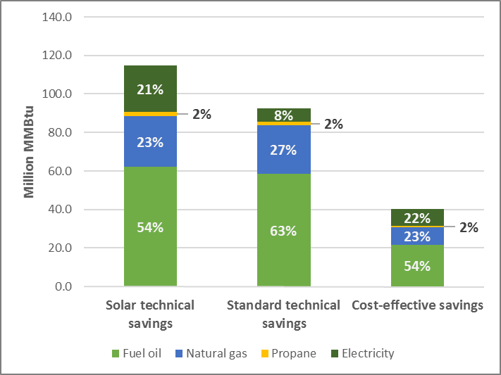

Table 25 shows cost-effective potential savings by fuel type. Upgrades that screened as cost-effective, with savings extrapolated over the ten-year period from 2016 to 2025, result in total ten-year savings of 24% relative to baseline consumption, and 27% in the first year.
Cost-effective oil and natural gas savings represent 29% and 28% of baseline consumption in the first year respectively, while propane savings account for 21% of first-year consumption. These proportions remain relatively the same over the ten-year period from 2016 to 2025, with gas and propane declining by two percentage points each and oil remaining at 29%.
Cost-effective electric savings represent 21% of baseline consumption in the first year, but only 15% over ten years. This is due to the influence of changes in federal minimum efficiency standards for lighting and appliances, which negate a substantial proportion of the savings in the later years of the study window. This is particularly true for lighting in years after 2020, when EISA standards are due to increase.

Table 25: Cost-Effective Potential Savings— Ten-Year Aggregate Savings (2016-2025)*
Base: all single-family homes (population-weighted)
 | Fuel Oil (gal) | Nat. Gas (ccf) | Propane (gal) | Electric (kWh) | Fossil Fuels (MMBtu) | All Fuels (MMBtu)
Baseline annual consumption (2016) | 526.6 | 326.8 | 34.4 | 12,047.2 | 108.9 | 150.0
First year annual savings (2016) | 155.1 | 92.1 | 7.4 | 2,582.0 | 31.4 | 40.2
Percent savings from baseline, first  year | 29% | 28% | 21% | 21% | 29% | 27%
Baseline aggregate consumption (2016-2025) | 4,795.0 | 3,373.4 | 350.3 | 126,040.0 | 1,034.3 | 1,464.4
Ten-year aggregate savings (2016-2025) | 1,369.6 | 880.0 | 68.1 | 18,399.2 | 284.2 | 346.9
Percent savings from baseline, ten-  year | 29% | 26% | 19% | 15% | 27% | 24%
* Savings are in millions of units.
Figure 14 shows the change in the proportion of cost-effective potential savings accounted for by each fuel type over the ten-year span from 2016 to 2025. Electric savings decline from 22% of the total to 15% during that window, due mostly to the impact of federal minimum efficiency standards for lighting, and to a lesser degree, appliances. Oil and natural gas savings both increase as a proportion of total cost-effective savings between 2016 and 2025, oil from 54% to 56%, and gas from 23% to 27%.
Figure 14: Fuel Type Percent of Cost-Effective Savings (MMBtu)
Base: all single-family homes (population-weighted)
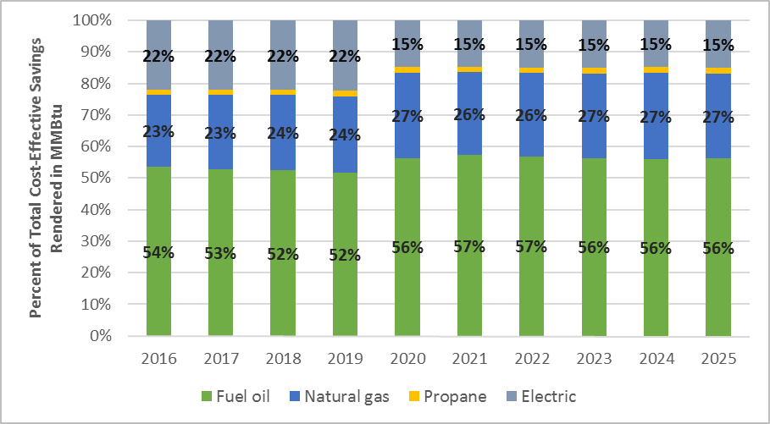

Most cost-effective fossil-fuel savings occur in space heating, which is the end use responsible for most energy consumption overall in Connecticut and the primary way in which consumers use fossil fuels (Table 26). Most cost-effective electric savings occur at the lights and appliances end use, though a substantial amount also occurs in water heating.
Table 26: Cost-Effective Potential Savings by End Use—First Year
Base: all single-family homes (population-weighted)
End Use | End Use % of Total | Fuel Oil (gal) | Nat. Gas (ccf) | Propane (gal) | Electric (kWh)
Heating | 72% | 141.8 | 83.3 | 5.8 | 156.7
Cooling | 1% | -- | -- | -- | 153.8
Water heating | 10% | 13.3 | 8.8 | 1.6 | 290.8
Lights & appliances | 17% | -- | -- | -- | 1,980.7
Total | 100% | 155.1 | 92.1 | 7.4 | 2,582.0

As a percentage of overall cost-effective savings—rendered in MMBtu to facilitate direct comparison—fuel oil is the most substantial contributor to savings, at 54% of all cost-effective savings (Table 27). About half (49%) of all cost-effective savings are attributable to fuel oil at the heating end use alone.
Table 27: Cost-Effective Savings Potential by End Use as a Percentage of Overall Savings in MMBtu —First Year
Base: all single-family homes (population-weighted)
End Use | End Use Percent | Fuel Oil | Natural Gas | Propane | Electric
Heating | 72% | 49% | 21% | 1% | 1%
Cooling | 1% | -- | -- | -- | 1%
Water heating | 10% | 5% | 2% | < 1% | 2%
Lights & appliances | 17% | -- | -- | -- | 17%
Fuel type percent | 100% | 54% | 23% | 2% | 22%

Figure 15 presents information from Table 27 in pie charts.
Figure 15: Cost-Effective Potential Savings by End Use & Fuel Type
Base: all single-family homes (population-weighted)
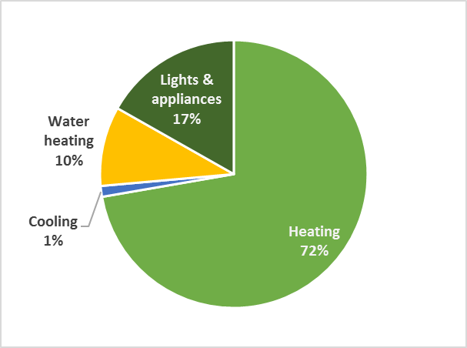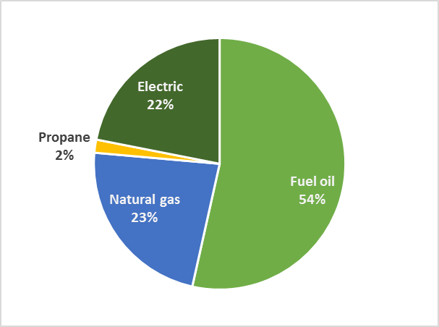

Table 28 details the share of annual cost-effective savings potential accounted for by each fuel type and compares it to its share of baseline consumption. The relative savings opportunity in fuel oil is more substantial than for other fuels—while oil only accounts for 49% of baseline consumption (measured in MMBtu), it accounts for 54% of cost-effective potential savings. In contrast, electricity accounts for a greater share of baseline consumption (27%) than cost-effective savings (22%).
Table 28: Fuel Type Share of Baseline Consumption and Cost-Effective Savings Potential
Base: all single-family homes (population-weighted)
Fuel Type | Share of Baseline | Share of Savings Potential
Fuel oil | 49% | 54%
Natural gas | 22% | 23%
Propane | 2% | 2%
Electricity | 27% | 22%

Table 29 shows cost-effective peak electric demand savings. Cost-effective summer peak demand savings range from 1,058 MW to 504 MW from 2016 to 2025, while winter peak demand savings range from 1,288 MW to 608 MW over the same time period. Demand savings decline along with consumption savings during the ten-year window due to the impact of federal minimum efficiency standards for lighting and appliances.
Table 29: Cost-Effective Peak Electric Demand Savings Estimates (MW)*
Base: all single-family homes (population-weighted)
Season | Baseline | 2016 Savings |  | 2025 Savings
 |  | MW | % of Baseline | MW | % of Baseline
Summer peak demand | 3,663 | 1,058 | 29% | 504 | 14%
Winter peak demand | 3,613 | 1,288 | 36% | 608 | 17%
* See the Methodology section of this report for details on coincidence factors.

Achievable Potential
5
This section provides estimates of the cost-effective savings that are achievable after changes in codes and standards and gradual market adoption of upgrade measures are taken into account.
Results included in this section describe maximum achievable potential savings; in other words, they do not take into account the impact of program activities on the market. In order to place the results of the analysis in context, achievable potential savings are compared to projected program savings for 2016 in the subsection entitled “Comparison to Projected Program Savings.”
Figure 16 shows that in the first year of the analysis, maximum achievable fossil fuel potential savings and projected program fossil fuel savings for 2016 are about 7% and 1% of cost-effective potential savings respectively. Program projected savings for 2016 represent 19% of 2016 maximum achievable potential fossil fuel savings.
Figure 16: First Year and Tenth Year Cost-Effective and Achievable Potential Fossil Fuel Savings
Base: all single-family homes (population-weighted)
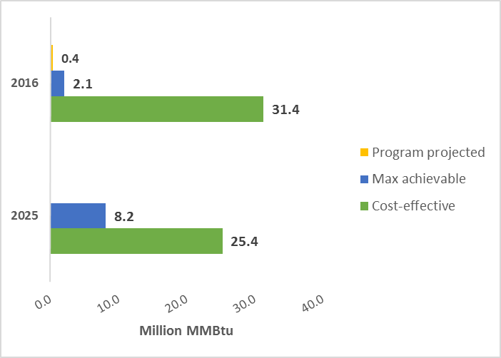

Figure 17 shows the same information as the prior table, though only for electric savings. Maximum achievable potential electric savings are about 23% of cost-effective savings in the first year, but rise to a much greater 45% by the tenth year of the study window due to declines in cost-effective electric savings (resulting from more stringent federal efficiency standards, particularly for lighting) and, to a lesser extent, gradually increasing measure adoption in the achievable analysis. Program projected electric savings for 2016 represent 18% of 2016 maximum achievable potential electric savings.
Figure 17: First Year and Tenth Year Cost-Effective and Achievable Potential Electric Savings
Base: all single-family homes (population-weighted)
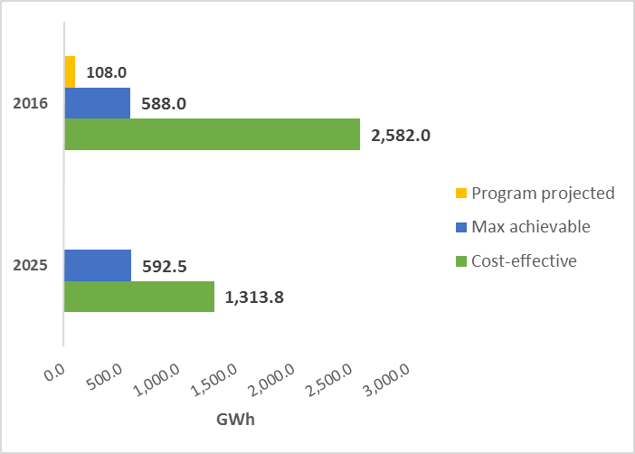

Table 30 details total achievable potential savings by fuel type. Achievable savings represent about 5% of baseline consumption for all fuels over the ten-year period from 2016 to 2025. Achievable electric savings comprise 5% of baseline consumption in both the first year and in aggregate over ten years, while fossil fuel savings increase substantially over time. This is due to the gradual market adoption of measures. See Appendix F for more details regarding market adoption assumptions.
Table 30: Achievable Potential Savings— Ten-Year Aggregate (2016-2025)*
Base: all single-family homes (population-weighted)
 | Fuel Oil (gal) | Nat. Gas (ccf) | Propane (gal) | Electric (kWh) | Fossil Fuels (MMBtu) | All Fuels (MMBtu)
Baseline annual consumption (2016) | 526.6 | 326.8 | 34.4 | 12,047.2 | 108.9 | 150.0
First year annual savings (2016) | 10.3 | 6.6 | 0.4 | 588.0 | 2.1 | 4.1
Percent savings from baseline, first year | 2% | 2% | 1% | 5% | 2% | 3%
Baseline aggregate consumption (2016-2025) | 4,795.2 | 3,372.9 | 350.3 | 126,040.4 | 1,034.3 | 1,464.4
Ten-year aggregate savings (2016-2025) | 251.7 | 165.5 | 11.4 | 5,913.6 | 52.5 | 72.7
Percent savings from baseline, ten-year | 5% | 5% | 3% | 5% | 5% | 5%
* Savings are in millions of units.
Figure 18 shows the growth in achievable potential savings over time, measured in MMBtu to make direct comparison between fuels possible. The analysis shows that due to the gradual adoption of upgrades and increasing market penetration of new technologies, achievable potential savings overall increase between 2016 and 2019, after which point their growth slows due to a downturn in achievable electric savings resulting from changing federal minimum efficiency standards. In particular, standards for residential appliances, and especially lighting, will become much more stringent around the year 2020.
Figure 18: Achievable Potential Savings Growth Rendered in MMBtu
Base: all single-family homes (population-weighted)
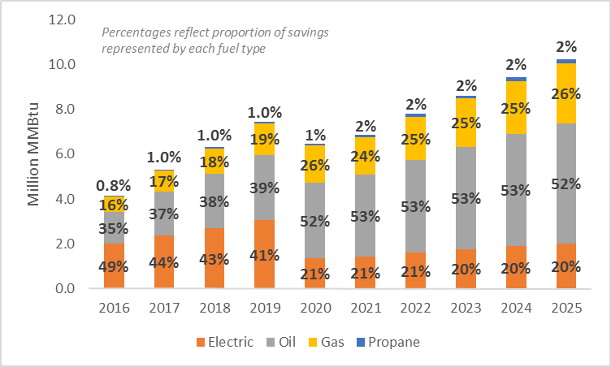

First-year achievable savings estimates are low in comparison to baseline consumption because the analysis assumes gradual adoption of upgrade measures over time. In year ten (2025), achievable potential savings constitute about 5% of overall baseline consumption (measured in MMBtu), 8% of fossil fuel consumption (MMBtu), and 9% of electric consumption (kWh) (Table 31). Annual achievable potential savings comprise about one third (32%) of cost-effective fossil fuel savings by 2025, and 45% of cost-effective electric savings.
Table 31: Achievable Savings as a Percent of Baseline in Year Ten
Base: all single-family homes (population-weighted)
Fuel Type | Year Ten Savings (2025) | Percent of Baseline | Percent of Cost-Effective | Percent of Solar Technical | Percent of Standard Technical
Fuel oil (million gallons) | 38.7 | 7% | 32% | 10% | 11%
Natural gas (million ccf) | 26.7 | 8% | 33% | 9% | 10%
Propane (million gallons) | 2.0 | 4% | 31% | 8% | 10%
Electricity (million kWh) | 592.5 | 9% | 45% | 8% | 26%
Fossil fuels (million MMBtu) | 8.2 | 8% | 32% | 10% | 11%
All fuels (million MMBtu) | 10.2 | 5% | 34% | 9% | 12%

All achievable fossil-fuel savings occur at the space heating and water heating end uses, while most electric savings occur in lighting and appliances. Due to gradual adoption of upgrade measures, the analysis estimates that fossil fuel savings in year ten will be much greater than in the first year of the window. Conversely, the analysis estimates that annual electric savings will drop by year ten; while gradual measure adoption leads to savings increases at the heating, cooling, and water heating end uses, more stringent federal standards lead to a decrease in savings at the lights & appliances end use.
Table 32: Achievable Potential Savings by End Use—Year One & Year Ten*
Base: all single-family homes (population-weighted)
End Use | Fuel Oil (gal) | Nat. Gas (ccf) | Propane (gal) | Electric (kWh) | Fossil Fuels (MMBtu) | All Fuels (MMBtu)
Year One (2016) Achievable Savings
Heating | 9.7 | 6.2 | 0.3 | 12.6 | 2.0 | 2.0
Cooling | -- | -- | -- | 8.9 | -- | < 0.1
Water heating | 0.6 | 0.4 | < 0.1 | 14.9 | 0.1 | 0.2
Lights & appliances | -- | -- | -- | 551.6 | -- | 1.9
Total | 10.3 | 6.6 | 0.4 | 588.0 | 2.1 | 4.1
Year Ten (2025) Achievable Savings
Heating | 30.3 | 22.7 | 1.7 | 41.7 | 7.8 | 8.0
Cooling | -- | -- | -- | 38.7 | -- | 0.1
Water heating | 1.7 | 1.0 | 0.2 | 77.0 | 0.4 | 0.7
Lights & appliances | -- | -- | -- | 387.9 | -- | 1.4
Total | 32.1 | 23.7 | 1.9 | 545.4 | 8.2 | 10.2
* In millions.

Table 33 presents achievable potential savings, by end use and fuel type, in year one and year ten as a percentage of overall savings in MMBtu. In year one (2016), electricity accounts for a higher percentage of achievable savings overall than any other fuel (49%, measured in MMBtu for direct comparison). By year ten (2025), the proportion of savings accounted for by fuel oil grows to slightly more than half (52%) of all achievable savings, while electric savings drop to 20%. The proportion of savings accounted for by natural gas also grows substantially from year one to year ten, from about 16% to about 26%.
Table 33: Achievable Potential Savings by End Use as a Percentage of Overall Savings in MMBtu—Year One and Year Ten
Base: all single-family homes (population-weighted)
End Use | Fuel Oil (MMBtu) | Nat. Gas (MMBtu) | Propane (MMBtu) | Electric (MMBtu) | All Fossil Fuels (MMBtu) | All Fuels (MMBtu)
Year One (2016) Achievable Savings
Heating | 33% | 15% | 1% | 1% | 48% | 49%
Cooling | -- | -- | -- | 1% | -- | 1%
Water heating | 2% | 1% | < 1% | 1% | 3% | 4%
Lights & appliances | -- | -- | -- | 46% | -- | 46%
Total | 35% | 16% | 1% | 49% | 51% | 100%
Year Ten (2025) Achievable Savings
Heating | 50% | 25% | 2% | 2% | 77% | 78%
Cooling | -- | -- | -- | 1% | -- | 1%
Water heating | 2% | 1% | < 1% | 3% | 4% | 6%
Lights & appliances | -- | -- | -- | 14% | -- | 14%
Total | 52% | 26% | 2% | 20% | 80% | 100%
Figure 19 presents the percentage of first-year savings associated with key end uses (measured in MMBtu, though it includes electric savings). The heating and lights & appliances end uses each account for about half of achievable potential savings in the first year, but by year ten, savings at the heating end use come to comprise nearly 80% of all savings. In the near-term, annual savings due to lights and appliances will be much more substantial than in ten years. This is due primarily to several imminent increases in federal minimum efficiency standards, especially for lighting.
Figure 19: Achievable Potential Savings by End Use (MMBtu)
Base: all single-family homes (population-weighted)
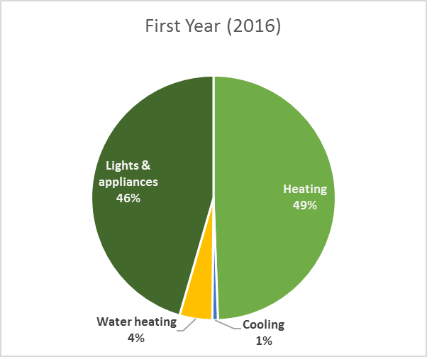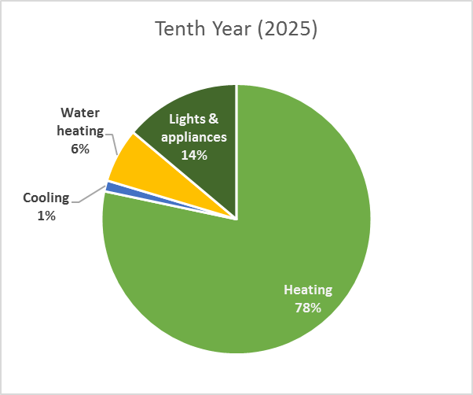

Figure 20 shows the various fuel types as a percentage of total achievable savings. The first two pie charts include electric savings rendered in MMBtu; the second two include fossil fuel savings only. The proportion of fossil fuel savings accounted for by each fuel changes little over ten years. However, codes and standards have a substantial impact on electric savings, which comprise a much smaller part of overall savings by 2025.
Figure 20: Fuel Type Share of Achievable Potential Savings (MMBtu)
Base: all single-family homes (population-weighted)
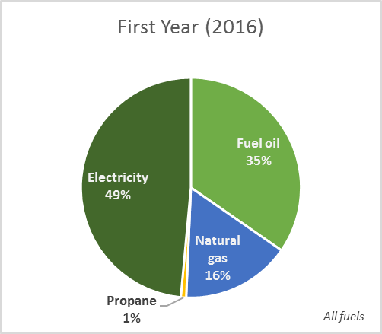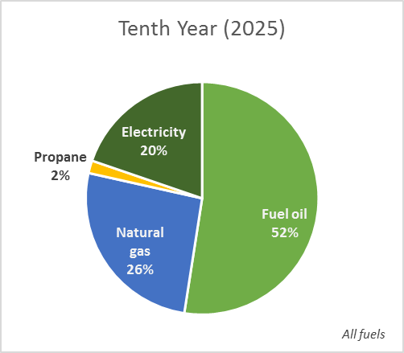
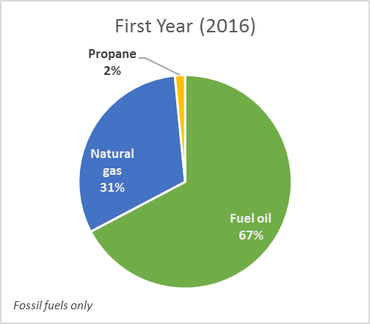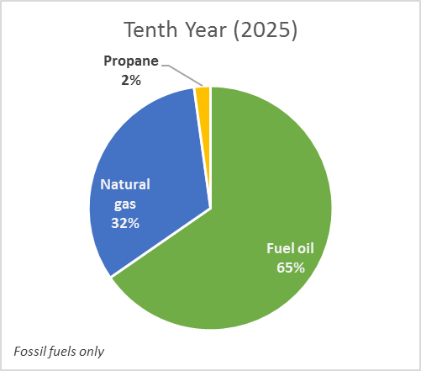

Table 34 shows maximum achievable peak electric demand savings. Achievable summer peak demand savings range from 251 MW to 236 MW from 2016 to 2025, while winter peak demand savings range from 307 MW to 294 MW. Demand savings decline somewhat, along with consumption savings, due to the impact of federal minimum efficiency standards for electric equipment, especially lighting.
Table 34: Achievable Peak Electric Demand Savings Estimates (MW)*
Base: all single-family homes (population-weighted)
Season | Baseline | 2016 Savings |  | 2025 Savings
 |  | MW | % of Baseline | MW | % of Baseline
Summer peak demand | 3,663 | 251 | 7% | 236 | 6%
Winter peak demand | 3,613 | 307 | 8% | 294 | 8%
* See the Methodology section of this report for details on the methodology and coincidence factors.

Comparison to Projected Program Savings
Table 35 shows the amount of program funding that would be necessary to achieve the amount of savings estimated by the maximum achievable potential analysis. Projected program costs and savings for 2016, provided by Eversource, suggest a cost of $0.52 per kWh of electric savings and $54.39 per MMBtu of fossil fuel savings.
These projected figures indicate that it would cost roughly $424 million in 2016 alone for the program to effect the amount of savings that results from the analysis, or about 5.5 times the amount of money that the Companies project will actually be spent on program activities in 2016.
Table 35: Extrapolated Costs Necessary to Achieve 2016 Maximum Achievable Potential Savings
Fuel type | Unit | Program Projected (2016) |  |  | Achievable Potential (2016)
 |  | Cost (Million $) | Cost per Unit of Savings | Savings | Savings | Extrapolated Cost (Million $)
Electric | kWh | $56.6 | $0.52 | 108.0 | 588.0 | $308.1
Fossil fuels | MMBtu | $21.9 | $54.39 | 0.4 | 2.1 | $115.8
Total | -- | $78.5 | -- | -- | -- | $423.9

Fuel Switching Potential
6
The results presented here detail the potential impacts from converting the heating and water heating equipment in single-family homes currently using oil, propane, biomass, or electric heating to either (a) natural gas space heating and water heating equipment, or (b) electric heat pump space heating and water heating equipment.
Three potential impacts from fuel switching are assessed in this study:
- Reduced oil and propane consumption.
- Increased natural gas consumption and electric consumption.
- Potential gas and electric savings from utility incentives.
Impacts are assessed in two ways: a base case scenario and an upgrade case scenario. The base case assesses the potential impacts of fuel switching without any utility intervention aside from that which would be necessary to persuade homeowners to switch fuels. The upgrade case assesses the potential effects of program incentives for higher-efficiency heating and water heating equipment for homes that undergo a fuel switch (see the Fuel Switching Methodology section for more details on the base case and upgrade case scenarios). All of the impacts detailed in this report are presented relative to what the annual consumption of a given fuel is expected to be in 2025; these trajectories were extrapolated using growth rates from various sources. For more detail on the sources for growth rates see Appendix E.
This report presents analysis results over a ten-year conversion period, with conversions increasing, under different scenarios, to 100%, 75%, 50%, and 25% over that period. All of the results presented in this report reflect the impacts of fuel switching on Connecticut’s single-family housing stock only.

Results
This section details the results of the fuel switching analysis. It includes the following subsections:
MMBtu Summary
Presents overall savings across all four of the fuel types included in the analysis, in order to provide an overview of the total potential savings due to fuel switching.
Results by Fuel
Presents the results of fuel switching for each of the four fuel types included in the analysis.
Base Case Scenario
Details the results of base case scenario fuel switching (fuel switching group features are described in detail in Table 7).

Upgrade Case Scenario
Details the results of upgrade case scenario fuel switching (fuel switching group features are described in detail in Table 7).
Fuel Switching Impact by End Use
Further details base case and upgrade case fuel switching impact by the heating, cooling, and water heating end uses.

MMBtu Summary
Table 36 shows the overall impact of fuel switching across all fuel types. Fuel switching, of course, results in more consumption of some fuels and less consumption of others. Nonetheless, because of the comparatively greater efficiency of replacement equipment, it would result in an overall decrease in total annual consumption in MMBtu (Table 36). The following impacts were identified during the fuel switching analysis:
- Over the next decade, single-family homes in Connecticut can be expected to consume about 1.5 billion MMBtu of energy.
- Base case fuel switching could, under the 100% conversion rate, potentially save 5.5% of that amount in total over the course of ten years.
- By year ten, annual fuel consumption in MMBtu would decline by 17.2% of the expected annual consumption level.
- Program incentives for higher-efficiency equipment can be expected to save a maximum of 43.8 million MMBtu over the course of ten years, or 7.8 million MMBtu annually by year ten.
  - This amount represents 3.1% of base case consumption over ten years and 6.4% of year-ten annual consumption.
Table 36: Fuel Switching—Overall Summary in MMBtu
Base: all single-family homes (population-weighted)
Conversion rate | Annual Consumption |  |  |  |  | Total Over Ten Years
 | Current | Year 2.5 | Year 5 | Year 7.5 | Year 10
No fuel switching | 155.9 | 154.5 | 152.2 | 149.9 | 147.7 | 1,475.5
Base Case
25% conversion rate (million MMBtu) | 155.9 | 152.8 | 148.9 | 145.1 | 141.3 | 1,455.3
Percent change from existing | -- | 1.1% | 2.2% | 3.2% | 4.3% | 1.4%
50% conversion rate (million MMBtu) | 155.9 | 151.2 | 145.7 | 140.3 | 135.0 | 1,435.1
Percent change from existing | -- | 2.1% | 4.3% | 6.4% | 8.6% | 2.7%
75% conversion rate (million MMBtu) | 155.9 | 149.5 | 142.4 | 135.4 | 128.7 | 1,414.9
Percent change from existing | -- | 3.2% | 6.4% | 9.7% | 12.9% | 4.1%
100% conversion rate (million MMBtu) | 155.9 | 147.9 | 139.1 | 130.6 | 122.3 | 1,394.7
Percent change from existing | -- | 4.3% | 8.6% | 12.9% | 17.2% | 5.5%
Upgrade Case
25% conversion rate (million MMBtu) | 155.9 | 152.3 | 147.9 | 143.6 | 139.4 | 1,444.4
Percent change from base | -- | 0.3% | 0.7% | 1.0% | 1.3% | 0.8%
50% conversion rate (million MMBtu) | 155.9 | 150.1 | 143.6 | 137.3 | 131.1 | 1,413.2
Percent change from base | -- | 0.7% | 1.4% | 2.1% | 2.9% | 1.5%
75% conversion rate (million MMBtu) | 155.9 | 148.0 | 139.4 | 130.9 | 122.8 | 1,382.1
Percent change from base | -- | 1.0% | 2.1% | 3.3% | 3.5% | 2.3%
100% conversion rate (million MMBtu) | 155.9 | 145.8 | 135.1 | 124.6 | 114.5 | 1,350.9
Percent change from base | -- | 1.4% | 2.9% | 4.6% | 6.4% | 3.1%
Incentive Impact in Million MMBtu
25% conversion rate (million MMBtu) | -- | 0.5 | 1.0 | 1.5 | 1.9 | 10.9
50% conversion rate (million MMBtu) | -- | 1.1 | 2.1 | 3.0 | 3.9 | 21.9
75% conversion rate (million MMBtu) | -- | 1.5 | 3.0 | 4.5 | 5.9 | 32.8
100% conversion rate (million MMBtu) | -- | 2.1 | 4.0 | 6.0 | 7.8 | 43.8

As Figure 21 and Figure 22 demonstrate, total annual fuel consumption in the state will decrease by 5% in the next decade (from 155.9 million MMBtu to 147.7 million MMBtu) if left on its current trajectory. Fuel switching could potentially lead to an additional 4% (base case scenario with 25% conversion rate) to 22% (upgrade case scenario with 100% conversion rate) decrease in annual fuel consumption in MMBtu in that same time period.
Figure 21: Fuel Switching—Change in Total Consumption in MMBtu, Base Case Scenario
Base: all single-family homes (population-weighted)
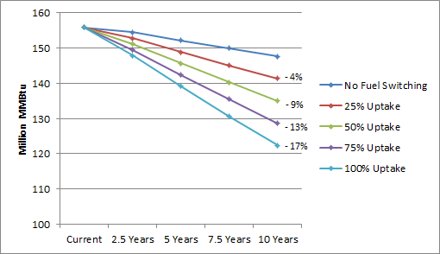
Figure 22: Fuel Switching—Change in Total Consumption in MMBtu, Upgrade Case Scenario
Base: all single-family homes (population-weighted)
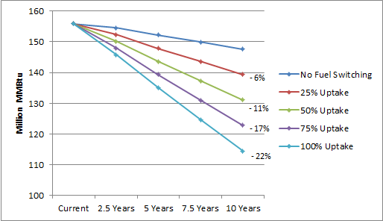

Results by Fuel
This section presents the results of fuel switching for each of the four fuel types included in the analysis.
Table 37 demonstrates the following:
- Fuel switching has the potential to decrease single-family home oil use in Connecticut by up to 77% of the year-ten expected annual consumption, in the absence of program incentives for efficient equipment.
  - With incentives for higher efficiency equipment fuel switching has the potential decrease single-family home oil use in Connecticut by up to 84% of the year-ten expected annual consumption.
- Fuel switching has the potential to decrease single-family home propane use in Connecticut by up to 59% of the year-ten expected annual consumption, in the absence of program incentives.
  - With incentives for higher efficiency equipment fuel switching has the potential decrease single-family home propane use in Connecticut by up to 73% of the year-ten expected annual consumption.
- Switching the state’s heating and water heating equipment to gas-fired models or heat pumps could result in up to an 89% increase in annual natural gas consumption and up to a 13% increase in annual electricity consumption by year ten in the base case.
  - In the upgrade case these fuel switches could result in up to an 82% increase in annual natural gas consumption and up to a 12% increase in annual electricity consumption by year ten.
Table 37: Fuel Switching—Change in Annual Consumption by Fuel at Year Ten
Base: all single-family homes (population-weighted)
Fuel type | Current Annual | Percent Change from Expected Consumption*
 |  | 25% Uptake | 50% Uptake | 75% Uptake | 100% Uptake
Base Case
Fuel oil (million gallons) | 527.6 | - 19% | - 39% | - 58% | - 77%
Propane (million gallons) | 34.4 | - 15% | - 30% | - 44% | - 59%
Natural gas (million ccf) | 326.8 | + 22% | + 44% | + 66% | + 89%
Electricity (million kWh) | 12,048.2 | + 3% | + 7% | + 10% | + 13%
Upgrade Case
Fuel oil (million gallons) | 527.6 | - 21% | - 42% | - 63% | - 84%
Propane (million gallons) | 34.4 | - 18% | - 36% | - 55% | - 73%
Natural gas (million ccf) | 326.8 | + 20% | + 41% | + 61% | + 82%
Electricity (million kWh) | 12,048.2 | + 3% | + 6% | + 9% | + 12%
* Expected consumption is the current annual consumption extrapolated over ten years using growth rates.

Consumers in the state of Connecticut could potentially avoid burning nearly 2 billion gallons of oil and over 100 million gallons of propane over the ten-year period from 2016 to 2025 as a result of fuel switching, assuming a 100% conversion rate and no utility intervention. The same switch would result in approximately a 1.7 billion ccf increase in natural gas consumption and about a 9.5 billion kilowatt-hour increase in electric consumption over a ten-year period, in aggregate. See Table 48 in Appendix D for detailed consumption growth trajectories under the maximum (100%) conversion rate.
The analysis also estimates that program incentives for energy efficient natural gas and heat pump heating and water heating equipment could potentially save 8% of the total increase in natural gas consumption (130.8 million ccf) and 11% of the total increase in electric consumption (1 billion kilowatt-hours) over the course of the next decade (Figure 23).
Figure 23 demonstrates the maximum impact of the two fuel switching scenarios on oil consumption over ten years.
Figure 23: Fuel Switching—Impact on Fuel Oil Consumption (100% Conversion Rate)
Base: all single-family homes (population-weighted)
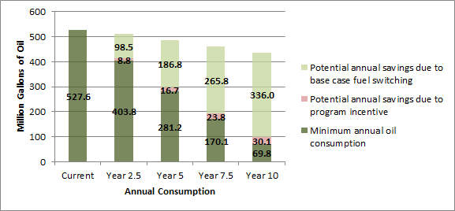

Figure 24 demonstrates the maximum impact of the two fuel switching scenarios on propane consumption over ten years.
Figure 24: Fuel Switching—Impact on Propane Consumption (100% Conversion Rate)
Base: all single-family homes (population-weighted)
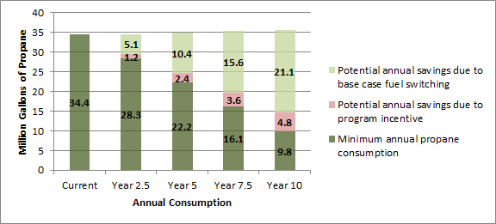

Likewise, Figure 25 demonstrates the maximum impact of fuel switching on natural gas consumption over ten years.
Figure 25: Fuel Switching—Impact on Natural Gas Consumption (100% Conversion Rate)
Base: all single-family homes (population-weighted)
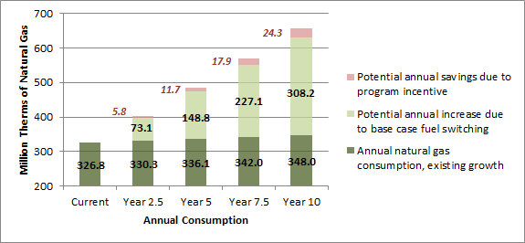

Figure 26 shows the maximum impact fuel switching could have on electricity consumption over the next ten years.
Figure 26: Fuel Switching—Impact on Electricity Consumption (100% Conversion Rate)
Base: all single-family homes (population-weighted)
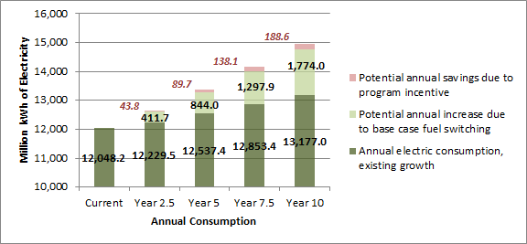

Lastly, Figure 27 demonstrates the maximum potential impact of fuel switching on overall fuel consumption, measured in MMBtu.
Figure 27: Fuel Switching—Impact on Overall Consumption in MMBtu (100% Conversion Rate)
Base: all single-family homes (population-weighted)
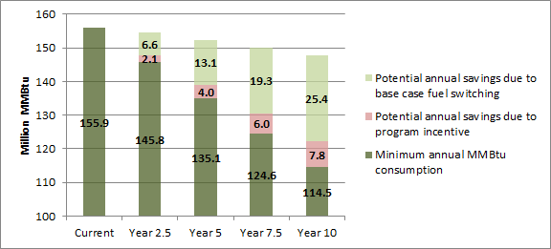

Base Case Scenario (No Utility Incentive)
This section details the results of base case scenario fuel switching. Fuel switching group features are described in detail in Table 7.
Table 38 details the impact of fuel switching under the base case scenario for various conversion rates. As shown:
Natural Gas
- Even with a 25% conversion rate, natural gas consumption in the state would exceed in 2.5 years a level (348 million ccf) which would otherwise not be reached for a decade under the no fuel switching scenario.
- Overall, fuel switching can be expected to increase natural gas consumption to between 130% and 201% of current annual consumption in the next decade.
Electricity
- A 25% conversion rate in the base case scenario would lead to an increased consumption of more than 2.3 billion kilowatt-hours of electricity in total over the next decade.
- A 50% conversion rate would result in more than 4.7 billion kilowatt-hours in increased usage, and a 100% conversion rate would lead to nearly 9.5 billion more kilowatt-hours over the next ten years than would be the case without fuel switching.
Fuel Oil and Propane
- Fuel switching could potentially reduce the state’s annual consumption of fuel oil for heating from the expected 435.9 million gallons per year in year ten to less than 100 million gallons.
  - This would represent a 77% decrease from the expected year-ten consumption level.
- Annual propane consumption could be reduced to 14.6 million gallons per year, which is a 59% decrease related to expected year-ten annual consumption.
Table 38: Fuel Switching—Annual Consumption Trajectories – Base Case Scenario
Base: all single-family homes (population-weighted)
Conversion Rate | Annual Consumption by Fuel |  |  |  |  |  | Difference in 10-Year Totals*
 | Current | Growth Rate | 2.5 Years | 5.0 Years | 7.5 Years | 10 Years
Fuel Oil Consumption Trajectory (million gallons)
No fuel switching | 527.6 | -2.1% | 511.1 | 484.7 | 459.7 | 435.9 | -
25% Uptake |  |  | 486.5 | 438.0 | 393.2 | 351.9 | - 493.1
50% Uptake |  |  | 461.9 | 391.3 | 326.8 | 267.9 | - 986.1
75% Uptake |  |  | 437.2 | 344.6 | 260.3 | 183.9 | - 1,479.2
100% Uptake |  |  | 412.6 | 297.9 | 193.9 | 99.9 | - 1,972.2
Propane Consumption Trajectory (million gallons)
No fuel switching | 34.4 | 0.4% | 34.6 | 35.0 | 35.3 | 35.7 | -
25% Uptake |  |  | 33.3 | 32.4 | 31.4 | 30.4 | - 28.6
50% Uptake |  |  | 32.1 | 29.8 | 27.5 | 25.1 | - 57.3
75% Uptake |  |  | 30.8 | 27.2 | 23.6 | 19.9 | - 85.9
100% Uptake |  |  | 29.5 | 24.6 | 19.7 | 14.6 | - 114.6
Natural Gas Consumption Trajectory (million ccf)
No fuel switching | 326.8 | 0.7% | 330.3 | 336.1 | 342.0 | 348.0 | -
25% Uptake |  |  | 348.6 | 373.3 | 398.8 | 425.1 | + 415.0
50% Uptake |  |  | 366.8 | 410.5 | 455.6 | 502.1 | + 829.9
75% Uptake |  |  | 385.1 | 447.7 | 512.3 | 579.1 | + 1,244.9
100% Uptake |  |  | 403.4 | 484.9 | 569.1 | 656.2 | + 1,659.9
Electricity Consumption Trajectory (million kWh)
No fuel switching | 12,048.2 | 1.0% | 12,229.5 | 12,537.4 | 12,853.4 | 13,177.0 | -
25% Uptake |  |  | 12,332.5 | 12,748.4 | 13,177.8 | 13,620.5 | + 2,368.3
50% Uptake |  |  | 12,435.4 | 12,959.4 | 13,502.3 | 14,064.0 | + 4,736.6
75% Uptake |  |  | 12,538.3 | 13,170.4 | 13,826.8 | 14,507.5 | + 7,104.9
100% Uptake |  |  | 12,641.2 | 13,381.4 | 14,151.3 | 14,951.0 | + 9,473.2
* Total aggregate difference over ten years.

Oil and Propane Savings
The current growth rate for fuel oil consumption in Connecticut is -2.1% per year. Therefore, as Figure 28 demonstrates, oil consumption is expected to decrease even in the absence of an effort to convert oil-fired heating equipment to gas. The analysis shows that a fuel switching effort would substantially accelerate the decrease in oil consumption. In the base case scenario—wherein some oil-fired heating equipment is converted to gas and others to heat pumps with an oil-fired backup, and water heating equipment is left as-is—oil consumption could decrease to as little as 23% of the expected annual consumption level by 2025 (if a 100% conversion rate is reached).
Figure 28: Fuel Switching—Change in Fuel Oil Consumption Under the Base Case Scenario
Base: all single-family homes (population-weighted)
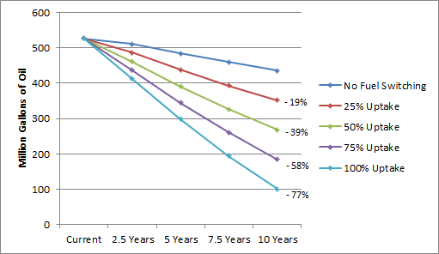

Currently, propane use in Connecticut is expected to increase by 0.4% per year. The analysis shows that fuel switching would reverse this trend even with a 25% conversion rate. In the next decade, annual propane consumption could potentially decline to 41% of the expected annual consumption level if a 100% conversion rate is reached. If the conversion rate only reaches 25%, then annual consumption would decrease by 15% relative to the expected annual consumption at year ten (Figure 29).
Figure 29: Fuel Switching—Change in Propane Consumption Under the Base Case Scenario
Base: all single-family homes (population-weighted)
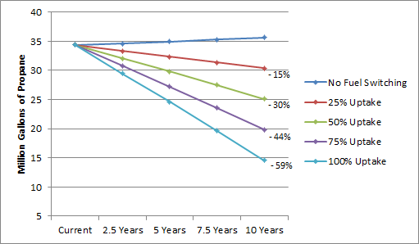

Increased Natural Gas and Electricity Consumption
Natural gas use could potentially increase 89% relative to expected annual consumption ten years from now if a 100% conversion rate is reached (Figure 30). At a 25% conversion rate, natural gas use would increase 22% relative to expected annual consumption ten years from now.
Figure 30: Fuel Switching—Change in Natural Gas Consumption Under the Base Case Scenario
Base: all single-family homes (population-weighted)
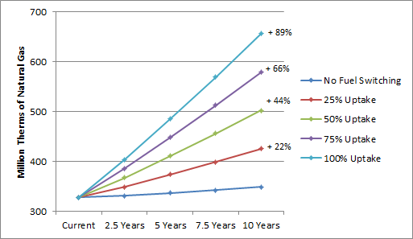

Under the base case scenario, increases in electric consumption are a result of the addition of ductless mini-splits in the place of oil- or propane-fired heating equipment, and thus occur primarily at the space heating end use. There are also small decreases in electricity use for water heating (due to the conversion of some water heaters at Group A sites from electric resistance to gas) and cooling (due to more efficient ductless mini-splits replacing existing cooling equipment) in the base case scenario.
At a 100% conversion rate, annual consumption of electricity could increase 13% relative to expected consumption ten years from now. If the conversion rate only reaches 25%, electric consumption would increase 3% relative to expected consumption ten years from now (Figure 31).
Figure 31: Fuel Switching—Change in Electricity Consumption Under the Base Case Scenario
Base: all single-family homes (population-weighted)
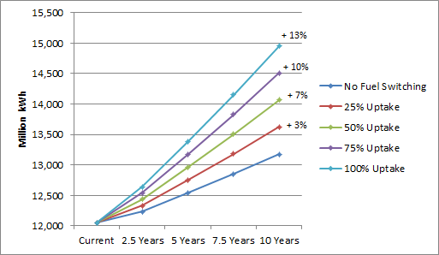

Upgrade Case Scenario (Program Incentive Impact)
This section details the results of upgrade case scenario fuel switching. Fuel switching group features are described in detail in Table 39.
Table 39 details the impact of fuel switching under the upgrade case scenario for the various conversion rates. Under this scenario, consumers in the state could potentially (i.e. with a 100% conversion rate) save more than 2 billion gallons of oil, more than 140 million gallons of propane, more than 1.5 billion ccf of natural gas, and nearly 8.5 billion kilowatt-hours of electricity in total over the next decade, relative to a scenario where fuel switching does not occur.
Table 39: Fuel Switching—Annual Consumption Trajectories – Upgrade Case Scenario
Base: all single-family homes (population-weighted)
Conversion Rate | Annual Consumption |  |  |  |  |  | Difference in 10-Year Totals*
 | Current | Growth Rate | 2.5 Years | 5.0 Years | 7.5 Years | 10 Years
Fuel Oil Consumption (million gallons)
No fuel switching | 527.6 | -2.1% | 511.1 | 484.7 | 459.7 | 435.9 | -
25% Uptake |  |  | 484.3 | 433.8 | 387.3 | 344.4 | - 537.2
50% Uptake |  |  | 457.5 | 382.9 | 314.9 | 252.8 | - 1,074.3
75% Uptake |  |  | 430.6 | 332.0 | 242.5 | 161.3 | - 1,611.5
100% Uptake |  |  | 403.8 | 281.2 | 170.1 | 69.8 | - 2,148.6
Propane Consumption (million gallons)
No fuel switching | 34.4 | 0.4% | 34.6 | 35.0 | 35.3 | 35.7 | -
25% Uptake |  |  | 33.0 | 31.8 | 30.5 | 29.2 | - 35.2
50% Uptake |  |  | 31.5 | 28.6 | 25.7 | 22.7 | - 70.4
75% Uptake |  |  | 29.9 | 25.2 | 20.9 | 16.2 | - 105.6
100% Uptake |  |  | 28.3 | 22.3 | 16.1 | 9.8 | - 140.8
Natural Gas Consumption (million ccf)
No fuel switching | 326.8 | 0.7% | 330.3 | 336.1 | 342.0 | 348.0 | -
25% Uptake |  |  | 347.1 | 370.4 | 394.3 | 419.0 | + 382.3
50% Uptake |  |  | 364.0 | 404.6 | 446.6 | 490.0 | + 764.5
75% Uptake |  |  | 380.8 | 438.9 | 498.9 | 560.9 | + 1,146.8
100% Uptake |  |  | 397.6 | 473.2 | 551.2 | 631.9 | + 1,529.1
Electricity Consumption (million kWh)
No fuel switching | 12,048.2 | 1.0% | 12,229.5 | 12,537.4 | 12,853.4 | 13,177.0 | -
25% Uptake |  |  | 12,321.5 | 12,726.0 | 13,143.3 | 13,573.3 | + 2,116.5
50% Uptake |  |  | 12,413.5 | 12,914.5 | 13,433.3 | 13,969.7 | + 4,232.9
75% Uptake |  |  | 12,505.4 | 13,103.1 | 13,723.3 | 14,366.0 | + 6,349.4
100% Uptake |  |  | 12,597.4 | 13,291.7 | 14,013.2 | 14,762.4 | + 8,465.9
* Total aggregate difference from current trajectory over 10-year period.

Savings Due to Program Incentives
In this analysis, the base case describes a scenario wherein fuel switching occurs, but a customer incentive to purchase higher-efficiency equipment is not offered. The upgrade case, conversely, describes a scenario wherein a program incentive is offered. The equipment efficiencies used in the REM/Rate modeling for each case are included in Table 6.
A program incentive for higher-efficiency equipment could potentially save between 0.9% and 2.6% of what the analysis estimates would be the total consumption of natural gas over the next decade under the base case scenario. For electric consumption that range is 0.2% to 0.7% of the total usage over ten years. See Table 49 in Appendix D for detailed estimates of potential savings from program incentives for higher efficiency heating and water heating equipment (i.e. the difference between base case and upgrade case consumption).
As Figure 32 shows, a potential program incentive for higher-efficiency equipment would have less of an impact relative to the base case scenario than base case fuel switching would have relative to the existing consumption trajectory. Furthermore, some of the difference between the impacts of the base and upgrade cases can be attributed to the fact that, for 85 out of the 134 homes in the sample that were converted during the modeling (63%), water heating conversions were only modeled in the upgrade case.
Figure 32: Fuel Switching—Change in Total Consumption in MMBtu, Base to Upgrade Comparison*
Base: all single-family homes (population-weighted)
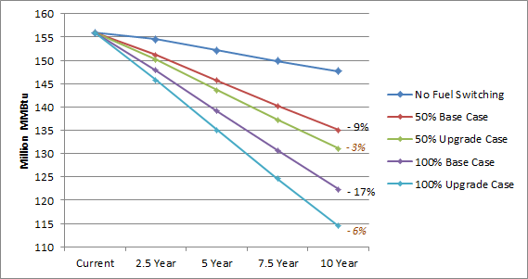
* Base case data labels show percent difference from a scenario without fuel switching at year ten. Upgrade case labels (in orange) show difference from base case.

Oil and Propane Savings
As Figure 33 demonstrates, the impact of a program incentive on the trajectory of annual consumption of fuel oil over the next decade is minimal, at least compared with the impact of base case fuel switching. This is because the difference between the base and upgrade cases is entirely attributable to oil consumption at the water heating end use—NMR’s presumption is that program incentives will be necessary to spur conversion to heat pump water heaters. Therefore, oil-fired water heating equipment in Groups B and C were left as-is in the base case and switched to heat pump water heaters in the upgrade case (see the Fuel Switching Methodology section of this report).
Since the models assume that oil space heating equipment is switched to gas or electric at the same rate for both the base and upgrade cases, the impact of a utility company incentive with reference to oil consumption is limited to switching oil-fired water heating equipment to heat pump water heaters.
Figure 33: Fuel Switching—Change in Fuel Oil Consumption, Base to Upgrade Comparison*
Base: all single-family homes (population-weighted)
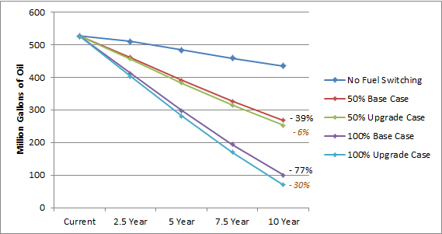
* Base case data labels show percent difference from a scenario without fuel switching at year ten. Upgrade case labels (in orange) show difference from base case.

The difference between propane consumption trajectories in the base and upgrade case scenarios is also due entirely to water heating, for the same reasons as oil: propane space heating equipment was switched to gas or heat pump in the base case, and thus a program incentive would only apply to propane insofar as it would convert propane-fired water heating equipment to a heat pump water heater (Figure 34).
Figure 34: Fuel Switching—Change in Propane Consumption, Base to Upgrade Comparison*
Base: all single-family homes (population-weighted)
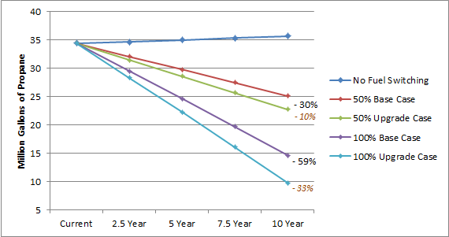
* Base case data labels show percent difference from a scenario without fuel switching at year ten. Upgrade case labels (in orange) show difference from base case.

Increased Natural Gas and Electricity Consumption
Figure 35 shows the change in natural gas consumption over the next decade in the base case scenario, the upgrade case scenario, and without fuel switching. More of the difference in gas consumption between the base case and upgrade case scenarios can be attributed to the water heating end use (58%) than space heating (42%) (see Table 50 for results by end use). As this figure shows, the maximum estimated impact of a program incentive for higher-efficiency natural gas equipment is 24.3 million ccf annually by year ten, or 4% of the annual consumption estimated by the base case models.
Figure 35: Fuel Switching—Change in Natural Gas Consumption, Base to Upgrade Comparison*
Base: all single-family homes (population-weighted)
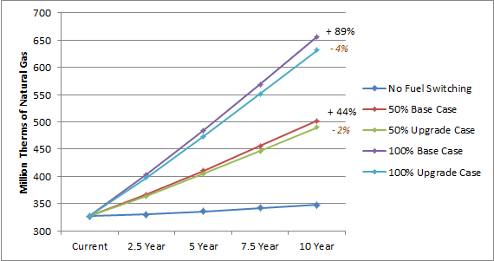
* Base case data labels show percent difference from a scenario without fuel switching at year ten. Upgrade case labels (in orange) show difference from base case.

The maximum impact of a program incentive for higher-efficiency electric heating and water heating equipment is about 1 billion kilowatt-hours over the next decade, or 0.7% of the ten-year total consumption estimated by the base case models (Figure 36). This impact is less substantial than it is for natural gas, predominantly because 69% of existing electric consumption occurs at the lights & appliances end use, which is unaffected by fuel switching. Most of the difference occurs at the heating end use while a small amount occurs at the cooling end use as well, since the ductless mini-splits which replaced oil- and propane-fired heating equipment also provide cooling.
Although electricity consumption would increase as a result of a possible program incentive for heat pump water heaters, this potential increase is substantially smaller than the potential savings which would be associated with an incentive for more efficient ductless mini-splits (see Table 49). It is also smaller than the amount of electricity which the analysis estimates could be saved by converting electric resistance water heaters to gas water heaters in homes that switch to gas.
Figure 36: Fuel Switching—Change in Electricity Consumption, Base to Upgrade Comparison*
Base: all single-family homes (population-weighted)
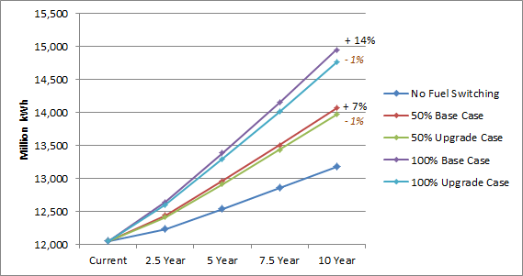
* Base case data labels show percent difference from a scenario without fuel switching at year ten. Upgrade case labels (in orange) show difference from base case.

Fuel Switching Impact by End Use
This section further details base case and upgrade case fuel switching impact by the heating, cooling, and water heating end uses.
Table 40 demonstrates the proportion of program incentive impacts taken up by each applicable end use. Because lights, appliances, and photovoltaics are not affected by fuel switching, those end uses are not included in the table. As shown:
- Most of the potential natural gas savings which an incentive could achieve (58%) would occur at the water heating end use, while the vast majority of electric savings (86%) would occur at the heating end use.
- Potential program incentives for more efficient natural gas equipment lead to more savings at the water heating end use than at the space heating end use, according to the models.
- There are also some modest increases in consumption from potential program incentives. Heat pump water heaters, which are present in 63% of upgrade case models but none of the base case models, account for 100% of the increase in electric consumption from possible program incentives.
  - These water heaters also account for small increases in oil and propane consumption in the upgrade case.
Table 40: Fuel Switching—Maximum Impacts of Program Incentive by End Use (100% Conversion Rate)
Base: all single-family homes (population-weighted)
Fuel type | End Use
 | Heating | Cooling | Water Heating | Difference Over 10 Years
Percent of Consumption Decrease from Base Case to Upgrade Case
Fuel oil (million gallons) | - | - | 100% | - 182.6
Propane (million gallons) | - | - | 100% | - 26.8
Natural gas (million ccf) | 42% | - | 58% | - 130.8
Electricity (million kWh) | 86% | 14% | - | - 1,564.1
Percent of Consumption Increase from Base Case to Upgrade Case
Fuel oil (million gallons) | 100% | - | - | + 6.2
Propane (million gallons) | 100% | - | - | + 0.5
Natural gas (million ccf) | - | - | - | -
Electricity (million kWh) | - | - | 100% | + 556.7

Impacts from base case fuel switching occur mostly at the heating end use, regardless of fuel (Figure 37). This is unsurprising—most existing consumption occurs at the heating end use, and 85 (63%) of the 134 sites in the sample for which a fuel switch was modeled did not receive a water heater upgrade in the base case (see Table 7).
Figure 37: Fuel Switching—Base Case Annual Savings in MMBtu at Year Ten, by End Use* (100% Conversion Rate)
Base: all single-family homes (population-weighted)
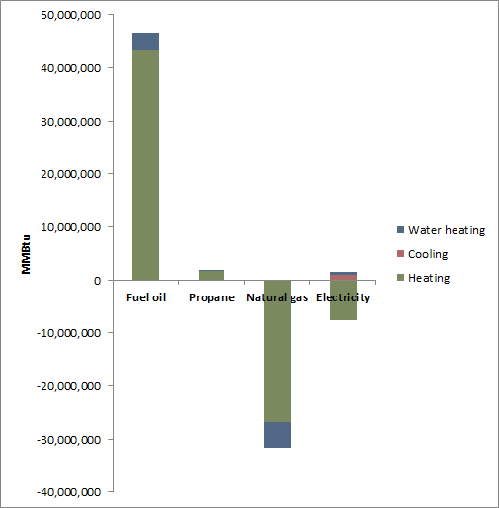
* Negative savings indicate a consumption increase.

Additionally, there is a negative impact on electricity consumption at the cooling end use in the base case. This shows that, while the models result in some extra electric consumption for cooling in homes where a ductless mini-split was modeled and no cooling equipment currently exists, that extra consumption is offset by savings from more efficient cooling in homes where ductless mini-splits were modeled and cooling equipment does currently exist. See Table 50 in Appendix D for more details regarding fuel switching impacts by end use.
Added impact attributable to a possible incentive for higher-efficiency equipment takes place primarily at the heating end use for electric consumption, but at the water heating end use for all other fuels (Table 40 and Figure 38). For oil and propane, this is because most consumption of those fuels was eliminated in the base case models, limiting the impact of the upgrade case models to water heating.
Figure 38: Fuel Switching—Upgrade Case Annual Savings from Base Case in MMBtu at Year Ten, by End Use (100% Conversion Rate)
Base: all single-family homes (population-weighted)
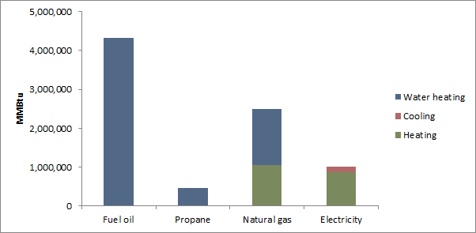

The models also show a nominal increase in oil and propane use between the base case and upgrade case (Table 40 and Table 49). This is because of interactive effects in the models. All the sites showing an increase in oil or propane use from the base case to the upgrade case are in Groups B or C, which were modeled with existing water heating in the base case and heat pump water heaters in the upgrade case. In these models, existing heating equipment remained in a backup capacity to supplement heat provided by ductless mini-splits. Since heat pump water heaters draw heat from the air around them in a manner that other water heaters do not, more backup heating fuel is consumed to make up for the difference.

- Major Changes from Original Draft
A
The first draft report of this study was submitted to the EEB on July 3, 2014. A review of that draft report resulted in an agreement that several methodological changes should be made, of which this report is the result. These changes in methodology included:
- Accounting for changes in codes and standards in the cost-effective potential stage, rather than solely in the achievable potential stage
- Using a net measure cost rather than full upgrade cost in benefit/cost ratios in the cost-effective potential stage
- Updating the study window from 2013-2022 to 2016-2025, and updating avoided costs accordingly
This appendix describes the major changes to the study’s results that sprang from these methodological changes. More details regarding methodology can be found in the Methodology section of this report.

Ductless Mini-Splits
In the original report draft, ductless mini-splits screened as cost-effective in 62% of applicable cases (109 out of 176 sites), with an average TRC ratio of 1.46. In this draft, just 6% of cases screened as cost-effective (10 of 176), with an average TRC ratio of -1.83. This shift in average TRC resulted in massive changes in cost-effective and maximum achievable potential savings estimates.
Because ductless mini-splits are a fuel switching measure, replacement schedule is irrelevant and therefore full cost was used in screening rather than the net measure cost. Changes in efficiency standards impacted the savings used in screening, but only for the fossil fuels that the mini-splits replace, not the additional electric consumption that results from installing them. For the 99 sites that screened as cost-effective in the original draft but not in this revised version, the difference was due almost entirely to changes in avoided costs.
Relative to the 2013 avoided costs that were used for the original draft, the 2016 avoided costs are slightly lower for electric energy (by about $0.01 per kWh per year), much lower for oil and propane (by about $7.30 for oil and $9.40 for propane per MMBtu per year), and much higher for natural gas (by about $5.50 per MMBtu per year). Indeed, of the 99 sites that screened as cost-effective for ductless mini-splits in the original draft but not in the revised draft, all but one used either oil (94 sites) or propane (4 sites) as their primary heating fuel.
Put another way, because of the decrease in oil and propane avoided costs, the benefits of fuel switching were not enough to eclipse the detriments associated with the increase in electric consumption caused by the mini-splits for many homes.

Appliances
Another major change relative to the original draft of this study is in the number of appliance replacements that screened as cost-effective. Table 41 shows the change in the percentage of applicable sites that passed cost-effectiveness screening and mean TRC ratio for refrigerators, dishwashers, and clothes washers, each of which saw a substantial change.
Table 41: Appliance Cost-Effectiveness Screening Comparison
Appliance | Applicable | Average Age of Existing | PSD Measure Lifetime | Original Analysis |  | Revised Analysis
 |  |  |  | Pass Percent | Average TRC | Pass Percent | Average TRC
Refrigerator | 180 | 11 years | 12 years | 26% | 0.82 | 78% | 1.77
Dishwasher | 153 | 9 years | 10 years | 1% | 0.10 | 55% | 8.49
Clothes washer | 177 | 10 years | 11 years | 47% | 0.97 | 98% | 2.09

For these appliances, the reason for the change relative to the original draft of this study stems from the use of net measure cost, rather than full replacement cost, in cost-effectiveness screening. Net measure cost accounts for the benefit of deferred equipment replacement, and is therefore smaller the older a piece of equipment is. For units older than their expected useful lifetime, replacement cost is equal to incremental cost.
Refrigerators, dishwashers, and clothes washers in the sample are, on average, close to the end of their respective useful lifetimes. Additionally, the incremental cost of replacement for refrigerators and dishwashers is low compared to many other measures. While electric avoided costs declined slightly in 2016 relative to the 2013 version, the switch to net measure cost instead of full replacement cost more than compensated for the decline in benefits for the appliances listed in Table 41.

- Potential Upgrade Measures
B
This appendix contains tables detailing the 43 measure upgrades which were considered as part of this study.

Table 42: Building Shell Measure Upgrades
Measure | Applicable Sites | Upgrade
Add flat attic insulation | 166 | R-38, grade I
Add vaulted ceiling insulation | 75 | R-38, grade II or maximum achievable by framing
Add above grade wall insulation | 165 | R-20, grade II or maximum achievable by framing
Add foundation wall insulation | 91 | R-13, grade II cavity insulation
Add rim joist insulation | 109 | R-20, grade II
Add frame floor insulation | 161 | R-30, grade II or maximum achievable by framing
Reduce air infiltration | 142 | 7.0 ACH@50Pa
Reduce duct leakage | 50 | 8.0 CFM@25Pa/100 s.f.
Add duct insulation | 78 | R-8 on supplies in attics, R-6 on supplies in other u.c. space
Upgrade windows | 180 | U-value 0.2, SHGC 0.25

Table 43: HVAC Measure Upgrades
Measure | Applicable Sites | Upgrade
Increase oil furnace AFUE | 31 | 90% AFUE (capacity same as rated home)
Increase oil boiler AFUE | 81 | 90% AFUE (capacity same as rated home)
Increase propane furnace AFUE | 2 | 97% AFUE (capacity same as rated home)
Increase propane boiler AFUE | 2 | 95% AFUE (capacity same as rated home)
Increase gas furnace AFUE | 25 | 97% AFUE (capacity same as rated home)
Increase gas boiler AFUE | 24 | 95% AFUE (capacity same as rated home)
Install ECM fan motor | 54 | 6% savings compared to PSC motor
Upgrade central air conditioner | 76 | 16 SEER, 13 EER (capacity same as rated home)
Upgrade room air conditioners | 66 | 11.5 EER (capacity same as rated home)

Table 44: Water Heating Measure Upgrades
Measure | Applicable Sites | Upgrade
Replace tankless coil with indirect water heater | 42 | EF=92% of boiler efficiency, 50-gallon tank
Replace oil storage DHW with more efficient oil storage | 9 | 0.63 EF
Replace electric DHW with heat pump DHW | 42 | 2.3 EF
Replace gas storage water heater with instantaneous | 43 | 0.93 EF
Replace gas storage DHW with more efficient gas storage | 39 | 0.8 EF
Replace gas storage DHW with gas condensing | 39 | 0.9 EF
Replace LP storage water heater with instantaneous | 6 | 0.93 EF
Replace LP storage DHW with more efficient LP storage | 4 | 0.8 EF
Replace LP storage water heater with LP condensing | 4 | 0.9 EF
Increase water heater tank wrap R-value | 102 | R-10 tank wrap
Install low-flow showerheads | 180 | Calculated using 2013 HES Program Savings Documentation
Install faucet aerators | 180
Add DHW pipe insulation | 138

Table 45: Lighting & Appliance Measure Upgrades
Measure | Applicable Sites | Upgrade
Upgrade refrigerator | 180 | 319 kWh/yr
Upgrade freezer | 60 | 188 kWh/yr
Upgrade dishwasher | 164 | 1.28 EF, 170 kWh/yr
Upgrade clothes washer | 177 | Calculated using 2013 HES Program Savings Documentation
Install dehumidifier | 49 | 2.6 EF
Increase socket saturation of efficient lighting | 180 | Increase saturation to 100%

Table 46: Heat Pump & Solar Technology Measure Upgrades
Measure | Applicable Sites | Upgrade
Install ground source heat pump | 103 | 17.1 EER, 3.6 COP
Install air source heat pump | 104 | 22.1 SEER, 11.3 HSPF
Install ductless mini-split | 180 | 12.1 EER (19.2 SEER), 3.0 COP (10.3 HSPF)
Add photovoltaic array | 108 | South-facing 7.1 kW system, 35º tilt with 95% inverter
Add solar hot water system | 109 | 66 ft² south-facing, double-glazed, liquid indirect system

Maximum R-value Achievable by Framing
Insulation upgrade values were assigned by determining the maximum R-value achievable with blown-in insulation in the framing found on-site.
Table 47: Insulation Upgrade Values by Framing Type
Measure | Applicable Sites | Upgrade R-value by Framing Type
 |  | 2x4 | 2x6 | 2x8 | 2x10 | 2x12
Attic insulation | 166 | R-38
Vaulted ceiling insulation | 75 | -- | R-19 | R-25 | R-32 | R-38
Above-grade wall insulation | 165 | R-12 | R-19 | -- | -- | --
Foundation wall insulation | 91 | R-10 or R-13
Frame floor insulation | 161 | -- | R-21 | R-30

- Modeling Assumptions and Other Details
C
This appendix provides additional information regarding the assumptions that were made in modeling and calculating potential savings.

Technical Feasibility for Advanced Measures
The following measures required special consideration when assessing technical feasibility.
Ground and conventional air source heat pumps. These heat pump upgrades were applied to all homes with duct work and also all homes where the primary heating fuel was electricity. When modeling these upgrades, the capacity of these heat pumps was based on the cooling design load of the baseline REM/Rate models. Back-up heating equipment was also upgraded to technical potential levels and any remaining heating load was applied to said equipment.
Photovoltaics and solar hot water. These upgrades were applied to 60% (108 homes) of the sample. This figure is based on informal interviews the Team conducted with a handful of Connecticut based residential solar contractors.
Ductless mini-split heat pumps. These units consist of two components—an outdoor condensing unit and an indoor air handler—linked by a conduit that contains refrigerant tubing and the power cable. Depending on capacity, an outdoor component can have up to six indoor components, which deliver heating or cooling directly to a room. Like other heat pumps, ductless mini-splits are capable of both heating and cooling. These upgrades were assumed to be technically feasible at all 180 homes. When modeling these upgrades, the capacity of the ductless mini-split was based on the cooling design load of the baseline REM/Rate models. Back-up heating equipment was also upgraded to technical potential levels and any remaining heating load was applied to said equipment.
These heat pumps were modeled using REM/Rate’s ground source heat pump library in order to account for the fact that REM/Rate does not adequately estimate the efficiencies of ductless mini-split heat pumps.

Baseline Assessment for Measures Not Inventoried During Site Visits
Data was not collected for the following measures during the site visits for this study, and as a result, assumptions were made regarding their baseline condition.
Lighting. As part of the Weatherization Baseline Study data collection efforts, information was collected on light fixtures but not on light bulbs. For this reason, results from a recent Connecticut lighting evaluation were leveraged to estimate the baseline saturation of energy efficient light bulbs. The number of sockets and number of efficient vs. inefficient bulbs was estimated for various single-family home sizes using the onsite data from the aforementioned study. The study results included a combination of CFLs, LEDs, and other efficient light bulbs that were all categorized together as “efficient.” The wattages that were modeled for this study were the average wattages of all efficient bulbs found in the Connecticut lighting evaluation. On average, the study found that CFL saturation in Connecticut homes was 27%.
Dehumidifiers. Dehumidifiers were not part of the Weatherization Baseline Study `data collection efforts. In order to develop a baseline estimate for dehumidifiers, the Team utilized onsite data from a recent existing homes baseline study that was conducted in Vermont. After reviewing the data, the Team determined that dehumidifiers should apply to 27% of the sample (49 homes).
Low-flow showerheads and faucet aerators: Low-flow showerheads and faucet aerators were not part of the Weatherization Baseline Study data collection efforts. Similar to dehumidifiers, the Team utilized onsite data from a recent existing homes baseline study in Vermont to estimate the baseline saturation of these technologies.
The Vermont data revealed that the mean number of faucet aerators per home in that state is 1.23, while the mean number of low-flow showerheads per home is 0.55. The level of opportunity for faucet aerator and low-flow showerhead installation was therefore judged as follows:
- Faucet aerator opportunity = (# Baths + 1) – 1.23
- Low-flow showerhead opportunity for homes with one bathroom = (# Baths – 0.55)
- Low-flow showerhead opportunity for homes with more than one bathroom = (# Baths – 1) – 0.55

- Detailed Fuel Switching Impact Tables
D
Table 48 describes the trajectory of annual consumption by fuel type for both the base case and upgrade case scenarios.

Table 48: Fuel Switching—Consumption Growth Trajectories Under the Maximum (100%) Uptake Rate
(Base: All SF homes, weighted to population)
Impact | Annual Consumption |  |  |  |  |  | Difference in 10-Year Totals
 | Current | Growth Rate | Year 2.5 | Year 5 | Year 7.5 | Year 10
Base Case
Oil consumption, existing trajectory (million gallons) | 527.6 | - 2.1% | 511.1 | 484.7 | 459.7 | 435.9 | -
Oil consumption trajectory with fuel switching |  |  | 412.6 | 297.9 | 193.9 | 99.9 | - 1,972.2
Propane consumption, existing trajectory (million gallons) | 34.4 | 0.4% | 34.6 | 35.0 | 35.3 | 35.7 | -
Propane consumption trajectory with fuel switching |  |  | 29.5 | 24.6 | 19.7 | 14.6 | - 114.6
Natural gas consumption, existing trajectory (million ccf) | 326.8 | 0.7% | 330.3 | 336.1 | 342.0 | 348.0 | -
Natural gas consumption trajectory with fuel switching |  |  | 403.4 | 484.9 | 569.1 | 656.2 | + 1,659.9
Electricity consumption, existing trajectory (million kWh) | 12,048.2 | 1.0% | 12,229.5 | 12,537.4 | 12,853.4 | 13,177.0 | -
Electric consumption trajectory with fuel switching |  |  | 12,641.2 | 13,381.4 | 14,151.3 | 14,951.0 | + 9,473.2
Upgrade Case
Oil consumption, existing trajectory (million gallons) | 527.6 | - 2.1% | 511.1 | 484.7 | 459.7 | 435.9 | -
Oil consumption trajectory with fuel switching |  |  | 403.8 | 281.2 | 170.1 | 69.8 | - 2,148.6
Potential oil savings due to program incentives |  |  | 8.8 | 16.7 | 23.8 | 30.1 | - 176.4
Propane consumption, existing trajectory (million gallons) | 34.4 | 0.4% | 34.6 | 35.0 | 35.3 | 35.7 | -
Propane consumption trajectory with fuel switching |  |  | 28.3 | 22.3 | 16.1 | 9.8 | - 140.8
Potential propane savings due to program incentives |  |  | 1.2 | 2.4 | 3.6 | 4.8 | - 26.2
Natural gas consumption, existing trajectory (million ccf) | 326.8 | 0.7% | 330.3 | 336.1 | 342.0 | 348.0 | -
Natural gas consumption trajectory with fuel switching |  |  | 397.6 | 473.2 | 551.2 | 631.9 | + 1,529.1
Potential gas savings due to program incentives |  |  | 5.8 | 11.7 | 17.9 | 24.3 | - 130.8
Electricity consumption, existing trajectory (million kWh) | 12,048.2 | 1.0% | 12,229.5 | 12,537.4 | 12,853.4 | 13,177.0 | -
Electric consumption trajectory with fuel switching |  |  | 12,597.4 | 13,291.7 | 14,013.2 | 14,762.4 | + 8,465.9
Potential electric savings due to program incentives |  |  | 43.8 | 89.7 | 138.1 | 188.6 | - 1,007.4

Table 49 details estimated savings attributable to a potential program incentive for higher efficiency heating and water heating equipment (i.e. the difference between base case and upgrade case consumption) in total over the course of a ten-year span from 2016 to 2025.
Table 49: Fuel Switching—Estimated Savings Due to Program Incentive Over Ten Years
(Base: All SF homes, weighted to population)
Fuel | Scenario | Conversion Rate
 |  | 25% | 50% | 75% | 100%
Natural gas (million ccf)
Total natural gas consumption over 10 years* | No fuel switching | 3,373.4
 | Base case scenario | 3,788.3 | 4,203.3 | 4,618.3 | 5,033.3
 | Upgrade case scenario | 3,755.6 | 4,137.9 | 4,520.2 | 4,902.5
Ten-year natural gas savings due to incentive* | n/a | 32.7 | 65.4 | 98.1 | 130.8
Savings percent of base case |  | 0.9% | 1.6% | 2.1% | 2.6%
Electricity (million kWh)
Total electricity consumption over 10 years* | No fuel switching | 126,051.1
 | Base case scenario | 128,419.4 | 130,787.7 | 133,156.0 | 135,524.3
 | Upgrade case scenario | 128,167.6 | 130,284.0 | 132,400.5 | 134,516.9
Ten-year electricity savings due to incentive* | n/a | 251.8 | 503.7 | 755.5 | 1,007.4
Savings percent of base case |  | 0.2% | 0.4% | 0.6% | 0.7%
Fuel oil (million gallons)
Total fuel oil consumption over 10 years* | No fuel switching | 4,804.5
 | Base case scenario | 4,311.5 | 3,818.4 | 3,325.4 | 2,832.3
 | Upgrade case scenario | 4,267.4 | 3,730.2 | 3,193.1 | 2,655.9
Ten-year fuel oil savings due to incentive* | n/a | 44.1 | 88.2 | 132.3 | 176.4
Savings percent of base case |  | 1.0% | 2.3% | 4.0% | 6.2%
Propane (million gallons)
Total propane consumption over 10 years* | No fuel switching | 350.3
 | Base case scenario | 321.7 | 293.1 | 264.4 | 235.8
 | Upgrade case scenario | 315.1 | 279.9 | 244.7 | 209.5
Ten-year propane savings due to incentive* | n/a | 6.6 | 13.1 | 19.7 | 26.2
Savings percent of base case |  | 2.0% | 4.5% | 7.4% | 11.1%
* In millions.

Table 50 details the impact of fuel switching by end use for the 100% conversion rate. Columns under the heading “base case difference from no fuel switching” demonstrate the impact of fuel switching without an incentive for higher-efficiency equipment, while columns under the heading “upgrade case difference from base case” describe the potential added impact of such an incentive.
Table 50: Fuel Switching—Maximum Impacts of Fuel Switching by End Use Under the 100% Conversion Rate^{i}
(Base: All SF homes, weighted to population)
End Use^{ii} | Current Annual^{iv} | Base Case Difference from No Fuel Switching |  |  |  |  | Upgrade Case Difference from Base Case
 |  | Annual Consumption |  |  |  | Ten-Year Total^{iii} | Annual Consumption |  |  |  | Ten-Year Total^{iii}
 |  | Year 2.5 | Year 5 | Year 7.5 | Year 10 |  | Year 2.5 | Year 5 | Year 7.5 | Year 10
Fuel Oil (million gallons)
Total | 527.6 | - 394.0 | - 373.6 | - 354.3 | - 336.0 | - 1,972.2 | - 8.8 | - 16.7 | - 23.8 | - 30.1 | - 176.4
Heating | 460.7 | - 365.7 | - 346.7 | - 328.8 | - 311.8 | - 1,830.3 | + 0.3 | + 0.6 | + 0.8 | + 1.1 | + 6.2
Water heating | 66.9 | - 28.3 | - 26.9 | - 25.5 | - 24.2 | - 141.9 | - 9.1 | - 17.3 | - 24.6 | - 31.1 | - 182.6
Propane (million gallons)
Total | 34.4 | - 20.5 | - 20.7 | - 20.9 | - 21.1 | - 114.6 | - 1.2 | - 2.4 | - 3.6 | - 4.8 | - 26.2
Heating | 24.3 | - 18.3 | - 18.5 | - 18.7 | - 18.9 | - 102.6 | + < 0.1 | + < 0.1 | + < 0.1 | + 0.1 | + 0.5
Water heating | 6.9 | - 2.1 | - 2.2 | - 2.2 | - 2.2 | - 11.9 | - 1.2 | - 2.4 | - 3.7 | - 4.9 | - 26.8
Natural gas (million ccf)
Total | 326.8 | + 292.4 | + 297.6 | + 302.8 | + 308.1 | + 1,659.9 | - 5.8 | - 11.7 | - 17.9 | - 24.3 | - 130.8
Heating | 276.3 | + 247.1 | + 251.5 | + 255.9 | + 260.4 | + 1,402.6 | - 2.4 | - 4.9 | - 7.5 | - 10.2 | - 54.8
Water heating | 41.9 | + 45.3 | + 46.1 | + 46.9 | + 47.8 | + 257.3 | - 3.3 | - 6.8 | - 10.4 | - 14.1 | - 76.0
Electricity (million kWh)
Total | 12,048.2 | + 1,646.5 | + 1,688.0 | + 1,730.5 | + 1,774.1 | + 9,473.2 | - 43.8 | - 89.7 | - 138.0 | - 188.7 | - 1,007.4
Heating | 1,868.3 | + 2,049.6 | + 2,101.2 | + 2,154.1 | + 2,208.3 | + 11,792.1 | - 58.4 | - 119.7 | - 184.1 | - 251.6 | - 1,343.5
Cooling | 1,288.9 | - 243.4 | - 249.5 | - 255.8 | - 262.2 | - 1,400.3 | - 9.6 | - 19.7 | - 30.2 | - 41.3 | - 220.6
Water heating | 798.4 | - 159.7 | - 163.7 | - 167.8 | - 172.0 | - 918.6 | + 24.2 | + 49.6 | + 76.3 | + 104.3 | + 556.7
^{i} Numbers in table assume a 100% conversion rate, and therefore describe maximum impacts.
^{ii} Fuel switching did not affect the lights & appliances end use.
^{iii} Total impact over the course of ten years.
^{iv} End uses may not add up to total because they do not include lights, appliances, or photovoltaics, which are unaffected by fuel switching.

- Sources of Growth Rates
E
In order to project potential savings out over time, the Team first had to identify growth rates for the various fuel types that are assessed in this report.
Electricity. The growth rates for electricity consumption and peak demand were estimated based on the Connecticut-specific forecasting details of the Capacity, Energy, Loads, and Transmission (CELT) report that is published by ISO-New England. Here is a link to the CELT forecasting details documents: http://iso-ne.com/trans/celt/fsct_detail/index.html
Natural gas. The growth rates for natural gas consumption are based on the biennial forecast of natural gas demand and supply submitted by Yankee Gas to the State of Connecticut on October 1, 2012. Here is a link to those documents: http://www.dpuc.state.ct.us/dockcurr.nsf/8e6fc37a54110e3e852576190052b64d/9a0971f21cbf5a3e85257a8d004be07c?OpenDocument
Fuel oil and propane. The growth rates for fuel oil and propane are based on the U.S. Energy Information Administration’s Annual Energy Outlook for 2013. Specifically, these growth rates were derived from projected energy consumption estimates for the residential sector in New England. Here is a link to the website where this information can be found: http://www.eia.gov/forecasts/aeo/sector_residential.cfm

- Achievable Potential Assumptions
F
This section includes information on assumptions used in the achievable potential stage of the study.

Federal Standards
The tables below describe the federal standards that were accounted for in the cost-effective potential and achievable potential analyses. Standards and effective dates were taken from the websites of the Department of Energy and the Appliance Standards Awareness Project (ASAP).
All current standards are published, but in many cases, amended standards have not yet been published. Unavailable amended standards were approximated by calculating the percent change between the current standard and the standard that was in effect prior to that, and then increasing the current standard by half that percentage, as shown in the equation below:
$$Amended=Current*\left[1+\left(0.5*\frac{Current-Prior}{Prior}\right)\right]$$

Standards that were approximated in this way are marked by blue cell shading in the tables below. Standards that were arrived at after discussion between NMR staff, EEB consultants, and representatives from the Companies are shaded gray.
Table 51: Federal Standards for Heating & Cooling Equipment
End Use | Measure | Efficiency Unit | Current Standard |  | Amended Standard
 |  |  | Standard | Effective | Standard | Effective
Heating | Oil hydronic boiler | AFUE | 84% | 2012 | 86% | 2021
 | Oil steam boiler |  | 82% | 2012 | 85% | 2021
 | Gas hydronic boiler |  | 82% | 2012 | 85% | 2021
 | Gas steam boiler |  | 80% | 2012 | 85% | 2021
 | LP hydronic boiler |  | 82% | 2012 | 85% | 2021
 | LP steam boiler |  | 80% | 2012 | 85% | 2021
 | Oil furnace |  | 83% | 2015 | 85% | 2021
 | Gas furnace |  | 80% | 2015 | 92% | 2021
 | LP furnace |  | 80% | 2015 | 92% | 2021
Cooling | Central air conditioner | SEER | 13.0 | 2015 | 14.0 | 2022
 | Room air conditioner | EER | 10.6 | 2014 | 11.9 | 2020

Table 52: Federal Standards for Water Heating Equipment
Type | Fuel | Storage Volume (gallons) | Current Standard (2015) | Amended Standard (2021)
Conventional storage | Gas | ≥ 20 and ≤ 100 | 0.675 - 0.0015V | 104% of 2015 standard
 |  | > 55 and ≤ 100 | 0.8012 - 0.00078V
 | Oil | ≤ 50 | 0.67 - 0.0019V | 118% of 2015 standard
 | Electric | ≥ 20 and ≤ 120 | 0.96 - 0.0003V | 102% of 2015 standard
 |  | > 55 and ≤ 120 | 2.057 - 0.00113V
Instantaneous | Gas | < | 0.82 - 0.0019V | 104% of 2015 standard
 | Electric | < 2 | 0.93 - 0.00132V | 102% of 2015 standard

Table 53: Federal Standards for Appliances
Appliance | Type | Efficiency Unit | Current Standard |  | Amended Standard
 |  |  | Standard | Effective | Standard | Effective
Refrigerator | Top freezer | kWh/year | 8.07V + 233.7 | 2014 | 84% of prior standard | 2021
 | Side-by-side |  | 8.51V + 297.8 |  | 76% of prior standard
 | Bottom freezer |  | 8.85V + 317.0 |  | 88% of prior standard
Freezer | Upright | kWh/year | 8.62V + 228.3 |  | 70% of prior standard
 | Chest |  | 7.29V + 107.8 |  | 75% of prior standard
Dishwasher | All | kWh/year | 307 | 2013 | 234 | 2019
Clothes washer | Top loading | MEF | 1.29 | 2015 | 1.57 | 2018
 | Front loading |  | 1.84 |  | 1.84
Dehumidifier | All | Liters/kWh | 1.7 | 2012 | 2.0 | 2019
Lighting | All | Δ Watts | Varies |  | 5 Watts

Market Adoption Assumptions
Table 54 shows the market penetration percentages that were used in approximating the gradual increase in market adoption of measures over the ten years from 2016 to 2025. The two numbers included in the table—the existing proportion of homes where a given measure’s efficiency upgrade level is already present, and the proportion of homes where this study predicts the level will be met in the year 2025—were used to make an adoption curve, which was subsequently used to adjust savings down to account for gradual measure adoption.
As noted in the Achievable Potential Methodology section of the report, these predicted market adoption figures were derived from a 2009 potential study conducted by the Electric Power Research Institute (EPRI).
Table 54: Future Market Penetration Assumptions
Measure | Existing % from Sample | 2025 Expected %
Heating and cooling equipment
Efficient traditional heating equipment | < 1% | 40%
Efficient central air conditioners | < 1% | 40%
Heat pumps | 2% | 40%
Building shell improvements
Infiltration control | 19% | 34%
Wall, ceiling, and foundation wall insulation | ~10% | 43%
Water heating
Efficient water heating system | < 1% | 43%
Faucet aerators & low-flow showerheads | 30%* | 40%
Pipe insulation | 13% | 40%
Water heater tank wrap | 1% | 40%
Appliances and lighting
Efficient clothes washers | < 1% | 48%
Efficient dishwashers | < 1% | 48%
Efficient refrigerators | 1% | 50%
Efficient freezers | < 1% | 50%
CFLs | 45% | 95%**
* This information was not collected during the Connecticut Weatherization Baseline Assessment on-site visits. This figure was taken from the recent Maine Residential Baseline Study.
** This figure is approximated, as the percentage from the sample of existing homes is already higher than the estimate from the EPRI study.

A technically feasible upgrade, for the purposes of this study, is an upgrade that can possibly be installed in a house given its configuration and existing characteristics. For instance, vaulted ceiling insulation upgrades were only applied to homes where vaulted ceilings are present.
Many of the measures considered for the potential study are not currently incentivized by the Companies and as a result they cannot be screened for cost-effectiveness using the Utility Cost Test. For this reason, the Total Resource Cost test was used to determine whether or not measures were cost-effective.
The in-progress R113 Ductless Heat Pump Evaluation will provide additional information on this technology.
That is to say, the mean TRC ratio among all the site models to which the measure was applied was greater than 1.0. Not all sites had ratios greater than 1.0 for these measures.
Note that the popularity of the attic and wall insulation incentives in HES coupled with low free ridership rates provide additional justification for this recommendation. NMR Group, Inc. Forthcoming. HES and HES-IE Process Evaluation (R4). To be delivered for public review in January 2016.
NMR Group, Inc. “Single-Family Weatherization Baseline Assessment (R5), Final Report” Submitted to The Connecticut Energy Efficiency Fund, Connecticut Light and Power, and The United Illuminating Company, June 3rd, 2014.
For example, a home with an oil boiler that is upgraded to a higher efficiency oil boiler in the core potential study may have the same boiler replaced by a high efficiency gas boiler in the fuel switching analysis; the savings from these two measure upgrades are duplicative.
A technically feasible upgrade, for the purposes of this study, is an upgrade that can possibly be installed in a house given its configuration and existing characteristics. For instance, vaulted ceiling insulation upgrades were only applied to homes where vaulted ceilings are present.
Many of the measures considered for the potential study are not currently incentivized by the Companies and as a result they cannot be screened for cost-effectiveness using the Utility Cost Test. For this reason, the Total Resource Cost test was used to determine whether or not measures were cost-effective.
REM/Rate is a residential energy analysis software that is commonly used to model the performance of residential buildings—the software is most notably used by the ENERGY STAR® Homes program.
Of the 180 homes audited for this study, 111 were primarily heated by fuel oil.
REM/Rate does not include photovoltaics, one of the upgrades in the potential study, in estimates of demand savings. However, it is unlikely that photovoltaics would influence winter peak demand savings as the winter peak in New England is from 5-7 PM during the months of December and January. It should also be noted that photovoltaics are not cost-effective at any of the 180 sites and as a result the exclusion of photovoltaics from demand estimates does not impact cost-effective or achievable demand savings estimates.
This is based on annual growth projections (see Appendix D).
The in-progress R113 Ductless Heat Pump Evaluation will provide additional information on this technology.
That is to say, the mean TRC ratio among all the site models to which the measure was applied was greater than 1.0. Not all sites had ratios greater than 1.0 for these measures.
Note that the popularity of the attic and wall insulation incentives in HES coupled with low free ridership rates provide additional justification for this recommendation. NMR Group, Inc. Forthcoming. HES and HES-IE Process Evaluation (R4). To be delivered for public review in January 2016.
NMR Group, Inc. “Single-Family Weatherization Baseline Assessment (R5), Final Report” Submitted to The Connecticut Energy Efficiency Fund, Connecticut Light and Power, and The United Illuminating Company, June 3rd, 2014.
For example, a home with an oil boiler that is upgraded to a higher efficiency oil boiler in the core potential study may have the same boiler replaced by a high efficiency gas boiler in the fuel switching analysis; the savings from these two measure upgrades are duplicative.
A technically feasible upgrade, for the purposes of this study, is an upgrade that can possibly be installed in a house given its configuration and existing characteristics. For instance, vaulted ceiling insulation upgrades were only applied to homes where vaulted ceilings are present.
Many of the measures considered for the potential study are not currently incentivized by the Companies and as a result they cannot be screened for cost-effectiveness using the Utility Cost Test. For this reason, the Total Resource Cost test was used to determine whether or not measures were cost-effective.
REM/Rate is a residential energy analysis software that is commonly used to model the performance of residential buildings—the software is most notably used by the ENERGY STAR® Homes program.
REM/Rate is a residential energy analysis software that is commonly used to model the performance of residential buildings—the software is most notably used by the ENERGY STAR® Homes program.
http://www.epa.gov/sites/production/files/2015-08/documents/potential_guide_0.pdf
Clothes washers, which are an input into the REM/Rate software, were also modeled outside of REM/Rate because the software’s model for clothes washers requires complete data on the machine from the Energy Guide label, which was not always available.
http://www.ctenergyinfo.com/2013%20Program%20Savings%20Documentation%20-%20Final.pdf
NMR believes this is appropriate for assessing technical potential given the versatility of the ductless mini-split technology.
http://energizect.com/sites/default/files/2013_2015_CLM%20PLAN_11_01_12_FINAL.pdf
The analysis identified an incentive-to-program cost ratio of 0.67 using Connecticut’s 2013-2015 Electric and Natural Gas Conservation and Load Management Plan for residential programs. This factor, in conjunction with the incentive levels provided by the Companies, was used to calculate administrative costs for cost-effectiveness screening.
If the existing equipment is brand new, then the NMC is equal to the full cost. Conversely, if the existing equipment has reached the end of its effective useful life, then the NMC will be equal to the incremental cost between a federal minimum efficiency unit and a high efficiency upgrade unit.
Brailove, Rachel, John Plunkett, and Jonathan Wallach. “Retrofit Economics 201: Correcting Common Errors in Demand-Side Management Cost-Benefit Analysis.” IGT’s Eighth International Symposium on Energy Modeling. Atlanta, GA. 1995.
Information on future standards was derived partially from the Federal Register, but mostly from the Appliance Standards Awareness Project (ASAP): http://www.appliance-standards.org/national
For measures where efficiency is measured as a quantity (e.g. refrigerator kWh/year) rather than a proportion (e.g. boiler AFUE), the ratio E/F is reversed to F/E.
http://neep.org/Assets/uploads/files/emv/emv-products/Incremental%20Cost_study_FINAL_REPORT_2011Sep23.pdf
http://neep.org/Assets/uploads/files/emv/emv-products/NEEP%20ICS2%20FINAL%20REPORT%202013Feb11-Website.pdf
http://neep.org/emv/forum-products-guidelines/index#incrementalcost
http://www.ma-eeac.org/Docs/8.1_EMV%20Page/2013/Residential%20Program%20Studies/Residential%20New%20Construction%20Program%20Incremental%20Cost%20Final%20Report%206-11-13.pdf
http://www.energizect.com/sites/default/files/CT%20GSHP%20Impact%20Eval%20and%20Market%20Assessment%20%28R7%29%20-%20final%20report.pdf
http://www.deeresources.com/
http://www.ct.gov/deep/lib/deep/energy/aescinnewengland2015.pdf
Connecticut Program Savings Document: 8th Edition for 2013 Program Year. February 21, 2013. Pages 264-266.
Electric Power Research Institute (EPRI). “Assessment of Achievable Potential from Energy Efficiency and Demand Response Programs in the U.S.” January 2009. Appendix F. Available at: http://www.edisonfoundation.net/iei/Documents/EPRI_AssessmentAchievableEEPotential0109.pdf
http://www.ctenergyinfo.com/2013%20Program%20Savings%20Documentation%20-%20Final.pdf
https://app.box.com/s/o1f3bhbunib2av2wiblu
http://www.nrel.gov/docs/fy09osti/44816.pdf
http://iso-ne.com/regulatory/tariff/sect_1/sect_i.pdf
Lisa Skumatz, email message to author, September 26th, 2013.
NMR Group, Inc. “Technical Savings Potential for Single-Family Homes in Connecticut.” Submitted to the Connecticut Energy Efficiency Board (EEB), September 13th, 2013.
2013 Comprehensive Energy Strategy for Connecticut. The Connecticut Department of Energy and Environmental Protection. Hartford, CT. February 19, 2013. Page 132, Table 5.
The list of towns served by gas lines was determined using a map found on the Yankee Gas website. Available here: http://www.yankeegas.com/downloads/servicemap.pdf?id=4294988935&dl=t
Ductless mini-splits are also often easier to retrofit into a home than conventional air source heat pumps or ground source heat pumps, particularly for homes that do not have existing duct work.
NMR assumes that it would be unlikely for these homeowners to switch to heat pump water heaters if an incentive is not offered, and impractical for them to switch to an electric storage water heater given the high cost of electricity and the fact that oil/propane heating equipment remains as a backup to the ductless mini-splits.
The sources used to calculate growth rates can be found in Appendix D.
NMR Group, Inc. “Weatherization Baseline Assessment-Revised Draft Report” Submitted to The Connecticut Energy Efficiency Fund, Connecticut Light and Power, and The United Illuminating Company, September 11th, 2013.
The coefficient of variation measures the dispersion of data in a series of data points; it is commonly used to estimate sampling error when measuring the efficiency of measures installed in weatherization efforts.
Underrepresentation of renters and low-income respondents is common in telephone surveys. For example, see Galesic, M., R. Tourangeau, M.P. Couper (2006), “Complementing Random-Digit-Dial Telephone Surveys with Other Approaches to Collecting Sensitive Data,” American Journal of Preventive Medicine, Volume 35, Number 5.
NMR Group, Inc. “Weatherization Baseline Assessment-Revised Draft Report” Submitted to The Connecticut Energy Efficiency Fund, Connecticut Light and Power, and The United Illuminating Company, September 11th, 2013.
http://www.epa.gov/cleanenergy/documents/suca/resource_planning.pdf
The EIA does not present information on propane consumption by end use and as a result propane was excluded from this analysis.
http://www.eia.gov/consumption/residential/index.cfm
Million Btus (British thermal units).
This 60% figure was adopted after interviews with several solar contractors in Connecticut suggested that about that proportion of single-family homes in the state could feasibly support the installation of a solar array without incurring the substantial extra costs associated with roof reinforcement, electrical system upgrade, or trimming or removing trees.
In the individual measure model runs, the savings due to the ductless mini-split upgrade exceeded the combined savings from upgrading existing heating and cooling equipment for every site. Because the individual measure upgrade resulting in the most savings was applied in the comprehensive model, ductless mini-splits were modeled for every site in the comprehensive model runs.
http://iso-ne.com/regulatory/tariff/sect_1/sect_i.pdf
While ductless mini-splits reduce overall heating energy consumption, they increase electricity consumption, in particular during the winter.
ISO-New England defines the summer on-peak period as non-holiday weekdays in June, July, and August between 1:00pm and 5:00pm.
The 2013 Connecticut Program Savings Documentation assumes a summer peak coincident factor of 59% for central air conditioning and 30% for room air-conditioners.
http://www.ctenergyinfo.com/2013%20Program%20Savings%20Documentation%20-%20Final.pdf
http://publicservice.vermont.gov/sites/psd/files/Topics/Energy_Efficiency/EVT_Performance_Eval/VT%20SF%20Existing%20Homes%20Onsite%20Report%20-%20final%20021513.pdf.
In this analysis and others like it, all fuels—including electricity---are converted to MMBtu solely to facilitate direct comparison between fuels.
The Energy Independence and Security Act of 2007 (EISA) includes a timeline by which inefficient lighting products such as incandescent lamps are gradually phased out.
Eversource provided an estimate of projected 2016 statewide program savings for the purposes of this comparison.
Projected costs and savings take into account the HES, HES-IE, residential HVAC, and retail products programs. They do not take into account residential new construction or behavioral programs.
Converting consumption figures to MMBtu makes them directly comparable across fuel types and makes it possible to discern the overall impact of fuel switching.
Specifically, these values assume that the number of homes with gas heating and water heating equipment would increase from 34% to 53%, which is the number of residences that the Connecticut Comprehensive Energy Strategy suggests is technically feasible in the near term. Additionally, these values assume that the remaining 47% of homes convert to heat pumps.
These are homes in Groups B and C, which were switched from oil or propane to ductless mini-splits in the models. NMR assumes that it would be unlikely for these homeowners to switch to heat pump water heaters if an incentive is not offered, and impractical for them to switch to an electric storage water heater given the high cost of electricity and the fact that oil/propane heating equipment remains as a backup to the ductless mini-splits.
This is because the increase in water heating efficiency from an Energy Factor of 0.62 to 0.93 saves more fuel than the increase in space heating AFUE from 92.4% to 95% (for boilers) or 97% (for furnaces).
Heat pump water heaters draw heat from the air around them, so oil and propane heating equipment used in a backup capacity to ductless mini-splits must produce more heat to make up the difference.
Ductless mini splits were modeled with the same efficiency levels as they would be normally (though converted to EER and COP), but they were modeled using the ground source heat pump library with no fan and no pump-based energy consumption.
This study was an add-on task that utilized data from the Weatherization Baseline Assessment site visits. As a result, the data collection was not designed for this study and therefore baseline information was not available for all measures.
REM/Rate requires information on light fixtures not light bulbs.
Connecticut Efficient Lighting Saturation and Market Assessment, Submitted to the Connecticut Energy Efficiency Fund, Connecticut Light and Power, and The United Illuminating Company by NMR Group, Inc. October 2012.
http://publicservice.vermont.gov/sites/psd/files/Topics/Energy_Efficiency/EVT_Performance_Eval/VT%20SF%20Existing%20Homes%20Onsite%20Report%20-%20final%20021513.pdf.
Ibid.
Because the table assumes a 100% conversion rate, the numbers contained in it should be considered maximum impacts.
U.S. Department of Energy, Office of Energy Efficiency & Renewable Energy. Standards and Test Procedures. http://energy.gov/eere/buildings/standards-and-test-procedures
Appliance Standards Awareness Project. National Standards. http://www.appliance-standards.org/national
http://www.efficiencymaine.com/docs/2015-Maine-Residential-Baseline-Study-Report-NMR.pdf

