Project R4 HES/HES-IE Process Evaluation and R31 Real-time Research
DRAFT
January 29, 2015
SUBMITTED TO:
Connecticut Energy Efficiency Board, Eversource, and United Illuminating
SUBMITTED BY:
NMR Group, Inc.

Table of Contents
Executive Summary I
Findings V
Executive Summary – Program Processes V
Executive Summary – Decision Making and Financing (R46) VI
Executive Summary – Short-Term Persistence and EUL VIII
Executive Summary – Net-to-gross IX
Executive Summary – Non-Energy Impacts X
Executive Summary – Health and Safety XI
Executive Summary – Connecticut Contractor Development XIII
Executive Summary – Connecticut Clean Energy Communities XIV
Executive Summary – Document Review XIV
Executive Summary – Database Review XVI
Conclusions and Recommendations XVI
Overarching Conclusion and Recommendations XVI
Program Processes XVII
Decision Making and Financing XVIII
Short-Term Persistence and EUL XX
Net-to-Gross XXI
Non-Energy Impacts XXII
Health and Safety XXII
Connecticut Contractor Development XXIII
Connecticut Clean Energy Communities XXIV
Evaluation Data Collection XXIV
Section 1 Background and Methodology 1
1.1 Task 1 – End-User Surveys – Methodology 5
1.1.1 End-user Participant Surveys 5
1.1.2 End-user Nonparticipant Survey 9
1.2 Task 2 – HES-IE Landlord and Property Manager Interviews – Methodology 11
1.2.1 HES-IE Landlord and Property Manager Interviews – Project Characteristics 11
1.3 Task 3 – On-site Persistence Visits – Methodology 14
1.3.1 On-site Persistence Visits Approach 15
1.4 Task 4 – Database Management, Cleaning, and Review – Methodology 18
1.5 Task 5 – Program Document Review – Methodology 19
1.6 Task 6 – Benchmarking – Methodology 19
1.7 Task 7 – Vendor Interviews – Methodology 19
1.8 Add-on Studies (R46 and R152) – Methodology 20
1.8.1 R46 Financing Evaluation 20
1.8.2 R152 Connecticut Clean Energy Communities (CCEC) Assessment 21
Section 2 Program Process Findings 23
2.1 Program Satisfaction 24
2.1.1 End-User Participant Surveys – Program Satisfaction 24
2.1.2 HES-IE Landlord and Property Manager Interviews – Program Satisfaction 28
2.1.3 End-User Data Analysis – Participant Wait Time 30
2.2 Program Awareness 32
2.3 Program Marketing and Outreach 33
2.3.1 End-User Participant Surveys – Marketing and Outreach 33
2.3.2 End-user Nonparticipant Surveys – Marketing and Outreach 34
2.3.3 HES-IE Landlord and Property Manager Interviews – Marketing and Outreach 35
2.4 Program Participation Drivers and Barriers 36
2.4.1 End-User Participant and Nonparticipant Surveys – Drivers and Barriers 36
2.4.2 HES-IE Landlord and Property Manager Interviews – Drivers and Barriers 37
2.5 Energy Savings Experiences 40
2.6 Energy Savings Expectations 41
2.7 Participant Suggestions for Improvement 42
2.7.1 End-User Participant Surveys – Suggestions for Improvement 42
2.7.2 HES-IE Landlord and Property Manager Interviews – Suggestions for Improvement 43
2.8 Benchmarking – Program Processes 44
Section 3 Decision-Making and Financing (R46) Findings 47
3.1 End-User Participant Surveys – Decision Making and Financing 47
3.1.1 Motivations for and Barriers to Making Additional Improvements 48
3.1.2 Financing 52
3.1.3 Rebates and Incentives 60
3.1.4 Financing Compared to Rebates and Incentives 64
3.1.5 Impact of Vendor Follow-up 65
3.2 End-User Nonparticipant Surveys 66
3.2.1 Nonparticipant Energy Efficiency Improvements 66
3.2.2 Nonparticipants and Program Financing and Incentives 69
3.3 HES-IE Landlord and Property Manager Interviews – Decision-Making and Financing 77
3.3.1 Measure Recommendations 77
3.3.2 Decision-making factors 78
3.3.3 Financing Discussions and Preferences 80
3.4 End-User Data Analysis – Deeper-Measure Uptake 81
3.5 HES Vendor Interviews – Decision Making and Financing 84
3.5.1 Vendor Promotion of Rebates and Financing 85
3.5.2 Participant Reactions to Rebates and Financing 88
3.6 Benchmarking – Decision Making and Financing 93
Section 4 Short-Term Persistence Findings 95
4.1 On-site Findings – Short-term Persistence 95
4.1.1 CFLs 97
4.1.2 LEDs 98
4.1.3 Faucet Aerators 99
4.1.4 Efficient-flow Showerheads 99
4.1.5 Refrigerators 100
4.2 End-User Participant Surveys – Short-Term Persistence 101
4.3 HES-IE Landlord and Property Manager Interviews – Short-Term Persistence 101
4.4 Benchmarking – Short-term Persistence 102
Section 5 Net-to-Gross Findings 103
5.1 Free Ridership 104
5.1.1 End-User Participant Surveys – Free Ridership 105
5.1.2 HES-IE Landlord and Property Manager Interviews – Free Ridership 113
5.2 Spillover 116
5.2.1 HES – Spillover 117
5.2.2 HES-IE – Spillover 120
5.3 Benchmarking – Net-to-Gross 121
Section 6 Non-Energy Impacts Findings 123
6.1 End-user Participant Surveys – Non-Energy Impacts 123
6.2 End-user Nonparticipant Surveys – Non-Energy Impacts 126
6.3 HES-IE Landlord and Property Manager Interviews – Non-Energy Impacts 127
6.4 HES Vendor Interviews – Non-Energy Impacts 130
6.5 Benchmarking – Non-Energy Impacts 131
Section 7 Health and Safety Findings 133
7.1 End-user Participant Surveys – Health and Safety 133
7.2 End-user Nonparticipant Surveys – Health and Safety 134
7.3 HES-IE Landlord and Property Manager Interviews – Health and Safety 135
7.4 HES Vendor Interviews – Health and Safety 135
Section 8 Connecticut Contractor Development 136
8.1 Direct Program Impact on Vendors’ Businesses 136
8.2 Impact of HES on Energy Service Industry 139
8.3 Benchmarking – Connecticut Contractor Development 140
Section 9 Connecticut Clean Energy Communities (R152) Findings 142
9.1 Findings From the CEC Interviews 142
9.1.1 Successful Community Characteristics 142
9.1.2 Relationship between CEC and HES 143
9.1.3 Suggested Improvements to CEC 143
9.2 Findings From CEC Data Analysis 144
9.2.1 Chi-Squared Test 144
9.2.2 ANOVA Test 145
9.2.3 Ordinary Least Squares Regression 146
Section 10 Document Review Findings 149
10.1 Participation Resources and Materials 152
10.2 Vendor Tools and Materials 152
10.3 Financing Tools and Materials 153
10.4 Marketing Materials 154
Appendix A Additional Details A-1
A.1 Methodology A-1
A.1.1 End-user Participant Surveys A-1
A.1.2 End-user Nonparticipant Surveys A-4
A.1.3 On-site Persistence A-5
A.2 Program Process A-6
A.2.1 End-user Surveys – Program Process A-6
A.2.2 End-User Data Analysis – Wait Time A-7
A.3 Decision-Making and Financing (R46) A-8
A.3.1 End-user Participant Surveys – Decision-Making and Financing A-8
A.3.2 End-user Nonparticipant Surveys – Decision Making and Financing A-13
A.3.3 HES Vendor Interviews – Decision-Making and Financing A-20
A.4 Short-Term Persistence A-20
A.5 Net-to-Gross A-21
A.5.1 Free Ridership A-21
A.5.2 Spillover A-24
A.6 Non-Energy Impacts A-24
A.6.1 Non-Energy Impacts Calculation Methodology A-24
A.6.2 End-user Participant Surveys – Non-energy Impacts A-27
A.6.3 Nonparticipant End-user Surveys – Non-energy Impacts A-28
A.6.4 HES-IE Landlords and Property Manager Interviews – Non-Energy Impacts A-29
A.7 Health and Safety A-30
A.8 Additional Feedback A-30
Appendix B Additional Characteristics B-1
B.1 End-user Respondents – Housing Characteristics and Demographics B-1
B.1.1 End-user Participant Surveys – Housing Characteristics and Demographics B-1
B.1.2 End-user Nonparticipant Surveys – Housing Characteristics and Demographics B-4
B.2 HES-IE Landlord and Property Manager Interviews – Additional Characteristics B-6
B.2.1 HES-IE Landlord and Property Manager Interviews – Key Project Attributes B-6
B.2.2 HES-IE Landlord and Property Manager Interviews – Company Firmographics B-8
B.2.3 HES-IE Landlord and Property Manager Interviews – Short-Term Persistence B-11
B.2.4 HES-IE Landlord and Property Manager Interviews – Health and Safety B-11
Figures
Figure 1: End-user Participant Survey – Verified Sample Measures Compared to Population Measures 9
Figure 2: HES-IE Landlord and Property Manager Interviews – Sample Comparison to HES-IE Participant Population 12
Figure 3: HES-IE Landlord and Property Manager Interviews – Program Measures at Key Project 13
Figure 4: HES-IE Landlord and Property Manager Interviews – Sample Comparison to HES-IE Participant Population Measures 14
Figure 5: Participant End-User Survey Respondents – Average Satisfaction 25
Figure 6: HES Participant End-User Survey Respondents – Satisfaction with Installed Measures 27
Figure 7: Participant End-User Survey Respondents – Satisfaction with Insulation 28
Figure 8: HES-IE Landlord and Property Manager Interviewees – Program Satisfaction Ratings 30
Figure 9: Nonparticipant End-user Survey Respondents – HES / HES-IE Program Awareness 32
Figure 10: Participant End-user Survey Respondents – Channels of Program Awareness 33
Figure 11: Nonparticipant End-user Survey Respondents – Channels of Program Awareness 34
Figure 12: HES-IE Landlord and Property Manager Interviewees – Channels to Participation 35
Figure 13: HES / HES-IE End-User Participant Survey Respondents – Motivations to Participate 36
Figure 14: Nonparticipant End-user Survey Respondents – Reasons for Nonparticipation 37
Figure 15: HES-IE Landlord and Property Manager Interviewees – Motivations to Participate 38
Figure 16: HES-IE Property Manager and Landlord Interviewees – Participation Challenges 39
Figure 17: End-user Participant Survey Respondents – Changes in Energy Consumption following Program Participation 40
Figure 18: HES-IE Landlord and Property Manager Interviewees – Initial Perceptions of Vendors’ Energy Savings Estimates 41
Figure 19: HES-IE Landlord and Property Manager Interviewees –Suggestions for Program Improvement 44
Figure 20: HES End-user Participant Survey Respondents – Vendor Discussions about Improvements 48
Figure 21: HES End-user Participant Survey Respondents – Additional Improvements Made 49
Figure 22: HES End-user Participant Survey Respondents – Barriers to Making Additional Upgrades 51
Figure 23: HES End-user Participant Survey Respondents – Whether or Not Financing was Recommended by Vendor 53
Figure 24: HES End-user Participant Survey Respondents – Awareness of HES Financing Options 54
Figure 25: HES End-user Participant Survey Respondents – Helpfulness of Vendor-Provided Financing Information 55
Figure 26: HES End-user Participant Survey Respondents – Have Used or Plan to Apply for Financing Options 56
Figure 27: HES End-user Participant Survey Respondents – Importance of Financing Options¹ 59
Figure 28: HES End-user Participant Survey Respondents – Whether Vendor Recommended Rebates and Incentives 60
Figure 29: HES End-user Participant Survey Respondents – Have Used or Plan to Apply for Program Rebates or Incentives 61
Figure 30: HES End-user Participant Survey Respondents – Vendor Follow-Up 65
Figure 31: End-user Nonparticipant Survey Respondents – Likelihood to Install Energy Efficiency Improvements in the Next Year 68
Figure 32: End-user Nonparticipant Survey Respondents – Awareness of Program Financing Options 69
Figure 33: End-user Nonparticipant Survey Respondents – Willingness to do Work if Known about Financing 71
Figure 34: End-user Nonparticipant Survey Respondents – Likelihood to Apply for Financing if Aware 72
Figure 35: End-user Nonparticipant Survey Respondents – Awareness of Program Rebates and Incentives 73
Figure 36: End-user Nonparticipant Survey Respondents – Importance of Financing and Rebates in Decision to Make Upgrades 76
Figure 37: HES-IE Landlord and Property Manager Interviewees – Measures Discussed During or After Assessment 78
Figure 38: HES-IE Landlord and Property Manager Interviewees – Add-on Measure Decision-Making Factors 79
Figure 39: HES-IE Landlord and Property Manager Interviewees – Financing Participation Barriers 80
Figure 40: HES-IE Landlord and Property Manager Interviewees – Financing Preferences 81
Figure 41: HES Vendor Interviewees – Participant Reactions to Rebates 88
Figure 42: HES Vendor Interviewees – Participant Interest in Financing 90
Figure 43: HES Vendor Interviewees – Participant Preferences for Rebates vs. Financing (Multiple responses; all 23 vendors responded; count of responses) 91
Figure 44: HES Vendor Interviewees – Clarity of Rebate and Financing Information 92
Figure 45: HES End-user Participant Survey Respondents – Action in Absence of Program Participation 107
Figure 46: HES End-user Participant Survey Respondents – Influence of Program Elements on Decision to Install 108
Figure 47: HES-IE Landlord and Property Manager Interviewees – Plans for Measure Installation before Program Participation 115
Figure 48: HES End-user Participant Survey Respondents – Spillover Measures 118
Figure 49: HES-IE End-user Participant Survey Respondents – Spillover measures 120
Figure 50: End-user Participant Survey Respondents – Net Non-Energy Impacts 124
Figure 51: End-user Participant Survey Respondents – Distribution of Non-Energy Impact Values 125
Figure 52: Nonparticipant Survey Respondents – Net Non-Energy Impacts 126
Figure 53: HES-IE Landlord and Property Manager Interviewees – Net Non-Energy Impacts 127
Figure 54: HES-IE Landlord and Property Manager Interviewees – Non-Energy Impacts Values 128
Figure 55: HES Vendor Interviewees – Percentage of Work from HES 136
Figure 56: HES Vendor Interviewees – Percentage of Revenue Increase from HES 139
Figure 57: HES Vendor Interviewees – Degree to which HES Has Affected/Will Affect Amount of Business 140
Figure 58: HES End-user Participant Survey Respondents – Likelihood to Install in the Next Year A-9
Figure 59: HES End-user Participant Survey Respondents – Improvements Made with Help of Program Financing A-12
Figure 60: HES End-user Participant Survey Respondents – Energy Improvements Made with Help of Rebates/Incentives A-12
Figure 61: HES End-user Participant Survey Respondents – Likelihood of Installing based on Vendor Follow-Up^{1, 2} A-13
Figure 62: Nonparticipant Energy Efficiency Improvements in Last Year A-14
Figure 63: End-user Nonparticipant Survey Respondents – Use of Utility Program Rebates A-17
Figure 64: Rebate Influence on Nonparticipant Decisions to Make Improvements A-19
Figure 65: End-user Nonparticipant Survey Respondents – Financing Used A-19
Figure 66: End-user Participant Survey Respondents – Initial Free Ridership Scoring Method A-22
Figure 67: End-user Participant Survey Respondents – Comparison between Net Non-Energy Impacts and Expected A-27
Figure 68: Nonparticipant Survey Respondents – Speculations of Possible Non-Energy Impacts A-28
Figure 69: HES-IE Landlord and Property Manager Interviewees – Non-Energy Impacts Expected Prior to Participating A-29
Figure 70: End-User Participant Surveys – Suggestions for the Companies’ Services A-31
Figure 71: HES-IE Landlord and Property Manager Interviewees – Geographical Distribution of Properties B-10

Tables
Table 1: Research Modules, Objectives, and Questions III
Table 2: Mapping of Study Modules and Tasks IV
Table 3: On-site Persistence Results VIII
Table 4: End-user Participant Survey Respondents – Verified Measures, Removal Rate, and Timing of Removal IX
Table 5: Research Modules, Objectives, and Questions 3
Table 6: Mapping of Study Modules and Tasks 4
Table 7: End-user Participant Survey Sample Design – Population, Sample Size, and Sampling Error by Stratum, Study, and Participation Period 6
Table 8: End-User Participant Surveys – Response Rates¹ 7
Table 9: Participant End-User Surveys – Comparison of Participant Population versus Sample by Company and Study 8
Table 10: End-user Nonparticipant Survey Sample Design – Population, Sample Size, and Sampling Error by Stratum 10
Table 11: Nonparticipant Survey - Response Rate¹ 10
Table 12: Comparison of Nonparticipant Records Provided Versus Sample by Company 11
Table 13: HES-IE Landlord and Property Manager Interviews – Number of Units in Sample and Population 13
Table 14: HES-IE Recruitment and Scheduled On-Sites 17
Table 15: HES-IE Short-Term Persistence On-Site Visits – Actual Sample Compared to Targeted Sample 18
Table 16: Vendor Interview Modules, Sample Sizes, and Research Questions 20
Table 17: R46 Financing Tasks, Sample Sizes, and Research Questions 20
Table 18: Participant End-User Survey Respondents – Satisfaction by Survey Timing 26
Table 19: HES End-user Average Wait Time between Scheduling and Receiving Assessment, by Vendor 31
Table 20: End-user Participant Survey Respondents – Suggestions for Program Improvement 42
Table 21: Program Process Results – Benchmarking 46
Table 22: HES End-user Participant Survey Respondents – Add-on Measure Decision-Making Factors^{1, 2} 50
Table 23: HES End-user Participant Survey Respondents – Motivations to Make Additional Improvements¹ 51
Table 24: HES End-user Participant Survey Respondents – Financing Options Selected 57
Table 25: HES End-user Participant Survey Respondents – Reasons for Not Using Financing Options¹ 58
Table 26: HES End-user Participant Survey Respondents – Reasons for Not Using Program Rebates or Incentives¹ 62
Table 27: HES End-user Participant Survey Respondents – Portion of the Cost Needed to Encourage Improvements 63
Table 28: HES End-user Participant Survey Respondents – Motivations for Moving Forward with Improvements 64
Table 29: End-user Nonparticipant Survey Respondents – Reasons for Selecting Improvements Made¹ 66
Table 30: End-user Nonparticipant Survey Respondents – Reasons for Not Making Improvements 67
Table 31: End-user Nonparticipant Survey Respondents – Reasons for Not Applying for Financing¹ 70
Table 32: End-user Nonparticipant Survey Respondents – Reasons for Not Using Rebates 74
Table 33: End-user Nonparticipant Survey Respondents – Reasons for Making Improvements 75
Table 34: HES Projects Deeper-Measure Uptake, by Vendor 83
Table 35: HES-IE Projects – Deeper-Measure Uptake, by Vendor 84
Table 36: HES Vendor Interviewees – Rebates and Financing Options Discussed with Participants¹ 86
Table 37: HES Vendor Interviewees – Material Left with Participant at End of Assessment 87
Table 38: Decision-Making and Financing Results – Benchmarking 94
Table 39: HES-IE Short-Term Persistence On-Site Visits – Summary of Results by Measure 96
Table 40: HES-IE Short-Term Persistence On-Site Visits – CFL Verified Installation and Persistence Rates 98
Table 41: HES-IE Short-Term Persistence On-Site Visits – LED Verification and Persistence Rates 99
Table 42: HES-IE Short-Term Persistence On-Site Visits – Faucet Aerator Verification and Persistence Rates 99
Table 43: HES-IE Short-Term Persistence On-Site Visits – Showerhead Verification and Persistence Rates 100
Table 44: HES-IE Short-Term Persistence On-Site Visits – Refrigerator Verification and Persistence Rates 100
Table 45: End-user Participant Survey Respondents – Verified Measures, Removal Rate, and Timing of Removal 101
Table 46: HES, HES-IE, and Rebate-only Program Net-to-Gross Ratios 104
Table 47: End-user Participant Survey Respondents – Free Ridership Scoring Methods 106
Table 48: HES End-user Participant Survey Respondents – Free Ridership Rates 109
Table 49: Implications for the 2015 Program Savings Document 111
Table 50: HES End-user Participant Survey Respondents – Free Ridership Rates by Survey Timing 112
Table 51: HES-IE Landlord and Property Manager Interviewees – Free Ridership Scoring Methods 114
Table 52: HES-IE Landlord and Property Manager Interviewees – Free Ridership Rates 116
Table 53: HES End-user Participant Survey Respondents – Spillover Rate 119
Table 54: HES-IE End-user Participant Survey Respondents – Spillover Rate 121
Table 55: Net-to-Gross Results – Benchmarking 122
Table 56: Vendor Perspectives on Non-energy Impacts 131
Table 57: Non-Energy Impacts Results – Benchmarking 132
Table 58: End-user Participant Survey Respondents – Health and Safety Issues Found and Rates of Remediation 134
Table 59: End-use Nonparticipant Survey Respondents – Health and Safety Issues Found and Rate of Remediation 135
Table 60: Connecticut Contractor Development – Benchmarking 141
Table 61: CEC Outreach Chi-Squared Test Results 145
Table 62: CEC Outreach ANOVA Test Results, Annual 146
Table 63: CEC Outreach Regression Results 147
Table 64: CEC Outreach Association with HES Deep-Measure Uptake, 2014 148
Table 65: Evaluation Recommendations – Relationship with Program Document Review Findings 150
Table 66: Program Documentation Included in Document Review 152
Table 67: Marketing Mediums Used to Support HES and HES-IE Programs¹ 155
Table 68: Participant End-user Survey – Weights for Analysis by Study A-1
Table 69: Participant End-user Survey – HES Sample Frame Development (R4) A-1
Table 70: Participant End-user Survey – HES-IE Sample Frame Development (R4) A-2
Table 71: End-user Participant Survey – Verified Sample Measures Compared to Population Measures A-2
Table 72: End-User Participant Survey – Reasons for Not Completing Survey A-3
Table 73: Nonparticipant End-user Survey – Sample Frame Development A-4
Table 74: R4 Nonparticipant Survey – Reasons for Not Completing Survey A-4
Table 75: Participant End-user Survey Respondents – Channels of Incentive Awareness A-6
Table 76: HES End-user Records Marked for Exclusion from Wait-Time Analysis, by Vendor A-7
Table 77: HES End-user Participant Survey Respondents – Add-on Measure Decision-Making Factors A-8
Table 78: HES End-user Participant Survey Respondents – Motivations to Make Additional Improvements A-9
Table 79: HES End-user Participant Survey Respondents – Reasons for Not Using Financing Options A-10
Table 80: HES End-user Participant Survey Respondents – Reasons for Not Using Utility Rebates or Incentives A-11
Table 81: Nonparticipant Improvements Made A-15
Table 82: Nonparticipant Reasons for Selecting Improvements Made A-16
Table 83: Nonparticipant Reasons for Not Applying for Financing A-18
Table 84: End-user Nonparticipant Survey Respondents – Type of Financing Options Used A-20
Table 85: HES Vendor Interviewees – Rebates Participants Like the Most and the Least A-20
Table 86: End-user Participant Survey Respondents – Reasons for Program Measure Removal A-20
Table 87: Rebate-only End-user Participant Survey Respondents – Free Ridership Rates A-24
Table 88: HES-IE Landlord and Property Manager Interviewees – Spillover Rate A-24
Table 89: Non-Energy Impacts Inputs and Related Research Instrument Questions A-26
Table 90: End-user Participant Survey Respondents – Reasons for Not Remedying Health and Safety Issues A-30
Table 91: End-user Nonparticipant Survey Respondents – Reasons for Not Remedying Health and Safety Issues A-30
Table 92: End-user Participant Survey Respondents – Age of Respondent B-1
Table 93: End-user Participant Survey Respondents – Ownership Status of Respondent B-1
Table 94: End-user Participant Survey Respondents – Type of Home B-2
Table 95: End-user Participant Survey Respondents – Length of Residency in Current Home B-2
Table 96: End-user Participant Survey Respondents – Highest Level of Education Achieved B-3
Table 97: End-user Participant Survey Respondents – Mean Occupancy of Home B-3
Table 98: End-user Participant Survey Respondents – Household Income B-3
Table 99: End-user Participant Survey Respondents – Low-income vs. NLI (based on HUD Median Income Limits) B-4
Table 100: End-user Nonparticipant Survey Respondents – Age of Respondent B-4
Table 101: End-user Nonparticipant Survey Respondents – Ownership Status of Respondent B-4
Table 102: End-user Nonparticipant Survey Respondents – Type of Home B-5
Table 103: End-user Nonparticipant Survey Respondents – Length of Residency in Current Home B-5
Table 104: End-user Nonparticipant Survey Respondents – Highest Level of Education Achieved B-5
Table 105: End-user Nonparticipant Survey Respondents – Mean Occupancy of Home B-6
Table 106: End-user Nonparticipant Survey Respondents – Household Income B-6
Table 107: End-user Nonparticipant Survey Respondents – Low-income vs. NLI (based on HUD Median Income Limits) B-6
Table 108: HES-IE Landlord and Property Manager Interviewees – Number of Units at Key Project B-7
Table 109: HES-IE Landlord and Property Manager Interviewees – Total Employees at Company B-8
Table 110: HES-IE Landlord and Property Manager Interviewees – Total Buildings Managed/Owned in Connecticut B-9
Table 111: HES-IE Landlord and Property Manager Interviewees – Total Units Managed/Owned in Connecticut B-9
Table 112: HES-IE Landlord and Property Manager Interviewees – Reported Measure Removal at Key Project B-11
Table 113: HES-IE Landlord and Property Manager Interviewees – Reported Health and Safety Problems at Key Project B-11

Executive Summary
ES
NMR Group, Inc., and its partner The Cadmus Group were contracted by the Connecticut Energy Efficiency Board (EEB) to conduct a process evaluation of its Home Energy Solutions (HES) and HES Income Eligible (HES-IE) programs—known as the R4 Project. This evaluation included assessments of program processes, short-term persistence, net-to-gross analysis (NTG), non-energy impacts (NEIs), health and safety, contractor development, and database and document quality. The EEB also contracted the evaluation team to conduct a separate study (R31), included in this report, which piloted the effectiveness of performing participant surveys addressing program processes and decision making in a timeframe closer to their dates of participation. The R31 study addresses not only HES and HES-IE, but also end-user rebates obtained outside of HES. Finally, the report also includes two additional projects leveraged with R4 and R31: the R46 Project, which examined decision making and financing, and the R152 Project, which assessed the impact of the Connecticut Clean Energy Communities (CCEC) program on HES participation and deeper-measure uptake.
The study included eight modules that focused on critical issues related to HES, HES-IE, rebate programs, and the CEC program. Table 1 on the next page outlines the modules and their objectives and research questions, while Table 2 maps each module to the research tasks designed to answer these questions.
While this report assumes that readers have some familiarity with four programs described in this study, brief descriptions are as follows:
- Home Energy Solutions is the “flagship” program funded by the Connecticut Energy Efficiency Fund (CEEF). Program vendors perform energy assessments of single-family and multifamily residences, providing “core services” measures such as efficient light bulbs, faucet aerators, showerheads, air sealing, and duct sealing for free. Vendors provide recommendations to participants on Tier II measures they could adopt to achieve deeper energy savings. These measures are usually eligible for rebates, zero- or low-interest program financing, or both.
- Home Energy Solutions – Income Eligible shares many characteristics with HES, but services are limited to low-income households. Participating households receive the same core services as in HES, but Tier II measures are generally provided for free to owner-occupants, although landlords are subject to co-pays. The list of Tier II measures differs somewhat between HES and HES-IE (e.g., HES-IE does not include central air conditioning), and HES-IE participants may simultaneously receive services from the Department of Energy’s Weatherization Assistance Program.
- Rebates are available for some measures outside of the HES and HES-IE umbrella. For example, households could adopt central air conditioning or ductless heat pumps without going through the HES programs. Participants buy these measures on their own or through a contractor and submit forms for a rebate. The study did not examine any upstream rebate programs (e.g., those for lighting, water heating, and other measures) in which rebates go to manufacturers, retailers, or contractors.
- Clean Energy Communities works with community groups to promote energy efficiency and renewable energy in towns across Connecticut. Towns sign Clean Energy Communities Municipal Pledges and engage in outreach activities that encourage energy efficiency and renewable energy in municipal buildings, residences, and small businesses. Towns earn “points” based on the number of participants and the types of measures they install.

Table 1: Research Modules, Objectives, and Questions
Module | Major Objectives / Research Questions
Module 1: Program Processes, Experience | Program awareness, experience, satisfaction; clarity of program materials; wait time for receiving services
Module 2: Health and Safety | Degree to which health and safety concerns limit services; types of concerns found; mitigation of health and safety concerns
Module 3: Decision-making and Financing (Study R46) | Awareness / use of rebates, financing; role of rebates, financing in decision to install measures; ease of applying for rebates, financing; vendor experience promoting rebates, financing
Module 4: Non-energy Impacts | Whether participants experience non-energy impacts; which they experience; value placed on impacts; impacts expected by non-participants; vendor discussion of impacts
Module 5: Net-to-Gross Ratios | Likelihood of purchasing measures without program incentives; additional purchases made because of program experience
Module 6: Persistence and Effective Useful Life | On-site verification of persistence of portable measures in HES-IE multifamily buildings; self-reported persistence of additional measures (via telephone); early check-in for EUL where appropriate
Module 7: Connecticut Contractor Development | Degree to which program has increased revenue, staff for program vendors and energy-efficiency service providers more generally; degree of reliance on HES for work
Module 8: Clean Energy Communities  (Study R152) | Degree to which activities performed through the Clean Energy Communities Program induces participation in HES and uptake of deeper measures

Table 2: Mapping of Study Modules and Tasks
 | Task 1: Participant and Non-participant Surveys | Task 2: HES-IE Multifamily Landlord Interviews | Task 3: On-site Visits | Task 4: Program database review | Task 5: Program document review | Task 6: Bench-marking | Task 7: Vendor Interviews | Task 8: CCEC in-depth interviews and database analysis
Sample Size | R4 Parts = 833  R31 Parts = 299  R4 Non-parts = 238 | 30 | Sites = 13  Units = 86 | N/A | N/A | N/A | 23 | 6
Module 1: Process and Experience | X | X | X | X | X | X
Module 2: Health & Safety | X | X |  |  |  |  | X
Module 3: Decision-making, Financing | X | X |  |  | X | X | X
Module 4: Non-energy Impacts | X | X |  |  | X | X | X
Module 5: Net-to-Gross | X | X |  |  |  | X
Module 6: Persistence & EUL | X | X | X |  |  | X
Module 7: Connecticut Contractor Development |  |  |  |  |  |  | X
Module 8: CEC Impact on HES |  |  |  |  |  |  |  | X

Findings
The following are the R4 study’s major findings on the key topic areas.

Executive Summary – Program Processes
The study examined program processes using nearly all research tasks, excepting vendor and CEC-focused interviews. The primary findings from the exploration of the program processes include the following:
- Satisfaction is high. End-users were highly satisfied with the program overall, in particular with core services and add-on measures. However, some expressed disappointment with the quality of rebate and incentive information. Landlords and property managers were highly satisfied, particularly with vendors, add-ons, and assessment reports.
- Program awareness is moderately high. Both rebate-only participants and customers who had neither received rebates nor participated in HES or HES-IE reported moderately high awareness of the programs.
- Word of mouth and utility outreach are effective marketing approaches. End-user participants most often learned about the program through word of mouth and learned of rebates and incentives for the first time during the assessments. Nonparticipant end-users learned of the program through word of mouth, bill inserts, and other utility advertisements. Landlords and property managers usually learned about it through utility outreach.
- Desire to save energy and energy costs drives participation. End-user participants were driven to participate in order to identify ways to save money on energy costs and to learn about energy-saving opportunities. Reducing energy bills was a top driver of landlord and property manager participation.
- Nonparticipants do not or cannot prioritize energy efficiency. Nonparticipant end-users do not participate because they have not made energy efficiency a priority, do not see a need, or find the cost prohibitive.
- Many participants observe energy savings. Most end-user participants self-reported reductions in energy consumption, with HES end-users seeing an average decrease of 10% and HES-IE end-users seeing an average decrease of 9%.
- Participants offer a variety of suggestions. End-user participants suggested improving program work quality and information, expanding offerings, and increasing advertising. HES-IE landlords and property managers suggested that the program communicate better, increase incentive amounts, and improve the quality of core services.

Executive Summary – Decision Making and Financing (R46)
The R46 study, an expansion of R4 and R31, assessed decision making and financing through the use of computer-assisted telephone interviewing (CATI) surveys with HES participants and nonparticipant end-users, and in-depth interviews with HES-IE landlords/property managers and HES vendors.

Preferences
- Participants prefer rebates to financing. Vendors generally found that participants prefer rebates as opposed to financing, with participants positively reacting to rebate opportunities—and being overwhelmingly enthusiastic about the amount of the insulation rebate.
- Participants want rebates that cover roughly one-half of project costs. On average, HES end-users who did not install all of the recommended improvements estimated that they would need close to one-half (48%) of the cost of upgrades to be covered by program rebates and incentives to be enticed to move forward with all of the recommended improvements. In that same vein, vendors’ observations of customers’ enthusiasm for the insulation rebates was driven by the portion of the cost that insulation rebates cover (up to 50% of the cost).
- Zero-percent loans and on-bill financing are attractive. Despite their preferences for rebates and incentives, landlords and property managers speculated that if they used any type of financing for energy-saving upgrades they would use utility low-interest loans or on-bill financing. Additionally, participant end-users who did not use financing considered the zero percent loans to be the most attractive possibility.

Barriers to participation in the financing option
- Customers are averse to financing. Vendors encounter many participants who are simply averse to financing. Nonparticipant end-users echoed this, with an aversion to debt being one of the most common reasons that they did not apply for financing support for the upgrades that they had made (outside of HES). The second most common reason reported by participating end-users for not making use of financing was an aversion to incurring debt.
- Lack of need detracts from partaking in financing. Most commonly, HES end-users have not or will not apply for rebates or incentives for the additional improvements because they already had sufficient funds. One of the more common reasons for nonparticipating end-users not wanting financing is also having sufficient funds to make the improvements. Similarly, HES-IE landlords and property managers often responded that they would not need financing because their operating or reserve budgets could support the upgrades.
- Financing is still not enough for some. For some HES end-users, the upfront cost of making improvements was still a deterrent despite financing opportunities. This issue of still not having enough funding to cover upfront cost was also the most common reason why nonparticipants did not apply for financing options. HES-IE landlords and property managers added that the long-term cost of paying off loans would still be out of their budgets.

Awareness of program rebates, incentives, and financing
- Vendors actively promote program opportunities. According to themselves and participants, vendors actively promote utility rebates, incentives, and financing. Vendors most often reported recommending CHIF loans, Smart-E Loans, and on-bill financing; they said their emphasis is on zero percent financing and on-bill repayment opportunities, but they try not to be invasive or “pushy” about these opportunities.
- Awareness is high among nonparticipants. Nonparticipant end-users expressed considerably high awareness of utility financing and rebates, especially when compared to similar programs in the Northeast.

Pivotal decision-making factors
- Incentives appear to be pivotal in the decision-making process. HES-IE landlords and property managers greatly value incentives in their decisions to install add-on measures, along with energy bill savings and return on investment. Additionally, the majority of nonparticipant end-users thought that rebates would influence them to move forward if they knew more about the rebates.
- Vendor recommendations do not always lead to installations. Vendors provide recommendations on additional improvements to the majority of HES end-users, but respondents’ reports of whether or not those recommendations were made do not statistically correlate with add-on measure installation follow-through.
- Vendor follow-up may be linked to insulation installation. Respondents whose vendors did not follow up with them did not view it as a critical factor; however, those who had insulation installed were significantly more likely to have had their vendor follow up with them than were participants who did not have insulation installed.

Clarity of information
- Financing materials and processes confuse some vendors and customers. Vendors understand and can explain program rebate structures and processes to customers, but some vendors, along with their customers, struggle with the legalistic terminology and complexities involved in applying for financing. Some vendors suggest that the program simplify language in the financing-related materials and applications.
- Sources vary in nomenclature. Vendors often refer to financing options by the organizations that offer the loans, and the Energize Connecticut website sometimes refers to the same loans with different names. These variations may cumulatively add to the participants’ and customers’ potential confusion.

Executive Summary – Short-Term Persistence and EUL
On-site visits to HES-IE multifamily buildings sought to determine the persistence of five portable measures distributed by the program: CFLs, LEDs, faucet aerators, showerheads, and refrigerators. This inquiry resulted in three primary findings (Table 3):
- Observed measures exceed counts in program data. Except for LEDs, measures showed higher observed counts than what had been recorded in the tracking database. One speculation is that this may reflect installations from other programs (e.g., the Department of Energy’s Weatherization Assistance Program) that occurred concurrent with HES-IE services. The study provides little evidence that the lower observed counts of LEDs reflect removals by the landlord or tenants to resell the products, as the undercount was distributed across units, and tenants independently confirmed that they had not received those LEDs.
- On-sites indicate limited measure removal. Field technicians did not find evidence that tenants had removed a large number of measures, based on verification rates and survey responses. Based on products verified as installed, persistence rates exceeded 90% for all five measures.
- Removals primarily occur due to breakage. For those occupants citing removals, the primary reason was burnout or breakage. In the case of showerheads, two of the three were removed because the tenant needed a model appropriate for persons with physical disabilities.
Table 3: On-site Persistence Results
Measures | Sites Visited | Units Visited | Verified Installed | Verified Installation Rate | Number Removed | Measure Persistence Rate¹
CFLs | 12 | 70 | 275 | 107% | 18 | 93%
LEDs | 3 | 17 | 41 | 47% | 0 | 100%
Faucet Aerators | 12 | 83 | 107 | 184% | 4 | 96%
Showerheads | 12 | 83 | 53 | 196% | 3 | 95%
Refrigerators | 3 | 5 | 3 | 150% | 0 | 100%
¹ Based on measures verified as received
Participant telephone survey respondents also measured short-term persistence. In general, the results confirm the on-site visit results (Table 45):
- End-users report limited measure removal. Respondents reported removing very few measures.
- Removal occurs due to breakage and dissatisfaction. Respondents said that they usually removed measures because they broke or did not work properly.
- Light bulbs diverged from other measures. Light bulbs are an anomaly in the on-site study results. While the on-site study observed a persistence rate of 93% in HES-IE multifamily units, HES respondents reported removing 14% of light bulbs (mainly CFLs), and HES-IE respondents reported removed 11% of light bulbs since participating in the program. Light bulb removals most often resulted from respondent dissatisfaction.
- Removals occur soon after participation for HES participants but can take up to a year for HES-IE participants. Most removals for HES respondents happened within four months of program participation, but removals among HES-IE respondents varied from one month (for air sealing) to one year (for duct sealing).
Table 4: End-user Participant Survey Respondents – Verified Measures, Removal Rate, and Timing of Removal
Measure | HES |  |  | HES-IE
 | N | % Removed | Average Time Removed¹ | N | % Removed | Average Time Removed¹
Light bulbs | 481 | 14% | 3.4 | 431 | 11% | 5.2
Water saving measures | 247 | 7% | 3.5 | 330 | 7% | 4.9
Air Sealing | 292 | 2% | 3.8 | 281 | 1% | 1.3
Water pipe wrap | 225 | <1% | 4.0 | 107 | 2% | 4.0
Duct sealing | 81 | 2% | 4.0 | 27 | 4% | 12.0
Note: Responses are unweighted. ¹ Indicates average number of months from installation to removal.

Executive Summary – Net-to-gross
Using findings from CATI surveys with HES end-user participants, the study estimated a free ridership rate of 0.22 and a spillover rate of 0.02, resulting in a net-to-gross ratio of 0.80 for the HES program [(1 – 0.22) + 0.02 = 0.80].,

Free ridership
- Two-score approach. Following industry best practices for estimating free ridership from survey responses and using a weighting scheme based on the number of measures and gross savings estimates, the analysis resulted in an HES free ridership score of 0.22 at the 90% confidence level with precision of +/- 3%. For more on the estimation method, see Section 5 in the main body of the report.
- Importance of Insulation Rebate. Free ridership for insulation was notably low (0.06) when compared to the other frequently asked-about measures. As a “sensitivity analysis,” the study calculated the free ridership rate in absence of insulation measures, arriving at a somewhat higher overall free ridership rate of 0.26. This difference demonstrates the high level of influence that the program has on the installation of insulation and the value of continuing to include insulation as a program measure.

Spillover
- Eligibility. Nearly one-fifth of the HES respondents, following their participation in the program, installed or performed an energy-saving measure that did not receive an incentive and indicated that their decision to move forward was influenced by the program.
- Initial results after weighting. After weighting the percentage of respondents reporting each spillover-eligible measure by the average savings values present in the program database associated with the measure type (where possible), the analysis resulted in an average initial spillover value of 0.06 for the HES program.
- Results after adjusting. To account for the likelihood that light bulbs (the most common spillover-eligible measure reported) had already received upstream rebates, the analysis discounted light bulb savings by half. Then, to account for unknown measure characteristics (quantities and efficiency levels), the algorithm counted one-third of the initial weighted spillover value (0.06), awarding the program some spillover credit where it was due but also making an educated assumption that participants likely install fewer quantities or lower efficiency levels of program-incented measures than what are performed through the program. The adjusted spillover value for the HES program resulted in 0.02 [0.06 * (1/3)].

Executive Summary – Non-Energy Impacts
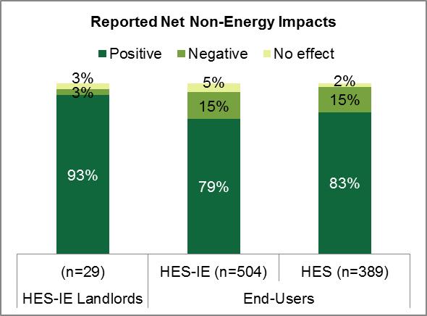
To estimate NEIs, the study asked participants if the program had a positive, negative, or no effect on various non-energy-related elements in their households or properties. For any elements for which participants observed positive or negative impacts as a result of the program, interview or survey questions asked them to compare the value of that NEI, and then finally all NEIs in aggregate, to the impact of the program on energy savings. From these inputs, the study estimated NEI values using methods consistent with industry best practices.

Net Non-Energy Impacts
Participants experienced positive net impacts from program NEIs. The vast majorities of end-user and landlord and property manager participants reported positive net impacts. The analysis found overall NEI values of 0.92 for HES end-users, 0.97 for HES-IE end-users, and 0.73 for HES-IE landlords and property manager participants. These values can be considered multipliers that can be translated as a percentage of household energy savings; for example, for every dollar that the average HES household saves on energy costs, the household perceives that they have received an additional 92 cents in NEIs.

Specific Impacts
- Comfort and safety were positively impacted. Of all NEIs, landlords and property managers placed the greatest value on the positive impacts on operations and maintenance, tenant comfort, and safety from improved lighting. HES and HES-IE end-user participants placed the greatest value on the positive impacts on comfort, safety from improved lighting, and their ability to pay energy bills.
- Negative NEIs are minimal. End-users very rarely reported negative NEIs—the few negative impacts that they reported were most often safety issues from the lighting changes. Landlords and property managers also reported very few negative NEIs, reporting tenant complaints or issues with safety from lighting or air sealing changes.

NEIs as Participation Drivers
- Expectations match experiences. Participants’ expectations of the positive NEIs that they would experience were about equal to what they actually experienced.
- Customers may not be tuned into possible NEIs. Nonparticipants hypothesized that they would experience net positive impacts from NEIs from program participation, but they were less likely to estimate that there would be a net positive impact from NEIs than participants were to observe actual net positive impacts from program participation.
- NEIs act as drivers. On average, HES-IE landlord and property managers rated NEIs as somewhat important in their decisions to participate in the program. The interviewees indicated that, to some extent, they had been motivated to participate to improve operations and maintenance, reduce tenants’ complaints, and increase tenants’ level of comfort. Coupled with the findings on nonparticipants having lower expectations of NEIs than participants actually experience, this suggests that greater emphasis of NEIs in program marketing materials may be warranted.

Executive Summary – Health and Safety
The study explored health and safety issues through telephone surveys and in-depth interviews with landlords and vendors. Some of the key findings on this topic include the following.

Common Health and Safety Issues Found
- Participants reported negligible health and safety issues. Ten percent of HES end-user participants and 22% of HES-IE end-user participants reported that the program vendors discovered at least one health and safety issue that kept vendors from completing the full assessment.
- Assessors most often discovered asbestos and vermiculite insulation and knob and tube wiring. Participants were most likely to fix gas and carbon monoxide leaks and least likely to remedy asbestos and vermiculite insulation.
- Nonparticipants discovered issues on their own—primarily issues with mold. Non-low-income (NLI) nonparticipants (16%) had more often discovered health and safety issues on their own than their HES participant counterparts had discovered during program assessments (10%). Often nonparticipants discovered mold (13%)—unlike program participants, who were more likely to learn that they had asbestos insulation (4% of HES and 8% of HES-IE).
- Low-income nonparticipant customers were less likely to discover issues than their HES-IE counterparts. Low-income nonparticipant customers (19%) were less likely to have had health and safety issues discovered outside of the program than their HES-IE counterparts did within the program (22%).

Barriers to Participation
- Vendors cited health and safety issues as major barriers to participation. From the vendor perspective, health and safety issues often prevent projects from moving forward. These issues frequently force technicians to halt the assessment until issues are remediated. Vendors estimated that health and safety issues occur in roughly one-quarter of all jobs (with estimates ranging between 5% and 40%). Participant surveys and interviews did not illustrate the extent to which health and safety issues prevent projects from ultimately taking place.
- Participant and nonparticipation remediation are hindered by cost. Commonly, for participants, remediation costs act as a barrier to having asbestos fixed, therefore keeping the full assessment from taking place. While nonparticipants were fairly likely to address issues, they expressed similar reasons as participants for not remedying health and safety issues: the cost and not having gotten around to it.
- Landlords and property managers reported health and safety issues were found but remediated without causing major program delays. Five of the 30 landlord and property manager interviewees said that vendors identified health or safety problems during the energy assessment, delaying the initial assessment at only one of the five properties until maintenance staff had remediated the problem. All problems were resolved, and the vendor was able to continue with the HES assessment and perform work at the property.

Executive Summary – Connecticut Contractor Development
The study included interviews with 16 HES vendors who served the program in 2014. The interviews were conducted in combination with those for R46 Financing, R151 Air Sealing, Duct Sealing, and Insulation, and R157 Multifamily Process studies. Questions focused on the qualitative impact of HES on their businesses. The major findings include the following:
- Vendors say that their businesses’ viability largely depends on the existence of HES. When asked to assess the impact of the hypothetical closing of HES on their businesses, most vendors explained it would have a large negative impact. Some speculated that they would go out of business, and most of the others believed they would have to reduce their staff by 60% to 80%. Only the three vendors who have substantial non-HES work felt that stopping the program would have little impact on their work.
- The program has led to increased vendor revenue and staffing levels. Most vendors believed that HES had boosted their revenue and the number of people they hire, with some vendors saying they had increased their staff levels by 500% to 800%. Vendors who saw post-HES increases in revenue and/or staffing attributed almost all of it to HES.
- Vendors believe the program has helped expand their energy efficiency business and the general market for energy efficiency services. When asked to use a zero-to-ten scale to rate the impact of HES on the amount of work for their business specifically and the energy efficiency services industry generally, every vendor rated both indicators at six or higher. The average impact on their own business was 9.5, and for the industry in general it was 8.4.
- Program-related business varies as portions of vendors’ revenue. Vendors serving HES fall into two types: Those who rely almost exclusively on HES for their work (75% to 100%) and those for whom HES supplements (50% or less) their other work. Five of the 12 vendors answering this question said 100% of their work comes from HES, but three said less than 10% of their work did.
- Program participants do not usually turn to their vendors for additional work. Vendors rarely found that HES participants hire them for additional, non-HES work in the home. When they are hired after HES, vendors attributed the decision to the customers’ positive experience and relationships stemming from HES.
- Vendors are skeptical that HES will continue to grow. Vendors were less certain that the HES-related growth can be sustained for either their business or the industry, ranking both with an average of about 7.0 on the same 10-point scale. Vendors generally felt the work load would continue at current levels.

Executive Summary – Connecticut Clean Energy Communities
The eighth study module, also known as Study R152, involved an assessment of the role played by the Connecticut Clean Energy Communities (CEC) program in boosting participation in HES and uptake of deeper savings measures. This assessment entailed interviews with utility program staff members and leaders of energy-related community groups. The study also examined rates of HES and other CEEF program participation and deeper-measure uptake through statistical analyses of program data available on the Energize Connecticut dashboard and of the HES program tracking databases for 2014.
- Successful CEC communities have a core group of motivated community members to spearhead community engagement. Formalizing the group as a town committee or task force assists in continuity and sustained activity, avoiding the disintegration of activity that can occur as one or two motivated individuals leave the group.
- Leveraging existing community events improves program outreach. The importance of this finding is best summed by an interview quotation: “People come to get their kids’ faces painted and leave with information on insulation and lighting efficiency.”
- Strong utility staff promote program success. Community leaders repeatedly spoke about the assistance, responsiveness, and resourcefulness of utility staff in ensuring their communities’ success.
- Community members suggested that additional structure or guidance could be added to the CEC program to aid in community engagement. They appreciated program flexibility and creativity but also felt that some additional structure may be helpful.
- Statistical analyses failed to find a consistent relationship between CEC program outreach, HES participation, and deeper-measure uptake. Simple statistical approaches (Chi-Squared tests and analysis of variance) suggested that utility staff outreach is associated with increased CEC points earned by the town. However, more sophisticated regression analyses that controlled for income, concentration of renters, and a “green” culture failed to find consistent relationships between CEC program outreach, the CEC points earned in 2014, and uptake of deeper measures.

Executive Summary – Document Review
The document review assessed the materials and resources that Energize Connecticut and the utilities provide in support of the HES and HES-IE programs, and whether those materials and resources are effective, clear, engaging, and accessible to potential program participants and vendors. The document review also assessed the relationship between the evaluation’s recommendations and the review findings to help identify successes and possible areas of improvement.
The analysis has indicated that the participation and financing materials and vendor documentation tools offered are generally clear and effective resources for customers and vendors to utilize. Some participants responding to the CATI survey recommended increasing advertising and the quality of information provided about the program. HES short-term respondents were significantly more satisfied than long-term respondents with the quality of program information, and both HES and HES-IE short-term respondents were significantly more satisfied with the rebate and incentive information when compared with long-term respondents, possibly signaling program improvements or superior recall due to more recent participation.
- Participation materials. Program materials contain a substantial amount of information about the assessment process that should be easy to understand from the customer perspective. The Energize Connecticut website and the HES Home Energy Report are relatively straightforward in their descriptions of program processes.
- Financing materials. The program produces a number of materials and resources to support customers as they learn about the financing options that are available to them. The Energize Connecticut website and its online financing tool as well as the Print-on-Demand Booklet (used by vendors when speaking with customers during the kitchen table wrap-up after the assessment) provide a good deal of background information for customers, but customers may find it valuable to speak with a specialist to clarify the process and specific steps needed (and the order in which steps should be taken). Vendors are provided with a chart of financing options, and the Implementation Manual instructs vendors to refer customers to the Energize Connecticut website to learn more about financing options.
- Vendor documentation tools. The program produces a number of materials and resources to support vendors as they work to educate customers about the assessment and program offerings. The Implementation Manual is a useful resource for vendors as they help guide customers through the program. It instructs them to assist customers in filling out rebate forms and to discuss the rebate and incentive options with them. It also provides detailed instructions for vendors about how to discuss the results of the energy assessment with customers and offers example language to use when explaining the results. Additionally, vendors are provided with a financing chart as well as a short description of rebate and incentive offerings to help them better explain these opportunities to customers.
- Marketing materials. The program provides many different marketing materials to reach potential HES customers. An analysis of these materials indicates that there are several marketing channels used, including traditional means (e.g., newspapers, bill inserts, brochures, letters, television, and phone outreach), as well non-traditional means, such as paid advertisements on Pandora Radio and Facebook, and Google pay-per-click advertisements. The marketing materials provided appear to be clear and easy to understand.

Executive Summary – Database Review
The Companies provided participation data for their HES, HES-IE, and rebate programs for participation that occurred between July 2013 and April 2015. The evaluators undertook numerous steps to clean, merge, and assess the data. Most of the findings and recommendations gained through this task have largely been incorporated into the R33 Database Improvement Task. Additional findings identified during on-site visits or as part of the estimation of deeper measure update and home energy assessment wait times have been incorporated into the On-site Persistence (Section 4.1) and Process Evaluation (Section 2) findings, respectively.

Conclusions and Recommendations
The study points to numerous conclusions and recommendations. The report first presents overarching conclusions and recommendations and then discusses those related to particular study modules and their related objectives.

Overarching Conclusion and Recommendations
Data collection and management. The on-site persistence visits identified apparent errors in the program tracking database. Several sites were associated with program data that incorrectly indicated the presence or absence of program measures. For example, refrigerator units that occupants reported as having been installed through the program were not listed in the tracking data. Similarly, refrigerator units were not found in apartments listed as receiving refrigerators through the tracking system. Additionally, more detail on-measure installations (such as brand/SKU for lighting and make/model/serial number for equipment) would allow for a more rigorous verification for future undertakings.
- Recommendation 1: The evaluation recommends that the Companies work closely with the program implementers and vendors to ensure that program data is entered into the tracking database correctly. Institute quality assurance/quality control procedures to verify the accuracy of data entry.
- Recommendation 2: It is critical for tracking databases to be developed/organized to account for evaluation aims as well as program implementation. Specifically, if CEEF-funded and non-CEEF-funded measures are installed in program units, it is critical to impact evaluations that the total number and type of measures installed through any funded source be listed. The study recommends working with vendors and community action agencies to develop procedures for listing all measures installed in units regardless of the funding source in order to improve the accuracy of impact evaluations.

Program Processes
Participant satisfaction. Satisfaction is high among end-user and landlord and property manager participants. End-users were highly satisfied with the program overall, in particular with core services and add-on measures. HES-IE landlord and property manager participants were also highly satisfied with add-on measures, but one of their suggestions—despite their high level of satisfaction with their vendors—was for the program to improve the quality of core services because they had received complaints from tenants about safety concerns stemming from the perception that the efficient lighting was too dim and quality concerns when it came to the air sealing (see Recommendation XX below). Some persistence issues among end-users were also linked to product quality and utility.
- Recommendation 3: Given this information, and the information discussed in the short-term persistence and EUL findings, it may be beneficial to reevaluate the actual materials that vendors are using for quality and utility. See Recommendation 16 below for specific recommendations on lighting.
Program awareness. Nonparticipants reported moderately high awareness of the programs. Word of mouth and utility outreach are effective marketing approaches as they were the channels through which participants became informed about the programs.
- Recommendation 4: Participants themselves suggested that the program increase its advertising. In an effort to leverage vendors’ desires to increase their own business revenues, the program may wish to engage nonparticipants through co-op marketing with vendors.
Program drivers. Participants’ desire to save energy and energy costs drove them to participate; additionally, they have observed energy reductions since the program improvements were made. In contrast, nonparticipant end-users do not participate because they have not made energy efficiency a priority, do not see a need, or find the cost prohibitive.
- Recommendation 5: Any new advertising should continue emphasizing energy and energy cost savings that the program improvements will create for them and have created for past participants. The messaging could focus on addressing customers’ skepticism that there is not a need to make improvements or on their “haven’t gotten around to it” attitudes by emphasizing that energy savings should be a priority. It would also be beneficial if the messaging stresses how little the assessments themselves cost, especially when compared to the value of the services provided. Landlords and property managers also suggested that the program promote possible costs/savings associated with program improvements during the solicitation process.
Communication. HES-IE landlords and property managers found that the entire participation process took longer than they expected. They also expressed frustration with program communications, including unreturned phone calls and emails to a program contact, discontinuity in communication, and a lack of communication with the contractor about important details of the work being done.
- Recommendation 6: The property managers and landlords had insightful suggestions for improving communications that the study considers worthwhile. They suggested creating a single contact for all program-related communications, communicating more clearly about timelines upfront, carrying out more direct communication as opposed to relying on third-party contractors, and clearly conveying what to expect from the technicians. The study suggests that the program address the timing issue by focusing on increasing the speed of rebate processing and communication response time with landlords.

Decision Making and Financing
Program offering information. The HES program uses a variety of methods to educate customers about program offerings. Utility marketing through bill inserts or through the program website are common sources of awareness. The HES program also relies heavily on vendors to promote and explain these offerings to eligible participants. However, some end-users expressed disappointment with the quality of rebate and incentive information, and one of their common suggestions was to improve the program’s quality of information. However, as noted above, some short-term survey respondents are significantly more satisfied with the quality of program information as well as with the rebate and incentive information provided when compared with long-term respondents, possibly signaling program improvements or superior recall due to more recent participation. The following recommendations are still encouraged for consideration to ensure that all customers and vendors are provided with the information that they need to make informed decisions.
- Recommendation 7: Vendors are currently provided with resources to help them understand and explain the program to customers, including language to use when discussing the program offerings. Providing vendors with additional or more detailed talking points and materials to encourage customers to consider add-on improvements may help overcome some of the challenges some end-users have expressed with the quality of information.
- Recommendation 8: The program does a good job of providing both print and online materials to support customers. (The website is well-designed and informative, for example.) However, clarifying or offering additional details about program offerings in customer-facing materials and marketing efforts may also help to address customer concerns over information quality.
Program incentive and rebate levels. The program offerings have been popular with customers, especially the insulation allowance that covers 50% of installed cost. Program participants as well as nonparticipants often cite not having enough funds to cover the upfront cost of program improvements as a key reason for not moving forward with the work.
- Recommendation 9: Continue offering substantial rebates and financing for insulation because free ridership is low and participants respond positively to them.
- Recommendation 10: If cost-effective, consider increases to incentives for other measures, given the success proven with 50% insulation allowance.
Financing materials and processes. Financing materials and processes confuse some vendors and customers. Vendors understand and can explain program rebate structures and processes to customers, but some vendors, along with their customers, struggle with the legalistic terminology and complexities involved in applying for financing. Some vendors suggest that the program simplify the language in the financing-related materials and applications.
- Recommendation 11: Provide an “everyday language” version of the loan application to accompany “legalese” documents through working with loan providers. Given that a greater percentage of Massachusetts households rated their loan application as easy to fill out (97% versus 43%), the EEB, Companies, and funding agencies may want to review the Massachusetts’ application materials for potential ideas on how to improve applications in Connecticut.
- Recommendation 12: Consider expanding on or updating existing materials that provide financing information, such as the vendor-focused Implementation Manual, or the customer-focused Print-on-Demand Booklet used during the wrap-up after the assessment. These documents already include some information and language about financing options that vendors can use, but it may be useful to provide more details or to clarify the messaging.
- Recommendation 13: Provide vendors with talking points and materials on sales methods to address initial loan rejections from customers.
Financing sources vary in nomenclature. Vendors often refer to financing options by the organizations offering the loans, but the Energize Connecticut website sometimes refers to the same loans with different names. HES participants already voice confusion and some skepticism about financing, and these variations in nomenclature may cumulatively add to participants’ and customers’ potential confusion.
- Recommendation 14: Provide guidance to vendors, website developers, and funding agencies about preferred language to use when referring to financing. Make certain that all websites and materials—vendor, program, and funding agency—use consistent nomenclature. Keep financing option name changes to a minimum, but when changes are necessary update all program materials and websites simultaneous with rolling out the name change. Make certain the vendors and program staff use consistence language, both in informal discussions (this will make the terminology second nature) as well as in written materials, such as the vendor-targeted Implementation Manual.

Short-Term Persistence and EUL
On-site visits verified high short-term persistence rates on portable measures. Based on the on-site assessment, the study did not identify persistence issues related to removal of the portable measures verified for multifamily participants of the HES-IE program. Because persistence rates were so high, it was not possible to estimate effective useful life for the portable measures examined in the on-site persistence study.
- Recommendation 15: The study finds no evidence to justify downwardly adjusting persistence rates or measure lives for CFLs, LEDs, faucet aerators, showerheads, or refrigerators in HES-IE multifamily units. The Companies should continue to use current assumptions as listed in the 2015 PSD in Appendix 4 at this time.
LEDs persistence exceeds that for CFLs. The analysis estimated a higher persistence rate for LEDs than CFLs. This may be due to the fact that they anecdotally expressed higher satisfaction with LEDs than with CFLs in terms of both aesthetics and performance.
- Recommendation 16: Given the increased marginal savings achieved by LEDs over CFLs, the greater tendency for participants to keep program LEDs installed compared to CFLs, and the longer measure life for LEDs, the program should continue its efforts in the 2016 to 2018 program cycle to shift resources from CFLs to LEDs, eventually making LEDs the default standard socket lighting measure for the program. Note that the recent Lamp 2.0 specification released by ENERGY STAR mean that no CFLs will be ENERGY STAR qualified as of January 2, 2017. Thus, it is likely that the switchover to LEDs will happen somewhat rapidly.

Net-to-Gross
Net-to-gross (NTG) ratios. Using findings from CATI surveys with HES end-user participants, the study estimated a free ridership rate of 0.22 and a spillover rate of 0.02, resulting in a net-to-gross ratio of 0.80 for the HES program. When compared to similar programs in the Northeast, the HES net-to-gross ratio is somewhat lower, with other programs having ratios greater than 1.0.The study also estimated net-to-gross ratios of 0.95 for HES-IE, and 0.93 for rebate-only programs. It is worth noting that Connecticut factors NTG ratios into its “net realization rates” in the PSD; at this time, the 2015 PSD lists only free ridership and spillover for individual measures and does not list overall program free ridership or spillover or overall NTG ratios.
- Recommendation 17: The evaluation team suggests that the Companies consider the findings of this study when revising free ridership, spillover, and realization rates in the PSD for the HES Program. Some of the confidence intervals are too large to serve as specific values for the PSD. However, they do provide information that could inform future revisions. The evaluation team suggests not using the HES-IE and rebate-only net-to-gross ratios formally because HES-IE programs generally assume a net-to-gross ratio of 1.0, and sample sizes are small among rebate-only respondents.
Insulation free ridership. Free-ridership for insulation was notably low (0.06) when compared to the other frequently asked-about measures. As a “sensitivity analysis,” the study calculated the free ridership rate in absence of insulation measures, arriving at a somewhat higher overall free ridership rate of 0.26. This difference demonstrates the high level of influence that the program has on the installation of insulation and the value of continuing to include insulation as a program measure.
- Recommendation 18: Considering the low free ridership rate and also the enthusiasm among customers for the insulation rebate opportunity that vendors observe, the program will benefit from continuing to offer its generous incentive for this cost-effective measure.
- Recommendation 19: Given the relatively low free ridership rates and higher adoption rates for insulation coupled with the claim by participants that would adopt more measures with deeper incentives, free ridership rates for some measures may actually decrease if the Companies increase incentives. That is, free ridership may be higher at lower incentive amounts, but higher incentive amounts really move people to adopt a measure that they otherwise would not have adopted. This would have the net effect of increasing the cost-effectiveness of higher incentives. Thus, as also stated in Recommendation 10, the Companies should consider increases to incentives or financing allowances for other measures.

Non-Energy Impacts
Overall NEI values. Participants experienced positive net impacts—household and other effects beyond energy savings—from the program. These positive NEIs far outweighed any negative NEIs. The vast majorities of end-user and landlord and property manager participants reported positive net impacts. The analysis found overall NEI values of 0.92 for HES end-users, 0.97 for HES-IE end-users, and 0.73 for HES-IE landlords and property manager participants. These values can be considered multipliers that can be applied to expected energy savings to estimate their worth to the participants; for example, HES-IE landlords and property managers value positive net NEIs nearly three-quarters (73%) as much as they do energy savings.
- Recommendation 20: The evaluation suggests that the program consider adopting these NEIs as a factor in program impacts estimates.
Perceptions of NEIs. HES-IE landlords and property manager participants perceived potential NEIs as a driver for their participation. Both they and end-user participants most often reported that comfort and safety were positively impacted. Vendors also agreed that participants would be likely to experience comfort and safety as a result of their participation and regularly mention these benefits as selling points during the assessment. Nonparticipants hypothesized that they would experience net positive impacts from NEIs from program participation, but they were less likely to estimate that there would be a net positive impact from NEIs than participants were to observe actual net positive impacts from program participation. That is, participants and nonparticipants diverge in terms of the impacts they expect from the program—which thereby affects their internal calculations of return on investments relative to the program and potentially their participation decision.
- Recommendation 21: The divergence between nonparticipants’ lower expectations for NEIs and participants’ actual experiences with NEIs suggests that greater emphasis on NEIs in program marketing materials may be warranted. Specifically, messaging should focus on the positive impacts on comfort and safety. This may help bring nonparticipants’ expectations of NEIs to values closer to those of participants, which could potentially increase participation rates from the same expenditures on outreach, thus reducing program cost per customer sign-up.

Health and Safety
Improved health and safety in terms of fewer illnesses, better air quality, and reduced fire risk, among others, are among the program NEIs named by participants and vendors. Yet, the study made clear that other health and safety concerns actually prevent the provision of services to some single-family and small-multifamily (two-to-four unit) homes and can delay services to multifamily buildings. Additionally, some landlords voiced concerns about tenant safety related to perceived dimness of efficient lighting.
Health and safety as barriers to participation. Vendors perceive health and safety issues as major barriers to participation, estimating that these issues impact close to one-fourth of all jobs. These issues frequently force technicians to halt the assessment until issues are remediated.
- Recommendation 22: This is a challenging barrier to address. Continuing to provide clear and effective health and safety-oriented messaging and support to end-users, landlords, and vendors may help to address these issues over the long term. Communicating with vendors about commonly occurring issues may help to target that messaging and support.
Remediation costs. Both participants and nonparticipants said that the costs associated with remediation of health and safety issues is a hindrance. For participants, these costs (often associated with asbestos insulation) act as barriers to having the full assessment take place.
- Recommendation 23: For both HES and HES-IE participants and landlords/property managers, provide more information on the financing options—including some external to the program—that cover at least part of the costs of remediating health and safety issues. Consider creative options for financing or assisting with remediation in order to secure deeper energy savings. One idea is to have customers contractually agree to install deeper measures in return for having a portion of the remediation offset through the use of ratepayer funds.
- Recommendation 24: When replacing light bulbs, make certain that the lumens duplicate or exceed the lumens of the bulb being replaced, unless doing so creates additional safety concerns (e.g., the wattage of the new bulb would be too great to use safely in the fixture). This applies to the interior and exterior of all single-family homes and multifamily buildings as well as common areas in multifamily buildings.

Connecticut Contractor Development
Indicators of effects. Vendors recognize the value that the program has carried for expanding their energy efficiency business and the general development of contractors that provide energy efficiency services in the state. Not only has the program led to increased vendor revenue and staffing levels, but many vendors’ businesses’ viability largely depends on the existence of HES; in fact, some vendors rely almost exclusively on HES for their revenue.
- Recommendation 25: Given these positive indicators that the program has had a positive effect on the development of contractors in the state from the perspective of vendors, the EEB may wish to conduct a larger study to quantify the extent of program market effects. A study along these lines would generally involve interviews or surveys with product distributors/ suppliers and participating and nonparticipating installation contractors.
Program structure. Vendors do not always agree with changes in rebates and measures offered. For example, a few mentioned their disagreement with the decision to shift some rebates upstream rather than continue supporting the rebates directly via HES.
- Recommendation 26: Given vendors’ reliance on the program and the program’s implicit reliance on vendors to have an impact on the market (and support program participation), it is pivotal to get vendor input before deciding to make structural program changes to foster a sustainable relationship between the program and its vendors. Additionally, any changes that are made should ideally be accompanied by clear communications to the vendors regarding the reasons for the changes and the mechanics or implications of the changes.

Connecticut Clean Energy Communities
Structure and guidance for Clean Energy Communities. Clean energy community leaders appreciated the flexibility and creativity afforded to them for hosting community events and reaching out to their constituencies. However, they also desired more structure and guidance regarding outreach and activities. Likewise, formalized town committees or paid positions help provide sustained activity and continuity for individual communities.
- Recommendation 27: Foster learning between towns by developing a CEC “playbook” that can be distributed to town committees and organizing periodic conference calls of town energy committees. The playbook can include one-page descriptions of replicable activities already successfully completed by other communities. It can be updated annually to reflect additional experiences of communities or evolving program goals. Towns should be encouraged to “add your play” to the book to build the collective knowledge base. Conference calls can be used to highlight successful activities and lessons learned in conjunction with the program.
- Recommendation 28: Encourage towns to formalize CEC positions within the town municipal structure so that if a key person leaves, someone new steps into that role.

Evaluation Data Collection
Short-term data collection. Regarding surveys, comparisons of short-term and long-term respondents only occasionally differed from each other statistically. Additionally, the short-term survey was fielded at least six to nine months post-participation. Yet, the differences observed suggest that short-term respondents are more satisfied with core services and program information on savings and incentives, are more likely to say they will use rebates, and exhibit lower levels of free ridership.
- Recommendation 29: Weighing all of this information, the study recommends that the EEB and Companies strongly consider fielding one more short-term survey using an instrument very similar to R31 within three to six months of program participation. This survey should provide enough information to allow for a definitive recommendation of whether a continuous short-term survey effort is justified for Connecticut HES, HES-IE, and downstream residential rebate programs.
Language barriers. While the majority of HES-IE participants—and the eligible population—speak English, a sizable (but unknown) portion primarily speak other languages, with Spanish being the most common. The available study budget did not support conducting telephone surveys or on-site interviews in Spanish, thus limiting who could respond to the phone survey and leading one landlord to decline participation in the on-site visits. In another building, the landlord acted as interpreter so the study could include Spanish-speaking participants.
- Recommendation 30: Future studies that reach out to HES-IE participants should be planned and adequately funded to ensure inclusion of non-English-speaking (primarily Spanish-speaking) customers. Providing adequate resources would allow future evaluations to hire trained bilingual technicians and interviewers, which would improve the exploration and characterization of the substantial non-English-speaking portion of the eligible population.

Background and Methodology
1
Home Energy Solutions (HES) and Home Energy Solutions-Income Eligible (HES-IE) are the two flagship programs in the Connecticut Energy Efficiency Fund (CEEF) residential program portfolio. According to the 2014 annual report, these two programs collectively served 51,947 residences in Connecticut in 2014. The ranked first and second in terms of residential program budgets for 2015 (35% for HES and 32% for HES-IE) and first and fourth in terms of expected 2015 residential savings (31% for HES and 19% for HES-IE).,The idea driving both programs is that the home energy assessment leads homeowners, renters, landlords, and property managers to adopt additional energy-saving measures, some of which are eligible for rebates or program-supported financing options. In short, the programs ideally serve as an entry point for capturing deeper savings.
Given the importance of the two programs and their offerings in the residential portfolio, the Connecticut Energy Efficiency Board (EEB) tasked the research area contractor NMR Group, Inc., and its partner The Cadmus Group with conducting a series of related studies of the HES and HES-IE programs. The four main studies are as follows:
- R4 Process Evaluation of the HES and HES-IE programs examined program processes, health and safety concerns, customer decision-making regarding participation and deeper-measure uptake, measure persistence, net-to-gross ratio estimation, and non-energy impacts for participants from July 2013 through December 2014.
- R31 Short-term Data Collection addressed many of the same issues as R4 but for HES and HES-IE participants as well as outside program rebate users from January to April 2015.
- R46 Financing Study, leveraging resources from the R4 and R31 studies, assessed awareness of, reactions to, and use of the various zero percent or low-interest financing options available to Connecticut ratepayers through the CEEF (some of which require HES or HES-IE participation).
- R152 Clean Energy Communities (CEC) Assessment, again leveraging resources from the R4 study, explored the degree to which this community outreach program influenced participation in HES and deeper-measure uptake, while also providing some insights into the characteristics of successful CEC communities.
The four studies explored topics through eight individual topic modules, including conducting telephone surveys with 1,370 program participants and non-participants; in-depth interviews with 30 HES-IE landlords, 23 HES vendors, two Clean Energy Communities program staff members, and four energy-efficiency community group leaders; and 13 visits to HES-IE multifamily buildings (86 units in total).
Table 5 on the next page outlines the modules and their objectives and research questions, while Table 6 maps each module to the research tasks designed to answer these questions. The remainder of this section describes the methods used across the four studies.

Table 5: Research Modules, Objectives, and Questions
Module | Major Objectives / Research Questions
Module 1: Program Processes, Experience | Program awareness, experience, satisfaction; clarity of program materials; wait time for receiving services
Module 2: Health and Safety | Degree to which health and safety concerns limit services; types of concerns found; mitigation of health and safety concerns
Module 3: Decision-making and Financing (Study R46) | Awareness/use of rebates and financing; role of rebates and financing in decision to install measures; ease of applying for rebates and financing; vendor experience promoting rebates and financing
Module 4: Non-energy Impacts | Whether participants experienced non-energy impacts (NEIs); which NEIs they experienced; value placed on impacts; impacts expected by nonparticipants; vendor discussion of impacts
Module 5: Net-to-Gross Ratios | Likelihood of purchasing measures without program incentives; additional purchases made because of program experience
Module 6: Persistence and Effective Useful Life | On-site verification of persistence of portable measures in HES-IE multifamily buildings; self-reported persistence of additional measures (via telephone); early check-in for EUL where appropriate
Module 7: Connecticut Contractor Development | Degree to which program has increased revenue and staff for vendors’ companies and for energy efficiency service providers more generally; degree of reliance on HES for work
Module 8: Clean Energy Communities  (Study R152) | Degree to which activities performed through the CEC Program has induced participation in HES and uptake of deeper measures

Table 6: Mapping of Study Modules and Tasks
 | Task 1: Participant and Nonparticipant Surveys | Task 2: HES-IE Multifamily Landlord Interviews | Task 3: On-site Visits | Task 4: Program database review | Task 5: Program document review | Task 6: Bench-marking | Task 7: Vendor Interviews | Task 8: CEC in-depth interviews and database analysis
Sample Size | R4 participants = 833  R31 participants = 299  R4 nonparticipants = 238 | 30 | Sites = 13  Units = 86 | N/A | N/A | N/A | 23 | 6
Module 1: Process and Experience | X | X | X | X | X | X
Module 2: Health & Safety | X | X |  |  |  |  | X
Module 3: Decision-making, Financing | X | X |  |  | X | X | X
Module 4: Non-energy Impacts | X | X |  |  | X | X | X
Module 5: Net-to-Gross | X | X |  |  |  | X
Module 6: Persistence & EUL | X | X | X |  |  | X
Module 7: Connecticut Contractor Development |  |  |  |  |  | X | X
Module 8: CEC Impact on HES |  |  |  |  |  |  |  | X

Task 1 – End-User Surveys – Methodology
Surveys with end-user participants and nonparticipants explored program processes, health and safety, decision making and financing, non-energy impacts, net-to-gross, and persistence.

End-user Participant Surveys
The end-user participant surveys were conducted in two waves: 1) surveys with HES, HES-IE, and rebate-only end-users fielded in September 2015 as part of the R31 study, and 2) surveys with HES and HES-IE end-users fielded in September and October 2015 as part of the R4 study.

Short-term Data Collection (R31)
As described earlier, this survey effort incorporated the R31 study as the first of two survey waves. The R31 study piloted the effectiveness of performing participant surveys addressing program processes and decision making in a timeframe closer to their dates of participation. R31 surveyed not only HES and HES-IE, but also end-user rebates obtained outside of HES.
The R31 study was originally referred to as “real-time” data collection with the intention to speak with participants within a few months of participation. Due to challenges aggregating participant contact data, coordinating the survey instrument with R4 objectives, finishing CATI survey programming, and ironing out sampling issues, the surveys took place six to nine months after participation. As a result, the analysis refers to these respondents—responding within nine months after participation—as short-term respondents instead of real-time respondents.
The short-term surveys asked the same question modules as the long-term (R4) participant surveys with the exceptions of excluding health and safety, persistence, and spillover question modules and including an additional feedback question module.

Sampling
Table 7 presents the end-user participant survey sampling errors and other sampling details. The overall sampling error for the combined R4 and R31 participant surveys was 3.0%, with the sampling error per individual strata ranging from 5.6% to 10.4%. The analysis weighted the results so that they better represented the program population in terms of participation period (i.e., survey timing – R4 vs. R31), program (HES vs. HES-IE vs. rebate-only), and type of measures installed (core service only vs. non-insulation add-ons vs. insulation). For some topic areas, the nature of the analysis necessitated the use of an alternative weighting scheme (e.g., net-to-gross was weighted to program savings and measure types) or no weighting scheme (e.g., persistence and NEIs). Appendix A.1.1 presents the R4 and R31 survey weights.
Table 7: End-user Participant Survey Sample Design – Population, Sample Size, and Sampling Error by Stratum, Study, and Participation Period
Stratum / Group | Study | Participation Period | Population Size | Sample Size | Sampling Error
HES – Core Only | R4 | July 2013 to December 2014 | 15,979 | 194 | 5.9%
HES – Insulation |  |  | 4,022 | 123 | 7.3%
HES – Other Tier II |  |  | 1,420 | 116 | 7.3%
HES-IE Core Only¹ |  |  | 3,958 | 209 | 5.6%
HES-IE Tier II¹ |  |  | 4,296 | 191 | 5.8%
Core Only | R31 | January to April 2015 | 5,500 | 119 | 7.5%
Insulation |  |  | 1,167 | 60 | 10.4%
Tier II |  |  | 646 | 60 | 10.2%
Rebate Only² |  |  | 815 | 60 | 10.3%
Total | Both | July 2013 to April 2015 | 37,803 | 1,132 | 3.0%
HES | R4 | July 2013 to December 2014 | 21,421 | 433 | 4.6%
HES-IE¹ |  |  | 8,254 | 400 | 4.0%
R4 Total | R4 | July 2013 to December 2014 | 29,675 | 833 | 3.5%
R31 Total | R31 | January to April 2015 | 8,128 | 299 | 5.4%
¹ Excludes participants that were not occupants / end-users: Eversource Subprogram 3 (Multifamily) and Subprogram 4 (Neighborhood Canvassing) contacts and UI contacts that appeared to be from commercial / property management entities.
² Represents respondents that received rebates outside of the HES umbrella.

Response Rates and Completions by Company
The R31 participant survey was fielded from September 4 to September 22, 2015, and then was briefly re-opened for fielding from November 11 to November 15, 2015, in order to ensure adequate representation by program and Company. A total of 299 CEEF program participants were surveyed. The response rate was 17%, as determined using a calculator developed by the American Association of Public Opinion Research (AAPOR; Table 8). Excluding numbers at which surveyors only left messages on answering machines or voicemail increases the rate to 19%. Both calculations exclude those screened from the survey and unusable phone numbers. Appendix A.1.1 provides additional details on why some eligible participants did not answer the survey.
The R4 participant survey was fielded from September 21 to October 17, 2015. A total of 832 participants in the HES and HES-IE programs were surveyed. The AAPOR calculation estimates a response rate of 10% including numbers at which surveyors left messages and 15% excluding message only numbers. It is worth noting that the response rate was higher for the R31 survey, for which the respondents generally had participated more recently than for R4; higher response rates reduce non-response bias, offering one argument in favor of fielding short-term surveys. However, here the higher response rate for R31 has more to do with the “active” sample remaining at the end of calling. Specifically, in order to reach quotas for R4, the survey firm had to release additional sample towards the end of calling. They began calling the newly released sample and left many answering machine messages but were reached all quotas before contacting most of the answering machine numbers again. The R31 survey did not have to release more sample in order to reach quotas, therefore avoiding this situation.

Table 8: End-User Participant Surveys – Response Rates¹
(Base = all phone numbers dialed at least once)
Response Rate | R4 |  | R31
 | w/ Answering Machine | w/o Answering Machine | w/ Answering Machine | w/o Answering Machine
All Numbers Dialed | 11,669 | 7,848 | 2,498 | 2,180
I=Complete Interviews | 832 | 832 | 299 | 299
P=Partial Interviews | 41 | 41 | 44 | 44
R=Refusal and break off | 1,568 | 1,568 | 869 | 869
NC=Not Contacted | 810 | 810 | 105 | 105
O=Other | 120 | 120 | 40 | 40
e=Estimated Proportion of Unknowns that are eligible² | 0.762 | 0.762 | 0.823 | 0.823
UH=Unknown Households | 7,248 | 3,427 | 850 | 532
Response Rate³ | 10% | 15% | 17% | 19%
¹ Response rate calculated using the AAPOR Outcome Rate Calculator
² (I+R+NC+O)/[(I+R+NC+)+(W+NE)]
³ (I+P)/((I+P) + (R+NC+O) + e(UH+UO))

Table 9 presents the distributions of the records that the Companies provided, the usable records within those, and the survey sample across Company and program. Appendix A.1.1 provides greater details on the development of the sample frame, demonstrating how the removal of duplicate, commercial, and incomplete contacts reduced the sample frame size (i.e., number of usable records). In summary, the most common reason for removals was the lack of usable contact information. Variations from the percentage of usable records versus percentage of completed surveys reflect the degree of customer cooperation by survey group, but also, to some extent, may be due to the availability of mailing information.
Table 9: Participant End-User Surveys – Comparison of Participant Population versus Sample
by Company and Study
Stratum / Group | Eversource |  |  |  |  | UI
 | Population |  |  | Sample |  | Population |  |  | Sample
 | Number of Original Projects | % of Original Projects | % of Usable Records¹ | Number of Completed Surveys | % of Completed Surveys | Number of Original Projects | % of Original Projects | % of Usable Records¹ | Number of Completed Surveys | % of Completed Surveys
R4 Study
HES | 20,443 | 62% | 54% | 377 | 45% | 3,892 | 12% | 10% | 56 | 7%
HES-IE | 5,931 | 18% | 25% | 345 | 41% | 2,885 | 9% | 12% | 56 | 7%
R31 Study²
HES | 4946 | 38% | 64% | 114 | 38% | - | - | - | - | -
HES-IE | 5163 | 39% | 26% | 125 | 42% | - | - | - | - | -
Rebate-only² | 3077 | 23% | 10% | 60 | 20% | - | - | - | - | -
¹ Refers to records with unique contacts and adequate contact information.
² UI opted not to provide sample for R31 as they were in the midst of performing follow-up with participants.
³ Refers to projects that received rebates outside of the HES umbrella, according to program records.

Respondent Characteristics
Appendix B.1 presents respondents’ housing and demographic characteristics. Figure 1 compares the program measures that respondents verified during the survey with the most common measures in the program population. With the exception of HES insulation and HES-IE refrigerators, it appears that the survey under-sampled the other measure types—but much of this may be a result of inaccurate self-verification on the part of respondents. Appendix A.1.1 compares the verified sample measures with the full list of population measures.
Figure 1: End-user Participant Survey – Verified Sample Measures Compared to Population Measures
(Percentage of contacts)
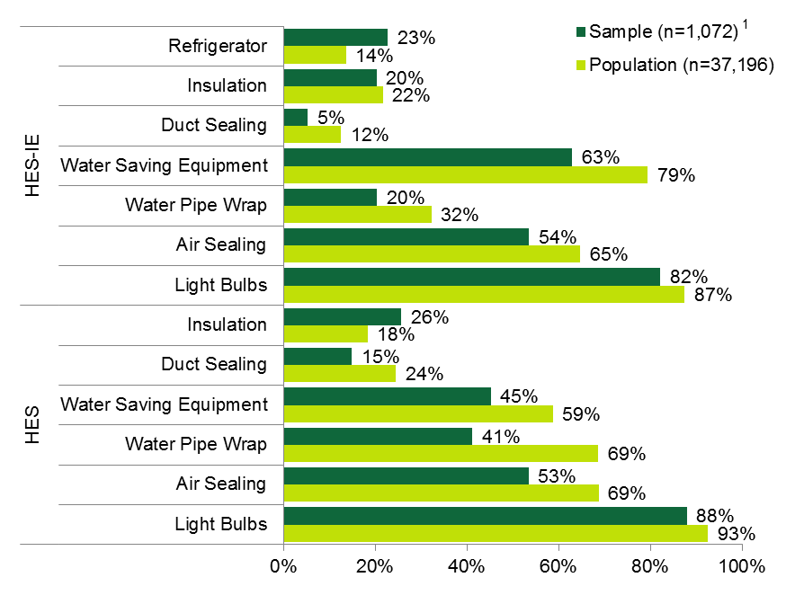
Note: Figure includes only the most common program measures.
¹ Percentages are based on the number of contacts in each program type: the end-user population consisted of 26,762 HES participants and 10,434 HES-IE participants; the sample consisted of 547 HES participants and 525 HES-IE participants.

End-user Nonparticipant Survey
End-user nonparticipant surveys were conducted with Company customers who had not participated in HES or HES-IE. The overall sampling error is 5.4%, assuming a 50% break in responses. The sampling error for HES-eligible homes was 7.0% and for HES-IE-eligible homes was 8.4%.
Table 10: End-user Nonparticipant Survey Sample Design – Population, Sample Size, and Sampling Error by Stratum
Stratum¹ | Population Size² | Sample Size | Sampling Error
HES Eligible (NLI) | 1,749,141 | 140 | 7.0%
HES-IE Eligible (Low-income) | 925,564 | 100 | 8.4%
Total | 2,676,705 | 240 | 5.4%
¹ Income eligibility was based on self-reported household size and median household income compared with the 2014/2015 Connecticut Low-income Heating Energy Assistance Program eligibility criteria. The analysis considered respondents that would not or could not provide household size and/or income information as non-low-income (NLI).
² Population estimates are approximate and are derived from the Census Bureau’s Data Ferret. The estimates are based on all households in Connecticut and are adjusted for income and household size. Adjusting for municipal utilities would have virtually no effect on sampling error due to the large sample size.

Response Rates and Completions by Company
The R4 nonparticipant survey was initially fielded from September 24 to October 21, 2015, and then, due to performance issues with the first firm, the EEB requested switching firms. The second firm fielded the survey from November 23 to December 13, 2015. A total of 219 participants in the HES program were surveyed. The AAPOR calculator estimated a response rate of 1% with answering machines and 3% without them (Table 11). As with the end-user surveys, the methods exclude from the calculation those who were screened from the survey and unusable phone numbers. Appendix A.1.2 provides additional details on why some eligible participants did not answer the survey.
Table 11: Nonparticipant Survey - Response Rate¹
(Base = all phone numbers dialed at least once)
Response Rate | R4 Nonparticipant
 | w/ Answering Machine | w/o Answering Machine
All Numbers Dialed | 20,765 | 8,635
I=Complete Interviews | 219 | 219
P=Partial Interviews | 3 | 3
R=Refusal and break off | 1,877 | 1,877
NC=Not Contacted | 2,555 | 2,555
O=Other | 88 | 88
e=Estimated Proportion of Unknowns that are eligible² | 0.919 | 0.919
UH=Unknown Households | 15,604 | 3,474
Response Rate³ | 1% | 3%
¹ Response rate calculated using the “AAPOR Outcome Rate Calculator”
² (I+R+NC+O)/[(I+R+NC+)+(W+NE)]
³ (I+P)/((I+P) + (R+NC+O) + e(UH+UO))

With the goal of representing the customer distribution between the two Companies, two-thirds of the sample frame consisted of Eversource customers, and the remaining one-third consisted of UI customers. Completed surveys were slightly skewed toward Eversource; 73% of respondents were Eversource customers and 27% were UI customers (Table 12), reflecting differential cooperation rates. The analysis properly weighted the results by income and dwelling type (multifamily versus single-family) as compared to the population in Connecticut.
Table 12: Comparison of Nonparticipant Records Provided Versus Sample
by Company
Utility | Number of Records Provided | Usable Records¹ | % of Usable Records | Number of Completed Surveys | % of Completed Surveys
Eversource | 3,400 | 3,118 | 67% | 176 | 73%
UI | 1,600 | 1,504 | 33% | 64 | 27%
Total | 5,000 | 4,622 |  | 240
¹ Refers to records with unique contacts and adequate contact information. Eight percent of the 5,000 customer contacts that the Companies provided were unusable mostly because they were commercial contacts (additional details in Appendix A.1.2).

Task 2 – HES-IE Landlord and Property Manager Interviews – Methodology
The HES-IE landlord and property manager interviews asked interviewees about program processes, decision making and financing, short-term persistence, free ridership, spillover, non-energy impacts, and health and safety. This task resulted in 30 interviews completed with landlords and property managers, including 29 telephone interviews and one in-person interview.

HES-IE Landlord and Property Manager Interviews – Project Characteristics
Interviewers asked each landlord and property manager about one of their projects served by the program (referred to as their “key project”) between July 2013 and April 2015. If the landlord or property manager was involved with more than one participating project, interview questions focused on the project with the largest amount of gross electric savings as reported in the program database.
Of the 30 projects, 24 were served by Eversource and six were served by UI. The 30 projects included 2,373 housing units, representing 7% of the projects and estimated number of units in the HES-IE participant population between July 2013 and April 2015, in total. The key projects ranged in size from five to 360 units, with an average of 79 units per project and a midpoint of 41 (Table 13)., Figure 2 compares the sample in terms of the number of units, projects, and unique landlord and property manager contacts to the HES-IE participant population.
Figure 2: HES-IE Landlord and Property Manager Interviews – Sample Comparison to HES-IE Participant Population
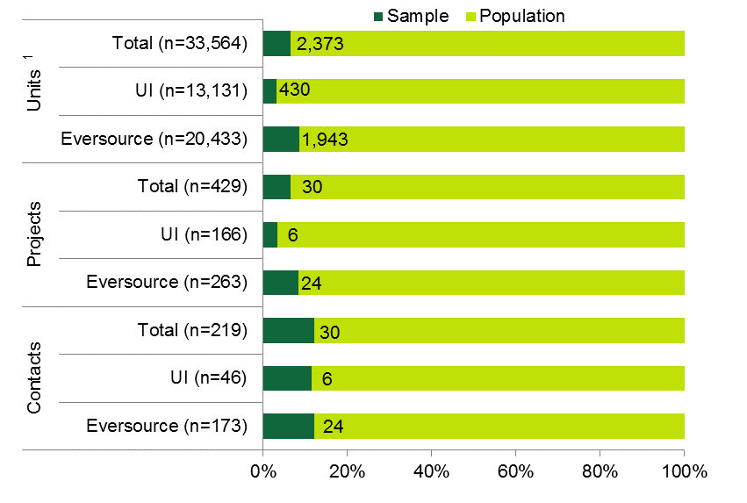
¹ In the absence of unit-level data in UI’s participation database, the study estimated the total number of units in the UI population by multiplying the mean units per projects among the key projects (79.10) by the number of UI projects in the participation database (166).

Table 13: HES-IE Landlord and Property Manager Interviews – Number of Units in Sample and Population
HES-IE Units per Project |  | Eversource | UI¹ | Total¹
Participant Population  (n=429 projects) | Average | 78 | - | -
 | Median | 51 | - | -
Interview Sample  (n=30 projects) | Average | 81 | 72 | 79
 | Median | 46 | 26 | 41
¹ UI’s participation database does not capture the number of housing units in its projects; as such, the table does not report the average or median number of units among the full population.
Figure 3 presents the program measure types installed at the 30 key projects. The key projects were most likely to have received incentives for refrigerators (7 projects) and insulation (7); for core services, they most often received light bulbs (29), water-saving equipment (21), and air sealing (19).
Figure 3: HES-IE Landlord and Property Manager Interviews – Program Measures at Key Project
(Count of projects)
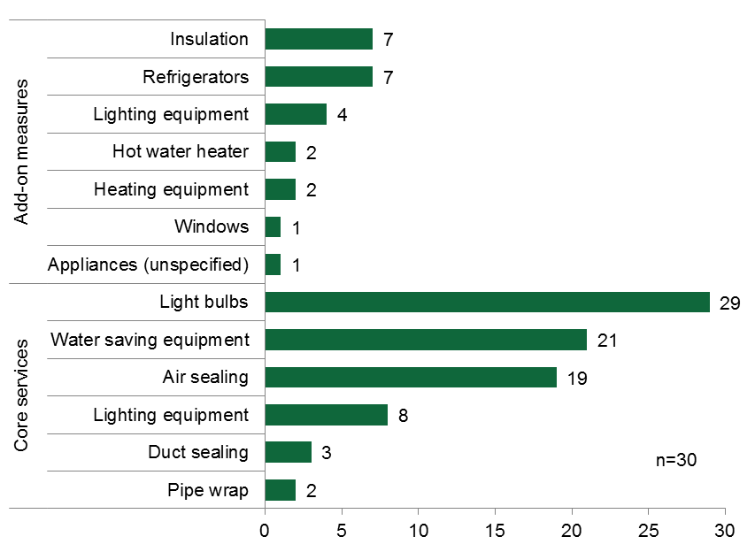
As illustrated in Figure 4, when compared to the HES-IE project population, the HES-IE landlord and property manager key project sample over-represented some measures (in particular, light bulbs and other lighting equipment and air sealing). For example, nearly all of the key projects had light bulbs installed (29 of 30) compared to one-quarter of the full HES-IE project population, and more than three-fifths of the sample (63%) had air sealing conducted, but slightly less than one-third of the population (31%) had it conducted. The report includes firmographics about the interviewees’ companies in Appendix B.2.2.
Figure 4: HES-IE Landlord and Property Manager Interviews – Sample Comparison to HES-IE Participant Population Measures
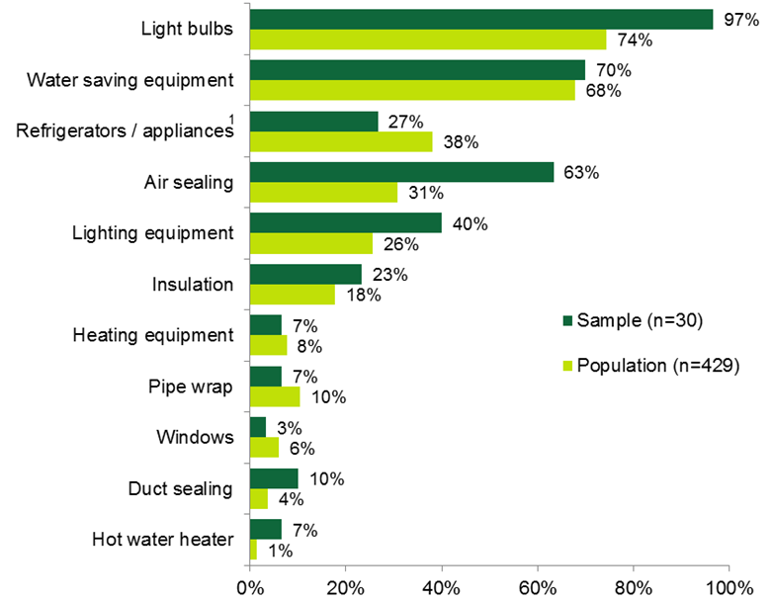
Note: The chart excludes a few measure types where none of the key projects installed those measures (e.g., central air conditioners and heat pumps); each represented 15 projects or fewer in the HES-IE population.
¹ Program tracking data did not specify the type of appliance for 72% of the 163 projects with either refrigerators or other appliances.

Task 3 – On-site Persistence Visits – Methodology
The study involved performing on-site verification to estimate short-term persistence of portable measures (e.g., light bulbs as opposed to insulation) installed in multifamily residences (five or more units) under the HES-IE program. Even though both HES and HES-IE serve multifamily buildings, the persistence study focuses on HES-IE. Measures examined include compact fluorescent lamps (CFLs) and light-emitting diodes (LEDs), direct hot water measures (showerheads and faucet aerators), and refrigerators. The research approach determined persistence during a simple visual inspection during the same visit. The effort also sought to understand why participants may have removed products.
The study defined persistence as the percentage of program measures that remain installed at the time of the survey or on-site visit (discussed below). Specifically, this study focused on research around key program measures and their short-term persistence (i.e., measures that remain installed within a few years of installation)., For more information on on-site methods, see Appendix A.1.3.

On-site Persistence Visits Approach
To estimate short-term persistence for portable measures, the study included on-site visits in 86 multifamily units across 12 buildings. The visits were at sites that had participated in the HES-IE program in the period from 2013 to 2015. Through landlord and property manager in-depth interviews (described in Section 1.2), the approach involved the recruitment of landlords and property managers willing to permit on-site verification in one of their buildings or complexes that had participated in the HES-IE program. The study provided participating landlords and property managers with a $100 gift card for gaining approval and coordination in conducting the on-site assessment. Additionally, the study provided $25 gift cards to occupants who responded to a short interview regarding measure persistence at the time of the site visit.

Verification Methodology
Site verification of measure persistence can identify at least two different types of problems. If the number of measures identified on site is fewer than the number of measures claimed by the program, two questions arise: 1) Is the amount recorded in the program database an error due to implementation or database problems? 2) Were the measures removed subsequent to installation? For the latter question, the research is dependent on self-reporting by tenants, which can be subject to errors of recall and of normative bias. The study was designed to estimate the percentage of program measures that were verified to be installed at the time of the assessment compared to the number as recorded in program tracking databases as well as the number recalled as installed by the tenants. There are, thus, two baseline denominators against which verified installed measures have been calculated and reported.
During the on-site visits, technicians collected data detailing whether the portable measures were still installed. For this study, while technicians used program tracking data listing the expected measure quantities, they did not identify and verify program equipment from lists of measure brands and model numbers. However, they were able, with a high degree of confidence, to identify program equipment based on 1) the expectation that identical measures were installed throughout the units in a building, and 2) corroboration from occupants. For measures not found, technicians asked occupants whether a measure had been removed and, if so, when and why it had been removed. Where possible, technicians spoke with the occupants of the housing units, as the occupants were in the best position to explain why a measure no longer persisted. However, if the occupants were not aware of the installation (because they moved in after its removal, for example), the technicians documented in-unit measure verification and asked the landlord, property manager, or building manager if they knew the date and reason for the measure removal and were able to communicate and interpret the questions.
The verified installation rate calculation uses the following formula:
$$Verified Installation Rate= \frac{Verified Received Quantity -Removed Quantities}{Tracking Database Quantity}$$
Given the substantial differences in quantities found on site and verified to have been installed by the landlord or tenant compared to the tracking database, the analysis has not used these values in the calculation of persistence rates. Rather, this study uses the number of measures that were verified received as the basis for calculating persistence:
$$Persistence Rate= \frac{Verified Received Quantity -Removed Quantities}{Verified Received Quantity}$$

Sample Design
The study developed the proposed sample size and calculated results according to procedures for cluster sampling that account for variability both across and within projects in an effort to make data collection as cost-effective as possible. This design also reflects the fact that, each year, the programs provide services to relatively few multifamily buildings but thousands of units within them. Projects were the primary sampling unit and housing units within projects were selected at random. The study recruited landlords and property managers through in-depth interviews with HES-IE landlords and property managers who were the point of entry into the program. In order to achieve the desired number of completed visits, the evaluators also recruited landlords through direct calls, with the landlords selected based on known information about the number of units served in order to achieve study objectives. A summary of recruitment and scheduled on-sites by utility is provided in Table 14.
Table 14: HES-IE Recruitment and Scheduled On-Sites
(Count of projects)
Recruitment and scheduling process |  | Eversource | UI | Total
HES-IE participants with data and contact information |  | 140 | 46 | 186
Completed IDIs |  | 24 | 6 | 30
IDIs recruited | Recruited for on-sites | 13 | 5¹ | 18
 | Scheduled for on-sites | 8 | 1 | 9
Non-IDI recruited | Recruited for on-sites | 6 | - | 6
 | Scheduled for on-sites | 4 | - | 4
Total on-sites |  | 12² | 1 | 13
¹ Unit-level data for all five UI sites expressing interest in the site visit were requested, though only one landlord actually followed through and agreed to schedule an on-site visit.
² For one site, data issues prevented complete on-site verification against tracked values; given this and sufficient sample to meet targets, this site was omitted from the analysis.
The evaluation aimed to achieve at least ±10% sampling error at the 90% confidence level, sampling ten projects and a minimum of seven units per project. The assumption informing the sample design was that landlords and property managers have relatively limited influence on tenant behaviors with respect to program measures. Thus, the average measure persistence rates would be relatively homogeneous across the population of buildings, with the variability in persistence rates arising across units. As shown in Table 15, the evaluation completed 86 site visits across 12 building sites, more than the sampling target of 70 total units across 10 buildings.
Table 15: HES-IE Short-Term Persistence On-Site Visits – Actual Sample Compared to Targeted Sample
Sample | Number of Sites | Average Housing Units per Site | Total Number of Sites
Targeted
Statewide | 10 | 7 | 70
Actual
Eversource | 11 | 7.1 | 78
UI | 1 | 8.0 | 8
Total | 12¹ | 7.2 | 86
¹ Number differs from previous table due to omission of one Eversource site as noted above.

Task 4 – Database Management, Cleaning, and Review – Methodology
The Companies provided participation data for their HES, HES-IE, and rebate programs for participation that occurred between July 2013 and April 2015. The evaluators undertook numerous steps to clean, merge, and assess the data to 1) determine how and if it could serve R4, R31, R46, and R152 and other studies’ research efforts; 2) estimate deeper-measure uptake by vendor and home energy assessment wait times; 3) prepare sample frames for end-user, landlord/property manager, and vendor surveys and interviews; and 4) evaluate the organization, completeness, consistency, and usability of the program participation database. The findings and recommendations gained through this task have largely been incorporated into the R33 Database Improvement Task. Additional findings identified during on-site visits or as part of the estimation of deeper measure update and home energy assessment wait times have been incorporated into the On-site Persistence (Section 4.1) and Process Evaluation (Section 2) findings, respectively.

Task 5 – Program Document Review – Methodology
Energize Connecticut and the utilities provided marketing materials, program resources, and other documentation used to support the HES and HES-IE programs. The document review assessed these materials and resources, as well as the program website, to understand whether they are effective, clear, consistent, engaging, and accessible to potential program participants and vendors. The document review also assessed whether any existing materials or resources currently support the evaluation’s recommendations.

Task 6 – Benchmarking – Methodology
Where possible, the study compared its findings to those of other evaluations of similar programs in the Northeast United States that were published in the last three to four years. If examples in the Northeast were unavailable or too limited, the study benchmarked the HES/HES-IE programs against programs outside of the Northeast. Comparisons were made only to other evaluation findings and not planning documents, deemed values, or screening tools, as these other values could represent considerations and assumptions other than those typical of evaluation methods.

Task 7 – Vendor Interviews – Methodology
Given the relatively small pool of vendors and overlapping research objectives, in-depth interviews with program vendors were coordinated with the R151 Air Sealing, Duct Sealing, and Insulation Practices Report and the R157 Multifamily Process Evaluation, both currently under public review. This coordinated approach endeavored to maximize efficient outreach to program stakeholders and minimize respondent fatigue. The interviews touched on four of the study modules. They were conducted either in person (during an R151 on-site visit) or via the telephone with one or two vendor employees who had knowledge of the topic areas—although, in order to limit respondent fatigue, only some vendors were asked to respond to the entire battery of questions. The study prioritized decision-making and financing questions, a reflection of the importance of R46 Financing Evaluation objectives and additional budget allocated to address them. Table 16 summarizes the number of vendors queried and the research questions addressed in each module.
Table 16: Vendor Interview Modules, Sample Sizes, and Research Questions
Module | Number of Vendors Responding | Research Questions
Module 2: Health and Safety | 10¹ | Degree to which health and safety concerns act as a barrier to measure installation
Module 3: Decision and Financing | 23 | Experiences discussing and promoting rebates and financing with participants
Module 4: Non-energy Impacts | 17 | If/how they discuss NEIs with participants; own thoughts on which NEIs participants are most likely to experience
Module 7: Connecticut Contractor Development | 17 | Degree to which the program has and will boost their business staffing and revenue and the energy services market in Connecticut
¹ Also addressed in R151 Air Sealing, Duct Sealing, and Insulation Practices Report

Add-on Studies (R46 and R152) – Methodology

R46 Financing Evaluation
As mentioned earlier, the R46 Financing Evaluation leveraged the participant, nonparticipant, landlord, and vendor survey and interview efforts to delve more deeply into program actors’ awareness, knowledge, opinions, and use/promotion of various financing options available to residents of Connecticut. Table 17 summarizes which tasks addressed decision-making and financing and the major questions covered in the inquiry.
Table 17: R46 Financing Tasks, Sample Sizes, and Research Questions
Research Task | Number of Respondents | Research Questions
Task 1: End-user HES Participant and Nonparticipant Surveys (includes R31 Surveys) | 547 Participants; 240 Nonparticipants | Awareness and use of financing,¹ drivers of and barriers to using financing, ease of applying, and satisfaction with financing programs
Task 2: Landlord and Property Manager Participant Interviews | 30 | Awareness and use of financing,¹ drivers of and barriers to using financing, ease of applying
Task 5: Document Review | N/A | Clarity, accuracy, and consistency of financing brochures, applications
Task 7: HES Vendor Interviews | 23 | Experiences discussing, promoting rebates and financing with participants
¹ If interviewees reported receiving financing, interviews and surveys asked for clarification on the type and name of the entity providing the financing.

R152 Connecticut Clean Energy Communities (CCEC) Assessment
Task R152 was a two-part sub-project to assess the Connecticut Clean Energy Communities program in boosting participation in HES and uptake of deeper savings measures. The first task included in-depth interviews of utility staff associated with CEC as well as leaders of energy-related community groups from towns that were identified as successful under the CEC program. These interviews were designed to develop a qualitative understanding of the replicable factors that are associated with successful community engagement with the CEC program as well as recommendations for program improvement, all with a focus on how program success may influence HES participation and deeper-measure uptake. The second task involved statistical analyses of Clean Energy Community program data, as reported on the Energize Connecticut dashboard, as well as HES program tracking databases for 2014 in order to assess the effectiveness of CEC program activity in boosting participation in HES and deeper-measure uptake.
The in-depth telephone interviews were completed in the fall of 2015, with separate questionnaire guides developed for the utility staff and for the community leaders (both of which are reproduced in full in Appendix C). Both interview guides contained questions aimed at identifying the characteristics and actions of successful towns in the CEC program and ties between those characteristics and actions, and participation in HES and deeper-measure uptake. The utility staff interviews had two additional objectives: 1) to identify contact information for communities deemed to be successful examples of engagement with the CEC program and 2) to determine what data sources, if any, were available that would be useful in augmenting the publicly available Energize Connecticut dashboard data in developing a quantitative assessment. The utility staff interviews were initially planned as two separate interviews, one for Eversource and one for UI. However, for scheduling reasons and adherence to the project timeline, the program managers and evaluators decided to hold a combined interview. The study completed in-depth interviews with four community leaders who had been identified by program staff as representing “successful” CEC case studies.
The statistical analysis portion of the project drew from the following four sources:
- Publicly available data from the Energize Connecticut Dashboard on rates of program participation and community points earned as a result of participation and measure uptake in various residential, municipal, and small business programs
- HES program tracking databases for 2014
- Event description, estimated attendance numbers, dates, and location of CEC outreach activities for 2012 through mid-2015, as supplied by the Companies
- Income data from the American Community Survey and rental data from the 2010 Census of Population and Housing
These data, normalized to town population, were analyzed using chi-squared tests, analysis of variance, and ordinary least squares regression to determine if any association between utility program outreach and CEC outcomes could be found as well as to assess possible relationships between utility program outreach and HES participation rates and deeper-measure uptake in the communities.

Program Process Findings
2
The R4 research project used surveys with HES and HES-IE participating and nonparticipating end-use customers as well as in-depth interviews with HES-IE landlords and property managers to evaluate the HES and HES-IE program processes. Survey and interview topics addressed program processes, including program awareness, participation drivers and barriers, marketing and outreach, participant satisfaction, and participant experiences with and attitudes toward energy savings, as well as gathered suggestions for program improvement. Process results showed the following key themes:
- Satisfaction is high among end-users and landlords and property managers. Ratings were quite high for the actual measures installed. Landlords and property managers expressed some dissatisfaction with program timing and communication, and end-users gave their lowest satisfaction ratings to the quality of rebate and incentive information that they received.
- Program awareness among nonparticipants is moderately high.
- Word of mouth and utility outreach have been effective marketing approaches.
- A desire to save energy and save on energy costs drives participation.
- Nonparticipants do not or cannot prioritize energy efficiency because they have not made energy efficiency a priority, do not see a need, or find the cost prohibitive.
- Many participants observe energy savings that are roughly in line with expectations.
- Participants offered a variety of suggestions.
  - End-user participants suggested improving program work quality and information, expanding offerings, and increasing advertising.
  - HES-IE landlords and property managers suggested that the program communicate better, increase incentive amounts, and improve the quality of core-services products.

Program Satisfaction

End-User Participant Surveys – Program Satisfaction
- End-user participants are highly satisfied with the program overall, and particularly with core services and the rebate applications; however, some express disappointment with the quality of rebate/incentive information.
The majority of HES (80%), HES-IE (72%), and rebate-only (93%) end-user participant respondents were highly satisfied with their overall experience in the program. As illustrated in Figure 5, their mean ratings varied by program element:
- Core services. Both HES and HES-IE respondents gave their highest average satisfaction ratings to the core service products, respectively rating them 4.4 and 4.3 on a scale of 1 to 5.
- Program application. HES respondents gave their next highest average satisfaction rating (4.35) to the ease with which they filled out the program applications; rebate-only respondents also rated this program element relatively highly (4.13).
- Financing application. HES respondents gave their lowest satisfaction ratings (3.61) to the ease with which they filled out the financing application; however, rebate-only respondents gave this their highest satisfaction ratings (4.32).
- Rebate and incentive information. Respondents gave low satisfaction ratings to the quality of the rebate and incentive information, with HES-IE (3.56) and rebate-only (3.75) respondents rating it the lowest compared to all other elements.
Figure 5: Participant End-User Survey Respondents – Average Satisfaction
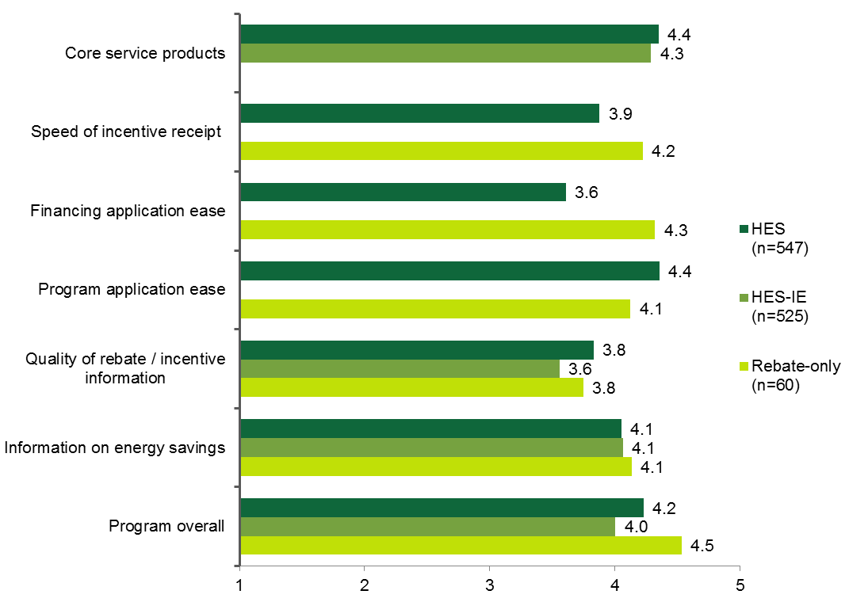
Note: Responses are weighted. Sample sizes vary across topic areas based on relevance.

- Short-term respondents are significantly more satisfied with program information and core services, possibly signaling program improvements or superior recall due to more recent participation.
Short-term respondents were statistically more likely to be highly satisfied with some elements of program participation. In particular, HES short-term respondents were significantly more satisfied than HES long-term respondents with the quality of program information on energy savings (90% versus 73%), on rebates and incentives (80% versus 64%), and with core-service product quality (90% versus 80%). While neither HES-IE group was overwhelmingly satisfied with the quality of program information on rebates and incentives, HES-IE short-term respondents (65%) were significantly more satisfied than long-term respondents (51%) with this element.
Table 18: Participant End-User Survey Respondents – Satisfaction by Survey Timing
(Percentage rating 4 or 5)
Program Element | HES |  | HES-IE
 | Short-term (n=55) | Long-term (n=492) | Short-term (n=125) | Long-term (n=400)
Program overall | 87% | 80% | 75% | 71%
Information on energy savings | 90%* | 73% | 76% | 72%
Quality of rebate/incentive information | 80%* | 64% | 65%* | 51%
Program application ease¹ | 57% | 81% | -- | --
Financing application ease¹ | 75% | 44% | -- | --
Speed of incentive receipt | 60% | 51% | -- | --
Core service products | 90%* | 80% | 82% | 82%
Note: Responses are weighted. Sample sizes vary across topic areas based on relevance.
* Indicates that short-term respondents were significantly more likely than long-term respondents to be satisfied at the 90% confidence level.
¹ While notable differences exist, sample sizes are too small to draw significant conclusions.

- HES end-user participants report strong satisfaction with insulation and other program measures.
As Figure 6 shows, respondents were very satisfied with their program measures (using the same 5-point scale). Across all measures, the weighted average satisfaction rating was 4.2. For nearly all measures, satisfaction was above 4.0.
Figure 6: HES Participant End-User Survey Respondents – Satisfaction with Installed Measures
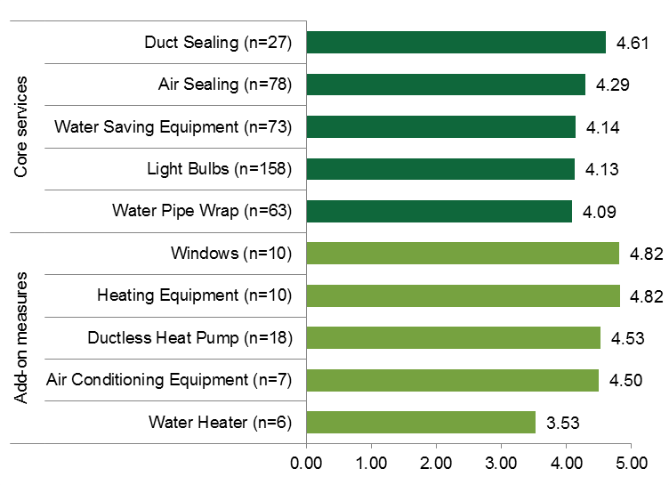
Note: Responses are weighted. Sample sizes are small (particularly for add-on measures) because, in an effort to minimize respondent fatigue, questions regarding measure satisfaction were asked only of individuals who responded to the free ridership module about that particular measure.
HES end-user respondents expressed strong satisfaction with their insulation contractors, when it came to the quality of the installation and the contractor’s cleanliness and punctuality. They also were quite satisfied with the comfort level resulting from the insulation (Figure 7).
Figure 7: Participant End-User Survey Respondents – Satisfaction with Insulation
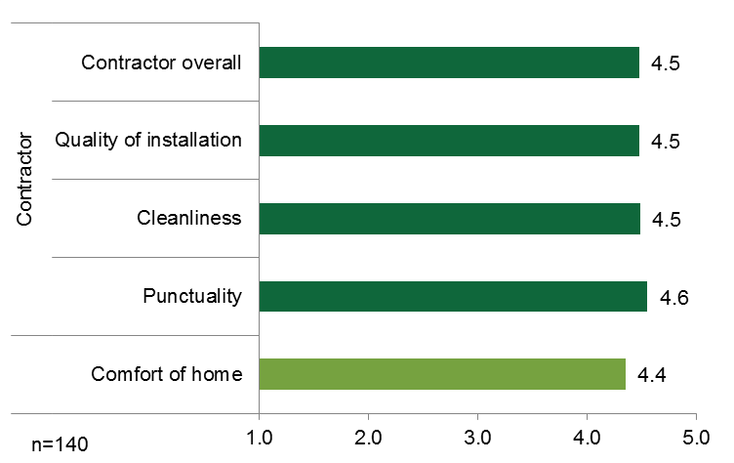

HES-IE Landlord and Property Manager Interviews – Program Satisfaction
- Landlords and property managers are highly satisfied, particularly with vendors, add-ons, and assessment reports.
Interviews asked landlords and property managers to rate their level of satisfaction with various aspects of the HES-IE program on a scale of 1 to 5, where 1 equaled “not at all satisfied” and 5 equaled “very satisfied.” Figure 8 on the next page displays their average ratings and the percentage of interviewees who indicated satisfaction with a rating of 4 or 5. The average satisfaction rating for each aspect of the program was at least 4.0, indicating high levels of program satisfaction.
“I think that [the HES-IE program] is a win-win for everyone: [the utility], the tenant, and the landlord.”
– HES-IE landlord participant
- Overall satisfaction. Landlords and property managers were very satisfied with the program overall: 93% rated it a 4 or 5, making positive statements such as “I’m very happy with the outcome of the program and look to use it again.” On average, they rated the program a 4.4 on a 5-point scale. However, they were not as satisfied with the energy savings that they saw from the program, rating this aspect a 4.0, on average.
- Contractor experiences. Landlords and property managers were also highly satisfied with their interactions with the contractors. All respondents rated this a 4 or 5, with an average of 4.8. Interviewees described the contractors as “easy to work with” and “wonderful.” One interviewee added:
The [vendor staff] were people that I would have considered hiring if they weren’t already working [for another company]. All of the residents had positive feedback about the [technicians] who did the work in the units.
- Quality. Landlords and property managers were very satisfied with the quality of the add-on measures and quite satisfied with the quality of the core services (basically the same measures as offered to single-family participants); 100% rated add-on measure quality 4 or 5, averaging 4.8. The vast majority of interviewees were satisfied with the core services (92%), noting that they did not receive complaints and they have found that tenants are “happy” with the free measures. Interviewees thought the quality of the assessment report was great, finding it “clear,” “comprehensive,” and “quite informative”—95% gave it a rating indicating they were satisfied.
- Information dissemination. While the average satisfaction rating was 4.0 for the information about incentives and financing options—indicating satisfaction—landlords and property managers were least likely to be satisfied with this aspect of the program: 63% assigned a rating of 4 or 5. One interviewee who provided a low rating explained:
I didn’t understand [the incentive and financing opportunities] all too well, so I didn’t take advantage of it. It seemed a little complicated to get involved with.
Figure 8: HES-IE Landlord and Property Manager Interviewees – Program Satisfaction Ratings
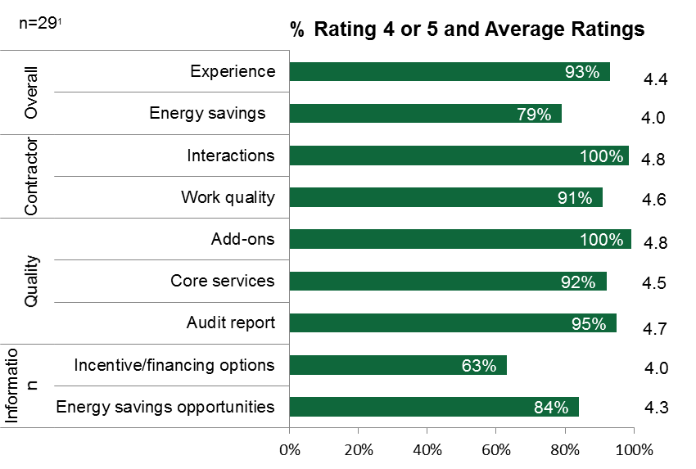
Note: Interviewees rated their level of satisfaction on a scale of 1 to 5, where 1 equaled “not at all satisfied” and 5 equaled “very satisfied.”
¹ Sample sizes vary across categories if topic areas were not applicable.

End-User Data Analysis – Participant Wait Time
Using the Eversource HES participation database (from July 2013 through April 2015), the study estimated the mean and median wait times that participants experienced from the time that they requested a home energy assessment to the date on which they received the assessment. Among HES participants, the average (mean) wait time was 22 days, though the distribution of wait times had a fairly high degree of skew, evidenced by the substantively smaller median wait time of 14 days. In other words, most participants received services rather quickly, but a few had to wait substantially longer. As Table 19 shows, five vendors had average HES participant wait times of one month or more (greater than or equal to 30 days); these five vendors served 3,303 customers, or about 14% of the Eversource core services recipients.
Table 19: HES End-user Average Wait Time between Scheduling and Receiving Assessment, by Vendor
Vendor Name | Records / Projects | Mean Wait Time (Days) | Median Wait Time (Days)
A Plus Installation, LLC | 427 | 35 | 23
Aiello Home Services | 925 | 23 | 13
BCB Conservation Group, LLC | 429 | 18 | 14
Climate Partners, LLC | 154 | 26 | 21
Competitive Resources, Inc. | 1,215 | 30 | 23
EcoSmart by R Pelton Builders, Inc. | 1,905 | 15 | 10
Energy Efficiencies Solutions, LLC | 1,595 | 25 | 19
Energy Resource Group | 720 | 36 | 26
EnergyPRZ, LLC | 1,441 | 21 | 16
Fox Heating Services, Inc. | 322 | 41 | 35
Greenbuilt Connecticut | 192 | 16 | 10
Gulick Building & Development, LLC | 541 | 20 | 14
Handyman Express Energy Solutions LLC | 419 | 41 | 38
Hoffman Fuel | 193 | 24 | 19
Home Doctor of America | 388 | 15 | 4
Lantern Energy, LLC | 1,143 | 20 | 14
Molina & Associates, Inc. | 279 | 21 | 10
New England Conservation Services, LLC | 1,098 | 25 | 19
New England Smart Energy Group, LLC | 1,730 | 21 | 14
Next Step Living, Inc. | 3,548 | 17 | 6
R&W Heating, LLC | 253 | 29 | 25
Santa Fuel, Inc. | 415 | 26 | 15
Tri City Home Energy Services | 371 | 15 | 9
Uplands Construction Group, LLC | 404 | 20 | 16
Victory Industries, LLC | 1,431 | 20 | 7
Wesson Energy, Inc. | 1,356 | 28 | 18
Other Vendors¹ | 75 | 24 | 17
Total | 22,969 | 22 | 14
¹ Vendors with fewer than 100 records have been combined into the “other” category.

Program Awareness
- HES / HES-IE nonparticipant end-users reported strong awareness of the programs.
The majority of rebate-only end-user participants (83%) stated that they were aware of the HES program. Additionally, end-users who had neither participated in the program nor received utility rebates were sometimes aware of the program—either prompted or unprompted (Figure 9). Between both prompted and unprompted responses, low-income nonparticipants were somewhat less aware of the program (75%) than non-low-income (NLI) nonparticipants (85%).
Figure 9: Nonparticipant End-user Survey Respondents – HES / HES-IE Program Awareness
(Percentage of respondents)
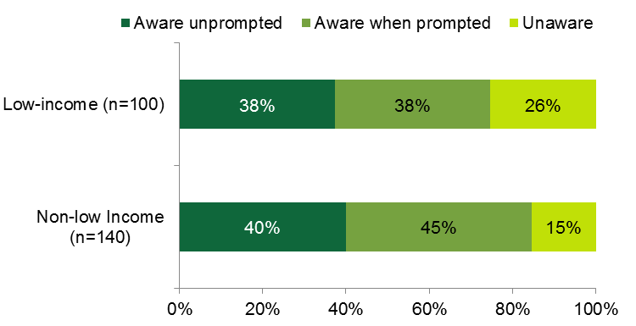

Program Marketing and Outreach

End-User Participant Surveys – Marketing and Outreach
- HES and HES-IE end-user participants most often learned about the program through word of mouth and learned of rebates and incentives through the assessments.
As shown in Figure 10, HES (32%) and HES-IE (23%) end-user participants most frequently reported that they learned about the program from family and friends (i.e., word of mouth). Other commonly cited sources of information about the program include utility advertisements (13% in HES and 10% in HES-IE), Community Action Agencies (CAAs; 12% in HES and 22% in HES-IE), and utility bill inserts or mailings (9% in HES and 14% in HES-IE).
Respondents most often learned about utility rebates and incentives during the energy assessment. (See Appendix A.2.1 for more details.)
Figure 10: Participant End-user Survey Respondents – Channels of Program Awareness
(Percentage of respondents)
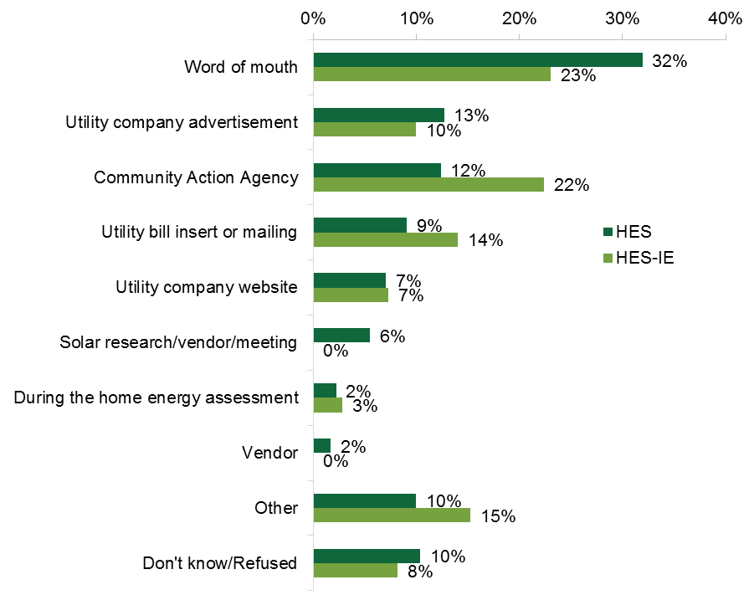
Note: Percentages are weighted.

End-user Nonparticipant Surveys – Marketing and Outreach
- Nonparticipant end-users learned of the program through word of mouth, bill inserts, and other utility advertisements.
Low-income (38%) and NLI (30%) nonparticipant end-user respondents most often learned of HES/HES-IE through word of mouth (Figure 11). Compared to other channels, low-income respondents were next most likely to have learned of the program through bill inserts (23%) and NLI respondents through utility advertisements (19%).
Figure 11: Nonparticipant End-user Survey Respondents – Channels of Program Awareness
(Percentage of respondents)
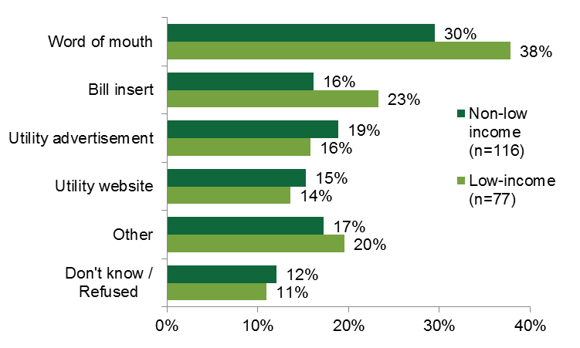

HES-IE Landlord and Property Manager Interviews – Marketing and Outreach
- Utility outreach to landlords and property managers is the most common program entry point.
HES-IE landlord and property manager interviewees were most likely to enter the program after being contacted by the utility company (Figure 12). Over one-third (eleven) of the 30 interviewees originally became involved with the program after the utility contacted them or other staff members at their company. The next most common channels were the landlord/management staff contacting the utility (eight) and a third-party vendor or contractor, such as HES-IE program vendors or insulation contractors, soliciting the landlord or property manager (seven).
Figure 12: HES-IE Landlord and Property Manager Interviewees – Channels to Participation
(Count of responses)
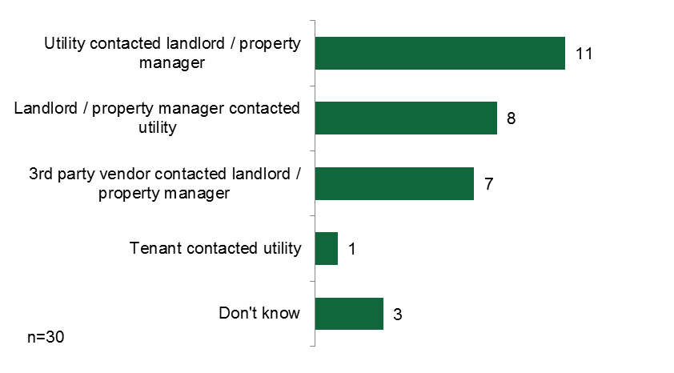

Program Participation Drivers and Barriers

End-User Participant and Nonparticipant Surveys – Drivers and Barriers
- End-user participants are driven to participate in order to identify ways to save money on energy costs and learn about energy saving opportunities.
When asked why they signed up for the assessment, HES and HES-IE end-user participants primarily indicated a desire to identify ways to save the most money (30% of HES and 33% of HES-IE participants) and to learn about energy-saving opportunities (28% of HES and 32% of HES-IE participants). Notable proportions of HES (13%) and HES-IE (17%) end-users also reported that they participated because they wanted to find ways to make their homes more comfortable. Respondents who participated because they wanted to see if they were eligible for an incentive or rebate often were interested in windows and insulation.
Figure 13: HES / HES-IE End-User Participant Survey Respondents – Motivations to Participate
(Multiple responses; percentage of respondents)
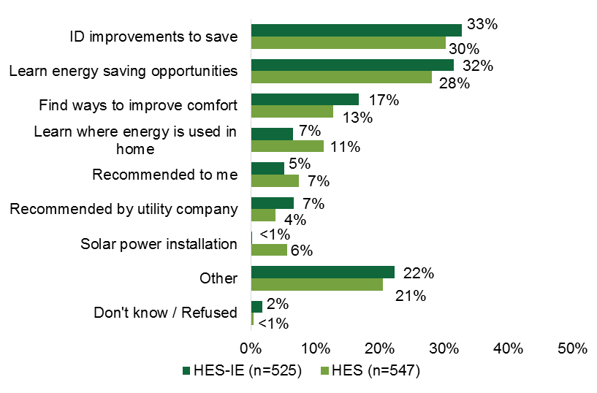
- Nonparticipant end-users do not participate because they have not made energy efficiency a priority, do not see a need, or find the cost to be prohibitive.
As illustrated in Figure 14, NLI nonparticipant respondents most often did not participate because they “had not gotten around to it” (27%) or felt that it was unnecessary (20%). Low-income nonparticipants were held back because they found it to be too expensive (24%) or they did not think it was necessary (19%).
Figure 14: Nonparticipant End-user Survey Respondents – Reasons for Nonparticipation
(Percentage of respondents)
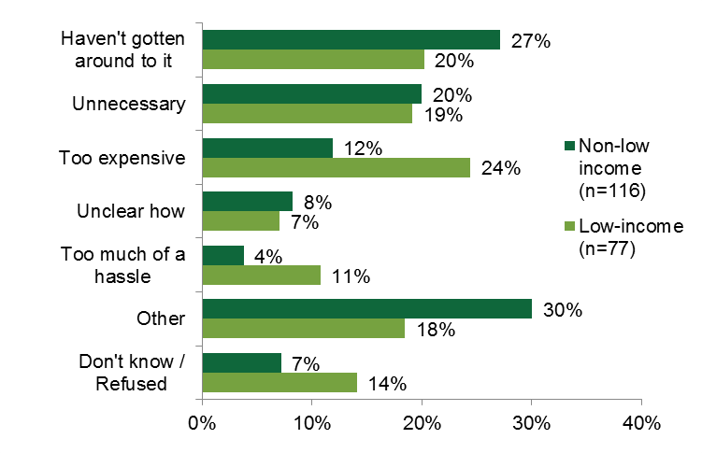

HES-IE Landlord and Property Manager Interviews – Drivers and Barriers
- Reducing energy bills is a top driver of landlord/property manager participation.
HES-IE landlord and property manager interviewees most commonly participated in the program out of a desire to reduce energy bills for their tenants (eight interviewees), themselves (five), or in general (six). The next most common reason was to save energy (eight), followed by the minimal cost to participate in the program (four). Interviewees were also motivated to participate in an effort to develop goodwill with tenants, receive upgrades that they found appealing, create room in their budgets to make other non-energy upgrades, and to install what they believed to be specific and necessary program measures such as insulation or lighting equipment (Figure 15).
Figure 15: HES-IE Landlord and Property Manager Interviewees – Motivations to Participate
(Multiple responses; count of responses)
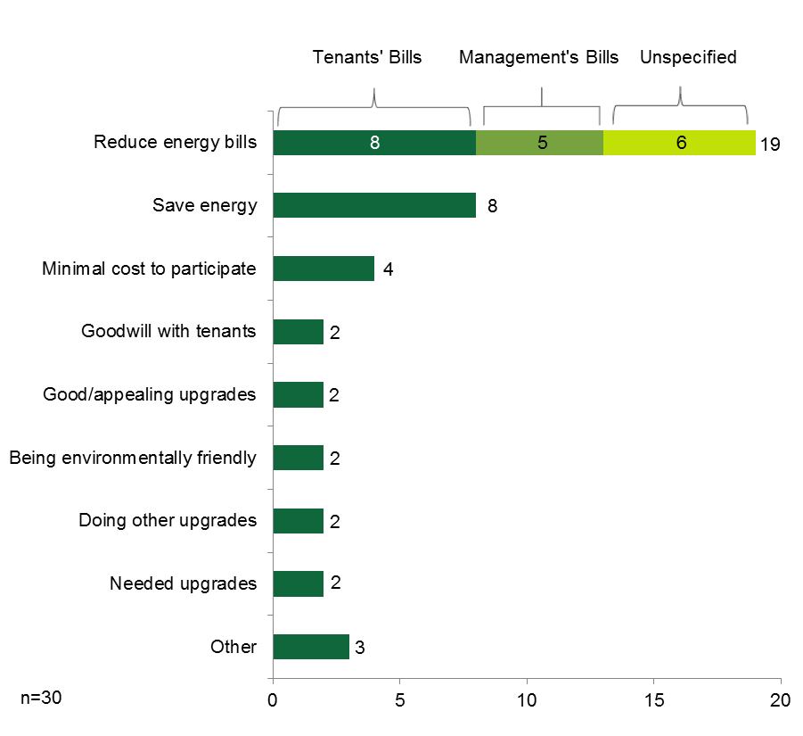
As mentioned above, landlords and property managers were driven to participate in the HES-IE program to reduce energy bills and save energy. Interviews asked them to rate the importance of the anticipated savings in their buildings’ energy bills and their tenants’ energy bills on their decision to participate. On a scale of 1 to 5, where 1 means “not at all important” and 5 means “very important,” they gave an average importance rating of 4.45 for their own energy bills (n=28) and 4.50 for their tenants’ energy bills (n=23). After rating the importance of reducing tenants’ bills as a 5.0, one property manager explained the rationale behind it:
I mean, it is low-income housing and some people struggle, especially in the winter with the electric heat. So the more reasonable [tenants’ living] costs are, the higher the likelihood of us receiving our rent is.

- Landlords and property managers had few obstacles to participation, only mentioning issues with timing, quality, and communication.
As illustrated in Figure 16, only one-third of the HES-IE landlord and property manager interviewees (ten) identified difficulties or challenges during their involvement in the program.
- Time span. Most often, they found that the entire process took longer than expected. Four said it took months to schedule installations or that the project lasted for more than one year.
- Measure quality. Only three interviewees were less than 100% satisfied; these three voiced concerns that the new light bulbs were not bright enough or were expensive to replace, that there was “sloppy” contractor work, and that tenants complained that they did not visually observe major improvements.
- Communications. Three interviewees expressed frustration with program communications, including unreturned phone calls and emails to a program contact, discontinuity in communication following the retirement of a program staff member, and a lack of communication with the contractor about important details of the work. That said, one interviewee made a point to comment on the positive communication with the program staff and vendors, saying, “The people I’ve worked with have been excellent.”
Figure 16: HES-IE Property Manager and Landlord Interviewees – Participation Challenges
(Multiple responses; count of responses)
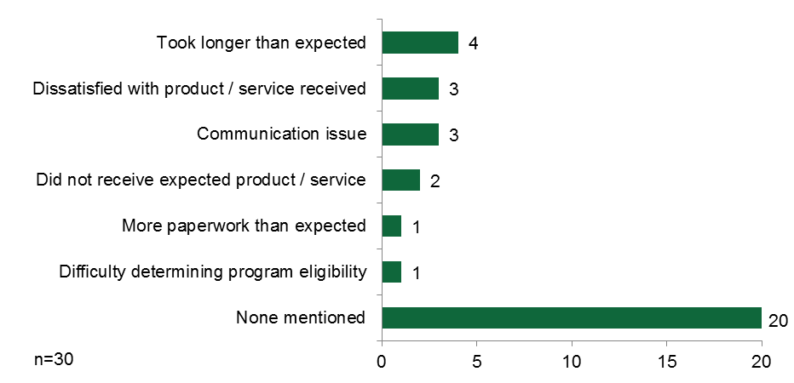

Energy Savings Experiences
- End-user participants self-report reductions in energy consumption.
Home energy assessment programs such as Connecticut HES/HES-IE programs are generally expected to save between 10% and 15% of household energy usage. While entirely self-reported, HES respondents estimated a 10% decrease and HES-IE respondents estimated a 9% decrease, on average. Over one-fifth of HES and HES-IE respondents did not know how or if their energy consumption had changed since participating; however, the majority of those who were familiar with their consumption saw a decrease. As illustrated in Figure 17, over one-half of all HES respondents saw a decrease (54%), and about two-fifths of all HES-IE respondents saw a decrease (43%). Rebate-only respondents were less familiar with their consumption, but those who were familiar estimated that, on average, their consumption had decreased by 22%.
Figure 17: End-user Participant Survey Respondents – Changes in Energy Consumption following Program Participation
(Percentage of respondents and mean change)

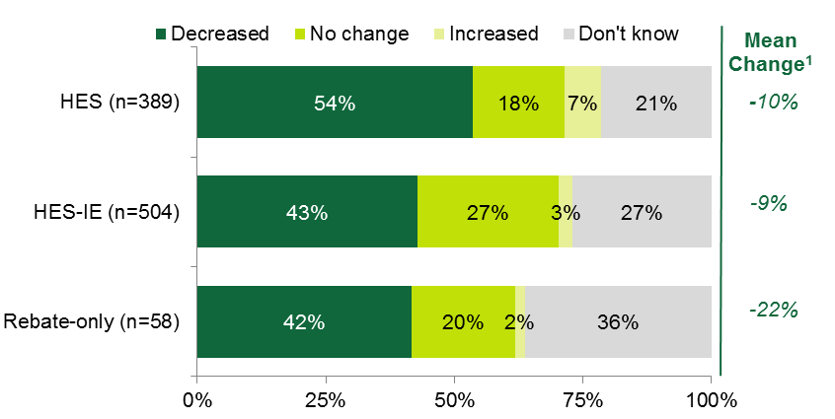
Note: Values are weighted.
¹ Denotes the average change that respondents reported seeing in their energy usage following program participation; excludes values more than three standard deviations from the mean.

Energy Savings Expectations
- Landlords voiced mixed perceptions of the accuracy of energy savings estimates.
Ten of the 29 landlords and property managers initially thought that the vendors’ estimates of the possible savings that they could reap from making energy efficiency upgrades through the program (prior to the upgrades being performed) would be accurate (four) or “pretty” accurate (six), and nine interviewees thought that they were inaccurate. Those interviewees who thought that the estimates were inaccurate generally thought the vendors overestimated savings (six of nine); for the most part, they thought that, prior to the upgrades being performed, the actual savings would have been between 15% and 30% lower than what the vendor was suggesting at the time. The three who thought the savings would be higher estimated that they would be between 15% and 23% higher.
Figure 18: HES-IE Landlord and Property Manager Interviewees – Initial Perceptions of Vendors’ Energy Savings Estimates
(Percentage of respondents)
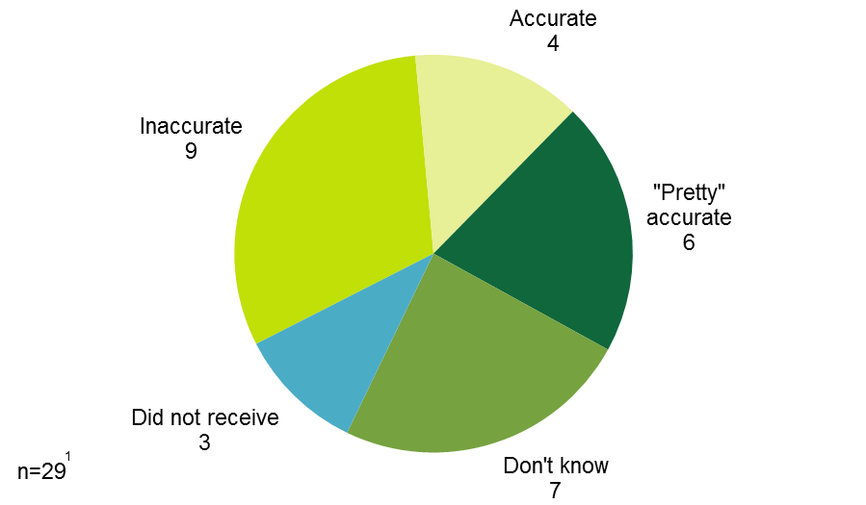
Note: The telephone interview guide asked interviewees, “At the time that the utility gave you an estimate of the expected savings on your overall building energy bill, how accurate did you think that estimate was?”
¹ The in-person interview guide did not ask this question; as such, only 29 interviewees answered this question.

Participant Suggestions for Improvement

End-User Participant Surveys – Suggestions for Improvement
- End-users have had good experiences with the program, but suggest improving program information sharing and advertising, improving work quality, and expanding offerings.
When asked for program feedback, HES (10%) and HES-IE (34%) respondents were most likely to report that, in fact, they had good experiences with program. HES-IE respondents were most likely to suggest that the quality and completeness of work be improved (15%) and to expand program offerings to include additional measures (12%).
Respondents offered other suggestions, that—broadly speaking—encouraged expanding and clarifying program information, sharing more information (including advertising), and expanding program offerings.
Table 20: End-user Participant Survey Respondents – Suggestions for Program Improvement
(Multiple response; percentage of respondents)
Feedback | HES (n=114) | HES-IE (n=125) | Rebate-only (n=60)
Improve / increase information about topic
Advertise | 8% | 5% | 5%
Structure of rebates and program | 4% | 4% | 14%
Energy savings / usage | 3% | 2% | 3%
Financing | 1% | - | -
Timing of work | - | 3% | -
Fuel conversion | - | - | 2%
Program process feedback / suggestions
Good experience | 10% | 34% | 10%
Make the process faster | < 1% | 3% | 3%
Perform follow-up visits | - | 1% | -
Provide vendors with IDs | - | < 1% | -
Program structure suggestions
Expand program measure offerings | 7% | 12% | 2%
Increase rebate amounts | 1% | 2% | 5%
Expand eligibility requirements | < 1% | 2% | -
Keep rebates the same | - | - | 5%
Work quality feedback / suggestions
Use better quality products | 3% | 2% | -
Work was inadequate / incomplete | 1% | 15% | -
Vendor damaged property | 1% | 2% | -
Note: Percentages are weighted. Sample sizes are small because this question was asked of short-term respondents only.

HES-IE Landlord and Property Manager Interviews – Suggestions for Improvement
- Landlord suggestions include better communication, increased incentive amounts, and improved quality of core-services products.
HES-IE landlords and property managers had few complaints and, as a result, few suggestions for program improvement. Six of the fifteen landlord and property manager interviewees who offered suggestions to improve the program recommended improving the HES-IE program communications (Figure 19). In particular, they suggested that the utilities undertake the following activities:
- Create a single contact for all program-related communications.
- Clearly convey what to expect from the contractors.
- Communicate more clearly about timelines up front.
- Emphasize possible costs and savings associated with program improvements during the solicitation process to increase participation rates.
- Carry out more direct communication as opposed to relying on third-party contractors.
The interviewee who suggested increasing the direct communication desired more confirmation of the legitimacy of the vendors’ recommendations, stating:
We were contacted [initially] by the contractor, and you just wonder whether the contractor is trying to sell you something that you really don’t need.
Other interviewees suggested the following:
- Increase financial incentives for windows (four), exterior lighting equipment, and refrigerators.
- Improve the quality of core-services (four), including additional air sealing in residential units, using caulking in place of foam for very small air-sealing jobs, using brighter light bulbs, and using LEDs instead of CFLs.
- Add products and services to the program (three), such as door sweeps (which are already installed where needed), kitchen stoves, and incentives for renewable energy measures.
Figure 19: HES-IE Landlord and Property Manager Interviewees –Suggestions for Program Improvement
(Multiple responses; count of responses)
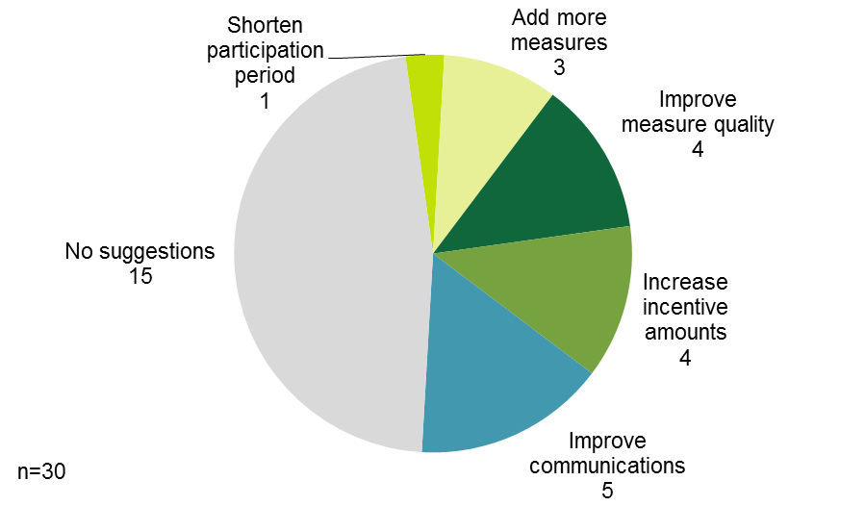

Benchmarking – Program Processes
- Awareness among nonparticipants is high compared to other programs; satisfaction is about average, but better when it comes to satisfaction with core services and lower when it comes to quality of information.
This study involves a benchmarking task in which its results are compared to other studies that assess similar NLI home energy assessment programs in the Northeast. Table 21 benchmarks some of the R4 process findings against other studies:
- Awareness. When it came to nonparticipant awareness, Connecticut customers were significantly more aware of the HES program than were New York customers of the Green Jobs – Green New York (GJGNY) Home Performance with ENERGY STAR® (HPwES) program. The share of Connecticut rebate-only participants who were aware of the HES program was exactly the same as the percentage of their counterparts in Massachusetts were of its Home Energy Services (HES) program.
- Satisfaction. Connecticut HES participants are generally as satisfied with HES as participants in New York, Efficiency Vermont (EVT) and Vermont Gas System (VGS), Efficiency Maine (ME), and Massachusetts HES are with their programs. Connecticut HES participants were more likely to be satisfied with the quality of the core services they received than were Massachusetts HES participants with theirs (although it should be noted that the number and type of core services could vary across the programs). Connecticut HES participants, however, were notably less likely than Efficiency Maine participants to be satisfied with the information that they received from the program about energy savings or rebates and incentives.
Table 21: Program Process Results – Benchmarking
Benchmarking Parameter | Comparison Program |  | Connecticut HES Value | Notes / Considerations
 | Program | Value
Awareness
Percentage of nonparticipants aware of program (prompted) | Green Jobs – Green New York (GJGNY)¹ | 36% | 81% | NY HPwES program structure is not perfectly comparable to the CT HES program structure; however, both involve home energy assessments that make recommendations for deeper measures.
Percentage of rebate-only participants aware of HES | Massachusetts Home Energy Services (MA HES)² | 83% | 83% | The CT rebate-only users represented respondents with numerous measure types; the MA study was limited to respondents receiving particular HVAC incentives.
Percentage of Participants Satisfied (ratings of 4 or 5 on a 5-point scale)
Program overall | Vermont Public Service Department (VT PSD)³ | 90% and 88% | 80% | Also uses a 5-point scale; Efficiency VT (90%) and VT Gas Systems (88%) had slightly different results.
 | Efficiency Maine (ME)⁴ | 86% |  | Efficiency ME uses a 10-point scale; the study considers ratings of 7-10 as satisfied.
 | GJGNY | 82% |  | Both use 5-point scales.
 | MA HES | 75% |  | MA uses a 4-point scale; the study considers ratings of 3 and 4 as satisfied.
Quality of core-service measures | MA HES | 77% and 74% | 80% | MA weatherization measures (77%) and portable measures (74%) received slightly different ratings.
Quality of information in assessment report | Efficiency ME | 86% | 65% and 74% | This CT study obtained values for information about energy savings (65%) and information about rebates and incentives (74%).
Ease of filling out program application | GJGNY | 86% | 79% | -
Quality of work | Efficiency ME | 83% | 86% | Efficiency ME and GJGNY percentages represent the percentages satisfied with the work generally, but this CT study only assessed quality of work for insulation.
 | VT PSD | 90% and 75%
Installation contractor | GJGNY | 93% | 85% | GJGNY percentage represents the percentage satisfied with installation contractors for numerous measures, but this CT study only assessed quality of work for insulation.
¹ NMR. Process Evaluation and Market Characterization and Assessment: Green Jobs – Green New York Residential Program. September 2012.
² Cadmus. Massachusetts Home Energy Services Initiative and HEAT Loan Delivery Assessment. July 31, 2015. http://ma-eeac.org/wordpress/wp-content/uploads/HES-and-HEAT-Loan-Program-Assessment-Final-Report.pdf.
³ GDS Associates, Inc. and Research into Action. Vermont Single-Family Retrofit Market Process Evaluation. February 20, 2013.
⁴ Opinion Dynamics and Dunsky Energy Consulting. Evaluation of the Efficiency Maine Trust PACE, Power Saver, and RDI Programs. Final Evaluation Report. Volume II: Residential Direct Install Program. October 23, 2013. http://www.efficiencymaine.com/docs/RDI-Final-Evaluation-Report-FINAL.pdf.

Decision-Making and Financing (R46) Findings
3
The number and nature of energy conservation financing options available to single-family homeowners and multifamily landlords and property managers in Connecticut has increased over the past few years. At the same time, the Companies still offer their customers numerous downstream rebates for energy efficiency upgrades. The R46 study, which leveraged evaluation resources with R4 and R31, assessed decision making and financing through the use of CATI surveys with nonparticipants. Collectively R4, R31, and R46 explored issues of awareness of, opinions about, and use of financing and rebates with participants, nonparticipants, landlords, property managers, and vendors. The main findings are as follows:
- High awareness. Respondents reported relatively high awareness of rebates and financing. Nonparticipant awareness of financing was high compared to similar programs.
- Preference for rebates. HES participants prefer rebates to financing, although the two in combination are appealing to many participants (73%).
- Attraction to zero percent financing and aversion to debt. While participants find zero percent financing and on-bill repayment attractive, they still seem averse to taking on debt, especially if they feel they can pay for the upgrades without a loan.
- Ideal rebate level. Although rebates influence measure uptake, participants would prefer that rebates cover roughly one-half of the project costs.
- Vendor follow-up. Vendor follow-up may be linked to insulation installation.
- Legal language. Legal terminology of financing materials confuses some participants.

End-User Participant Surveys – Decision Making and Financing
The CATI surveys completed as part of the R4 and R31 studies asked HES end-user respondents to assess their decision making regarding additional upgrades performed or installed based on vendor recommendations. The surveys also explored decision making about financing and rebates.

Motivations for and Barriers to Making Additional Improvements
- Vendors provide deeper measure recommendations to the majority of HES end-users, but this does not correlate with follow-through with add-on measure installation.
Overall, three-fourths of all HES end-user respondents (75%) reported that the vendor sat down with them and discussed additional improvements that they could make. It does not appear that having a discussion with the vendor impacted respondents’ likelihood to install add-on measures, given that 75% who had only core measures installed had recalled having a discussion with the vendor, and 73% of those who had insulation installed and 73% of those who had Tier II measures installed recalled having a discussion with the vendor (Figure 20).
Figure 20: HES End-user Participant Survey Respondents – Vendor Discussions about Improvements
(Base = all HES respondents)
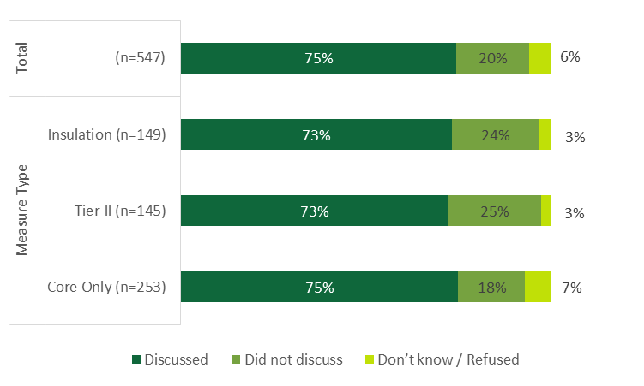
Note: Percentages are weighted.
Slightly more than one-half of HES respondents who had discussions with the vendors installed either all or some of the improvements that the vendor recommended (52%). Short-term survey respondents (87%) were significantly more likely than other respondents (51%) to have made some of the improvements that the vendor recommended (Figure 21). This association may be related to improvements in vendors’ sales strategies over time as they figure out how to most effectively encourage participants to make additional improvements. It could also reflect increased efforts by the vendors and Companies to follow up with participants after the assessment to encourage deeper-measure uptake. Both of these possible explanations are speculative, however.
Figure 21: HES End-user Participant Survey Respondents – Additional Improvements Made
(Base = respondents who vendor discussed additional improvements with)
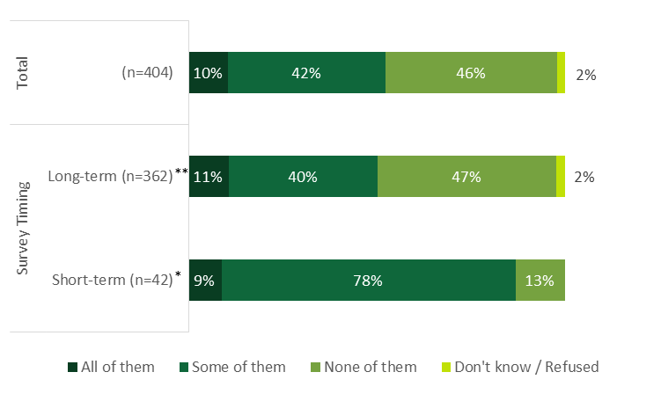
Note: Percentages are weighted.
* Indicates that short-term respondents were significantly more likely to install all additional improvements than long-term respondents at the 90% confidence level.
**Indicates that long-term respondents were significantly more likely to install no improvements than short-term respondents at the 90% confidence level.

- Upfront cost and potential energy savings are pivotal factors in HES end-users’ decision to install add-on measures.
As shown in Table 22, “partial installers” (those who had installed only some of the recommended measures) most often chose the improvements that they made by selecting those that were the least expensive (37%) and that would save the most energy and provide the most utility bill savings (32%). This was similar when improvements were compared by measure type, with the exception that core-only HES respondents were more likely than others to make their selection by choosing the least expensive option (40%). Core-only respondents were also significantly more likely (25%) than those who installed insulation (10%) to base their decision on what was easiest to install. Respondents who installed insulation were more likely than others to make their decisions based on what would provide them with the greatest energy or utility bill savings (41%).
Table 22: HES End-user Participant Survey Respondents – Add-on Measure Decision-Making Factors^{1, 2}
(Multiple responses, base = partial installers only)
Improvement Selection Reasoning | Measure Type |  |  | Total (n=204)
 | Core Only (n=65) | Tier II (n=68) | Insulation (n=71)
Least expensive | 40% | 31% | 34% | 37%
Biggest energy/utility bill savers | 28% | 32% | 41% | 32%
Easiest to install | 25%* | 16% | 10% | 20%
Note: Percentages are weighted.
* Indicates that core-only respondents were significantly more likely to make decisions based on what was easiest to install than Insulation respondents at the 90% confidence level.
¹ This table provides the most common response categories only. See Appendix A.3.1 for the full table.
² Respondents to this question are considered “partial installers” (those who have installed only some of the recommended measures).
As illustrated in Figure 22, over three-fifths of “non-installers” (those who have not installed any of the additional vendor-recommended improvements; 61%) who did not make any additional improvements recommended by the vendor explained that they had not done so because the improvements were too expensive. Some also did not make the improvements because they did not think they were necessary (21%). Nearly one-half of those who did not make any additional improvements plan to install some (41%) or all (5%) of the improvements within the next year (illustrated in Appendix A.3.1).
Figure 22: HES End-user Participant Survey Respondents – Barriers to Making Additional Upgrades
(Multiple responses, base = non-installers only)
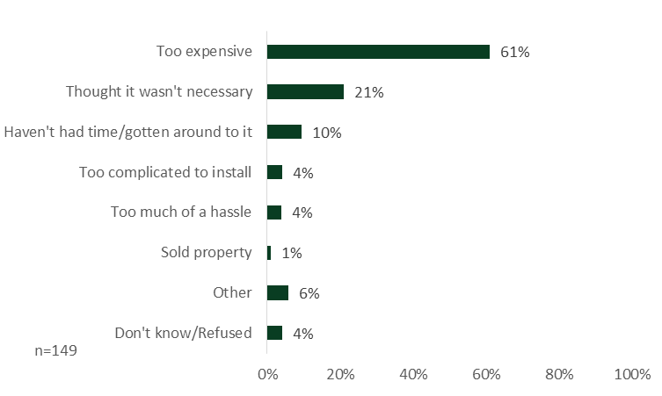
Note: Percentages are weighted.
HES respondents who installed some (partial installers) or all (full installers) of the vendor-recommended improvements were most often driven to make these improvements to save money on their energy bills (57%) and to save energy generally (32%). As shown in Table 23, those who installed core-only measures were significantly more likely (63%) to be motivated to save money on their energy bills, those who installed insulation were significantly more likely to also be driven by a desire to be “green” or help the environment (11%), and those who made other Tier II improvements were significantly more likely than others to also report comfort as a motivator (16%).
Table 23: HES End-user Participant Survey Respondents – Motivations to Make Additional Improvements¹
(Multiple responses, base = both partial installers and full installers)
Reasons for Making Improvements | Measure Type |  |  | Total (n=249)
 | Core Only (n=81) | Tier II (n=74) | Insulation (n=94)
Save money on energy bill | 63%* | 41% | 49% | 57%
Save energy | 33% | 33% | 30% | 32%
Comfort | 6%* | 16%** | 1% | 6%
Be “green” / help environment | 1% | 5% | 11%*** | 4%
Note: Percentages are weighted.
* Indicates statistically significant difference from Tier II and Insulation respondents at the 90% confidence level.
** Indicates statistically significant difference from Insulation respondents at the 90% confidence level.
*** Indicates statistically significant difference from core-only respondents at the 90% confidence level.
¹ This table provides the most common response categories only. See Appendix A.3.1 for the full table.

Financing
- HES end-users have fairly high levels of financing awareness; short-term survey respondents more often recall financing recommendations provided to them by their contractor and are more aware of financing options in general, likely as a result of survey timing.
Slightly less than one-half of all HES respondents (49%) recalled that the vendor who completed the home energy assessment talked to them about program-related financing options, such as zero percent loans or on-bill repayments, to help with the financing of any of the additional improvements (Figure 23). Some interesting differences occurred across respondent types:
- Survey timing. Short-term survey respondents were somewhat more likely to recall being told about financing options (57%) than the long-term survey respondents (49%). This increased recall may be due to these respondents having participated more recently, perhaps because vendors are more consistently discussing options with participants (vendors do say they bring it up with almost every participant, as discussed below), or possibly due to the expansion of financing options offered and the efforts to promote them.
- Measure type. Similarly, when compared by measure type, HES respondents who had insulation installed were significantly more likely to recall being told about financing options (59%) than those who had only core measures installed (48%) or Tier II measures installed (43%), which may be attributed to the significant amount of financing offered for insulation.
Figure 23: HES End-user Participant Survey Respondents – Whether or Not Financing was Recommended by Vendor
(Base = all HES respondents)
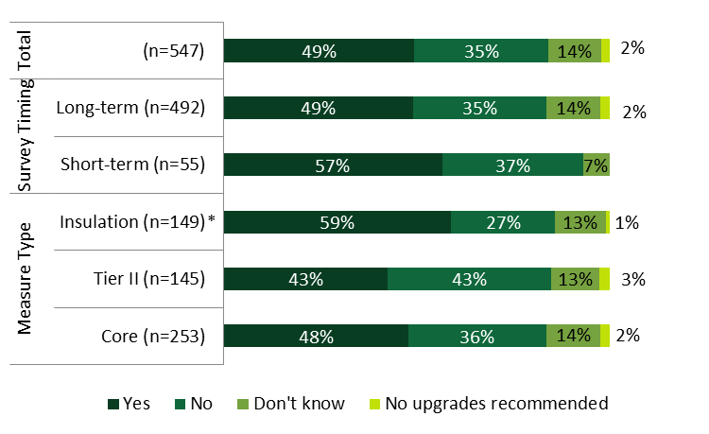
Note: Percentages are weighted.
* Indicates that respondents installing insulation were significantly more likely to be told about financing options than core-only and Tier II respondents at the 90% confidence level.

Three-fifths of all HES survey respondents (60%) were either somewhat aware or very aware of financing options—such as zero- or low-interest financing, on-bill financing, or other loan options—available to them through the program (Figure 24). Short-term survey respondents were more likely to be very aware or somewhat aware of program financing options (66%) than other survey respondents (60%). This likely stems from the fact that they are more likely to recall the conversations with their vendor, as mentioned above.
Figure 24: HES End-user Participant Survey Respondents – Awareness of HES Financing Options
(Base = all HES respondents)
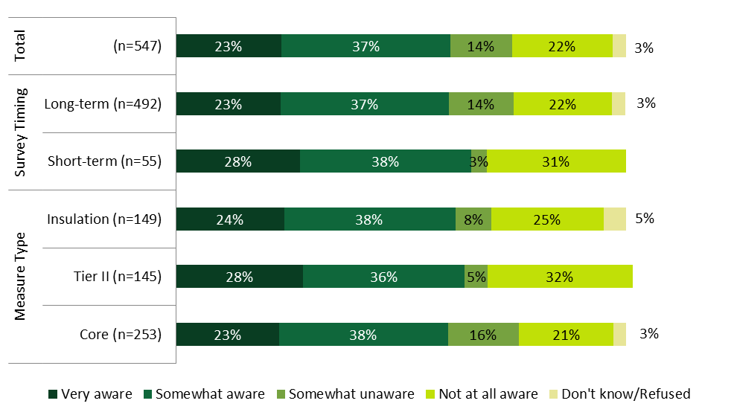Note: Percentages are weighted.
- HES end-users overwhelmingly found the program financing information that the vendors shared to be helpful.
As shown in Figure 25, the vast majority of HES respondents whose vendor told them about program financing options (90%) found the information to be very helpful or somewhat helpful. When compared by measure type, a smaller percentage of core-only respondents found the information provided to be very helpful (41%) compared to those who installed insulation (52%) or Tier II measures (53%).
Figure 25: HES End-user Participant Survey Respondents – Helpfulness of Vendor-Provided Financing Information
(Base = respondents whom vendor discussed financing with)
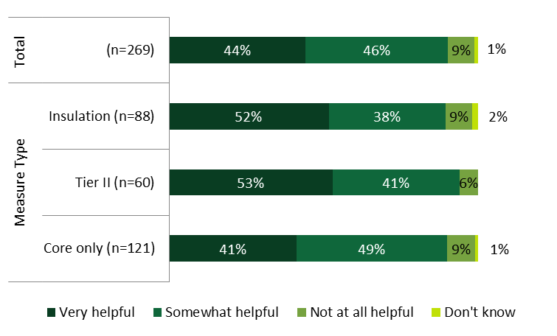 Note: Percentages are weighted.
- The few HES end-users who have or will use financing most often use the zero percent loans offered by the Connecticut Housing Investment Fund (CHIF) or the Energize Connecticut Heating Loan; the zero percent loan program is most attractive to non-users.
As illustrated in Figure 26, only 13% of respondents who are aware of program financing opportunities have or plan to use these options. When compared by measure type, core-only installers were less likely to have used or plan to use financing for upgrades (11%) than those who installed insulation (20%) or made Tier II improvements (21%). Respondents most commonly reported that they had or will use financing for insulation (51%) and heating equipment improvements (33%); Appendix A.3.1 illustrates the full list of measures for which they had or will use financing.
Figure 26: HES End-user Participant Survey Respondents – Have Used or Plan to Apply for Financing Options
(Base = HES respondents aware of financing)

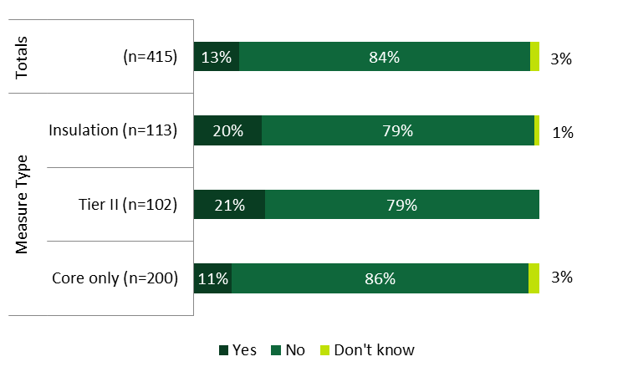
Note: Percentages are weighted.
As shown in Table 24, the most common financing options that partial or full installers have plans to apply for or have already used to make energy improvements include the Residential Energy Efficiency Financing, which most respondents referred to simply as the zero percent loan or CHIF loan (35%). Others also named the Energize Connecticut heating loan (21%). When compared by measure type, those who installed insulation were more likely to choose zero percent payment plans (n=7) than those who installed other improvements.
Table 24: HES End-user Participant Survey Respondents – Financing Options Selected
(Multiple responses, base = partial or full installers using or planning to use financing)
Financing Options | Measure Type (Count of respondents) |  |  | Total (n=43)
 | Core Only (n=14) | Tier II (n=12) | Insulation (n=17)
Zero-percent loans, CHIF, Residential Energy Efficiency Financing | 4 | 5 | 8 | 35%
Energize Connecticut heating loan | 2 | 3 | 3 | 21%
Smart-E loan | 2 | 0 | 0 | 9%
Other | 0 | 1 | 2 | 4%
Don't know/Refused | 6 | 3 | 4 | 36%
Note: The measure type columns provide unweighted counts, and the total column provides weighted percentages. R31 survey participants were not asked this question because the survey was already in the field before the question was added to the R4 participant survey.
Close to one-half (48%) of non-installers speculated that they would be likely to select zero or low-interest financing if they were to decide to make the vendor-recommended improvements, and over two-fifths (44%) would not use any of the options available to them regardless.
- HES end-users often do not need financing programs because they already have sufficient funds.
Having sufficient funds (44%) is the most commonly reported reason HES respondents who have installed all or some of the recommended improvements provided for not using program financing to make additional improvements (Table 25). Second most commonly, they were not interested in pursuing program financing because they did not want to incur debt (12%). When compared by measure type, fewer core-only installers (41%) than Tier II (51%) or insulation installers (50%) did not use the financing options because they already had sufficient funds.
Table 25: HES End-user Participant Survey Respondents – Reasons for Not Using Financing Options¹
(Multiple responses, base = partial or full installers not applying for financing)
Reasons for Not Using Financing | Measure Type |  |  | Total (n=158)
 | Core Only (n=61) | Tier II (n=41) | Insulation (n=56)
Have sufficient funds | 41% | 51% | 50% | 44%
Do not want debt | 10% | 13% | 16% | 12%
Did not have enough for upfront cost anyhow | 8% | 6% | 5% | 7%
Did not want to make the improvements anyway | 18% | 13% | 7% | 15%
Note: Percentages are weighted.
¹ This table provides the most common response categories only. See Appendix A.3.1 for the full table.

- Program financing is not an important factor in HES end-users’ decision to move forward.
As depicted in Figure 27, using a 5-point scale, HES respondents who have installed all or some of the recommended improvements did not think that financing options were very important in their decision to install those improvements (mean of 2.4). When compared across time periods, those who had the assessment performed within the shorter term rated financing as somewhat more important (mean of 2.8) than those who had the survey conducted at a later time (mean of 2.4). Note that, given the small sample size of the short-term respondents, it is difficult to draw a statistically significant conclusion, but results are still likely to be indicative of the increase in importance that financing held in the program during the late 2014 and early 2015 time period.
Figure 27: HES End-user Participant Survey Respondents – Importance of Financing Options¹
(Mean Rating, base = partial and full installers)
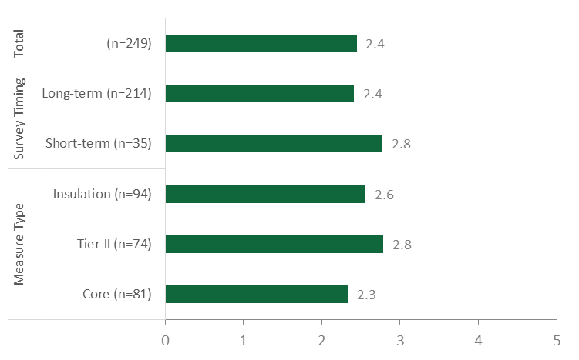
Note: Percentages are weighted.
¹ Rated on a scale from 1 to 5 where 1 equals “Not at all important” and 5 equals “Very important.”

Rebates and Incentives
- Vendors tell the majority of HES end-users, especially insulation installers, about program rebate and incentive opportunities.
As shown in Figure 28, more than three-fifths (69%) of all HES respondents recalled being told about rebate or incentive options by the vendor. When compared by measure type, those who installed insulation were significantly more likely to recall being told about rebates or incentives (87%) than Tier II (76%), or core-only respondents (64%). This difference is not surprising given that vendors have observed a great deal of enthusiasm among end-users about the size of insulation rebates (Section 3.5.2); it may mean that vendors are more often recommending them or that the size of the insulation rebates has more of a resounding impact on participants’ memories.
Figure 28: HES End-user Participant Survey Respondents – Whether Vendor Recommended Rebates and Incentives
(Base = all HES respondents)
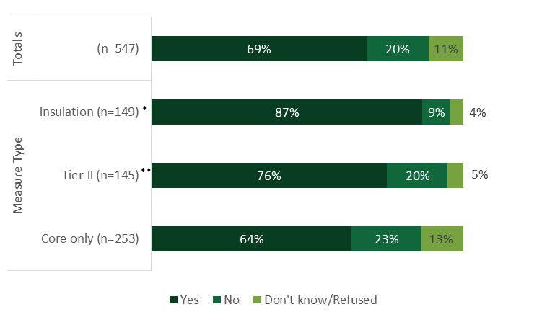
Note: Percentages are weighted.
* Indicates that respondents installing insulation were significantly more likely to have been told about rebates and incentives than core-only and Tier II respondents at the 90% confidence level.
** Indicates that respondents installing Tier II upgrades were significantly more likely to have been told about rebates and incentives than core-only respondents at the 90% confidence level.

Close to one-third of all HES respondents (31%) plan to use or have used rebates and incentives for the recommended improvements (Figure 29). Most often, they planned to use or have used them for insulation (53%) and heating equipment (19%; Appendix A.3.1). When compared by time period, short-term survey respondents were significantly more likely than long-term respondents to be planning to apply or to have applied for rebates or incentives (57% compared to 29%).
Figure 29: HES End-user Participant Survey Respondents – Have Used or Plan to Apply for Program Rebates or Incentives
(Base = all HES respondents)
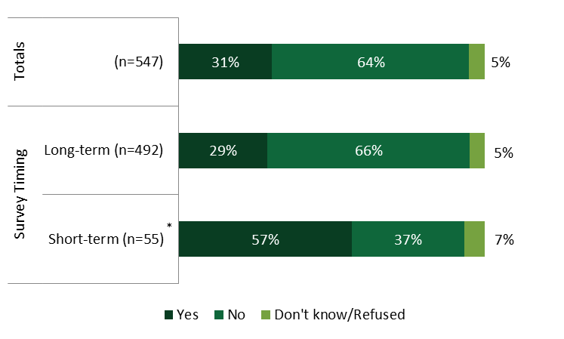
Note: Percentages are weighted.
* Indicates that short-term respondents were significantly more likely than long-term respondents to have used or to have plans to use rebates and incentives at the 90% confidence level.

- Some HES end-users choose not to use rebates and incentives because they already have sufficient funds or, in contrast, the rebates are still not enough to help them cover upfront costs.
As indicated in Table 26, the most common reason provided by HES respondents who have not or will not apply for rebates or incentives for the additional improvements is that they already have sufficient funds (15%). In contrast, the second most common reason provided is that they still would not have enough funds to pay for the upfront cost of the upgrades (11%). When compared by time period, short-term survey respondents were more likely to report not needing the rebates or incentives (26%) than other respondents (14%). Long-term respondents were more likely to not want to make upgrades anyhow.
Table 26: HES End-user Participant Survey Respondents – Reasons for Not Using Program Rebates or Incentives¹
(Multiple responses, base = HES respondents not using rebates or incentives)
Reasons for not Using Program Rebates or Incentives | Survey Timing |  | Totals (n=340)
 | Short-term (n=25) | Long-term (n=315)
Have sufficient funds | 26% | 14% | 15%
Did not have enough for upfront cost anyhow | 15% | 11% | 11%
Unaware of rebates | 12% | 10% | 10%
Do want to make the improvements anyway | 3% | 21% | 21%
Note: Percentages are weighted.
¹ This table provides the most common response categories only. See Appendix A.3.1 for the full table.

- HES end-users suggest that rebates and incentives would be most attractive if they covered close to one-half of the upgrade cost.
On average, HES respondents who either did not install any of the recommended improvements or installed only some of the recommended improvements would need close to one-half (48%) of the cost of improvements to be covered by program rebates and incentives to be enticed to move forward with all of the recommended improvements (Table 27). When compared by time period, short-term respondents were less likely to want all of the cost covered (8%) than other respondents (16%).
Table 27: HES End-user Participant Survey Respondents – Portion of the Cost Needed to Encourage Improvements
(Base = non-installers and partial installers)
Portion of Cost Desired to Install All Recommended Measures | Survey Timing |  | Totals (n=347)
 | Short-term (n=33) | Long-term (n=314)
Percentage of Respondents
All of the cost | 8% | 16% | 16%
76-99% of cost | 0% | 6% | 6%
51-75% of cost | 0% | 5% | 5%
26-50% of cost | 58% | 43% | 44%
1-25% of cost | 33% | 17% | 18%
None | 0% | 13% | 12%
Vendor did not make recommendations | 5% | 3% | 3%
Would not move forward regardless of rebates | 16% | 12% | 12%
Don't know/Refused | 16% | 26% | 26%
Average | 45% | 48% | 48%
Median | 50% | 50% | 50%
Note: Percentages are weighted.

Financing Compared to Rebates and Incentives
- The combination of the availability of the program rebates and incentives with the availability of financing options is a motivating factor for those who use them.
As shown in Table 28, the availability of the program rebates and incentives in combination with the availability of program financing options motivated close to three-fourths (73%) of HES respondents who have already applied or plan to apply for program financing, rebates, or incentives to move forward with the work. The availability of financing options alone motivated 15%, and rebates and incentives alone motivated 13%. Similar motivations are seen when compared by measure type installed.
Table 28: HES End-user Participant Survey Respondents – Motivations for Moving Forward with Improvements
(Base = HES respondents who have applied or plan to apply for financing or rebates/incentives)
Motivations | Measure Type (Count of respondents) |  |  | Total (n=40)
 | Core Only (n=14) | Tier II (n=13) | Insulation (n=13)
The availability of program rebates and incentives was very important | 1 | 1 | 3 | 13%
The availability of program financing options was very important | 2 | 3 | 1 | 15%
The availability of rebates and incentives IN COMBINATION WITH the availability of financing options was very important | 11 | 9 | 9 | 73%
Note: The table provides unweighted estimates given the small number of respondents. Also note that the
measure type columns provide unweighted counts, and the total column provides weighted percentages.

Impact of Vendor Follow-up
- Only some end-users report that vendors followed up with them after the assessment, but respondents do not view this as a critical factor; follow-up, however, is linked with the installation of insulation.
Overall, slightly more than one-third of HES end-users (34%) recalled that their vendor followed up with them after the assessment (Figure 30). When compared by measure type, those who had insulation installed (48%) were significantly more likely to recall vendor follow-up than those who installed core-only improvements (32%) or Tier II improvements (28%). This difference shows the importance of follow-up in encouraging end-users to adopt deeper-saving measures, with insulation being the deepest of them all. Using a scale of 1 to 5 where 1 means “not at all likely” and 5 means “very likely,” respondents who did not receive follow-up contact rated their likelihood of moving forward with additional upgrades if they had received such a call as 2.1, on average (illustrated in Appendix A.3.1).
Figure 30: HES End-user Participant Survey Respondents – Vendor Follow-Up
(Base = respondents who did not recall a follow-up call from vendor)
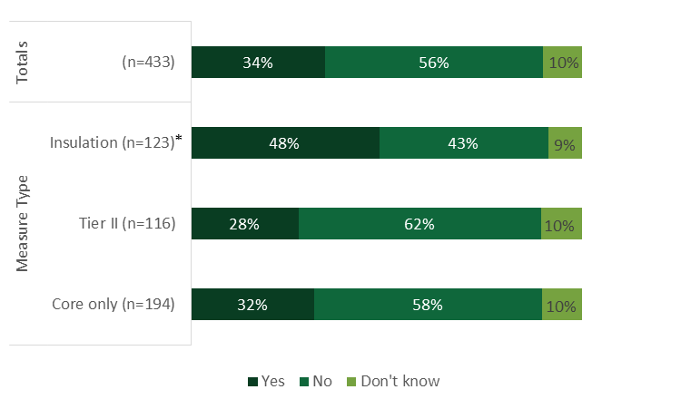
Note: Percentages are weighted.
*Indicates that those who installed insulation were significantly more likely to have been followed up with by the vendor as core-only and Tier II respondents at the 90% confidence level.

End-User Nonparticipant Surveys
The CATI surveys asked program nonparticipating customers to assess their decision making regarding program upgrades they may have considered if they had participated in the program. The surveys also explored hypothetical decision making about program financing and rebate and incentive selections.

Nonparticipant Energy Efficiency Improvements
- Many nonparticipants making improvements chose them based on which ones would save the most on energy bills.
More than one-half of nonparticipants have made energy efficiency improvements within the last year, but light bulbs, which may have been supported by upstream programs, were the most commonly mentioned upgrade (more details in Appendix A.3.2). Close to one-fourth (24%) of all program nonparticipants who installed energy effiiency improvements chose improvements that would save them the most on their energy bills (Table 29). Non-low-income (NLI) nonparticipants also cited the need to replace old or broken equipment (24%), and NLI nonparticipants were equally as likely to make improvement selections based on affordability (21%) as they were to make their selection based on what would save them the most on their energy bills (21%).
Table 29: End-user Nonparticipant Survey Respondents – Reasons for Selecting Improvements Made¹
(Multiple responses, base = made improvements)
Reason for Choosing Improvements | NLI (n=95) | Low-Income (n=59)
Greatest energy/utility bill savings | 26% | 21%
Replace aging/broken equipment | 24% | 18%
Most affordable | 16% | 21%
Easiest to find | 8% | 9%
Research/comparison shopping | 8% | 8%
Easy installation | 7% | 9%
Contractor/vendor recommendation | 9%* | 0%
Note: Percentages are weighted.
* Indicates statistically significant difference from low-income category at the 90% confidence level.
¹ This table provides the most common response categories only. See Appendix A.3.2 for the full table.

- Program nonparticipants who have not made energy efficiency improvements believe that such improvements are unnecessary; they have no plans to make any other improvements in the next year.
As indicated in Table 30, the most common reason why program nonparticipants who have not made energy efficiency improvements to their homes in the last year did not do so is that they think they are unncessary (41%). Low-income nonparticipants were significantly more likely to cite the cost as a reason for not making the improvements (14% in comparison to 37%).
Table 30: End-user Nonparticipant Survey Respondents – Reasons for Not Making Improvements
(Multiple responses, base = no improvements made)
Reason for Inaction | NLI (n=45) | Low-Income (n=41)
Deemed unnecessary | 44% | 39%
Too expensive | 14% | 37%*
Lack of time | 17% | 14%
Home is efficient enough | 10% | 2%
Renting home | 3% | 4%
Planning to move | 2% | 5%
Installation too complicated | 2% | 4%
Too much of a hassle | 2% | 4%
Missed deadline | 0% | 5%
Other | 7% | 7%
Don't know/Refused | 10% | 4%
Note: Percentages are weighted.
*Indicates that low-income respondents were significantly more likely than NLI respondents to provide this response at the 90% confidence level.

Close to three-fifths (57%) of nonparticipants who have not yet made energy efficiency improvements do not plan to make any of these improvements to their homes in the next year (Figure 31). Similar results occur by income, with 59% of NLI nonparticipants and 53% of low-income nonparticipants not intending to make improvements.
Figure 31: End-user Nonparticipant Survey Respondents – Likelihood to Install Energy Efficiency Improvements in the Next Year
(Base = no improvements made)
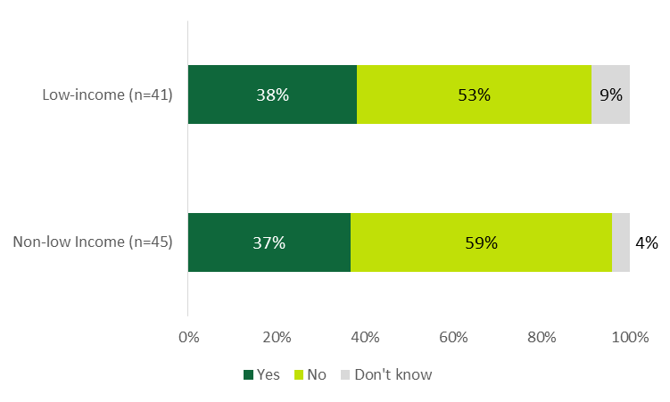 Note: Percentages are weighted.

Nonparticipants and Program Financing and Incentives
- Nonparticipant awareness of program financing is relatively high; they did not apply because they had sufficient funds or because it would not have been enough money anyway.
Overall, two-fifths (41%) of all program nonparticipants are somewhat aware or very aware of options to help help them pay for improvements such as zero- or low-interest financing, on-bill financing, or other loan options that the program offers (Figure 32). Significantly more NLI nonparticipants are somewhat aware (34%) of financing options in comparison to low-income nonparticipants (31% somewhat or very aware).
Figure 32: End-user Nonparticipant Survey Respondents – Awareness of Program Financing Options
(Base = all nonparticipants)
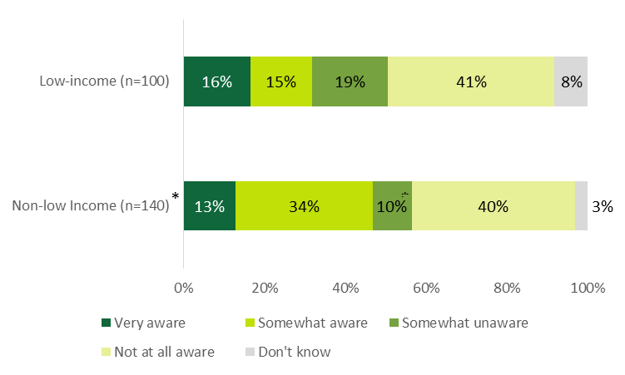
* Indicates that NLI respondents were significantly more likely to be somewhat aware of financing options than low-income respondents at the 90% confidence level.
Note: Percentages are weighted.

As shown in Table 31, regardless of whether they had made improvements or not, NLI nonparticipants who were at least somewhat aware of financing options most commonly did not apply for financing because they had sufficient funds (17%). Low-income nonparticipants who were at least somewhat aware of financing options most commonly did not apply for financing because they would not have had enough money anyhow (23%). NLI nonparticipants also said that it would not have been enough money anyhow (15%), and low-income nonparticipants cited concerns about not having enough for the upfront cost (14%) and not wanting to incur debt (10%).
Table 31: End-user Nonparticipant Survey Respondents – Reasons for Not Applying for Financing¹
(Multiple responses, base = at least somewhat aware of financing)
Reason for Not Applying for Financing | Non-low Income (n=65) | Low-Income (n=32)
Amount of money not sufficient | 15% | 23%
Not necessary* | 17% | 8%
Did not want debt | 13% | 10%
Could not cover upfront cost* | 5% | 14%
Did not want to make improvements | 5% | 10%
Just learning about program now | 5% | 6%
Have not had time | 6% | 5%
¹ This table provides the most common response categories only. See Appendix A.3.1 for the full table.
*Note that the direction of differences is as expected between the NLI and low-income respondent groups.
Note: Percentages are weighted.
- Many nonparticipants would have made improvements and applied for financing if they had known about financing.
Close to three-fifths (58%) of all nonparticipants who had not made any energy efficiency improvements in the last year would reconsider moving forward with energy-saving improvements if they knew more about financing opportunities (Figure 33).
Figure 33: End-user Nonparticipant Survey Respondents – Willingness to do Work if Known about Financing
(Base = no improvements made)
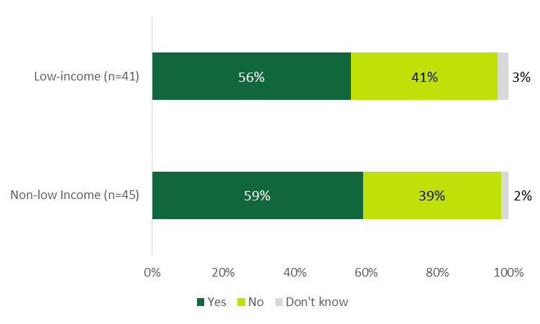

Note: Percentages are weighted.

Close to three-fifths (56%) of nonparticipants who have installed energy-saving upgrades in the last year and who were not very or not at all aware of program financing options said they would have been likely to apply for them if they had known more about the financing options (Figure 34). Low-income nonparticipants were somewhat more likely to respond in this way (65%). Unlike NLI households, low-income households likely have less disposable income to spend on upgrades, so they may find financing options to be an appealing alternative compared to not completing the work at all.
Figure 34: End-user Nonparticipant Survey Respondents – Likelihood to Apply for Financing if Aware
(Base = made improvements but low financing awareness)

Note: Percentages are weighted. Sample consists of those who had made installations.
- Nonparticipant awareness of rebates is high, but usage of rebates is low.
Just over two-fifths of all nonparticipants (41%) are aware of the rebates and incentives that the program offers to help people pay for energy efficiency improvements in their homes (Figure 35). Significant differences were seen between NLI nonparticipants and low-income nonparticipants who were somewhat aware (34% and 18%, respectively), as well as those who were somewhat unaware (10% and 29%, respectively). As illustrated in Appendix A.3.2, rebates were not used to make energy-saving improvements by the vast majority of low-income nonparticipants (82%) and NLI nonparticipants (72%).
Figure 35: End-user Nonparticipant Survey Respondents – Awareness of Program Rebates and Incentives
(Base = all nonparticipants)
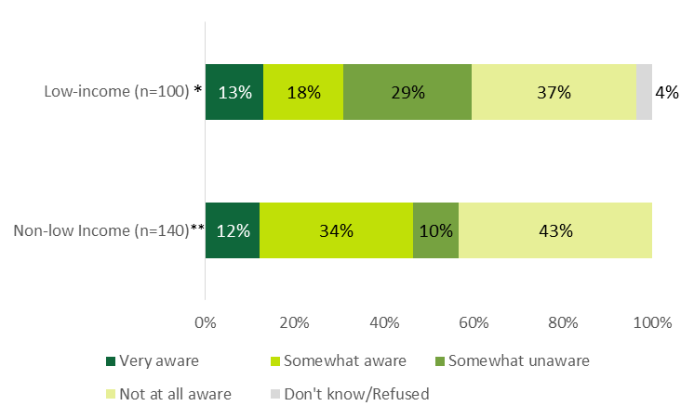
*Indicates that low-income respondents were significantly more likely to be somewhat unaware of program rebates and incentives than NLI respondents at the 90% confidence level.
**Indicates that NLI respondents were significantly more likely to be somewhat aware of program rebates and incentives than low-income respondents at the 90% confidence level.
Note: Percentages are weighted.

- Lack of awareness of program rebates was the primary reason nonparticipants did not use them, but they could have been influential in the decision-making process.
Not being very aware of rebates (n=8) was the primary reason why NLI nonparticipants did not use them, despite having made energy savings improvements (Table 32). NLI nonparticipants also commonly mentioned that the rebate was unnecessary for them to make the improvements (n=6). Due to small sample sizes, it is unclear what the most common reasons low-income nonparticipants had for not using the rebates (n=11). The rebates would have been somewhat or very influential on just over one-half (55%) of all nonparticipant decisions to move forward with work if they had known about them (Appendix A.3.2).
Table 32: End-user Nonparticipant Survey Respondents – Reasons for Not Using Rebates
(Multiple responses, base = made improvements and at least somewhat aware of rebates)
Reason for Not Using Rebate | Non-low Income (n=29) | Low-Income (n=11)
Low rebate awareness | 8 | 1
Rebate was unnecessary | 6 | 0
Did not want to make improvements | 2 | 0
Too much of a hassle | 2 | 1
Upgrade not covered by the program | 3 | 2
Rebate amount not sufficient | 1 | 1
Cannot cover upfront cost | 1 | 0
Have not had time | 1 | 0
Forgot about rebate | 0 | 2
Rebate too confusing | 0 | 1
Other | 1 | 1
Don't know | 4 | 2
Note: Unweighted counts are shown given the small number of responses.

- Saving money on energy bills was the most common reason nonparticipants made energy efficiency improvements.
As shown in Table 33, saving money on energy bills was one of the most common reasons both NLI nonparticipants (31%) and low-income nonparticipants (42%) had for making the energy-saving improvements that they did. Saving energy was also a common reason why both NLI nonparticipants (29%) and low-income nonparticipants (39%) made improvements, as was needing to replace aging or broken equipment (31% and 21%, respectively). Note that waiting until equipment broke to replace these measures implies that the nonparticipants did not take advantage of all the bill and energy savings they could have had they replaced the equipment earlier. This “early replacement” approach is what at least some participants do once they learn about program rebates and financing.
Table 33: End-user Nonparticipant Survey Respondents – Reasons for Making Improvements
(Multiple responses, base = made improvements)
Reasons for Making Improvements | Non-low Income (n=95) | Low-Income (n=59)
Save money on energy bill | 31% | 42%
Save energy | 29% | 39%
Needed to replace aging/broken equipment | 31% | 21%
Health and safety | 11%* | 1%
Improve comfort | 4% | 6%
Be "green"/help environment | 4% | 3%
Wanted to make home improvements | 2% | 0%
Tax write-off | 1% | 0%
New home | 1% | 0%
Other | 3% | 4%
Don’t know/Refused | 1% | 0%
*Indicates that NLI respondents are significantly more likely than low-income respondents to provide this response at the 90% confidence level.
Note: Percentages are weighted.
Very few nonparticipants who had made energy savings improvements on their own had used financing to help with the expense of those improvements (8% used financing overall; further details in Appendix A.3.2).
- When considered separately, neither the availability of rebates nor the availability of financing is very influential on nonparticipants’ decisions to make improvements; the combination of both rebates and financing is also not very influential on nonparticipant decision-making.
Interviewees rated the importance of financing, rebates, and the combination of financing and rebates on a scale of 1 to 5, where 1 equaled “Not at all important” and 5 equaled “very important” (Figure 36):
- Rebates and financing alone. A majority of nonparticipants who had made improvements thought that the general availability of rebates (66%) nor financing (67%) was not at all or not very important in their decision to move forward. Low-income nonparticipants (mean of 2.8) were significantly more likely to be influenced by the general availability of financing than NLI nonparticipants were by financing (1.9).
- Rebates and financing in combination. Similarly, close to three-fourths (72%) of nonparticipants who had made improvements thought that the combination of the two had very little or no influence on their decision to move forward with installing upgrades, with low-income nonparticipants slightly more likely to attribute influence (2.7) than NLI nonparticipants (1.8)
Figure 36: End-user Nonparticipant Survey Respondents – Importance of Financing and Rebates in Decision to Make Upgrades
(Base = made improvements and at least somewhat aware of financing or rebate options)

Note: Means are weighted. Interviewees rated the importance of each on a scale of 1 to 5, where 1 equaled “Not at all important” and 5 equaled “very important”.
* Indicates that low-income respondents provided a significantly higher average rating than NLI at the 90% confidence level.

HES-IE Landlord and Property Manager Interviews – Decision-Making and Financing
Sixteen HES-IE landlord and property manager interviewees who installed add-on measures received program incentives. One of them—the project installed refrigerators and additional lighting equipment—also received on-bill financing from the program.

Measure Recommendations
- Landlords recall that vendors discuss lighting, insulation, and refrigerators most often.
Most landlords and property managers (25 of 30) recalled their vendors discussing energy efficiency upgrades either during the assessment or after the assessment, recalling discussions around lighting equipment (16 of 30), insulation (12), and refrigerators (9) as potential add-on measures. Comparing the number of measures that were installed to the number of measures discussed among this sample, it appears that hot water heaters, refrigerators, and insulation had the highest “rates of adoption” (Figure 37).
Figure 37: HES-IE Landlord and Property Manager Interviewees – Measures Discussed During or After Assessment
(Count of projects)
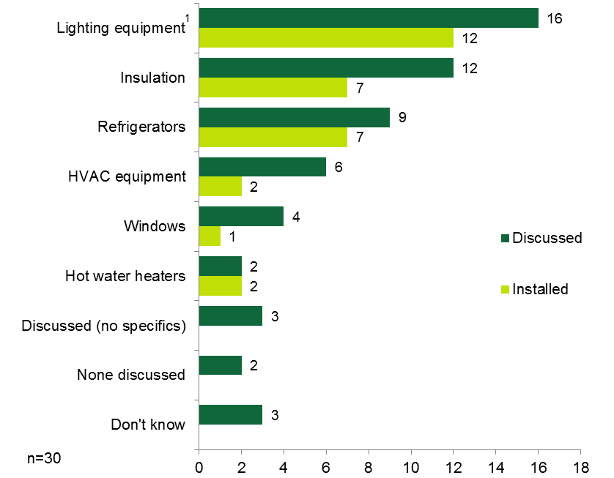
¹ The “lighting equipment” category in this chart includes both core-service and add-on lighting measures (aside from light bulbs).

Decision-making factors
- Landlords cite incentives, energy bill savings, and return on investment as pivotal factors in deciding to install measures.
“[The incentives] were everything.”
– HES-IE property manager
Landlords and property manager interviewees greatly value incentives in their decisions to install add-on measures. Using a scale of 1 to 5 where 1 means “not at all important” and 5 means “very important,” HES-IE landlords and property managers rated the program incentives that they were offered a 4.9, on average, with only two of them rating it less than 5.0 (n=13).
When asked to identify the factors involved in their processes of deciding which energy efficiency upgrades (both recommended and not recommended) to make, they pointed to incentives, as well as energy bill savings and return on investment (Figure 38):
- Incentive availability. Nine pointed to the availability of incentives. A couple interviewees said that the incentives simply made it clear that they should move forward with refrigerators, in particular, with one of them saying that the substantial incentive amount made them feel that “money didn’t really enter into” the decision to purchase new refrigerators.
- Energy bill savings. Often referring to their own limited budgets, their concerns for their tenants’ budgets, and recognizing the inefficiency of their existing equipment, nine interviewees specified that they made their decisions with the goal of decreasing energy bills.
- Return on investment. Nine interviewees said that the return on investment was a key input. For example, two of the interviewees considered cost effectiveness as an important factor in their decisions to invest in energy-efficient lighting:
If it was just a fixture, just a simple replacement, [we would estimate]: “Would we get it back in three years, five years, seven years, or ten years?” And then we tried to figure out if it was worthwhile investing the money.
Figure 38: HES-IE Landlord and Property Manager Interviewees – Add-on Measure Decision-Making Factors
(Multiple responses; count of responses)
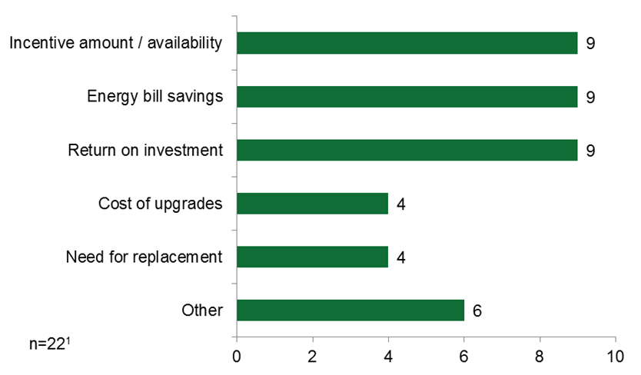
¹ Eight interviewees did not respond to this question.

Financing Discussions and Preferences
- Long-term costs, lack of information, and lack of need detract from partaking in financing.
Fourteen of the landlords emphasized that they would not be interested in loans or financing opportunities to make additional energy-saving upgrades, explaining that the projects would be too expensive to implement despite financial support (five), there was not enough information available to them (five), or they already have the funds in their operating or reserve budgets (four).
[The vendor] may have brought it up, but it would not be anything that we were interested in at the time . . . Because if there is an interest rate attached to it—we had the cash on hand—[loans] just increase the cost to us [in the long term]. If it was low-interest financing, that might have been something we would have looked at. This was part of a longer construction project, so we were trying to package it up and handle it with slow-source financing.
Ten interviewees said that they had no interest in making additional upgrades regardless of financial factors. Figure 39 illustrates the financing participation barriers that interviewees described.
Figure 39: HES-IE Landlord and Property Manager Interviewees – Financing Participation Barriers
(Multiple responses; count of responses)
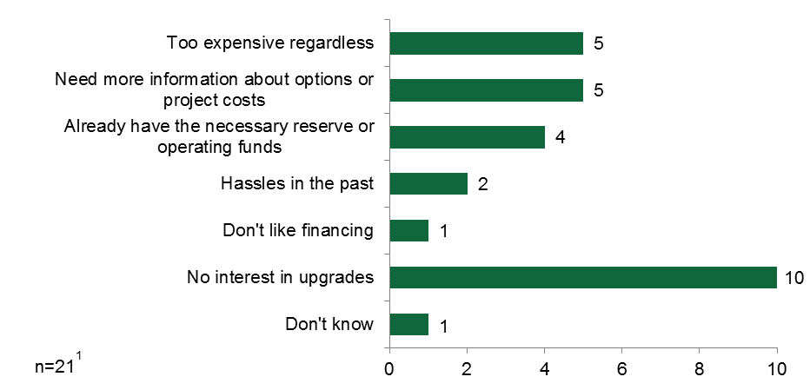
¹ Nine interviewees did not respond to this question.
- Utility low-interest loans or on-bill financing are attractive to some landlords and property managers.
When speculating what financing options they would use if they were to move forward with making additional energy efficiency upgrades, most often they said that they would use utility program loans or on-bill financing (6 of 20), observing that the rates are “reasonable.” Four of the interviewees said that they had enough “cash on hand” to pay for the upgrades out of their own operating or reserve funds and, as a result, would not need loans. Others needed more information about project costs and financing opportunities to make an educated decision (five). Figure 40 presents their responses in full.
“We really don’t do anything with financing, but if we did, we would go through the utility.”
– HES-IE property manager
Figure 40: HES-IE Landlord and Property Manager Interviewees – Financing Preferences
(Count of respondents)
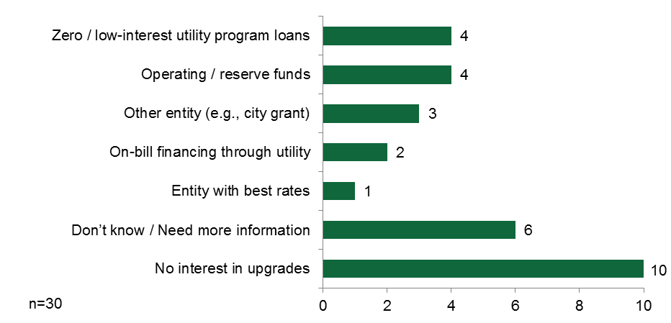

End-User Data Analysis – Deeper-Measure Uptake
Using the Eversource participation database (from July 2013 through April 2015) to assess deeper-measure uptake, the study estimated the percentage of core-services participants who, following the assessment, subsequently installed additional add-on measures both overall and by vendor. The overall “deeper-measure uptake rate” at which core-services customers installed these additional measures was 21% among HES participants and 11% among HES-IE participants, although it should be remembered that adoption of deeper measures by HES-IE households is largely a reflection of which measures the program rules dictate they should receive for free.
Among HES participants, the rate of uptake across vendors ranged from 11% to 31% (Table 34). However, the comparison of rates between vendors does not account for demographic differences in customer bases or any other factors which may influence the uptake of add-on measures. Note also that the variation in the percentage of total projects for each vendor depends in part on where they operate in the state and their own ability to take on greater or fewer HES jobs from the Companies. It may also indicate the vendors’ own marketing and outreach, as a company such as Next Step Living tends to promote itself more than some of the smaller, local vendors may.
Table 34: HES Projects Deeper-Measure Uptake, by Vendor
 | HES Projects |  | Projects with Add-on Measures
Vendor Name | Count of Projects | % of Total Projects | Count of Projects | % of Vendor’s Projects
A Plus Installation, LLC | 431 | 1.8% | 65 | 15%
Aiello Home Services | 991 | 4.2% | 216 | 22%
BCB Conservation Group, LLC | 445 | 1.9% | 128 | 29%
Climate Partners, LLC | 157 | 0.7% | 36 | 23%
Competitive Resources, Inc. | 1,279 | 5.4% | 329 | 26%
EcoSmart by R Pelton Builders, Inc. | 1,959 | 8.2% | 604 | 31%
Energy Efficiencies Solutions, LLC | 1,602 | 6.7% | 447 | 28%
Energy Resource Group | 734 | 3.1% | 136 | 19%
EnergyPRZ, LLC | 1,459 | 6.1% | 341 | 23%
Fox Heating Services, Inc. | 323 | 1.4% | 61 | 19%
Greenbuilt Connecticut | 269 | 1.1% | 71 | 26%
Gulick Building & Development, LLC | 549 | 2.3% | 72 | 13%
Handyman Express Energy Solutions LLC | 426 | 1.8% | 48 | 11%
Hoffman Fuel | 198 | 0.8% | 31 | 16%
Home Doctor of America | 408 | 1.7% | 106 | 26%
Lantern Energy, LLC | 1,177 | 4.9% | 229 | 19%
Molina & Associates, Inc. | 280 | 1.2% | 43 | 15%
New England Conservation Services, LLC | 1,113 | 4.7% | 204 | 18%
New England Smart Energy Group, LLC | 1,789 | 7.5% | 337 | 19%
Next Step Living, Inc. | 3,834 | 16.1% | 828 | 22%
R&W Heating, LLC | 263 | 1.1% | 49 | 19%
Santa Fuel, Inc. | 434 | 1.8% | 84 | 19%
Tri City Home Energy Services | 403 | 1.7% | 56 | 14%
Uplands Construction Group, LLC | 409 | 1.7% | 98 | 24%
Victory Industries, LLC | 1,467 | 6.2% | 258 | 18%
Wesson Energy, Inc. | 1,390 | 5.8% | 228 | 16%
Other¹ | 76 | 0.3% | 9 | 12%
Total | 23,865 | 100% | 5,114 | 21%
¹ Vendors with fewer than 100 records have been combined into the “other” category.
Table 35 shows for each core-services vendor the percentage of HES-IE core-services customers who subsequently install additional add-on measures. The rate of additional measure uptake, 11%, is significantly lower than the rate for HES participants (21%). This difference is not surprising given that most HES-IE households receive deeper measures for free from the program, and the list of approved add-on measures for HES-IE is smaller than for HES. Variations across vendors could reflect characteristics of the participants and their residences, program budgets, and the degree to which the vendor can draw on leveraged resources from the DOE’s Weatherization Assistance Program.
Table 35: HES-IE Projects – Deeper-Measure Uptake, by Vendor
 | HES-IE Projects |  | Projects with Add-on Measures
Vendor Name | Count of Projects | % of Total Projects | Count of Projects | % of Vendor’s Projects
ABCD | 1,076 | 3.8% | 90 | 8%
ACCESS | 2,840 | 9.9% | 450 | 16%
CRT | 5,416 | 19.0% | 731 | 13%
Competitive Resources, Inc. | 3,351 | 11.7% | 31 | 1%
Energy Efficiencies Solutions, LLC | 1,144 | 4.0% | 60 | 5%
Energy Resource Group | 614 | 2.2% | 191 | 31%
HESHP | 104 | 0.4% | 0 | 0%
Handyman Express Energy Solutions LLC | 1,185 | 4.2% | 180 | 15%
Mr. Handyman of Upper Fairfield County | 1,589 | 5.6% | 416 | 26%
New England Conservation Services, LLC | 1,072 | 3.8% | 213 | 20%
New Opportunities, Inc. | 4,585 | 16.0% | 574 | 13%
Santa Fuel, Inc. | 120 | 0.4% | 2 | 2%
WRAP | 4,988 | 17.5% | 0 | 0%
Wesson Energy, Inc. | 311 | 1.1% | 67 | 22%
Other¹ | 191 | 0.7% | 73 | 38%
Total | 28,586 | 100% | 3078 | 11%
¹ Vendors with fewer than 100 records have been combined into the “other” category.

HES Vendor Interviews – Decision Making and Financing
While some HES participants know prior to having the assessment that rebates and financing options exist, the HES program relies on vendors to promote and explain these incentives to eligible participants. Given the importance of vendors in the rebate and financing process, the study queried 23 of the 24 vendors interviewed as part of the joint R4/R46/R151/R157 effort about their promotion of rebates and financing and participant reactions to the two incentives.

Vendor Promotion of Rebates and Financing
- Vendors most often recommend CHIF loans, Smart-E Loans, and on-bill financing; among both the vendors and program materials, the financing nomenclatures used are inconsistent.
The study asked vendors which rebates and financing opportunities they typically discussed with HES participants.
- Measures recommended. Vendor interviewees most often reported discussing rebates and financing for insulation (n=9) with HES participants; after insulation, they were most likely to say that the rebates and financing opportunities that they discussed were for “whatever [the participant] qualifies for” (n=7), in recognition of the various measure and customer eligibility requirements for the various loans (Table 36).
- Financing recommended. Turning to financing, “CHIF” led the list of financing options (n=13), with CHIF serving as the lender for the Energy Conservation Loans and the Residential Energy Efficiency Financing Program. Other common financing options included the Smart-E Loans, including the solar options covered by the Green Bank (n=9), and a generic reference to “on-bill” financing (n=6).
- Nomenclature used. One small but critical element evident from Table 36 is that vendors generally refer to financing options by the organization that offers the financing rather than the name of the loan as it appears on the Energize Connecticut website. The one exception is Smart-E Loans, which vendors typically shortened to E-Loans. As shown in Table 24 above, end-users typically refer to either the selling feature of the loan (zero percent financing) or its name (Residential Energy Efficiency Financing, Energize Connecticut Heating Loan). Additionally, as part of the document review, the study notes that links from the Energize Connecticut website sometimes refer to the same loan with a different name. For example, the CHIF website includes a link that still references the “HES Micro Loan” and the “HES Comprehensive Loan,” even though most of the other links on the CHIF website and the Energize Connecticut website instead discuss the Residential Energy Efficiency Financing Program. The different nomenclature used by vendors, on websites, and in program documents may add to customer confusion over financing and the various options available mentioned by participants and vendors.
Table 36: HES Vendor Interviewees – Rebates and Financing Options Discussed with Participants¹
(All 23 vendors responded)
Rebates | Number of Mentions | Financing | Number of Mentions
Insulation | 9 | CHIF³ | 13
Whatever they qualify for or is in the POD² | 7 | Smart-E Loans / Green Bank (solar) | 9
All possible rebates | 4 | On-bill repayment³ | 6
Windows | 3 | In-house (offered by vendor) | 3
HVAC Equipment | 3 | Small third-party financer | 2
Appliances | 1 | AFC⁴ | 2
Solar | 1
¹ As a reminder, see http://www.energizect.com/your-home/solutions-list?ptype=1 for more detail on the rebate and financing options available to residential customers.
² “Print on Demand” booklet with recommendations and information on rebates and financing that gets left with the participant at the end of the assessment.
³ Most likely refers to the Energize Connecticut Heating Loan program or the Residential Energy Efficiency Financing Program.
⁴ Most likely refers to the Energize Connecticut Heating Loan program, financed by AFC First Financial Corporation.
- Vendors use the personalized assessment information packet as a tool for participants.
When asked what information they leave with participants to help them make choices about measure upgrades, rebates, and financing, most vendors mentioned the “print on demand” (POD) booklet, including the list of recommendations, rebates, and financing options (Table 37). Note that the POD is another example of divergent nomenclature used by vendors and end-users, with the latter typically talking about an assessment report. This is likely a small point, as the vendors probably do not use the program acronym with customers, but it may ease conversations to use consistent terminology in program implementation manuals, between the Companies and vendors, and between vendors and participants.
Table 37: HES Vendor Interviewees – Material Left with Participant
at End of Assessment
(All 23 vendors responded)
Materials Left | Number of Mentions
POD (Print on demand packet) | 19
Utility Literature | 4
Proposals and Cost estimates | 4
Point to website | 3
Rebate forms | 3
Loan brochures | 3
Marketing materials | 2
Spreadsheets | 1
Community literature | 1

Participant Reactions to Rebates and Financing
- Vendors receive positive reactions to rebate opportunities and find that participants seek out the program with rebates in mind.
As shown in Figure 41, vendors report that participants generally respond positively to rebate information (n=14). Some vendors highlighted that participants often know about rebates before the assessment and set up the visit specifically to find out if they were eligible for a desired measure (n=6).
Figure 41: HES Vendor Interviewees – Participant Reactions to Rebates
(Multiple responses; all 23 vendors responded; count of responses)
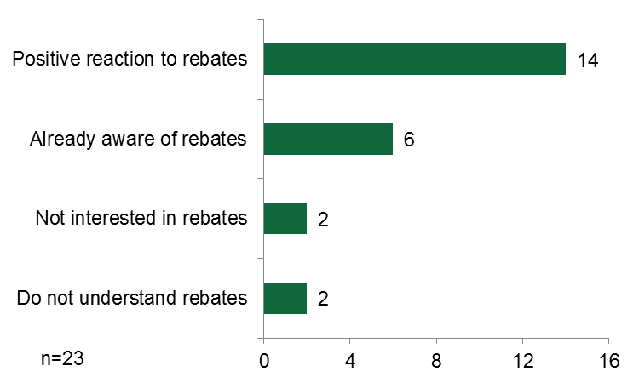
- Vendors find that customers are overwhelmingly enthusiastic about the amount of the insulation rebate.
“Insulation is very appealing because it’s a big number—50%. That’s huge!”
– HES vendor
When asked which rebates customers like the most, the 23 vendors resoundingly named insulation (full list in Appendix A.3.3). Importantly, only three vendors cited the promised energy savings as being a driver for the insulation rebate; instead, the depth of the rebate—50% of cost—explained its appeal to participants.
While insulation is by far the most popular rebate, vendors did mention that participants are also drawn to the more tangible rebates, such as windows and heating equipment, as opposed to solar, where the installer receives the rebate.
- Vendors observe varied reactions to financing opportunities; zero percent financing and on-bill repayment opportunities are attractive to some, but others are simply averse to or disinterested in financing
In contrast to rebates, vendors showed less agreement on participant reactions to financing options.
“[Participants] are ecstatic at having the financing rolled into their utility bill.”
– HES vendor
- Positive reactions. Eight vendors suggested that participants were interested in financing, while nine other respondents noted specific characteristics of the financing packages participants appreciated (Figure 42), specifically zero percent financing (n=4), instant approval for those with strong bill payment histories (n=3), and on-bill repayment (n=2). This signals their customers’ reported attraction to the Residential Energy Efficiency Financing Program administered by CHIF. Vendors spoke of the enthusiasm that they observe among participants:
[Participants] are excited when we tell them about the zero percent financing.
- Negative reactions. In contrast, five of the vendors said participants are not interested in financing, with reactions ranging from explicit lack of interest to passive lack of interest. For example, one vendor noted that many of the participants already had loans on homes, cars, or other items and “are not crazy about another financing option.” One vendor believed that the financing does not entice people who had no plans to do work to change their minds:
I don’t know that financing . . . necessarily encourages people to do the work. I don’t think they [think], “Well, we weren’t thinking about doing the insulation, but this deal is so good we’re going to do it.”
- Dependent reactions. Finally, a vendor who serves both single-family and multifamily residences offered a unique perspective: While single-family homeowners rarely voiced interest in financing, “[The multifamily landlords] like hearing about financing if they don’t have that capital; the big seed-based options are attractive to them.”
Figure 42: HES Vendor Interviewees – Participant Interest in Financing
(Multiple responses; all 23 vendors responded; count of responses)
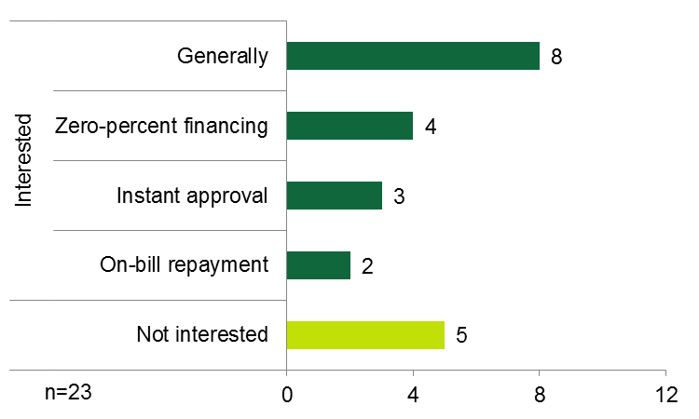
- Vendors emphasize zero percent financing and on-bill repayment opportunities, but try not to be invasive.
Vendors were asked how they respond to customers who initially say they are not interested in financing. In general, vendors explained that they simply stressed the zero percent financing, on-bill repayment, and instant approval possibilities. One vendor attempted to lay out the costs for them—the price of the measure adjusted for rebates, the amount the borrower had to put down, the amount to be financed, and what that would mean to their monthly electric bill. A few left literature or followed up with phone calls, but most simply respected the participants’ wishes not to discuss financing. “We don’t want to be pushy” or “That is their personal financial situation” were common responses.
- Vendors generally find that participants prefer rebates over financing.
The study also asked vendors to weigh in on whether participants preferred rebates, financing, or a combination of the two. Overwhelmingly, the vendors selected rebates (n=16; Figure 43). In fact, not a single vendor said that participants prefer financing over rebates, although some did note that the preference depended on the participant’s personal situation (n=6). For example, if they needed a “big ticket item,” the participant may prefer financing over rebates. Three vendors said that participants like rebates and financing in combination, which is actually the option end-users said they preferred (Table 28).
Figure 43: HES Vendor Interviewees – Participant Preferences
for Rebates vs. Financing
(Multiple responses; all 23 vendors responded; count of responses)
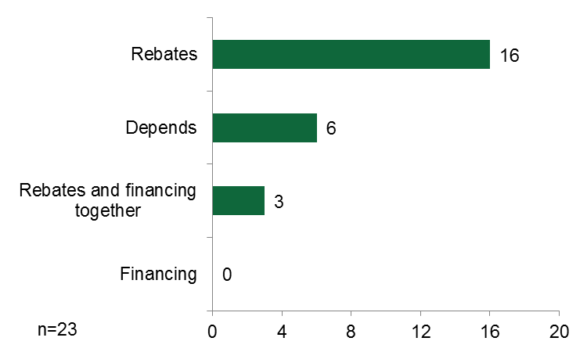
- Vendors understand and can explain program rebate structures and processes to customers, but some, along with their customers, struggle with the legalistic terminology and complexities involved in financing options
As shown in Figure 44, vendors generally believed that the rebate information was clear, but they offered mixed opinions on the clarity of financing information.
- Rebate clarity. Regarding rebates, vendors explained that some customers—and even HES technicians—may find the rebate information confusing due to “small print,” but most of the vendor staff understood the rebate structures and processes and could explain them to participants.
- Financing clarity. The same was not true of financing information. Vendors complained of “legalese” and “too many options” as well as confusion over which financing program covered which measures for which group of customers. Thus, the information was confusing both to the vendor staff and to the participants. Two vendors made a point of saying that they felt that, as far as legal documents go, the HES-related financing information and agreements were fairly clear, yet many of their customers still had too little experience with legal documents to be able to decipher the agreements.
Figure 44: HES Vendor Interviewees – Clarity of Rebate and Financing Information
(Multiple responses; all 23 vendors responded; count of responses)
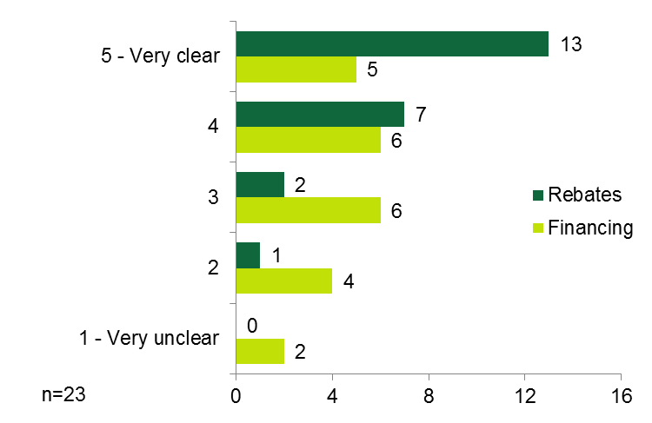

- Vendors offered varied suggestions for program improvements, including altering the program structure or enhancing program rebate and financing processes.
Finally, the vendors offered opinions on ways to improve rebates and financing. Some of their ideas are presented below. Please note that the study offers these as information only and not necessarily as specific recommendations.
- Extend the cutoff date for using rebates (up to a year)
- Reduce the “fine print” in the PODs
- Simplify financing options, applications, materials; use language that is easily accessible to the layperson
- Improve CHIF financing approval turnaround time
- Develop a way to run preliminary estimates accounting for rebates, financing, amount to put down, amount to be borrowed, and impact on energy bill; essentially, “what it would look like in payment terms or payments per month”
- Use a mid-stream model that issues rebates to vendors rather than to participants
- Rebate more measure types, increase rebate amounts, and begin offering rebates for hot water heater again
- Smart-E Loan program should consider small credit unions as partners

Benchmarking – Decision Making and Financing
- Awareness levels of program financing, relative importance to encouraging add-on measures, and usage rates are comparable to neighboring states, but its application process appears to be more challenging.
The study benchmarked four parameters within the decision-making and financing findings:
- Awareness. Awareness among Connecticut HES participants of program financing (60%) is somewhat lower than that of their counterparts in Massachusetts, 69% of whom are aware of the Massachusetts HEAT Loan; however, awareness is considerably higher in comparison to Efficiency Maine participants and nearly the same as among New York HPwES participants. Comparing awareness of the various financing programs among nonparticipants, Connecticut HES nonparticipating customers (41%) are somewhat more aware than Massachusetts customers (32%).
- Importance. It appears that program financing is somewhat more important for encouraging Connecticut HES participants (86%) to move forward with making improvements than for their Massachusetts counterparts (81%) and notably more important than for New York HPwES participants (71%).
- Application. Connecticut HES participants (43%) are less likely than their Massachusetts counterparts (97%) to find the program financing applications easy. This may reflect the fact that Massachusetts relies on a single loan for all eligible measures and households than having numerous loans that target different measures and households. A review of the Massachusetts application forms may offer some insights into ways to make them more accessible to Connecticut households.
- Uptake. The portion of HES participants in Connecticut that use program financing (10%) is comparable to that of HES participants in Massachusetts (9%).
Table 44 presents additional details.
Table 38: Decision-Making and Financing Results – Benchmarking
Benchmarking Parameter | Comparison Program |  | Connecticut HES Value | Notes / Considerations
 | Program | Value
Awareness
% of HES participants aware of financing / loans | MA HES¹ | 69% | 60% | The MA, ME, and NY studies use binary awareness responses (yes/no), and this study uses a 4-point scale (ratings of 3 and 4 count as aware)
 | Efficiency ME² | 37%
 | GJGNY³ | 59%
% of nonparticipants aware of financing / loans | GJGNY | 32% | 41%
Importance
% of financing-users reporting that financing was important in decision to move forward | GJGNY | 71% | 86% | Both the NY study and this study use a 5-point scale (counting ratings of 4 and 5 as important)
 | MA HES | 81% |  | The MA report asks if it enabled them to make improvements that they would not have (yes/no); this study uses a 5-point scale (counting ratings of 4 and 5 as important)
Experience
Ease of filling out financing application | MA HES | 97% | 43% | The MA report uses a 4-point (counting ratings of 3 and 4) scale and this study uses a 5-point scale (counting ratings of 4 and 5)
Usage
% of HES participants using program financing | MA HES | 9% | 10% | The MA report bases it on program tracking data and this study bases it on self-report
¹ Cadmus. Massachusetts Home Energy Services Initiative and HEAT Loan Delivery Assessment. July 31, 2015. http://ma-eeac.org/wordpress/wp-content/uploads/HES-and-HEAT-Loan-Program-Assessment-Final-Report.pdf.
² Opinion Dynamics and Dunsky Energy Consulting. Evaluation of the Efficiency Maine Trust PACE, Power Saver, and RDI Programs. Final Evaluation Report. Volume II: Residential Direct Install Program. October 23, 2013. http://www.efficiencymaine.com/docs/RDI-Final-Evaluation-Report-FINAL.pdf.
³ NMR. Process Evaluation and Market Characterization and Assessment: Green Jobs – Green New York Residential Program. September 2012.

Short-Term Persistence Findings
4
To estimate persistence, the study used on-site visits at HES-IE multifamily projects, CATI surveys with HES/HES-IE occupants, and in-depth interviews with HES-IE landlords and property managers. The evaluation results indicate that 1) persistence of measures verified as installed is high, 2) some inconsistencies with program tracking data result in an excess of installed measures, and 3) program light bulbs are removed because they burn out, and water-saving measures are removed because participants do not like them.

On-site Findings – Short-term Persistence
- On-site visits find an excess of measures compared to program tracking databases but limited measure removals—all persistence rates exceed 90%.
The on-site visits resulted in three primary findings on short-term persistence:
- Excess of measures. CFLs and other measures showed higher observed counts than what has been recorded in the tracking database. Only LEDs diverged from this pattern.
- Limited measure removal. Field technicians did not find evidence that tenants had removed a large number of measures, based on verification rates and survey responses.
- CFL burnout. For those occupants citing removals, the primary reason was a result of burnt-out lamps; however, they reported removing only 18 out of 295 CFLs that they verified they had received.
An excess of program measures found on site creates a complication in determining which values should be used to estimate a verified installation rate relative to the tracking data. Table 39, which provides a summary of verification results by measures, includes all sites and units where a measure was recorded in the tracking database or where a measure was verified by tenants to have been installed through the program. When interpreting results, take note of the small sample sizes of units for LEDs and refrigerators.

Table 39: HES-IE Short-Term Persistence On-Site Visits – Summary of Results by Measure
Measure | Sites Visited¹ | Housing Units Visited¹ | Qty: Tracking Database | Qty: Verified Received | Qty: Verified Installed | Verified Installation Rate | Precision at 90% Confidence Level | Measure Persistence Rate² | Precision at 90% Confidence Level
CFLs | 12 | 70 | 256 | 295 | 275 | 107% | 41% | 93% | 4%
LEDs | 3 | 17 | 88 | 41 | 41 | 47% | 147% | 100% | 14%³
Faucet Aerators | 12 | 83 | 58 | 111 | 107 | 184% | 54% | 96% | 3%
Showerheads | 12 | 83 | 27 | 56 | 53 | 196% | 61% | 95% | 7%
Refrigerators | 3 | 5 | 2 | 3 | 3 | 150% | 446% | 100% | 35%³
¹ The counts of sites/housing units assessed where one or more units had the given measure installed according to tracking data, or tenant, or landlords or property managers. Take careful note of the small sample size of units for LEDs and refrigerators when interpreting the results.
² For a 100% measure persistence rate, there is no observed variability around which to estimate uncertainty; however, the Wilson binomial formula for estimating uncertainty associated with a sampled proportion provides an estimate even in such circumstances. That is the basis for the precision estimate.

- Data inconsistencies are not frequent enough to cause overwhelming concern, but the program may want to consider additional verification of measure quantities installed.
As noted, the evaluation found some inconsistencies between measures recorded in the tracking data and those found on site, but these inconsistencies were not frequent enough to overwhelmingly point to any major program or measure-specific issues.
- Excess of measures. For all measures except LEDs, field technicians verified a few more measures on site than were reported in the tracking data. The evaluation found this to be the case for two sites with CFLs, four sites with hot water measures (faucet aerators and efficient-flow showerheads), and two sites with refrigerators. One speculation is that these measures may have been installed using a different pool of money (e.g., the Department of Energy’s Weatherization Assistance Program [WAP]) at the same time as the HES-IE measures. Tenants and landlords/property managers would be unable to distinguish between HES-IE and WAP lamps.
- Zero or low installation rates. Conversely, the visits found some sites where fewer measures were installed than were reported. Some examples are discussed below. The most severe of these discrepancies included one site where the tracking data showed seven CFL installations per unit for one site, but field technicians found only circline fluorescent fixtures installed through the program. The technicians’ conversations with both tenants and landlords or property managers at this site indicated that they never received CFLs through the program.

CFLs
The evaluation identified approximately 7% more CFLs on site than were reported in the program data. In most cases, the tenants stated that they had purchased and installed the additional lamps either before or after participating in the program, and the analysis excludes such bulbs. Additionally, only six tenants across all the buildings visited reported that any of the program CFLs had failed since installation.
Table 40 shows the response dispositions and quantity verification that the analysis used in calculating the verification rate.
Table 40: HES-IE Short-Term Persistence On-Site Visits – CFL Verified Installation and Persistence Rates
CFL Disposition | Number of Lamps
A. Lamps in Tracking Database | 256
B. Lamps Verified Received | 295
Not received | -73
Received in excess of tracking database | 112
C. Lamps Verified Installed | 275
Broken/burn out | 18
Missing other / reason not reported | 2
Verified Installation Rate (C ÷ A) | 107%
Persistence Rate (C ÷ B) | 93%

LEDs
According to the tracking data, three of the sites assessed had LEDs installed. At two of those sites, the study was able to verify that all of the installed LEDs remained installed. However, at the third site, only 16 of 64 LEDs reported were installed—neither tenants nor landlords and property managers were able to confirm receiving more LEDs than what were currently installed, leaving most of the missing LEDs unaccounted for. The study provides little evidence that the lower observed counts of LEDs reflect removals by the landlord or tenants to resell the products, as the undercount was distributed across units, and tenants in units independently confirmed that they had not received those LEDs. In addition to the high persistence rate, it should be noted that tenants anecdotally expressed higher satisfaction with LEDs than with CFLs, in terms of both aesthetics and performance.

Table 41 shows the response dispositions and quantity verification that the analysis used in calculating the verification rate.
Table 41: HES-IE Short-Term Persistence On-Site Visits – LED Verification and Persistence Rates
LED Disposition | Lamps
A. Lamps in Tracking Database | 88
B. Lamps Verified Received | 41
Not received | -47
Received in excess of tracking database | 0
C. Lamps Verified Installed | 41
Broken/burn out | 0
Missing other / reason not reported | 0
Verified Installation Rate (C ÷ A) | 47%
Persistence Rate (C ÷ B) | 100%

Faucet Aerators
The evaluation found that 97% of the faucet aerators installed through the program were still installed. Only four of 111 aerators verified as received had been removed.
Table 42: HES-IE Short-Term Persistence On-Site Visits – Faucet Aerator Verification and Persistence Rates
Aerator Disposition | Aerators
A. Aerators in Tracking Database | 58
B. Aerators Verified Received | 111
Not received | -3
Received in excess of tracking database | 56
C. Aerators Verified Installed | 107
Broken | 4
Missing other / reason not reported | 0
Verified Installation Rate (C ÷ A) | 184%
Persistence Rate (C ÷ B) | 96%

Efficient-flow Showerheads
The evaluation found that all but three of the low-flow showerheads installed through the program were still installed. The tenants who removed two of the showerheads did so because they needed physical disability-accessible units.
Table 43: HES-IE Short-Term Persistence On-Site Visits – Showerhead Verification and Persistence Rates
Showerhead Disposition | Showerheads
Showerheads in Tracking Database | 27
Showerheads Verified Received | 56
Not received | -3
Received in excess of tracking database | 32
Showerheads Verified Installed | 53
Broken | 1
Missing other / reason not reported | 2
Verified Installation Rate (C ÷ A) | 196%
Persistence Rate (C ÷ B) | 95%

Refrigerators
Field technicians were not able to verify the two refrigerator units that were listed in the program tracking data associated with the sites. Both the tenants and the program vendor confirmed that they never intended to install refrigerators at those two locations. Technicians did, however, find six refrigerators ostensibly installed through the program at two other sites.
Table 44: HES-IE Short-Term Persistence On-Site Visits – Refrigerator Verification and Persistence Rates
Refrigerator Disposition | Refrigerators
Refrigerators in Tracking Database | 2
Refrigerators Verified Received | 3
Not received | -2
Received in excess of tracking database | 3
Refrigerators Verified Installed | 3
Missing other / reason not reported | 0
Verified Installation Rate (C ÷ A) | 150%
Persistence Rate (C ÷ B) | 100%

End-User Participant Surveys – Short-Term Persistence
- End-users remove light bulbs and water-saving measures because they do not like them, they break, or they do not work properly.
Light bulbs and water-saving measures had the highest reported removal rates among HES and HES-IE survey respondents (Table 45). On average, HES respondents removed those measures about three and a half months after participating, and HES-IE participants removed them roughly five months after participating. Note that the percentages of self-reported removals among these occupants exceed the on-site verified removal rate in multifamily units discussed above. Most often, respondents removed CFLs, along with other core service measures, because they simply did not like them, they broke, or they did not work properly (Table 86 in Appendix 0). HES participants most often reported that they removed measures because they did not like them (compared to other reasons for removal), while HES-IE respondents most often reported that they removed measures because the products broke (compared to other reasons for removal).
Table 45: End-user Participant Survey Respondents – Verified Measures, Removal Rate, and Timing of Removal
Measure | HES |  |  | HES-IE
 | N | % Removed | Average Time Removed¹ | N | % Removed | Average Time Removed¹
Light bulbs | 481 | 14% | 3.4 | 431 | 11% | 5.2
Water saving measures | 247 | 7% | 3.5 | 330 | 7% | 4.9
Air Sealing | 292 | 2% | 3.8 | 281 | 1% | 1.3
Water pipe wrap | 225 | <1% | 4.0 | 107 | 2% | 4.0
Duct sealing | 81 | 2% | 4.0 | 27 | 4% | 12.0
Note: Responses are unweighted.
¹ Indicates average number of months from installation to removal.

HES-IE Landlord and Property Manager Interviews – Short-Term Persistence
- Landlords and property managers report limited measure removal.
Only two landlords and property managers indicated that measures installed through the program had been removed, both saying that very few items were removed (Table 112 in Appendix B.2.3 includes more details). Water-saving measures were removed because tenants did not like them, and CFLs were removed because they had burnt out.

Benchmarking – Short-term Persistence
- Connecticut CFL verification rates are somewhat high compared to other programs
Given the unique participant segment (i.e., low-income, multifamily occupants) and specific research objective (i.e., short-term measure persistence) of this study, it is somewhat challenging to identify directly comparable studies for benchmarking purposes. Two CFL studies appeared to be comparable to this one; as reported above, the Connecticut HES-IE on-site visits revealed a CFL verification rate of 107% and a CFL persistence rate of 93%:
- A Northeast Energy Efficiency Partnerships (NEEP) commercial and industrial study that included some multifamily units in its commercial-based sample found that the 10-year persistence rate for compact fluorescent lamps (CFLs) was 33% and the two-year persistence rate was 73%. Both rates are notably lower than that of this R4 study.
- In Michigan, a recent evaluation of Consumers Energy’s Income Qualified Program conducted a combination of phone and on-site verification, finding a CFL verification rate of approximately 89% -- somewhat lower than this R4 study.
- More in line with the R4 study, in Ohio, evaluations of Dayton Power and Light’s Low-Income Weatherization Program have used phone surveys to identify a CFL in-service rate of 97%.

Net-to-Gross Findings
5
The study relied on industry best practices to estimate net-to-gross (NTG) ratios for HES, HES-IE, and rebate-only programs using findings from CATI surveys with end-user participants and in-depth interviews with HES-IE landlord and property manager participants. Within energy efficiency program evaluation, exact calculations of NTG vary by program administrator, program and measure type, and data availability. Yet most definitions—including those used in Connecticut—include the following:
- Free Ridership: The proportion of participants who have implemented the program measure a) within a specified time period, b) at the same efficiency level, and c) in the absence of the program (see Table 47 below for more discussion on these components).
- Spillover: Reductions in energy consumption and/or demand caused by the presence of an energy efficiency program, beyond the program-related gross savings of the participants and without financial or technical assistance from the program. Spillover can manifest in participants (who take actions beyond the program) and nonparticipants who adopt energy-efficient measures or behavior due to program influence (e.g., after being exposed to program marketing or acting on the recommendation of a participant).
The net-to-gross ratios are estimated using free ridership and spillover rates that are weighted and then input into this formula:
$$\left(1-Free ridership\right)+Spillover= Net to gross ratio$$
In Connecticut, NTG serves as a component of the net realization rate using the following equation:
(Gross realization %) x (Installation rate %) x (100% - Free ridership% + Spillover%)
The evaluation measured free ridership for HES, HES-IE, and rebate-only participant end-users and landlords as well as spillover for HES and HES-IE participant and non-participant users and participant landlords. Estimates are provided for the program overall and for individual measures. Note that Connecticut only tracks NTG for individual measures at this time.
The study estimated weighted net-to-gross ratios of 0.80 for HES, 0.95 for HES-IE, and 0.93 for rebate-only programs. The evaluation suggests not using the HES-IE and rebate-only net-to-gross ratios formally because HES-IE programs generally assume a net-to-gross ratio of 1.0, and sample sizes are small among rebate-only respondents. The following section describes in more detail the free ridership and spillover rate algorithms and findings presented in Table 46.
When compared to similar programs in the Northeast, the HES net-to-gross ratio is somewhat lower, with other programs having ratios greater than 1.0.
Table 46: HES, HES-IE, and Rebate-only Program Net-to-Gross Ratios
Rates and Ratio | HES | HES-IE¹ | Rebate-only¹
Weighted free ridership rate | 0.22 | 0.08 | 0.07
Weighted spillover rate | 0.02 | 0.03 | Not asked
Net-to-gross ratio | 0.80 | 0.95 | 0.93
¹ The study recommends not using the HES-IE and rebate-only values as formal net-to-gross ratios.

Free Ridership
As shown above, the study found weighted free ridership rates of 0.22 for HES, 0.08 for HES-IE, and 0.07 for rebate-only programs. The HES and rebate-only free ridership rates come from the results of the end-user participant surveys, and the HES-IE free ridership rate comes from the landlord and property manager interviews.

End-User Participant Surveys – Free Ridership
CATI survey questions asked 369 HES end-users free ridership questions about 601 randomly selected measures—representing 1,235.7 MWh/year in gross savings—that they had installed through the program.
To estimate the HES free ridership rate, the analysis used the product of two scores:
- Initial score. Survey questions asked HES end-users if they had specific plans to install the measure in question prior to participating in the program. If they had no specific plans to install the same measure, the question series asked them if they would have installed that kind of measure at all, and if so what they would have installed or performed in terms of efficiency level and when they would have done it. If they had specific plans to install the same measure, then they received an initial free ridership score of 1.0 (full free rider). If they would not have installed that kind of measure in the absence of the program, then they received an initial free ridership score of 0.0 (non-free rider). For all other measures, when the end-user would have installed that kind of measure, the algorithm assigned initial free ridership scores ranging from 0.0 to 1.0, depending on their responses about efficiency level and timing. Appendix A.5.1 includes a flow chart illustrating this logic sequence.
- Influence-rating score. Using a scale of 1 to 5, where 1 means “no influence” and 5 means “a great influence,” survey questions asked respondents to rate the level of influence of three program elements on their decision to install the measure. The analysis assigned scores ranging from 0.0 to 1.0 based on the maximum rating they gave to the influence of the incentive or rebate, the installation contractor, and program information. For example, a maximum rating of 1 received an influence rating score of 1.0 and a maximum rating of 5 received 0.0.
Table 47 outlines survey questions, response options, and the range of resulting initial and influence-rating free ridership rates associated with specific responses.
Table 47: End-user Participant Survey Respondents – Free Ridership Scoring Methods
Question wording | Response | Initial Free Ridership Score
Before learning about the program, did you have any specific plans to purchase and install the [MEASURE] that you installed through the program? | Yes | Automatic free rider  (1.0)
 | No / Don’t know | Possible free rider  (0.0 to 1.0)
Inter-related Considerations in Determining Initial Free Ridership Score¹
If you had not participated in the program, would you have purchased one that was a more / same / less efficient? | More / Same | Possible free rider  (0.0 to 1.0)
 | Less | Possible free rider  (0.0 to 0.75)
 | Not at all | Automatic non-free rider  (0.0)
If you had not participated in the program, when would you have purchased/installed the measure? | Sooner / Same time / Within three months | Possible free rider  (0.75 to 1.0)
 | Within six months | Possible free rider  (0.50 to 0.75)
 | Within one year | Possible free rider  (0.25 to 0.50)
 | More than one year | Possible free rider  (0.0 to 0.25)
Question Wording | Maximum Rating | Influence Rating Free Ridership Score
Please consider how influential the following elements were on your decision to install the measure. Please base your answer on a scale of 1 to 5, with 1 indicating “No influence on your decision to install it” and 5 indicating “had a great influence on your decision to install it.”  - The utility company’s incentive or rebate  - Installation contractor, if used  - Information from the utility company | 1 | Free rider  (1.0)
 | 2 | Partial free rider  (0.75)
 | 3 | Partial free rider  (0.50)
 | 4 | Partial free rider  (0.25)
 | 5 | Non-free rider  (0.0)
¹ Any measures for which the interviewee expressed they did not have specific plans to install the measure in the absence of the program were asked about these remaining three inputs.

While end-users would have installed nearly one-half of the measures asked about (48%) at either the same or higher efficiency levels in absence of the program (Figure 45), the free ridership scores for those individual measures were diminished because of end-users’ estimates of when they would have been installed or because of high influence ratings that end-users reported—indicating that the program still had an influence on their decision making even though they said that they would have purchased a high efficiency unit.
Figure 45: HES End-user Participant Survey Respondents – Action in Absence of Program Participation
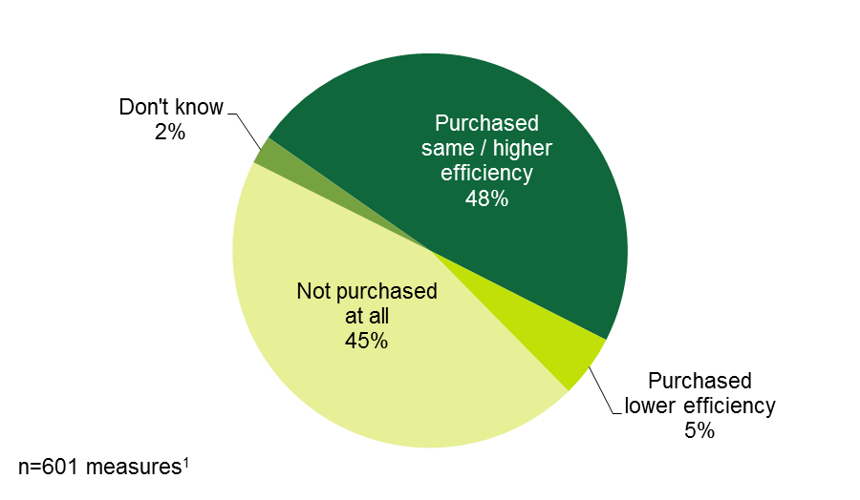
¹ The sampling chose the 601 measures by defaulting to asking end-users about program add-on measures (with greater preference on insulation) wherever possible, and it assigned one to two measures about which to ask depending on what they installed and verified installing.
Respondents gave high influence ratings to program incentives and rebates, particularly for insulation: nearly three-fifths (58%) of respondents gave add-on measures ratings of 4 or 5, and 85% gave rebates and incentives for insulation installations ratings of 4 or 5. Installation contractors (68%) had the highest influence on non-insulation add-on measures compared to the other two elements—information from the utility (35%) and incentives/rebates (58%; Figure 46).
Figure 46: HES End-user Participant Survey Respondents – Influence of Program Elements on Decision to Install
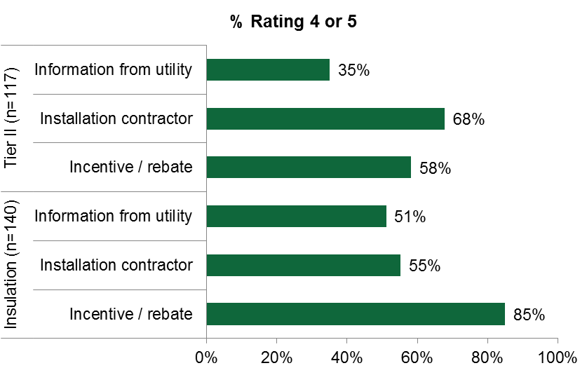
Note: The free ridership question series only asked the three influence questions about add-on measures (not core services). Responses are based on a five-point scale, with 1 indicating “no influence” and 5 indicating “a great influence.”
After weighting the average free ridership scores for each measure by the number of measures (as compared to the population) and then by the sum of those measures’ gross savings (including electric, gas, oil, and propane) recorded in the program tracking database (associated with the respondents), the analysis resulted in an HES free ridership score of 0.22 at the 90% confidence level with precision of +/- 3% (Error! Reference source not found.).
Free ridership for insulation, for which the study intentionally oversampled, was notably low when compared to the other frequently asked-about measures. The most dramatic difference was between insulation and light bulbs; the free ridership rate for insulation was 0.06 (n=140), whereas for light bulbs (n=158) it was 0.55. As a “sensitivity analysis,” the study calculated the free ridership rate in absence of insulation measures and arrived at a somewhat higher overall free ridership rate of 0.26 versus a rate of 0.22 with insulation included. This difference demonstrates the high level of influence that the program has on the installation of insulation and the value of continuing to include insulation as a program measure.
Table 48: HES End-user Participant Survey Respondents – Free Ridership Rates
Measures (n=369 respondents) | n | Average Free Ridership Rate | Sum of Gross Savings (MWh/yr)¹ | Confidence Interval²
 |  |  |  | Maximum | Minimum
Air sealing | 80 | 0.25 | 230.2 | 0.33 | 0.17
Duct sealing | 27 | 0.18 | 79.6 | 0.30 | 0.06
Light bulbs | 158 | 0.55 | 137.6 | 0.62 | 0.49
Water pipe wrap | 66 | 0.28 | 15.2 | 0.37 | 0.19
Water saving | 76 | 0.20 | 28.5 | 0.28 | 0.13
AC equipment | 7 | 0.17 | 2.7 | 0.40 | 0.00
Clothes washer | 1 | 0.00 | 0.3 | 0.00 | 0.00
Ductless HP | 18 | 0.25 | 21.8 | 0.42 | 0.08
Geothermal HP | 2 | 0.00 | 2.7 | 0.00 | 0.00
Heating equipment | 10 | 0.14 | 39.2 | 0.33 | 0.00
Water heater | 6 | 0.23 | 19.1 | 0.51 | 0.00
Windows | 10 | 0.05 | 44.7 | 0.16 | 0.00
Insulation | 140 | 0.06 | 614.1 | 0.09 | 0.03
Total | 601 |  | 1,235.7
Weighted Average Free Ridership Rates³
With insulation |  | 0.22 |  | 0.25 | 0.19
Without insulation |  | 0.26 |  | 0.30 | 0.23
¹ Savings in the program database are associated with the respective measure and respective interviewees. Gas, oil, and propane savings have been converted into kWh/year.
² Figures are at a 90% confidence level.
³ The free ridership rate is weighted by number of measures (as compared to the population) and by gross annual savings.

Table 49 lists the free ridership rates for individual measures as estimated from this study together with current assumed gross realization, installation, free ridership, spillover, and net realization rates as listed in the 2015 PSD. It also updates the net realization rate based on the NTG ratios for each measure. The table does not consider the estimated spillover rates for this study (discussed below) because the analysis only yields an overall spillover rate, not a measure-specific one. The study does not recommend updating every PSD free ridership or realization rate based on these revised estimates due to small sample sizes and wide confident intervals for some measures. Yet Recommendation 17 does suggest taking these into consideration when updating the PSD.
Table 49: Implications for the 2015 Program Savings Document
Measures | Estimated Free Ridership Rate | 2015 PSD Assumptions |  |  |  |  | Revised Net Realization Rate
 |  | Gross Realization Rate | Installation Rate | Free Ridership Rate | Spillover Rate | Net Realization Rate
Air sealing: Prescriptive | 25% | 7% | 100% | 0% | 0% | 7% | 5%
Air sealing: Blower door | 25% | 90% | 100% | 0% | 0% | 90% | 68%
Duct sealing | 18% | 90% | 100% | 0% | 0% | 90% | 74%
Insulation | 6% | 70% | 100% | 0% | 0% | 70% | 66%
Light bulbs | 55% | 100% | 100% | 0% | 0% | 100% | 45%
Water pipe wrap¹ | 28% | 100% | 100% | 0% | 0% | 100% | 72%
Water saving¹ | 20% | 100% | 100% | 0% | 0% | 100% | 80%
Central AC equipment² | 17% | 100% | 100% | 42% Ev.  26% UI | 0% | 58% Ev.  74% UI | 83%
Clothes washer³ | 0% | 94% | 100% | 0% | 0% | 93% | 94%
Ductless HP (single family) | 25% | 63% | 100% | 0% | 0% | 63% | 47%
Heating equipment | 14% | 64% | 100% | 0% | 0% | 64% | 55%
Water heater | 23% | 100% | 100% | 0% | 0% | 100% | 77%
Windows | 5% | 100% | 100% | 0% | 0% | 100% | 95%
¹ Not listed so assumed 100% values for PSD.
² The PSD presents separate estimates of free ridership for UI and Eversource (Ev.). We have listed both Companies’ assumptions but the revised value is based on a single free ridership estimate from this study.
³ Based on the appliances assumptions in the PSD.

When assessing the HES free ridership results by survey timing, the analysis shows a notable difference, with the short-term respondents’ free ridership rates being significantly lower than that of other respondents (0.22 versus 0.15). This difference could reflect short-term respondents’ better recalling their decision processes since the survey was soon after the measure was installed. Note that the short-term survey sample sizes are too small to draw any inferences about individual measures.
Table 50: HES End-user Participant Survey Respondents – Free Ridership Rates by Survey Timing
Measure | Long-term (n=317) |  |  | Short-term (n=52)
 | n | Average Free Ridership Rate | Sum of Gross Savings (MWh/yr)¹ | n | Average Free Ridership Rate | Sum of Gross Savings (MWh/yr)¹
Air sealing | 74 | 0.26 | 217.8 | 6 | 0.13 | 12.4
Duct sealing | 23 | 0.20 | 68.8 | 4 | - | 10.8
Light bulbs | 145 | 0.56 | 128.9 | 13 | 0.53 | 8.6
Water pipe wrap | 57 | 0.29 | 12.9 | 9 | 0.25 | 2.3
Water saving | 67 | 0.18 | 24.7 | 9 | 0.32 | 3.8
AC equipment | 6 | 0.20 | 2.3 | 1 | - | 0.4
Clothes washer | 1 | - | 0.3 | - |  | -
Ductless HP | 11 | 0.31 | 17.2 | 7 | 0.03 | 4.6
Geothermal HP | 1 | - | 0.7 | 1 | - | 2.0
Heating equipment | 5 | 0.21 | 26.3 | 5 | 0.02 | 12.9
Water heater | 4 | 0.07 | 14.0 | 2 | 0.67 | 5.0
Windows | 6 | 0.03 | 27.2 | 4 | 0.08 | 17.5
Insulation | 115 | 0.04 | 482.7 | 25 | 0.11 | 131.3
Total | 515 |  | 1,024.1 | 86 |  | 211.7
Weighted Average Free Ridership Rates²
With insulation |  | 0.22* |  |  | 0.15
Without insulation |  | 0.27* |  |  | 0.16
* Indicates statistically significant difference across time periods at the 90% confidence level.
¹ Savings values in the program database are associated with the respective measure and respective interviewees. Gas, oil, and propane savings have been converted into kWh/year.
² The free ridership rate is weighted by gross annual savings in addition to number of measures in the population.
Short-term survey questions also asked 58 non-HES rebate-only participants free ridership questions about 63 measures representing 109.9 MWh/year in gross savings. The study estimated a free ridership rate of 0.07 for these measures. This ratio is not factored into the HES net-to-gross ratio and the study does not suggest adopting it as a formal free ridership rate because of small sample sizes and because the intent of the R4 study was not to establish a free ridership rate for non-HES/HES-IE participants, but rather to lay the ground work for an ongoing real-time data collection effort in the future. Appendix A.5.1 presents the rates by measure and confidence intervals.

HES-IE Landlord and Property Manager Interviews – Free Ridership
Interview questions asked 29 landlords and property managers questions related to free ridership for 55 randomly selected measures they had installed through the program.
To estimate the HES-IE landlord and property manager free ridership rate, the interviews asked a similar series of questions as used in the CATI surveys of the end-users, but took a somewhat different approach: if they indicated that they had specific plans to install the measure in question prior to participating in the program, interviewers asked them about what they would have installed or performed in terms of quantity, efficiency level, and timing. If they had not had specific plans or would not have installed the measure in the absence of the program, then the algorithm automatically assigned the measure a free ridership rate of 0.0. The rates for all other responses ranged from 0.0 (non-free rider) to 1.0 (full free rider) depending on the combination of responses that are shown in Table 51. Appendix A.5.1 includes examples of combinations of responses and the resulting scores that the study assigned.
Table 51: HES-IE Landlord and Property Manager Interviewees – Free Ridership Scoring Methods
Question wording | Response | Result
Prior to taking part in the program, had you considered installing this measure in any of your units in this building? | Yes | Possible free rider  (0.0 to 1.0)
 | No / Don’t know | Automatic non-free rider  (0.0)
Did you have specific plans to install this measure prior to taking part in the program? | Yes | Possible free rider  (0.0 to 1.0)
 | No / Don’t know | Automatic non-free rider  (0.0)
Inter-related Considerations in Determining Free Ridership¹
If you had not participated in the program, please think about how your decisions might have changed regarding installation of the amount / number of units of the measure / number of housing units? | Fewer / Same / More | Possible free rider  (0.25 to 1.0)
 | None | Automatic non-free rider  (0.0)
If you had not participated in the program, please think about how your decisions might have changed regarding level of efficiency installed? | Lower / Same / Higher | Possible free rider  (0.25 to 1.0)
 | None | Automatic non-free rider  (0.0)
If you had not participated in the program, please think about how your decisions might have changed regarding timeline of installation? | Sooner / Same time / Within three months | Possible free rider  (0.75 to 1.0)
 | Within six months | Possible free rider  (0.50 to 0.75)
 | Within one year | Possible free rider  (0.25 to 0.50)
 | More than one year | Possible free rider  (0.0 to 0.25)
¹ For any measures for which the interviewee expressed specific plans to install the measure in the absence of the program, the interviewee was asked about these remaining three inputs. If they would have installed the measure, the study then considered the combination of these elements to estimate a free ridership score between 0.25 and 1.0.

Landlords and property managers reported having specific plans to install eight of the 55 measures before participating in the program (Figure 47).
Figure 47: HES-IE Landlord and Property Manager Interviewees – Plans for Measure Installation before Program Participation
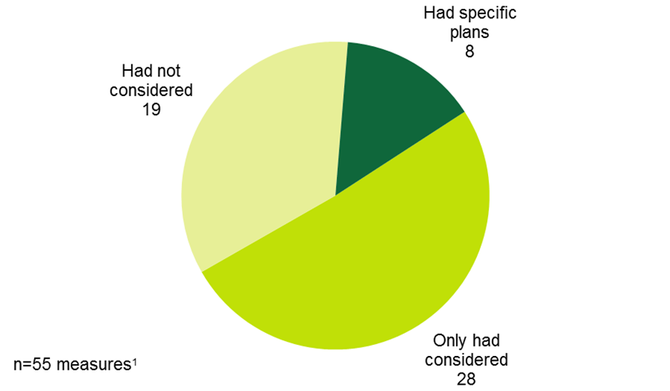
¹ The participants verified that they had installed these 55 measures either as HES-IE free core service or as incented add-on measures.
For most (five) of the eight measures that they had specific plans to install, the interviewed landlords planned to install the same efficiency level as those that they eventually had installed through the program. Generally, they would have installed the measures at later dates than they did (five) and would have installed the same quantities (four).
Table 52 shows the average free ridership rates by measure. After being weighted by the number of interviewees asked about that measure type, the study found an overall weighted free ridership rate of 0.08 for HES-IE.
Table 52: HES-IE Landlord and Property Manager Interviewees – Free Ridership Rates
Measure | Count of interviewees | Average free ridership rate
Water saving | 15 | 0.10
Light bulbs | 12 | 0.16
Air sealing | 4 | 0.00
Pipe wrap | 1 | 0.00
Lighting equipment | 9 | 0.00
Insulation | 8 | 0.00
Refrigerators | 3 | 0.60
HVAC equipment | 1 | 0.00
Hot water heater | 1 | 0.00
Windows | 1 | 0.92
Weighted free ridership rate¹ |  | 0.08
¹ Free ridership rates are weighted by the number of interviewees responding about the specific measure types.

Spillover
As described earlier, the second input into the net-to-gross ratio is the spillover rate.
- Non-rebated measures. To estimate the spillover rate, interviews began by asking participating end-users and landlords/property managers if they had made any energy efficiency upgrades that had not received rebates or incentives since participating in the program.
- Program influence level. If they had done so, respondents rated the program’s level of influence on their decision. If they considered the program as having had influence on their decision to make the upgrade, the study considered them to be spillover-eligible measures.
- Weighting by savings. For end-users, the analysis weighted the percentage of respondents installing a spillover-eligible measure by the average savings in the program database (or other sources where possible and necessary) associated with that measure type. The weighted average proportion of respondents installing particular measures represented an initial spillover value.
- Adjusting for additional factors. The estimate integrated the possibility that light bulbs were already incented through upstream program efforts and, therefore, halved the average savings as a proxy for its value in the weighting process. Additionally, the surveys and interviews did not collect two measure characteristics that are integral to estimating associated savings: 1) the quantities/number of units or 2) the efficiency levels of the spillover-eligible measures. To take this parameter into account, the algorithm counted one-third of the initial weighted spillover value.
The study arrived at a spillover rate of 0.02 for HES based on end-user survey responses and 0.03 for HES-IE, which is the weighted average of the results from HES-IE end-user survey responses (0.03) and HES-IE landlord and property manager interviews (0.03). The study did not ask short-term (R31) study respondents about spillover given the relatively short time span between participation and survey completion.
Critically, the approach likely underestimates spillover because it does not factor in nonparticipant spillover, which, due to program marketing, increased availability of products, and word-of-mouth from participants, can be substantial. Future study designs that focus more exclusively on NTG estimation should consider using alternative survey questions or even a completely different approach that would allow for the more precise estimation of overall and measure-specific spillover for both participant and non-participant end-users.

HES – Spillover
As illustrated in Figure 48, nearly one-fifth of the HES respondents who were asked about spillover (19%) had installed or performed an energy-saving measure that did not receive an incentive following their participation in the program and indicated that their decision to move forward was influenced by the program—meaning that they rated the program’s level of influence on their decision to install or perform the measure a 3 or higher on a scale of 1 to 5, where 1 means “no influence” and 5 means “a great influence.” In total, they listed 73 measures that were influenced by the program, making those measures eligible for spillover; most often they mentioned light bulbs (26% of measures) and insulation (11% of measures).
Figure 48: HES End-user Participant Survey Respondents – Spillover Measures
(Count of measures - multiple responses)
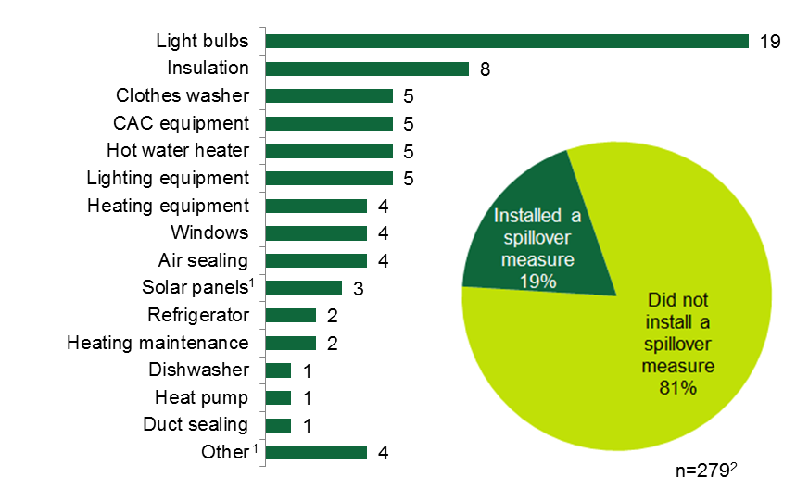
Note: Percentages are weighted and counts are unweighted.
¹ These measures are not in the HES program savings database.
² Represents the number of respondents asked about spillover. Fifty-four respondents installed one or more spillover-eligible measures.

After weighting the percentage of respondents reporting each spillover measure by the average savings values present in the program database associated with the respective measure type (where possible), the analysis resulted in an average spillover value of 0.06 for the HES program; the adjusted spillover value for the HES program is one-third of that initial value, or 0.02.
Table 53: HES End-user Participant Survey Respondents – Spillover Rate
Program-Influenced Measure Installed Outside of Program | % of Respondents (n=279)¹ | Average Gross Savings (kWh/yr)¹
Light bulbs | 40% | 484
Insulation | 13% | 3,595
Lighting equipment | 11% | 484
Hot water heater | 10% | 3,293
CAC equipment | 10% | 308
Clothes washer | 8% | 214
Refrigerator | 7% | 264
Air sealing | 6% | 1,395
Heating equipment | 4% | 1,882
Windows | 4% | 3,305
Duct sealing | 3% | 1,119
Solar panels² | 3% | 3,287
Heating maintenance² | 2% | 3,992
Heat pump | 1% | 285
Dishwasher | 1% | 226
Initial weighted spillover | 0.06
Adjusted spillover | 0.02
Note: Percentages are weighted.
¹ Average savings in the program database associated with each measure. Gas, oil, and propane savings have been converted into kWh/year. The initial spillover rate is the average of the proportions of respondents naming the spillover measure weighted by the average gross annual savings. The adjusted spillover is one-third of that value.
² Solar rebate program data were not readily available; therefore, solar panel estimates come from calculations using PV Watts’ online calculator tool, which can be found here: http://pvwatts.nrel.gov/pvwatts.php. The estimate does not include the Other category because of lack of savings data.

HES-IE – Spillover
As illustrated in Figure 49, 10% of HES-IE end-users each installed one or more spillover-eligible measures. Like HES end-users, HES-IE end-users most frequently reported light bulbs as their spillover measures (19%).
Figure 49: HES-IE End-user Participant Survey Respondents – Spillover measures
(Count of measures - multiple responses)
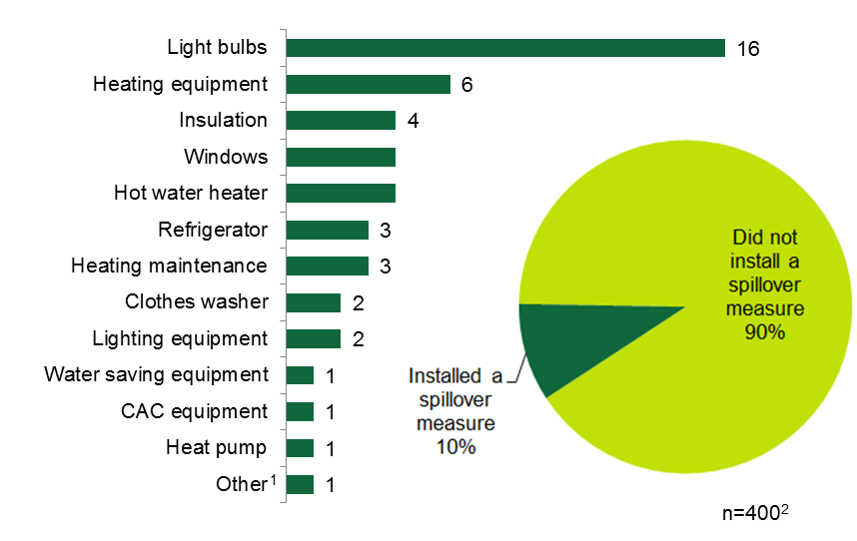
Note: Percentages are weighted and counts are unweighted.
¹ These measures are not in the HES program savings database.
² Represents the number of respondents asked about spillover. Thirty-eight respondents installed one or more spillover-eligible measures.

These responses, once weighted by the average program savings by measure, result in a spillover rate of 0.08 among HES-IE end-users; the adjusted spillover value is one-third of that, or 0.03.
Table 54: HES-IE End-user Participant Survey Respondents – Spillover Rate
Program-Influenced Measure Installed Outside of Program | % of Respondents (n=400) | Average Gross Savings (kWh/yr)¹
Light bulbs | 42% | 484
Insulation | 11% | 3,595
Lighting equipment | 6% | 484
Hot water heater | 11% | 3,293
CAC equipment | 2% | 308
Clothes washer | 5% | 214
Refrigerator | 7% | 264
Air sealing | - | 1,395
Heating equipment | 16% | 1,882
Windows | 11% | 3,305
Water-saving equipment | 2% | 247
Heating maintenance | 8% | 3,992
Heat pump | 3% | 285
Initial weighted spillover | 0.08
Adjusted spillover | 0.03
Note: Percentages are weighted.
¹ Average savings in the program database associated with the respective measure. Gas, oil, and propane savings have been converted into kWh/year. The initial spillover rate is the average of the proportions of respondents naming the spillover measure weighted by the average gross annual savings. The adjusted spillover is one-third of that value.
Three HES-IE landlords and property managers reported making three energy efficiency upgrades following participation in the program that did not receive rebates or incentives but were influenced by the program (Appendix A.5.2); the study considers these three measures to be spillover measures. Because all three interviewees named different measures, and each represented 3% of the sample, there is no need to weight the measures by savings. Their responses result in a spillover rate of 0.03 among HES-IE landlords and property managers. Averaging this rate with end-user participants’ spillover rate—which also was 0.03—the resulting spillover value was 0.03.

Benchmarking – Net-to-Gross
Table 55 compares this study’s estimates of Connecticut HES free ridership, spillover, and overall net-to-gross values with other recent estimates from the Northeast:
- Free ridership. The HES program-wide free ridership rate of 0.22 is slightly higher than the free ridership values estimated for Efficiency Maine and NYSERDA, which vary from 0.14 to 0.20. The HES free ridership values for insulation, air sealing, and CFL measures differ somewhat from those found in Massachusetts, with Connecticut insulation free ridership (0.06) being much lower than that of Massachusetts (0.25), and Connecticut CFL and air-sealing free ridership rates (0.25 and 0.55) being higher than those in Massachusetts (0.08 and 0.29).
- Spillover. Connecticut HES spillover is lower than that of nearby programs, except in the case of light bulbs where the Massachusetts spillover rate is 0.03 and that of Connecticut (even when adjusted for upstream incentives) is seven times higher (0.20). Additionally, unlike the Massachusetts study, the Connecticut study estimate includes other light bulbs, not just CFLs (e.g., LEDs), which might even point to a greater value.
- Net-to-gross. The Connecticut HES overall net-to-gross ratio is 0.80, while neighboring programs have values greater than 1.0. However, the insulation net-to-gross ratio for Connecticut (1.07) is higher than that of Massachusetts (0.95)
Table 55: Net-to-Gross Results – Benchmarking
Net-to-Gross Element | Measurement Level | Comparison Program |  | Connecticut HES Ratio / Value
 |  | Program | Ratio / Value
Free Ridership Rate | Program-wide | Maine RDI | 0.18 |  | 0.22
 |  | Maine HESP | 0.14
 |  | NYSERDA HPES | 0.20
 | Insulation | Massachusetts HES | 0.25 |  | 0.06
 | Air Sealing |  | 0.08 |  | 0.25
 | CFLs / light bulbs |  | 0.29 |  | 0.55
Participant Spillover | % participants installing | Maine RDI | 28% |  | 19%
 | Program-wide |  | 0.77 |  | 0.02
 | Program-wide | NYSERDA HPwES | 0.14
 | Insulation | Massachusetts HES | 0.20 |  | 0.13
 | Air Sealing |  | 0.08 |  | 0.06
 | CFLs / light bulbs |  | 0.03 |  | 0.20
Net-to-Gross | Program-wide | Maine RDI | 1.59 |  | 0.80
 |  | NYSERDA HPwES | 1.08
 |  | Massachusetts HES | 1.13
 | Insulation |  | 0.95 |  | 1.07
 | Air Sealing |  | 1.00 |  | 0.81
 | CFLs / light bulbs |  | 0.73 |  | 0.65

Non-Energy Impacts Findings
6
Non-energy impacts, or NEIs, refer to benefits or drawbacks that participants experience as a result of program participation that do not tie directly to energy use or savings. They can considerably affect a participants’ decision to adopt a measure and their experience with the measure post installation.
To develop non-energy impact (NEI) rates, in-depth interviews and CATI surveys asked end-user HES and HES-IE CATI survey respondents and HES-IE landlords and property manager interviewees if the program had a positive, negative, or no effect on various non-energy-related elements in their households or properties. Additionally, using similar questions, CATI surveys asked nonparticipant end-users to speculate on the types of non-energy impacts that they could imagine might happen; the analysis used their responses to contextualize end-user participants’ responses to NEI questions. Interviews with HES vendors also involved discussion of NEIs, but the analysis does not use those findings to estimate any NEI values.
For any elements where participants observed positive or negative impacts as a result of the program, questions asked them to compare the value of that NEI to the impact of the program on energy savings. After asking about individual NEIs, the questions asked them to consider the net impacts of NEIs combined—qualitatively and quantitatively. From these inputs, the study estimated NEI values.
The analysis resulted in NEI values of 0.92 for HES end-users, 0.97 for HES-IE end-users, and 0.73 for HES-IE landlords and property manager participants. Meaning that, on average, for every $100 worth of savings that they/their tenants experience on their energy bills, HES-IE landlords and property managers consider that non-energy impacts add an additional $73 of value, for example. In other words, the NEI values can be considered as multipliers that are applied to energy savings (e.g., 73% * expected energy savings). For further explanation behind the methodology for calculating these values, see Appendix A.6.1.

End-user Participant Surveys – Non-Energy Impacts
- End-user participants experience high levels of positive net non-energy impacts.
The vast majorities of HES (83%), HES-IE (79%), and rebate-only (93%) end-user participants observed positive net impacts from NEIs (Figure 50). In general, end-user participants said they experienced NEIs that aligned with their expected NEIs, although this did vary to some extent.
Figure 50: End-user Participant Survey Respondents – Net Non-Energy Impacts
(Percentage of respondents)
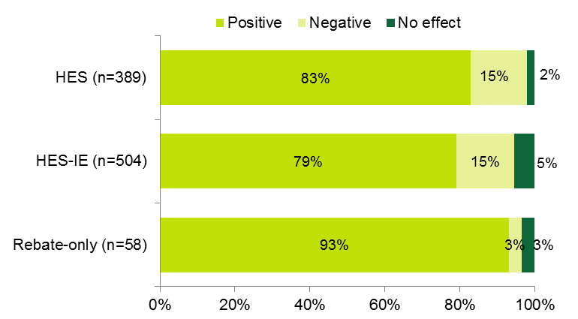
Note: Responses are weighted.
Surveys asked end-user participants if the program had a positive, negative, or no effect on each of the following elements: the comfort of the home, outside noise, appliance or equipment noise, illnesses and missed days from work or school, equipment maintenance and durability, ability to pay energy bills or other bills (e.g., water bills), lighting quality, safety from other improvements or new equipment, home appearance and value or the ability to sell it, or any other NEIs they may have noticed. Responses to these questions indicated the following:
- As proportions of the overall NEI values among HES (0.92) and HES-IE (0.97) participants, comfort carried the greatest importance for both (0.30 and 0.24), accounting for one-quarter or more of the NEI values.
- Positive impacts on improved lighting quality (0.11 and 0.18) and ability to pay energy bills (0.13 and 0.14) contributed relatively large portions to HES and HES-IE overall NEI values.
- Rebate-only end-users placed the greatest importance on the positive impacts on their comfort (0.36), composing nearly one-third of their overall NEI value of 1.18; they also placed a great deal of importance on the positive impacts on their homes’ value/ability to sell their homes (0.20) and equipment maintenance (0.16).
- While few reported negative impacts, those who did most often reported that the quality of their lighting had been negatively impacted.
Figure 51: End-user Participant Survey Respondents – Distribution of Non-Energy Impact Values
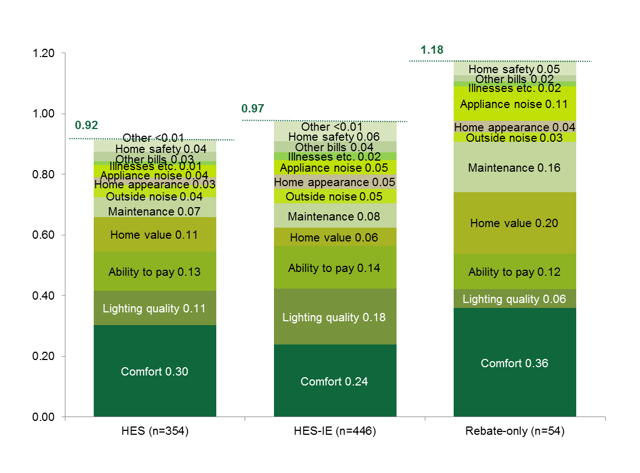
Note: Sample sizes do not include all respondents that were asked the NEI module. Some respondents gave responses that resulted in outlier values; other respondents did not know the magnitude of effects despite identifying them as positive or negative. The analysis excluded them from the NEI values. Appendix A.6.1 provides greater explanation.

End-user Nonparticipant Surveys – Non-Energy Impacts
- Nonparticipants project net-positive NEIs.
When not prompted with specific examples, most nonparticipant end-user survey respondents could not name any NEIs that might result from a program like HES/HES-IE. Low-income respondents speculated that there would be non-energy impacts more frequently than non-low-income (NLI) respondents. Of those who did offer some possible NEIs, most nonparticipant respondents speculated that their ability to pay energy bills, comfort, and appliance or HVAC system noises would be positively impacted. (Appendix A.6.3 illustrates these results in greater detail.)
Once the survey asked about specific impacts, nonparticipant respondents voiced higher levels of expected NEIs: the majorities of NLI (76%) and low-income (75%) nonparticipants hypothesized that they would experience net-positive impacts from NEIs (Figure 52). When compared with their HES and HES-IE participant counterparts’ actual experiences, nonparticipants were more likely to estimate that there would be no effect and less likely to estimate that there would be a positive effect.
Figure 52: Nonparticipant Survey Respondents – Net Non-Energy Impacts
(Percentage of respondents)
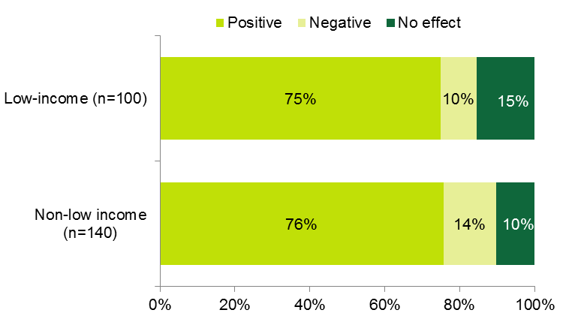
Note: Responses are weighted

HES-IE Landlord and Property Manager Interviews – Non-Energy Impacts
- Interviews indicate high NEI values among landlords and property managers
As reported, the NEI value among HES-IE landlords and property managers was 0.73. Nearly all (93%) reported positive net impacts resulting from NEIs (Figure 53).
Figure 53: HES-IE Landlord and Property Manager Interviewees – Net Non-Energy Impacts
(Count of interviewees)
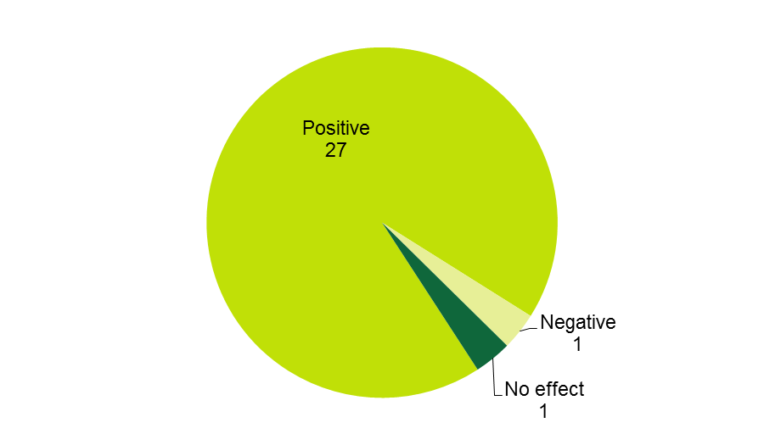
- Landlords and property managers observe positive impacts on operations and maintenance, tenant comfort, and safety.
In-depth interviews asked landlords and property managers if the program had a positive, a negative, or no effect on each of the following elements: the comfort of the residents, operations and maintenance, tenant complaints, tenant ability to pay rent, the amount of other bills (e.g., water bills), safety from improved lighting, safety from other improvements or new equipment, property value or the ability to sell, or any other NEIs they may have noticed. As proportions of the overall NEI value of 0.73, operations and maintenance (0.15), tenant comfort (0.14), and safety from improved lighting (0.14) carried the greatest importance. One property manager interviewee reflected on the positive value of improving tenant comfort and operations and maintenance for their company:
[The first priority] is the comfort of our residents. [It matters] to us in the office because when we have happier residents, we have fewer things to work on. We spend less time going up to people’s apartment to fix maybe a window draft or things like that. And plus we want our residents to be comfortable.
Figure 54 illustrates how the individual NEIs sum to 0.73.
Figure 54: HES-IE Landlord and Property Manager Interviewees – Non-Energy Impacts Values
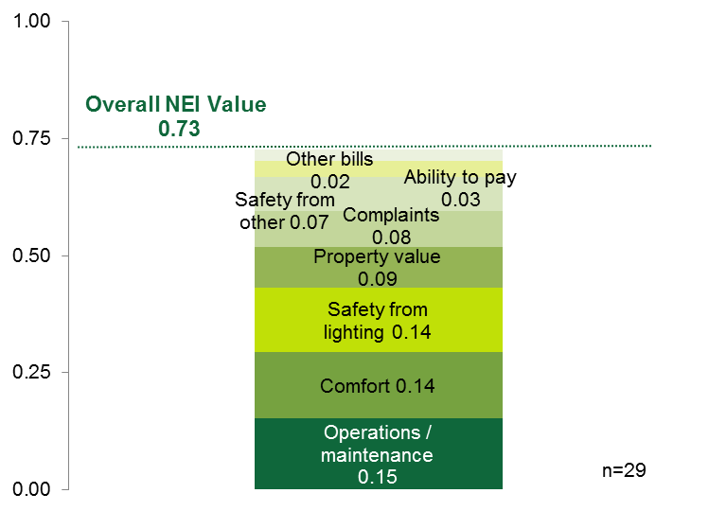

- Landlords and property managers report very few negative NEIs, but note some negative impacts on tenant complaints and safety.
Landlords and property managers were very unlikely to report any negative NEIs—the only elements for which they reported negative NEIs were tenant complaints (10%) and safety (7%). For example, two interviewees received complaints about the dimness of the new lighting installed by the program, both recounting how tenants have removed the lighting covers to remedy the issue:
There have been a ton of complaints about the energy-efficient [bulbs] installed in the apartments. The residents can’t stand them, because they are not as bright as the previous [bulbs]. In fact I have a ton of fixtures that our residents have asked us to remove the covers off the light fixtures because the lights are so dim. They don’t help at all. But with the covers off they give a little more light.
Two interviewees identified safety concerns from the air-sealing measures that needed to be remedied; the air sealing made it difficult to open windows or latch exterior doors closed. While one thought the problem outweighed the energy savings, the other thought it had much less negative value than the possible energy savings value:
It saves the energy, so it is worth doing it. It was worth it because they were doing a good job tightening things up [to stop air] leaks. Some of them were too tight for tenants, but it is still worth it.
- NEIs are somewhat important drivers
NEIs were somewhat important in HES-IE landlords and property managers’ decisions to participate in the program. Rating the importance of expected NEIs on their decision to participate in the program by using a scale of 1 to 5 where 1 equals “not at all important” and 5 equals “very important,” on average, they rated the importance a 3.72 for themselves (n=27) and a 3.80 for their tenants (n=28). Before participating, the majority had some particular NEIs in mind that they thought would result from program participation (Figure 37 in Appendix A.6.4)—specifically, improving operations and maintenance, reducing tenants’ complaints, and increasing tenants’ level of comfort. In the words of one property manager,
“When we have happier residents we have fewer things to work on.”
– HES-IE property manager
We knew from experience that anything new would help improve [the property]. Most of the tenants are low-income and disabled. Anything they can get to improve their [lifestyle] makes it easier for them and for us.

HES Vendor Interviews – Non-Energy Impacts
While end-users, landlords, and property managers may experience NEIs after installing measures, vendors have the opportunity of informing HES and HES-IE participants about the impacts they may experience as a result of installing both core measures and deeper measures. Vendors answered a series of questions about their discussions and promotions of NEIs to HES and HES-IE participants. A total of 16 vendors answered these questions, although not all of them responded to each question.
- Nearly all vendors discuss comfort and health and safety as positive non-energy impacts with program participants—and actually think participants will experience them.
Of the 16 vendors asked about NEIs, 13 mentioned comfort and 11 mentioned health and safety (Table 56). Importantly, while vendors explained that participants may experience these impacts from core services, they stressed that installing deeper measures such as insulation or early replacement of heating systems will only increase the comfort and health and safety of the household. It is not surprising that vendors focus on these two measures, as most also believed that participants would actually see improvements to their comfort and health and safety, and, according to the vendors, participants seemed to care about these benefits more than others; the participant surveys discussed above support this belief. Some other NEIs mentioned by a few vendors included home value; outside noise; equipment maintenance, durability, and ease of operation; and ability to pay other bills.
Vendors also displayed an in-depth and nuanced understanding of what constitutes “comfort” and “health and safety.” For the latter, they included not only issues such as mold or asbestos insulation but also reduced fire hazards, indoor air quality, or the sealing of gaps and holes that let rodents and insects in. On comfort, one vendor explained that it was not just physical comfort but also the psychological comfort associated with equipment maintenance and reliability:
If [the measure is] heating or cooling they are [considering], they’ll save energy but [they are] also thinking, “Oh great! I can get rid of that system that doesn’t work, and it will be a more comfortable winter.” So it’s comfort in terms of peace of mind and then comfort physically.
A few additional noteworthy observations from vendors on NEIs include the following:
- Vendors did not consider “ability to pay energy bills” to be a non-energy benefit. They believed participants would see lower energy bills, but vendors categorized this as an energy-related benefit—and the reason the programs exist in the first place.
- One vendor who served multifamily buildings asserted that the inclusion of water-saving measures made the ability to pay water and sewer bills very important to landlords and property managers.
- Echoing end-users and landlords, the only negative impact mentioned was reduced light quality tied to CFLs, and even this one vendor called it a “double-edged sword” because participants typically like fixtures and brighter bulbs in the kitchen, but disliked the quality of light for other applications.
- A vendor who argued that the programs boost a home’s value called out the addition of the “home energy score” in support of this benefit.
Table 56: Vendor Perspectives on Non-energy Impacts
Number of responses | Mention to Participants | Personally Believe Participants will Experience | Participants seem to Value¹
Comfort | 13 | 11 | X
Home health and safety | 11 | 6 | X
Home value / appearance or the ability to sell the home | 5 | 2 | X
Outside Noise | 4 | 2
Equipment maintenance and/or durability | 4 | 1
Ability to pay non-energy bills such as water or sewer | 3 | 2 | X
Appliance or heating/cooling system noise | 2 | 1
Family illnesses and missed days from work or school and associated medical care | 2 | 0
Light quality | 1 | 1 | X
Environmental benefits / climate change | 1 | 1 | X
Avoid ice dams | 1 | 1
¹ As this question came at the very end of the survey, fewer than one-half of the 16 vendors provided an answer. Therefore, the table includes only an indicator of those mentioned by any vendors and not counts of how many respondents mentioned them.

Benchmarking – Non-Energy Impacts
The study benchmarked its results against two Northeast program evaluations that had been conducted relatively recently and were comparable in methodology. The first study evaluated a low-income program in Rhode Island (RI) that is similar to the Connecticut HES-IE program, and the second evaluated numerous programs offered by MA program administrators to both low-income and NLI customers. Table 57 compares the results.
Connecticut HES-IE participants (62%) were just as likely as their counterparts in RI (61%) to experience positive impacts on their comfort resulting from the program. When it came to their ability to pay energy bills, HES-IE participants (48%) were less likely than their counterparts in RI (62%) to report a positive impact.
The percentages of HES and HES-IE participants reporting that the program had a positive impact on other elements were lower than participants in the MA programs, although the differences were negligible for low-income participants’ comfort. An important difference between the studies, however, was that the MA study only asked about specific NEIs (e.g., comfort or property value) for deeper retrofit measures such as new HVAC systems and/or insulation, while the R4 study focused more broadly on the impact of the HES/HES-IE program, asking all respondents about all NEIs.
When asked to compare the combined value of the NEIs to the expected energy savings, Connecticut HES and HES-IE participants valued program NEIs considerably more than their MA peers, reporting that the NEIs were roughly equal to expected energy savings, whereas MA NLI participants estimated NEIs equal to about three-quarters and MA low-income participants estimated NEIs equal to just over one-half of their expected savings.
Table 57: Non-Energy Impacts Results – Benchmarking
Benchmarking Parameter | Comparison Program |  | Connecticut Value | Notes / Considerations
 | Program | Value
Percentage experiencing positive impacts – Low-income/HES-IE
Comfort | Rhode Island (RI) Income Eligible¹ | 61% | 62% | None
 | MA Cross-cutting² | 65% |  | The MA study asks about thermal comfort specifically.
Ability to pay energy | RI Income Eligible | 62% | 48% | None
Property value or ability to sell | MA Cross-cutting | 57% | 30% | For both, the base is only homeowners (not renters).
Quality of lighting | MA Cross-cutting | 68% | 59% | The MA study also asks about lifetime in addition to quality.
Percentage experiencing positive impacts – NLI/HES
Property value or ability to sell | MA Cross-cutting | 80% | 35% | See above.
Comfort |  | 76% | 63%
Maintenance and/or durability |  | 73% | 37%
Quality of lighting |  | 70% | 49%
Value of NEIs as percentage of bill savings
NLI/HES | MA Cross-cutting | 77% | 92% | None
Low-income/HES-IE |  | 52% | 97%
¹ Cadmus. National Grid Rhode Island: Income Eligible Services Process Evaluation. October 1, 2014.
² NMR. Massachusetts Special and Cross-Sector Studies Area, Residential and Low-Income Non-Energy Impacts (NEI) Evaluation. Prepared for Massachusetts Program Administrators. August 15, 201

Health and Safety Findings
7
The study asked participating HES/HES-IE end-users, HES-IE landlords and property managers, and HES vendors about the home health and safety issues that vendors have found during the home energy assessments. The respondents also addressed the implications that health and safety problems have on moving projects forward and the remediation steps that at least some participants take to resolve the issues in order to install energy-efficient measures. CATI surveys also asked nonparticipating occupants if they have discovered any health and safety issues in their homes to use as a baseline for comparison purposes. Four key themes emerged:
- From the vendor perspective, health and safety issues often prevent projects from moving forward.
- Comparisons between participants (who learned about health and safety issues during the assessment) and nonparticipants (who knew of the issues on their own) offered results that varied by income.
  - Low-income: HES-IE participants more frequently learned about health and safety issues via the assessment compared to income-eligible nonparticipants, who had prior knowledge about the same issues.
  - NLI: In contrast, HES participants were somewhat more likely to have learned about health and safety issues during assessments compared to nonparticipants in the same income category who had learned of such issues on their own.
- Participating end-users were more likely to learn that they have asbestos insulation from the vendors than were nonparticipating end-users to discover this on their own.
- Remediation costs act as a barrier to having asbestos fixed, therefore preventing the full assessment from taking place.

End-user Participant Surveys – Health and Safety
- Vendors discover asbestos and vermiculite insulation and knob and tube wiring; participant remediation is hindered by cost.
Ten percent of HES and 22% of HES-IE end-user participants reported that the program vendors discovered at least one health and safety issue that kept vendors from completing the full assessment. Asbestos issues were most commonly mentioned in both programs (4% of HES and 8% of HES-IE); HES-IE participants also noted mold (6%), vermiculite insulation (4%), and knob and tube wiring (4%) rather frequently. As shown in Table 58, when it came to remediation, similar patterns occurred among the two programs, with participants most likely to respond to gas (typically repaired by the natural gas companies, who are HES and HES-IE program administrators) and carbon monoxide leaks and least likely to remedy asbestos and vermiculite insulation. While only a few of them did not address the issues, participants had varied reasons for not doing so, such as indicating that the projects would be too costly, remediation was unnecessary, or they simply had not “gotten around to it” (Table 90 in Appendix A.6.1).
Table 58: End-user Participant Survey Respondents – Health and Safety Issues Found and Rates of Remediation
Health or Safety Issue | Percentage With Issue Found |  | Percentage With Issue Fixed¹
 | HES (n=433) | HES-IE (n=400) | HES (n=49) | HES-IE (n=90)
Gas leak | 2% | 2% | 100% | 100%
Carbon monoxide leak | 1% | 2% | 100% | 78%
Radon | 1% | 1% | 50% | 40%
Asbestos | 4% | 8% | 37% | 13%
Vermiculite | 1% | 4% | 14% | 21%
Mold | 1% | 6% | 80% | 41%
Knob and tube wiring | - | 4% | - | 31%
Other | 3% | 4% | 64% | 50%
Note: Responses are weighted.
¹ Sample sizes vary based on the base number of respondents that reported the issue being discovered by vendors.

End-user Nonparticipant Surveys – Health and Safety
- Nonparticipants discover issues on their own—primarily issues with mold.
NLI nonparticipant customers (16%) had more often discovered health and safety issues on their own than their HES counterparts had discovered during program assessments (10%). Conversely, low-income nonparticipant customers (19%) were less likely to have had health and safety issues discovered outside of the program than their HES-IE counterparts (22%). Put another way, the programs tend to help low-income households identify health and safety issues more than they help other households. As shown in Table 59, nonparticipants often discovered mold (13%). This is unlike program participants, however, who were more likely to learn that they had asbestos insulation. While nonparticipants were fairly likely to address issues, aside from vermiculite and knob and tube wiring, they expressed the same reasons as participants for not remedying health and safety issues: the cost and not having gotten around to it (Table 91 in Appendix A.6.1).
Table 59: End-use Nonparticipant Survey Respondents – Health and Safety Issues Found and Rate of Remediation
Health or Safety Issue | Percentage With Issue Found |  | Percentage With Issue Fixed¹
 | NLI (n=140) | Low-income (n=100) | NLI (n=23) | Low-income (n=19)
Gas leak | - | 1% | n/a | 100%
Carbon monoxide leak | 1% | - | 100% | n/a
Radon | 3% | 1% | 75% | 100%
Asbestos | 2% | - | - | n/a
Vermiculite | 3% | 5% | 67% | 29%
Mold | 12% | 13% | 72% | 79%
Knob and tube wiring | 1% | 2% | - | 67%
Note: Responses are weighted.
¹ Sample sizes vary based on the base number of respondents that reported the issue being discovered.

HES-IE Landlord and Property Manager Interviews – Health and Safety
- Health and safety issues were found but remediated without causing major program implementation delays.
Five of the 30 landlord and property manager interviewees said that vendors identified health or safety problems during the energy assessment at only one of the five properties, thus delaying the initial assessment until maintenance staff had remediated the problem. All problems were resolved and did not cause extensive delays (additional details in Table 113 in Appendix B.2.4).

HES Vendor Interviews – Health and Safety
Participant surveys and interviews did not illustrate the extent to which health and safety issues prevent projects from ultimately taking place. The main obstacle that vendors need to navigate around is the health and safety issues they often face when conducting the assessment. The discovery of mold, asbestos, knob and tube wiring, vermiculite insulation, gas leaks, etc., frequently force technicians to halt the assessment because some core measures cannot be installed until the issues are remediated. Vendors estimated that health and safety issues occur in roughly one-quarter of all jobs (with estimates ranging between 5% and 40%).

Connecticut Contractor Development
8
The study asked vendor interviewees about the growth of the industry and development of contractors’ businesses and practices in the state they have seen from the HES/HES-IE program. Interviewees included 16 HES vendors who served the program in 2014. Questions focused primarily on the impact of HES on their businesses and, to some extent, the impact on the market overall.

Direct Program Impact on Vendors’ Businesses
- Vendors fall into two types: those who rely almost exclusively on HES for their work and those for whom HES supplements their work.
When asked to provide an estimate of how much of their work is HES-related, seven of the 12 vendors answering the question said 75% to 100%, while five said 50% or less (Figure 55). Breaking this down shows even more bifurcation: five of the vendors said 100% of their work comes from HES, but three said less than 10% of their work did. This last group includes one vendor who served HES in 2014 but was not selected to continue with the program in 2015, and a second vendor who had actively reduced their involvement in HES due to associated increased “administrative costs” of working with the program.
Figure 55: HES Vendor Interviewees – Percentage of Work from HES
(Count of responses)
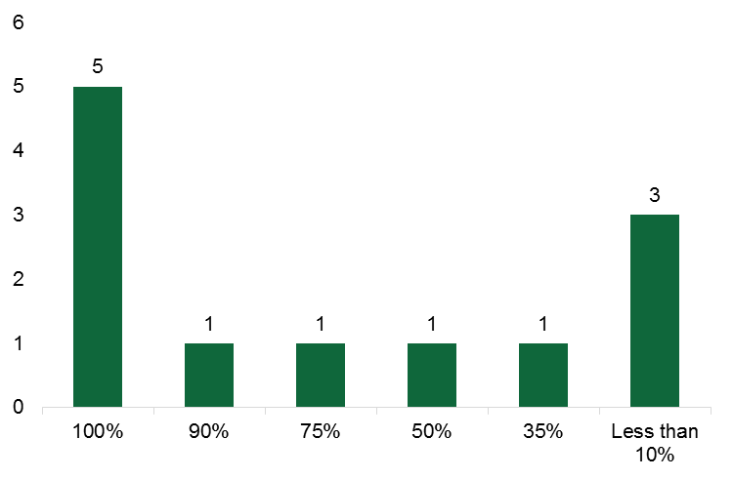

- Viability of vendors’ businesses largely depends on the existence of HES.
Being extremely careful to stress that the scenario was completely hypothetical, interviewers asked vendors to assess the impact of the closing of HES on their business. Most vendors explained that it would have a large negative impact. Some argued that not only would they have to close their businesses, but also that the entire industry would collapse:
I basically would just shut down shop, give up, and do something else.
Right now, the market is not ready to really have any type of robust energy-efficiency industry without a subsidized program.
I think if the program did go away, we wouldn’t have an industry, and we would lose everything that we’ve worked for to this point.
Others argued that their businesses would survive, but they predicted revenue decreases of 60% to 80%. Only the few vendors who already have substantial non-HES work felt that stopping the program would have little impact on their work.

- Vendors report that the program has led to increased staffing and revenue levels.
Interviews asked vendors about the program’s impact on their staffing and revenue:
- Staffing levels. Many vendors reported that their staff levels had at least doubled since they started working with HES; five said they had increased staffing by more than 500%, although the initial staffing levels often were quite small (e.g., only two staff members). Vendors generally attributed these increases to their partnership with the program. Others argued that their staffing levels vary with their workload, with two in this group directly tying the fluctuations to HES budgets and program “constraints.” One of these two vendors clarified that the program’s “tightening” of rules around the vendor’s measure recommendations and the “push for gas” have negatively affected their HES business, causing the vendor to lay off people they had initially hired for program work.
- Revenue. Likewise, 10 of the 16 vendors reported that their revenue had increased since joining HES. However, four explained that their revenue initially went up and then went down, while two others said their revenue had not really changed. Vendors attributed at least 50% of the revenue increase directly to HES work, with only one reporting that revenue was less than 50% and three others choosing not to answer (Figure 56). HES participants, however, rarely turn to the vendors to perform additional non-HES work. Ten of the 13 vendors answering this question said less than 10% of their work comes from HES participants who hire them for non-HES services following HES participation, but some vendors were quick to point out that this reflects their decision to focus their business solely on providing HES services. The other three vendors responding said 10% to 29% of their non-HES work stemmed from former HES customers.
Figure 56: HES Vendor Interviewees – Percentage of Revenue Increase from HES
(Count of responses)
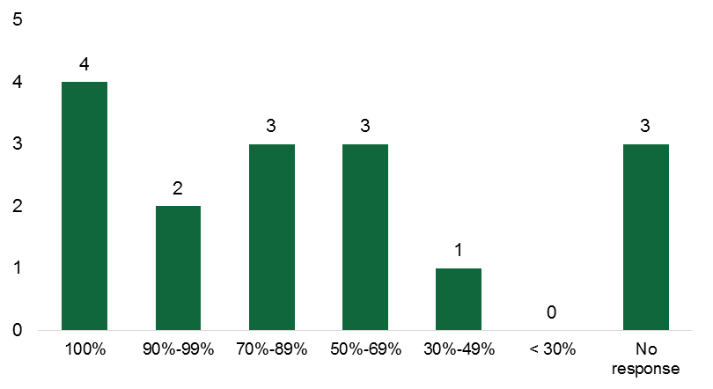

Impact of HES on Energy Service Industry
- Vendors believe HES has helped expand their energy efficiency business and the general market for energy efficiency services, but they are more uncertain about the continued HES-induced growth of the industry.
Vendors also rated their agreement with four statements about the current and future impact of HES on the market for energy efficiency services, using a zero-to-ten scale, where zero was “strongly disagree” and ten was “strongly agree.” The four questions read as follows:
“I think that the program actually creates the marketplace.”
– HES vendor
- There is more business for your company than there would have been without the program.
- There is more business in general in the marketplace than there would have been without the program.
- There will be more business for your company than there would have been without the program.
- There will be more business in general in the marketplace than there would have been without the program.
Every vendor agreed (with a rating of six or higher) that HES has increased the amount of work available for their business; the mean was 9.5 (Figure 57). They also generally agreed that HES has positively impacted the energy services market in general; every vendor again provided a rating of six or higher, but the mean response of 8.4 was lower than for direct vendor impact.
I have seen other companies not linked directly with the program directly benefit through referrals.
Some vendors, however, did voice concerns about the rules and requirements to be a program-approved contractor. Some also said they perceived greater allocation of program funds to core services as opposed to the deeper measures, which they thought were barriers to HES having a greater impact on the marketplace in general.
Vendors held a wider range of opinions about the future impact of HES on the amount of work for their business and the marketplace, and the mean ratings were 7.9 and 7.4, respectively. The greater uncertainty about the future impact of the program centered on the program “rules,” such as the test results for recommending measures and the measures rebated by the program. As one vendor explained, “If things stay the same, and they don’t change or tighten rules, I would say eight or nine.” Another vendor pointed out that, while not there yet, if the market were to become saturated, business would decrease for all vendors.
Figure 57: HES Vendor Interviewees – Degree to which HES Has Affected/Will Affect Amount of Business
(Count of responses)
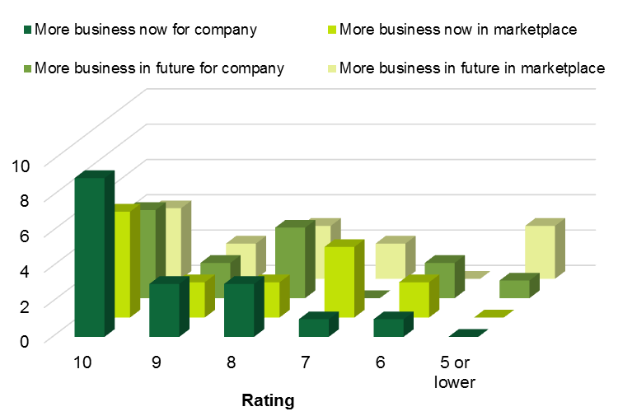
Note: Responses are on a scale of zero to ten, where zero is “strongly disagree” and ten is “strongly agree.”

Benchmarking – Connecticut Contractor Development
The benchmarking of the contractor development compared the results of this study with those of the Better Buildings Neighborhood Program (BBNP) market effects study. The BBNP study asked the same set of scale questions of participating program contractors as this Connecticut HES study asked its program vendors, offering a point of comparison despite a number of caveats in program structure and study focus when comparing the studies and programs. Due to these caveats, the reader should interpret these results with caution. Percentages of vendors agreeing with the statements related to Connecticut HES were considerably higher than those ratings for BBNP. As with the BBNP study, this Connecticut study shows a decrease in the expectations for impacts on the market in the next two years. However, the decreases in expected changes in the market in the next two years were notably larger for the Connecticut vendors compared to the BBNP contractors—possibly reflecting vendors’ concerns about the future of the program, but also higher initial values and hence more potential for a decrease.
Table 60: Connecticut Contractor Development – Benchmarking
Benchmarking Parameter | Comparison Program |  | Connecticut HES Value | Notes / Considerations
 | Program | Value
Staff increases
Percentage of program vendors reporting staff increases attributable to the program | Better Buildings Neighbor-hood Program (BBNP)¹ | 43% | 60% | BBNP percentages includes commercial contractors (29 of 147 contractors)
Agreement Scales (percentage of vendors rating 7 to 10)
Impact program has had on my company | BBNP | 58% | 94% | This analysis excluded commercial contacts from BBNP results so percentages in this table do not appear in the original BBNP report
Impact program will have on my company |  | 51% | 79%
Impact program has had on the market generally |  | 58% | 88%
Impact program will have on the market generally |  | 52% | 79%
¹ Research into Action, Inc. and NMR. Market Effects of the Better Buildings Neighborhood Program: Volume 5. February 2015.
Note: The differences in sample sizes between this study (n=15 vendors) and the BBNP study (n=147 vendors) is quite large.

Connecticut Clean Energy Communities (R152) Findings
9
Findings from the Clean Energy Communities task (R152) were split into two subsections: themes that emerged from the in-depth interviews with utility staff and leaders of energy-related community groups, and results of the data analysis.

Findings From the CEC Interviews
Findings from the in-depth interview portion of this task have been split into three segments: 1) observations about the characteristics and behaviors associated with successful CEC engagement, 2) common responses from community leaders in regard to driving HES participation through the CEC program, and 3) community leader recommendations for improving the CEC program.

Successful Community Characteristics
The first theme that emerged from the in-depth interviews is that successful community engagement in the CEC program is driven by a core group of highly motivated individuals within that community. One community leader respondent said that the key to program success is “identifying a small group of passionate people who are willing to work long and hard together.” The identification of a small group of dedicated individuals can be a strength; however, relying on a small group can also be a weakness. A different community leader mentioned that their community had previously had one community member who was responsible for much of the impetus for that town’s engagement with the program but, after that person left the town, engagement with the program ceased for a few years. Activity only restarted when a new cadre of motivated community members re-engaged with the program. All of the communities identified as successful in the CEC program have now formalized their core group through the creation of a town taskforce or committee rather than simply being a group of interested individuals acting on their own. By creating such a body, the loss of a key individual does not remove the position that person held, and thus creates some stability in the community’s engagement with the program.
A second theme common to the interviews is that piggy-backing on other community events in order to engage the public in the CEC program (and energy efficiency and clean energy in general) served as a successful strategy for community outreach and education. Such occasions include town fairs, celebrations on community greens, back-to-school events, and the like. By joining existing events, the CEC reached community members who may not otherwise have engaged with energy-related issues. As one respondent said, “People come to get their kids’ faces painted and leave with information on insulation and lighting efficiency.” Interviewees also noted, however, that capturing the attention of people in the community who are not self-motivated about energy efficiency remained one of the challenges for CEC, leading some to stress the importance of managing expectations for this kind of community engagement. For example, one respondent voiced frustration about having to compete with the cupcake booth located next to their table of fliers on energy efficiency.
A final theme common to all the interviews was the importance of the utility staff in executing the program. The utility staff were clearly proud of their efforts to be accessible and responsive to community members, and this was reflected by community member recognition of the efforts and effectiveness of the utilities’ program staff. Several of the community respondents appreciated the utilities’ efforts to assist in outreach and partner with the town or town energy committee. Due to the uniform praise regarding the accessibility of the utility program staff, towns seeking to increase their program engagement should be encouraged to communicate with the utility staff members to develop a strong relationship between the town’s energy taskforce and the CEC utility program staff. Community members should invite utility staff to meetings and events, ask their advice on the most effective strategies for encouraging adoption of energy conservation (and renewable energy) behavior, and brainstorm creative ways to engage community members who may have little interest in energy-related issues.

Relationship between CEC and HES
Community leaders’ responses were mixed regarding the extent to which the CEC program drives HES program participation. Several community leaders expressed disappointment at the low levels of HES uptake in their communities, even in communities that have relatively high levels of HES uptake compared to the rest of the state. As one respondent said, “People who are already interested in [energy efficiency] are already aware of the program, but we’re not sure how to reach those not interested.” Another respondent suggested that working with specific contractors could be an asset for program outreach; however, it is not appropriate for most towns to recommend specific contractors. A third respondent identified having a high proportion of renters as an additional challenge associated with encouraging HES participation in a community, saying that they were still searching for a way to better engage landlords and property managers. One community found that giving away HES home assessments as prizes at a community event (that is, paying the HES assessment co-pay) was an effective way to raise awareness and interest in the program, and that doing so seemed to encourage people to sign up for the program. The CEC program was praised for the way in which points are accumulated for participation in HES and other programs as well as deeper measure update; one respondent likened this approach to frequent flier miles or credit card points and thought this was a useful way to simplify targets and encourage success.

Suggested Improvements to CEC
Responses from community leaders regarding how the CEC program could be improved fell into two related categories. First, community leaders suggested that more structure would be beneficial to the program. One respondent said that it was “empowering that the taskforce decided how and what to do, but a more standardized framework would be helpful.” Respondents indicated that it would be useful if they were given some guidance or recommendation of what activities they can take and how to accomplish them. The second category related to simplifying the program. The respondents were glad that multiple energy efficiency programs are available, and they understood that each of these programs evolve to reflect changing circumstances and program goals. However, the frequent changes and evolution made it difficult for the volunteer committees to keep up to date with all of the relevant program details.

Findings From CEC Data Analysis
This section describes the findings of the data analysis, progressing from the simplest measures of statistical association toward an analysis that controls for additional factors which may influence that association. There are two questions that are tested in this section: first, if measure of utility outreach to communities is associated with greater community CEC point accumulation and, second, whether utility outreach is associated with higher community HES deep-measure uptake. The findings are that there is a relatively weak association between outreach and point accumulation, once other community factors that are associated with point accumulation are controlled for, and that there is not a statistically detectable consistent relationship between utility outreach and deep-measure uptake. A more detailed description of this work follows.
Data on outreach activities by utility staff were used to group towns based on the intensity of the outreach received. The estimated number of utility interactions for each town was normalized by the town’s size (using household counts, as reported by the CEC dashboard) to generate normalized town outreach rates. Towns were then grouped by quartile of these normalized outreach rates. The resulting quartiles are not uniform in terms of town counts due to a clustering of towns at the lower bound (i.e., those with no outreach events). These town quartile groups were used to test for independence between the groups using points accumulated, as reported on the CEC dashboard, as an outcome of interest. This was done for both total residential points (program and rebate points summed) and total town efficiency points, which include municipal and small business activities as well.

Chi-Squared Test
- Participation in CEEF-funded residential, municipal, and small business programs varies by level of CEC program activity, as measured by the program point system.
This subsection reports results of a chi-squared test of the association between utility outreach and CEC point accumulation. Table 61 reports the values and results of the chi-squared tests of group independence. The town quartile columns are the groupings of towns based on the normalized utility outreach activities. The points achieved under the CEC program are listed for all CEC activities in the left-hand tables and for residential activities only in the right-hand tables. The “expected points” columns indicate the number of points that would be expected of that quartile given the number of towns and an assumption that there is no relationship between the quartiles and point accumulation. The two top tables show results of all points accumulated in the CEC program to date, while the bottom two tables show results only for the same period as the outreach data that were available from the utility staff. The tests indicate there is a statistically significant relationship (p < 0.1) between membership in the town quartiles and points accumulated for each of the four points measures tested.

Table 61: CEC Outreach Chi-Squared Test Results
 | Total CCEC Points |  |  |  |  |  | Residential Only Points
All points accumulated through October, 2015 | Town Utility Outreach Quartile | Achieved Points | Town Count | Expected Points |  |  | Town Utility Outreach Quartile | Achieved Points | Town Count | Expected Points
 | 1 (highest) | 7,206 | 41 | 6,239 |  |  | 1 (highest) | 4,748 | 41 | 3,979
 | 2 | 6,295 | 39 | 5,935 |  |  | 2 | 3,736 | 39 | 3,785
 | 3 | 3,364 | 20 | 3,043 |  |  | 3 | 2,248 | 20 | 1,941
 | 4 (lowest) | 8,852 | 69 | 10,500 |  |  | 4 (lowest) | 5,668 | 69 | 6,696
 | Total | 25,717 | 169 | 25,717 | χ², p < .001 |  | Total | 16,400 | 169 | 16,400 | χ², p < .001
Points accumulated 2012 through October, 2015 | Town Utility Outreach Quartile | Achieved Points | Town Count | Expected Points |  |  | Town Utility Outreach Quartile | Achieved Points | Town Count | Expected Points
 | 1 (highest) | 4,678 | 41 | 4,082 |  |  | 1 (highest) | 2,816 | 41 | 2,481
 | 2 | 4,199 | 39 | 3,883 |  |  | 2 | 2,416 | 39 | 2,360
 | 3 | 2,246 | 20 | 1,991 |  |  | 3 | 1,494 | 20 | 1,210
 | 4 (lowest) | 5,704 | 69 | 6,870 |  |  | 4 (lowest) | 3,500 | 69 | 4,175
 | Total | 16,827 | 169 | 16,827 | χ², p < .001 |  | Total | 10,226 | 169 | 10,226 | χ², p < .001

ANOVA Test
This subsection reports additional findings of the relationship between utility outreach and CEC point accumulation. Table 62 shows the results of a series of analysis of variance (ANOVA) tests in which the annual normalized outreach quartile groups are tested for joint significance (F statistic) as predictors of total points accumulated in each year (left-hand table) and as predictors of the percent of households in a town that are new participants in the HES program (right-hand table). This test was selected in order to identify the years in which the utility outreach grouping is, jointly, associated with each outcome. Statistical significance in these tests is shown with p-values less than 0.1. These ANOVA tests indicate a statistically significant relationship at the 90% confidence level between normalized outreach quartile and CEC points in 2013, 2014, and 2015 and between normalized outreach quartile and new household participation in 2013 and 2015.
Table 62: CEC Outreach ANOVA Test Results, Annual
 | New Points per Year |  |  |  | New Household Participation per Year
Year | F stat | df | p value |  | F stat | df | p value
2012 | 0.46 | 1 | 0.5003 |  | 0.21 | 1 | 0.6458
2013 | 19.32* | 1 | <0.0001 |  | 8.43* | 1 | 0.0042
2014 | 6.47* | 2 | 0.0020 |  | 1.52 | 2 | 0.2228
2015 | 9.61* | 2 | 0.0001 |  | 4.20* | 2 | 0.0167
* Indicates significance at 90% confidence level
The results shown in Table 61 and Table 62 suggest a relationship between the level of town outreach and CEC outcomes. However, these simple analyses do not prove a causal relationship. Instead, other factors such as social, economic, or demographic characteristics of town residents could be driving the results. Therefore, the study turned to ordinary least squares regression to tease out impacts of the program after controlling for some of these other factors.

Ordinary Least Squares Regression
This subsection reports a final set of measures of association between utility outreach and CEC point accumulation as well as findings of the association between utility outreach and HES deep-measure uptake rates. Table 63 presents the results of a series of regression models that tested for the relationship between normalized town outreach and the accumulated points in each prior program year, while controlling for median town income and the percentage of renters in the town. Compared to the chi-squared and ANOVA analyses, the analysis suggests a much weaker relationship between outreach activity and CEC points earned by households in a community in a given year, as indicated by the coefficient estimates for normalized interactions, after controlling for other factors. Only 2014 shows a statistically significant effect of outreach once these additional controls are included.
Table 63: CEC Outreach Regression Results
Predictor Variable | Coefficient Estimate  (Standard Error)
 | 2012 | 2013 | 2014 | 2015
Cumulative Points (t-1) | 0.105* | 0.075* | 0.131* | 0.084*
 | (0.045) | (0.030) | (0.022) | (0.017)
Median Income | 0.739 | 0.345 | 0.714* | 0.038
 | (0.470) | (0.398) | (0.330) | (0.305)
Rental % | 0.244* | 0.135* | 0.158* | -0.041
 | (0.096) | 0.081 | (0.068) | (0.063)
Normalized Utility Outreach (t) | -3.263 | -0.302 | 9.100* | 3.678
 | (32.477) | (2.660) | (3.504) | (6.499)
Constant | 0.276 | 4.091 | -1.106 | 6.796*
 | (5.575) | (4.678) | (3.878) | (3.548)
R² | 0.075 | 0.061 | 0.288 | 0.147
Dependent variable is points earned in year (t).
* Indicates significance at 90% confidence level
A final set of tests performed was an examination of the association between CEC outreach and the uptake of deeper HES measures. Table 64 shows the results of these multivariate regressions in which the dependent variable in each column is a different deep HES measure category, normalized to town population. The table reflects results from 2014, which is the only complete year for which deeper HES measure data were available for both Companies. As the table shows, the only significant relationships between outreach and deeper HES uptake are for heat pumps and air conditioning—and the results are in the wrong direction, suggesting that outreach is associated with lower uptake of these two measures. Lacking a theoretic explanation for the inverse relationship between uptake of these measures and CEC outreach, combined with the relatively poor explanatory power of the models (R²), it is likely that this finding is spurious. That is, the finding of a reduction in deeper-measure uptake as a function of utility outreach is probably an aberration rather than a meaningful result. However, the results do suggest that there is no consistent relationship between outreach and uptake of these individual measures.

Table 64: CEC Outreach Association with HES Deep-Measure Uptake, 2014
Predictor Variable | Coefficient Estimate  (Standard Error)
 | Insulation | Furnace/Boiler | Heat Pump | Air Conditioning | Windows
Normalized Utility Outreach | 0.0007 | -0.0008 | -0.0046* | -0.0013* | -0.0002
 | (0.0007) | (0.0005) | (0.0013) | (0.0006) | (0.0002)
Median Income | 0.0003* | <0.0001* | -0.0002* | 0.0002* | <0.0001
 | (<0.0001) | (<0.0001) | (0.0001) | (<0.0001) | (<0.0001)
Rental % | >-0.0001* | <0.0001 | -0.0001* | >-0.0001 | >-0.0001
 | (<0.0001) | (<0.0001) | (<0.0001) | (<0.0001) | (<0.0001)
Constant | 0.0004 | <0.0001 | 0.0092* | -0.0001 | 0.0005
 | 0.0007 | <0.0001 | (0.0015) | (0.0007) | (0.0002)
R² | 0.318 | 0.039 | 0.183 | 0.185 | 0.025
* Indicates significance at 90% confidence

Document Review Findings
10
The document review assessed the materials and resources that Energize Connecticut and the utilities provide in support of the HES and HES-IE programs, and whether those materials and resources are effective, clear, engaging, consistent and accessible to potential program participants and vendors. The analysis indicates that the participation and financing materials and vendor documentation tools offered are generally clear and effective resources for customers and vendors to utilize. The document review also helped to clarify whether any existing materials or resources currently support the evaluation’s recommendations. The program provides many resources to meet customer and vendor needs. Table 65 summarizes the program recommendations and discusses them in light of existing materials and resources.
Table 65: Evaluation Recommendations – Relationship with Program Document Review Findings
# | Recommendation Description | Audience | Documentation Review Findings
Process Recommendations
#4 | Participants recommend increased advertising; consider new/additional opportunities with vendors to conduct co-op advertising | Customers | The document analysis did not find evidence of co-op advertising.
#5 | Future advertising should continue to emphasize energy and energy cost savings; address customer skepticism about need for improvements or "I haven't gotten around to it" attitudes | Customers | The program provides a great deal of advertising using a variety of mediums, but it does not appear to underscore the necessity of making the improvements and “act fast” language.
Financing and Decision-making Recommendations
#7 | Provide vendors with additional or more detailed talking points/materials to encourage add-on measure upgrades | Vendors | The document review findings indicate that the program provides extensive print and online materials to support customers and vendors, but survey and interview findings indicate that additional details about program offerings may be needed to address customer concerns about information quality. Short-term survey respondents are significantly more satisfied with information quality than long-term respondents, possibly signaling program improvements or superior recall due to more recent participation.
#8 | Clarify program processes and offerings further for customers who are concerned about information quality | Customers
#11 | Provide "everyday" language version of loan applications | Customers | The program's online financing tool already provides a great deal of assistance to customers, but the other evaluation efforts indicate that customers and vendors need clearer and/or further guidance.
#12 | Expand on materials that provide financing information | Customers
#13 | Provide vendors with additional talking points/sales methods to address initial loan rejections | Vendors | The Implementation Manual asks vendors to direct customers to the Energize Connecticut website for more information about financing options, but does not encourage them to explain the options in detail to better ensure that that the customer understands the options and how best to take advantage of them.
#14 | Provide guidance to vendors about preferred language to use when referring to financing | Vendors
NEI Recommendations
#15 | Greater emphasis on NEIs in program materials | Customers | Program messaging does not actively highlight NEIs such as improved comfort and safety, which can be major motivators for participation.
Health and Safety Recommendations
#23 | Provide more information on the financing options that cover at least part of the costs of remediating health and safety issues. | Customers | Current program materials do not suggest financing options for health and safety remediation.
Note: Evaluation recommendations can be found in greater detail in the Executive Summary of this report.

As noted above, the document review included the customer-facing and vendor-facing resources and materials that the Companies provided, as well as the program website. Table 66 links commonly used documents with their target audiences and the program areas they support. Refer to Sections 10.1 through 10.4 for further details about these documents.
Table 66: Program Documentation Included in Document Review
Resources/Materials | Target Audience |  | Related Program Areas
 | Customers | Vendors | Process | Financing | Decision-making
Energize CT website | x |  | x | x
Energize CT Online Loan Tool | x |  |  | x
Print on Demand Booklet | x |  |  | x
HES Home Energy Report | x |  | x |  | x
Financing Chart |  | x |  | x | x
Rebate and Incentives Chart |  | x |  | x | x
Implementation Manual |  | x | x | x | x

Participation Resources and Materials
Program materials contain a significant amount of information about the assessment process that appears to be easy to understand from the customer perspective. In particular, the Energize Connecticut website and the HES Home Energy Report are relatively straightforward in their descriptions of program processes. The following is a more detailed description of key program resources and materials provided to end-users:
- The Energize Connecticut website is straightforward and should be easy for customers to use to find information on particular areas of interest, such as contractors to work with or rebates to apply for. It is also clear and easy to figure out how to schedule an assessment as well as find out which services are offered.
- The HES Home Energy Report is customer-facing and explains exactly what should take place during the assessment in clear language; it is not overly technical or written in language that might be confusing. The Recommendations pages in this Packet could be difficult for customers to understand, but it is assumed it would be covered in person by the vendor during the kitchen table wrap-up.

Vendor Tools and Materials
The program produces a number of materials and resources to support vendors as they work to educate customers about the assessment and program offerings. Overall, these resources appear to be clear and concise. Following is a more detailed description of key program tools offered to vendors.
- The Print-on-Demand Booklet is used by vendors when speaking with customers during the kitchen table wrap-up after the assessment. It provides information such as release forms, rebate applications, and an HES “checklist” that highlights the key areas to cover during the assessment.
- The Implementation Manual appears to be a useful resource for vendors as they help guide customers through the program. It instructs them to assist customers in filling out qualifying rebate forms and to discuss the rebate and incentive options with customers. It provides example language to use during this explanation for each type of offering. It also provides detailed instruction for vendors about how to discuss the results of the energy assessment with the customer and offers example language to use when explaining the results. It also includes language on how to make specific recommendations to the customer for further work in each area of efficiency covered by the assessment.

Financing Tools and Materials
The program produces a number of tools and materials to support customers as they learn about the financing options that are available to them. The Energize Connecticut website and its online financing tool as well as the Print-on-Demand Booklet provide a good deal of financing background information for customers. Vendors are provided with a chart of financing options, and the Implementation Manual instructs vendors to refer customers to the Energize Connecticut website to learn more about financing options. Following is a more detailed description of key financing tools and materials offered to end-users and vendors.
- The Online Financing Tool is housed on the Energize Connecticut website; it is a customer-facing interactive financing tool that is easy to find and helps customers learn about and apply for financing options online. The process may be somewhat confusing without talking with a specialist before filling out an application, but it appears to provide a good summary of information and description of the various options available to customers.
- The Implementation Manual asks vendors to direct customers to the Energize Connecticut website for more information about financing options, but does not encourage them to explain the options in detail to better ensure that that the customer understands the options and how best to take advantage of them.
- The Financing Chart provides a brief yet useful overview of individual loan types available to customers. The Implementation Manual does not encourage vendors to refer to this chart.
- The Print-on-Demand Booklet has two pages on financing. One contains a table listing the different loan programs and associated program improvements, and the second page has information on the Energy Conservation Loan Program. It not clear if this is referring to one of the types of loans included in the first page, and if not, how it differs and why it is listed separately.

Marketing Materials
The program provides many different marketing materials to reach potential HES customers. An analysis of these materials indicates that there are several marketing channels used, including traditional means (e.g., newspapers, bill inserts, brochures, letters, television, and phone outreach), as well non-traditional means, such as paid advertisements on Pandora Radio and Facebook, and Google pay-per-click advertisements (Table 67). Based on the marketing materials provided, they appear to be clear and easy to understand. Despite these numerous activities, participants responding to the CATI survey recommended increasing advertising and the quality of information provided about the program.
Table 67: Marketing Mediums Used to Support HES and HES-IE Programs¹
Medium | HES Specific | HES-IE Specific | General Energy Efficiency Messaging
TV |  |  | X
Radio (English and Spanish) | X | X | X
Google Pay-Per-Click | X | X | X
Pandora Radio |  |  | X
Digital Display Advertising | X | X | X
Transit: Bill boards |  |  | X
Transit: Bus |  |  | X
Transit: Metro North |  |  | X
Facebook advertising |  |  | X
Direct Mail | X | X
Bill inserts | X | X | X
E-mail | X |  | X
Print ads, newspaper, Spanish only | X | X
You Tube Advertising | X | X | X
Community Events | X | X | X
Door-to-door canvassing (done by trade allies with company supervision) | X | X | X
Point-of-purchase info |  | X
Association advertising (Chambers, environmental group, AARP, neighborhood associations) in newsletters, directories, websites | X | X | X
Public Relations (formal energy efficiency campaigns, not just opportunistic) | X | X | X
Authorized contractors coop advertising | X | X
¹ Source: HES Marketing_Jan_26_2015.docx
² 2015 marketing plans include an expansion of e-mail communications with HES-IE customer and door-to-door canvassing with HES customers.

- Additional Details
A
  - Methodology
    - End-user Participant Surveys
Table 68 presents the strata weights that the study used for analysis.
Table 68: Participant End-user Survey – Weights for Analysis by Study
Strata Group | Weight
R4 Strata
HES – Core Only | 1.66
HES – Insulation | 0.66
HES – Other Tier II | 0.25
HES-IE – Core Only | 0.92
HES-IE – Tier II | 1.11
HES-IE – Insulation | 1.07
R31 Strata
Core Only | 1.70
Insulation | 0.72
Tier II | 0.40
Rebate Only | 0.50

Table 69: Participant End-user Survey – HES Sample Frame Development (R4)
HES Participants (July 2013 – December 2014) | Eversource | % of Total | UI | % of Total | Total
Original records provided (measure-level) | 284,482 | 83% | 60,217 | 17% | 344,699
Original projects | 20,443 | 84% | 3,892 | 16% | 24,335
Duplicate/incomplete/commercial contacts | 1899 | 69% | 851 | 31% | 2,750
Unique contacts | 18,544 | 86% | 3,041 | 14% | 21,585
% of original projects | 91% |  | 78%
Contacts reserved for other studies | 6,317 | 90% | 720 | 10% | 7,037
% of unique contacts | 34% |  | 24%
No measures | 101 |  | 63 |  | 164
Sample frame provided for R4 | 12,126 | 84% | 2,258 | 16% | 14,384
% of unique contacts | 65% |  | 74%
Completed surveys | 377 | 87% | 56 | 13% | 433
% of sample | 3% |  | 2%

Table 70: Participant End-user Survey – HES-IE Sample Frame Development (R4)
HES-IE Participants (July 2013 – December 2014) | Eversource | % of Total | UI | % of Total | Total
Original records provided (measure-level) | 187,323 | 88% | 24,655 | 12% | 211,978
Original HES-IE projects | 5,931 | 67% | 2,885 | 33% | 8,816
Duplicate/incomplete contacts | 347 | 68% | 167 | 32% | 514
No measures | 13 | 27% | 35 | 73% | 48
Unique contacts | 5,571 | 67% | 2,683 | 33% | 8,254
% of original HES projects | 94% |  | 93%
Sample frame provided for R4 | 5,571 | 67% | 2,683 | 33% | 8,254
% of unique contacts | 100% |  | 100%
Completed surveys | 345 | 86% | 56 | 14% | 401
% of sample | 6% |  | 2%

Table 71: End-user Participant Survey – Verified Sample Measures Compared to Population Measures
Measure | HES |  | HES-IE |  | Rebate-only
 | Population (n=26,762) | Sample (n=547) | Population (n=10,434) | Sample (n=525) | Population (n=815) | Sample (n=60)
Air Sealing | 69% | 53% | 65% | 54% | - | -
Duct Sealing | 24% | 15% | 12% | 5% | - | -
HVAC maintenance | - | - | 6% | 5% | - | -
Light Bulbs | 93% | 88% | 87% | 82% | - | -
Water Pipe Wrap | 69% | 41% | 32% | 20% | - | -
Lighting equipment | - | - | 1% | < 1% | - | -
Water Saving Equip. | 59% | 45% | 79% | 63% | - | -
AC Equipment | 2% | 3% | - | - | 30% | 23%
Appliance (unspecified) | < 1% | < 1% | 18% | 3% | - | -
Clothes washer | < 1% | < 1% | - | - | - | -
Air Source Heat Pump | < 1% | < 1% | - | - | 9% | 8%
Ductless Heat Pump | 3% | 4% | - | - | 45% | 57%
Freezer | - | - | 2% | 3% | - | -
Geothermal Heat Pump | < 1% | 1% | - | - | < 1% | 3%
Heating Equipment | 2% | 4% | < 1% | < 1% | 20% | 13%
Water Heater | 1% | 2% | - | - | 6%
Refrigerator | < 1% | < 1% | 14% | 23% | - | -
Windows | 2% | 4% | 1% | 1% | - | -
Insulation | 18% | 26% | 22% | 20% | - | -
Note: Excludes some measures that represented very small portions of the population and were not included in the samples.
Table 72 includes more detail on the reasons that surveys were not completed for R4 and R31. For R4, no answer (30%) or pickup by an answering machine or voicemail (35%) were the most common reasons for non-response. These served as the second (24% no answer) and third (14% answering machine) most common reasons for R31 non-response. The most common R31 reason for non-response was refusal to complete the survey (40%), which was the third most common reason for non-response among R4 respondents. The different rates of answering machines between the two surveys reflects that 1) the surveyors had more numbers to draw on for R4 than R31, and 2) more sample was released and called on to meet quotas toward the end of the surveys, but quotas were reached before these numbers could be dialed further to either turn them into completes or other dispositions.
Table 72: End-User Participant Survey – Reasons for Not Completing Survey
(Base = all phone numbers dialed at least once)
Reasons for not completing survey | Percent of Numbers Dialed
 | R4 | R31
Phone Numbers not Yielding Completed Survey | 10,837 | 2,199
Non completed surveys | 15% | 42%
Mid-survey termination | <1% | 2%
Household-level refusal | 14% | 40%
Not Contacted – Respondent never available | 7% | 5%
Other | 1% | 2%
Language problem | 1% | 2%
Miscellaneous | <1% | 0%
Unknown Eligibility | 67% | 39%
Always busy | 1% | 0%
No answer | 30% | 24%
Answering machine | 35% | 14%
Call blocking | <1% | <1%
Not Eligible | 10% | 13%
Fax/data line | 1% | <1%
Disconnected number | 4% | 4%
Number changed | 3% | 0%
Cell phone | <1% | 0%
Business, government office, other organizations | 1% | 1%
No eligible respondent | 1% | 1%
Quota filled | <1% | 6%

    - End-user Nonparticipant Surveys
Table 73: Nonparticipant End-user Survey – Sample Frame Development
HES Nonparticipants | Eversource | % of Total | UI | % of Total | Total
Original records received | 3,400 | 68% | 1,600 | 32% | 5,000
Missing/invalid phone number | 2 | 6% | 32 | 94% | 34
Commercial contact | 238 | 81% | 55 | 19% | 293
Duplicate contact (phone, address, or contact name) | 19 | 95% | 1 | 5% | 20
Participant sample contact | 23 | 74% | 8 | 26% | 31
Final sample frame | 3,118 | 67% | 1,504 | 33% | 4,622
% of original records in sample frame | 92% |  | 94%
Table 74 includes more detail on the reasons that surveys were not completed for 20,546 of the R4 nonparticipant phone numbers called. Most commonly, the phone call was picked up by an answering machine (59%) or was not answered (14%). The third most common reason was that the respondent was never available (12%). The high rate of answering machines reflects the release of additional sample toward the end of calling in order to achieve desired quotas for low-income and NLI. The firm achieved its quotas before having the opportunity to redial answering machine-only numbers, so the numbers remained in that disposition.
Table 74: R4 Nonparticipant Survey – Reasons for Not Completing Survey
(Base = all phone numbers dialed at least once)
Reasons for not completing survey | Percent of Numbers Dialed
Phone Numbers not Yielding Completed Survey | 20,546
Non completed surveys | 9%
Mid-survey termination | <1%
Household-level refusal | 9%
Not Contacted – Respondent never available | 12%
Unknown Eligibility | 76%
Always busy | 2%
No answer | 14%
Answering machine-don't know if household | 59%
Not Eligible | 2%
Fax/data line | <1%
Disconnected number | <1%
Number changed | 1%
Business, government office, other organizations | <1%
No eligible respondent | <1%

    - On-site Persistence
Two drivers underlie the on-site persistence research into short-term persistence and laying the groundwork for future EUL studies. First, there are relatively few studies of persistence and EUL within the field of energy efficiency because program sponsors primarily allocate budget for process and impact evaluations that estimate annual savings rather than lifetime savings. Based on relatively simple primary research methods, the results of this study provide the EEB with Connecticut-specific information on persistence and EUL on the most common measures distributed through HES and HES-IE core services.
The second research driver is the commercial and industrial study conducted for NEEP (described earlier in this report) that included some multifamily units in its commercial-based sample and found that the 10-year persistence rate for compact fluorescent lamps (CFLs) was 33% and the two-year persistence rate was 73%. This raises the question of whether persistence may be similarly low for these programs.
The study presents two different variations on installation rates. The verified installation rate reflects the number of working lamps installed at the time of the site visit divided by the number of lamps in the tracking database. This value combines the effect of database and implementation issues with the effect of lamp removals, burnouts, and other lamp persistence factors. Note that the two-way mismatch between verified measures and tracking data greatly increases variance and thus reduces precision.
The persistence rate reflects the number of working lamps that were verified installed at the time of the site visit divided by the number of lamps that were verified received through the program. Thus, it excludes the effect of database and implementation issues reflected in the tracking data.
The verified installation rate calculation uses the following formula:
$$Verified Installation Rate= \frac{Verified Received Quantity -Removed Quantities}{Tracking Database Quantity}$$
Given the substantial differences in quantities found on site and verified to have been installed by the landlord or tenant compared to the tracking database, the analysis has not used these values in the calculation of persistence rates. Rather, this study uses the number of measures that were verified received as the basis for calculating persistence:
$$Persistence Rate= \frac{Verified Received Quantity -Removed Quantities}{Verified Received Quantity}$$
  - Program Process
    - End-user Surveys – Program Process
The majority of HES and HES-IE end-user respondents first learned about utility rebates and incentives during the energy assessment. HES (13%) and HES-IE (11%) respondents often learned through word of mouth as well, and rebate-only participants often learned of it through contractors (35%) or CAAs or similar organizations (14%).
Table 75: Participant End-user Survey Respondents – Channels of Incentive Awareness
(Percentage of respondents)
First channel for learning about incentives | HES (n=433) | HES-IE (n=400) | Rebate-only (n=60)
During the Home Energy Assessment | 28% | 12% | 11%
Word of mouth | 14% | 11% | 4%
Utility company advertisement | 7% | 4% | 7%
Community action agency or organization | 6% | 9% | 14%
Utility company bill insert | 6% | 8% | 4%
Utility company website | 5% | 5% | 7%
Another organization | 4% | 15% | 0%
Solar research / vendor / meeting | 4% | 0% | 4%
Installation contractor or vendor | 4% | 2% | 35%
Other | 6% | 7% | 0%
Don’t know / Refused | 16% | 28% | 15%

    - End-User Data Analysis – Wait Time
Table 76: HES End-user Records Marked for Exclusion from Wait-Time Analysis, by Vendor
Vendor Name | Total Records | Percent of Records Excluded
A Plus Installation, LLC | 431 | 0.9%
Aiello Home Services | 991 | 6.7%
BCB Conservation Group, LLC | 445 | 3.6%
Climate Partners, LLC | 157 | 1.9%
Competitive Resources, Inc. | 1,279 | 5.0%
EcoSmart by R Pelton Builders, Inc. | 1,959 | 2.8%
Energy Efficiencies Solutions, LLC | 1,602 | 0.4%
Energy Resource Group | 734 | 1.9%
EnergyPRZ, LLC | 1,459 | 1.2%
Fox Heating Services, Inc. | 323 | 0.3%
Greenbuilt Connecticut | 269 | 28.6%
Gulick Building & Development, LLC | 549 | 1.5%
Handyman Express Energy Solutions LLC | 426 | 1.6%
Hoffman Fuel | 198 | 2.5%
Home Doctor of America | 408 | 4.9%
Lantern Energy, LLC | 1,177 | 2.9%
Molina & Associates, Inc. | 280 | 0.4%
New England Conservation Services, LLC | 1,113 | 1.3%
New England Smart Energy Group, LLC | 1,789 | 3.3%
Next Step Living, Inc. | 3,834 | 7.5%
R&W Heating, LLC | 263 | 3.8%
Santa Fuel, Inc. | 434 | 4.4%
Tri City Home Energy Services | 403 | 0.5%
Uplands Construction Group, LLC | 409 | 1.2%
Victory Industries, LLC | 1,467 | 2.5%
Wesson Energy, Inc. | 1,390 | 2.4%
Other¹ | 76 | 0.0%
Total | 23,865 | 3.8%
¹ Vendors with fewer than 100 records have been combined into the “other” category.

  - Decision-Making and Financing (R46)
    - End-user Participant Surveys – Decision-Making and Financing
Table 77 is associated with Table 22 and includes all response options provided by HES respondents.
Table 77: HES End-user Participant Survey Respondents – Add-on Measure Decision-Making Factors
(Multiple responses, base = partial installers only)
Improvement Selection Reasoning | Measure Type |  |  | Total (n=204)
 | Core Only (n=65) | Tier II (n=68) | Insulation (n=71)
Least expensive | 40% | 31% | 34% | 37%
Biggest energy/utility bill savers | 28% | 32% | 41% | 32%
Easiest to install | 25%* | 16% | 10% | 20%
Already considering | 3% | 6% | 1% | 3%
Needed it | 3% | 3% | 4% | 3%
Age of equipment | 2% | 3% | 1% | 2%
Vendor recommendation | 2% | 4% | 3% | 2%
Easiest to find | 2% | 2% | 4% | 2%
Solar contractor recommendation | 0% | 0% | 3% | 1%
Other | 3% | 8% | 10% | 5%
Don't know/Refused | 3% | 1% | 1% | 2%
Note: Percentages are weighted. Respondents to this question are considered “partial installers” (those who have installed only some of the recommended measures).
* Indicates that core-only respondents were significantly more likely to make decisions based on what was easiest to install than Insulation respondents at the 90% confidence level.

Table 78 is associated with Table 23 and includes all response options provided by HES respondents.
Table 78: HES End-user Participant Survey Respondents – Motivations to Make Additional Improvements
(Multiple responses, base = both partial installers and full installers)
Reasons for Making Improvements | Measure Type |  |  | Total (n=249)
 | Core Only (n=81) | Tier II (n=74) | Insulation (n=94)
Save money on energy bill | 63%* | 41% | 49% | 57%
Save energy | 33% | 33% | 30% | 32%
Comfort | 6%* | 16%** | 1% | 6%
Be “green” / help the environment | 1%** | 5% | 11%*** | 4%
Increase ability to sell home or home value | 2% | 3% | 1% | 2%
Needed it | 1% | 1% | 4% | 2%
Health / safety | 0%* | 4% | 7% | 2%
Rebate | 0%* | 4% | 4% | 2%
Other | 10% | 12% | 10% | 10%
Note: Percentages are weighted.
* Indicates statistically significant difference from Tier II and Insulation respondents at the 90% confidence level.
** Indicates statistically significant difference from Insulation respondents at the 90% confidence level.
*** Indicates statistically significant higher than core service respondents at the 90% confidence level.
Figure 58: HES End-user Participant Survey Respondents – Likelihood to Install in the Next Year
(Base = non-installers only)
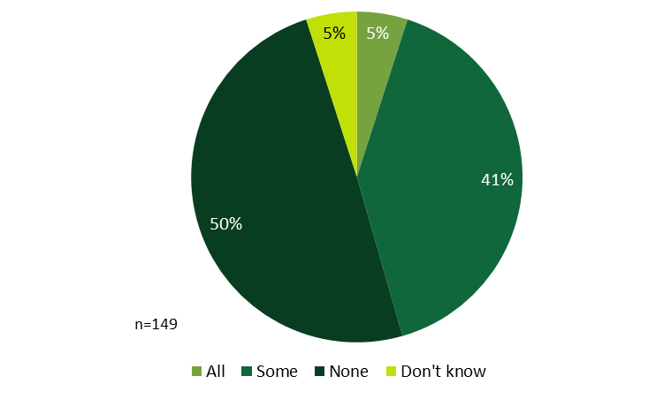
Note: Percentages are weighted.
Table 79 is associated with Table 25 and includes all response options provided by HES respondents.
Table 79: HES End-user Participant Survey Respondents – Reasons for Not Using Financing Options
(Multiple responses, base = partial or full installers not applying for financing)
Reasons for Not Using Financing | Measure Type |  |  | Total (n=158)
 | Core Only (n=61) | Tier II (n=41) | Insulation (n=56)
Have sufficient funds | 41% | 51% | 50% | 44%
Do not want debt | 10% | 13% | 16% | 12%
Did not have enough for upfront cost anyhow | 8% | 6% | 5% | 7%
Would not have been enough | 5% | 2% | 4% | 4%
Too much of a hassle | 2% | 2% | 5% | 3%
Application not approved | 2% | 0% | 2% | 2%
Used an outside loan option | 2% | 0% | 0% | 1%
Was not recommended | 2% | 0% | 0% | 1%
Other | 7% | 11% | 7% | 7%
Did not want to make the improvements anyway | 18% | 13% | 7% | 15%
Don't know/Refused | 7% | 2% | 5% | 6%
Note: Percentages are weighted.

Table 80 is associated with Table 26 and includes all response options provided by HES respondents.
Table 80: HES End-user Participant Survey Respondents – Reasons for Not Using Utility Rebates or Incentives
(Multiple responses, base = HES respondents not using rebates or incentives)
Reasons for not Using Rebates/Incentives | Survey Timing |  | Totals
 | Short-term (n=25) | Long-term (n=315) | (n=340)
Have sufficient funds | 26% | 14% | 15%
Did not have enough for upfront cost anyhow | 15% | 11% | 11%
Unaware of rebates | 12% | 10% | 10%
Expired/not enough time | 14% | 7% | 7%
Would not have been enough | 0% | 7% | 6%
Application not approved | 0% | 4% | 4%
Too confusing | 6% | 3% | 3%
Work not eligible | 6% | 3% | 3%
Too much of a hassle | 0% | 3% | 3%
Used Federal rebate | 3% | 0% | 0%
Haven't made improvements yet | <1% | <1% | <1%
Up to landlord | <1% | <1% | <1%
Other | 3% | 7% | 7%
Do want to make the improvements anyway | 3% | 21% | 21%
Don't know/Refused | 0% | 3% | 8%
Note: Percentages are weighted.

Figure 59: HES End-user Participant Survey Respondents – Improvements Made with Help of Program Financing
(Multiple responses, base = HES respondents at least somewhat aware of financing)
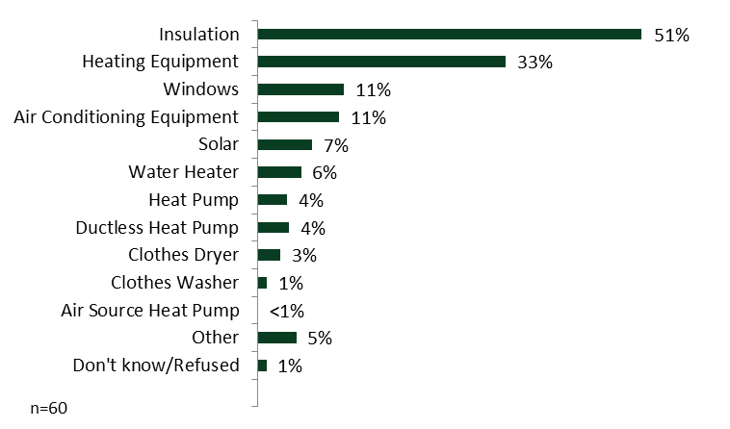
Note: Percentages are weighted.
Figure 60: HES End-user Participant Survey Respondents – Energy Improvements Made with Help of Rebates/Incentives
(Multiple responses, base = HES respondents at least somewhat aware of rebates and incentives)
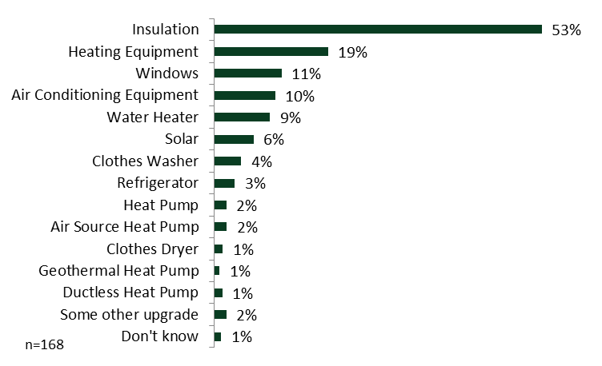
Note: Percentages are weighted.
As shown in Figure 61, HES respondents who did not recall having the vendor follow up with them after their initial visit and who did not install any additional improvements or only installed some of the recommended additional improvements were only slightly likely to have moved forward with improvements if the vendor had followed up with them both overall (mean rating of 2.1) and when compared by measure type.
Figure 61: HES End-user Participant Survey Respondents – Likelihood of Installing based on Vendor Follow-Up^{1, 2}
(Mean rating, base = partial or non-installers who did not recall vendor follow up)

Note: Means are weighted.
¹ Responses were not broken out by survey time as all were attributed to the longer time period.
² Rated on a scale from 1 to 5, with 1 indicating “Not at all likely” and 5 indicating “Very likely.”
    - End-user Nonparticipant Surveys – Decision Making and Financing
As shown in Figure 62, in the past year, over three-fifths of program nonparticipants (65%) have made improvements to their homes that were intended to increase energy efficiency. Note that these are self-reported purchases, and the study is not able to verify that the respondents actually obtained energy-efficient models. As shown in Table 81, light bulbs or lighting equipment improvements were the most common improvements made by both non-low-income (NLI) nonparticipants (52%) and low-income nonparticipants (52%). In reality, at least some of these bulbs were likely supported through upstream incentives at participating retailers, even if the purchasers did not realize they were taking part in a program. Low-income nonparticipants also commonly installed refrigerators (23%), and NLI nonparticipants also commonly installed insulation (19%). There was a significant difference between NLI nonparticipants (10%) and low-income nonparticipants (22%) who installed clothes washers.
Figure 62: Nonparticipant Energy Efficiency Improvements in Last Year
(Base = all nonparticipants)
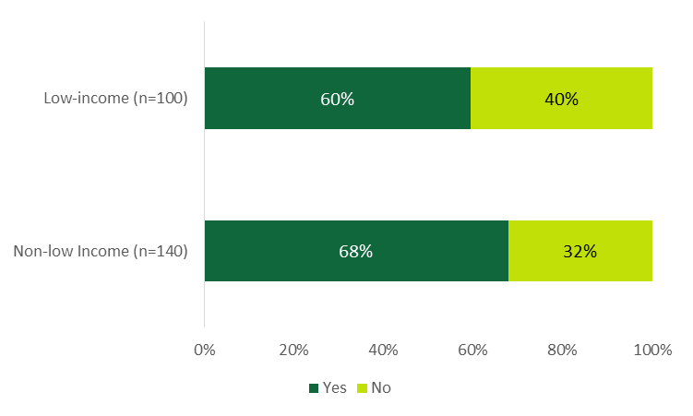
Note: Percentages are weighted.

Table 81 includes all response options provided by program nonparticipants.
Table 81: Nonparticipant Improvements Made
(Multiple responses, base = made improvements)
Improvements Made | Non-low Income (n=95) | Low-Income (n=59)
Light bulbs or lighting equipment | 53% | 52%
Refrigerators | 17% | 23%
Insulation | 19% | 16%
Clothes Washers | 10% | 22%*
Windows | 16% | 7%
Furnace | 7% | 7%
Central Air Conditioner | 7% | 3%
Appliances (General) | 3% | 7%
Doors | 3% | 4%
Stove | 6% | 1%
Heating System (General) | 3%* | 1%
Boiler | 3%* | 0%
Heat Pump | 3%* | 0%
Solar | 3%* | 0%
Dishwasher | 3% | 0%
Fuel Conversion | 2% | 0%
Windows | 2%* | 0%
Dryer | 2% | 0%
Showerheads | 1% | 1%
Other | 4% | 4%
Don’t know/Refused | 2% | 7%
* Indicates that low-income respondents were significantly more likely than NLI respondents to install clothes washers at the 90% confidence level.
Note: Percentages are weighted.

Table 82 is associated with Table 29 and includes all response options provided by program nonparticipants.
Table 82: Nonparticipant Reasons for Selecting Improvements Made
(Multiple responses, base = made improvements)
Reason for Choosing Improvements | Non-low Income (n=95) | Low- Income (n=59)
Greatest energy/utility savings | 26% | 21%
Replace aging/broken equipment | 24% | 18%
Most affordable | 16% | 21%
Easiest to find | 8% | 9%
Research/comparison shopping | 8% | 8%
Easy installation | 7% | 9%
Contractor/vendor recommendation | 9%* | 0%
Friend/family recommendation | 3% | 4%
Utility employee | 1% | 5%
Increased comfort | 1% | 5%
Most advanced technology | 2% | 0%
Most aesthetically pleasing | 1% | 1%
Store recommendation | 1% | 1%
Best quality | 1% | 0%
Other | 6% | 4%
Don’t know/Refused | 4% | 12%
* Indicates statistically significant difference from low-income category at the 90% confidence level.
Note: Percentages are weighted.

Figure 63: End-user Nonparticipant Survey Respondents – Use of Utility Program Rebates
(Base = all nonparticipants)

Note: Percentages are weighted.

Table 83 is associated with Table 31 and includes all response options provided by program nonparticipants.
Table 83: Nonparticipant Reasons for Not Applying for Financing
(Multiple responses, base = at least somewhat aware of financing)
Reason for Not Applying for Financing | Non-low Income (n=65) | Low Income (n=32)
Amount of money not sufficient | 15% | 23%
Not necessary | 17% | 8%
Did not want debt | 13% | 10%
Could not cover up-front cost | 5% | 14%
Did not want to make improvements | 5% | 10%
Just learning about program now | 5% | 6%
Have not had time | 6% | 5%
Did not qualify | 5% | 5%
Too much hassle | 3% | 5%
Used alternate financing | 2% | 5%
Already made upgrades | 3% | 0%
Did not receive assessment | 2% | 0%
Financing was not available | 2% | 0%
Have participated in the past | 2% | 0%
Too confusing | 0% | 0%
Other | 10% | 14%
Don't know/Refused | 15% | 14%
. Note: Percentages are weighted.

Figure 64: Rebate Influence on Nonparticipant Decisions to Make Improvements
(Base = not at all or not very aware of rebates and incentives)
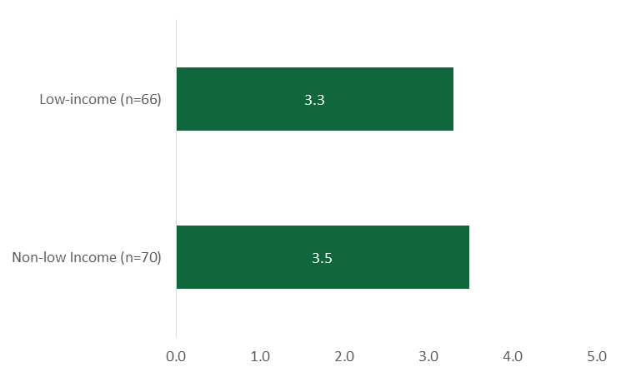
Note: Means are weighted.
Note: Interviewees rated the influence of rebates on a scale of 1 to 5, where 1 equaled “not at all influential” and 5 equaled “very influential”.

Figure 65: End-user Nonparticipant Survey Respondents – Financing Used
(Base = made improvements)
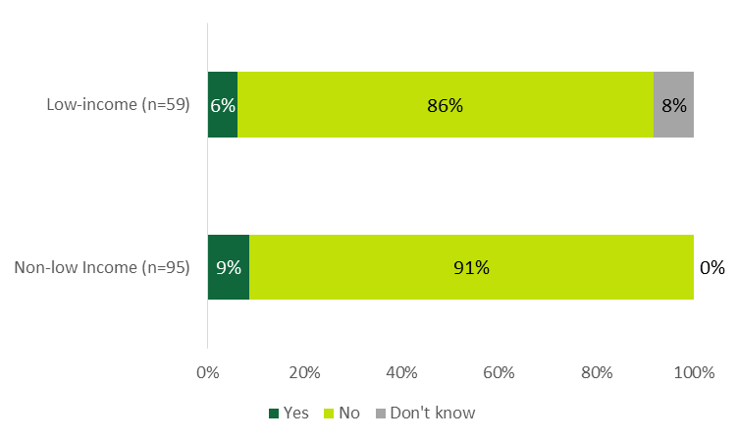
Note: Percentages are weighted. Sample includes nonparticipants who had made energy-saving improvements.
Table 84: End-user Nonparticipant Survey Respondents – Type of Financing Options Used
(Base = made improvements and used some type of financing options)
Financing Used | Non-low Income (n-8) | Low-Income (n=5)
Financing offered by my contractor | 3 | 1
Zero percent payment plan | 4 | 0
On-bill financing | 0 | 3
Store financing | 1 | 0
Residential Energy Efficiency Financing | 0 | 1
Note: Unweighted counts given the small number of respondents.

    - HES Vendor Interviews – Decision-Making and Financing
Table 85: HES Vendor Interviewees – Rebates Participants Like the Most and the Least
(Multiple responses)
Rebates | Participants Like Most | Participants Like Least
 | Yes¹ | No²
Insulation | 21 | -
Windows | 4 | 1
Heating | 2 | 1
Ductless Heat Pumps | 2 | 1
HVAC (general) | 1 | 2
Appliances | - | 3
Solar | - | 1
Depends | 2
¹ Includes “it depends” responses.
² Most focused on what people did get excited about, not what they did not, hence the small number of responses to this question.

  - Short-Term Persistence
Table 86: End-user Participant Survey Respondents – Reasons for Program Measure Removal
(Percentage of respondents that removed measure)
 | Light Bulbs |  | Water Saving Equipment |  | All Core Services¹
Issue | HES (n=66) | HES-IE (n=48) | HES (n=17) | HES-IE (n=22) | HES (n=134) | HES-IE (n=57)
Dissatisfied with product | 42% | 6% | 41% | 14% | 39% | 11%
Product broke | 28% | 46% | 35% | 41% | 29% | 42%
Product did not work properly | 14% | 21% | 0% | 0% | 10% | 13%
Product needed repairs | 1% | 6% | 0% | 5% | 3% | 5%
Dissatisfied with installation | 6% | 6% | 0% | 9% | 4% | 9%
Other | 10% | 15% | 24% | 32% | 14% | 20%
Don’t know/Refused | 0% | 0% | 0% | 0% | 1% | 0%
Note: Responses are weighted. Percentages represent percent of responses given.
¹ Includes air sealing, light bulbs, duct sealing, water pipe wrap, and water-saving measures.
  - Net-to-Gross
The following appendix subsection includes additional details referred to in the body of the report.
    - Free Ridership
Figure 66 illustrates the logic sequence involved in estimating an initial end-user free ridership score. For add-on measures, the initial free ridership score is subsequently adjusted with the influence rating score by taking the product of the two scores.
Figure 66: End-user Participant Survey Respondents – Initial Free Ridership Scoring Method
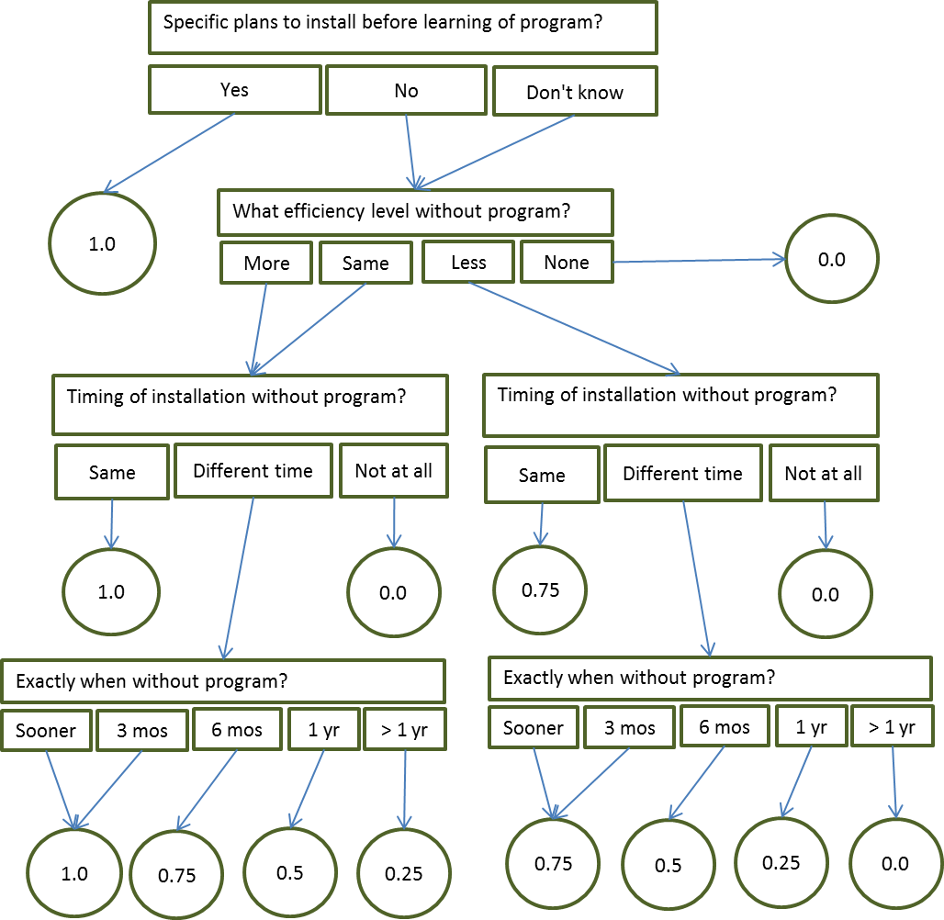

The following are examples of how the analysis assigned free ridership scores to HES end-users’ measures.
- Example 1: A respondent indicated that they had specific plans to install the same HVAC equipment as they had installed with a program incentive, receiving an initial free ridership score of 1.0. That respondent also gave a rating of 1 for all three elements, earning an influence-rating free ridership score of 1.0. The product of the two scores equals 1.0—a full-free-rider measure.
- Example 2: A respondent did not have specific plans to install the same light bulbs as were installed through the program (as a core service); however, that respondent speculated that they would have installed light bulbs of the same efficiency levels as they had received through the program, but would have installed them six months after they had been installed through the program. This is equated to an initial free ridership score of 0.75, and the surveys did not ask for influence ratings for core service measures. As a result, the final free ridership rate for the light bulbs is 0.75.
- Example 3: A respondent installed insulation through the program. They speculated that they would have installed the same amount outside the program, but would have installed it about a year after they had done it through the program. They received an initial free ridership rating of 0.5. When asked the influence-rating questions, the maximum rating they reported was 2, earning them an influence-rating score of 0.75. The product of these two scores is 0.38, the free ridership rate for this measure.
- Example 4: A respondent would have installed the same ductless heat pump as they had through the program and would have done so more than one year after participating, indicating an initial free ridership score of 0.25. That respondent also gave one of the three program elements a rating of 5, equaling an influence-rating free ridership score of 0.0. The final free ridership rate is therefore 0.0 (0.25 * 0.0).
The following are examples of how the analysis assigned free ridership scores to HES-IE landlords and property managers’ measures.
- Example 1: One property manager said that they had specific plans to install insulation before installing it through the program. The interviewee clarified that they would have installed less insulation, however, and that, while they did not know exactly when, it would be “later.” The study assumes that “later” would mean more than one year. The study considers this a non-free-rider measure, giving it a rate of 0.0.
- Example 2: Another property manager’s company had already planned to install the same amount and type of water-saving measures that the program vendors installed; however, they had planned to do so more than one year later than the program had done it. Given that it was more than a year later, the analysis assigned that measure a partial free ridership rate of 0.25.
- Example 3: The third example was somewhat more complicated. The interviewee would have installed the same type of light bulbs at the same time in the absence of the program; considering these elements, the algorithm might initially result in a free ridership rate of 1.0. However, the interviewee clarified that they would have installed fewer light bulbs, which might indicate a free ridership rate of 0.75 if installed at the same time, but since they would have been the same type of light bulb, the analysis used the average rate between 0.75 and 1.0: 0.88.
- Example 4: In another case, an interviewee planned to install more of the water-saving measures of the same type and would have done so within three months of the program vendor doing so. Because they would have installed more and the timing was so close, the analysis assigned a full free ridership rate of 1.0.
Table 87 presents the free ridership rates for rebate-only end-users.
Table 87: Rebate-only End-user Participant Survey Respondents – Free Ridership Rates
Measure (n=58 respondents) | N | Average Free Ridership Rate | Sum of Gross Savings (MWh/yr)¹ | Confidence Interval²
 |  |  |  | Maximum | Minimum
AC equipment | 14 | 0.18 | 6.6 | 0.35 | 0.01
Air source HP | 5 | 0.10 | 11.3 | 0.32 | 0.00
Ductless HP | 34 | 0.15 | 53.3 | 0.26 | 0.05
Geothermal HP | 2 | 0.12 | 3.1 | 0.50 | 0.00
Heating equipment | 8 | 0.00 | 35.7 | 0.00 | 0.00
Total | 63 |  | 109.9
Weighted average free ridership³ |  | 0.07 |  | 0.13 | 0.02
¹ Savings in the program database are associated with the respective measure and respective interviewees. Gas, oil, and propane savings have been converted into kWh/year.
² Figures are at a 90% confidence level.
³ The free ridership rate is weighted by gross annual savings.
    - Spillover
The table below presents the spillover-eligible measures that landlords and property managers installed and the resulting spillover rate.
Table 88: HES-IE Landlord and Property Manager Interviewees – Spillover Rate
Measure | Count of interviewees | % of interviewees (n=29)
Door sweeps | 1 | 3%
Storm doors | 1 | 3%
Lighting motion sensors | 1 | 3%
Spillover |  | 0.03
  - Non-Energy Impacts
Non-energy impacts, or NEIs, refer to benefits or drawbacks that participants experience as a result of program participation that do not tie directly to energy use or savings. They can considerably affect a participant’s decision to adopt a measure and their experience with the measure post-installation.
    - Non-Energy Impacts Calculation Methodology
For any elements where participants observed positive or negative impacts as a result of the program, questions asked them to compare the value of that NEI to the impact of the program on energy savings. After asking about individual NEIs, the questions asked them to consider the net impacts of NEIs combined—qualitatively and quantitatively. From these inputs, the study estimated NEI values. Table 89 presents the inputs into the NEI algorithm and the survey and interview questions associated with them. The analysis involved five primary steps:
- Develop magnitude scale. The analysis began with calculating the average numeric values of combined effects (row f in Table 89) that respondents gave that were associated with the qualitative value of combined effects (e) that they gave. This resulted in what can be referred to as a magnitude scale where much more negative value is associated with the lowest percentage (a value below zero) and much more positive value is associated with the highest percentage (a value above zero). No effect is always associated with a value of zero.
- Apply magnitude values. The study then applied the magnitude scale values to the given qualitative values for each of the individual NEIs (b) so that each respondent had a value associated with each of their responses for each NEI element. For example, if the magnitude scale determined that somewhat more negative value was equivalent to -130%, and a respondent estimated that comfort was negatively impacted and that the negative impact was somewhat more negative than the value of the expected energy savings, then the value of -130% would be applied to that respondent for that NEI.
- Correct for overlaps. In any cases where end-users articulated which, if any, of the individual NEIs overlapped, the analysis divided their individual NEI magnitude scores for any NEIs that they identified as overlapping. This step accounts for any over-counting of one individual NEI.
- Normalize values. After applying magnitude values, the study compared each respondent’s given numeric value of combined effects (f) with the sum of the values of the individual NEIs that they had reported. The study then proportionally decreased the individual NEI values so that they did not total to greater than the value of that respondent’s reported combined effects.
- Impute missing values. Due to a CATI survey programming misunderstanding, 71% of respondents who should have been asked to provide qualitative (e) or quantitative (f) estimates of the combined net effects were not asked. The team sought to call back a statistically adequate number of these contacts, setting goals of 68 HES/rebate-only and 68 HES-IE respondents (20% of those that were erroneously skipped). Using the responses of the called-back respondents and those that originally went through the module correctly, the analysis imputed the values of those that were mistakenly skipped by first estimating the average normalized values for each scenario for each individual NEI among respondents who had provided the estimates, and second applying those to the individual NEIs reported among those that were erroneously skipped out of those questions. The sum of the imputed values for each of those respondents equated to their quantitative value of combined effects.
- Estimate final NEI values. The overall NEI value is equal to the average value of the combined effects across respondents (f). In the same vein, the value of the individual NEIs are the average normalized values associated with those NEIs across respondents.

Table 89: Non-Energy Impacts Inputs and Related Research Instrument Questions
Input | Related Survey / In-depth Interview Question
Impact on individual elements (a) | Did the program have a positive effect, negative effect, or no effect on [list of NEIs]
Qualitative value of impact on individual elements (b) | How does the value of the positive/negative effect on [NEI] compare to the value of the expected energy savings?
 | Does the positive effect have much less value, somewhat less value, same value, somewhat more value, or much more value?
 | Does the negative effect have much more negative value, somewhat more negative value, same value or balances out, somewhat less negative value, or much less negative value?
Overlap of impact on individual elements¹ (c) | Thinking about all these effects that you have mentioned are there any that you think “overlap” or that you had a hard time separating out?
Net combined effects (d) | Now, think about the combination of all the positive and negative effects that you received from the program not including possible energy savings. Would you say that the combination of these effects is overall positive, negative, or had no effect?
Qualitative value of combined effects (e) | How does the overall positive/negative value of the combination of these effects compare to the value of the expected energy savings?
 | Does the positive combination of effects have much less value, somewhat less value, same value, somewhat more value, or much more value?
 | Does the negative combination of effects have much more negative value, somewhat more negative value, same value or balances out, somewhat less negative value, or much less negative value?
Numeric value of combined effects (f) | If you were to estimate its value as a fraction, percentage, or multiple, by about what amount more or less valuable is the combination of positive effects? We’d like to know a value relative to average energy bill savings.
 | If you were to estimate its cost as a fraction, percentage, or multiple, by about what amount more or less negative is the value of the combination of effects? We’d like to know a value relative to average energy bill savings.
¹ Nonparticipant end-user surveys and HES-IE landlords and property manager interviews did not ask about overlaps.

    - End-user Participant Surveys – Non-energy Impacts
HES (51%) and HES-IE (42%) end-user respondents were most likely to think that the net positive impact that they experienced from the NEIs was about equal to what they expected, but responses were mixed, with about one-third of each group (31% HES and 35% HES-IE) finding that the positive net impact was higher than what they expected. The negative responses were few, but HES (44%) and HES-IE (47%) respondents were most likely to have expected less of a negative net impact than they did. Figure 67 illustrates these differences in detail.
Figure 67: End-user Participant Survey Respondents – Comparison between Net Non-Energy Impacts and Expected
(Percentage of NEI respondents)
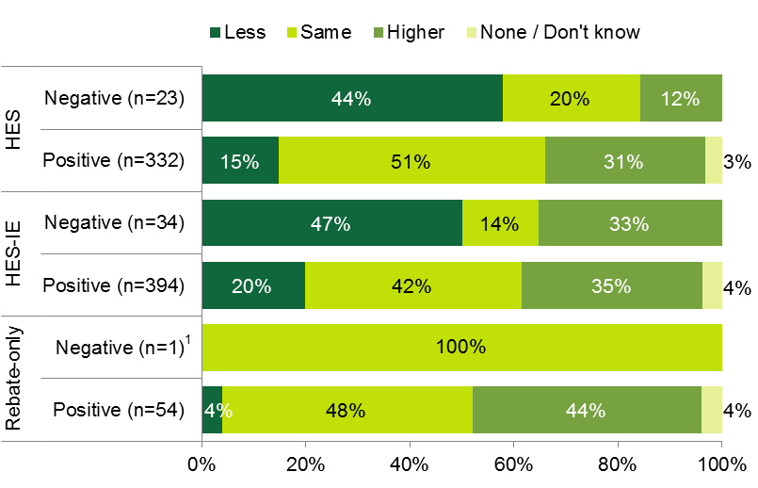
Note: Percentages are weighted. Respondents answered the following question: Is the overall positive or negative value of the combination of these energy and non-energy effects less than, equal to, or higher than what you expected at the time of participation in the program?
¹ Due to weighting, this single respondent’s response actually has no value, and is included here only for illustrative purposes.

    - Nonparticipant End-user Surveys – Non-energy Impacts
Figure 68: Nonparticipant Survey Respondents – Speculations of Possible Non-Energy Impacts
(Multiple responses; unprompted; percentage of respondents)
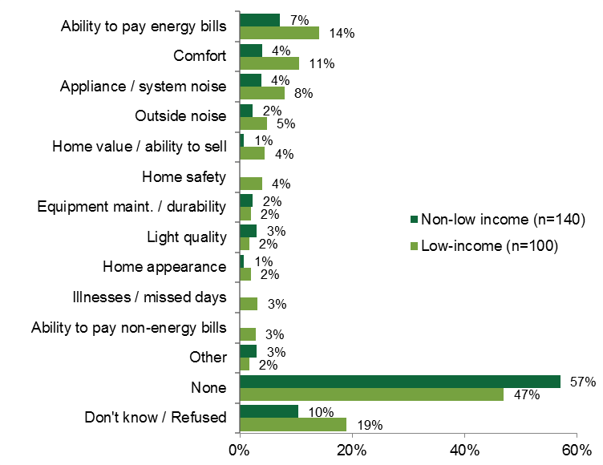
Note: Responses are weighted.

    - HES-IE Landlords and Property Manager Interviews – Non-Energy Impacts
Figure 69: HES-IE Landlord and Property Manager Interviewees – Non-Energy Impacts Expected Prior to Participating
(Multiple responses; count of respondents)
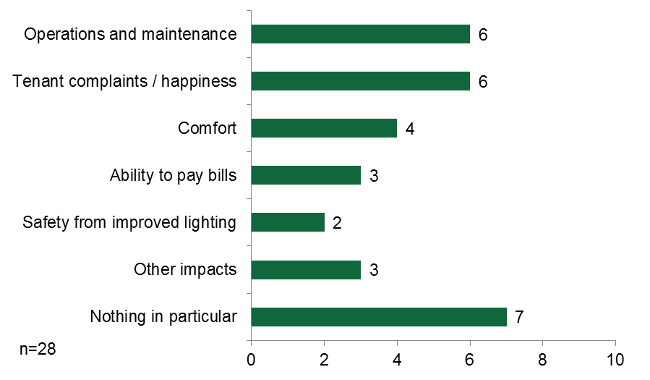
Five of the landlords and property managers recalled their vendors discussing NEIs and emphasizing that the landlord or property manager would need to change the light bulbs less frequently (three), tenants’ comfort would be increased (two), and tenants’ ability to pay their rent would improve (one).

  - Health and Safety
Table 90: End-user Participant Survey Respondents – Reasons for Not Remedying Health and Safety Issues
Explanation | Count of Respondents (Multiple Responses)
 | HES (n=12) | HES-IE (n=42)
Too expensive | 3 | 15
Have not gotten around to it | 2 | 5
Unable to find contractor | - | 1
Repair/removal scheduled | - | 5
Too much trouble | 1 | 1
Repair/removal not possible | 2 | -
Repair/removal deemed unnecessary | 1 | 2
Incorrect assessment of issue | 2 | 7
Requires action by landlord | 1 | 4
Awaiting additional information | 1 | 0
Don’t know | - | 15
Note: Responses are unweighted
Table 91: End-user Nonparticipant Survey Respondents – Reasons for Not Remedying Health and Safety Issues
Explanation | Count of Respondents (Multiple Responses)
 | NLI (n=6) | Low-Income (n=6) | Total (n=12)
Too expensive | 2 | 4 | 6
Have not gotten around to it | 4 | - | 4
Repair/removal scheduled | - | 1 | 1
Repair/removal deemed unnecessary | 1 | 1 | 2
Requires action by landlord | - | 2 | 2
Don’t know | 1 | 1 | 2
Note: Responses are unweighted

  - Additional Feedback
Short-term survey respondents had very few suggestions for ways that the Companies could improve their services. Most often they had concerns about energy rates (Figure 70).
Figure 70: End-User Participant Surveys – Suggestions for the Companies’ Services
(Percentage of respondents)
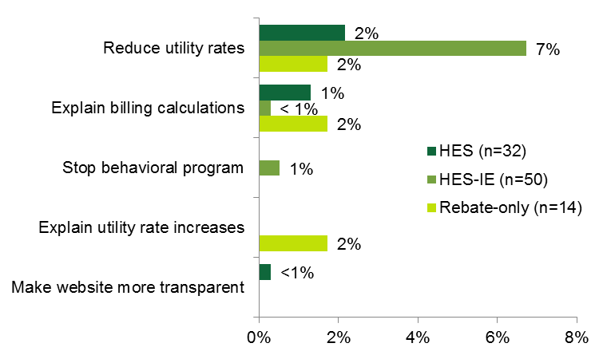

Note: Sample sizes are small because this question was asked only of short-term respondents.
- Additional Characteristics
B
This section contains additional details about respondents and interviewees.

  - End-user Respondents – Housing Characteristics and Demographics
    - End-user Participant Surveys – Housing Characteristics and Demographics
Table 92: End-user Participant Survey Respondents – Age of Respondent
Age Group | HES (n=547) | HES-IE (n=525) | Rebate-only (n=60)
18-24 years | 2% | 1% | -
25-44 years | 25% | 26% | 21%
45-64 years | 46% | 39% | 57%
65 years or older | 24% | 33% | 22%
Don’t know/Refused | 3% | 1% | -
Note: Responses are weighted
Table 93: End-user Participant Survey Respondents – Ownership Status of Respondent
Ownership Status | HES (n=547) | HES-IE (n=525) | Rebate-only (n=60)
Own | 95% | 72% | 100%
Rent | 2% | 26% | 0%
Don’t know/Refused | 3% | 2% | 0%
Note: Responses are weighted

Table 94: End-user Participant Survey Respondents – Type of Home
Type of Home | HES (n=547) | HES-IE (n=525) | Rebate-only (n=60)
Single Family | 90% | 64% | 93%
Two to four units | 3% | 18% | 3%
Multifamily | 2% | 9% | -
Townhouse | 2% | 5% | 4%
Mobile home | 1% | 3% | -
Don’t know/Refused | 2% | 1% | -
Note: Responses are weighted
Table 95: End-user Participant Survey Respondents – Length of Residency in Current Home
Years in Home | HES (n=433) | HES-IE (n=400)
Less than 1 year | 1% | 1%
1-2 years | 15% | 10%
3-5 years | 14% | 20%
6-7 years | 5% | 6%
8-10 years | 11% | 11%
11-15 years | 15% | 15%
16-20 years | 7% | 10%
More than 20 years | 31% | 26%
Don’t know/Refused | 1% | 1%
Note: Responses are weighted

Table 96: End-user Participant Survey Respondents – Highest Level of Education Achieved
Level of Education | HES (n=547) | HES-IE (n=525) | Rebate-only (n=60)
Less than High School | 1% | 6% | -
High School or equivalent | 7% | 27% | 7%
Some college | 9% | 22% | 11%
Associate’s Degree | 9% | 17% | 14%
Bachelor’s Degree | 31% | 17% | 28%
Graduate or Professional Degree | 39% | 8% | 36%
Don’t know/Refused | 4% | 3% | 4%
Note: Responses are weighted
Table 97: End-user Participant Survey Respondents – Mean Occupancy of Home
 | HES (n=547) | HES-IE (n=525) | Rebate-only (n=60)
Mean number of occupants | 2.8 | 2.6 | 2.9
Note: Responses are weighted
Table 98: End-user Participant Survey Respondents – Household Income
Income Group | HES (n=547) | HES-IE (n=525) | Rebate-only (n=60)
Less than $10,000 | 1% | 9% | -
$10,000-$14,999 | 1% | 13% | -
$15,000-$24,999 | 2% | 25% | -
$25,000-$34,999 | 2% | 15% | 4%
$35,000-$49,999 | 5% | 13% | -
$50,000-$74,000 | 12% | 7% | 18%
$75,000-$99,999 | 13% | 3% | 7%
$100,000-$149,999 | 20% | 1% | 30%
$150,000-$199,999 | 8% | 1% | 7%
$200,000 or more | 16% | 1% | 7%
Don’t know/Refused | 20% | 12% | 27%
Note: Responses are weighted
Table 99: End-user Participant Survey Respondents – Low-income vs. NLI (based on HUD Median Income Limits)
Income Type | HES (n=61) | HES-IE (n=44) | Rebate-only (n=7)
Low-income | 31% | 70% | 33%
Non low-income | 61% | 25% | 67%
Don’t know/Refused | 8% | 5% | -
Note: Responses are weighted
    - End-user Nonparticipant Surveys – Housing Characteristics and Demographics
Table 100: End-user Nonparticipant Survey Respondents – Age of Respondent
Age Group | Non-Low Income (n=140 ) | Low-Income (n=100)
18 to 24 years old | 3% | 2%
25 to 44 years old | 30% | 29%
45 to 64 years old | 47% | 40%
65 years or older | 19% | 26%
Don’t know / Refused | 1% | 2%
Note: Responses are weighted.
Table 101: End-user Nonparticipant Survey Respondents – Ownership Status of Respondent
Ownership Status | Non-Low Income (n=140) | Low-Income (n=100)
Own | 93% | 73%
Rent | 6% | 22%
Don’t know/Refused | 1% | 5%
Note: Responses are weighted.
Table 102: End-user Nonparticipant Survey Respondents – Type of Home
Type of Home | Non-Low Income (n=140 ) | Low-Income (n=100)
Single family | 81% | 48%
Two or three family | 5% | 12%
Multifamily with three or more units | 2% | 29%
Townhouse | 12% | 7%
Mobile home | - | 1%
Don’t know/Refused | - | 2%
Note: Responses are weighted
Table 103: End-user Nonparticipant Survey Respondents – Length of Residency in Current Home
Years in Home | Non-Low Income (n=140 ) | Low-Income (n=100)
Less than one year | 4% | 7%
One or two years | 8% | 12%
Three to five years | 15% | 14%
Six to seven years | 10% | 8%
Eight to ten years | 12% | 6%
Eleven to fifteen years | 17% | 12%
Sixteen to twenty years | 8% | 20%
More than twenty years | 25% | 18%
Don’t know/Refused | 1% | 2%
Note: Responses are weighted.
Table 104: End-user Nonparticipant Survey Respondents – Highest Level of Education Achieved
Education Level | Non-Low Income (n=140 ) | Low-Income (n=100)
Less than high school diploma | - | 1%
High school diploma or GED | 8% | 19%
Some college | 17% | 24%
Associates or technical school degree | 8% | 15%
Bachelor’s degree | 30% | 20%
Graduate or professional degree | 33% | 12%
Don’t know/Refused | 4% | 8%
Note: Responses are weighted.
Table 105: End-user Nonparticipant Survey Respondents – Mean Occupancy of Home
 | Non-Low Income (n=140 ) | Low-Income (n=100)
Mean number of occupants | 2.8 | 2.6
Note: Responses are weighted
Table 106: End-user Nonparticipant Survey Respondents – Household Income
Income Group | Non-Low Income (n=140 ) | Low-Income (n=100)
Less and $10,000 | - | 6%
$10,000 to $14,999 | - | 6%
$15,000 to $24,999 | - | 21%
$25,000 to $34,999 | 1% | 17%
$35,000 to $49,999 | 2% | 26%
$50,000 to $74,999 | 27% | 24%
$75,000 to $99,999 | 29% | -
$100,000 to $149,999 | 11% | -
$150,000 to $199,999 | 9% | -
$200,000 or more | 7% | -
Don’t know/Refused | 14% | -
Note: Responses are weighted
Table 107: End-user Nonparticipant Survey Respondents – Low-income vs. NLI (based on HUD Median Income Limits)
Income Type | Non-Low Income (n=140) | Low-Income (n=100)
Low-income | 140 | 100
Non low-income | 100 | 140
Note: Responses are weighted
  - HES-IE Landlord and Property Manager Interviews – Additional Characteristics
    - HES-IE Landlord and Property Manager Interviews – Key Project Attributes
For the most part, the HES-IE landlord and property managers’ key participating projects were of average size in terms of number of tenant units. The number of participating units within interviewees’ sampled projects ranged from five to 360 units, with an average of 79 units per project. Most often they had fewer than 50 units, with only a few projects that were very large and included 200 units or more (Table 108).
Table 108: HES-IE Landlord and Property Manager Interviewees – Number of Units at Key Project
Number of Participating Units | Count of Key Projects (n=30)
300-360 | 2
200-299 | 1
100 to 199 | 4
50 to 99 | 6
25-49 | 9
<25 | 8
Total | 2,360
Average | 79
Median | 41

    - HES-IE Landlord and Property Manager Interviews – Company Firmographics
Most HES-IE landlord and property manager interviewees’ companies are relatively small, yet they range in size from one employee to 2,000 employees, averaging 141 employees. Over one-half of the interviewees (18) own or work for companies that employ fewer than 25 employees.
Table 109: HES-IE Landlord and Property Manager Interviewees – Total Employees at Company
Total Employees | Count of Interviewees (n=30)
2,000 or more | 1
100 to 1,999 | 2
50 to 99 | 4
25 to 49 | 4
10 to 24 | 5
5 to 9 | 2
Fewer than 5 | 11
Don’t know | 1
Total | 4,081
Average | 141
In total, landlord and property manager interviewees manage 378 buildings (Table 110) with 20,037 units (Table 111) in Connecticut, averaging 13 buildings and 716 units. They were most likely to have small to medium enterprises: most commonly managing ten or fewer buildings (19) and fewer than 500 units in Connecticut (17).
Table 110: HES-IE Landlord and Property Manager Interviewees – Total Buildings Managed/Owned in Connecticut
Number of Buildings with Five or More Units in Connecticut | Count of Interviewees (n=30)
41 to 50 | 3
31 to 40 | 1
21 to 30 | 1
11 to 20 | 5
5 to 10 | 8
Fewer than 5 | 11
Don’t know | 1
Total | 378
Average | 13
Table 111: HES-IE Landlord and Property Manager Interviewees – Total Units Managed/Owned in Connecticut
Total Units Managed/Owned in Connecticut | Count of Interviewees (n=30)
3,000 or more | 1
2,000 to 2,999 | 2
1,500 to 1,999 | 2
1,000 to 1,449 | 4
500 to 999 | 2
250 to 499 | 5
100 to 249 | 5
Fewer than 100 | 7
Don’t know | 2
Total | 20,037
Average | 716
Landlord and property manager interviewees most commonly managed properties within Hartford (31), New Haven (20), and Fairfield (11) Counties (Figure 71):
- Two of the 30 interviewees said that they owned or managed properties all across Connecticut.
- The cities and towns in Hartford County that they listed most frequently included Hartford (10), Newington (5), and New Britain (4).
- Aside from listing New Haven County (2) generally, they frequently specifically identified the cities of Waterbury (6) and New Haven (5).
Figure 71: HES-IE Landlord and Property Manager Interviewees – Geographical Distribution of Properties
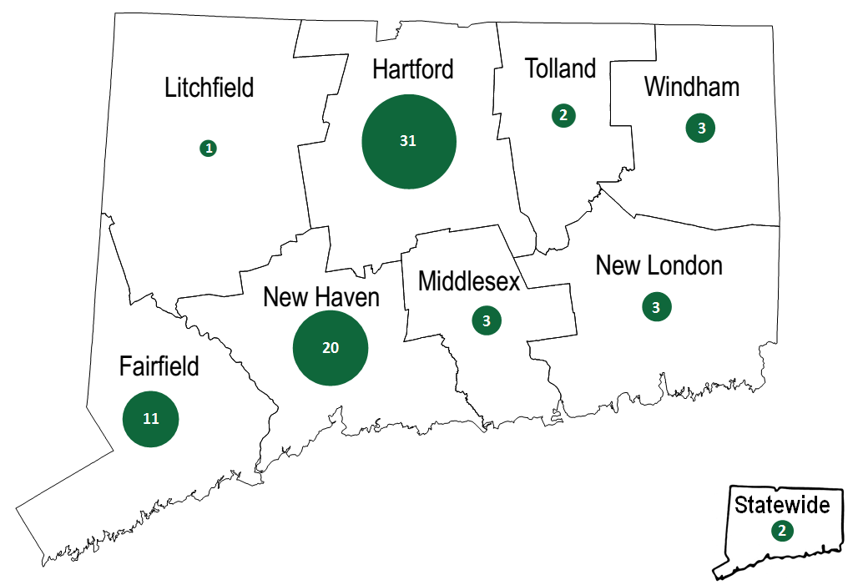
Note: The size of the circle within each county corresponds with the number of times interviewees identified either 1) the county itself or 2) a town/city within the county as a place where their properties were located.

    - HES-IE Landlord and Property Manager Interviews – Short-Term Persistence
Only two interviewees indicated that measures installed through the program had been removed. At one property, two low-flow showerheads had been removed by tenants who did not like them; the interviewee speculated that the maintenance person had stored the units and estimated that they were removed fairly soon after they were installed. At another property, a couple of CFLs installed through the program burnt out at some point after being installed and were subsequently replaced with new CFLs that were identical to those installed through the program but were not issued through the program.
Table 112: HES-IE Landlord and Property Manager Interviewees – Reported Measure Removal at Key Project
Removed Program Measures | Count of Interviewees (n=30)
No | 26
Yes | 2
Don’t know | 2
Type of Measure Removed | Quantity Removed
Low-flow showerheads | 2
CFLs | 2
Total | 4
    - HES-IE Landlord and Property Manager Interviews – Health and Safety
Five of the 30 landlord and property manager interviewees said that vendors had identified health or safety problems during the energy assessment. Vendors discovered mold at all five of these properties and a gas leak at one of the five. The health and safety problems delayed the initial assessment at only one of the five properties until maintenance staff had remediated the problem. The interviewees confirmed that all of these health and safety problems had been resolved since the initial visit.
Table 113: HES-IE Landlord and Property Manager Interviewees – Reported Health and Safety Problems at Key Project
(Multiple responses)
Health and Safety Problems | Count of Interviewees (n=30)
No issues found | 24
Mold | 5
Gas Leak | 1
Don’t know | 1

This analysis is meant neither to compare and contrast the financing or rebate options nor to make specific recommendations on rebate amounts or financing interest rates and terms. Instead, the study shares the experiences, preferences, and observations of program participants and vendors.
The study also estimated net-to-gross ratios of 0.95 for HES-IE and 0.93 for rebate-only programs. The evaluation suggests not using the HES-IE and rebate-only net-to-gross ratios formally because HES-IE programs generally assume a net-to-gross ratio of 1.0, and sample sizes are small among rebate-only respondents.
When compared to similar programs in the Northeast, the HES net-to-gross ratio is somewhat lower, with other programs having ratios greater than 1.0.
CATI survey questions determined if a respondent was low-income if their responses confirmed that their income was less than 80% of the area median income as reported by U.S. Department of Housing and Urban Development: https://sites.google.com/site/connecticutmortgagelimits/hud-median-income-limits.
The interviewers stressed this was completely hypothetical.
Note that this evaluation included an experimental approach to test whether traditional delayed process evaluation results might differ from responses obtained close to the time of actual program participation. “Short-term” refers to participants who were surveyed closer to the time of participation (six to nine months post-participation), and “long-term” survey respondents refer to participants who were surveyed at a later time (after nine months post-participation). See Section 1.1 for additional details.
NMR Group, Inc. Forthcoming. Observations & Recommendations from CT Residential Program Database Interviews. Draft Report available at http://www.energizect.com/sites/default/files/Observations%20%26%20Recommendations%20from%20CT%20Residential%20Program%20Database%20Interviews%20%28R33%29%2C%20draft%20report%2C%2012.4.15.docx.
The database review yielded additional insights but those have been addressed in the R33 Database Management Study. The public review draft of R33 is available at http://www.energizect.com/sites/default/files/Observations%20%26%20Recommendations%20from%20CT%20Residential%20Program%20Database%20Interviews%20%28R33%29%2C%20draft%20report%2C%2012.4.15.docx. The final report should be posted in January of 2016.
The document review, once complete, will add further insight into this.
The document review, once complete, will also add further insight into this.
The 2010 NEEP study by KEMA performed verification on a small sample of multifamily buildings, which included a mix of commercial and residential multifamily spaces. This may have conflated the concern around CFL persistence.
United Illuminating Company and Connecticut Light and Power. 2014. Connecticut Program Savings Document: 10th Edition for 2015 Program Year. Document dated November 5, 2014.
See https://www.energystar.gov/products/spec/lamps_specification_version_2_0_pd for more details.
The United Illuminating Company and Connecticut Light & Power. 2014. Connecticut Program Savings Document: 10th Edition for 2015 Program Year. Specifically Appendix 3: Realization Rates.
Note that the program already provides many customer-facing materials in both Spanish and English, such as print, newspaper, and radio advertisements, program brochures, and interest, eligibility, and rebate forms. Resources for vendors are also provided in both Spanish and English, such as the Print-on-Demand Booklet to be used by vendors at kitchen table “wrap ups”.
Connecticut Energy Efficiency Board. 2015. Energy Efficiency Board 2014 Programs and Operations Report. Available at http://www.energizect.com/sites/default/files/Final%20ALR%202014%20Pages.2.26.15.pdf.
Connecticut Light & Power, The United Illuminating Company, The Yankee Gas Services Company, Connecticut Natural Gas Corporation, and Southern Connecticut Gas. 2014. 2015 Annual Update of the 2013-2015 Electric and Natural Gas Conservation and Load Management Plan. See Table A-1 for budget and B-3 for expected savings. Note that the 2016 to 2018 plan is now available, but the study cites the 2015 update given the retrospective nature of the evaluation.
Retail Products had the second highest expected savings (23%) and Behavior the third highest (22%).
The findings section of this report provides more information about distinctions between HES and HES-IE. Additional information is available on the Energize Connecticut website at http://www.energizect.com/your-home/solutions-list?ptype=1.
Not all R31 respondents were ultimately considered short-term respondents because some sample sizes were too small and the CATI team needed to re-enter the field to obtain additional completes. The analysis considers respondents that completed surveys more than nine months after participating to be long-term respondents even if they were contacted as part of the R31 survey effort.
American Association for Public Opinion Research (2015) “Response Rate Calculator” Excel File available at www.aapor.org/AAPORKentico/Education-Resources/For-Researchers/Poll-Survey-FAQ/Response-Rates-An-Overview.aspx. Accessed December 31, 2015.
Survey contacts are “active” when they have been added to the call list but their final disposition (whether they completed the survey and, if not, why) is still unknown.
Surveys were preceded by letters notifying participants that they would be contacted to complete the survey. Mailings were conducted in waves, and the contacts were dialed shortly after they would have received their letters. Some data provided by the Companies did not include the ZIP codes; as a result, the CATI team reserved those contacts for dialing after they made efforts to contact the participants who had received letters.
The response rate with answering machines included for the two firms were 3% for the initial firm and 1% for the second firm. The second firm had to release more sample to finish the survey, but did so before re-contacting numbers originally sent to answering machines.
Survey management monitored the distribution of completed surveys between the two Companies, but also needed to prioritize the focus on achieving income-base quotas.
Population data came from U.S. Census Bureau/Data Ferret. 2009-2013 American Community Survey. www.dataferret.census.gov December 2015.
The evaluation included an interview with one property manager in person because when the study attempted to recruit him for the R157 Multifamily Initiative Process evaluation HES focus group, the contact reported participating in the program a great deal. A scheduling issue prevented the property manager from attending the actual focus group, but it was determined that it would be important to interview this contact to learn more. During the interview, it was gleaned that the interviewee had participated in HES-IE, not HES, and as a result, the study uses the responses from that interview (which did not follow the same question structure, yet did touch on the same themes) in the analysis of these HES-IE landlord in-depth interviews.
The base population (429 HES-IE projects) excludes projects where the occupant was the point of entry into the program. In-depth interview sampling targeted projects only if the landlord or property manager was the point of entry.
UI did not provide participation data for 2015.
Table 108 in Appendix B.2.1 includes a more detailed breakdown of the key projects’ sizes.
Because UI’s participation database does not capture the number of housing units in projects, the study estimated the number of units among UI projects by multiplying the mean units per projects among the key projects (79.10) by the number of UI projects in the participation database (166) to estimate the number of participating units.
This difference may reflect the study’s sampling approach. The study leveraged the HES-IE landlord and property manager in-depth interviews to recruit sites for the R4 on-site short-term persistence research where the sampling focused first on projects that had measures relevant to that study (light bulbs, water-saving equipment, and refrigerators). As a result, projects with quantifiable measures, such as light bulbs, were given preference when it came to interviewing.
The EEB Evaluation Committee considered expanding the study to include HES but ultimately voted against that option.
While on site, technicians marked program CFL and LED lamps, writing the date of the site visit at the bulb’s base using a heat-resistant fine-point marker. Technicians marked a total of 307 lamps out of 333 lamps (the others could not be accessed due to fixture location or type) identified, including both program and non-program lamps. This activity will allow for future persistence studies that the EEB may wish to perform to track the long-term persistence of lamps identified during this first visit.
Short-term persistence is different from Effective Useful Life (EUL). EUL is the length of time one can expect a program measure to continue working after it has been installed. While evaluators typically define EUL to be the point at which 50% of the measures can be expected to fail (the median life), this evaluation will serve as an early check-in for this important lifetime savings parameter. The study assumes that the EEB will fund future EUL check-ins for HES- and HES-IE-supported measures in order to update EUL over time.
Note that a prior commercial and industrial area study that included some multifamily units in the analysis found that the 10-year persistence rate for compact fluorescent lamps (CFLs) was 33% and the two-year persistence rate was 73%. This unexpected finding served as one of the drivers of the current study. See KEMA. C&I Lighting Measure Life and Persistence Project: Final Report. Prepared for NEEP 2010. Available online: http://issuu.com/neepenergy/docs/neep_ci_persistence_report-final/1?e=12509042/8424638.
In other words, there can be a response bias where the participant is providing responses they perceive are socially desirable, rather than accurate.
The program tracking databases did not provide information such as make/model, so the study needed to assume that a measure type that looked like other confirmed program measures in the building were likely program models.
The study examined only the residential units—not the common areas—of these buildings.
At one site, the majority of tenants did not speak English. For this site, the field technicians completed as many of the surveys as possible with the landlord translating. The study approach only counted these surveys as completed if the tenants clearly demonstrated that they understood the questions.
No additional UI landlords were recruited via this method due a lack of interest. Attempts to contact each of the 46 UI landlords were made at least six and up to nine times. Additionally, while six UI landlords completed interviews (20% of completions), only five expressed interest in the on-sites, and only one followed through with agreement to schedule the actual visit. Thus, while the study strived to maintain the original 75% Eversource/ 25% UI split of landlords with contact information in the original database, the completed on-site visits included only one UI site (8%).
The additional studies included R113, R151, and R157.
NMR Group, Inc. Forthcoming. Observations & Recommendations from CT Residential Program Database Interviews. Draft Report available at http://www.energizect.com/sites/default/files/Observations%20%26%20Recommendations%20from%20CT%20Residential%20Program%20Database%20Interviews%20%28R33%29%2C%20draft%20report%2C%2012.4.15.docx.
NMR Group, Inc. 2015. Connecticut HES Air Sealing, Duct Sealing, and Insulation Practices Report (R151). Draft posted for public review December 2015. http://www.energizect.com/sites/default/files/CT%20HES%20Air%20Sealing%2C%20Duct%20Sealing%2C%20and%20Insulation%20Practices%20%28R151%29_review%20draft_12.23.15.docx.; NMR Group. 2015. Multi-family Initiative Process Evaluation (R157). Draft posted for public review December 2015. http://www.energizect.com/sites/default/files/Multi-Family%20Initiative%20Process%20Evaluation%20%28R157%29%2C%20review%20draft%2C%2012-17-15.docx
Although the study offered to compare self-reported and actual participation in financing programs for the telephone survey respondents and perform a financing database review, the Companies declined this offer.
Responses of 4 or 5 on a 5-point scale, where 1 equals “not at all satisfied” and 5 equals “very satisfied,” represent high satisfaction.
Predominantly lighting, direct hot water, air sealing, and duct sealing. However, HES-IE participants, including landlords and property managers, are sometimes eligible for a greater number of free Tier II (add-on) measures, with refrigerators being one of the most common.
Neither Eversource HES-IE data nor UI HES and HES-IE data included the date (or vendor name) variables necessary to conduct this analysis.
For a small percentage (1%) of projects, the date the customer requested services was listed as being after the receipt of core services. A similar percentage (3%) of records had the same date the customer requested as the recorded date of core services receipt. The wait time estimates excluded these records. Appendix 2.1.3 presents the share of excluded records, by vendor.
Interviewees did not provide ratings respectively if the program activities would not impact the overall building energy bill (from their perspective) or if the tenants did not pay any energy bills.
Estimated developed through values reported in the R16 HES and HES-IE Impact Evaluation and subsequent conversations among evaluation team members. See R16 study at http://www.energizect.com/your-town/hes-and-hes-ie-impact-evaluation-r16-final-report-12-31-14.
It is not apparent that there are any residential programs in Connecticut or elsewhere that support residential kitchen stoves, almost certainly reflecting the fact that ENERGY STAR® does not currently have specifications—and therefore qualified models—for residential kitchen stoves.
The benchmarking activity is limited to non-low-income programs because of the limited research that has been performed on low-income programs.
Note that HPwES program structure is not perfectly comparable to HES program structures; however, they both involve home energy assessments that make recommendations for deeper measures.
HES-IE end-user respondents were not asked financing and decision-making questions for two reasons. First, most deeper-measure upgrades are provided free of charge to HES-IE end users. Second, the study approach operated under the assumption that low-income customers are in less of a position to make additional energy efficiency investments on their own, even with rebates and financing options.
For reporting purposes, this report refers to non-insulation add-on measures as Tier II measures.
Core services-only respondents may have installed measures on their own outside of the program; they could alternatively be referring to services that fall under the “core” category, but the vendor discussed installing the measure with the end-user before actually doing so.
There were no statistically significant differences between measure types or between survey time periods.
Not a statistically significant difference.
Not a statistically significant difference.
This type of outreach could include the vendor following up with the homeowner to solicit them to install add-on measures that they themselves perform in addition to energy assessments.
Nonparticipants using utility rebates and incentives to make improvements were participants in a CEEF program, but not HES or HES-IE participants.
Interviewees often had a difficult time distinguishing the difference between the free core-service lighting equipment and the add-on lighting equipment in which they or their companies needed to invest. Interviewers did their best to help them differentiate, but the analysis cannot be certain of exactly which interviewees were recommended to invest further in lighting upgrades and exactly which of those moved forward with investing in the recommended lighting upgrades.
The study does not formally consider these “adoption rates.” To estimate a true adoption rate, the algorithm requires the number of recommended measures that participants installed as recorded in the program database. Given that program tracking data did not include measure recommendations, the analysis used interviewee recall as a proxy to suggest adoption. The small sample size does not support this as a statistically sound estimate.
The UI HES and HES-IE data did not include the vendor name variable necessary to conduct this analysis.
The estimates exclude projects where a landlord or property manager was the point of entry into the program.
One vendor did not have adequate time to answer these questions.
Which could be either the Energize Connecticut Heating Loan or the Residential Energy Efficiency Financing Program
http://www.chif.org/page/energy-efficiency-loans
http://www.chif.org/page/borrower-information-and-application
Two also noted that participant reactions to rebates depends on their own situation—if they had electric baseboard heat and found out they were eligible for ductless heat pumps, they may prefer that incentive over insulation. The smaller amount of the rebates relative to costs and to insulation and the fact that customers will “buy them anyway” served as explanations for why participants did not get terribly excited about appliance rebates.
The Residential Energy Efficiency Financing Program terms include these characteristics.
“Big seed” refers to landlord eligibility for $3,500 per unit up to $100,000 available through Energy Conservation Loan Program and other loan programs.
Note that HPwES program structure is not perfectly comparable to HES program structures; however, they both involve home energy assessments that make recommendations for deeper measures.
KEMA. C&I Lighting Measure Life and Persistence Project: Final Report. Prepared for NEEP 2010. Available online: http://issuu.com/neepenergy/docs/neep_ci_persistence_report-final/1?e=12509042/8424638
Using a nested sampling approach, the evaluation found a 98% verification rate for installed CFLs through a phone survey, then found through on-site assessments that verified 91% of the phone survey responses. Cadmus, 2015. Income Qualified Program Evaluation Report – 2014 Program Year. Consumers Energy. Jackson, MI.
Cadmus, 2015. 2014 Evaluation, Measurement, and Verification Report. For Dayton Power and Light. Dayton, OH.
Definitions and discussion are modified from NMR Group and Research Into Action. 2010. Net Savings Scoping Paper. Final delivered the Northeast Energy Efficiency Partnership’s Evaluation, Measurement, and Verification Forum November 13, 2010. Available at: http://www.neep.org/net-savings-scoping-paper-1.
Note that the last set of parentheses in the equation are the same as the NTG ratio equation, but converted to a percentage. For more information see Appendix 3 in United Illuminating Company and Connecticut Light and Power. 2014. Connecticut Program Savings Document: 10th Edition for 2015 Program Year. Document dated November 5, 2014.
The sampling defaulted to asking respondents about add-on measures wherever possible, and it assigned one to two measures about which to ask depending on what respondents installed and verified installing. The savings come from the program database; gas, oil, and propane savings have been converted into kWh/year.
This approach was based on the methodology of an Energy Trust of Oregon evaluation: Research into Action. Production Efficiency Program: Process and Impact Evaluation. Appendix A. 2006.
The window free ridership rate was even lower than that of insulation, but the sample size for windows was quite small (n=10).
The sampling defaulted to asking them about add-on measures wherever possible and asked them about one to three measures, depending on what they installed and the time available to complete the interview.
A percentage of 33% seemed to be a conservative estimate for awarding the program some spillover credit where it was due but also making an educated assumption that participants are likely installing fewer quantities or lower efficiency levels of program-incented measures than what are performed through the program. Regardless, given the small percentages of respondents installing the particular spillover-eligible measures, the study observed that using a proportion of 33% (as compared to 10% or 90%, for example) did not present a major difference.
This ratio is weighted by number of program contacts present in the end-user population and landlord and property manager population. Because both spillover rates are the same, the weighted value appears the same.
Spillover among this population can be assessed in future evaluation efforts.
Evaluation of the Efficiency Maine Trust PACE, Power Saver, and RDI Programs. Final Evaluation Report. Volume II: Residential Direct Install Program. Opinion Dynamics and Dunsky Energy Consulting. October 23, 2013.
Efficiency Maine Trust Home Energy Savings Program Final Evaluation Report. Cadmus Group. November 30, 2011.
NYSERDA 2007-2008 Home Performance with ENERGY STAR Program Impact Evaluation Report. Megdal & Associates. September 2012.
Home Energy Services Net-to-Gross Evaluation - Part of the Massachusetts Residential Retrofit and Low Income Program Area Evaluation, Cadmus Group and Navigant. June 2012.
The NYSERDA HPES and Massachusetts HES reports both include non-participant spillover in the overall NTG calculations; however, we have included only free ridership and participant spillover here in order to facilitate direct comparisons with the Connecticut results.
Rebate-only respondents received an NEI value of 1.18; however, the sample size was small with only 54 respondents being factored into the estimate while both HES and HES-IE estimates came from sample sizes greater than 350 (Figure 51).
Despite this problem, one of these two interviewees thought that the program had a net positive impact on tenant complaints.
This difference may be indicative of differences in changes in energy billing rates rather than the efficacy of program improvements.
Note that the R4 survey asked participants to compare NEIs to an undefined bill savings amount while the MA analysis compared them to a defined dollar value. Additionally, the two studies did not ask about the exact same NEIs.
This indicates a non-energy benefit of the programs, as addressed in Section 6.
However, not every vendor had time or could answer each of the questions in this section.
The vendor provided fair and reasoned responses on their 2014 involvement with HES and continues to work with the Companies on other programs (to say more would breach confidentiality). Therefore, despite no longer serving HES, the analysis includes the vendor’s responses from this interview.
None of the four vendors citing less than 50% or who chose not to answer was the vendor no longer providing HES services.
Sponsored by the U.S. Department of Energy, BBNP provided three-year funding to 41 state and local governments to support programs promoting whole-building energy upgrades.
BBNP grantees did not necessarily carry the same program structure or same type of implementers as the Connecticut HES program – however, all were retrofit programs, and many were home energy assessment-based programs that sought to encourage additional upgrades through use of rebates and financing. Grantees were distributed throughout the U.S., but nearly one-fifth of them were located in the Northeast. Additionally, this R4 study did not measure market effects specifically, but was assessing the extent to which the program has impacted the development of contractors in the state.
In this context, independence means that membership in one group is not associated with a different point accumulation compared to the other groups.
The inclusion of this variable recognizes that some communities are more “green” in their outlook than others, and this “greenness” could also be driving participation in CEEF programs. Controlling for prior points, therefore, controls for this possible characteristic and allows the model to isolate the annual effect of outreach on the points gained in a single year.
The exact number is unknown, but respondents to the R154 Lighting On-site Saturation Study indicated that they purchased 50% of CFLs and 70% of LEDs from home improvement and club stores, which carry the majority of upstream program bulbs in Connecticut.
As an example, the average normalized NEI value for comfort where respondents indicated that there was a positive impact on comfort that was much less valuable than expected energy savings (b) was 0.05 (excludes outliers more than three standard deviations from the mean). For any instances where the “incomplete” respondents indicated that there were positive impacts on comfort that were much less valuable, the analysis applied a rate of 0.05 for that respondent as a proxy for the normalized value for comfort.
For example, average project size among Eversource’s HES-IE SP3 population database included 78 units (n=263 projects). UI’s database did not identify the number of units associated with the projects.
One interviewee could not estimate the number of buildings that the company managed, and two could not estimate the number of units. The results include the number of buildings and units that are associated with their key project in this total figure, but exclude it from averages and include it as a “Don’t know” response in the tables.

