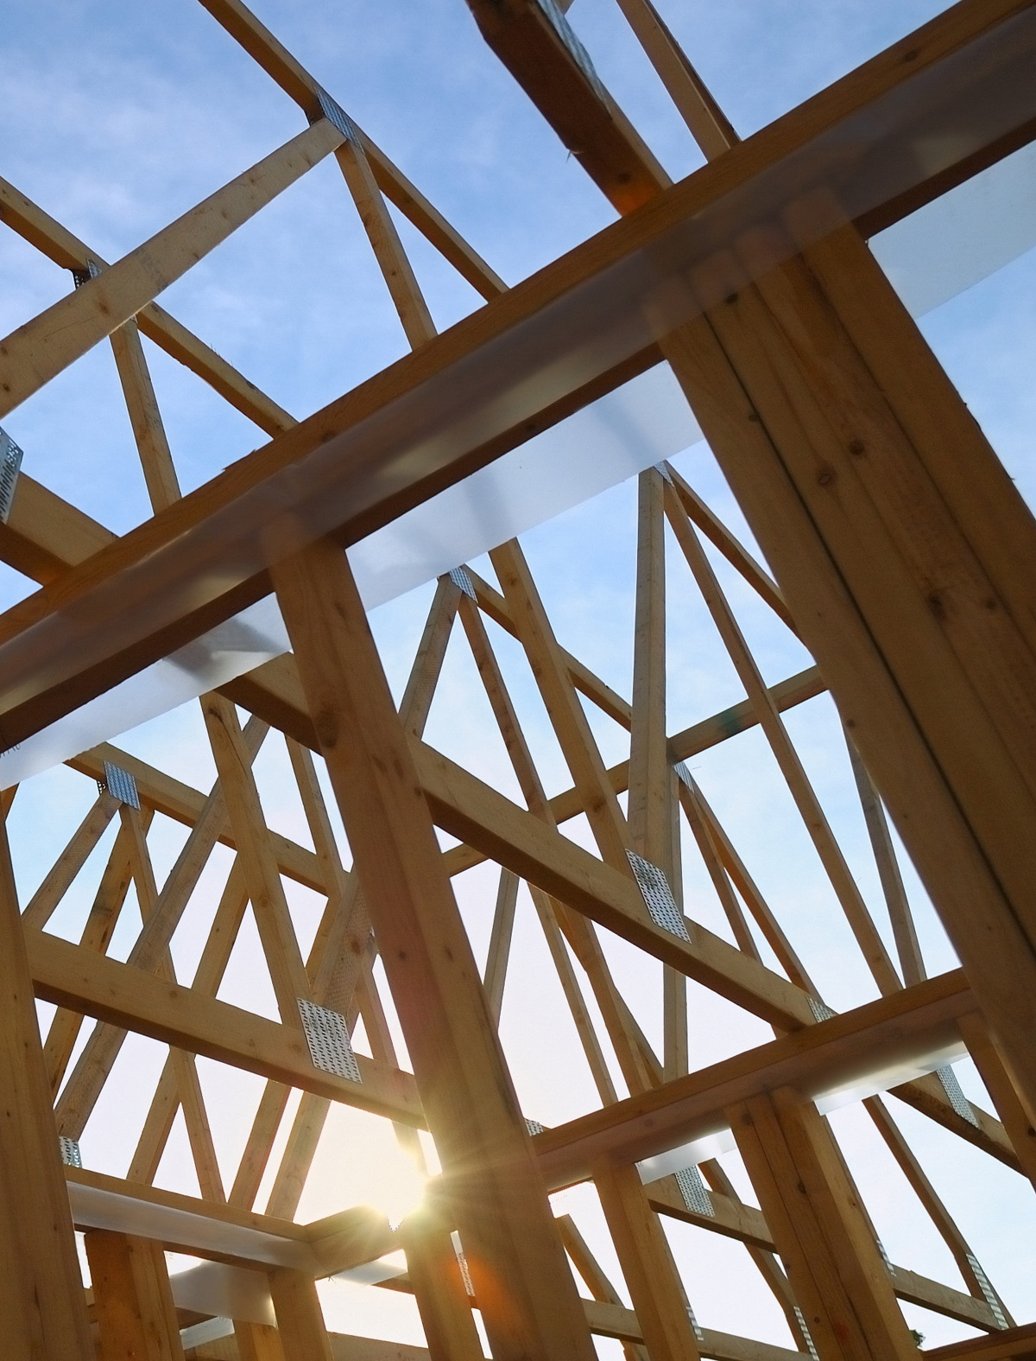

C1902-B: Energy Conscious Blueprint Baseline and Code Compliance Results

FINAL
May 13, 2022
SUBMITTED TO:
Connecticut Energy Efficiency Board
SUBMITTED BY:
Yogesh Patil and Tim Steis, NMR Group, Inc.
Miles Ingram, DNV
Lynn Roy, BrightLine Group

Table of Contents
Section 1 Introduction 3
1.1 Purpose 3
1.2 Background 3
1.3 Overall Goal 4
1.4 Summary of Results 4
1.5 Recommendations 5
Section 2 Study Tasks 6
2.1 Task 1 – Data request 6
2.2 Task 2 – Data review, cleaning, and preparation 7
2.2.1 Data Related Issues 7
2.3 Task 3 – Literature Review 7
2.4 Task 4 – Sampling and Primary Data Collection 7
2.5 Task 3 – Data analysis 10
Section 3 Results 11
3.1 Code Compliance 11
3.2 Baseline 12
3.2.1 Lighting 12
3.2.2 Heating Systems 13
3.2.3 Domestic Hot-Water System 14
3.2.4 Cooling Systems 14
Section 4 Recommendations 17
4.1 Lighting 17
4.2 Unitary AC Systems 17
4.3 Heat Pump 17
4.4 Variable Refrigerant Flow 17
4.5 Domestic Hot Water Heaters 18

Introduction

Purpose
To establish new construction baselines and code compliance, this study conducted primary data collection for new buildings permitted, completed, or under construction from January 2019 through March 2020. This report discusses the baseline and code compliance results from the analysis. The primary data collected included construction drawings obtained through building department visits and Dodge data purchase, market actor interviews, and code official interviews. This study also consists of two other tasks that are not included in this report. The tasks that are not included are:
- Net-to-Gross (NTG) ratios for the Energize CT Commercial Midstream HVAC & Water Heating and Commercial Foodservice & Laboratory Programs. A separate report for this study component was completed in May 2022 and already provided to the Evaluation Committee.
- NTG ratios for the Energy Conscious Blueprint (ECB) Program. The results for this component are expected to be completed in July 2022.

Background
The ECB program offers incentives for new construction, major renovation, and tenant fit-out projects, as well as new (or end-of-useful-life replacement) equipment projects. The ECB program changed structure in August 2020 from a format that saw mostly prescriptive measure-level projects, to a four-path program with an increased emphasis on whole building projects. Two pathways referred to as the Deep Energy Savings path (Path 1) and the Whole Building Modeled path (Path 2), are focused on deep energy savings and involve expert technical assistance (TA) and tiered incentives based on achieving low building energy use intensities (EUIs). The Simplified Whole Building path (Path 3) provides less intensive TA, while the Systems path (Path 4) is primarily a prescriptive program available for smaller buildings. Path 3 and Path 4 references the Program Savings Document (PSD) for baseline assumptions and savings calculations methodologies. Paths 1 and 2 are based on reducing the whole building EUI and may not directly refer to the PSD for inputs. This study assessed baseline efficiencies for the measure categories in the PSD and compared them with the code requirements and those required by the PSD.
In addition, Connecticut’s utilities plan to increase efforts to improve non-residential code compliance and increase savings through code-related efforts. This study also measured the statewide code compliance and compared with prior compliance results in Connecticut and neighboring states.

Overall Goal
This study includes four primary components—baseline measurement, ECB NTG analysis, code compliance research, and midstream non-lighting NTG analysis. Since this report only covers discussion for the baseline and code compliance components, the related objectives are presented below in bold font. The overall study objectives of this study are to:
- Update measure-level baseline values for true new construction and replacement on failure
- Update NTG ratios for true new construction (i.e., end use-level and whole building values to the extent feasible)
- Ensure alignment between baseline and free ridership assumptions
- Document current code compliance and gather data to support future evaluation and attribution of savings for code compliance and development efforts
- Determine NTGRs for the Upstream Non-Lighting Program, and gain insight into customer market event (e.g., replace on failure, new construction)

Summary of Results
Table 1 presents the results from baseline and code compliance analysis components of this study.
Table 1. Statewide Code Compliance Results by Building Components
Description | % Envelope Compliance | % Lighting Compliance | % Heating Compliance | % Cooling Compliance | % Hot Water Compliance | % Total Compliance
Unweighted | 58% | 99% | 100% | 62% | 72% | 78%
Weighted by Counts | 68% | 98% | 100% | 76% | 90% | 86%
Weighted by Area | 57% | 100% | 100% | 73% | 94% | 85%
For commercial and industrial buildings permitted, completed, or under construction between 2019 and Q1 of 2022, the compliance with energy efficiency code requirements was estimated at 85% of the population when reasonable assumptions were used for missing data points and the sample was weighted by strata areas and 86% when the sample was weighed by strata counts.
The average efficiencies of installed equipment were found to be generally higher than the 2015 IECC code and PSD (2021 and 2022). Measures specific high-level observation are presented below:
- Lighting – overall installed lighting power density (LPD) was found to be 46% better than code mandated LPD
- Boilers and furnaces - The average rated efficiency in all capacity bins exceeded the code requirements and the PSD
- Radiant heaters - The average rated efficiency in all capacity bins exceeded the PSD requirements
- Domestic hot water systems – the average efficiency of gas fired systems exceeded the code requirements and PSD but was marginally lower for electric systems
- Chillers – The average rated efficiency for air cooled chillers was about equal to code requirements and PSD
- Unitary AC systems - The average rated efficiency in all capacity bins exceeded the code requirements and the PSD
- Heat pumps - The average rated efficiency in all capacity bins exceeded the code requirements and the PSD
- Variable refrigerant flow (VRF) - The average rated efficiency in all capacity bins exceeded the code requirements and the PSD

Recommendations
Table 2 presents the list of measures for which the study team recommends considering updating the baselines in the PSD:
Table 2. Summary of Recommendations for Consideration
Systems | Recommended Updates for Consideration
Lighting | An adjustment factor of 40% better than code across the buildings
Unitary systems - DX units <65,000 Btu/h | 15 SEER for cooling
Unitary systems - split units <65,000 Btu/h | 14 SEER for cooling
Split heat pumps < 65,000 Btu/h | 10.2 HSPF for heating and 17.3 EER for cooling
Multi-split VRF with heat recovery >= 135,000 Btu/h and <= 240,000 Btu/h | HT heating efficiency of 3.7 COP  LT heating efficiency of 2.9 COP  Cooling efficiency of 12.1 EER
Multi-split VRF with heat recovery >= 240,000 Btu/h | LT heating efficiency of 2.2 COP  Cooling efficiency of 10.3 EER
Gas water heaters - instantaneous and storage | Efficiency of 95%

Study Tasks

Task 1 – Data request
For this component of the study, the comprehensive data request from the utilities requested the program materials, ECB program participation data, and ECB participant consumption data for the period from January 1, 2019 through March 31, 2020.
The following ECB program materials were requested:
- All customer-facing marketing materials not on Energize CT website
- Program implementation manual
- Program planning documents
- QA/QC manuals/protocols
- Any program documentation for non-PSD measures that were incentivized
- Customer memoranda of understanding forms/templates
- Project application forms/templates
The following program tracking data was requested:
- Participant details such as name, mailing address, site address, contact information, dates of participation, project type (replacement on failure, new construction, renovation), program pathway – old program pathways (whole building, prescriptive), building type (or building use codes), customer account numbers and any other unique identifiers, vendor name, vendor type (architect, MEP, etc.), annual consumption data (to the extent available)
- Installed measure details such as measure name, technology type, efficiency (e.g. SEER, AFUE, etc.), reported or estimated energy savings, project cost, incentive amount, incentive type (whole building performance, prescriptive, custom), end use or measure type (lighting, HVAC, etc.), quantity
- List of available program data tracking fields (to determine whether there are additional field that may be of use in the study)
- Non-participant C&I customer accounts (electric and gas) that were added during the period of interest, associated contact information.
- List of implementers and contractors the program interacts with, including contact information

Task 2 – Data review, cleaning, and preparation
Upon receipt of the requested data from the utilities, the study inspected the data for completeness and identified any data elements that were missing, incomplete, or potentially incorrect. The study team informed utility data teams of any data issues identified, and scheduled meetings as needed, to discuss and resolve these issues. The study team also purchased an annual subscription for Dodge data to form a comprehensive dataset of non-participants for sampling. After all data issues were addressed, the study team cleaned the data, checked the overlap with the purchased Dodge data, and prepared the overall data for sampling. The purchase of annual subscription to Dodge data provided the study team access to construction drawings for new buildings through its portal.

Data Related Issues
The utilities did not have specific fields that clearly tracked whole building projects. To determine whole building projects, the study team worked with the utility staff to understand the various field and descriptions within those to deduce if the project is whole building or not. The fields considered in making this deduction included program component (equipment replacement of new buildings), measure category, and additional measure description.
Another data related issue was matching the buildings in Dodge data and tracking data. Given the large number of records, the study team found it challenging to match the two data sets without spending considerable time reviewing address and building name fields.

Task 3 – Literature Review
The study team conducted a literature review to inform the baseline and code compliance study components.
For the baseline component, the review focused on recently completed new construction baseline and potential studies in the neighboring states. In addition, the study team reviewed other studies completed in Connecticut that had an overlap with measure baselines being explored. For example, the recently completed X1931 study updated the baseline efficiencies for boilers and furnaces in the 2022 PSD and was used to compare the results from this study. In addition, the C1634 study is also a relevant reference, that explored baselines for a few measures in a limited capacity.
Similarly, for the code compliance component, the study team reviewed prior research on code compliance in Connecticut—including the 2015 C19 C&I New Construction Baseline and Code Compliance study—and studies from neighboring jurisdictions.

Task 4 – Sampling and Primary Data Collection
The data collection effort for both the baseline and code compliance components consisted of industry standard practice baseline data collection through review of construction drawings and interviews with market actors and code officials. These activities are discussed in detail in the following sections.
Market Actor In-Depth Interviews
The study team reviewed market data to identify an In-Depth Interview (IDI) sample of up to 20 market actors serving C&I customers in Connecticut. The sampled interviewees included distributors, contractors, manufacturers, architectural and engineering firms, energy modelers and code officials in order to represent a diverse mix of all major end-use types and business sectors. Table 3 presents the breakdown of completed market actor interviews.
Table 3. Market Actors Interviews - Sample Distribution
Market Actor | # Targeted Interviews | # Completed Interviews
Distributors / manufacturers | 5 | 4
General contractors | 3 | 1
Architects | 4 | 2
Mechanical Engineers | 3 | 0
Energy Modelers | 3 | 2
Code officials / C&S Committee | 2 | 2
Total | 20 | 11
This study was in progress when the COVID-19 pandemic was at its peak. We speculate that this may be the reason for poor response rates for the market actor interviews. The study team repeatedly contacted the entire list of available market actors to recruit them to conduct the interviews and increased the incentive levels from $50 to $150. The increase in incentives for completed interviews resulted in a marginal increase in the response rate, but overall, it was not enough to reach the target of 20 completed interviews.
Baseline Web-Surveys
With the understanding that web surveys help mitigate declining telephone survey response rates and require less time for customers to complete it, the study team deployed web-surveys for the entire sample frame. The web-surveys were designed to collect high level building and equipment information. The details were going to be collected using the information obtained from construction drawing that the respondents were asked to upload. However, the response rate for the web-surveys was very low. The study team sent multiple email reminders and mailers and followed up with phone calls to encourage the respondents, but those efforts did not make much difference in the response rate. The study team increase the incentives for web-survey completes from $150 to $250 and then to $300. The increase in incentive did not make much of a difference in the response rates.
This forced the study team to explore alternative approach to collect data. The study team leveraged construction drawings available from building department visits and through Dodge data portal. Due to the lack of response from building owners and COVID-19 limitations, the study team did not conduct on-site visits.
Baseline and Code Compliance Sample
The study team used the Dodge data to develop the sample for baseline and code compliance components. The dataset contained a total of 369 sites for which either the construction was complete, ongoing, starting, or building permits issued throughout the state from 2019 through Q1 of 2020. Out of these 228 sites had plans available for download from Dodge data’s portal and a total of 146 sites had square footage information available.
Based on prior experience and literature review, square footage was the traditional baseline characterization variable used in sampling stratification. The study team used a similar approach in developing the baseline and code compliance sample.
A sample of 41 sites for code compliance and 52 for baseline components were targeted in the sample design to balance the available funding for the study and providing reasonable baseline and code compliance estimates. This sample size was targeted to achieve 80/15 precision assuming a coefficient of variation of 0.5. Table 4 and Table 5 shows the proportion of population and the sample by area and counts for baseline and code compliance components.
Table 4. Baseline Population and Sample Proportions by Strata
Stratum | Stratum Description | % Site Count |  | % Site Area
 |  | N=146 | n=52 | N=146 | n=52
1 -Small | <=25,000 sq. ft. | 51% | 62% | 5% | 8%
2 - Medium | Up to 60,000 sq. ft. | 12% | 10% | 7% | 8%
3 - Large | Up to 250,000 sq. ft | 32% | 27% | 55% | 71%
4 - X-Large | Up t0 400,000 sq. ft. | 5% | 2% | 21% | 13%
5 - XX-Large | Over 400,000 sq. ft. | 1% | 0% | 12% | 0%
Table 5. Code Compliance Population and Sample Proportions by Strata
Stratum | Stratum Description | % Site Count |  | % Site Area
 |  | N=146 | n=41 | N=146 | n=41
1 -Small | <=25,000 sq. ft. | 51% | 78% | 5% | 8%
2 - Medium | Up to 60,000 sq. ft. | 12% | 12% | 7% | 10%
3 - Large | Up to 250,000 sq. ft | 32% | 34% | 55% | 65%
4 - X-Large | Up t0 400,000 sq. ft. | 5% | 2% | 21% | 17%
5 - XX-Large | Over 400,000 sq. ft. | 1% | 0% | 12% | 0%
The study team also checked for participant and non-participant breakdown. The population, since it was primarily based on Dodge data, had only two participant sites. Given the low number of identified participants, those sites were removed from the sample frame. As a result, the sample did not include any participant sites and the results are entirely based on non-participant data.
Consideration of Bias in Sample
The study team considered the following sampling and selection related bias:
- Due to the low response rate from the building owners, the study team primarily relied on the information available in the construction drawings obtained through Dodge data portal and building department visits. This resulted in selecting a sample frame which only consisted of sites that had construction drawings available for download.
- The study team checked the quality and completeness of the data available for all the sampled sites and dropped the ones that were deemed to have insufficient data. For example, the sites with incomplete information or construction drawings was dropped from the sample and replaced with the next random site with complete data.
Data Collection
This study relied primarily on comprehensive review of construction documents for both baseline and code compliance. In addition, the study team developed Excel based data collection tools. The data from these tools were used along with COMCheck software to assess compliance.
The measure specific data from these tools were also used to determine the industry standard practice for new construction. The measures assessed for each sampled site were consistent with those listed in PSD.

Task 3 – Data analysis
The study team conducted two separate types of analysis using the data collected from the construction drawings – one to estimate the level of compliance with Connecticut’s commercial building energy code and the second to assess measure specific baselines to inform inputs in PSD.
The study team determined code compliance through USDOE’s COMcheck tool for the sampled sites and aggregated the site level compliance to develop statewide estimate. COMcheck’s data requirements are extensive and data entry into this tool served as a quality control step. Through an iterative process of data entry, analysis, and data revision evaluators developed
For measure specific baseline analysis, all the data from the data collection tool was consolidated into one master file. In the master file, the baseline efficiencies were weighted by floor area served by the sampled site for the PSD specified measure type bin (e.g. packaged vs. split systems, capacity size bins, etc.). The results were then compared with code and PSD requirements.
One key aspect to consider is that the study relied on construction drawings obtained through Dodge data portal which may not always be the final set. Without verification site visits, which were not possible due to unresponsive building owners and limitations due to COVID-19, the study team was unable to assess the level of differences between the construction drawing sets used and the actual as-builts.

Results

Code Compliance
The study team chose COMCheck software to assess the compliance of sampled sites. COMCheck analyzes compliance for major systems for each site by either providing a pass/fail response or a difference between the installed system efficiency/energy use and the maximum allowed by the code. Table 6 presents the code compliance findings by strata and aggregated at state level. The “Total” column in the table represents the portion of buildings that were found to be compliant using the COMcheck software. The compliance scores presented in the table below means that the commercial buildings in Connecticut meet 85% of the energy code requirements. This interpretation of compliance is consistent with similar studies in neighboring states and other studies throughout the country. Please note that non-compliance in a particular building characteristic category may represent tradeoffs allowed under a whole building approach.
Table 6. Strata and Statewide Code Compliance by Building Components
Stratum | Counts |  | % Compliance
 |  |  | Envelope | Lighting | Heating | Cooling | Hot Water | Total
1 | 27 |  | 81% | 96% | 100% | 80% | 88% | 89%
2 | 4 |  | 100% | 100% | 100% | 90% | 100% | 98%
3 | 9 |  | 50% | 100% | 100% | 76% | 100% | 85%
4 | 1 |  | 0% | 100% | 100% | 0% | 0% | 40%
Unweighted |  |  | 58% | 99% | 100% | 62% | 72% | 78%
Weighted by Counts |  |  | 68% | 98% | 100% | 76% | 90% | 86%
Weighted by Area |  |  | 57% | 100% | 100% | 73% | 94% | 85%
A recent code compliance study in Connecticut, C19- Commercial & Industrial New Construction Baseline and Code Compliance Study, investigated a sample of building completed in the 2010-to-2014-time frame. The sample size, data collection methodology and the analysis methodology used in that study were similar to this study. The findings from C19 study provides some context for the findings of this study. Levels of compliance for selected systems found by that study were as follows:
- Envelope - 99% compliance (26% with defaults)
- HVAC - 95% compliance
- Lighting - 92% compliance
- Overall - 73% compliance

Baseline
This section presents the measure/equipment specific findings from the research on baseline efficiency of installed equipment. The information provided for each measure includes weighted efficiency values by equipment type, number of equipment researched, efficiency values allowed by Code and 2021 and 2022 PSD.

Lighting
For lighting the key comparison unit is lighting power density (LPD). LPD of the installed lighting in the new commercial and industrial buildings in the sample was significantly lower than that required by the 2015 IECC and the baseline specified in the PSD, as shown in Table 7 below. The overall LPD for the sampled sites was found to be 46% better than code, 32% better than 2021 PSD, and 21% better than 2022 PSD.
Table 7. Percent Better Lighting Efficiency Compared to Code and PSD
Building Type | Counts | LPD % Better than Code | 2015 IECC LPD | LPD % Better than 2021 PSD | LPD % Better than 2022 PSD
Elderly/Assisted Living | 2 | -8% | 0.57 | 3% | -20%
Dining: Cafeteria/Fast Food | 9 | 41% | 0.9 | 30% | 27%
Health Care Clinic | 2 | 67% | 0.9 | 59% | 58%
Hotel/Motel | 1 | 65% | 0.87 | 53% | 29%
Library | 1 | 75% | 1.19 | 34% | 39%
Office | 4 | 37% | 0.82 | 34% | 19%
Police/Fire Station | 3 | 29% | 0.87 | 22% | 8%
Retail | 4 | 68% | 1.26 | 48% | 26%
School/University | 10 | 42% | 0.87 | 36% | 27%
Town Hall | 3 | 41% | 0.89 | 32% | 21%
Warehouse | 1 | 21% | 0.66 | 3% | 0%
Overall |  | 46% |  | 32% | 21%
The elderly/assisted living building type was the only one that showed higher LPD levels compared to the code and PSD.
The study team observed LED to be the primary fixture type at all the sites. Two sites were found to have a handful of linear and compact fluorescent fixtures and metal halide lamps. These non-LED fixtures accounted for less than 0.2% of the fixture count at the sites. This is not a surprise since prior baseline studies in Massachusetts (2015 and 2017), both showed a trend of increased LED fixture distribution at sites. The percentage of LED fixture distribution in newly constructed buildings went from 33% in 2015 to 84% in Massachusetts.
Figure 1 below presents the observed lighting controls at the sampled sites. The figure shows the distribution of various control types and the percent of area they served. Occupancy sensors control the majority of lighting fixture when considering both square feet and installed watts. Manual light switches are the second highest means of lighting control. This is a change compared to the findings from the previous C19 Connecticut baseline study. That study found that manual switches were the most common type of lighting control with occupancy controls as the second highest.
Figure 1. Interior Lighting Control Types Observed in Sample (n=40)
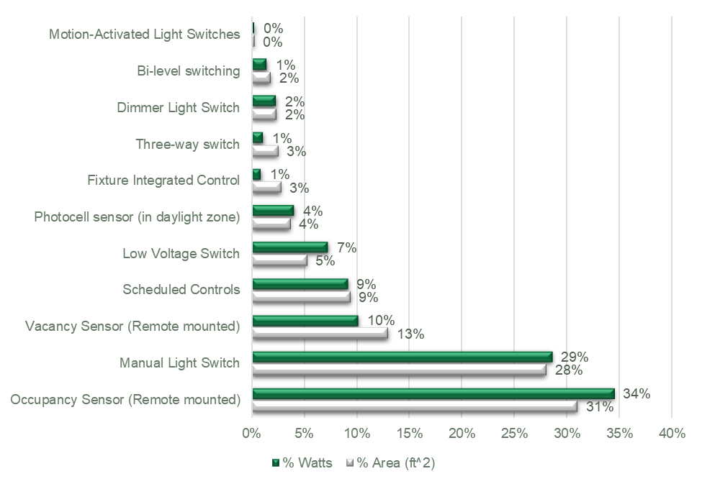

Heating Systems
Table 8 presents the different heating systems observed at the sampled sites. The table also presents the counts by observed fuel type. Boilers and furnaces represented the largest gas users in the sample. Variable Refrigerant Flow (VRF) and air source heat pumps were the largest electric users in the sample. This is also consistent with findings from similar studies in Massachusetts.
Table 8. Heating System Distribution by Fuel Type
Technology | Counts | % Installed Heating Capacity
 |  | % of Total | % Gas | % Electric
Steam boilers | 7 | 1.30% | 1.50% | 0.00%
HW boilers | 35 | 59.10% | 68.00% | 0.00%
Central & duct furnaces | 175 | 22.90% | 26.30% | 0.00%
Condensing boilers | 2 | 1.80% | 2.10% | 0.00%
Radiant heaters | 157 | 1.90% | 2.20% | 0.00%
Air-source heat pumps | 65 | 3.40% | 0.00% | 26.00%
Variable refrigerant flow systems | 11 | 9.70% | 0.00% | 74.00%
Table 9 presents the efficiencies for the heating systems observed in the sample. Overall, the efficiencies were found to exceed those required by the code and PSD. The boiler and furnace efficiency values in 2022 PSD were updated recently through the X1931 study.
Table 9. Heating Systems Efficiencies
Measure Categories | Counts | Sample Efficiency | IECC 2015  Efficiency | 2021 PSD Efficiency | 2022 PSD Efficiency
Boilers, Large (>2,500 MBH) | 8 | 92.50% | 82% Ec | 82% Ec | 90% Ec
Boilers, Medium (300 MBH to 2,500 MBH) | 22 | 95.70% | 80% | 80% Et | 90% Ec
Boilers, Small (<300 MBH) | 5 | 87.2% AFUE | 80% AFUE | 82% AFUE | 92% Ec
Steam Boilers, All Sizes | 7 | 82.30% | 79% Et | 79% Et | 82% Ec
Furnace, All Sizes | 175 | 91.70% | 80% Ec | 80% Ec | 90% Et
Radiant Heaters | 157 | 95.30% | N/A | 80% | 80%

Domestic Hot-Water System
Table 10 presents the observed efficiencies for domestic hot-water systems. The majority of the systems observed were gas fired and were efficient compared to the code and PSD. The electric water heaters were found to have marginally lower efficiencies compared to the code.
Table 10. Domestic Hot Water System Efficiencies
HW Heating System | Counts | Sample Efficiency | IECC 2015 Efficiency | 2021 PSD Efficiency | 2022 PSD Efficiency
Electric, <12 kW | 14 | 0.92 EF | 0.93 EF | N/A | N/A
Gas, Instantaneous | 38 | 96% | 80% Et | 80% | 80%
Gas, Condensing | 2 | 97% | N/A | 80% | 80%
Gas, Storage | 34 | 96% | 80% Et | 80% | 80%

Cooling Systems
Table 11 presents the chiller and unitary AC systems observed in the sample. Smaller split and DX systems dominated this segment of equipment. Overall, the cooling systems were found to be more efficient compared to the code and PSD. The sample did not have any water-cooled chillers.
Table 11. Chiller and Unitary AC System Efficiencies
Measure Categories | Counts | Sample Efficiency | IECC 2015  Efficiency | 2021 PSD Efficiency | 2022 PSD Efficiency
Chiller, Air-Cooled, >=150 | 4 | 10.1 EER | 10.1 EER | 10.1 EER | 10.1 EER
DOAS - DX ≥ 135,000 Btu/h and < 240,000 Btu/h | 7 | 12.0 EER | 10.8 EER | 11.0 EER | 11.0 EER
DX < 65,000 | 98 | 15.1 SEER | 13 SEER | 14 SEER | 14 SEER
DX ≥ 135,000 Btu/h and < 240,000 Btu/h | 15 | 12.3 EER | 10.8 EER | 11.0 EER | 11.0 EER
DX ≥ 240,000 Btu/h and < 760,000 Btu/h | 11 | 11.8 EER | 9.8 EER | 10.0 EER | 10.0 EER
DX ≥ 65,000 Btu/h and < 135,000 Btu/h | 22 | 12.1 EER | 11 EER | 11.2 EER | 11.2 EER
DX ≥ 760,000 Btu/h | 3 | 10.2 EER | 9.5 EER | 9.7 EER | 9.7 EER
Split System < 65,000 Btu/h | 166 | 14.0 SEER | 13 SEER | 13.0 SEER | 13.0 SEER
Split System ≥ 135,000 Btu/h and < 240,000 Btu/h | 1 | 11.6 EER | 10.8 EER | 11.0 EER | 11.0 EER
Split System ≥ 240,000 Btu/h and < 760,000 Btu/h | 1 | 13.0 EER | 9.8 EER | 10.0 EER | 10.0 EER
Split System ≥ 65,000 Btu/h and < 135,000 Btu/h | 4 | 13.2 EER | 11.0 EER | 11.2 EER | 11.2 EER
Table 12 presents the observed efficiencies for heat pump systems in the sample. Similar to the unitary AC cooling systems, smaller split heat pump systems accounted for the majority of the share. All the systems were found to have considerably better cooling efficiencies compared to the code and PSD. The heating efficiencies of larger systems were at code and those for smaller systems were better than the code and PSD.
Table 12. Heat Pump System Efficiencies
Heat Pump Technology | Counts | Mode | Efficiency | IECC 2015  Efficiency | 2021 PSD Efficiency | 2022 PSD Efficiency
Single Package  < 65,000 Btu/h | 3 | Heating | 9.5 HSPF | 8.0 HSPF | 8.0 HSPF | 8.0 HSPF
 |  | Cooling | 14.7 SEER | 14 SEER | 14 SEER | 14 SEER
Split Systems  < 65,000 Btu/h | 58 | Heating | 10.2 HSPF | 8.2 HSPF | 8.2 HSPF | 8.2 HSPF
 |  | Cooling | 17.3 SEER | 14 SEER | 14 SEER | 14 SEER
Single Package  ≥ 135,000 Btu/h and < 240,000 Btu/h | 4 | Heating | 3.2 COP | 3.2 COP | 3.2 COP | 3.2 COP
 |  | Cooling | 12.5 EER | 10.4 EER | 9.3 EER | 10.6 EER
Ground/water source heat pumps were not observed in the sample.
Table 13 presents the efficiencies for VRF systems observed in the sample. The installed systems had better efficiencies across the board compared to the code and PSD.
Table 13. Variable Refrigerant Flow System Efficiencies
VRF Technology | Counts | Mode | Efficiency | 2021 PSD Efficiency | 2022 PSD Efficiency
Multi-split with Heat Recovery  ≥ 135,000 Btu/h and < 240,000 Btu/h | 4 | Heating | 3.7 HT COP | 3.2 HT COP | 3.2 HT COP
 |  |  | 2.9 LT COP | 2.05 LT COP | 2.05 LT COP
 |  | Cooling | 12.1 EER | 10.4 EER | 10.4 EER
Multi-split with Heat Recovery  ≥ 240,000 Btu/h | 6 | Heating | 3.2 HT COP | 3.2 HT COP | 3.2 HT COP
 |  |  | 2.2 LT COP | 2.05 LT COP | 2.05 LT COP
 |  | Cooling | 10.3 EER | 9.3 EER | 9.3 EER
Multi-split with Heat Recovery  ≥ 65,000 Btu/h and < 135,000 Btu/h | 1 | Heating | 3.8 HT COP | 3.3 HT COP | 3.3 HT COP
 |  |  | 2.6 LT COP | 2.25 LT COP | 2.25 LT COP
 |  | Cooling | 14.0 EER | 10.8 EER | 10.8 EER

Recommendations
Based on findings from this study, the team recommends that the Energy Efficiency Board, the program administrators, and other stakeholders consider adopting baseline findings for specific measures in the PSD. These recommended changes will apply to projects that will be implemented through Path 3 and Path 4 of the ECB program. These baseline updates will be applicable to true new construction projects. These baseline updates will not be applicable to replace on failure projects since those type of projects were not included in the study and have a different delivery mechanism that could result in a different standard practice baseline.
Please note that the study team is not recommending changes to boilers and furnaces measures since those measures were updated through a recent study (X1931).

Lighting
The installed lighting was found to be consistently more efficient than both the code and PSD for almost all building types. For building types that had a good amount of representation in the sample, the LPDs were approximately 40% better than the code. The study team recommends using an adjustment factor of 40% better than code in the PSD across the board for all building types.

Unitary AC Systems
Given the large sample size for packages DX units with capacities lower than 65,000 Btu/h, the study team recommends updating the baseline efficiency to 15 SEER.
Similarly, the study team recommends updating the baseline efficiency to 14 SEER for split units with capacities lower than 65,000 Btu/h.

Heat Pump
Split heat pumps with capacities lower than 65,000 Btu/h accounted for almost 90% of all the heat pumps observed in the sample. We recommend considering updating the heating and cooling baselines for these systems in the PSD to 10.2 HSPF and 17.3 SEER respectively.

Variable Refrigerant Flow
Within the sample, multi-split VRF systems with heat recovery and with capacities between 135,000 Btu/h and 240,000 Btu/h and greater than 240,000 Btu/h were most prominent. The study team recommends considering updating the cooling baseline efficiency for these systems in the PSD to 12 EER and 10 EER respectively. The team recommends considering updating the high temperature heating baseline for multi-split VRF systems with heat recovery and with capacities between 135,000 Btu/h and 240,000 Btu/h to 3.7 COP. Similarly, team recommends considering updating the low temperature heating baseline for multi-split VRF systems with heat recovery and with capacities between 135,000 Btu/h and 240,000 Btu/h and greater than 240,000 Btu/h to 2.9 COP and 2.2 COP respectively.

Domestic Hot Water Heaters
Instantaneous and storage gas heaters accounted for 43% and 38% of water heaters in the sample. We recommend considering updating the baselines for these two measures in the PSD from 80% to 95%.

Reference code for new buildings during January 2019 through Q1 of 2020 is 2015 IECC.
The compliance score means that the commercial buildings in Connecticut meet 85% of the energy code requirements. This interpretation of compliance is consistent with similar studies in neighboring states and other studies throughout the country.
https://www.energycodes.gov/comcheck

