R157 Multifamily Initiative Process Evaluation
DRAFT
December 17, 2015
SUBMITTED TO:
Connecticut Energy Efficiency Board, Eversource, and United Illuminating
SUBMITTED BY:
NMR Group, Inc.

Table of Contents
Executive Summary I
Key Findings II
Goals and Objectives II
Market Barriers II
Marketing and Outreach II
Participation Drivers II
Participation Barriers II
Initiative Awareness and Satisfaction III
Initiative Design and Implementation III
Program Strengths IV
Program Challenges IV
Conclusions and recommendations V
Section 1 Introduction 1
1.1 Evaluation Objectives 1
1.2 Methodology 2
1.2.1 Program Staff Interviews 2
1.2.2 Vendor Interviews 2
1.2.3 HES Landlord / Property Manager Focus Group 3
1.2.4 HES-IE Landlord/Property Manager Interviews 4
1.3 Report Outline 5
Section 2 Multifamily Initiative Overview 6
2.1 Goals and Objectives 6
2.2 Market Barriers 7
Section 3 Initiative Awareness and Satisfaction 8
3.1 Awareness of the Multifamily Initiative 8
3.1.1 Vendors’ Perspective 8
3.1.2 HES Landlord/Property Managers’ Perspective 9
3.2 Vendor Satisfaction 9
3.3 Landlord/Property Manager Satisfaction 11
3.3.1 Satisfaction with the HES Program 11
3.3.2 Satisfaction with the HES-IE Program 14
Section 4 Initiative Design and Implementation 16
4.1 Program Staffing 17
4.2 Audit Process 17
4.2.1 Vendors’ Perspective 18
4.2.2 HES Landlord/Property Managers’ Perspective 18
4.3 Marketing and Outreach 22
4.3.1 Program Staff Perspectives 22
4.3.2 Vendors’ Perspective 22
4.3.3 HES-IE Landlord / Property Managers’ Perspective 23
Section 5 Participation Patterns, Drivers, and Barriers 25
5.1 Participation Patterns 25
5.2 Participation Drivers 26
5.2.1 Program Staff and Vendors’ Perspectives 26
5.2.2 HES Landlords’/Property Managers’ Perspective 27
5.2.3 HES-IE Landlords’/Property Managers’ Perspective 28
5.3 Participation Barriers 30
5.3.1 Program Staff and Vendors’ Perspective 30
5.3.2 HES Landlords’/Property Managers’ Perspective 31
5.3.3 HES-IE Landlords’/Property Managers’ Perspective 32
Section 6 Strengths and Challenges 34
6.1 Program Strengths 35
6.1.1 Program Staff Perspective 35
6.1.2 Vendors’ Perspective 35
6.1.3 HES Landlords’/Property Managers’ Perspective 36
6.1.4 HES-IE Landlords’/Property Managers’ Perspective 37
6.2 Program Challenges 38
6.2.1 Program Staff Perspective 38
6.2.2 Vendors’ Perspective 38
6.3 Suggestions for Improvement 39
6.3.1 HES-IE Landlords’/Property Managers’ Perspective 39
Appendix A Evaluation Participants A1
A.1 Vendor Participants A1
A.2 HES Landlord/Property Manager Focus Group Participants A2
A.3 HES-IE Landlord/Property Manager Interview Participants A5
6.3.2 Project Characteristics A5
Appendix B Detailed Results from the HES Landlord/Property Manager Focus Group B1
B.1 Audit Process B1
B.2 Satisfaction with Energy and Non-Energy Benefits B7
Appendix C Detailed Results from the HES-IE Landlord/Property Manager In-Depth Interviews C1
C.1 Health and Safety C1
Appendix D Evaluation Instruments D1
D.1 Program Staff Interview Guide D1
D.2 Vendor Interview Guide D9
D.3 HES Landlord / Property Manager Focus Group Interview Guide D21
D.4 HES Landlord / Property Manager Focus Group Scorecard D25
D.5 HES-IE Landlord / Property Manager Interview Guide D28
Figures
Figure 1: Vendors Were Generally Satisfied with the MF Initiative 10
Figure 2: Landlords/Property Managers Were Satisfied with Various Elements of the HES Program 13
Figure 3: Landlords/Property Managers Were Satisfied with Various Aspects of the HES-IE Program 15
Figure 4: Landlords/Property Managers Primarily Learned about the HES-IE Program from Utility Outreach 24
Figure 5: Participation Drivers (Cited by Vendors) 27
Figure 6: HES-IE Landlords’/Property Managers’ Participation Drivers 29
Figure 7: Barriers to Participation (cited by Vendors) 30
Figure 8: HES-IE Landlords/Property Managers Generally did not Experience Participation Challenges 33
Figure 9: Program Strengths (Cited by Vendors) 36
Figure 10: HES-IE Landlords’/Property Managers’ Initial Perceptions of Auditors’ Energy Savings Estimates 37
Figure 11: HES-IE Landlords’/Property Managers’ Suggestions for Program Improvement 40
Figure 12: HES Landlord/Property Manager Focus Group Attendees Compared to Participant Population A2
Figure 13: HES Landlord/Property Manager Focus Group Attendee Characteristics A3
Figure 14: HES-IE Landlord/Property Manager Interviews – Sample Comparison to HES-IE Participant Population A6
Figure 15: HES-IE Landlord/Property Manager Interviewees – Geographical Distribution of Properties A10
Figure 16: HES Landlord/Property Manager Focus Group – Satisfaction with HES Audit Process Overall and Scheduling (average rating) B1
Figure 17: HES Landlord/Property Manager Focus Group – Satisfaction with Audit Report, Discussion, and Recommendations (average rating) B2
Figure 18: HES Landlord/Property Manager Focus Group – Satisfaction with Follow-up and Health and Safety Recommendations (average rating) B3
Figure 19: HES Landlord/Property Manager Focus Group – Satisfaction with Measures (average rating) B4
Figure 20: HES Landlord/Property Manager Focus Group – Satisfaction with Measure Installation Scheduling (average rating) B5
Figure 21: HES Landlord/Property Manager Focus Group – Satisfaction with Rebates (average rating) B6
Figure 22: HES Landlord/Property Manager Satisfaction with Energy and Non-Energy Benefits (average rating) B7

Tables
Table 1: Evaluation Tasks I
Table 2: Landlord/Property Manager Program Satisfaction 11
Table 3: Vendors’ Estimates of their HES/HES-IE Multifamily Projects A1
Table 4: Vendors’ Work in HES and HES-IE A1
Table 5: HES-IE Landlord/Property Manager Interviews – Number of Units in Sample and Population A6
Table 6: HES-IE Landlord/Property Manager Interviewees – Number of Units at Key Project A7
Table 7: HES-IE Landlord/Property Manager Interviewees – Total Employees at Company A8
Table 8: HES-IE Landlord/Property Manager Interviewees – Total Buildings Managed/Owned in Connecticut A9
Table 9: HES-IE Landlord / Property Manager Interviewees – Total Units Managed/Owned in Connecticut A9
Table 10: HES-IE Landlord/Property Manager Interviewees – Reported Health and Safety Problems at Key Project C1

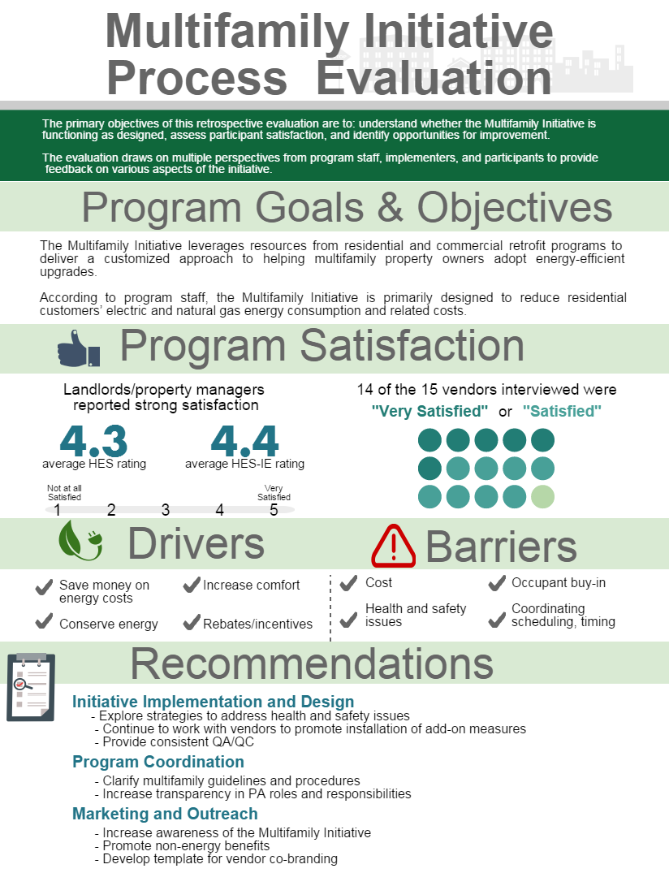

Executive Summary
ES
This report presents the results of a process evaluation of the Multifamily (MF) Initiative. The Connecticut Energy Efficiency Board (EEB) contracted NMR Group, Inc., to conduct a retrospective study, the primary objectives of which are to understand whether the initiative is functioning as designed, to assess participant satisfaction, and to identify opportunities for program improvement.
The MF Initiative is designed to provide a customized approach to serving multifamily property owners and managers. Measures in the multifamily sector are common to both residential single-family homes and commercial buildings. As a result, the MF Initiative leverages measures from residential retrofit programs—Home Energy Solutions (HES) and Home Energy Solutions-Income Eligible (HES-IE)—for in-unit measures, and additionally coordinates with commercial programs such as C&I Retrofit and Small Business Energy Advantage to address common-area measures. From the property owner’s perspective, the upgrades are intended to be offered seamlessly as a single package that puts them on a pathway to increase the efficiency of their property.
The objective of this process evaluation is to provide the EEB and Connecticut Program Administrators (PAs) with actionable recommendations about how to improve the design, delivery, and administration of the MF Initiative. The evaluation consisted of a review of program documentation and tracking databases; a series of in-depth telephone interviews with program staff, participating vendors, and landlords/property managers who participated in HES-IE; and an in-person focus group with landlords/property managers who participated in HES. Table 1 below lists the evaluation data collection tasks and associated sample sizes.
Table 1: Evaluation Tasks
Task | n
In-depth interviews with program staff | 3
In-depth interviews with program vendors | 15
Focus group with HES landlords / property managers | 9
In-depth interviews with HES-IE landlords / property managers | 30

Because the MF Initiative is not currently promoted as an offering separate from the HES and HES-IE programs, which are explained in more detail later, and evaluation participants specifically referenced their involvement in the MF Initiative through these programs, this evaluation accordingly reports on their respective experiences with these programs. When referring to issues that are not specific to either program, the evaluation refers to the MF Initiative as a whole.

Key Findings
The key findings from this evaluation are summarized below. The main body of the report explores these findings in more detail.

Goals and Objectives
The MF Initiative encompasses the HES and HES-IE programs as well as commercial programs such as C&I Retrofit and Small Business Energy Advantage. The MF Initiative seeks to provide multifamily property owners with a customized approach to adopting energy-efficient measures and equipment. According to program staff, the MF Initiative is primarily designed to reduce energy consumption and related costs in multifamily buildings, for both residential units and common areas.

Market Barriers
The primary market barrier that the MF Initiative intends to address is the cost of energy-efficient upgrades. Other significant market barriers include split incentives, limited customer knowledge of incentives and financing opportunities, lack of trust in contractors, and widespread health and safety hazards, all of which prevent the installation of many efficient upgrades.

Marketing and Outreach
Program staff use a variety of approaches for marketing and outreach. These different methods work together to engage customers in different ways. In addition, vendors use both formal and informal strategies to reach customers and generate leads. A few vendors stated that they feel like the PAs are too restrictive in allowing the vendors to market the program as they see fit, and that approvals for branded collateral take too long to turn around to be effective.

Participation Drivers
Program staff, vendors, and landlords/property managers all consistently stated that the primary motivation to participate in HES or HES-IE stemmed from a desire to save money on energy costs or conserve energy (on the both overall building and in-unit energy bills).

Participation Barriers
According to program staff and vendors, the main barriers to participation in HES and HES-IE include health and safety issues, and lack of access to units or equipment. The most common barrier to installing add-on measures, according to program staff and vendors, is the high upfront costs for such upgrades.
On the whole, landlords/property managers reported very few barriers to participation; the most common challenges that they cited were occupant buy-in, scheduling and timing of installations, measure quality, and communication issues with program and contractor staff.

Initiative Awareness and Satisfaction
Program vendors and landlords/property managers reported very little awareness of the Multifamily Initiative, reflecting the fact that it is not currently promoted as an offering separate from the HES and HES-IE programs: roughly one-half of the vendors interviewed were aware of this initiative, and those who reported that they had heard of it expressed a limited knowledge of the effort.
None of the HES landlords/property managers was initially familiar with the initiative, and only and after being read a description of the effort did three of the nine focus group attendees state that they had heard of it.
Although the MF Initiative had low name recognition, vendors as well as multifamily landlords/property managers reported relatively strong satisfaction with its residential component, the HES and HES-IE programs.
- Fourteen of the 15 vendors who were interviewed (93%) reported that they were satisfied with their experience in the program.
- The majority of multifamily landlords/property managers who participated in HES and HES-IE said that they were satisfied with their experience in the program. On a scale of one to five, where one means not at all satisfied and five means very satisfied:
  - Seven of the nine HES landlord/property manager focus group attendees (78%) gave the program a 4 or 5 rating, and their average rating was 4.3.
  - Twenty-eight out of 30 HES-IE landlord/property manager interviewees (93%) rated their satisfaction a 4 or 5, with an average rating of 4.4.

Initiative Design and Implementation
The audit process for a multifamily property involves initial diagnostic testing of 10% of the facility’s units to identify opportunities for energy savings. During the initial visit (based on the unit’s condition), residents can receive an assortment of direct-install measures such as air and duct sealing, energy-efficient light bulbs, domestic hot water measures, and pipe insulation.
Following the audit, vendors and program staff develop a proposal that includes a package of electric and natural gas measures that will help the landlord or property manager as well as the tenants reduce overall energy consumption. The proposal leverages measures and rebates from the other programs and is presented as a comprehensive offering for the landlord or property manager.
Landlords/property managers reported that they generally were satisfied with the audit, including the installation of the core and add-on measures. However, they reported that they encountered challenges in a few areas:
- HES landlords/property managers cited difficulties with scheduling the vendors’ visit for both core and add-on measures. A few also reported that the vendor did not provide sufficient information regarding the audit recommendations and related incentives. They also provided the lowest average satisfaction rating for post-installation follow-up and quality assurance and quality control (QA/QC).
- HES-IE landlords/property managers also noted inadequate follow-up, particularly related to information on incentives and financing options.

Program Strengths
Program staff reported that the primary strength of the MF Initiative is that it provides multifamily owners and managers with a customized approach to adopting energy upgrades that helps building owners and occupants save energy and money and become more aware of energy-efficient practices.
Vendors similarly cited benefits to customers, including improved energy efficiency, discounted upgrades, and increased awareness.
HES landlords/property managers overwhelmingly reported that they were pleased with the energy savings that they experienced through the program.

Program Challenges
When citing program challenges, program staff discussed obstacles to effective implementation in the multifamily sector such as a limited pool of qualified vendors and the level of coordination that is needed with different people involved with the property. Staff also mentioned the pervasive problem of health and safety issues present in both the single-family and multifamily sectors.
Vendors brought up various challenges related to coordinating with PAs, including high turnover, staff restructuring, slow response times, and lack of clarity on program procedures.
HES-IE landlords/property managers voiced mixed perceptions regarding the accuracy of their energy savings estimates. Roughly one-third of HES-IE interviewees (10 out of 29 respondents) thought that the energy savings estimate from their audit was accurate, another one-third believed that it was inaccurate (nine overall, with six stating that it was overestimated), and the remainder said that they did not receive an estimate or that they “don’t know” if the estimate was accurate.

Conclusions and Recommendations
Initiative Design and Implementation: Landlords/property managers reported that, overall, they are highly satisfied with the MF initiative (referencing their experiences in the HES and HES-IE programs). Effective practices to engage participants and provide services should be maintained, and program staff may consider developing other strategies to further their goals with this sector, such as the following:
- Explore strategies for addressing health and safety issues. Vendors indicated that health and safety issues are prevalent in as many as 40% of all sites. Although vendors and program staff noted that these hazards typically are less likely in multifamily settings, it is clear that the presence of health and safety issues prevent the installation of energy-efficient measures for a sizable proportion of residents. The HES and HES-IE programs should verify the extent to which this prevents multifamily properties from fully accessing program services and explore how other programs, such as Massachusetts’ Low Income Multifamily (LIMF) program, address such concerns.
- Continue to work with vendors to promote installations of add-on measures. These efforts could involve trainings that emphasize the importance of consistently offering recommendations for add-on measures through a comprehensive discussion following the audit. This review should also focus on approaches for informing participants about the opportunities for program financing and incentives. Given that the program attempts to take a whole-building approach, it seems that giving attention to all building areas—units and common areas—is essential. Ideally, vendors will be encouraged to take this approach. Additionally, establishing and/or maintaining guidance for vendors to conduct follow-up outreach after the audit will likely improve participation in the rebate and incentive programs. If participants happen to be ineligible for program-incented add-on measures, then the auditors may wish to document the reasons participants may have been ineligible.
- Provide consistent QA/QC. The program currently undertakes great efforts to conduct rigorous QA/QC to ensure quality measure installation and there do not appear to be any major issues with the process. The program may nevertheless benefit from implementing a higher level of QA/QC with non-program-approved contractors as a number of HES landlords/property managers mentioned using non-program contractors who may not have the qualifications or meet the standards set for program-approved contractors.
Program coordination: Program staff and vendors indicated that there has been improved communication across agencies and organizations in recent years. Vendors noted areas for improvement specifically related to slow response times and lack of clarity on program procedures. Overall, vendors were more likely to say that their experiences with single-family projects were comparatively better because of these issues. The following suggestions would likely improve vendors’ experiences in these areas:
- Clarify multifamily guidelines and procedures. Currently, the guidelines for multifamily projects are included the HES/HES-IE Implementation Manual. While this document provides a general overview, it does not get into the particulars of program requirements for vendors. Developing a separate document that outlines guidelines and procedures for multifamily projects would help define specific protocols for vendors and program staff and improve vendors’ perceptions that the program is not well-defined.
- Increase transparency in PAs roles and responsibilities. Since vendors voiced confusion regarding appropriate program staff contacts to answer questions or clarify issues, they would likely benefit from an explanation of staffing structures, including whom to contact for which issues. A solution as simple as an organizational chart for each Company would likely assist vendors in making appropriate connections with staff. Providing vendors with accurate information on which staff to contact for certain issues may also improve response times and vendors’ experiences with the approval process.
Marketing and outreach: Program staff and vendors reported that the various strategies to reach customers and generate leads is generally effective. Program staff should consider additional approaches to marketing and outreach, including the following:
- Increase awareness of the MF Initiative. The program may wish to enhance its branding strategy to increase awareness of the MF Initiative. Given the relatively low levels of awareness of this initiative, program staff should consider better highlighting the benefits of this initiative.
- Promote non-energy benefits. The program should be commended for the quality and relevance of its offerings and services for their energy impacts and should continue offering and promoting audits, core services, and program rebates and incentives. While marketing and outreach materials should underscore energy savings, they should highlight non-energy benefits that will appeal to property managers (e.g., reduced tenant complaints, reduced water bills) if they are not already doing so.
Develop template for vendor co-branding. A number of vendors expressed a desire to have more latitude with marketing the program on their own. Developing a set of pre-approved marketing templates that have space for the vendor to add their logo would remove the need for vendors to obtain individual approval for materials throughout the year, while producing high-quality co-branded collateral for the program.

Introduction
1
The Multifamily (MF) Initiative is designed to provide a customized approach to serving multifamily property owners and managers. Measures in the multifamily sector are common to both residential single-family homes and commercial buildings. As such, the MF Initiative coordinates with the HES and HES-IE programs for in-unit measures and with commercial programs, such as C&I Retrofit and Small Business Energy Advantage, to address common areas. From the customer’s perspective, the upgrades are offered seamlessly as a single package that puts them on a pathway to increase the efficiency of their building.

Evaluation Objectives
The Energy Efficiency Board (EEB) contracted with NMR Group, Inc., to conduct a process evaluation of the Multifamily Initiative. The primary objectives of this process evaluation are as follows:
- To document initiative implementation
  - How is the initiative intended to operate and how, if at all, does that differ from how it currently works in practice?
  - What goals do program stakeholders plan to achieve through the program?
- To assess participant response
  - Are customers satisfied with their experience with the initiative? Specifically:
  - How satisfied are customers with the measures they have installed, or services they have used?
  - What are their reasons for participating? Why did some customers start the process and fail to complete participation?
  - What is driving the interest in participation? What are the barriers to participation? What are the barriers to measure installations?
  - What might be done to improve satisfaction and initiative engagement?
- Are vendors satisfied with their experience with the implementing the initiative?
  - What challenges or barriers have they encountered in implementing the initiative?
  - What might be done to improve satisfaction and initiative engagement?
- To identify and recommend initiative improvement opportunities
  - What changes can be made to the initiative to:
    - Increase customer satisfaction?
    - Increase vendor engagement?
    - Overcome barriers to participation and increase participation and savings?

Methodology
The evaluation draws on multiple perspectives from program staff, implementers, and participants to provide feedback on various aspects of the initiative. The following tasks were completed for this evaluation:
- Task 1: In-depth interviews with program staff
- Task 2: In-depth interviews with program vendors
- Task 3: Focus group with HES landlords/property managers
- Task 4: In-depth interviews with HES-IE landlords/property managers
Data collection for these different tasks was closely coordinated with other research efforts, including R4 HES/HES-IE Process Evaluation and R151 Air Sealing, Duct Sealing, and Insulation Practices Evaluation. This coordinated approach endeavored to maximize efficient outreach to program stakeholders and minimize respondent fatigue.

Program Staff Interviews
An initial task of the evaluation included in-depth interviews with three program staff—one from Eversource and two from UI. These interviews served as the primary method of understanding the program goals and objectives, providing information on the structure of the MF Initiative, and informing subsequent research tasks. The structured interviews with program staff addressed a number of topics, including the following:
- Overall program goals and objectives, including those specific to the MF Initiative
- Linkages between the MF Initiative and the single-family and multifamily portions of HES/HES-IE, as well as any coordination with the small C&I program
- Structure of the MF Initiative, including components, processes, staffing, and resources
- Initiative marketing and promotion
- Impact on the market in terms of initiative awareness and participation
- Drivers of and barriers to customer participation
- Initiative strengths, challenges, and opportunities for improvement

Vendor Interviews
Given the relatively small pool of vendors and overlapping research objectives, in-depth interviews with program vendors were coordinated with the R4 HES/HES-IE Process Evaluation as well as R151 Air Sealing, Duct Sealing, and Insulation Practices Evaluation. Vendors who completed the initial R151/R157 questions received a $50 incentive. Fifteen of the 19 participating vendors completed interviews. Most of the vendors interviewed reported that they work in both the HES and HES-IE programs. Four of the vendors stated that 5% or less of their projects are in the multifamily sector, five indicated that multifamily projects make up between 5% and 50% overall work, and four reported that more than 50% of their work in HES and HES-IE involved multifamily properties. The in-depth interviews covered a range of topics, such as the following:
- Vendor roles and responsibilities, including marketing and outreach, customer enrollment, audits, project application and approval, and measure implementation
- Initiative processes, tracking, and reporting
- Satisfaction with initiative procedures
- Participation barriers and drivers
- Perceptions of customer value and satisfaction
- Overall initiative strengths, challenges, and suggestions for improvement

HES Landlord / Property Manager Focus Group
The process evaluation also included a focus group with landlords/property managers, These attendees participated in the HES program between July 2013 and April 2015. Using program participation data from Eversource and UI, 56 landlords/property managers with available contact information were recruited for the focus group. The attendees were landlords, property managers, and condominium association representatives of buildings with five or more units that participated in HES. Eleven contacts, all of whom were involved with at least one participating multifamily site, agreed to attend the focus group; nine of them ultimately attended the focus group. Prior to the focus group, attendees received a scorecard (i.e., handout), included in Appendix D, asking them to rate their level of satisfaction with various aspects of the program. Their ratings were used as a starting point for discussing the various focus group topics. In some cases, through the conversation, attendees realized that they should change their scores; the average satisfaction ratings in this report use the final ratings that the attendees provided. The focus group addressed the following topics:
- Program satisfaction
- Program awareness
- Participation decision-making
- Audit processes
- Audit report
- Measure installations
- Rebates and incentives
- Energy and non-energy benefits

HES-IE Landlord/Property Manager Interviews
Thirty HES-IE landlords/property managers participated in in-depth interviews designed to obtain information about their experience with the program. This task was also coordinated with data collection for the R4 HES/HES-IE Process Evaluation. The interviews explored issues similar to those covered in the focus group, including the following:
- Satisfaction with the audit, audit report, and measures installed
- Satisfaction with the effects of the energy conservation measures on their energy bills
- Overall satisfaction with the program
- Motivations and barriers to participation
- Recommendations for program improvements
It is important to note that, while landlords/property managers who participated in HES and HES-IE were asked questions on similar topics through the two separate data collection efforts, not all of the individual items and results are comparable across the two groups. Although it is likely that landlords in both programs had similar experiences with these two programs, there are key differences in how they are implemented and in the populations who are served by them. As a result, unless otherwise noted, the findings for the two groups are reported separately throughout this report.

Report Outline
This report synthesizes the overarching themes that emerged from the individual evaluation tasks. The following outlines the overall structure of the main body of the report.
- Multifamily Initiative Overview
- Initiative Design and Implementation
- Initiative Awareness and Satisfaction
- Participation Patterns, Drivers, and Barriers
Within each section, we separately report the findings from each interview group (Program Staff, Program Vendors, HES Landlords/Property Managers, and HES-IE Landlords/Property Managers), as appropriate. The key findings across all interview groups are summarized at the beginning of each section.
The appendices to this report provide additional information on the evaluation participant groups, detailed results from certain topics identified in the main body, and copies of the evaluation instruments.

Multifamily Initiative Overview
2
The MF Initiative is designed to offer customers a tailored approach to adopting energy upgrades. The MF initiative serves many types of multifamily properties, including assisted living facilities, dormitories, group homes, apartment complexes, high-rise dwellings, and mixed-use developments. In the HES and HES-IE programs, a program vendor provides “core services,” which include initial diagnostic testing and evaluation of the building followed by direct installations of cost-effective energy-saving measures such as air and duct sealing, energy-efficient light bulbs, domestic hot water measures, and pipe insulation. Additional direct-install measures may also include occupancy sensors, limiting thermostats, cool/reflective roofing, and interior and exterior LEDs. Participants may also install measures—such as HVAC and appliance replacement, insulation, and windows—that are rebated through other programs. PAs and vendors work together to facilitate the process and deliver a seamless package of electric and natural gas measures that will help to reduce overall energy consumption.
This section relies primarily on information gathered from reviewing program documents and in-depth interviews with program staff. The principal findings include the following:
- Goals and objectives: The MF Initiative seeks to provide multifamily property owners with a customized approach to adopting energy-efficient measures and equipment. According to program staff, the MF Initiative is designed to reduce residential customers’ energy consumption and related in-unit and common-area costs.
- Market Barriers: The MF Initiative’s primary market barrier is the cost of energy-efficient upgrades. Other significant market barriers include limited customer knowledge of incentives and financing opportunities, lack of trust in contractors, and widespread health and safety hazards, all of which prevent the installation of many efficient upgrades.

Goals and Objectives
- Program staff stated that the MF Initiative is designed to reduce residential customers’ energy consumption and related costs.
According to program staff, the HES and HES-IE programs are designed to reduce energy consumption and related costs as well as improve the overall comfort of the home. Program staff also noted that improved energy efficiency goes hand-in-hand with residents’ comfort. That is, if a home is warmer in the winter and cooler in the summer due to the energy efficiency upgrades, the resident will be more comfortable in his or her home. In addition, while addressing health and safety issues is not a primary goal or objective of the HES and HES-IE programs, program staff noted that the energy audits help property owners to identify such concerns, and that vendors will often assist them in locating appropriate resources to help remediate those issues. Program staff also noted that they aim to provide high quality, easily accessible services for residential customers, and emphasized that they use a highly customized approach for each multifamily property. Unlike with single-family sector offerings, which are more prescriptive, program staff have greater latitude to tailor projects in the multifamily sector.

Market Barriers
- PAs reported that the cost of energy-efficient upgrades remains the primary market barrier for the MF Initiative.
During their interviews, program staff spoke about market barriers that the HES and HES-IE programs intend to address and the implications for the multifamily sector. The primary barrier cited by all staff interviewed is the cost of the upgrades. The programs offer deeply discounted add-on measures, but the cost often remains a barrier for many property owners. A couple of program staff spoke about how the programs offer “incentive bonuses” for multifamily properties, which allow staff to propose higher rebates as the property owner adopts deeper energy-saving measures to offset the cost of other expenses within the overall proposal for services. A related issue for many multifamily property owners is the negative perceptions from the split incentives that come with participating in these programs. To combat this, program staff and vendors make sure to underscore the non-energy benefits of the program such as improved building aesthetics, enhanced comfort, and increased tenant satisfaction and retention.
Another significant market barrier that program staff mentioned was limited customer knowledge of saving opportunities. According to program staff, marketing and outreach efforts have been very effective at increasing awareness about HES and HES-IE as well as other energy efficiency programs. However, staff also stated that even with the successful marketing of HES, HES-IE, and other programs like these, there remains room for improvement.
Other market barriers mentioned by staff include vendors’ technical skills and knowledge of the various types of multifamily properties, and customers’ lack of trust in contractors. Staff noted that these are persistent barriers that these programs continually must address. Although the prevalence of health and safety issues was not mentioned by program staff when asked directly about market barriers, the frequent mention of these issues during interviews with program staff as well as vendors suggests that the incidence of these hazards should be considered among the other market barriers.

Initiative Awareness and Satisfaction
3
This section provides details about program awareness and satisfaction, including perceived effectiveness of marketing and outreach, satisfaction with program elements, and the value to customers of their energy savings. This analysis specifically examines these aspects of the program from the point of view of customers, vendors, and program staff, and compares and contrasts these points of view with one another as applicable. The overall results reveal the following:
- Awareness of the MF Initiative: Program vendors and landlords/property managers reported very little awareness of the MF Initiative. Roughly one-half of vendors were aware of the initiative, and none of the HES landlords/property managers were initially familiar with it. Landlords/property managers who participated in HES-IE were not asked about their awareness of the MF Initiative.
- Program Satisfaction: Although they were not aware of the MF Initiative, vendors as well as multifamily landlords/property managers noted relative strong satisfaction with the residential components of the initiative (e.g., the HES and HES-IE programs).
  - Fourteen out of the 15 vendor interviewees (93%) reported that they were satisfied with their experience in HES and/or HES-IE.
  - Using a scale of 1 to 5, where 1 equals not at all satisfied and 5 equals very satisfied, seven of the nine HES landlord/property manager focus group attendees (78%) rated their satisfaction a 4 or 5, and their average rating was 4.3.
  - Using the same scale, HES-IE landlord/property manager interviewees (93%) provided a 4 or 5 rating, with an average rating of 4.4.
More detail on these and other findings is presented below.

Awareness of the Multifamily Initiative
- Vendors and HES landlords/property managers reported very little name recognition of the Multifamily Initiative.

Vendors’ Perspective
Roughly one-half of the vendors interviewed were aware of the MF Initiative. Among those who stated that that they were familiar with the initiative, most expressed limited knowledge of it. Most of these interviewees acknowledged that they “had heard of the term” or were familiar with it “from a conceptual standpoint.” Through their responses, it was clear that very few of the vendors were able to say that they were very knowledgeable about the initiative and its purpose.

HES Landlord/Property Managers’ Perspective
Landlords/property managers who participated in the HES focus group also were asked about their awareness of the MF initiative. When asked, all interviewees confirmed that they were familiar with the Home Energy Solutions program, but none of them were familiar with the Multifamily Initiative. After being read a description of the initiative, three of the attendees indicated that they had heard of it.
The limited awareness of the MF Initiative is not entirely surprising since, according to program staff, the MF initiative is not promoted as an offering separate from HES or HES-IE. During their interviews, program staff stated that there is no marketing or other collateral which describes it as such, and that when they interact with property owners they do not speak of it in that way.

Vendor Satisfaction
- Program vendors were generally satisfied with their experiences with the MF Initiative, yet noted specific areas for improvement.
The majority of vendors interviewed for the evaluation (14 out of 15) reported that they were satisfied with the MF Initiative (specifically, their experiences with HES and HES-IE) as shown in Figure 1. They cited positive experiences working with program staff, serving customers, and supporting overall program goals. Despite overall positive experiences with the programs, many vendors, including one vendor who candidly expressed dissatisfaction, described challenges in two main areas: 1) communication and coordination with program staff and 2) lack of clarity regarding program procedures and protocols, particularly those that relate to multifamily projects.
Figure 1: Vendors Were Generally Satisfied with the MF Initiative
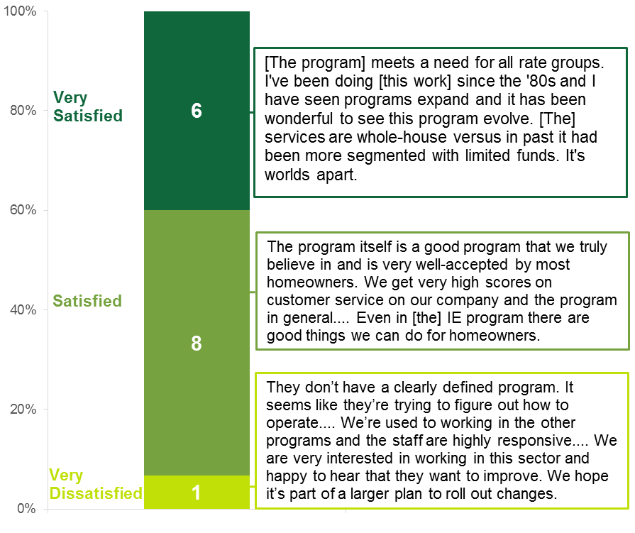
A number of vendors cited specific issues with working with program staff, including uncertainty in knowing whom to contact for questions, and delayed response from program staff. One vendor remarked,
There’s also sometimes a delay in the response from the utility. They seemed to be understaffed, so questions which might be time-sensitive and important do go unanswered due to a lack of response from the utility. For the most part, in general, there is a pretty good response rate, but it could be better. There’s room for improvement; they have opportunities to grow, as far as communication goes.
A different vendor who also expressed frustration with the response time from program staff additionally noted that it took “three or four months to figure out what their organization was—who we were talking to or who should we be talking to on specific items.” Other vendors similarly shared that they encountered problems with response times and making appropriate contacts within the respective utility companies.
A few vendors additionally noted differences between their experience with single-family and multifamily projects and related staff. On the whole, vendors were more likely to say that their experiences with single-family projects were comparatively better. Most often, vendors mentioned that they experienced longer response times and that the approval process for multifamily projects takes an inordinate amount of time. According to vendors, sometimes the delays cause the landlord or property manager to lose interest, which negatively impacts the vendor’s relationship and business with that property owner or manager.

Landlord/Property Manager Satisfaction
- Landlords/property managers who participated in HES and HES-IE reported high levels of program satisfaction.
Two different evaluation tasks assess landlord/property manager satisfaction with the program. The in-person focus group engaged those who participated in HES, and the telephone interviews targeted those who participated in HES-IE. Stakeholders from both programs reported very high levels of satisfaction. Because the individual questions regarding their satisfaction differed, it is difficult to present consistent comparisons across items and participant groups. However, their rating of their overall satisfaction on a scale of 1 to 5, where 1 equaled not at all satisfied and 5 equaled very satisfied, reveal overwhelming high satisfaction in both programs (Table 2):
- Landlords/property managers who participated in HES reported strong satisfaction with the program. Seven of nine focus group attendees gave a 4 or 5 rating, and their average rating was 4.3. They additionally thought that their building occupants were satisfied with the program as well; the average rating for their perception of their tenants’ overall satisfaction also was 4.3.
- Landlords/property managers who participated in HES-IE were very satisfied with the program overall: 93% of them rated it a 4 or 5, making positive statements such as “I’m very happy with the outcome of the program and look to use it again.” On average, they rated the program a 4.4.
Table 2: Landlord/Property Manager Program Satisfaction
Overall Satisfaction | Average Rating
HES program landlords/property managers | 4.3
HES-IE landlords/property managers | 4.4

Satisfaction with the HES Program
Prior to the focus group with landlords/property managers who had participated in HES, attendees completed a “scorecard” that assessed their satisfaction with various aspects of the program, including overall satisfaction, the audit process, report and recommendations, and measure performance and energy savings. Respondents rated most elements (18 of 22) a 4.0 or higher. Their ratings reveal the following overall patterns and themes:
- In-unit energy savings. The attendees who received incentives for in-unit measures consistently gave the highest ratings for this aspect of the program (5.0 on a scale of 1 to 5).
- Audit process. Attendees also provided high ratings for the audit report overall, the audit scheduling process, and the free measures installed/conducted in the common areas, giving average ratings of 4.5 for each.
- Common-area energy savings and non-energy benefits. Attendees gave their lowest relative ratings to energy savings that they experienced in their common areas and non-energy benefits (NEBs) that they themselves experienced, giving average ratings of 3.6 and 3.5, respectively. While these ratings were relatively lower than the other categories, they still represent positive rankings on the 1 to 5 scale.
Greater detail on these different ratings are presented in the relevant sections of this report.
Figure 2: Landlords/Property Managers Were Satisfied with Various Elements of the HES Program
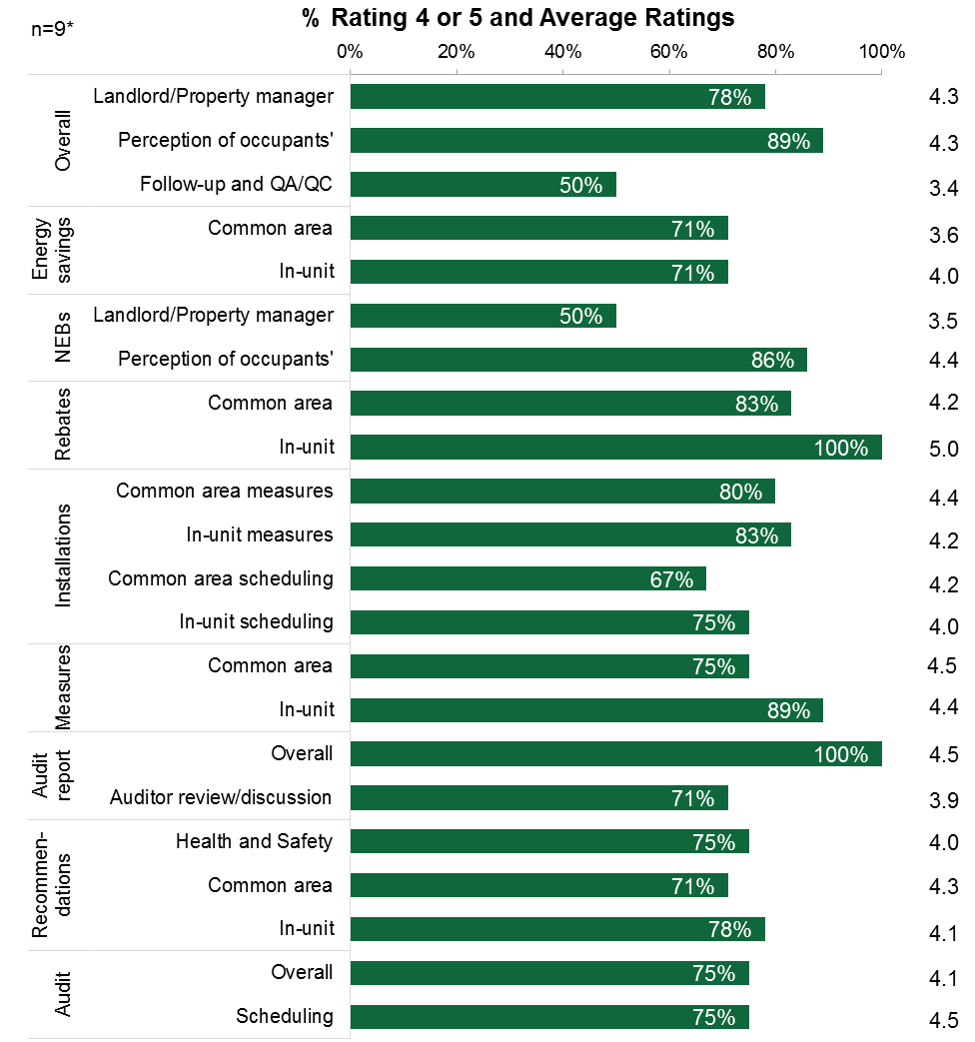
Note: Interviewees rated their level of satisfaction on a scale of 1 to 5, where 1 equaled “not at all satisfied” and 5 equaled “very satisfied.”
* Sample sizes vary across categories if topic areas were not applicable.

Satisfaction with the HES-IE Program
Landlords/property managers who participated in the HES-IE program assessed their satisfaction with the program differently from those in the focus group who addressed experiences with the HES program. During their interviews, landlords/property managers rated their overall satisfaction, their experience with the contractor, the quality of the work, and information that they received about rebates, financing, and energy-saving opportunities. Figure 3 displays their average ratings on these aspects and the percentage of interviewees who indicated satisfaction with a rating of 4 or 5. The average satisfaction rating for each aspect of the program was at least 4.0, indicating high levels of program satisfaction. Their responses show the following:
“I think that it is a win-win for everyone: [the utility], the tenant, and the landlord.”
– HES-IE landlord participant
- Contractor experiences. Interviewees were highly satisfied with their interactions with the contractor: all who could rate this aspect gave a 4 or 5, with an average rating of 4.8. Interviewees described the contractors as “very good to work with,” “easy to work with,” and “wonderful.” One interviewee added,
The [vendor staff] were people that I would have considered hiring if they weren’t already working [for another company]. All of the residents had positive feedback about the [technicians] who did the work in the units.
- Quality. Interviewees were very satisfied with the quality of the add-on measures and quite satisfied with the quality of the core services: 100% rated add-on measure quality with a 4 or 5, averaging 4.8. The vast majority were satisfied with the core services (92%), noting that they did not receive complaints and found that tenants are “happy” with the free measures. Interviewees thought the quality of the audit report was great, finding it “clear,” “comprehensive,” and “quite informative”—95% gave it a satisfied rating.
- Information dissemination. While the average satisfaction rating was 4.0 for the information about incentives and financing options—indicating satisfaction—interviewees were least likely to be satisfied with this aspect of the program: 63% assigned a rating of 4 or 5. One interviewee who provided a low rating explained,
I didn’t understand [the incentive and financing opportunities] all too well, so I didn’t take advantage of it. It seemed a little complicated to get involved with.
Figure 3: Landlords/Property Managers Were Satisfied with Various Aspects of the HES-IE Program
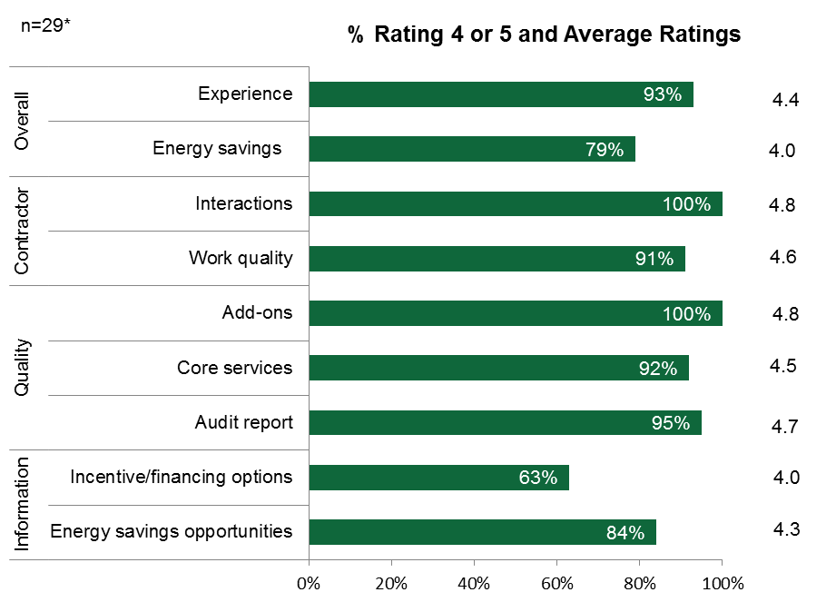
Note: Interviewees rated their level of satisfaction on a scale of 1 to 5, where 1 equaled “not at all satisfied” and 5 equaled “very satisfied.”
* Sample sizes vary across categories if topic areas were not applicable.

Initiative Design and Implementation
4
Drawing primarily on information from program staff, vendors, and participating multifamily landlords/property managers, this section summarizes the MF Initiative’s overall design and implementation. As noted above, findings from landlords/property managers who participated in HES and HES-IE primarily are reported separately. A high-level summary of results across evaluation participants is included below.
- Program Staffing: Program administrators provide the oversight and funding for the MF Initiative, while third-party vendors deliver program services to customers. Program staff and vendors work together to develop a comprehensive package of cost-effective energy upgrades for the multifamily landlord or property manager. Their process of leveraging resources for in-unit upgrades from the residential HES and HES-IE programs as well as related measures for common areas from commercial programs is designed to provide a seamless experience for the landlord or property manager.
- Audit Process: Program staff, vendors, as well as landlords/property managers provided multiple perspectives on the audit process.
  - The audit for a multifamily property includes initial testing of a sample of the property’s units (10%) and an assessment of common areas to determine the potential for improving the building’s energy efficiency.
  - In addition to the audit, during the initial visit vendors’ technicians install an assortment of core measures (such as air sealing, duct sealing, energy-efficient light bulbs, and water-saving equipment) that help the customer achieve immediate energy savings.
  - Although the majority of vendors shared positive remarks about the audit process, they also discussed a number of issues that are specific to providing services to multifamily properties, such as the technical skillsets that are required and the extra coordination that is needed with different types of building owners and managers.
  - Landlords who participated in the HES program also were generally satisfied with the audit process. Areas in which they experienced challenges include scheduling (also mentioned by vendors), timing of visits, and limited understanding of audit recommendations and vendor follow-up.
- Marketing and Outreach: Evaluation participants described the multiple approaches program staff and vendors use to promote the services offered through the MF Initiative.
  - Program staff recounted how the Companies and Energize Connecticut (EnergizeCT) market the HES and HES-IE programs through formal and informal channels.
  - Vendors confirmed that they also promote the HES and HES-IE programs through limited formal marketing activities, but noted that the majority of their customers come from “word-of-mouth” referrals.
  - Landlords/property managers who participated in the HES-IE program reported that they were most likely to enter the program after being contacted by the utility (11 landlords/property managers mentioned this). The other most common ways landlords/property managers indicated learning about HES-IE were from contacting the utility or the vendor contacting the landlord/vendor (eight and seven, respectively, reported these approaches).
More information on each of these topics is outlined below.

Program Staffing
- Program staff provide the oversight and funding for the MF Initiative, while third-party vendors deliver program services to customers.
Interviews with program staff revealed that the two Companies delegate responsibilities for single-family and multifamily projects differently. At Eversource, PAs handle projects for both HES and HES-IE but focus on either the single-family or multifamily sector. The PAs at UI are responsible for one of the two programs, but they are responsible for a combination of single-family and multifamily projects. Staff at both Companies were consistent in describing their approach to providing customized services to multifamily projects. They also spoke in concert about how services are well coordinated with the C&I programs to deliver a seamless experience for multifamily property owners.
Program vendors are primarily the public face of HES and HES-IE. Vendors are responsible for scheduling and conducting the energy audit, installing core measures, identifying savings and recommending measures, and, if needed, installing additional energy-saving upgrades such as insulation or providing referrals for such services. Vendors also provide general customer service and perform marketing and outreach activities for the HES and HES-IE programs.

Audit Process
Through the HES and HES-IE programs, residential property owners receive a thorough energy audit, installation of core program measures that result in immediate energy savings, and, if eligible, recommendations for deeper energy-saving measures. The audit process for a multifamily property involves initial testing of 10% of the property’s units. During the audit and initial visit, based on their unit’s condition, residents can receive an assortment of core services such as air sealing (weather stripping, caulking, and foam sealing) and duct sealing, as well as other direct-install measures like efficient light bulbs, and domestic hot water measures. For each crew that is deployed, there is at least one lead technician that is BPI-certified. The audit begins with a “walkthrough” visual inspection of the unit, and a technician documents the unit’s characteristics, including measurements needed for the in-unit blower door tests. A technician then conducts safety testing for the presence of hazardous materials which would prevent testing and installation of certain air-sealing measures. Barring any health and safety issues or other situations that would prevent testing (such as a property owner or tenant refusing such services), the crew completes the diagnostic audit and installs core services in the units. During the audit, the vendor’s team is also responsible for identifying the potential for energy upgrades for common areas like hallways, staircases, and entryways.

Vendors’ Perspective
- Vendors discussed various audit-related issues for multifamily properties, including technical skillsets, scheduling, and working with different types of building owners and managers.
Vendors discussed a number of issues that are particular to providing services to multifamily properties.
- Technical skills. Because of the unique characteristics of multifamily properties, serving these properties requires a more specialized technical skillset. Technicians must have a strong knowledge of industry standards and practices related to serving this sector. Vendors generally reported that their technicians are proficient in multifamily building science standards and practices.
- Scheduling. Vendors frequently stated that they encounter challenges with scheduling the initial audit as a well as any follow-up visits related to add-on measures. Landlords/property managers similarly reported scheduling challenges, as noted in greater detail below.
- Working with different types of property owners and managers. Overall, vendors did not indicate any differences in working with the variety of landlords/property managers in the multifamily sector. Vendors stated that each project receives a customized proposal for add-on measures that attempts to take into account the specific needs of the customer (landlord or property manager as well as tenants).

HES Landlord/Property Managers’ Perspective
During the focus group with landlords/property managers who had participated in the HES program, attendees were asked about their experience with the audit. The highlights from their responses are presented below. Note that HES-IE landlords/property managers were also asked about different aspects of their experiences with the audits, but those topics have slightly different emphases and therefore are incorporated in other sections of this report.
- Despite challenges with scheduling the audits, HES landlords/property managers had positive attitudes toward the audits.
As noted above, HES landlords/property managers were generally satisfied with the overall audit process. Focus group attendees gave fairly high ratings to the specific processes involved in the audit as well as the audit overall. Two attendees stated that the overall audit was generally a positive experience, three of them observed that the process was “smooth,” and another found the auditors to be very thorough and professional. Seconding a previous respondent’s satisfaction with the program, one property manager recalled that the auditors followed all of his requests, had positive attitudes, and were easy to coordinate with, requiring minimal time from him:
I was very much pleased as well. They followed all the requests. [The vendors] wanted to be there, they made sure to go around the [residents’] schedule. They would always call us when they got in and my maintenance guys would go there and open the doors and they would be there. They would always call, never leave anything behind, and never leave the apartments open. They didn’t consume too much of my time.
All of the focus group attendees concurred that “juggling” the scheduling for the audits was a challenge. Two of the attendees, both condominium association representatives, gave the audit itself a rating of 3 or lower (on the 1-to-5 satisfaction scale) because of the challenges in coordinating with auditors, suggesting that the vendors “take the reins” and work with the occupants and not rely on a central contact (i.e., the focus group attendees) to schedule the audits. Notwithstanding these reported challenges, the attendees gave an average rating of 4.5 for their satisfaction with the audit scheduling process.

Audit Recommendations and Follow-Up
- HES landlords/property managers reported satisfaction with, but limited understanding of, audit report.
The four focus group attendees who recalled seeing the audit report gave it high satisfaction ratings (averaging 4.5). Those who did not recall receiving an audit report were fairly confused about what it was. Three of them, all property managers, hypothesized that their audit reports went to their corporate offices. One of the attendees conjectured that her condominium association might have installed add-on measures if the auditor had given her association more assistance interpreting the audit report:
Once they gave us the [audit] report, I had to make sense of it, but I would’ve liked to have actually sat with somebody and formally gone over it and had some of my questions answered. That was never a part of it.
Interviews with program staff and vendors clarified that multifamily property owners receive a proposal for recommended measures following the audit, but reports from landlords/property managers indicate that at least a few vendors also use an audit report similar to those used in the single-family sector. The evaluation team’s understanding of the MF Initiative is that 1) measure installation proposals are intended to be one of the program’s central activities meant to spur participation in the rebates and financing opportunities for the program add-on measures, and 2) the MF Initiative seeks to take a whole-building approach. The evaluation team assumes that such an approach requires that the auditors give attention to common-area measures in addition to the individual units to identify opportunities for savings throughout the building.
- HES landlords/property managers reported a lack of recommendations and wrap-up discussion.
Based on the focus group attendees’ responses, it appears that their auditors largely did not debrief the property managers and condominium association representatives on the results of their findings. On the scorecard, attendees provided an average rating of 3.9 (n=7) for their satisfaction with the discussions with the auditors about recommendations for energy upgrades. Some landlords/property managers did not receive recommendations and were disappointed, but it may be the case that their buildings were ineligible for the add-on measures.
- HES landlords/property managers gave poor ratings for vendor follow-up and program QA/QC.
Attendees offered limited comments about post-installation follow-up and QA/QC efforts. However, they provided the lowest average satisfaction rating for post-installation follow-up and QA/QC, rating it 3.4. This was in large part due to two of the attendees providing very low ratings. One of the two explained her low rating of 2:
We’d get a report that a unit had been done and we’d check back with the unit owner and, no, they’d never been there. So it was an issue where I could never really trust the word of the [vendor]. We would have to go back and check with every single unit to make sure that it was really done. I really didn’t feel like that was [supposed to be] our job.
She later emphasized that the program staff, in contrast, had been immensely helpful and that, without the program staff assistance, the project would not have been as successful as it was in the face of the challenges with the vendor. She did, however, suggest that the program make greater efforts to review the quality of approved vendors’ work and question their level of commitment to the program.

Measure Quality and Installations
- HES landlords/property managers reported generally good experiences with free and add-on measures and installations.
Overall, interviewees were very satisfied with the free common-area (4.5) and in-unit measures (4.4), but a couple of them recalled needing to notify vendors about specific measures that they had “missed” in some of the units that they had visited, and another two had hoped to receive free measures in the common areas but did not. Overall, attendees said that the occupants in their buildings were “happy” with the results. The only negative feedback about the quality of the core measures that interviewees reported was that occupants dislike low-flow showerheads; they concurred, however, that this is not the fault of the program but is the nature of the measure itself.
The five attendees who installed add-on measures following the audits were pleased with those measures, rating the common-area measures at 4.4 and in-unit measures at 4.2. The add-on measures that the five interviewees installed included common-area lighting (n=4), insulation (n=2), windows (n=2), and boilers (n=2); not all of these measures were recommended by the auditors.
Only one of the attendees expressed frustration with the add-on measures; her company’s installation contractor—subcontracted by the audit vendor—had miscalculated the cost of the installation, causing her company to pay far more than planned. This experience was what she liked least about the program “just because it was another contractor that came in and did it and went out on their own without involving us.” It is unclear if the auditor’s subcontractor was program-approved (program tracking data only show the program vendor as associated with that installation). Generally, the respondents seemed unclear about which vendors were directly connected to the program.

Rebates and Incentives
- HES landlords/property managers reported general satisfaction with rebates and incentives.
The property managers who applied for and received program incentives gave the incentive amounts and add-on measures high praise, giving the in-unit measure rebates the highest average satisfaction rating of 5. The attendee mentioned above who was disappointed with the cost of installation because the vendor miscalculated the project costs added that the program incentives were also considerably lower and the vendor had miscalculated those as well; despite her disappointment with the final incentive amount, this attendee was pleased with the program and the quality of the add-on measure installation.
- HES landlords/property managers were not aware of program rebates and incentives.
Some interviewees were completely unaware of the availability of rebates and incentives for add-on measures, wishing that the auditor or another program representative would have provided information about them. At least two of them said that they would have strongly considered making additional improvements if they had been aware that rebates and incentives were available for them. One of the interviewee’s remarked,
I followed up with the [vendor] and got really little response, but there was no follow-up from [them]. I wanted to find out [what they had done in other units], were the incentives still in place? Could we try to continue? And what I was told is that the incentive program had ended completely.
It may be the case that in these instances the sites were ineligible for any program-supported add-on measures.

Marketing and Outreach
Program staff use a variety of approaches for marketing and outreach. These different methods work together to engage customers in different ways. In addition, vendors use both formal and informal strategies to reach customers and generate leads.

Program Staff Perspectives
- Program staff reported that they employ a variety of formal and informal marketing and outreach methods to attract customers to the MF Initiative.
As noted above, the Companies do not promote the MF Initiative as a separate coordinated effort. However, program staff reported that the HES and HES-IE programs are marketed centrally by the Companies and are supported by additional statewide promotion by Energize Connecticut (EnergizeCT). These programs are marketed to a broad audience through the use of the internet, television, and radio advertisements as well as print media and bill inserts. In addition, program staff conduct outreach in local community settings to promote the program. When asked which particular methods were most effective at reaching customers, staff generally thought that the different techniques worked together to capture customers’ attention. As one staff member stated,
I think they work together.... They see the billboard that says EnergizeCT or HES, they hear the commercial on the radio, and then if that wasn’t enough for them to sign up, then they see the vendor, and the vendor says, “Have you heard of Home Energy Solutions?” ...Or vice versa—they saw the vendor and they say, “I don’t know a lot about this program, I’m going to wait for now.” Then they start hearing the radio ads... they see the billboard, and [then] they call up.... I think they really do complement each other quite well.

Vendors’ Perspective
- Vendors’ most effective method of marketing is word-of-mouth referrals.
Vendors also reported that they conduct limited formal marketing activities through print or online promotions, but stated that the majority of their customers come from word-of-mouth referrals. A few vendors also thought that overall program messaging from the utilities and Energize CT does not resonate well with customers and does not have much of an impact. One vendor remarked, “They have the generic EnergizeCT campaign, which absolutely means nothing and people have no idea what it means.” Other vendors thought that the overall marketing was a start at connecting with customers, but that the messaging needs a “call to action” or a way to communicate a pathway to greater services for the customer, as evidenced in the following comment:
Energize CT needs to promote that HES is a starting point to unlock the other rebate opportunities—broaden the message and laying the groundwork [for additional energy savings].
A few vendors additionally shared that they thought the PAs are too restrictive with allowing the vendors to market the program as they see fit and that approvals for branded collateral take too long to turn around to be effective. One vendor suggested that the program should develop pre-approved marketing templates that allow the vendor to simply add their logo. According to that vendor, the current process of submitting materials for approval is often very lengthy and by the time materials are approved, the window of opportunity has passed.
It would be nice if we could get it approved by another agency instead of the utilities. Take that responsibility away from them. Maybe a board member on the EEB... The utilities are the program administrators... and to try to get stuff through them, it takes weeks on end. There’s a lack of response, and then there’s a review time… For one simple little piece, it could take up to three to four weeks to get approval, and by that time the window of opportunity for that has gone and left.

HES-IE Landlord/Property Managers’ Perspective
- Utility outreach to HES-IE landlords/property manager is the most common program entry point.
HES-IE landlord/property manager participants were most likely to enter the program after being contacted by the utility company (Figure 4). Over one-third (11) of the interviewees originally got involved with the program after the utility contacted them or other staff members at their company. The next most common channels of program entry were the landlord/management staff contacting the utility (8) and a third-party vendor or contractor, such as HES-IE program vendors or insulation contractors, soliciting the landlord or property manager (7).
Figure 4: Landlords/Property Managers Primarily Learned about the HES-IE Program from Utility Outreach
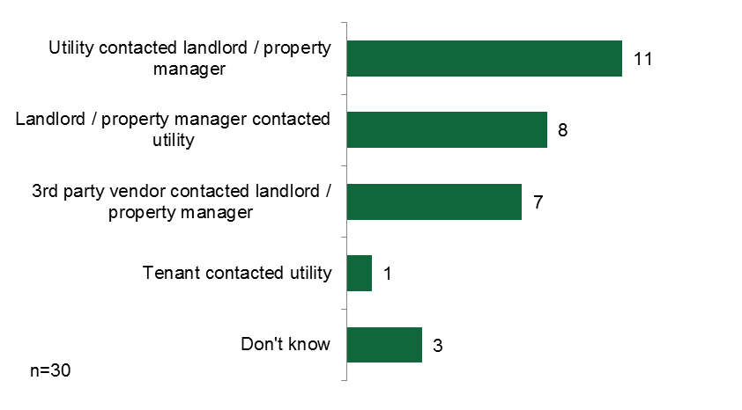

Participation Patterns, Drivers, and Barriers
5
This section summarizes participation in both HES and HES-IE and identifies drivers of and barriers to participation for landlords’/property managers’ as well as other obstacles to fully implementing program measures. This analysis is based on program data as well as information from program staff, vendors, and landlords/property managers. Since landlords/property managers are most knowledgeable about their own drivers and barriers, their results are more prominently featured and supplemented with perspectives from program staff and vendors. The key takeaways for this section are listed below.
- Program participation: Program data for July 2013 through April 2015 show that over 570 projects involving nearly 48,000 units were treated by HES and HES-IE.
- Drivers: Evaluation participants all consistently stated that the primary motivation to participate in HES or HES-IE stemmed from a desire to save money on energy costs or conserve energy.
- Barriers: Program staff and vendors reported that the most common barriers to implementing core services include health and safety hazards that prevent the prerequisite testing and installation of certain measures, vendors’ lack of access to equipment or areas of the unit/building, and customers’ refusal. When it comes to add-on measures, program staff and vendors agreed that the most significant barrier is the high upfront costs of the equipment and upgrades.
  - Other barriers cited by landlords/property managers include lack of occupant buy-in, scheduling of core and add-on services, timing and duration of the measure installation, and inconsistent communications with the program staff and vendor contacts.
The remainder of this section explores these issues in greater depth.

Participation Patterns
According to HES and HES-IE participation data from July 2013 through April 2015 (note that UI only provided data for July 2013 through December 2014):
- 111 landlords/property managers were involved with 144 HES projects, with an estimated 14,334 units that were treated by the program
- 173 landlords/property managers were involved with 429 HES-IE projects, with an estimated 33,564 units that were treated by the program
Table 3 shows participation by utility and overall.
Table 3: HES and HES-IE Multifamily Participation
 | HES |  |  | HES-IE
 | Landlords¹ | Projects | Units | Landlords | Projects | Units
Eversource | 109 | 131 | 13,138² | 173 | 263 | 20,433
UI | 7 | 13 | 1,196 | 46 | 166 | 13,131²
Overall | 111 | 144 | 14,334 | 219 | 429 | 33,564
¹ Note that several landlords/property managers were involved with both Eversource and UI HES projects.
² Due to missing data, the evaluation estimates the number of units in some Eversource HES projects and in all UI HES-IE projects by using the average number of units per project associated with other similar program projects.

Participation Drivers

Program Staff and Vendors’ Perspectives
- According to program staff and vendors, participation in HES and HES-IE is driven by financial and energy savings and comfort.
Program staff and vendors’ assessment of participation drivers were consistent with those shared by landlords/property managers (presented below). Interestingly, although program staff and vendors frequently mentioned that increased comfort from the energy upgrades was a primary motivation to participate in the HES and HES-IE programs, this was not cited by landlords or property managers. Figure 5 below shows the drivers most commonly identified by vendors.
Figure 5: Participation Drivers (Cited by Vendors)
(Multiple responses)
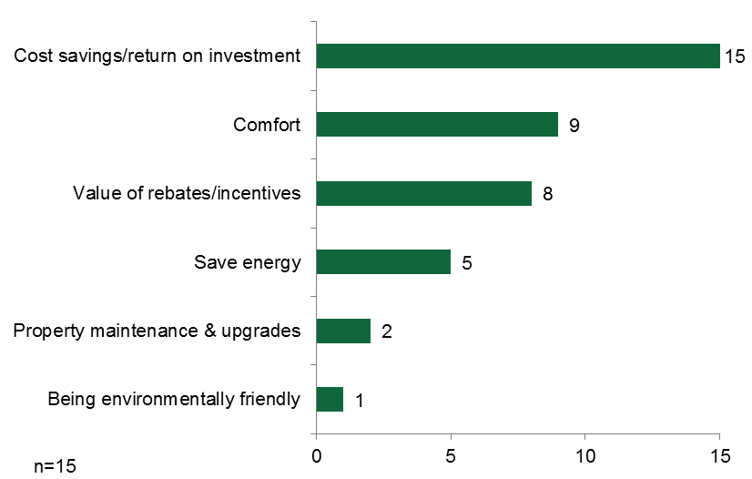

HES Landlords’/Property Managers’ Perspective
- HES landlords/property managers indicated that their primary driver was to reduce energy bills for both tenants and management.
During the HES landlord/property manager focus group, attendees stated that they and their companies or condominium associations decided to participate primarily to save money on energy bills for themselves, as property managers, and in some cases for their occupants. One interviewee asserted, “[Landlords and property managers] have nothing to lose and everything to gain.” An additional interviewee added that her condominium association participated to prevent ice dams (and later said that the program measures in fact prevented ice dams from recurring).
When the focus group moderator asked about split-incentives (i.e., a landlord or property manager invests time and/or money, but may not reap all of the positive benefits him- or herself), two property managers expressed reservations. One of them explained,
When we did it, the work in the units was fully paid for—we paid nothing out of pocket. When that happens, it’s a no-brainer. But it’s very hard to put up money for something that you are ultimately not going to see the return on unless it significantly impacts the residents’ utility usage, which we’ve seen is somewhat marginal.

HES-IE Landlords’/Property Managers’ Perspective
- HES-IE landlords/property managers also reported that their participation in the program was motivated by a desire to reduce overall building and in-unit energy bills.
The interviews with HES-IE landlords/property managers support the comments shared in the HES focus group. The results show that HES-IE landlord/property manager interviewees most commonly wanted to participate in the program in the first place out of a desire to reduce energy bills for their tenants (8), themselves (5), or generally (6). The next most common reason was to save energy (8), followed by the minimal cost to participate in the program (4). Interviewees were also motivated to participate in an effort to develop goodwill with tenants, receive upgrades that they found appealing, create room in their budgets to make other non-energy upgrades, and to install what they believed to be specific and necessary program measures such as insulation or lighting equipment (Figure 6).
Figure 6: HES-IE Landlords’/Property Managers’ Participation Drivers
(Multiple responses)
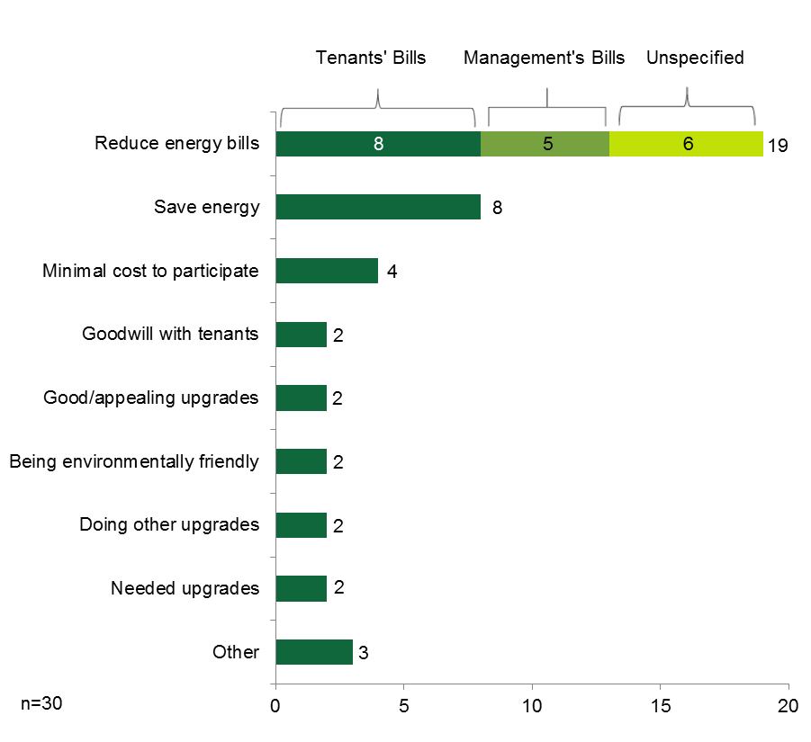
The HES-IE landlords/property managers were further asked to rate the importance of the savings that they expected in their overall building energy bill and their tenants’ energy bills in their decision to participate. On a scale of 1 to 5, where 1 means “not at all important” and 5 means “very important,” they gave an average rating of 4.5 for importance for their own energy bills (n=28) and 4.5 for their tenants’ energy bills (n=23). After rating the importance of reducing tenants’ bills at 5, one property manager explained the rationale behind it:
I mean, it is low-income housing and some people struggle, especially in the winter with the electric heat. So the more reasonable [tenants’ living] costs are, the higher the likelihood of us receiving our rent is.

Participation Barriers
In addition to discussing participation drivers, program stakeholders were asked to identify barriers to participating in HES and HES-IE. The main findings from their responses are presented below.

Program Staff and Vendors’ Perspective
- According to program vendors, health and safety hazards, lack of access to equipment or areas of the unit/building, and customers’ refusal to install certain measures are the most significant barriers to implementing core services. The upfront cost of upgrades is the primary barrier to implementing add-on on services.
According to program staff and vendors, the most common barriers to implementing core services include presence of health and safety issues, lack of access to equipment or areas of the unit/building, ideal starting minimum ventilation guidelines (MVG), and customers’ refusal to install measures because of aesthetics or other reasons. Vendors estimated that the presence of health and safety issues prevents them from performing core services at as many as 40% of all projects. The most common issues cited by vendors include asbestos, mold, carbon monoxide leaks, and gas leaks. However, both program staff and vendors reported that health and safety issues are not as prevalent in the multifamily sector because landlords/property owners are required by law to maintain safe living environments for their occupants. The most common barrier to installing add-on measures, according to program staff and vendors, is the high upfront costs for such upgrades. Figure 7 shows the participation barriers that vendors mentioned during their interviews.
Figure 7: Barriers to Participation (cited by Vendors)
(Multiple responses)
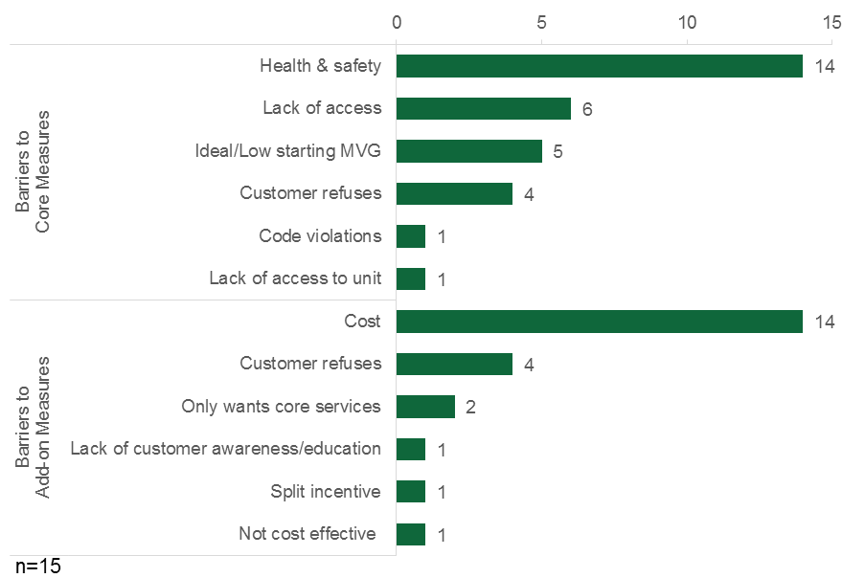

HES Landlords’/Property Managers’ Perspective
- HES landlords/property managers cited occupant buy-in as a barrier to participation.
During the HES focus group, attendees stated that occupant buy-in is a barrier to participation. The condominium association representatives emphasized that getting their fellow occupants to actually participate in the program was the greatest challenge because the auditors could not gain access to all of the building units when their neighbors were not “on board.” The property managers noted that, because they generally have rights over the property, they were able to simply notify tenants that the program would be servicing the units and, as such, did not need to seek occupant buy-in. Some interviewees, both condominium association representatives and property managers, suggested that the audit vendors should provide occupants with hand-outs, such as flyers to slip under doors, to help solicit their participation. As one property manager noted:
The only hang-up that we had was getting people informed [about the program]. I heard somebody mention [here] that [the vendors] were handing out flyers, but the onus was kind of on us to put a flyer together and [give] notice [to] the community, and it really just got a bunch of phone calls to me with questions that I couldn’t answer. If they had a detailed flyer or pamphlet that we could distribute with all the bullet points answered, that probably would’ve been helpful.
Another property manager noted, however, that the audit vendor that his company used had in fact distributed this type of handout without much success. Another said that her vendor had hosted a party for the residents to try and stir interest in participation, without much success.

HES-IE Landlords’/Property Managers’ Perspective
- HES-IE landlords/property managers reported that health and safety issues were found and remediated without causing delays.
Five of the thirty HES-IE landlord/property manager interviewees said that auditors identified health or safety problems during the energy assessment, delaying the initial assessment at only one of the five properties until maintenance staff had remediated the problem. All problems were resolved. (Additional details can be found in Table 10 in Appendix C.1: Health and Safety.)
- HES-IE landlords/property managers had few participation challenges, mentioning issues with timing, quality, and communication.
Besides health and safety issues, the interviews with HES-IE landlords/property managers revealed a few other difficulties or challenges during their participation in the program. As illustrated in Figure 8, only one-third of the HES-IE landlord/property manager interviewees (ten) identified specific issues.
- Time span. Most often, they found that the entire process took longer than they had expected, with four of them saying that it took months to schedule installations or that the project lasted more than one year.
- Measure quality. Only three interviewees indicated that they were less than 100% satisfied; these three voiced problems such as the new light bulbs not being bright enough or being expensive to replace, “sloppy” contractor work, and tenants complaining that they did not physically observe major improvements.
- Communications. Three interviewees expressed frustration with program communications, including unreturned phone calls and emails to a program contact, discontinuity in communication following the retirement of a program staff member, and a lack of communication with the contractor about important details of the work being done. That said, one interviewee made a point to comment on the positive communication with the program staff and vendors, saying, “The people I’ve worked with have been excellent.”
Figure 8: HES-IE Landlords/Property Managers Generally did not Experience Participation Challenges
(Multiple responses)
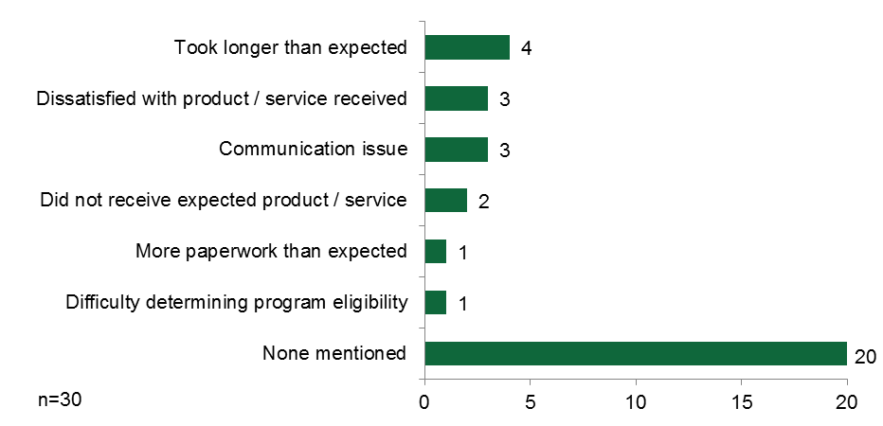

Strengths and Challenges
6
Program staff and vendors were asked to describe the primary strengths and challenges of the HES and HES-IE programs, particularly as they relate to the MF Initiative. This section summarizes their responses and presents related findings from the focus group and interviews with HES and HES-IE landlords/property managers. The highlights from the different evaluation stakeholders are recapped below.
- Strengths: Evaluation participants cited similar issues when discussing the MF Initiative and specific strengths of the HES and HES-IE programs.
  - Program staff and vendors commonly cited benefits to multifamily landlords/property owners, including improvements in energy efficiency and related costs and greater customer awareness and education.
  - HES Landlords/property owners also cited the benefits of the energy and cost savings.
- Challenges: When asked about their challenges with the MF Initiative (and experiences specific to HES and HES-IE), evaluation participants referenced a range of issues.
  - Program staff described a number of obstacles they face working in the multifamily sector, including the limited pool of qualified vendors and the complexities of working with a vast array of stakeholders.
  - In addition to discussing the prevalence of health and safety issues, vendors also shared the challenges they face coordinating with PAs, including issues stemming from staff restructuring and lack of clarity regarding protocols specific to processing multifamily projects.
  - HES-IE landlords/property managers voiced mixed opinions on the accuracy of the estimated savings when the audit was conducted. Ten of the 29 interviewees felt it was accurate, another nine stated that it was inaccurate and the majority felt that vendor overestimated savings (6 of the 9), and the remaining interviewees said that don’t know how accurate the estimate was (7) or that they did not receive one (3).
  - HES-IE landlords/property managers cited few suggestions for improving the program. The main issue that they mentioned is inconsistent communications with program staff and/or vendors, which they believe could be improved by streamlining program contacts, providing a clearer explanation of the audit process, and outlining the role and expectations of program vendors.
  - HES landlords/property managers offered very few but specific suggestions related to the audit process (e.g., audit follow-up, vendor QA/QC), as noted above in greater detail.
The rest of this section provides more information on these topics.

Program Strengths

Program Staff Perspective
- HES and HES-IE provide multifamily owners and managers with a customized approach to adopting energy upgrades that helps participants save energy and money and informs them about reducing their energy consumption.
When asked to cite the strengths of the HES and HES-IE programs, staff mostly referred to the benefits to customers: high-quality services, energy savings, and increased education about energy efficiency. Staff spoke about the advantage of offering air sealing as a core service that helps customers achieve immediate savings and noted that the program offers a pathway to greater energy savings. Program staff also spoke highly of the customized approach that is used to help multifamily property owners and managers. Tailoring each proposal to the particular needs of the property, its owner/manager, and the tenants was regarded as a major strength of the program.

Vendors’ Perspective
- Vendors similarly cited benefits to customers, including improved energy efficiency, value of core services, discounted upgrades, and increased awareness.
Vendors were similar to the PAs in their assessment of the programs’ strengths. They most frequently mentioned that customers improve their energy efficiency, benefit from the value of the core services, have access to rebates and incentives to help defray the costs of the upgrades, and improve their knowledge of energy-efficient practices (Figure 9).
Figure 9: Program Strengths (Cited by Vendors)
(Multiple responses)
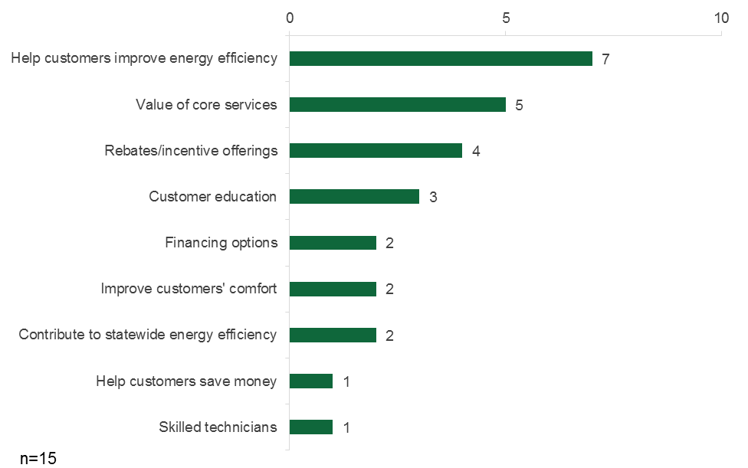

HES Landlords’/Property Managers’ Perspective
- HES landlords/property managers confirmed that the program results in considerable energy savings and increased comfort.
Although HES landlords/property managers were not ask explicitly to cite the program’s strengths, their responses are consistent with assertions from program stakeholders. During the focus group discussion, seven of the attendees indicated that they were very pleased with the energy savings that they experienced (one of the other two attendees did not see the energy bills). Two of the seven said that their savings were quite large—one of them installed insulation and windows, and the other installed lighting, windows, and a boiler.
When it came to NEBs, a couple interviewees noted that air leak drafts were minimized, with one property manager happily reporting that occupants had not complained about the temperature in the winter as they did every other year:
Many people gave positive feedback. To me, what counts even more is winter, how quiet my phone was. It was a cold winter; I used to get phone calls and complaints about drafts all the time. This year, there was not even one phone call about any [of those] problems.
A condominium association representative whose complex was in part driven to participate with the goal of stopping ice dams that the property had experienced in the past reported that the program measures prevented ice dams in the winter following program participation. One of the large property managers thought that his property value increased as a result of the improvements.

Program Challenges

Program Staff Perspective
- Program staff focused on the challenges inherent to working in the multifamily sector, such as the limited pool of qualified vendors and the extra coordination with various stakeholders.
When discussing program challenges related to the MF Initiative, staff primarily focused on obstacles to effective implementation. Due to the range of building types in the multifamily sector, staff are continually challenged by the limited pool of qualified vendors who have the appropriate training and skills to complete the diagnostic audits or properly install measures and equipment. Another challenge related the assortment of building types is having to coordinate different people involved with the property. Staff specifically mentioned the challenge of working with condominiums and having to get buy-in from various stakeholders. Another significant barrier that was cited for multifamily projects is the limited financing options. One staff member compared the very low rates available for the single-family sector and noted that rates for multifamily projects aren’t as competitive. Program staff stated that health and safety issues remain a challenge for both single-family and multifamily projects.

Vendors’ Perspective
- Vendors cited challenges related to coordinating with PAs, including high turnover, staff restructuring, slow response times, and lack of clarity on program procedures.
Like program staff, vendors also mentioned the pervasive challenge that health and safety issues pose. Five of the fifteen vendors mentioned health and safety issues when asked about the programs’ greatest challenges. Aside from the prevalence of health and safety concerns, vendors commonly mentioned occasional difficulties that they face in coordinating with program staff. As noted above, during their interviews vendors remarked on various issues related to coordination with PAs, including high turnover, staff restructuring, slow response times, and lack of clarity on program procedures. Although they acknowledged that issues like turnover and understaffing require longer-term solutions, vendors thought that increased transparency and communication regarding PAs’ roles and responsibilities could help in the short term.

HES-IE Landlords’/Property Managers’ Perspective
- HES-IE landlords/property managers voiced mixed perceptions of the accuracy of energy savings estimates.
The landlords/property managers who participated through the HES-IE program were also not asked directly to cite program challenges, but did respond to a question regarding their perception of energy savings. Their comments were slightly different from those of respondents who had participated in HES. Ten of the HES-IE landlords/property managers initially thought that the auditors’ estimates of the possible savings that they could reap from making energy efficiency upgrades through the program would be accurate (4) or “pretty” accurate (6) and nine thought that they were inaccurate. Those who thought that they were inaccurate generally thought the auditors overestimated savings (6 of 9). For the most part, they thought that the actual savings would be between 15% and 30% lower than what the auditor suggested; the three who thought the savings would be higher estimated that it would be between 15% and 23% higher.

Suggestions for Improvement

HES-IE Landlords’/Property Managers’ Perspective
- HES-IE landlord/property manager suggestions include better communication, increased incentive amounts, and improved core measure quality.
HES-IE landlords/property managers had few complaints and, as a result, few suggestions for program improvement. Six of the 15 landlord/property manager interviewees who offered suggestions for ways to improve the program made suggestions that pertained to improving the HES-IE program communications (Figure 11). In particular, they suggested that the utilities implement the following changes:
“Just keep doing what you’re doing and come up with ways to save more energy.”
– HES-IE property manager
- Create a single contact for all program-related communications.
- Clearly convey what to expect from the contractors.
- Communicate more clearly about timelines upfront.
- Promote possible costs/savings associated with program improvements during the solicitation process to increase participation rates.
- Carry out more direct communication as opposed to relying on third-party contractors.
The interviewee who suggested increasing the direct communication described wanting more confirmation of the reliability of the vendors’ recommendations, stating,
We were contacted [initially] by the contractor, and you just wonder whether the contractor is trying to sell you something that you really don’t need.
Others suggested the following:
- Increase financial incentives for windows (4), exterior lighting equipment, and refrigerators.
- Improve the quality of core services (4), including additional air sealing in residential units, using caulking in place of foam for very small air-sealing jobs, using brighter light bulbs, and using LEDs instead of CFLs.
- Add products and services to the program (3), such as door sweeps (generally already installed where needed), kitchen stoves, and incentives for renewable energy measures.
Figure 11: HES-IE Landlords’/Property Managers’ Suggestions for Program Improvement
(Multiple responses)
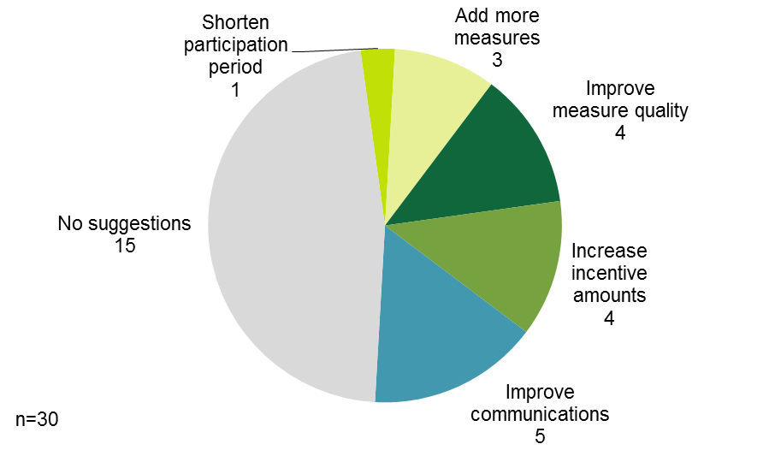

- Evaluation Participants
A
  - Vendor Participants
Four of the thirteen vendors who reported an estimate of their work stated that of their projects, 5% or less are in the multifamily sector; more than half of the interviewees indicated that multifamily projects make up 50% or less of their overall work in HES and HES-IE.
Table 3: Vendors’ Estimates of their HES/HES-IE Multifamily Projects
Percentage of Multifamily Projects | Number of Vendors
≤5% | 4
5-20% | 2
20-50% | 3
50-70% | 2
70-100% | 2
Note: Two vendors did not provide an estimate of what proportion of their work is in the multifamily sector.

Most vendors interviewed conduct work in both the HES and HES-IE programs.
Table 4: Vendors’ Work in HES and HES-IE
HES/HES-IE Split | Number of Vendors
0%/100% | 3
50%/50% | 2
60%/40% | 2
70%/30% | 1
85%/15% | 1
100%/0% | 3
Note: Three vendors did not provide an estimate of the how their work is distributed between HES and HES-IE.

  - HES Landlord/Property Manager Focus Group Participants
    - Project Characteristics
In total, the nine attendees were involved with 12 projects that went through the program in recent years; as shown in Figure 12, they represented 8% of all Eversource and UI HES multifamily program landlord/property manager contacts and 9% of all projects. Those 12 projects were associated with 15% of the gross program electric savings and 12% of the gross program gas savings in the participation data for the period from July 2013 through April 2015.
Figure 12: HES Landlord/Property Manager Focus Group Attendees Compared to Participant Population
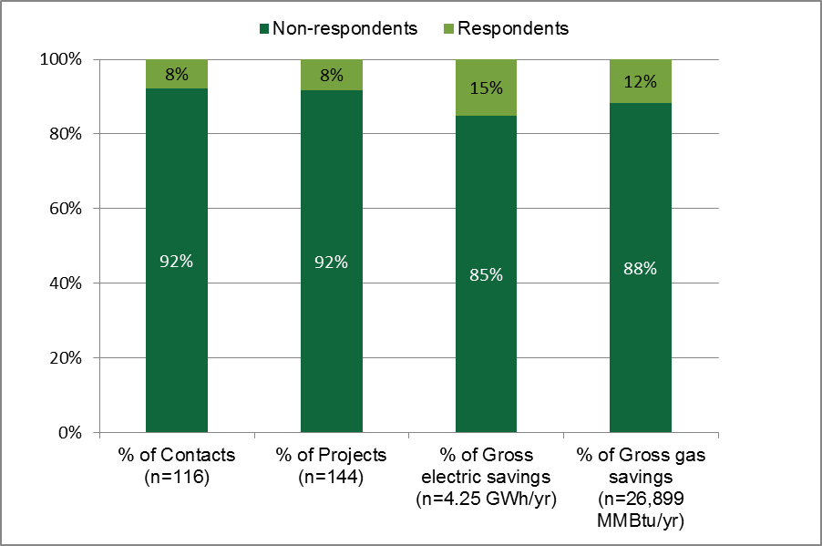
Note: “Contacts” represent the number of unique landlord/property manager contacts in UI and Eversource’s HES multifamily participation database from July 2013 through April 2015.
    - Focus Group Attendees
The nine respondents were equally distributed between the following three types of entities, all larger properties with at least 50 units.
- Three individuals were condominium association members in the buildings where they lived (their properties had fewer than 200 units).
- Three individuals were property managers or owners representing fairly large companies that managed more than 100 and less than 800 units in total.
- Three individuals represented very large entities that managed or owned properties with more than 800 units.
This group had a good representation of different perspectives in terms of company size, unit ownership structure, and bill responsibility. Attendees were most likely to represent buildings with entirely or primarily renter-occupied units (5 of 9). The property manager attendees most often managed buildings where they, as the property managers, paid for the heating in the occupants’ units (4 of 9); all interviewees reported that building occupants pay for their own electricity. The following graphics illustrate these characteristics.
Figure 13: HES Landlord/Property Manager Focus Group Attendee Characteristics
What are their roles?
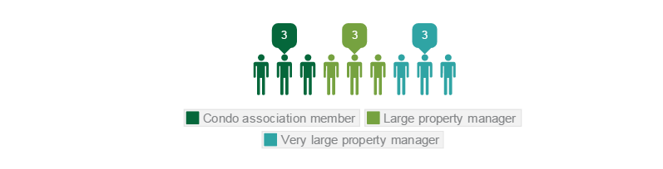
What is the ownership structure of their properties?
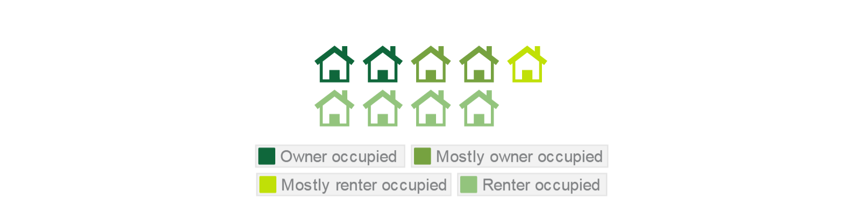
Who pays for the heating in the occupants’ units in their buildings?
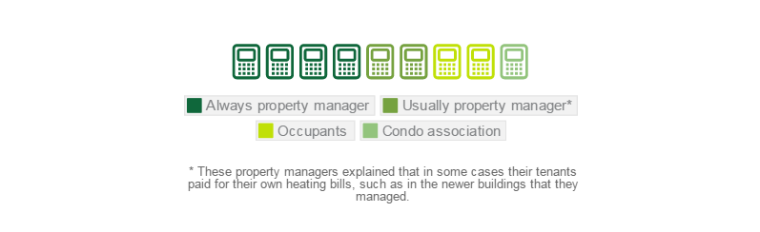
  - HES-IE Landlord/Property Manager Interview Participants

Project Characteristics
Interviews asked each landlord/property manager about one of their projects that participated in the program (referred to as their “key project”) between July 2013 and April 2015. If they were involved with more than one participating project, the interview question focused on the project with the largest amount of gross electric savings in the program database.
Of the 30 projects, 24 were served by Eversource and six were served by UI. The 30 projects included 2,373 housing units, representing 7% of the projects and estimated number of units in the HES-IE participant population that participated between July 2013 and April 2015, in total. The key projects ranged in size from five to 360 units, with an average of 79 units per project and a midpoint of 41 (Table 5)., Figure 14 compares the sample in terms of number of units, projects, and unique landlord/property manager contacts to the HES-IE participant population.
Figure 14: HES-IE Landlord/Property Manager Interviews – Sample Comparison to HES-IE Participant Population
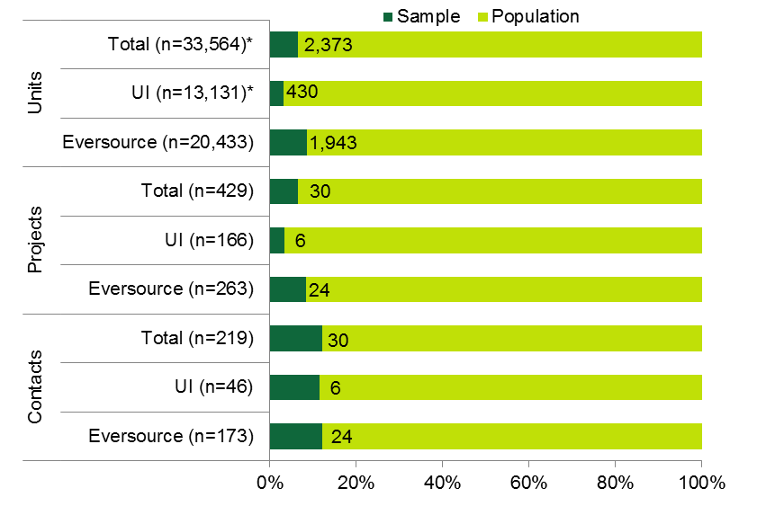
* In the absence of unit-level data in UI’s participation database, the study estimated the total number of units in the UI population by multiplying the mean units per projects among the key projects (79.10) by the number of UI projects in the participation database (166).
Table 5: HES-IE Landlord/Property Manager Interviews – Number of Units in Sample and Population
HES-IE Units per Project |  | Eversource | UI* | Total*
Participant Population  (n=429 projects) | Average | 78 | - | -
 | Median | 51 | - | -
Interview Sample  (n=30 projects) | Average | 81 | 72 | 79
 | Median | 46 | 26 | 41
* UI’s participation database does not capture the number of housing units in its projects; as such, the table does not report the average or median number of units among the full population.
    - Key Project Attributes
For the most part, the HES-IE landlords’/property managers’ key participating projects were of average size in terms of number of tenant units. The number of participating units within interviewees’ sampled projects ranged from five to 360 units, with an average of 79 units per project. Most often they had fewer than 50 units, with only a few projects that were very large and included 200 units or more (Table 6).
Table 6: HES-IE Landlord/Property Manager Interviewees – Number of Units at Key Project
Number of Participating Units | Count of Key Projects (n=30)
300-360 | 2
200-299 | 1
100 to 199 | 4
50 to 99 | 6
25-49 | 9
<25 | 8
Total | 2,360
Average | 79
Median | 41

    - HES-IE Landlord/Property Manager Interviews – Company Firmographics
Most HES-IE landlord/property manager interviewees’ companies are relatively small, yet they range in size from one to 2,000 employees, averaging 141 employees. Over one-half of the interviewees (18) own or work for companies that employ fewer than 25 employees.
Table 7: HES-IE Landlord/Property Manager Interviewees – Total Employees at Company
Total Employees | Count of Interviewees (n=30)
2,000 or more | 1
100 to 1,999 | 2
50 to 99 | 4
25 to 49 | 4
10 to 24 | 5
5 to 9 | 2
Fewer than 5 | 11
Don’t know | 1
Total | 4,081
Average | 141

In total, landlord/property manager interviewees manage 378 buildings (Table 8) with 20,037 units (Table 9) in Connecticut, averaging 13 buildings and 716 units. They were most likely to have small-to-medium enterprises, most commonly managing ten or fewer buildings (19) and fewer than 500 units in Connecticut (17).
Table 8: HES-IE Landlord/Property Manager Interviewees – Total Buildings Managed/Owned in Connecticut
Number of Buildings with Five or More Units in Connecticut | Count of Interviewees (n=30)
41 to 50 | 3
31 to 40 | 1
21 to 30 | 1
11 to 20 | 5
5 to 10 | 8
Fewer than 5 | 11
Don’t know | 1
Total | 378
Average | 13

Table 9: HES-IE Landlord / Property Manager Interviewees – Total Units Managed/Owned in Connecticut
Total Units Managed/Owned in Connecticut | Count of Interviewees (n=30)
3,000 or more | 1
2,000 to 2,999 | 2
1,500 to 1,999 | 2
1,000 to 1,449 | 4
500 to 999 | 2
250 to 499 | 5
100 to 249 | 5
Fewer than 100 | 7
Don’t know | 2
Total | 20,037
Average | 716

Landlord/property manager interviewees most commonly managed properties within Hartford (31), New Haven (20), and Fairfield (11) Counties (Figure 15).
- Two of the 30 interviewees said that they owned or managed properties all across Connecticut.
- The cities and towns in Hartford County that they listed most frequently included Hartford (10), Newington (5), and New Britain (4).
- Aside from listing New Haven County (2) generally, they frequently specifically identified the cities of Waterbury (6) and New Haven (5).
Figure 15: HES-IE Landlord/Property Manager Interviewees – Geographical Distribution of Properties
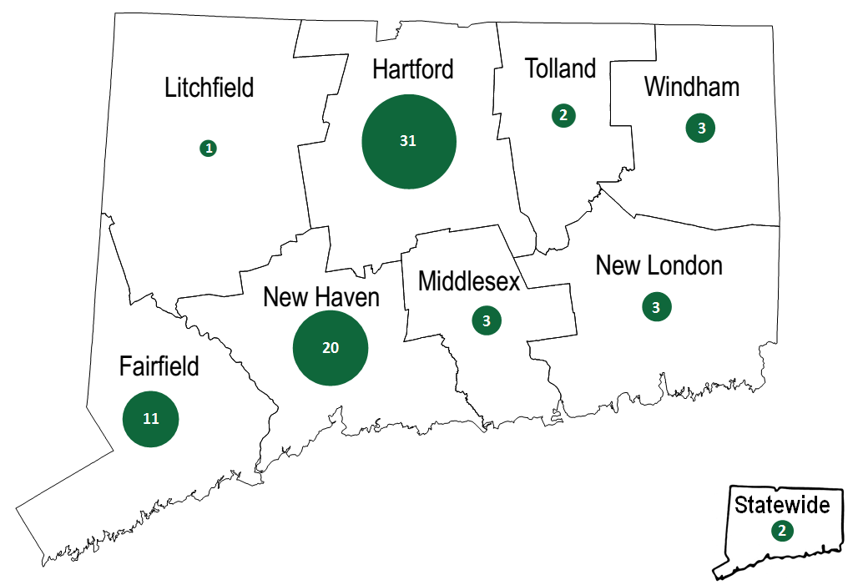
The size of the circle within each county corresponds with the number of times interviewees identified either 1) the county itself or 2) a town/city within the county as a place where their properties were located.

- Detailed Results from the HES Landlord/Property Manager Focus Group
B
  - Audit Process
Figure 16: HES Landlord/Property Manager Focus Group – Satisfaction with HES Audit Process Overall and Scheduling (average rating)
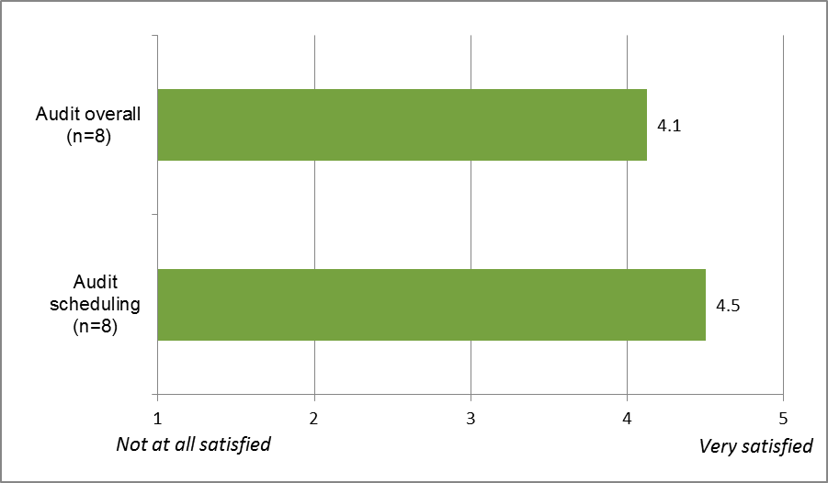
Note: Interviewees provided ratings for “the audit process overall” and “scheduling of the audit” on a scale of one to five, where one means not at all satisfied and five means very satisfied.
    - Audit Recommendations and Follow-Up
Figure 17: HES Landlord/Property Manager Focus Group – Satisfaction with Audit Report, Discussion, and Recommendations (average rating)
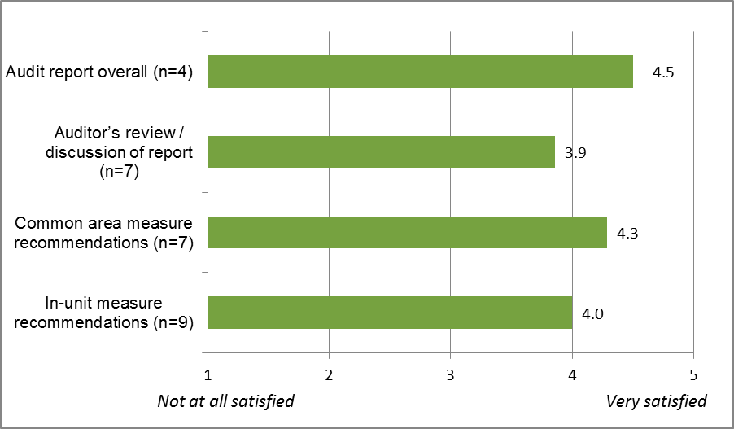
Note: Interviewees provided ratings for “audit report overall,” “auditor’s review and discussion of the report,” “recommendations for measures in common areas,” and “recommendations for measures in apartments/ building units” on a scale of one to five, where one means not at all satisfied and five means very satisfied.

Figure 18: HES Landlord/Property Manager Focus Group – Satisfaction with Follow-up and Health and Safety Recommendations (average rating)
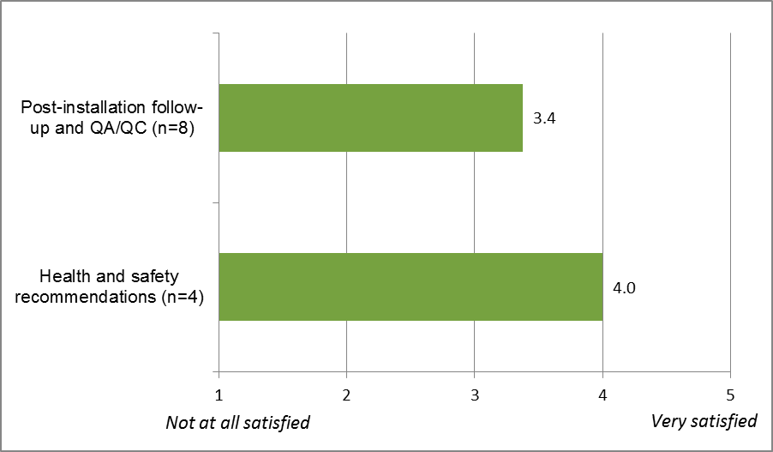
Note: Interviewees rated “post-installation follow-up and quality assurance/quality control” and “recommendations for health and safety improvements” on a scale of one to five where one means not at all satisfied and five means very satisfied.

    - Measure Quality and Installations
Figure 19: HES Landlord/Property Manager Focus Group – Satisfaction with Measures (average rating)
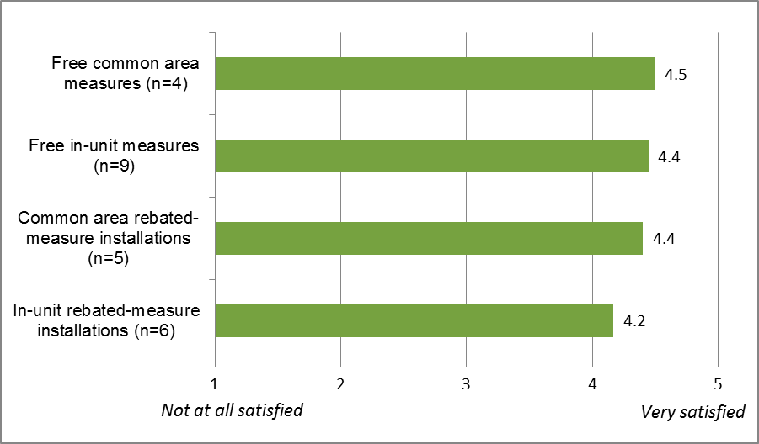
Note: Interviewees provided ratings for “measures installed for free in common areas,” “measures installed for free in apartments/building units,” “installations of rebated measures in common areas,” “installations of rebated measures in apartments/building units” on a scale of one to five where one means not at all satisfied and five means very satisfied.

Figure 20: HES Landlord/Property Manager Focus Group – Satisfaction with Measure Installation Scheduling (average rating)
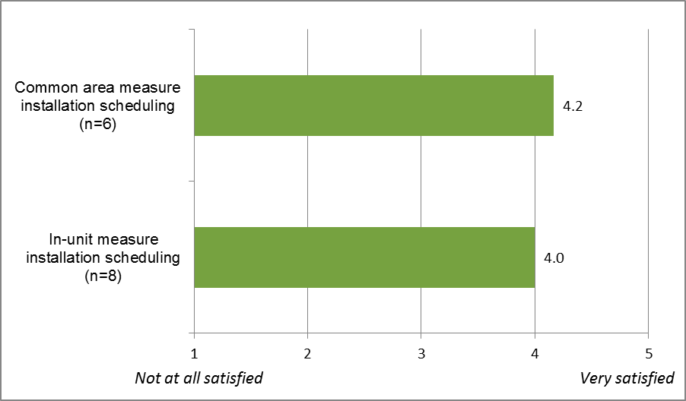
Note: Interviewees provided ratings for “scheduling of measure installation for common areas” and “scheduling for measure installation in apartments/building units” on a scale of one to five where one means not at all satisfied and five means very satisfied.

    - Rebates and Incentives
Figure 21: HES Landlord/Property Manager Focus Group – Satisfaction with Rebates (average rating)
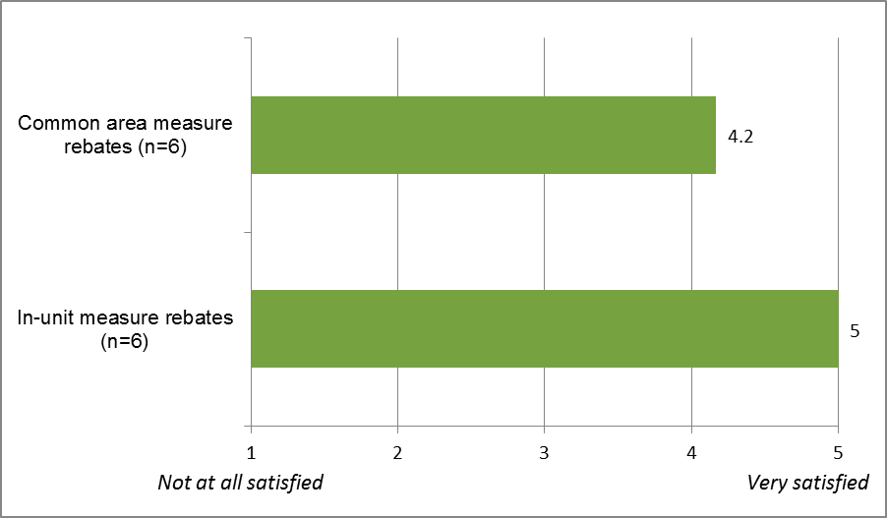
Note: Interviewees provided ratings for “rebates for measures in common areas” and “rebates for measures in apartments/building units” on a scale of one to five where one means not at all satisfied and five means very satisfied.

  - Satisfaction with Energy and Non-Energy Benefits
Figure 22: HES Landlord/Property Manager Satisfaction with Energy and Non-Energy Benefits (average rating)
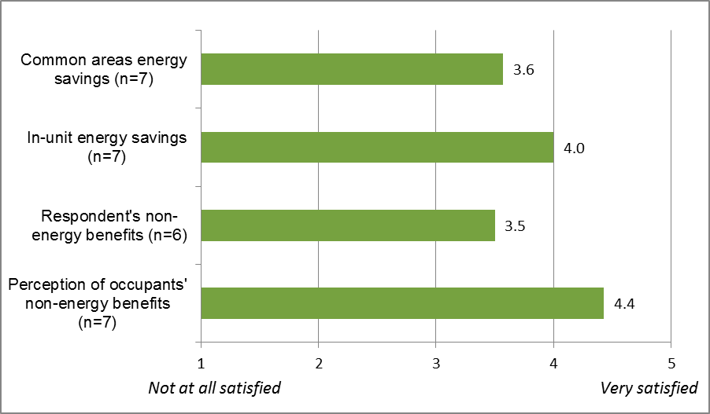
Note: Interviewees provided ratings for “savings from measures installed in common areas,” “savings from measures installed in apartments/building units,” “non-energy benefits for you, e.g., improved property value, reduced tenant turnover, etc.,” “non-energy benefits for occupants, e.g., increased comfort, healthy environment, etc.” on a scale of one to five where one means not at all satisfied and five means very satisfied.

- Detailed Results from the HES-IE Landlord/Property Manager In-Depth Interviews
C
  - Health and Safety
Five of the 30 landlord/property manager interviewees said that auditors identified health or safety problems during the energy assessment. Auditors discovered mold at all five of these properties and a gas leak at one of the five. The health and safety problems delayed the initial assessment at only one of the five properties until maintenance staff had remediated the problem. The interviewees confirmed that all of these health and safety problems had been resolved since the initial visit.
Table 10: HES-IE Landlord/Property Manager Interviewees – Reported Health and Safety Problems at Key Project
(Multiple responses)
Health and Safety Problems | Count of Interviewees (n=30)
No issues found | 24
Mold | 5
Gas Leak | 1
Don’t know | 1

- Evaluation Instruments
D
  - Program Staff Interview Guide
[NOTE: THE QUESTIONS IN THIS INTERVIEW GUIDE WILL NOT NECESSARILY BE READ VERBATIM BUT MAY BE MODIFIED TO SUIT THE INTERVIEW. IN ADDITION, THE INTERVIEWERS MAY SKIP QUESTIONS THAT ARE LESS RELEVANT TO A PARTICULAR INTERVIEW]
Thank you for taking the time to talk with me today about the HES/HES-IE program. I’m part of a team at NMR conducting an evaluation of these programs because the EEB is interested in obtaining feedback from program staff who have direct experience with HES/HES-IE; our evaluation has different components to it. One focus is on HES program practices related to three specific measures: air sealing, duct sealing, and insulation. Another is to do a process evaluation of the Multifamily Initiative. I have some general questions that address these different studies as a whole, but I also have specific questions regarding each of the different study objectives. Our conversation today, along with other information that we will collect for the evaluation, will help us to formulate actionable recommendations for HES/HES-IE programs. This interview will last about an hour and a half. If you don’t have time to go through all the questions now, we can break it up or send you some of the questions via email.
Before we start, do you have any questions? I would like to record the interview so that I am sure to capture everything you say. Is that OK?
With your permission, I would like to record the interview. Do I have your permission to record the interview ____? [IF NEEDED: We will use the recording for transcription purposes, in order to make sure we accurately represent your responses. No one but NMR staff members will listen to the recording.]

Program Background
First, I’d like to get some background on you and the [HES/HES-IE] program.
- What are your primary responsibilities for the [HES/HES-IE] program?

- At a high level, could you describe how the HES/HES-IE program works as a whole? SPECIFIC PROBES/ISSUES:
- Participants, with attention to underserved populations
- Role of vendors
- Measures recommended and installed
- QA/QC
- Marketing
- Evaluation

- What would you say are the overall goals and objectives of the program? What market barriers or other problems is the program designed to address? [CITE GOALS/OBJECTIVES/BARRIERS MENTIONED ABOVE AS APPLICABLE]

- What is the program doing now that will help to achieve the goals and objectives that you think are most critical for the program?
- How do air sealing, duct sealing, and insulation support the overall objectives of the program? What specific barriers are related to these measures?
- What role does the Multifamily Initiative play in supporting the overall objectives? What particular barriers are unique to this portion of the program?
- Has the Multifamily Initiative resulted in any changes in how the HES/HES-IE program is structured or delivered?
- As part of the Multifamily Initiative, do you have to do any coordination with parts of the program (e.g., single-family) or other programs (e.g., C&I)? What type of coordination do you have to do? Who do you have to coordinate with? What are the types and frequency of communications with them? What has been your experience with that coordination?

- What additional processes might be helpful in achieving the program’s overall goals and objectives?

- What are the program’s greatest strengths, particularly as they relate to –
- air sealing, duct sealing, and insulation?
- the Multifamily Initiative?

- Thinking specifically about the three measures of interest (air sealing, duct sealing, and insulation), are there any gaps in coverage—segments, measures, technologies, or anything else you can think of—that are currently not covered by the HES program?
a. What could the program do to address these gaps in coverage?

- Thinking about the Multifamily Initiative in general, are there any gaps in coverage—segments, measures, technologies, or anything else you can think of—that are currently not covered by the initiative, either through the HES/HES-IE program or the C&I program?
- What could the program do to address these gaps in coverage?

- Besides gaps in coverage, what other challenges or barriers does the program face, again with regard to -- [REFER TO RESPONSES ABOVE AS APPLICABLE]
- air sealing, duct sealing, and insulation?
- Multifamily projects? [Probes: barriers regarding program structure, program delivery, coordination with other components of the HES/HES-IE program, coordination with other programs]

- What kind of documentation is available for the program? As I understand it, the HES/HES-IE programs collect data from a number of sources including the vendor score card, post-inspection form, and QI form. I’ve also reviewed the Implementation Manual and Quality Assurance Plan. Are there other data or documents that we should be aware of? How can we obtain those data?

Participation Patterns, Drivers, and Barriers
Now, I’d like to talk a little bit about why a customer decides to participate in HES and what influences their decisions to install recommended measures.
- How do customers typically learn about the program? SPECIFIC PROBES IF NEEDED
- Vendor outreach
- Representative from the utility contacted customer
- Bill inserts
- Internet, newspaper, or other advertisement
- Customer (homeowner or landlord) contacted the utility

- [IF MENTIONED A-D] How effective are these methods of marketing and outreach? Are there other ways that the program should consider marketing the program?

- How, if at all does the marketing and outreach differ for the Multifamily Initiative?
- How do landlords or property managers learn about the Multifamily Initiative?
- How effective is the outreach?
- Are there other ways that the initiative should engage in marketing and outreach for the Multifamily Initiative?

- What are the primary reasons a customer decides to participate in HES? In the Multifamily Initiative (if different)?

- According to program data that we reviewed, 92% of homes that participated in HES received air sealing services, 21% received duct sealing, and 14% had insulation installed. Does that sound about right?

- The data also show that 5% of homes (755) that received air sealing services had an air sealing CFM reduction of 0% or, in other words, showed no difference between CFMs pre- and post-air sealing. Why would a home show no change pre and post air sealing?

- The majority of homes that participated in HES were owner-occupied, but renter-occupied homes had a higher average CFM reduction due to air sealing than owner-occupied (28% vs 20%)? Is this part of a targeted strategy, or due to the smaller home sizes (sq. footage) in the rental market, or is there some other explanation?

- Do customers receive ALL core measures for which they are eligible? In multifamily buildings, how does this vary by common areas and in-unit installations? Are there ever instances when measures are not installed or savings are not pursued? Why?

- What proportion of eligible participants receive add-on measures (insulation, ductless heat pumps, air conditioning equipment, refrigerators, or windows)? In multifamily buildings, how does this vary by common areas and in-unit installations?

- What are some of the most common reasons that customers decide to implement recommended measures? In multifamily buildings, how does this vary by common areas and in-unit installations?

- What are the primary reasons that customers choose not to implement recommended measures? [PROBE BEYOND THE COSTS OF DOING SO] In multifamily buildings, how does this vary by common areas and in-unit installations?

- What percentage of participating single-family homes would you estimate have significant, cost effective, energy saving opportunities remaining after the program services are complete?
- [If > 0%] What are the remaining opportunities?
- Why doesn’t the program address or capture these opportunities?
- How could future program address or capture these opportunities?

- What percentage of participating multifamily homes would you estimate have significant, cost effective, energy saving opportunities remaining after the program services are complete?
- [If > 0%] What are the remaining opportunities? [Probe for differences from SF homes]
  - Why doesn’t the program address or capture these opportunities?
  - How could future program address or capture these opportunities?

- What strategies are used currently to increase the installation of air sealing, duct sealing, or insulation either as a proportion of homes or within a given home?
- What else could the program do to increase installation of these measures?

- For the Multifamily Initiative, what strategies are used currently to increase the installations of measures in common areas of participating buildings? What strategies are used currently to increase the in-unit installations of measures of participating buildings?
- What else could the program do to increase common areas measure installations? In-unit measure installations?

- How does the program balance comprehensiveness and the high demand for services? In other words, how do you—or the program rules and procedures—decide whether to provide deeper services to fewer participants or more shallow services to a greater number of participants?

Vendor Practices
Let’s talk about the role of the vendors.
- [If not already answered in previous questions] At a high level, could you walk me through the vendor’s responsibilities from start to finish? [PROBE: Scheduling, assessment, kitchen table wrap up, recommending measures, identifying savings, customer service]. What are the differences in the process for single-family versus multifamily buildings?

- What are the most common reasons vendors may not have been able to fully implement all eligible measures at a home? [Clarify if needed: Are these the most common reasons for air sealing, duct sealing, and insulation?] What are the most common reasons for not implementing all eligible measures in a multifamily building? Are there instances when vendors don’t or haven’t recommended all the eligible measures? Why? Does this vary by single-family versus multifamily buildings?

- Based on the program data that we received, there appears to be some general patterns that indicate that the most active vendors provide the greatest level of services - air sealing, duct sealing and insulation. Does the program rely on a core set of vendors for the majority of the services? Are less active vendors actively encouraged to take on more work or does this accurately the capacity of participating vendors?

- We want to get a sense of the quality of vendors’ performance on a range of factors. As I read the list, please indicate if there are any differences between vendors that provide services to single-family versus multifamily properties. Using a scale of 1 to 5, where 1 is “very poor quality” and 5 is “very high quality”, how would you rate the quality of vendors’ performance on:
- Performing outreach and marketing [PROBE FOR EACH ITEM: IS THIS THE SAME FOR VENDORS THAT SERVE SINGLE-FAMILY AND THOSE THAT SERVE MULTIFAMILY PROPERTIES?]
- Scheduling the appointment [PROBE]
- Performing the energy assessment [PROBE IF NEEDED]
- Conducting the kitchen table wrap up [PROBE IF NEEDED]
- Identifying savings [PROBE IF NEEDED]
- Recommending measures [PROBE IF NEEDED]
- Collecting data during the assessment [PROBE IF NEEDED]
- Submitting documentation [PROBE IF NEEDED]
- Overall customer service [PROBE IF NEEDED]
- Other __________ [PROBE IF NEEDED]

- [For any item above, that receives a rating of 3 or below, ask] Why did you give [XXX] a [INSERT NUMBER] rating?

Contractor Practices and QA-QC Protocols
- What QA-QC protocols are in place to ensure quality installation? [PROBE IF NEEDED]
- Inspection scoring process.
- QI Form
- Post Inspection Report
- Vendor Scorecard

- How do you use the QA/QC reports? Do you review the data in aggregate or is it on a case-by case basis as QA/QC visits are completed? What trends have you noticed?
- [IF AGGREGATE QA/QC REPORTS] Could we get a copy of an aggregate report? [Probe if needed: We received copies of QI data forms for individual homes but we did not receive any aggregated data. Do you receive aggregated/consolidated QI data from the QA/QC vendor? Or do you inspect individual reports as they come in?]

- Using a scale of 1 to 5, where 1 is “very poor quality” and 5 is “very high quality,” how would you rate the QA-QC contractor’s overall performance?
- Why do you give the contractor a rating of [X]?

- Using a scale of 1 to 5, where 1 is “not at all effective” and 5 is “very effective,” how would you rate the overall QA-QC process?
- Why do you give that rating?

- What could be done improve existing QA-QC?
- Are there any requirements that aren’t really needed?
- Are there quality checks that should be added?

Wrap Up

- We also want to schedule interviews with the appropriate program staff at Eversource. Who are the appropriate people to contact there?
[Email these topics to interviewees prior to interview—so they can think about them and/or provide information via email]
I have just a few more questions to help inform interviews we have planned with HES vendors and a review of best practices for other energy-efficiency programs. You may recall I emailed you these questions before the interview.

- As you know, we are planning to talk with HES vendors and will survey customers to get their feedback and experiences with the program. Again, the focus of our evaluation is on the three measures: air sealing, duct sealing, and insulation practices as well as the Multifamily Initiative.
- We want to get a sense of which vendors we should prioritize interviewing. Do you have recommendations regarding which vendors we should be sure to contact? Are there differences among vendors who serve single-family and multifamily properties? [IF NECESSARY ASK THEM TO EMAIL LIST WITH CONTACT INFORMATION]
- What types of issues regarding air sealing, duct sealing, and insulation practices should we be sure to have vendors address? What about the Multifamily Initiative?
- What topics/questions are important to include on the customer survey?

- We also plan to look into best practices from other state energy-efficiency programs that offer air sealing, duct sealing, and/or insulation.
  - Do you have suggestions regarding specific programs or program staff that we should target?
  - What specific topics that you think we should be sure to cover?

- Do you have anything else to share with me on these topics or other topics that I have not addressed?

NOTES FOR INTERVIEWER: Before thanking the interviewee, remind them to email the following as applicable:
• Additional program data or documentation
• QA/QC reports
• Contact information for Eversource program staff
Thank you for your time today. We appreciate you taking time out of your busy schedule. After reviewing your responses along with responses from other interviews, we may have some additional short follow-up clarifying questions. Can we email you those questions if they arise? [Confirm best contact method, phone, email, and number / email address]

  - Vendor Interview Guide

R151/R157 Modules
[NOTE: NOT MEANT TO BE READ VERBATIM BUT AS ROUGH GUIDE]
Thank you for taking the time to talk with me today about [UTILITY NAME]’s the HES/HES-IE program. The EEB is interested in obtaining feedback from program vendors who have direct experience with the program. Your input will help identify the strengths and challenges with the program. Our interview for today has a particular focus on program practices related to three specific measures: specific measures: air sealing, duct sealing, and insulation. We also have some specific questions regarding the program as it relates to multifamily properties.
Does your company serve multifamily properties through HES/HES-IE? Are you the appropriate person with speak with about specific issues related to multifamily properties? [IF THEY SERVE MULTIFAMILY PROPERTIES, BUT THE INDIVIDUAL IS NOT THE APPROPRIATE PERSON GET CONTACT INFORMATION AND SKIP MULTIFAMILY QUESTIONS]
We also have some additional questions about customers’ financing and decision-making, non-energy impacts, and potential market effects. If time allows, we can cover those at the end or schedule a separate time to cover those questions. Are you the appropriate person to discuss these issues? [IF NO, GET CONTACT INFORMATION]
We are offering a $50 check for your time. The interview will take about 45 minutes to an hour. We can complete the interview now or schedule it for another time.
The information you provide will be treated as confidential. That is, I will not identify you or your responses individually; the information that you provide will be combined with observations from other individuals and organizations and the results will be reported in aggregate.
Before we start, do you have any questions? I would like to record the interview so that I am sure to capture everything you say. Is that OK?

R151/R157 – Respondent and Program Background
@*R1. Are you involved with both the Home Energy Solutions program for market-rate customers and the Home Energy Solutions Income Eligible program? (IF NO, CLARIFY)
- IF YES: Thinking of HES and HES-IE combined, about what percentage of your work is in HES and what percentage is in HES-IE? Is this percentage share of your HES vs HES-IE work, the same for single-family and multifamily properties?
- IF NO: About what percentage of your multifamily work is in HES and what percentage is in HES-IE? And about what percentage of your single-family work is in HES and what percentage is in HES-IE?

@*R2. What are your specific responsibilities for the HES/HES-IE program, including administrative responsibilities?

R3. Could you describe how the HES/HES-IE program works as a whole? SPECIFIC PROBES/ISSUES:
- Participants, with attention to underserved populations
- Role of vendors
- Measures recommended and installed
- Working with utilities, customers, landlords
- QA/QC
- Marketing
- Evaluation

*R4. Is the process different for single-family vs. multifamily properties? In what way?

*R5. Are you aware of the Multifamily Initiative that is a separate initiative of the utilities that combines HES / HES-IE and C&I programs to specifically focus on meeting the needs of multifamily (those with more than four units) properties? IF YES: Do you have to do anything different as part of the Multifamily Initiative?

R151/R157 – Program Administration

@P1. Overall, how satisfied are you with your experience of working with the HES / HES-IE program?
- Why do you say that?
- How does this differ by single-family vs. multifamily properties?
- IF AWARE OF MULTIFAMILY INITIATIVE: Is this any different with regard to your experience with the Multifamily Initiative?

*P2. Could you describe the interaction and communication between the utility and your organization (vendor staff)?
- How closely do you work with utility staff members?
- How frequently are you in communication? Have there been any breakdowns in communications? If so, how were they resolved and what steps have been taken to avoid future breakdowns?
- Are current interactions adequate? Why or why not?
- How can interactions/communication be improved?

*P3. How do you exchange applications, work orders, invoices, or other information with the utilities?
- Are current methods of exchange adequate? Why or why not?
- How can they be improved?

R151/R157 – Participation Patterns, Drivers, and Barriers
@*D1. How do customers typically learn about the program? SPECIFIC PROBES IF NEEDED
- Vendor outreach
- Representative from the utility contacted customer
- Bill inserts
- Internet, newspaper, or other advertisement
- Customer (homeowner or landlord) contacted the utility

*D2. [IF MENTIONED A-D] How effective are these methods of marketing and outreach? Are there other ways that the program should consider marketing the program?

*D3. What are the primary reasons a customer decides to participate in HES/HES-IE? IF AWARE OF MULTIFAMILY INITIATIVE: In the Multifamily Initiative?
- IF SERVES HES-IE: Is the process for securing permission any different by landlords, property managers, or public housing authorities?

*D4a. What differences, if any, are there in the approach your staff takes to conducting audits of single-family versus multifamily properties?
- What is the reason for this?
- Are there differences in your staff comfort level with conducting audits of single-family versus multifamily properties? Why is that?

*D4b. When you audit multifamily buildings, are there are any differences in the approach your staff takes to assessing the individual units versus the common areas?
- What is the reason for these differences?
- Are there any differences by staff person in the comprehensiveness of recommendations made for individual units versus the common areas? Why is that?

D4c. How receptive are customers to the recommendations you provide in the audit report?
- Are there any differences in receptivity to core services versus add-on measures?
- Are there any differences in the receptivity to the audit report between single-family and multifamily customers?

*D4d. Do customers receive ALL core measures for which they are eligible? In multifamily buildings, how does this vary by common areas and in-unit installations?

D4e. How easy or difficult is it to schedule installations of core service measures in single-family homes?
- How about for installations in multifamily property common areas and individual units?
- If difficulties cited: how do you think these can be addressed or overcome?

*D5. Are there ever instances when measures are not installed or savings are not pursued? If so, why?
- [IF AIR SEALING IS NOT MENTIONED] What about air sealing? What prevents you from conducting air sealing or pursuing greater levels of installation?
- [IF DUCT SEALING IS NOT MENTIONED] What about duct sealing? What prevents you from conducting duct sealing or pursuing greater levels of installation?
*D5c_R4. To what extent do health and safety issues prevent the installation of measures?
  - Which issues are most prevalent?
  - In what percent of homes do you encounter health and safety issues?
  - In what percent of homes are the issues remediated to allow the project to move forward?
  - We know that the age of the home relates to these problems, but do you find any other patterns in the types of homes where they tend to exist? For example, single or small multifamily? Particular parts of the state? [IF THEY SERVE HES-IE AS WELL AS HES] More prevalent in HES-IE eligible homes than HES?

- Are there challenges like these faced in providing services that are specific to multifamily buildings (i.e., those with more than four units)? What are the barriers to serving more multifamily buildings? What are some possible solutions to overcoming these barriers?

@D6. In your experience, what proportion of eligible participants receive recommendations for add-on measures (insulation, ductless heat pumps, air conditioning equipment, refrigerators, or windows)?
- Are there differences between single-family versus multifamily properties? In multifamily buildings, how does this vary by common areas areas and in-unit installations?

*D6. What are some of the most common reasons that customers decide to implement recommended measures?
- Are there differences between single-family versus multifamily properties? In multifamily buildings, how does this vary by common areas areas and in-unit installations?
- What about add-on measures? Does it vary forinsulation, ductless heat pumps, air conditioning equipment, refrigerators, or windows?

*D7. What are the primary reasons that customers choose not to implement recommended measures? [PROBE BEYOND THE COSTS OF DOING SO]
- Are there differences between single-family versus multifamily properties?
- What reasons have you been given as to why landlords have not wanted HES/HES-IE services? [PROBES: LANDLORDS WHO PAY/DON’T PAY UTILITIES, OWN/DOWN’T OWN APPLIANCES, SMALL VS. LARGE MULTIFAMILY]
- [IF NOT MENTIONED] To what extent do co-pays keep landlords from agreeing to HES/HES-IE services in their buildings?
- [IF NOT MENTIONED] To what extent do concerns about adherence to building codes and health and safety regulators keep landlords from agreeing to HES/HES-IE services in their buildings?
- In multifamily buildings, how does this vary by common areas areas and in-unit installations?

@*D8. What percentage of homes would you estimate have significant, cost effective, energy saving opportunities remaining after the core program services are complete?
- What percentage of homes opt out of add-on measures?
- Of those who choose to install the add-on measures, what percentage still have opportunites for further energy savings?
- What specific measures frequently are missed opportunities for further installation?
- Are there differences between single-family versus multifamily properties?

*D9.
- What could the program do to increase installation of air sealing, duct sealing, or insulation?
- Are there differences between single-family versus multifamily properties?
- In multifamily buildings, how does this vary by common areas areas and in-unit installations?

@D10. Overall, how satisfied do you think customers are with HES / HES-IE program?
- Why do you say that?
- How does this differ by single-family vs. multifamily properties?
- IF AWARE OF MULTIFAMILY INITIATIVE: How is this different for the multifamily initiative?

D11. How does the program balance comprehensiveness and the high demand for services? In other words, how do you—or the program rules and procedures—decide whether to provide deeper services to fewer participants or more core or low-cost services to a greater number of participants?

R151/R157 – Contractor Practices and QA-QC Protocols
QC1. What QA-QC protocols has the program established to ensure quality installation? [PROBE IF NEEDED]
  - Inspection scoring process
  - QI Form
  - Post Inspection Report
  - Vendor Scorecard
  - In-progress inspections, Post inspections

@*QC2. Using a scale of 1 to 5, where 1 is “not at all effective” and 5 is very effective,” how would you rate the overall QA-QC process?
a. Why do you give that rating?

@*QC3. What could be done to improve existing QA-QC?
- Are there any requirements that aren’t really needed?
- Are there quality checks that should be added?

R151/R157 – Wrap Up
*W1. What are the program’s greatest strengths? [PROBE SPECIFICALLY ABOUT AIR SEALING, DUCT SEALING, INSULATION; MULTIFAMILY INITIATIVE]

*W2. What challenges or barriers does the program face? [PROBE SPECIFICALLY ABOUT AIR SEALING, DUCT SEALING, INSULATION; MULTIFAMILY INITIATIVE]

W3. Are there any opportunities that the program is not taking advantage of? Or are there gaps in coverage—segments, measures, technologies, or anything else you can think of—that are currently not covered by the HES/HES-IE program? [PROBE SPECIFICALLY ABOUT: MEASURES OF INTEREST (AIR SEALING, DUCT SEALING, AND INSULATION); MULTIFAMILY INITITIATIVE]
- What could the program do to take advantage of these opportunities or address these gaps in coverage? [CITE ISSUES MENTIONED; ASK SPECIFICALLY ABOUT EVALUATION TOPICS IF NOT MENTIONED]

W4. Thinking about the Multifamily Initiative in general, are there any opportunities that the program is not taking advantage of? Or are there gaps in coverage—segments, measures, technologies, or anything else you can think of—that are currently not covered by the initiative, either through the HES/HES-IE program or the C&I program?
- What could the program do to address these gaps in coverage?
- * Do you have any suggestions for how the multifamily initiative can increase the number of participants from the market rate sector?
  - Are there barriers in the market rate sector that it could focus on addressing?
  - Are there changes that the program could make that might make it more attractive to the market rate sector?

*W5. Is there anything that came up during the course of our conversation that you want to emphasize OR is there anything that we did not cover that you want to be sure to mention?

R151/R157 – Confirm Information for the Incentive
Name:
Address:

R4/R151 – On-Site and R4 Follow-up Interview Recruitment
*Our research team is also conducting site visits at a select number of properties that participated in the program to help us understand when energy savings are not fully pursued and determine additional barriers that homeowners face. We’re offering a $200 incentive for you or someone from your company to visit the property with one of our HERS raters during a mutually scheduled time. We feel it’s important to involve you in this portion of the research because you and/or staff at your company have first-hand knowledge of the properties served, and can help us identify barriers or other factors that may beyond your control such as lack of access, health and safety issues, customers’ cooperation, and scheduling. We also have some additional questions to ask either you or a colleague; these questions would be about customers’ financing and decision-making, non-energy impacts, and potential market effects that we will want to discuss during the visit or we can schedule a separate time to discuss by telephone.

@O1. Would you or your company/organization be interested in this?

@O2. [IF NO] Do you think you or someone else from your company would at least like to respond to the additional questions in a telephone interview for an additional $50? The person would need to be able to answer questions about HES financing and decision-making, non-energy impacts, and potential market effects. [IF YES, COLLECT CONTACT INFORMATION OF APPROPRIATE PERSON OR SCHEDULE APPOINTMENT]

@O3. [IF YES TO ON-SITE] Excellent! I will follow up you within the next few weeks to schedule an appointment and will provide more information about what will take place during the visit.

@O4. [MAYBE/DON’T KNOW TO ON-SITE] You do not have to decide now. Would it be okay if I called you back around the time that we’re scheduling the visits to talk more about what would be involved?

@Let me confirm that the best way to contact you is [INSERT PHONE NUMBER, EMAIL]

On behalf of the utility companies, I want to thank you for your time and insights. They will be very helpful for our evaluation. Feel free to email or call me if you think of anything else you think of that you would like to convey.

R151 – On-site Frequently Asked Questions
We understand you are unsure about the on-site visit; here is some additional information to help make your decision -
- What’s in it for me and how long will this take?
  - We are offering $200 for your time
  - The visit should take around one to one and half hours, depending on the size of the home
- What does the visit involve? The NMR technicians will walk around your home the technician from your company and discuss the initial audit, measures installed and recommended, and any missed opportunities for further energy savings.
- When will the visits take place? Can I schedule a visit now? We will be calling in the next two to six weeks to schedule the visits. The visits will happen in September and October.
- Who we are? The NMR Group, Inc. We have been hired as an independent third-party consultant by the Connecticut utilities and Energy Efficiency Board to perform this study.
- What is the purpose of this study?
  - This study will help identify missed opportunities for energy savings in the HES program, and will explore what barriers significantly prevent installation of cost-effective measures in participants’ homes.
  - The results of the study will be used to inform future program design for the HES program in Connecticut

R4 Modules
Depending on respondents’ roles and available time, this series of modules will be asked either at the same time as the R151/R157 interview questions with the same individual, at a different time with the same individual, or with a different individual at a different time. The interviewer should be aware of the results from the initial R151/R157 interview before asking these questions.
The R4 questions will be used for in-depth interviews (up to 15) with HES vendors to learn more about vendors’ experiences promoting and explaining financing options to participants, participant reactions to the options, and their thoughts on ways to increase uptake of financing.
R4 questions are not intended for HES-IE community action agency (CAA) vendors, as they typically do not engage in work in the open market. It is our understanding that all non-CAA HES-IE vendors also work with the HES program, and, if they agree to an interview, we will make certain to ask them about both HES and HES-IE market effects.)

R4 – Program Market Effects
*ME1. Has your company’s revenue increased since it became involved with HES?
(If increased)
- How much of this increase would you attribute to the HES program directly?
- How much of it would you attribute to the HES program indirectly, meaning that the business was not necessarily directly incented by HES (e.g., customers adopted non-HES measures with you; HES participants told friends who then called you for non-HES incented work)?

*ME2. To date, what affect, if any, do you think the HES program has had on the market for energy efficiency services in Connecticut? Please tell me if you agree or disagree with each statement, using a scale from 0 to 10, where 0 is “strongly disagree” and 10 is “strongly agree.”
- There is more business for your company than there would have been without the program.
- There is more business in general in the marketplace than there would have been without the program.
(If either greater than six, ask for details)

*ME3_0. Do you do any work outside of HES?

*ME3. [IF YES TO ME3_0] What portion of the equipment that your company installs or services that it offers stems directly from HES? In other words, what portion comes from measures that you install during the initial HES assessment or that customers adopt based on HES recommendations?

*ME4. How often do customers that have gone through HES continue to use your services for non-HES services?
- (If at all) To what extent do you think this can be attributed to their participation in HES?

*ME5. Has the number of staff that your company employs increased since it became involved with the HES program?
(If yes)
- By what percentage has the number of employees increased? [Probe if needed: How many employees did you have before you become involved in the program? How many do you have now? [WE CAN CALCULATE THE %])
- To what degree would you attribute this to the HES program?

*ME6. What affect, if any, do you think the HES program will have on the market for energy efficiency services in the next two years? Please tell me if you agree or disagree with each statement, using a scale from 0 to 10, where 0 is “strongly disagree” and 10 is “strongly agree.”
- There will be more business for your company than there would have been without the program.
- There will be more business in general in the energy efficiency marketplace than there would have been without the program.
(If either greater than six, ask for details)

*ME7. Before I ask this next question I want to emphasize that there are absolutely no plans to do away with the HES program. Hypothetically, if the HES program stopped operating, what impact would this have on your company in terms of services offered, types of measures you install, revenue, staffing, etc.? Please explain your responses.

R4 – Financing and Decision Making
*FD1. What rebate and financing options do you typically discuss with your customers? (Probe: Utility/program financing, bank financing outside of the program, other lending sources, grants from foundations, etc.)
(Skip to FD8 if they do not discuss rebates or financing at all)
- How does this vary by equipment type or customer type?
- (If they discuss one but not the other) Why do you only talk to customers about [rebates/financing]?
(Unless otherwise directed, probe about rebates and financing separately, making sure they answer about both if they discuss both.)

*FD2. At what point in your interactions with customers do you typically discuss HES rebates and financing? What about rebates and financing from other entities?

*FD3. What types of information and materials about program offerings do you provide them with on rebates and financing? (Probe by program)

*FD4. How do customers typically react when you describe rebate options to them? Do their reactions differ by type of measure? (Probe for whether rebates make them more/less interested, comments on amounts, asking why not eligible for more, etc.)

*FD5. What kinds of rebates do customers appear to be most attracted to (or interested in)?
a. What factors appear to make those options the most attractive?

*FD6. Let’s talk about financing now. How do customers typically react when you first mention financing options to them?
- If a customer initially says they are not interested in financing, what do you do?
- What financing packages or options do customers appear to be most attracted to (or interested in)?
- Based on your experience, what factors appear to make those options the most attractive?
*FD7. Do customers seem more interested in rebate opportunities, or do they seem more interested in financing opportunities?

*FD8. Using a scale of one to five where one is “very unclear” and five is “very clear,” how clear are the HES program rebate requirements and processes to you? What about for financing option requirements and processes?

*FD9. Are there ways in which the HES program could improve its rebate and financing offerings or processes? (If yes) How so?

R4 – Non-Energy Impacts
*NE1. Now, let’s discuss potential non-energy impacts of the program. To what degree do you discuss potential non-energy impacts with customers?
(Probe on the elements below if ample time available)
a. Comfort
b. Outside noise
c. Appliance or heating/cooling system noise
d. Family illnesses and missed days from work or school and associated medical care
e. Ability to pay energy bills
f. Equipment maintenance and/or durability
g. Home value or the ability to sell the home
h. Home’s appearance
i. Ability to pay non-energy bills such as water or sewer
j. Home safety
k. Light quality
l. Any other elements [SPECIFY]

*NE2. (If any a through l = no, ask) You say that you do not discuss [a through l] potential non-energy benefits with customers. Why not? (Probe: Not convinced they are an impact, an impact but not very important compared to energy savings or other benefits, customers not really interested, not enough time, etc.)

*NE3. In your opinion, which of the non-energy impacts I mentioned do you think customers are most likely to experience? Why?

*NE3a. Which non-energy benefits do customers seem to value the most? Which non-energy drawbacks do they seem to be most concerned with?

NE4. At what point or points do you discuss the non-energy impacts? For example, do you discuss them during the audit, during the kitchen table wrap-up, during a follow-up call, before installing recommended measures, or at other times?

NE5. How do you communicate the non-energy impacts? For example, are there particular materials that you provide customers with to help explain the potential non-energy impacts?

On behalf of the utility companies I want to thank you for your time and insights. They will be very helpful for our evaluation. Feel free to email or call me if you think of anything else you think of that you would like to convey.

  - HES Landlord / Property Manager Focus Group Interview Guide
Focus Group Discussion Guide
Connecticut Home Energy Solutions Multifamily Participants
One Group: 8 pm, Thursday, August 27, 2015
Connecticut Connection
17 Talcott Notch Road
Farmington, CT 06032
860-677-2877

Property owners and managers of multifamily buildings who participated in HES
Script:
Introduction 5-10 minutes
Rules of focus groups
Topic of discussion: You are all here tonight because you participated in the Multifamily Initiative of the Home Energy Solutions (“HES”) residential retrofit program. In the next hour and a half I’d like to get feedback on your experience with the program overall and its different facets as well as identify any opportunities to improve the program.
Introductions: Starting here, I would like each of you to give your name and describe yourself. Do you own, manage, or own and manage the buildings your represent. Also please tell me the types of multi-family buildings you own and manage. I would like to know the number of buildings, number of units, number of floors, are they rentals or condos, and who pays heating and electric bills.
Awareness of Multifamily Initiative 5 minutes
- To begin, I’d like to know how many of you have heard of or know about the Multifamily Initiative that is associated with the HES program. PROBES: What do you know about it? How is it similar to or different from the HES program?
- IF NECESSARY, READ DESCRIPTION: The Multifamily Initiative is designed to offer electric and natural gas energy efficiency measures from residential and commercial programs in one package to make participation easier—so the in-unit measures that are typically included in the HES program and measures for common areas and the whole building that are typically included in commercial programs such as C&I Retrofit and Small Business Energy Advantage both come under the Multifamily Initiative. Now can you tell me, how many of you have heard of or know about the Multifamily Initiative? [GET SHOW OF HANDS]. PROBES: Do any of you know anything more about the Initiative than I just read out?
- As owners or managers of multifamily properties that participated in the HES program, you had also participated in the Multifamily Initiative. Please tell me how you learned of the Multifamily Initiative and the HES program.
Participation Decision 5-7 minutes
- Why did you decide to participate in the Multifamily Initiative and the HES program? [PROBES: Energy / bill savings, improved property values, make property more attractive to tenants / unit buyers, reduce tenant turnover, improve tenant comfort, etc.]
- Who in your organization was involved in the decision to participate? Who made the final decision?
- Why do you think other multifamily property owners and managers do not participate? What can the program do to get them to participate?
- Some multifamily property owners and manager may hesitate to participate because they don’t want to invest their time and money if they perceive the program as providing greater benefits to property occupants rather than to the property management. How do you think the program can address these concerns?
Overall Satisfaction 5-7 minutes
- Before the group, you were asked to complete a sheet in which you rated your satisfaction with the Multifamily Initiative and the HES program. Can you tell me what rating did you give for overall satisfaction? Why did you give that rating? What part of your overall experience was most satisfactory to you? And what was least satisfactory?
- What rating did you give to the building occupants’ overall satisfaction? Why did you give that rating?
Audit Process 7-10 minutes
- Now we turn to specific facets of the program. Let’s start with the audit process. Were you present during the audit? [GET SHOW OF HANDS]
- What ratings did you give for audit process overall and the audit scheduling? Why did you give those ratings? What parts of the overall audit process and scheduling were most satisfactory to you? And what were least satisfactory? PROBES: Were you satisfied with convenience and professionalism of the auditor? Did the auditor discussed incentives or financing the measures with you?
- Were there any measures installed for free as part of the audit process? What were the measures that were installed in the common areas of the building and what measures were installed in apartments units?
- What ratings did you give for the measures installed for free as part of the audit process? Is there any difference in the ratings you gave for measures installed in the common areas versus those installed in the apartment units? What is the reason for the difference? What parts of the installation of free measures during the audit were most satisfactory to you? And what were least satisfactory?
Audit Report and Recommended Measures 12-15 minutes
- What ratings did you give for the audit report overall? Why did you give those ratings? What parts of the audit report were most satisfactory to you? And what were least satisfactory?
- How useful was the audit report? [PROBE: Did you receive the audit report from the auditor or was it sent to you at a later date? How much time did you spend reading the report? Did you have questions and were they answered to your satisfaction?]
- How much did you learn from having the audit done? Had you thought of having an audit before learning about the program?
- What ratings did you give for the auditor’s review and discussion of the report? Why did you give those ratings? What parts of auditor’s review were most satisfactory to you? And what were least satisfactory?
- Can you briefly tell me the measures that were recommended for your building(s)? Were the recommendations what you had expected?
- What ratings did you give for the measures recommended for common areas and for apartments / building units? Why did you give those ratings? What aspects of the recommended measures were most satisfactory to you? And what were least satisfactory?
Measure Installation and Incentives 12-15 minutes
- Which of the recommended measures did you install? Which of the recommended measures did you install in common areas and which did you install in the units.
- Did you install all of the measures that were recommended? If not, are you planning on installing more in the future? For those who did not install everything recommended by the audit, how did you decide which measures to install? Any differences by common area vs. in-unit measures? Would you have done the installations if you had not had the audit?
- What ratings did you give for the scheduling of measure installation? Did you rate the scheduling of installations in common areas differently from the installations in apartments / building units? Why? In general, why did you give those ratings? What aspects of the installation scheduling were most satisfactory to you? And what were least satisfactory?
- What ratings did you give for the actual measure installations? Did you rate the installations in common areas differently from the installations in apartments / building units? Why? In general, why did you give those ratings? What aspects of the installation were most satisfactory to you? And what were least satisfactory? [PROBE: Dealing with the contractor, quality of the contractor’s work, any other issues.]
- What ratings did you give for the rebates provided for the measure installations? Did you rate the rebates provided for common area measures differently from those provided for apartments / building units? Why? In general, why did you give those ratings? What aspects of the rebates were most satisfactory to you? And what were least satisfactory? [PROBE: How important were the rebates in your decision to install the measures? Would you have done the installations if there were no rebates?]
Measure Performance and Energy Savings 12-15 minutes
- Do you pay the electric and gas bills for your buildings’ common areas? For the apartment / building units?
- Have you looked for and noticed bill reductions since installing the measures?
- Have you received any feedback from building occupants about the improvements in general?
- For those with buildings where the occupants pay for heating and/or electricity: have you received any feedback from building occupants about savings they have noticed from the measures?
- What ratings did you give for the savings from the measure installations? Did you rate the savings from measures in common areas differently from the apartments / building units? Why? In general, why did you give those ratings? What aspects of the savings were most satisfactory to you? And what were least satisfactory? [PROBE: Were the savings about what you had expected? Have you tried to determine if the savings are in line with the audit report estimates? Any differences by common area vs. in-unit measures?]
- What ratings did you give for non-energy benefits for you as the property owner or manager? Why did you give those ratings? What non-energy benefits did you derive as a result of participation in the program? What aspects of these benefits were most satisfactory to you? And what were least satisfactory?
- What ratings did you give for non-energy benefits for the occupants? Why did you give those ratings? What non-energy benefits did the property occupants derive as a result of participation in the program? What aspects of these benefits were most satisfactory to them? And what were least satisfactory?
- Have you made any additional energy-saving improvements that did NOT receive incentives or support from this program since having your building served by the program? This could be in the building that participated in the program or other buildings that you own or manage in Connecticut [IF APPLICABLE].
Suggestions for Program Improvements and Closing 12-15 minutes
- We are close to the end of the time allotted, and I would like to ask you to think back to what you liked the most and the least about your participation in the HES Program; try to focus on specific aspects of the program. Then I am looking for suggestions for improving the program and any other comments about the program that you would like to make. [PROBE: Marketing, audit process and technical assistance, measures included, quality assurance, incentives, financing]
- TIME PERMITTING: WRITE SUGGESTIONS ON BOARD
  - Looking at what is on the board, if you had to prioritize, what would you say are the most important suggestions for improvement?
THANK YOU FOR YOUR TIME!

  - HES Landlord / Property Manager Focus Group Scorecard
HOME ENERGY SOLUTIONS (HES) MULTIFAMILY FOCUS GROUP
FARMINGTON, CT 8 PM

NAME: ____________________________________

- The first column in the following table lists a variety of different elements of the Multifamily Initiative and the Home Energy Solutions (HES) program.
- In the second column, please circle the rating you give for your satisfaction with that program element. Please use scale of 1 to 5, where 1=Not at all Satisfied and 5=Very Satisfied.
- Please use the third column to provide any additional comments or the reasons for giving that rating. If you need more space for your comments, please use the back of the sheet or ask the facility host for additional sheets.
SATISFACTION RATINGS | RATING  (5= Very Satisfied;  1 = Not At All Satisfied) | COMMENTS
Your overall satisfaction | 1 2 3 4 5
Building occupants’ satisfaction | 1 2 3 4 5
AUDIT PROCESS
The audit overall | 1 2 3 4 5
Scheduling of the audit | 1 2 3 4 5
Measures installed for free in common areas | 1 2 3 4 5
Measures installed for free in apartments / building units | 1 2 3 4 5
AUDIT REPORT AND RECOMMENDED MEASURES
Audit report overall | 1 2 3 4 5
Auditor’s review and discussion of the report | 1 2 3 4 5
Recommendations for measures in common areas | 1 2 3 4 5
Recommendations for measures in apartments / building units | 1 2 3 4 5
MEASURE INSTALLATION AND INCENTIVES
Scheduling of measure installation for common areas | 1 2 3 4 5
Scheduling of measure installation for apartments / building units | 1 2 3 4 5
Installations of rebated measures in common areas | 1 2 3 4 5
Installations of rebated measures in apartments / building units | 1 2 3 4 5
Rebates for measures in common areas | 1 2 3 4 5
Rebates for measures in apartments / building units | 1 2 3 4 5
MEASURE PERFORMANCE AND ENERGY SAVINGS
Savings from measures installed in common areas | 1 2 3 4 5
Savings from measures installed in apartments / building units | 1 2 3 4 5
Non-energy benefits for you, e.g., improved property values, reduced tenant turnover, etc. | 1 2 3 4 5
Non-energy benefits for occupants, e.g., increased comfort, healthy environment, etc. | 1 2 3 4 5

  - HES-IE Landlord / Property Manager Interview Guide

R4 Connecticut HES-IE Multifamily Landlord Participants
In-Depth Interview Guide

Background
The team will conduct up to 30 semi-structured qualitative interviews with landlords of multifamily buildings (i.e., more than four units) that participated in HES-IE. Interviews, conducted via telephone, will last 15 minutes or fewer. The interviews will also be used to recruit for the Task 3b: HES-IE Portable Measure On-site Persistence component of this evaluation. For Eversource (formerly CL&P) participants, the team will sample landlords from among the Subprogram 3 participants, whereas for UI participants, the team will identify multifamily landlords based on other identifiers in the data. The interviews will largely result in qualitative findings that will help the team offer context for the findings from quantitative surveys with occupants. This approach assumes that contact information will be available for the landlord or management company that engaged in multifamily services through the HES-IE study.
The team will develop a sample frame of landlords using the HES-IE participation lists. During the interviews, interviewers will also attempt to recruit the interviewees to participate in the study’s on-site persistence visits. The questions below are not intended to be asked verbatim but instead to be used as a guide for the interview process. Interviewees that complete the interview will receive a check for $50.

Introduction
Interview Details | Attempt to complete fields prior to interview
Interviewer
Interviewee (Landlord)
Date of interview
Utility
Address(es) of participation
Number of units/buildings participating
Types of measures installed (from program data)
Rebates and financing used (from program data)
Date(s) of participation

Prior to beginning interview, confirm that 1) the selected project has five or more units, 2) the project participated, and 3) the interviewee is involved in the decision making for upgrades to the building(s)’s energy-related equipment. If contact person was not involved in decision making, ask for the name and contact info of the person who was. Inform interviewee that his/her responses will be confidential and reported in aggregate. At the start of the interview, ask if the interviewee is willing to be recorded.
Thank you for agreeing to speak with me today. I would like to ask you about your building(s)’s participation in [UTILITY]’s Home Energy Solutions – Income Eligible program. To confirm, I am speaking about the building at [ADDRESS] served by this program in the month[s] of [INSERT DATE(S)]. Throughout the interview, I will refer to the Home Energy Solutions – Income Eligible Program as the program. When I say this, I mean the program in which a representative or vendor working with [UTILITY] came to the building and discussed upgrades to help you and your tenants save energy. They may have worked with you to decide which upgrades to adopt and may have provided some of the upgrades for free or reduced the cost by directing you to program incentives.
INT1. My records show that [number of units] units in [number of buildings] buildings were assessed through the program. Is this correct? (If not, clarify amount(s))

INT2. It appears that you had the following types of measures installed through the program: [list measures]. Is that correct?
  - (If no) Could you clarify what was actually installed, what was free during the assessment, and what later improvements received support from the program?
  - Is there anything I’m missing?

Process
PR1. I’d like to ask you to rate your level of satisfaction with some aspects of the program. You can use a scale of one to five where 1 equals “not at all satisfied” and 5 equals “very satisfied.” How satisfied were you with…
(Record number. For any ratings of 1 or 5, probe: Why do you give that rating?)
- The information that [UTILITY] provided about the energy savings opportunities associated with the program
- The information that [UTILITY] provided about the incentives and financing options available from the program
- The quality of the audit report that the auditor shared with you
- The quality of the free improvements that the auditor made during the energy assessment
- The quality of the additional equipment or improvements that received incentives or financing from the program
- The energy savings resulting from the program supported improvements
- The quality of the contractor’s work
- Your interactions with that contractor
- Your overall experience with the program
    - Why do you give the program that overall rating? [Probe no matter the rating]

PR2. Do you have any suggestions for ways that the program could improve? Do you have any comments about the program that you would like to make?

Persistence
PE1. Have any of the improvements that were made through the program been removed?
  - Yes
  - No (Go to next section)
  - Don’t know (Go to next section)
  - Refused (Go to next section)

PE2. What was removed? [Use table below if helpful](For each removed measure type)
  - Who removed it/them? (e.g., respondent, tenant, owner, property manager)
  - Why was it/they removed? (e.g., broken, did not like appearance, worked poorly)
  - How many months after it/they were installed were it/they removed?
  - Where were they put after they were removed?
  - Did you or do you have plans to replace it/them? (If yes) What did you/do you plan to do?

Measures | Removed? | Who? | Why? | When? | Replace?
Faucet aerators
Showerheads
Light bulbs
Light fixtures
Pipe insulation
Other [specify]

Health and Safety
I want to remind you that everything we’re discussing is confidential.
HS1. During the energy assessment, did the auditor notice any health and safety problems like gas or carbon monoxide leaks, asbestos or vermiculite insulation, mold, or knob and tube wiring?
  - Yes
  - No
  - Don’t know
  - Refused
(If b-d, skip to next module.)

HS2. What did the auditor find? [check all that apply]
- Gas leak
- Carbon monoxide
- Asbestos insulation
- Vermiculite insulation
- Mold
- Knob and tube wiring
- Other [SPECIFY]

HS3. Did any of these problems initially delay the assessment? (If yes) Can you explain what happened?

HS4. Has/have the problem(s) been taken care of since the initial visit?

Decision Making and Financing
FD1. How did you originally get involved with the program? Did you or your staff contact the utility, did the utility contact you, or did someone else such as a tenant make the contact?
  - Landlord/management staff contacted the utility
  - Utility contacted landlord/management staff
  - Tenant contacted the utility
  - Other [SPECIFY]

FD2. Why did you/your company want to participate in the program? Were there any challenges or hurdles that you had to overcome in making the decision to participate in the program?

FD3. During or after the audit, what types of measures did you and the auditor discuss installing or conducting in the building(s)? Please name those you discussed even if you did not install them? [do not read – listed common ones but may be others]

Measures | Discussed? | Program incentives?  (asked after next question)
Air sealing
Duct sealing
Insulation
Boilers
Furnaces
Lighting (units/common areas?)
Water saving measures
Refrigerators
Windows
Heat pump (type?)
Other [specify]

FD4. Of the upgrades that the auditor suggested, how did you decide which improvements to make? (Probe) What were the most important factors in your decision-making process?

FD5. Did you receive rebates or incentives from the program? (If yes) For which measures? [Use table above]

FD6. Did the auditor discuss possible ways of financing the measures with you?
- If so, what options did you discuss? [PROBE FOR SPECIFICS: Utility/program financing, bank financing outside of the program, other lending sources, grants from foundations, etc.]

FD7. (If discussed financing) Did you use any of those financing options?
- (If yes) Which financing option(s) did you use and for which improvements?
- (If no) Was there a particular reason why you didn’t use any financing options?

FD8. If you were going to make more/any improvements that the contractor recommended, what financing options would you be MOST likely to choose, either those offered through the program or through other entities?

Net-to-Gross

Free-ridership – Tier 2 Measures
(Select a maximum of two measures to ask about; cycle through battery for each.)
(Special instruction for insulation: Insulation series is below. If they had insulation installed, always include it as one of the two measures you ask about.
FR1. Prior to taking part in the program, had you considered installing this measure in any of your units in this building?
  - Yes
  - No (Go to next section)
  - Don’t know (Go to next section)
  - Refused (Go to next section)

FR2. (If yes) Did you have specific plans to install this measure prior to taking part in the program? [If no to this question, skip battery; will not be considered a free rider.]
- Yes
- No (Go to next section)
- Don’t know (Go to next section)
- Refused (Go to next section)

FR3. If you had not participated in the program, please think about how your decisions might have changed regarding installation of the [MEASURE]…
- Number of units OF THE MEASURE installed
    - Installed none [If this, mark for all and go to instructions at end of this section]
    - Installed fewer [Probe for number or percentage fewer]
    - Installed same number
    - Installed more [Probe for number or percentage more]

- Number of HOUSING UNITS receiving the measure [skip for common area measures such as common area lighting].
- Installed in no housing units [If selected for b but not a, ask respondent to clarify]
- Installed in fewer housing units [Probe for number or percentage fewer]
- Installed the same number of housing units
- Installed in more housing units more [Probe for number or percentage more]

- Level of efficiency installed
- Installed none
- Installed a lower level of efficiency [Probe for efficiency level, or approximate]
- Installed same level of efficiency
- Installed a higher level of efficiency [Probe for efficiency level, or approximate]

- Timeline of installation? [Which best fits]
1. Would have purchased sooner
2. Postponed purchase or installation by three months
3. Postponed purchase or installation by six months
4. Postponed purchase or installation by a year
5. Postponed purchase or installation more than one year

INSTRUCTIONS: If second measure THAT IS NOT INSULATION and TIME ALLOWS, repeat series asking about second measure then continue to SPILLOVER. IF INSULATION, continue to FREE RIDERSHIP – INSULATION. IF NO INSULATION, continue to SPILLOVER,

Free ridership – Insulation
(Skip sub-section if they did not install insulation.)
FRI1. If you had not participated in the program, would you have installed any insulation in this building?
- Yes
- No (Go to next section)
- Don’t know (Go to next section)
- Refused (Go to next section)

FRI2. Would you have installed the same type of insulation?
  - Yes
  - No (Probe for type they would have installed)
  - Don’t know
  - Refused

FRI3. Would you have installed less insulation, the same amount, or more?

FRI4. [If would have installed less or more] You say that you would have installed [LESS/MORE] insulation? Can you explain what you mean by that? [Probe regarding depth of insulation, resulting R-value, area of the building(s) served, etc. Especially ask if they have any idea of what the R-value would have been if they had not gone through the program. Unlikely they will know but we should ask]

FRI5. Would you have installed the insulation later, about the same time, or earlier than you did? Specifically…
1. Would have purchased sooner
2. Postponed purchase or installation by three months
3. Postponed purchase or installation by six months
4. Postponed purchase or installation by a year
5. Postponed purchase or installation more than one year

Spillover
SO1. Have you made any additional energy-saving improvements that did NOT receive incentives or support from this program since having your building served by the program? This could be in the building that participated in the program or other buildings that you own or manage in Connecticut.
  - Yes
  - No (Go to next section)
  - Don’t know (Go to next section)
  - Refused (Go to next section)

SO2. What was done after the assessment? [Do not read – list below includes common measures]

SO3. Did you receive any grants, financing, or other financial assistance in funding the installation of these measures? [If yes] From whom did you receive this assistance?

SO4. How influential was participating in the [UTILITY] program on your/their decision to make the energy saving improvements? Please base your answer on scale of 1 to 5, with 1 indicating “No influence” and 5 indicating “had a great influence.” Why do you give that rating?

SO5. Was there a particular reason why you did not go through the [UTILITY] program for this improvement? (If yes, probe)

Measures | Installed outside of program? | This site/ other sites/ both? | Any/type financial assistance? | Program influence rating
Air sealing
Duct sealing
Insulation
Boilers
Furnaces
Lighting (units/common areas?)
Water saving measures
Refrigerators
Windows
Heat pump (type?)
Other [specify]

Non-Energy Impacts
Let’s talk about various factors that may have influenced your decision to participate.
NE1. Usually, property owners or managers weigh the importance of expected savings to themselves and their tenants. On a scale of 1 to 5 where 1 equals “not at all important” and 5 equals “very important,” how important were the savings that you expected in your overall building energy bill in your decision to participate? What about the importance of the savings your tenants were expected to experience? (Get rating for both)
  - At the time that the utility gave you an estimate of the expected savings your overall building energy bill, how accurate did you think that estimate was?
  - Did you think the actual savings would be higher or lower?
    - (If different) What percentage lower/higher than the utility representative’s estimate did you think the savings would have been? [CLARIFY HIGHER OR LOWER THAN THEY ESTIMATED]
    - How did you factor this difference in what you expected versus what the utility expected into your expected return on investments in these energy savings upgrades?

NE2. Let’s talk about any rebates, reduced prices, or “deals” that the utility offered on the measures installed in your units. On a scale of 1 to 5 where 1 equals “not at all important” and 5 equals “very important,” how important were the rebates in your decision to participate?
- Can you describe how you factored rebates into your consideration about the expected return on investments in these energy savings upgrades?
- How if it at all, did this vary by measure type?

NE3. Now, let’s think about the non-energy impacts of having your units served by the program. For example, non-energy impacts might include the comfort of the residents, a need for outreach and marketing, tenant complaints, payment of rent, the amount of other bills (e.g., water bills), safety, property value or the ability to sell units/building.
- On a scale of 1 to 5 where 1 equals “not at all important” and 5 equals “very important,” how important were the non-energy benefits you expected to experience in your decision to participate? What about the benefits your tenants were expected to experience? (Get rating for both and probe for ratings for particular NEIs)
- What were some of the benefits that the utility discussed with you?
- Do you think that the benefits you actually achieved have been more, less, or about equal to what the utility said you could expect?
- Why do you say this?
- What about possible drawbacks? Did the utility discuss any with you?
    - (If yes) Do you think the drawbacks have actually been more, less, or about equal to what the utility representative said you could expect? Why do you say this?
- Can you describe how you factored these non-energy benefits and drawbacks into your considerations about the expected return on investments in these energy savings upgrades?

NE4. We’d like to know if there were any actual non-energy benefits or drawbacks after having your building(s) served by the program. Did the program have a positive effect, negative effect, or no effect on…
  - The comfort of the residents
  - Operations and maintenance
  - Tenant complaints
  - Payment of rent
  - The amount of other bills (e.g., water bills)
  - Safety from improved lighting
  - Safety from other improvements or new equipment
  - Property value or the ability to sell units/building

NE5. Are you aware if there were any other benefits or drawbacks that I didn’t mention? (if yes, probe for details and clarify positive vs. negative)

NE6. [ASK FOR EACH POSITIVE] How does the value of the positive effect on [NEI] compare to the value of the expected energy savings? Does the positive effect have…
1. Much less value
2. Somewhat less value
3. Same value
4. Somewhat more value OR
5. Much more value?

NE7. [ASK FOR EACH NEGATIVE] How does the value of the negative effect on [NEI] compare to the value of the expected energy savings? Does the negative effect have…
1. Much more negative value than the possible energy savings value
2. Somewhat more negative value than the possible energy savings value
3. Same value or balances out the possible energy savings value
4. Somewhat less negative value than the possible energy savings value
5. Much less negative value than the possible energy savings value

NE8. Now, think about the positive and negative effects all together , not including possible energy savings. Would you say that the overall net effect of the combination of these effects is positive, negative, or balanced out?
1. Net positive effects
2. Net negative effects
3. Balanced out (positives cancel the negative)

NE9. [Ask if combination of effects is positive] Again, thinking about this combination of all the positive and negative effects from the program… How does the overall positive value of the combination of these effects compare to the return on your investment? Does the combination of effects have…
[IF NEEDED: If you compared the positive and negative impacts that you said that the program had on things other than energy use, would you say that change has much less value, somewhat less value, the same value, somewhat more value or much more value to you than the return on your investment?]
1. Much less value
2. Somewhat less value
3. Same value
4. Somewhat more value OR
5. Much more value

NE10. [Ask if combination of effects is positive] If you were to estimate its value as a fraction, percentage, or multiple, by about what amount more or less valuable is the combination of effects? We’d like to know a value relative to the bill savings.
[IF NEEDED: As an example, is the positive value of the combined effects twice as valuable as the bill savings? One-third as valuable? Another multiplier?]

NE11. [Ask if combination of effects is negative] Again, thinking about this combination of all the positive and negative effects from the program… How does the overall negative value of the combination of these effects compare to the value of the expected energy savings? Does the combination of effects have
[IF NEEDED: We are wondering if you think that the energy savings you might get from the program were worth the negative impact that you think it had on all of the other things you mentioned.]
1. Much more negative value than the possible energy savings value
2. Somewhat more negative value than the possible energy savings value
3. Same value or balances out the possible energy savings value
4. Somewhat less negative value than the possible energy savings value
5. Much less negative value than the possible energy savings value

NE12. [Ask if combination of effects is negative] If you were to estimate its cost as a fraction, percentage, or multiple, by about what amount more or less negative is the value of the combination of effects? We’d like to know a value relative to the bill savings.
[IF NEEDED: As an example, is the negative value of the combined effects twice the cost of the bill savings? One-third of the cost? Another multiplier?]

Firmographics
I have just a few more questions for you.

FM1. How many employees are in your company?

FM2. How many buildings with five or more units do you manage/own in Connecticut?

FM3. How many units in total are in those/the building(s)?

FM5. [If more than one building] In what parts of Connecticut are your properties?

COLLECT ADDRESS FOR MAILING $50 CHECK BEFORE READING RECRUITMENT SCRIPT

Recruitment
Notes for Interviewer in case Respondent asks: The on-site engineer will need to be accompanied by someone with access to the all units in the building. The engineer will have a pre-arranged list of units to visit including reserves in case of vacancies or no access. The tenants will only receive an incentive if they are present to answer a short survey. In each visited unit, the engineer will primarily be recording the quantity and applicable nameplate information for the products installed through the program. The engineer will take applicable photos with the tenant’s approval.
Those are all of the questions that I have for you about the program. In the next few weeks, our research team is also conducting some site visits at a select number of buildings that participated in the program to see how many measures remain in place in common areas and in a subset of housing units and to understand any reasons for removals. For each property manager that participates, we will be able to provide a $100 Visa® Gift Prepaid Card or $100 to you or a charity of your choice. We will also offer a $25 Visa® Gift Prepaid Card for tenants who are present during the visit and are able to answer a short survey. The visits would last between 20 and 30 minutes for each unit.
R1. Would you or your company/organization be interested in this? It would really help [UTILITY] in their future program planning.
R2. (If yes) We would need to be able to enter at least 5-10 units. Would that be possible? (If not, thank and explain that they are not eligible.)
R3. (If eligible) Excellent! Someone from The Cadmus Group, a member of our research team, will contact you/them within the next few weeks to schedule an appointment. We will also provide you with an [UTILITY] approved letter to leave with your tenants to inform them of our planned site visits. (Confirm the best way to contact.)
On behalf of [UTILITY], thank you so much for your time today.
Additional background on entering tenant units:
There is clear state law in Connecticut about when a landlord can enter a tenant unit (section Sec. 47a-16 of the Rights and Responsibilities of Tenants and Landlords). These are the situations in which a landlord can enter:
- to enter without advanced notice:
  - landlord has reasonable cause to believe there is an emergency; does not need to provide advance notice
  - if the tenant is away for an extended period of time for a vacation, etc. An emergency is not needed for them to enter.
  - Court order
  - Tenant has abandoned property
- Enters with advance notice:
  - landlord gives written or oral advance notice to the tenant that they will enter the apartment. Notice must be given at least 48 hrs in advance. After providing advance notice, if tenants are not home at the time of entry, landlord can enter but has to leave a written note describing why entered and when
- One other possibility: an individual's lease might grant permission to a landlord to enter without consent

The low incidence of reported barriers may be more of a reflection of the sample than a representation of all participants. That is, landlords/property managers who faced significant barriers to participation likely would not have accessed program services, and, therefore would not be included the sample for this evaluation.
HES-IE landlords/property managers were not asked if they were aware of the MF Initiative.
For more information on the benefits of non-energy benefits (also referred to as non-energy impacts), see NMR Group, Inc. & Tetra Tech. 2011. Massachusetts Special and Cross-Sector Studies Area, Residential and Low-Income Non-Energy Impacts (NEI) Evaluation. Prepared for the Massachusetts Program Administrators.
Vendors who participated in follow-up research activities related to R4 and R151 garnered additional incentives, but they are not relevant to this study.
Respondents included two vendors whose work in the multifamily sector is very limited (<5% of their projects are in this sector) as well as one vendor who only installs add-on measures. Although their experiences are limited, these vendors are included in the overall results to provide the range of perspectives of vendors involved in HES and HES-IE.
Two vendors did not provide an estimate of what proportion of their work is in the multifamily sector.
See HES Landlord/Property Manager Focus Group Participants in Appendix A for more information on the sample of HES landlords/property managers who contributed to this evaluation.
Program vendors were contacted in an effort to obtain participant telephone numbers. In the instances where vendors were not reachable, online searches (i.e., reverse lookups) were conducted to find as many telephone numbers as possible. This resulted in 56 unique contacts.
One additional landlord expressed interest in attending the focus group, but was unable to attend. The interviewee reported having a high volume of participation in the program. An in-depth interview was conducted with this individual using the same questions planned for the focus group, but over the course of that interview, it became clear that this interviewee’s experiences were with HES-IE, not HES. As a result, the evaluation uses this interviewee’s responses as inputs into the R4/R157 HES-IE landlord in-depth interview analysis.
For example, further discussion of particular topics informed attendees that they may not have included all dimensions of a topic when considering the satisfaction rating that they had initially recorded. The direction in which attendees changed their scores varied based on their particular experience with the different facets of the program.
See HES-IE Landlord and Property Manager Interview Participants in Appendix A for more information on the sample of HES-IE landlords/property managers for this evaluation.
The evaluation included an interview with one property manager in person because when the study attempted to recruit him for the R157 Multifamily Initiative Process evaluation HES focus group, the contact reported participating in the program a great deal. A scheduling issue prevented the property manager from attending the actual focus group, but it was determined that it would be important to interview this contact to learn more. During the interview, it was gleaned that the interviewee had participated in HES-IE, not HES, and as a result, the study uses the responses from that interview (which did not follow the same question structure, yet did touch on the same themes) in the analysis of these HES-IE landlord in-depth interviews.
Topics from the R4 evaluation include program processes, decision-making and financing, short-term persistence, free ridership, spillover, non-energy impacts, and health and safety.
HES-IE landlords/property managers were not asked about their awareness of the MF Initiative.
Attendees completed “scorecards” before the focus group began where they were given the opportunity to select ratings for the 22 program elements and write any confidential explanation or commentary associated with their ratings.
The scorecard included an ‘NA’ response. Only six out of nine respondents provided a rating for this aspect.
HES-IE landlords/property managers were also asked about their experience with the audit process, but those topics have slightly different emphases and therefore are incorporated into other sections of this report.
HES landlords/property managers were not asked how they learned about the program.
Some HES landlords/property managers similarly expressed scheduling challenges for the add-on measures that they adopted through the program.
It may be the case that the vendors did not think that those units needed the requested measures as opposed to being “missed” or that the common areas were ineligible for program measures, but the evaluation cannot verify this.
Note that HES landlords/property managers were not asked how they learned about the program.
UI only provided data for July 2013 through December 2014
For more information on related drivers for HES-IE landlords/property managers, see detailed findings in the R4 HES/HES-IE Process Evaluation and R31 Real-time Research, which examines decision making and financing. While there was a great deal of overlap with this evaluation, the exploration of these topics in that report better support the scope of work for R4.
Interviewees did not provide ratings, respectively, if the program activities would not impact the overall building energy bill (from their perspective) or if the tenants did not pay any energy bills.
This evaluation could not obtain sufficient independent verification from program data of vendors’ estimates of health and safety issues in single family and multifamily sectors.
A representative from the Companies who attended the focus group confirmed that some vendors already undertake this practice.
For more information on other barriers cited by HES-IE landlords/property managers, see detailed findings in the R4 HES/HES-IE Process Evaluation and R31 Real-time Research, which examines decision making and financing. While there was a great deal of overlap with this evaluation, the exploration of these topics in that report better supports the scope of work for R4.
During the focus group with HES landlords/property managers, attendees were asked to provide suggestions for program improvements. The small group of participants offered very few but specific suggestions. Since their recommendations directly pertained to the audit process (e.g., audit follow-up, vendor QA/QC), those issues have been incorporated into the above sections on these topics.
It is not apparent that there are any residential programs in Connecticut or elsewhere that support residential kitchen stoves, almost certainly reflecting the fact that ENERGY STAR® does not currently have specifications—and therefore qualified models—for residential kitchen stoves.
It is difficult to accurately estimate the number of projects because program participation data does not track the number of units in each project or necessarily disaggregate sites’ data by unit (i.e., the data for all units at a particular site are presented as a single record for that site without specifying the number of units associated with the site).
Note that the sample did not have representation from small multifamily property owners, such as a landlord who owns and manages a single building with five units.
The base population (429 HES-IE projects) excludes projects where the occupant was the point of entry into the program. In-depth interview sampling targeted projects only if the landlord or property manager was the point of entry.
UI did not provide participation data for 2015.
Table 6 includes a more detailed breakdown of the key projects’ sizes.
Because UI’s participation database does not capture the number of housing units in projects, the study estimated the number of units among UI projects by multiplying the mean units per projects among the key projects (79.10) by the number of UI projects in the participation database (166) to estimate the number of participating units.
For example, average project size among Eversource’s HES-IE SP3 population database included 78 units (n=263 projects). UI’s database did not identify the number of units associated with the projects.
One interviewee could not estimate the number of buildings that the company managed and two could not estimate the number of units. The number of buildings and units that are associated with their key project is included in this total figure, but excludes it from averages and is indicated as a “Don’t know” response in the tables.
Questions with an asterisk (*) are the high priority questions; questions with the at-sign (@) are questions that were sent via email if needed/preferred.

