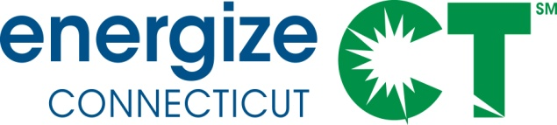
Energy Efficiency Board
Commercial & Industrial Committee Meeting
Tuesday, August 13, 2013, 1:00 – 3:30 PM
Department of Energy and Environmental Protection
79 Elm Street, Hartford, CT – Russell Room
Meeting Materials are available at: https://app.box.com/s/19tnu760jnhbj0imxlf6
Call-in number: 800-655-1109 Passcode: 875 8697

AGENDA

- Introductions/Agenda Review
- Updates:
  - DEEP updates/policy issues
  - 2013 C&I Financing Market Assessment
  - Pilot Projects: Retroficiency, FirstFuel, KiloJolts, etc. - initial findings, implications for customer engagement/SEM
- CEFIA/CPACE Presentation – 2013 progress, 2014 targets (Genevieve Sherman).
- Draft ISE 2014 Work Plan (Bill Leahy)
- DEEP Draft Determination – EEB Consultants initial assessment
- Committee Planning

