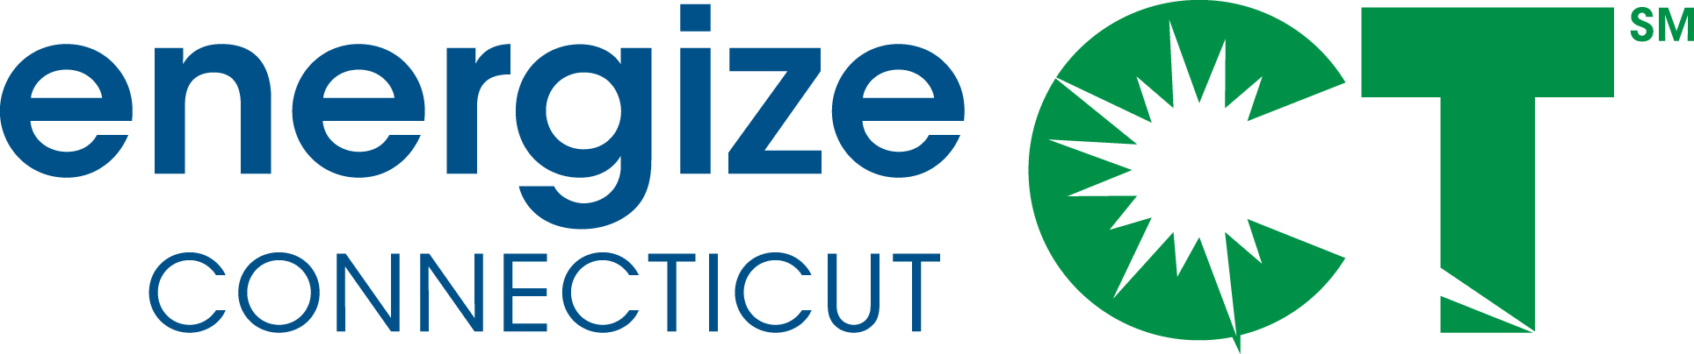

Energy Efficiency Board Marketing Committee Meeting
January 15, 2014, 2:00-4:00 p.m.
Department of Energy and Environmental Protection – Public Utilities Regulatory Authority
Adjudication Conference Room, 10 Franklin Square, New Britain, CT
Meeting Materials Available in Box.net Folder: https://app.box.com/s/0aj9mmn3b0071myf50ud
Call-in number: 800-655-1109 / Passcode: 875 8697

AGENDA

- Introduction and agenda review
- Update on the Energize Connecticut joint marketing project
  - Website update
  - January presentation on survey by Opinion Dynamics
- 2014 Marketing Plan (see attached schedule and high-level outline)
  - Review of process and schedule for development of 2014 Marketing Plan
  - Distinction between Marketing Plan activities (budget line item) and program marketing
  - Review of 2014 Marketing Plan outline and initial draft
    - Introduction & background
    - 2014 Marketing Plan activities
    - Schedule and timeline
    - Budget and funding
    - Organization and implementation
- Status update on marketing metrics and reporting schedule (as background, see the slides that Ellen Zuckerman presented to the EEB on January 8)
- Setting goals for marketing
- Other Business

2014 Marketing Plan Timeline and Outline

Process and Schedule for Development of 2014 Marketing Plan
- December 4, 2013 – EEB Marketing Committee meeting: Continued discussion on the main proposed marketing activities for 2014, review of Company marketing resources and capabilities.
- December 2013 – January 2014: Continued work on proposed 2014 marketing activities, preparation of components for initial draft 2014 Marketing Plan.
- January 15, 2014 – EEB Marketing Committee meeting: Review and discussion of initial draft 2014 Marketing Plan.
- February 5, 2014 – EEB Marketing Committee Meeting: Review of Final 2014 Marketing Plan, and upon approval/modification, distribution to full EEB for review at February 19 EEB meeting.
- March 2014: 2014 Marketing Plan incorporated as part of the 2014 Plan Update.
2014 Marketing Plan High-Level Outline
- Introduction & Background
  - CT’s energy goals (including the Comprehensive Energy Strategy)
  - The intersection and coordination of the 2014 Marketing Plan, program marketing, and the Energize Connecticut brand
  - Marketing goals and overall objectives (including the objectives and orders in the DEEP Final Decision)
- Strategies, activities, and marketing mix (components of the Marketing Plan line item)
  - Market research
  - Market segmentation
  - Value of EE to customers (including home performance, building labeling, etc.)
  - Full brand launch/blast
  - Customer engagement platform
  - Energize CT website enhancements
- Schedule/timeline
- Budget and funding
- Organization and implementation (EEB Marketing Committee; marketing staff/resources and capabilities of the companies; role of potential additional marketing consultant per DEEP Final Decision; coordination with CEFIA, etc.)

