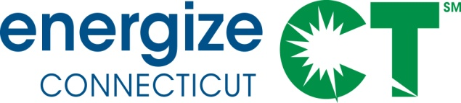

EEB Residential Committee Meeting
Wednesday, August 12, 2020, 10:00 am – 12:00 pm (Webinar Only)

Meeting Materials: https://app.box.com/s/db4sijvvs1xmewx4qbmpwug0uofjdlcs
Conference number: +1 (408) 650-3123/ Passcode: 461-485-165
Web conference: https://global.gotomeeting.com/join/461485165

Agenda (Draft 2)
- Welcome
- Meeting procedures and process update - Amy McLean 1 min
- Public Input/Comments (limit to 3 min/person) 10 min
- Approve 7/8/20 Residential Committee Meeting Minutes 1 min
- Companies’ updates 20 min
  - Q2 Program Update
    - Residential New Construction, Multifamily, HVAC
  - Program Activity Update
- Weatherization Barrier Resources 35 min
  - Follow up from July meeting
  - Opportunities to develop a plan for next steps
    - Task Force
    - Report with recommendations
    - Budget in 2021 Plan Update
  - Discussion
- Serving Underserved Communities 35 min
  - DEEP Notice of Proceeding and Request for Scoping Comments
  - PURA Sprint update (Bonnie Roswig, JD, Director, Disability Rights Project, Medical-Legal Partnership, Center for Children’s Advocacy)
  - Companies’ Planned Efforts for 2021
  - Discussion
- 2021 Plan Update 15 min
  - Review of issues – Consultants
  - Company plans
- Agenda items for future Residential Committee meetings 3 min
  - 2021 Plan Planning
  - Savings Attribution for Policy Advocacy Support
    - Codes & Standards
    - Market Transformation/Real Estate Industry Support
Adjourn

