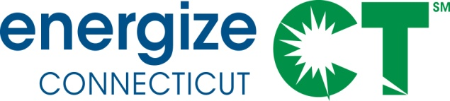

EEB Evaluation Committee Monthly Meeting

Monday May 9, 2016 – 10:00-11:30am

Department of Energy and Environmental Protection – Public Utilities Regulatory Authority, Commissioner's Conference Room, OCC, 10 Franklin Sq., New Britain, CT

Meeting Materials in Box folder: https://app.box.com/s/4cbzks9o8da1u86qa9qenr2zmbhztjjq

Call-In Number: 712/432-1680 Code 624802#
WEBINAR ACCESS: www.join.me/SkumatzEconomics

DRAFT AGENDA

- Public Comment

- Discussion of Notes from previous meeting provided, interim calls, and e-votes. (not Approval of Minutes). Lisa provides notes with votes for information purposes only. 5 min

- Non-Project Updates and Issues: 15 min
  - Review Thursday report and highlights;
    - Schedule of reports to review & upcoming reports and presentations / technical meetings
    - Review of interim votes and meetings (e-votes on invoice, calls on one-pagers, presentation on R4, NEI webinar).
  - Invoices from SERA – Discussion / votes for April invoice
  - Residential and Commercial Contracts Progress / Update

- Discussion of Projects / Status (and data) – see Gantt & Project summaries 45 min
  - Walk-though of Projects / Monthly Status Report – focus on Gantt “changes” and status of new projects; update on results of call / meeting on “new” steps for projects
    - Scott’s Projects
    - Lori’s Projects
    - Lisa’s Projects
    - One-pagers

- Legislative report discussion 10 min

- Budget issue / DEEP / EEB

- Other items –

*** Supporting Materials in Box folder and attached, including:
- Updated Gantt Chart & Project Status Summary  - E-votes / call notes  - Invoices | - One pagers  - Latest Thursday report  - Legislative Report

