Memo to: Lisa Skumatz, Dakers Gowans, Pete Jacobs, and Ralph Prahl; Connecticut EEB Evaluation Administrators | From: Geoffrey Cooper, Christopher Dyson, and Sue Haselhorst, DNV
 | Date: June 28, 2021
RE: Connecticut C2014 C&I Lighting Saturation and Remaining Potential – Phase One Results and Recommendations

Executive summary
This memorandum (memo) serves as the phase one deliverable for the C2014 C&I Lighting Saturation and Remaining Potential study. The overall study objectives include:
- Characterizing the current status of the Connecticut commercial and industrial (C&I) lighting market
- Forecasting the remaining potential for lighting programs
- Updating measure lives for calculating lifetime gross savings in a rapidly changing market
For the last several years, the non-residential lighting market in Connecticut has been experiencing a rapid transition from fluorescent technology to LEDs. It began with a transition to screw-based LEDs and TLEDs but is now being fueled by conversion to LED luminaires—accelerated by the influence of lighting programs within the state. These savings generated by the program have accounted for a significant portion of total energy efficiency program savings over the years, yet these bountiful savings are expected to decline due to increasing market saturation and the natural adoption of LED technologies. Opportunities for Connecticut programs to impact the lighting market are diminishing, so it is important to identify and target the remaining opportunities
The rapid adoption of LED technology impacts the magnitude of the remaining lighting potential in two ways. First, the number of sockets available for implementation is declining each year because the long life of LEDs reduces product turnover and because increasing LED saturations leaves fewer socket with any potential savings. Secondly, the claimable savings per socket is declining because the increasing market share of LEDs leads to more efficient baseline conditions. Lifetime savings are the most impacted since the measure’s second baseline must reflect future market conditions, when LED penetration is even higher. This reduced lifetime savings is reflected in an appropriately shortened adjusted measure life (AML).
The key to characterize how rapidly the available sockets are declining and how baselines are evolving is to understand trends in lighting equipment market shares (i.e. for linear lighting: annual share of sales of T12, T8, T4, TLEDs, and LED fixtures). The higher the market share of LED technology is today, the more quickly LEDs will replace legacy technologies leaving declining potential each year.
For phase one of this study, we adapted a national stock turnover model (the Model) designed to forecast the current and future saturation of the linear lighting submarket. This Model predicts the number of existing sockets (i.e. saturations) in the Connecticut C&I sector and the number of new construction, retrofit, and burnout fixtures and fixture turnover each year. The Model includes data characterizing the Connecticut C&I sector (square-footage by building type and the prevalence of technology types per square-foot). The DNV team interviewed 15 Connecticut lighting distributors during the April-May 2021 period to understand Connecticut specific trends in lighting market share. These Connecticut lighting market share trend estimates were the key inputs into the stock turnover model and the measure life calculations.
Phase two of this study will be completed later this year and will collect additional primary data collection from customers and other market actors to provide increased certainty to the forecasted saturation and market trajectory. We will prioritize specific areas of the market that present specific opportunities to continue to transform the C&I lighting market in Connecticut.
This memo summarizes the findings from phase one. This includes the responses from distributor interviews and the results produced from a stock turnover model designed to forecast the current and future saturation of the linear lighting submarket and market share of sales of linear equipment. The key findings were as follows:
- The 2020 saturation (% of installed stock) of LED linear fixtures across the C&I market is estimated to be approximately 40%, with about 11% LED luminaires and about 29% TLED fixtures. The saturation of LEDs in the market has been increasing from about 1% in 2015 and 21% in 2018. It is expected to continue to increase rapidly, reaching over 72% by 2024. Fluorescent T8 fixtures, which have historically account for the majority of installed stock, are expected to continue to decline. The mix of fluorescent T5 and T12 fixtures already make up a small minority of total installed stock in the linear submarket.
- The market share (% of sales) is continuing to be dominated by LED technologies. Approximately 67% of linear products sold in 2020 were LED, and this is expected to increase to 85% by 2024. Even in the absence of the program, the market share of LEDs would still reach 76% by 2024. However, lighting distributors indicated that the ratio of TLED fixtures to the more efficient LED luminaires would be greater in the absence of the program indicating that program incentives are effective in pushing customers toward LED luminaires.
- Because of the rapid adoption of LED technologies, the gross lifetime saving associated with LED measures are continuing to decline. As the baselines continue to become more efficient, the lifetime savings of LEDs are declining, leading to shortened measure lives.
- There is additional potential to generate program savings in the high/low bay and exterior/outdoor submarket. Qualitative responses indicate that while the total volume of LED sales is less, programs are effective in reducing the high costs associated with these fixtures, and if the program were to go away then LED sales would decrease.
The findings from phase one resulted in the following recommendation:
- The DNV team recommends that Eversource and UI (the Companies) update the lifetime of measures in the 2022 PSD from 13 years for retrofit measures and 15 years for lost opportunity measures to take into account dual-baseline lifetime savings estimates. For retrofit measures, we recommend using an AML of 7.0 years for fixtures (LED) and 6.6 years for lamp and ballast conversions as well as lamp replacement (LED). This is a blended lifetime that takes into account both replace-on-failure (ROF) and early-replacement (ER) event types. Since lost opportunity savings are based on code triggering events, in the absence of site-specific information, we recommend using 12.2 years based on an LED rated for 50,000 hours and a weighted building hours of use of 4,109 hours. The recommended values and the values they are replacing are listed in Table 1-1.
Table 1-1. Updated measure lives for 2022 PSD
PSD Measure Description | Retrofit – 2021 | Retrofit – 2022 | Lost Opportunity – 2021 | Lost Opportunity – 2022
Fixture (LED)  applies to: LED luminaire, troffers, high/low bay, exterior/outdoor | 13 | 7.0 | 15 | 12.2
Lamp and Ballast Conversion  applies to: linear retrofit kits | 13 | 6.6
Lamp Replacement (LED)  applies to: TLED | 4 | 6.6
The following sections are setup to provide information on the scope of the research, the characterization of the market, forecasts of the remaining potential in the market, an explanation of the AMLs, and an appendix with detailed methodologies on the distributor interviews and stock turnover model.

Scope of the Research

Rationale for the Study
The purpose of this study is to understand the evolution of the C&I lighting market, forecast the remaining potential to generate program savings, and update the measure lives to account for the lifetime gross savings. The primary focus of the first phase of research was on the linear submarket, which consists of common recessed, suspended, or surface-mounted fixtures intended to provide ambient lighting. Historically, this lighting application was dominated by fluorescent lighting (T12, T8, and T5), and while the trend had been to replace inefficient T12s with higher-efficiency T8s and T5s, the market is now trending, with help from program-induced acceleration, toward replacing all fluorescents with TLEDs and, most recently, LED luminaires. Nationally, linear fixtures represented approximately 56% of the total installed commercial stock of all lighting equipment in 2020 and had the lowest LED saturation rate of any submarket. Combined with the fact that the largest volume of program incentives has been given to this submarket, we prioritized the linear submarket for detailed research. However, the study also collected some information, mostly of a qualitative nature, for the high bay/low bay and the exterior/outdoor lighting market segments.
In addition to the primary data collected described below, we also leveraged an extensive body of research on the same issues from Massachusetts. Over the last several years, Massachusetts has collected customer saturation data as part of annual on-site surveys; conducted interviews with lighting distributors, manufacturers, and contractors; and aggregated other sources of data to calibrate and inform a stock turnover model that yields estimates of future market baselines and calculates AMLs. Given the proximity, similarity of the programs, and overlap with market actors, we leveraged this Massachusetts research and approach as a key resource to inform the Connecticut study. However, we recognize that lighting markets are likely at different stages of transformation, so all the inputs and results presented in this memo are specific to Connecticut and take into account the differences in the markets.
Given the timing of this study and the July 1st deadline for input to support the development of the 2022-2024 Conservation and Load Management Plan (the Plan), this study was broken into two phases. Phase one of this study was designed to characterize and forecast the overall C&I lighting market to inform the program potential and the measure lives characterizing lifetime savings. Because of the rapidly changing market, it was important to ensure that we were able to complete research in time to be incorporated into the Connecticut 2022 Program Savings Document (2022 PSD). Since it was not possible to complete the entire study by the July deadline, the team determined that the key source of data for the first phase of this project was distributor interviews that could help inform a Connecticut stock turnover model. As part of this first phase, we rely heavily on the known relationships between distributor interview results and other key data sources and modeling that have been deployed in Massachusetts. Since there are many more sources of Connecticut data and information, phase two of this project will continue to investigate the overall market and research specific areas of potential program opportunities.
While the data collected as part of phase one creates some level of uncertainty around the quantitative assessment of the status of the overall market, the core lifetime savings estimates expressed in the AML findings are highly robust and based on rigorous and proven calculations. The lifetime savings are a significant reduction from the current assumptions, but this is driven by the well-documented fact that the national market is moving rapidly to towards LEDs and by the fact that fluorescent lamps don’t last nearly as long as LEDs. The combination of these factors means that, regardless of whether customers replace a fixture or lamp early or on failure, in the baseline scenario, they would be forced onto the market long before the physical failure of the actual LED they installed. Once forced onto the market, they would likely purchase an LED technology, meaning the measure they installed would in effect no longer produce much savings. The specific methodology for these calculations and inputs are presented in Section 5.

Methodology Overview
To better understand the linear submarket, we conducted interviews with 15 lighting distributors – 13 that participated in the upstream program and 2 non-participating distributors. Results from these surveys were then used to develop market share trends extending from 2016 through 2029 for both a program and program-ending scenario. The year-over-year market share estimates were inputs to the stock turnover model (the Model) designed to forecast the saturation and net annual first-year savings associated with the program. The key input parameter for the model is market share, so the primary focus of the distributor interviews was to understand the market share of sales. Using the market share inputs and assumptions about the rate of stock turnover, the model forecasts the turnover, composition, and consumption of the installed stock each year. These market share forecasts are then used to calculate the AML values. Figure 2-1 shows the steps in this approach. A detailed methodology of the distributor interviews and stock turnover model are included in Appendix A.
Figure 2-1. Methodological approach.

The key objective of the distributor surveys was to determine recent and future market share by equipment technology. To capture recent market activity, we asked distributors to estimate their company’s market share for 2019 and 2020. For each of these periods, the distributors were asked to estimate the percentage of their linear lighting sales by equipment category. To understand where the market is headed, distributors were asked to estimate their company’s market share projections for 2021 and 2023. The lighting distributors were asked to provide sales projections for two scenarios: a program scenario where the Connecticut C&I lighting incentive programs continued as-is, and a program-ending scenario where the programs ended offering incentives at the conclusion of 2020. In most cases, the distributors were asked to provide projections for their own lighting sales. However, to compare company-reported market share to overall estimates of the market, one question in the survey asked distributors to provide projections for the whole C&I Connecticut market. In addition to the market share estimates/projections, the study also collected qualitative information about Connecticut C&I lighting market characteristics, drivers, trends, and impacts from COVID-19 that could help explain these estimates/projections.
The results from the distributor interviews were then analyzed and reviewed in combination with research/data from Massachusetts to derive a full set of market share rates going back to 2016 through the forecast period ending in 2029. Distributors were also asked how the Connecticut market differs to Massachusetts, and those responses were used to help inform how we expect the Connecticut market share to compare to Massachusetts. To provide multiple scenarios in the model, we derived two sets of market share curves – one with program continuing as-is and one with the program ending after 2020. The magnitude of the difference between the scenarios were based on distributor reported differences in market share.
To characterize the status of the market and forecast the remaining potential for C&I lighting programs, we adapted a stock turnover model developed in Massachusetts to include Connecticut-specific inputs and assumptions. The Model assumes a certain percentage of stock turns over every year due to burnout, retrofit, and new construction. The pool of stock that turns over is the eligible to be replaced with the existing technology or a higher efficiency technology. The Model applies the derived market share curves each year to the pool of stock turnover and then calculates the new installed stock in a given year. The model then applies a first-year savings factor to the LED technologies sold in the program and program-ending scenario. The difference in savings between these two scenarios yields a net annual first-year savings each year.
In addition to forecasting the stock, we used the market share estimates in the program-ending scenario to calculate the retrofit AMLs for LED luminaires and TLED fixtures. To calculate gross lifetime savings, program savings are assessed as a product of the first-year annualized savings and the AML. Since early replacement (ER) and replace-on-failure (ROF) measures are subject to dual baseline savings methods, the AML is used to account for both event types. To estimate the second-period savings in ER and ROF, we used the forecasted market share from the model. The rest of this memo presents the results from these efforts. Section 3 characterizes the current status of the market based on distributor responses, Section 4 presents the forecasted results from the Model, and Section 5 details the AML calculations and results.

Characterizing the C&I Lighting Market
This section summarizes results from the lighting distributors concerning the characterization of the Connecticut C&I linear submarket as well as qualitative information about the high/low bay and building exterior/outdoor submarkets. This includes a summary of distributor reported market share, applying relative findings from Massachusetts, the structure of the overall market, impacts from COVID-19 on the market, and opportunities beyond the linear market.

Distributor Reported Market Share
Overall, distributors reported the market share of all LED technologies at 80% or higher starting in 2019. They estimated that this would increase to 94% by 2023. LED luminaires make up the large majority of distributor reported sales and are forecasted to continue to gain additional market share, whereas TLED fixtures represent a smaller percentage of total sales and are forecasted to decline. However, distributors reported that if the programs did not exist, LED luminaires would show a slower growth rate, and TLEDs would continue to gain market share. This indicates that the programs have been successful in pushing customers towards the higher efficiency LED luminaires that still have higher equipment and installation costs. Fluorescent technologies accounted for less than 20% of total sales in 2019, with approximately half of that coming from T8s and the remaining half split between T12s and T5s. The proportion of fluorescent T8s is expected to continue to decline, although at a slightly slower pace if program incentives were to disappear. Figure 3-1 below shows the distributor estimates of market share, and Table 3-1 provides the estimates and associated descriptive statistics.
Figure 3-1. Distributor reported estimates of market share (n=13)
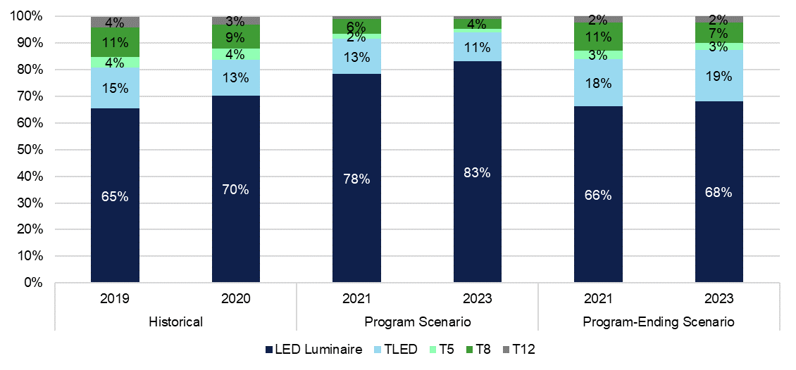
Table 3-1. Distributor reported estimates of LED market share and descriptive statistics
Scenario | Year | Equipment | Sample Size | Estimate | Standard Error | Lower CI | Upper CI | Absolute Precision | Relative Precision
Historical | 2019 | TLED | 13 | 15.4% | 0.04 | 8.8% | 22.1% | 6.6% | 43.1%
 |  | LED Luminaire | 13 | 65.4% | 0.09 | 49.4% | 81.5% | 16.1% | 24.5%
 | 2020 | TLED | 13 | 13.5% | 0.03 | 7.3% | 19.6% | 6.1% | 45.6%
 |  | LED Luminaire | 13 | 70.4% | 0.09 | 54.9% | 85.9% | 15.5% | 22.0%
Program Scenario | 2021 | TLED | 13 | 13.2% | 0.04 | 5.6% | 20.7% | 7.6% | 57.4%
 |  | LED Luminaire | 13 | 78.4% | 0.08 | 63.8% | 92.9% | 14.6% | 18.6%
 | 2023 | TLED | 13 | 10.9% | 0.03 | 5.5% | 16.3% | 5.4% | 49.5%
 |  | LED Luminaire | 13 | 83.1% | 0.06 | 73.1% | 93.0% | 9.9% | 12.0%
Program-Ending Scenario | 2021 | TLED | 13 | 17.7% | 0.04 | 10.6% | 24.7% | 7.0% | 39.8%
 |  | LED Luminaire | 13 | 66.3% | 0.09 | 49.4% | 83.3% | 17.0% | 25.6%
 | 2023 | TLED | 13 | 19.3% | 0.05 | 10.9% | 27.6% | 8.3% | 43.3%
 |  | LED Luminaire | 13 | 68.1% | 0.10 | 50.9% | 85.4% | 17.3% | 25.3%

The distributors provided several explanations for the growing popularity of the LED luminaires including:
- Decreasing LED luminaire equipment costs: Several distributors observed that the cost of LED luminaires has decreased significantly in recent years. National forecasts of prices ($/klm) for four-foot LED luminaires showed an 11.5% decrease per annum from 2017 through 2020. This is expected to continue to decline by 5% per year through 2025.
- Increasing ease of LED luminaire installations: Several distributors noted that lighting manufacturers have recently made most lighting luminaires and retrofit kits much easier to install than they had been in the past. This growing ease of installation can improve payback periods for lighting retrofit projects due to reduced labor costs.
- Improved LED luminaire lighting quality and variety: One distributor observed that the color quality and lumen output of the LED luminaires has improved recently compared to earlier models. He also noted that currently there are a wider variety of luminaire product types available than there had been in the recent past.
- Concerns about reductions in Connecticut TLED incentives: One distributor said that Connecticut lighting distributors are concerned that the Connecticut program incentives for TLEDs will be reduced or eliminated. Therefore, some distributors are encouraging their customers to rescope lighting retrofits to use LED luminaires which had originally been scoped to use TLEDs.
- Limited TLED production: One distributor claimed that only three manufacturers are still producing TLEDs which can reduce product availability and variety.
- Linear fixtures in poor repair: One distributor observed that many linear fixtures are in poor repair with old diffusers and chipped covers. In these cases, it makes more sense to install an integrated LED fixture.

The distributors also reported that the remaining demand for TLEDs is mainly driven by cost considerations. Despite declining costs for LED luminaires, the TLEDs are still the less expensive LED option. All the distributors who still sold linear fluorescents said that their sales of these products were declining. Several noted that they no longer sell the fluorescent fixtures but still sell the replacement lamps.
It is important to note that these distributors estimates are not direct inputs into the model but rather are used, along with information from Massachusetts and distributor reported differences between states, to inform the trajectory of market share. We use what we know about distributor reported market share and the likely relationship between interview results and what other sources of data tell us to calibrate the actual market share input into the model. There are several reasons why it’s likely that distributors results overstate the total market share of LEDs and ratio of LED luminaires to TLEDs.
One of the main reasons that distributors may overstate the total LED market share across that market is that distributors tend to serve larger businesses and customers interested in lighting retrofit projects and new construction projects. While distributors also serve customers replacing burned out or failed lighting systems, there are also other actors outside of the traditional sales that also offer lamp replacement options. These actors include big box stores, home improvement stores, online retailers, and energy service companies (ESCOs). The lamp replacement market likely includes a higher rate of non-LED technologies and a smaller ratio of LED luminaires to TLEDs. When asked to estimate 2021 estimates of the overall market rather than their own company sales, distributors reported that the overall share of LED technologies dropped from 91% to 86%. Similarly, the ratio of LED luminaires to TLEDs went from 78% and 13%, respectively, when asked about their company sales to 65% and 21% when asked about the overall market.
Another reason why distributors may overstate LED market share is because distributors that responded to this survey were dominated by participating distributors that likely sell a higher proportion of LEDs than non-participating distributors. While we assume that most of the LEDs in the market are sold through participating distributors, we know that there are at least several non-participating distributors; however, it is difficult to understand how much non-participating distributors contribute to the total number of lamps sold in the program.
Given these caveats, distributors still provide the best source of information on the direction of the sales market. Because of that, we used these results to inform the shape of the market share curves in the model and to estimate the differences in market share between the program and program-ending scenario. Section 4 also presents a comparison between the distributor reported results and the market share curves derived for use in the model.

Applying Findings from Massachusetts to Help Understand Connecticut
While the Connecticut landscape has its own set of characteristics and history of program influence, Massachusetts provides a helpful comparison to Connecticut. Over the last several years, the Massachusetts Program Administrators have supported a multi-year research effort to carefully understand the C&I lighting market and the rate of change. The higher than expected overall rate of LED market share reported by distributors in Connecticut matches a very similar pattern to research conducted in Massachusetts. A 2019 study in Massachusetts included distributor in-depth interviews aimed at understanding market share that resulted in estimates of at least 90% LED market share. Putting this together with results from on-site saturation surveys in Massachusetts and results from the Massachusetts stock turnover model, it was evident that actual LED market share in Massachusetts was less than what distributors reported but that distributors could forecast the trajectory of market share.
Since we know that C&I lighting programs have a longer history and higher amounts of incentives paid in Massachusetts, the survey effort conducted in Connecticut asked distributors to compare how the Connecticut market compares to Massachusetts and how the linear sales over the last five years compares. The responses to these questions were used to assess the credibility of the quantitative responses that were collected in Connecticut and the results from the modeling effort. We made sure that the overall characterization of the market in Connecticut compared to Massachusetts was consistent with the responses to these questions.
Of the 11 distributors that were familiar with operations in both Connecticut and Massachusetts, all but one indicated that LED sales were more dominant in Massachusetts historically because of the length of program activity and the incentive levels. The one distributor that disagreed suggested that incentive levels were higher in Connecticut and that Massachusetts was not taking as much advantage of the incentives that are available. One of the largest distributors suggested that “Massachusetts has had much larger incentives compared to Connecticut on specific products, but the range of eligible products was larger in Connecticut.”
Massachusetts is likely slightly ahead of Connecticut on the adoption path, but Connecticut will likely catch up to Massachusetts in the near future. When asked to think back over the last five years, distributors again pointed to the fact that Massachusetts has traditionally been ahead of Connecticut, but Connecticut has been catching up. Almost all of the distributors pointed out that Connecticut is quickly catching up to Massachusetts. One distributor reported that there tends to be a higher percentage of TLEDs and LED luminaires in urban areas versus less urban areas. “So, because Boston is so much bigger than Connecticut cities like Hartford or Stamford, the LED penetration would be higher in Massachusetts,” said one distributor. However, three distributors suggested that the two markets have been very close or the same over the last few years.

The Structure of the Connecticut C&I Lighting Market
Distributors likely represent the majority of C&I lighting sales across the state, but there are also sales happening outside of the traditional distribution sales chain. Twelve of the fifteen (80%) distributors identified competitors outside of the distribution sales chain. They most frequently mentioned retailers, especially big box stores and home improvement stores such as Home Depot and Lowes. Several noted that these retailers participate in Connecticut’s upstream lighting program which makes their prices even more competitive. One distributor noted that Home Depot has professionals in their stores who are trained to work with contractors and ESCOs.
Several distributors also mentioned online vendors such as Grainger, Amazon, Fastenal, and Bulbs.com as their competitors. Finally, two of the distributors mentioned ESCOs and energy management companies as their competitors. One of these distributors said that ESCOs can sometimes operate independently of a lighting distributor while in other cases they have a dedicated distributor partner. The distributors who mentioned ESCOs as competitors observed that these companies could offer attractive services such as project management and financing. They also noted that the ESCOs were generally more aggressive at marketing than the distributors with many doing in-person selling.
The distributors were asked why some C&I customers prefer to purchase their lamps and fixtures through these non-traditional channels. They mentioned convenience and price most frequently. “It’s much must easier to walk into a store, take [the lamp/fixture] off the shelf, look at it with your hands, and get the discount right there,” said one distributor. “Our job is to make it as easy as possible for our customers to work with us, but it's always going to be less easy to work with us versus walking into a store and getting a $5 discount on a lamp.”
“End users who use alternative channels like retail are often operating in a replace-on-failure mode,” said another distributor. “So, they only need a small volume of lamps and this is more easily handled sometimes through retailers versus wholesalers …. Nowadays it is very rare when a customer is … re-lamping the building with fluorescent fixtures. So, most of the fluorescent sales are lamp, not fixture, sales which can sometimes be purchased more easily from a retailer.”

COVID-19 Impacts on the Connecticut Market
The COVID-19 pandemic disrupted lives and businesses, and Connecticut distributors indicated that the lighting market did not escape these impacts. However, these distributors report a mix of impacts on business. They reported an average sales decline of 26% in 2020 due to the pandemic. However, the impacts varied a lot from distributor to distributor as Figure 3-2 shows. The market share curves input into the model account for the impacts described below based on the percent of sales and how the sales were allocated between technologies. This means that the AMLs account for the impacts of COVID-19. However, we did not adjust the burnout rate or retrofit rate in 2020 to account for these impacts on the overall characterization of the market.
Figure 3-2. Sales Declines Due to COVID-19 (n=15)
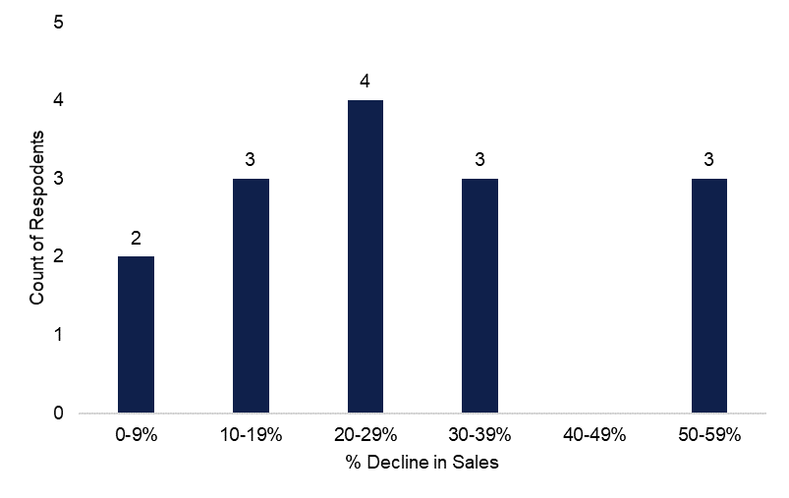
Some distributors reported new sales opportunities during the pandemic which helped offset the decline in their normal Connecticut sales. For example, one distributor observed that their online lighting sales increased during the pandemic because people were afraid to do in-person shopping, and this helped counterbalance revenue losses in their commercial business. Another distributor reported that some commercial customers used the fact that their buildings were unoccupied to get some rehab projects done including lighting retrofits. A third distributor said that some of their competitors were shut down for extended periods during the pandemic while they stayed open for business all year long. This allowed them to win work that otherwise would have gone to their competitors.
Impacts from the pandemic which continue to affect the Connecticut linear lighting market, according to the distributors, are supply shortages. China manufactures most C&I lighting products, and the pandemic has caused labor shortages that have impacted production levels. Labor shortages have also impacted the importation of these lighting products to the United States including both the shipping of the products and the unloading of containers at California ports. Some distributors said that while these supply shortages eased up in late 2020, they reappeared in the first quarter of 2021.
The distributors were also asked whether the pandemic impacted the mix of linear lighting products they sold in 2020. They were divided on this question with 47% saying that their linear product mix did change due to the pandemic and 53% saying that it did not. Two distributors said that the pandemic has impacted supplies of LED luminaires more than the TLEDs. One reason they cited was a shortage of resins which are used extensively in the manufacture of luminaires. Another reason they mentioned is that inventories of TLEDs in the United States were better stocked than LED luminaire inventories before the pandemic hit. None of the distributors said that the pandemic caused increased sales of linear fluorescents.
Many distributors reported having to do work furloughs during the pandemic but most of these were only a few weeks long. However, there was other evidence of longer lasting impacts from the pandemic. The distributors were asked how long they expected the impacts of the pandemic to impact their company’s operations. Figure 3-3 shows that only 20% of the distributors said that their operations were back to normal and over half said that it will be 1-2 years before their operations normalize.
Figure 3-3. When distributors expect their operations to return to normal (n =15)
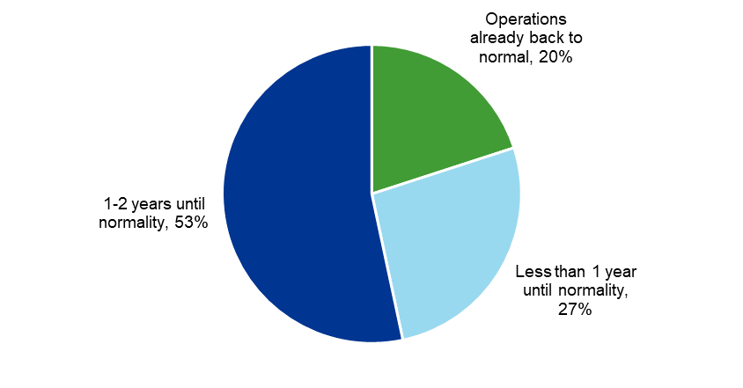

Opportunities Beyond Linear Submarket
While this study did not collect quantitative market share estimates for non-liner submarkets, distributors were asked to characterize the Connecticut market for lighting in high bay/low bay and building exterior/outdoor applications. Nationally, these applications combined account for approximately 21% of the total installed stock of fixtures, but they are also higher output systems making them candidates for large savings. The high/low bay market across the country was estimated to be at about 29% LED saturation in 2020, whereas the exterior and outdoor submarkets were over 60% LED saturation already.

High and Low Bay Lighting
The high bay/low bay lighting submarket includes pendent, recessed, or surface-mounted fixtures used in indoor high ceiling spaces. The term “high bay” is traditionally used to describe lighting installed in ceilings that are 25 feet or higher while “low bay” traditionally refers to lighting installed in high ceilings that are 25 feet or lower. In general, the distributors identified the Connecticut high bay/low bay market as having great potential for future LED penetration, especially for the LED luminaires. They identified the following reasons for this market potential:
- Legacy T5 lighting systems are starting to age: Two of the distributors claimed that many high-bay T5 lighting systems had replaced HID lamps in Connecticut during the 2010s. They said that because some of these T5 systems had been installed relatively recently, some building owners were unwilling to rip them out for replacement with LEDs. “When those T5 lamps were installed, many customers were told they were going to get 70,000-80,000 hours /10 years hours of life,” said one distributor. “So, until that customer starts seeing a high failure rate in that T5 system, they're not going to replace them.” For these reasons they claimed that the LED saturation in the Connecticut high bay low bay market was lower than it was for the conventional linear lighting market. However, these same distributors also observed that these T5 systems were now reaching the ends of these 10-year lifespans and therefore building owners will be more willing to retrofit these legacy systems.
- Longer LED measure lives reduce expensive O&M: Because replacing high bay lighting can be very expensive due to the need to use scissor lifts, etc., some distributors see the longer lives of LEDs as a good selling point for these types of applications.
- TLEDs lacking adequate lumens: While many end users view TLEDs as a good interim solution for their lighting needs when they are unwilling to replace whole fixtures, one distributor said that for the higher ceiling heights the TLEDs were not designed to project light effectively from that height. Therefore, in such cases, the LED luminaires would be the preferred alternative.

Building Exterior and Outdoor Lighting
The exterior/outdoor lighting market segment includes high-output lights or fixtures for use outdoors or in locations open to elements like building exteriors, parking garages, or wide-open spaces. For the purposes of this study, this segment does not include street or stadium lighting. Most distributors noted that exterior fixtures represent a smaller portion of the total volume of sales, but the fixtures offer greater opportunities for savings. Several distributors pointed out that many of the exterior fixtures have already been upgraded to LED technology, but there is still some non-LED stock out there that can be converted. One distributor suggested that exterior lighting was the first to get done, and “six to seven years ago there was a strong focus on replacing them, but it has slowed over the last few years.”
The primary reasons distributors cited for resistance to conversion was due to the higher costs associated with exterior lights that “have to be built to last” and that these fixtures tend to last a long time so people don’t need to touch the fixtures for a while. Three distributors suggested that program incentives have been helpful in reducing the high costs, and six distributors also indicated that sales would decrease 10%-50% in the absence of the program. However, one distributor did point out that the availability of non-LED products is going away, so most of the sales would be LED regardless of the program.

Forecasting the Remaining Potential for the CT C&I Lighting Market
The following section details how we derived market share inputs, saturation results, and estimated net annual savings estimated through the forecast period 2015 – 2029 in both the program and program-ending scenarios.

Deriving Market Share Inputs into the Model
The key input into the Model is market share. The model assumes a certain portion of the installed stock turns over in a given year, and then we apply market share estimates each year to determine how much of the stock is upgraded to LED technologies. Distributors provide key insights into the market share curves input to the model, but the distributor results are not direct inputs into the model. We use the market share estimates and qualitative information from distributors along with information from research conducted in Massachusetts and in the Pacific Northwest (PNW) to help derive the shape of these curves.
In the early years (2016-2018), we don’t have distributor results in Connecticut, but we assume that the market share of LEDs is likely similarly to Massachusetts and the PNW since these years had low rates of LED market share and LED sales were driven by early adopters that were less influenced by program incentives. For the middle years (2019-2023), we assumed that the actual LED market share was less than that reported by distributors due to the potential for distributor self-selection effects and the non-distributor-based sales discussed earlier. The specific magnitude of the assumed gap is based on the difference between Massachusetts distributor reported market share and Massachusetts derived market share. The outcome from this adjustment aligns with qualitative responses from distributors that market share in Connecticut historically lagged slightly behind Massachusetts but has been catching up in recent years. For the later years (2024-2029), there is limited information to know what the future looks like, so we assumed a declining rate of increase as market share approaches 100%.
Figure 4-1 below shows the overall LED market share curves derived for the program scenario in the model compared to existing sources of data. The dark blue lines show Connecticut-specific data while the green lines show the Massachusetts data. The light blue line is also overlayed on the graph to show distributor sales in the PNW. The graph also shows both distributors reported results as well as derived LED market share curves in Connecticut and Massachusetts with the solid lines showing distributor reported estimates and the dashed lines showing the derived curves.
In addition to the program scenario overall LED market share curve, Figure 4-2 also compares the program scenario overall LED market share to the program-ending scenario overall LED market share. It also breaks down the split in overall LED market share between LED luminaires and TLED fixtures. The overall LED market share grows from 67% to 85% in 2024 in the program scenario, but in the program-ending scenario to only grows to 76% in 2024. Much of the growth in the program scenario is attributed to an increase in the LED luminaires while TLEDs decline. In the program-ending scenario, the growth in market share is attributed to TLED fixtures with a smaller contribution from LED luminaires.

Figure 4-1. Modeled Connecticut (program scenario) overall LED market share compared to other jurisdictions
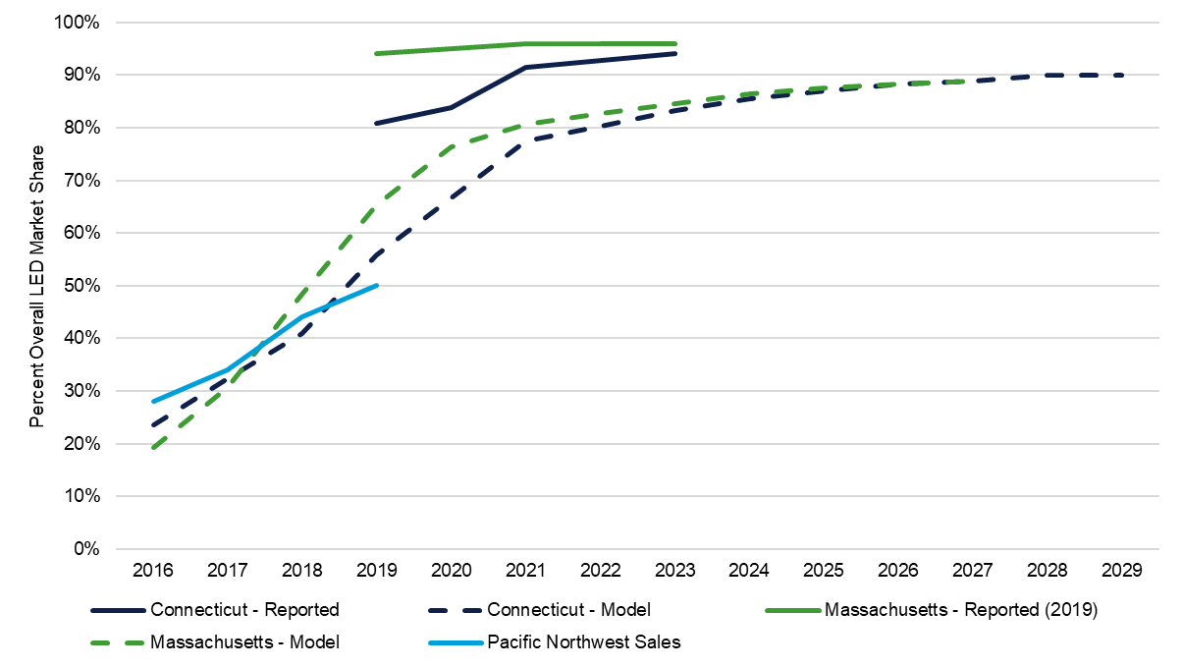
Figure 4-2. Modeled LED market share: program versus program-ending scenario
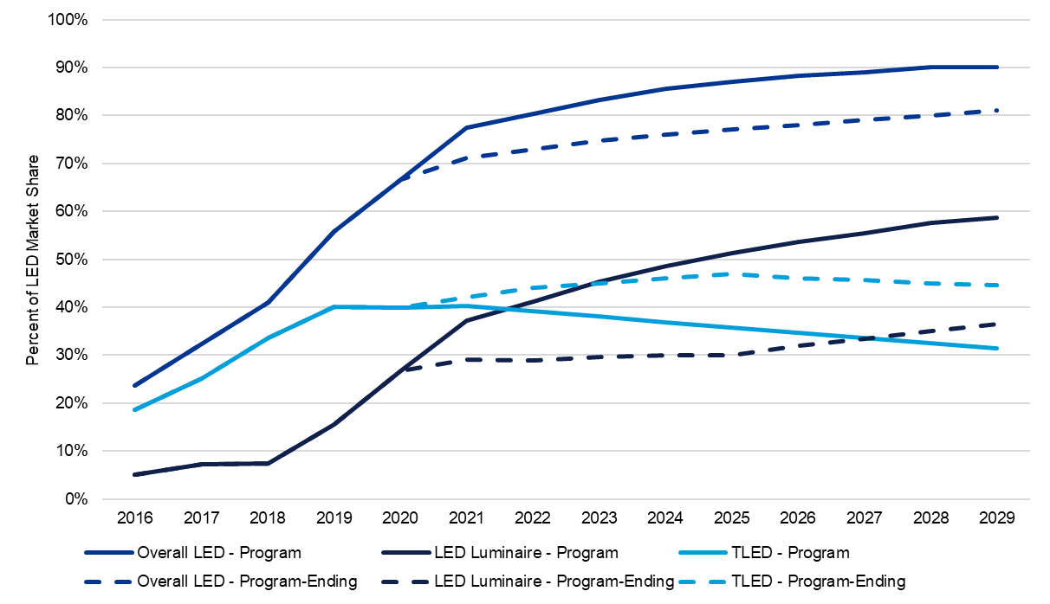

Forecasted Installed Stock Saturation
After inputting the market share results explained above into the model, we estimate the annual change in installed stock over time. Starting at about 1% LED saturation in 2015 when LEDs were starting to be introduced into the linear market, we estimate that the saturation of LEDs has risen sharply accounting for approximately 40% of all instead linear stock in 2020. These saturation values are an estimate and are based on limited data collection and a variety of assumptions in the Model. As a comparison to other jurisdictions, the national commercial linear submarket was estimated to be about 28% saturated with LEDs, and Massachusetts was at 49%. Based on the Model forecasts, in Connecticut, LED saturation is expected to increase to 77% by 2025 assuming the program continues as-is versus 71% if the programs were to end. Table 4-1 presents the comparisons or saturation rates in 2020 and 2025 and
Figure 4-3 shows the trajectory of overall LED saturation over time in both the program and program-ending scenario.
Table 4-1. Comparison of LED saturation rates across C&I jurisdictions
Jurisdiction | 2020 LED Saturation Rate | 2025 LED Saturation Rate
Connecticut (Program Scenario) | 40% | 77%
Massachusetts (Program Scenario) | 49% | 89%
National | 28% | 59%

Figure 4-3. Forecasted overall LED saturation - program versus program-ending scenario
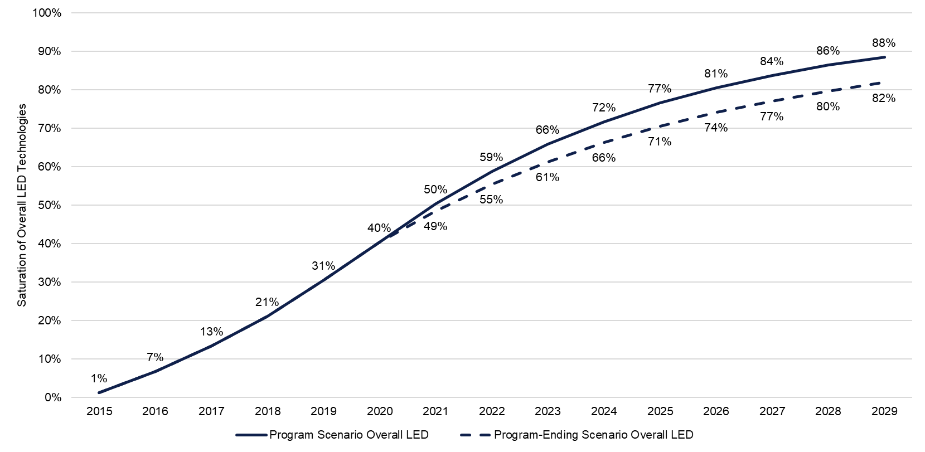
In the program scenario, this rate of increase in LED saturation in the future will be driven by a rapid adoption of LED luminaires as opposed to the TLEDs that fueled the early conversions from fluorescent technologies. In the program-ending scenario, TLEDs will continue to fuel the conversion to LEDs while LED luminaires will play a smaller role due to the higher costs. Fluorescent T8s, which have historically accounted for the majority of installed stock have declined from about 75% in 2015 to about 46% in 2020. This is expected to continue to decline to about 18% in 2025. Fluorescent T12 and T5 fixtures are expected to continue a modest decline as they become fully phased-out. Figure 4-4 and Figure 4-5 show the change in the installed stock for all equipment types through the forecast period in both the program and program-ending scenario.
Figure 4-4. Forecasted installed stock saturation - program scenario
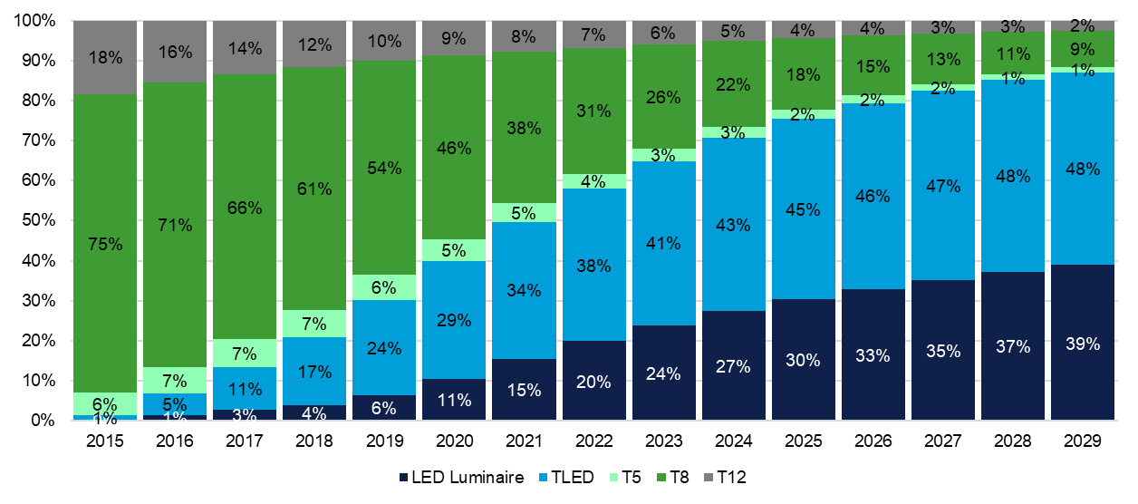
Figure 4-5. Forecasted installed stock saturation - program-ending scenario
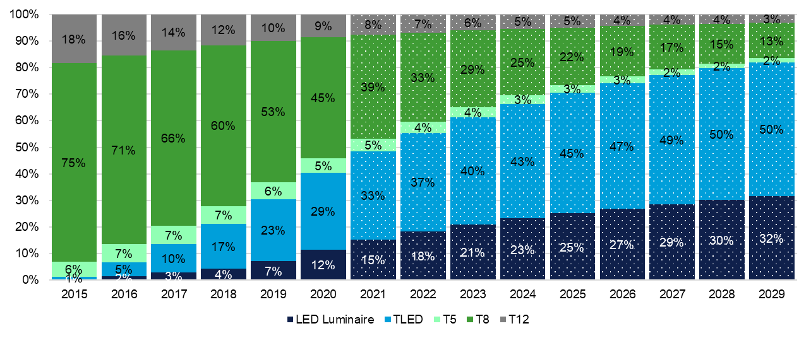

Annual Net Savings
With the longer lifetimes associated with LEDs and increasing rates of LED saturation, there are fewer sockets available for upgrade leading to decreasing opportunities to generate program savings. Figure 4-6 shows that the first-year net annual savings have already peaked and are expected to decline through the forecast period. These values are the difference in the sum of delta watts savings between LEDs installed in the program scenario versus the program-ending scenario. For simplicity purposes, this assumes that the first-year savings remain constant for LEDs. However, the baselines are also expected to shift, which means that net savings will likely decline even faster than projected here. Similar to our saturation forecasts, there are many assumptions that go into this forecasts, which compounds the uncertainty around exact estimates of savings; however, the overall takeaway is that savings expected to decline and that lighting cannot be relied upon to generate massive savings moving forward.
Figure 4-6. First-year net annual savings (2021-2029)
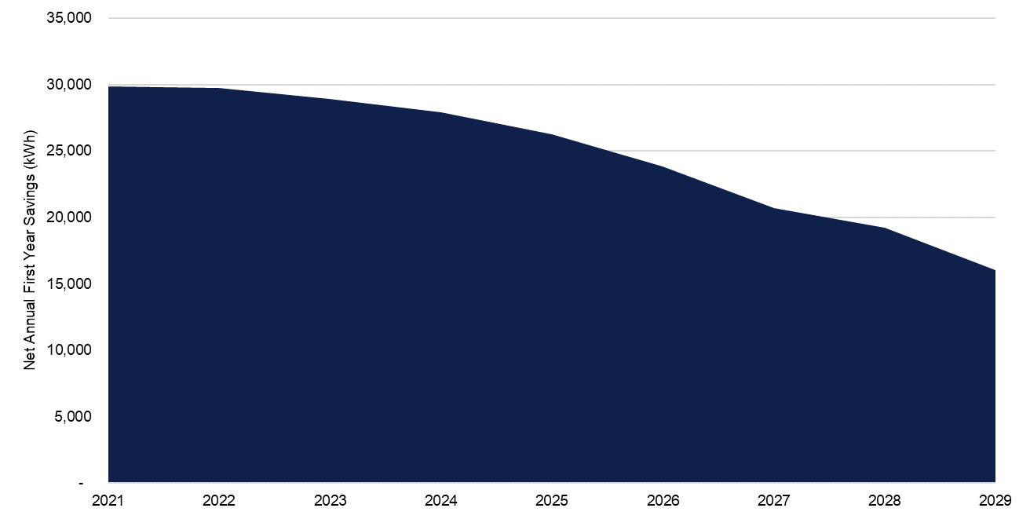

Adjusted Measure Life (AML)
Gross lifetime savings for the C&I lighting programs are assessed as a product of the first-year annualized savings and the measure life. Lighting is subject to dual-baseline principles, so the easiest way to handle these different baselines is through an AML. To calculate the AML, we take the ratio of lifetime savings to first-year savings (delta watts). As lifetime savings and delta watts change, the AML changes.
The 2021 PSD includes measures lifetimes that are intended to reflect the equipment life and measure persistence. Measure persistence takes into account business turnover, early retirement of installed equipment, and other reasons program-installed measures might be removed or discontinued. For lighting, this was also intended to account for the anticipated adoption of more efficient baseline technologies. The measure lifetimes for fixtures (LED) in the 2021 PSD are 15 years for lost opportunity measures and 13 years for retrofit measures. Lamp and ballast conversions also use 13 years as the measure life for retrofit measures. The 13-year measure life is equivalent to an AML; however, the assumptions associated with the 13 years are based on a 2007 report that is now outdated and overrepresents the lifetime savings for LEDs given the rated lifetimes and rapidly changing baselines.
Phase one of this study did not calculate an AML for lost opportunity measures; however, the assumed 15-year life is beyond the rated lifetime for a typical LED fixture. At a maximum, lost opportunity measures should only be credited with rated lifetime of an LED fixture divided by the building hours of use. In the absence of site-specific information, the measure life should assume a rated lifetime of 50,000 hours divided by 4,109 hours of use per year, which is equal to 12.2 years. For lighting, lost opportunity measures are intended to capture new construction and major renovation events, and the first-year savings are calculated using the difference between installed lighting and code lighting power density (LPD). C1902 – ECB NTG and Baseline Study will be examining the baselines for lost opportunity measures to update first-year savings assumptions.
For retrofit measures, the measures lives should be taking into account different baseline assumptions for ER and ROF event types. The easiest way to apply this is using an AML. For fixture (LED), the recommended AML is 7.0 years, and for lamp and ballast conversion as well as lamp replacement (LED) the recommended AML is 6.6 years. These values are the ratio of lifetime gross savings to first-year annual savings, accounting for both ER and ROF. Table 5-1 shows the new values compared to the previous values used in the 2021 PSD.
Table 5-1. Updated measure lives for 2022 PSD
PSD Measure Description | Retrofit – 2021 | Retrofit – 2022 | Lost Opportunity – 2021 | Lost Opportunity – 2022
Fixture (LED)  applies to: LED luminaire, troffers, high/low bay, exterior/outdoor | 13 | 7.0 | 15 | 12.2
Lamp and Ballast Conversion  applies to: linear retrofit kit | 13 | 6.6
Lamp Replacement (LED)  applies to: TLED | 4 | 6.6
There are two main drivers for why these values should replace previous assumptions – EULs that take into account the rated lifetime of the lighting equipment and baselines that are shifting faster than previously expected. The starting point for calculating the AML is the EUL – the rated lifetime of the lamp technology. Previously, it was assumed that lighting measures had a 15-year lifetime. This was based on the fact that even though lamps will burnout multiple times during a 15-year period, the individual lamps could be replaced. However, the lighting system – or housing – would be in place for 15 years upon which the entire system would likely fail and need replacement. But, when a lamp burns out, a customer is faced with existing market conditions and must decide whether or not they will replace the burned-out lamp with the existing equipment type or replace it with an LED technology. For this study, we adjusted the AML calculations to use EULs based on the lifetime operating hours by lamp technology type divided by the weighted average annual operating hours for C&I buildings in Connecticut (4,109 hours). So, a fluorescent T8 that is rated for 32,000 operating hours has an EUL of 7.8 years, whereas a TLED rated for 50,000 hours has an EUL of 12.2 years. This assumption is a methodological change and independent of market forecasting and results in a lower starting point than the previously assumed 15-year EUL for all equipment technologies. The rated lifetimes of fluorescent lamps have the largest impact on the reduced AML because it dictates at what point we shift the baseline, which we know is changing quickly.
In addition to the change in EUL starting point, we rely on the market share forecasts in the program-ending scenario to inform the future baselines for ROF and ER. In the ROF component of the calculation, the first period savings is based on the hypothetical fluorescent technology that would have been installed and lasts for the rated lifetime of the mix of fluorescents that would have been installed. Since we know that fluorescent technologies do not last as long as LEDs, the second period savings is based on the market conditions at the time the fluorescent would have burned out. In the ER component of the calculation, the first period savings are based on the difference between the wattage of the LED technology and the equipment that is installed that is being replaced early. The second period is based on the market conditions at the time that the original equipment would have burned out. Figure 5-1 diagrams these components of the AML calculations for LED luminaires in 2022. A detailed list of equations for calculating the AMLs are included in Appendix A. Figure 5-2 shows the decline in AML values over time due to the rapidly changing baselines. The values presented in 2022 are the recommended AMLs that would replace the current assumptions in the 2021 PSD.

Figure 5-1. Illustration of AML calculations for LED luminaires in 2022

Figure 5-2. Trend in AMLs
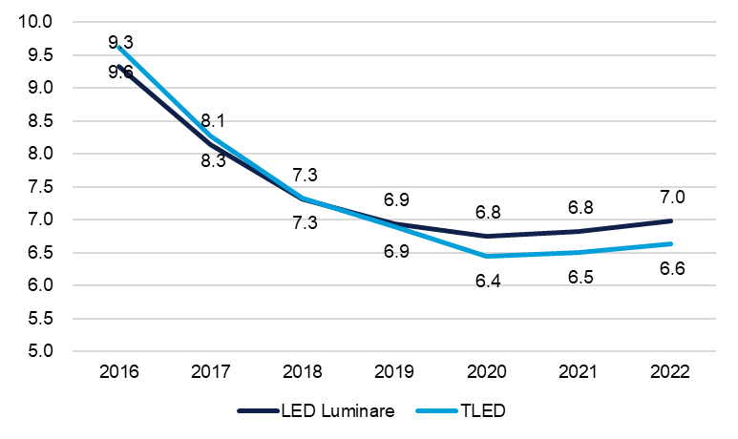
- Methodology
The following sections provide details on the methodologies used to collect information from distributors and how the stock turnover model functions.

Distributor Interviews
The DNV team conducted in-depth interviews with lighting distributors with the primary focus of estimating distributor-reported market share. The survey also collected information on impacts from COVID-19, comparisons to the Massachusetts market, and qualitative information on high/low bay and exterior/outdoor submarkets.
The sample frame for distributors included both participating distributors and non-participating distributors. The participating distributors were split between two groups – upstream participants where the team had data about upstream sales from 2019 sales and qualified participants that are listed on the EnergizeCT website but did not have 2019 upstream sales data. The non-participant distributors were pulled from a ZoomInfo search based on SIC codes 5063 or NAICS code 4236. We manually searched through each entry to ensure that only lighting distributors were included in the sample frame. We completed 15 partial or full interviews including 13 with upstream participants representing 90% of upstream savings from 2019 and 2 non-participants. We were unable to complete any interviews with qualified participants, so we used all the upstream participant completes to represent all participating distributors. Two distributors were unable to provide quantitative market share estimates, so the quantitative estimates are based on responses from 11 participating distributors representing 52% of the upstream program savings in 2019 as well as 2 non-participating distributors. The table below breaks out the count of distributors in the population, the original sample, and the total number of completes by stratum.
Strata | Population (N) | Sample | Quantitative Completes (n) | Full Completes
Participant Upstream | 23 | 12 | 11* | 13**
Participant Qualified | 13 | 4
Non-Participant | 18 | 4 | 2 | 2
* representing 52% of the upstream lighting program savings in 2019
** representing 90% of the upstream lighting program savings in 2019
Responses to the interviews were analyzed and weighted based on sample weights (N/n) multiplied by the response to a question asking about how much of the market each respondent represents. One of the non-participating distributors responded that they represented 30% of the total market, which is highly unlikely, so we gave this respondent a sample weight of 1 so that it does not overrepresent non-participating distributors. We compared the weighted results to the unweighted results and found minimal differences.

Stock Turnover Model
The following subsection describes the steps in the stock turnover model. The full set of inputs into the model are included in the associated model spreadsheet -- CT C2014_National Stock Turnover Model_REVISED DRAFT_20210607.

Step 1: Determine Baseline Stock
The starting year for the Model was 2015 since that was the point at which linear LED adoption was just beginning and the saturation of LEDs was close to 0%. The total installed stock in 2015, by building type, was calculated by multiplying the total lit floorspace by the number of linear fixtures per square foot (applicability factor) multiplied by the starting saturation rate by equipment type.
$$Installed Stock= Lit Floorspace ×Applicability Factor ×Equipment Saturation$$
To determine the lit floorspace, we used Commercial Buildings Energy Consumption Survey (CBECS) lit floorspace in 2012 by building type for New England and scaled it to Connecticut based on the ratio of GDP by state. We applied a 1.1% growth rate for all commercial buildings and 0.8% growth rate for industrial buildings. The applicability factor was based on on-site data from Massachusetts and is the same rate as used in the Massachusetts modeling effort. The starting saturation rates were based on national estimates of installed stock in 2015.

Step 2: Calculate annual stock available for turnover
There are three event types that create an opportunity for stock turnover or new installations. The sum of fixtures that burn out, are retrofitted, and are added due to new construction comprise the total stock available for turnover annually.
The number of lamps that burn out every year is equal to the total installed stock multiplied by the burnout rate. The burnout rate is 1 divided by the expected useful life of the equipment (EUL). In this model, the EUL is determined by the building-specific lighting hours of use divided by the market standard lifetime operating hours of the lighting equipment.
$$Lamps Available Through Burnout=Installed Stock ×\frac{1}{\left(\frac{Lamp Rated Hours}{Building Annual Hours of Use }\right)}$$
The retrofit rate is the percent of non-LED fixtures (after burnout) that are retrofitted with an LED technology. This includes fixtures being installed to replace existing lamps and fixtures during renovation, retrofit/upgrade, or remodeling. The model assumes that this occurs at a rate of 10% each year in each sector, for a mean renovation cycle of 10 years. The retrofit rate is held constant rate through the forecasts period, except in the program-ending scenario where the retrofit rate is 8% when the scenarios diverge in 2021 due to a lack of program influence.
$$Lamps Available Through Retrofit=\left(Installed Stock-Lamps Available Through Burnout\right)×10\%$$
In addition to burnout and retrofit, the Model assumes a 1.1% new construction growth rate for commercial building and 0.8% for industrial buildings. The number of fixtures added through new construction is based on the total lit floorspace added and the linear fixtures per square foot.
$$New Lamps Through New Construction=Lit Floorspace ×Growth Rate ×Applicability Factor$$

Step 3: Apply market share to stock turnover
To calculate the composition of the new stock each year, the Model applies the derived market share curves to the total pool or eligible stock from burnout, retrofit, and new construction to determine of the total volume of new stock by equipment category. The market share inputs are derived based on the results of the distributor interviews and calibrated based on an adjustment factor from Massachusetts distributor and calculated market share and similar estimates from Massachusetts and the PNW. This is calculated at the building level; however we don’t have any data to support differences in market share by building type, so the market share is applied evenly across all building types. We apply two different sets of market share to forecast the market in a program scenario and program-ending scenario, where the program incentives end after 2020.

Step 4: Calculate saturation and net savings
To estimate the installed stock of fixtures, the Model adds the stock turnover volume of sales to the unchanged stock each year. To estimate first-year net savings, we apply a delta watts savings assumption for all TLEDs and LED Luminaires installed each year. The difference between the total savings from the program scenario and program-ending scenario yields the annual fist-year net savings attributed to C&I linear program sales.

Step 5: Calculate AML
The AMLs are the ratio of lifetime gross savings and the first-year annual savings, account for both ER and ROF. To calculate the AMLS, the model uses the standard wattage and rated lifetime assumptions for lamp technologies and the market share forecasts in the program-ending scenario. The formulas for calculating AMLs are included below.
Input | Definition
%ROF | % of lamps installed that replace-on-failure versus early-replacement
Watts_{F} | Weighted average wattage of equipment sold without program-eligible technology
Watts_{PM} | Wattage of program measure (TLED or LED Luminaire)
Watts_{A} | Average wattage of all measures sold in year
Watts_{I} | Average wattage of all measures installed that are being retrofitted
EUL_{F} | Weighted average rated lifetime of non-program measure
EUL_{PM} | Weighted average rated lifetime of program measure
RUL_{I} | Remaining useful life of measures installed that are being retrofitted
Y | Year (future baseline)

Program Savings
$$Adjusted Measure Life = \frac{{Lifetime Savings}_{Program}}{{First Year Savings}_{Program}}$$
${Lifetime Savings}_{Program}= {(Lifetime Savings}_{ROF}*\%ROF)+ {(Lifetime Savings}_{ER}*(1-\%ROF))$
${First Year Savings}_{Program}= {(First Year Savings}_{ROF}*\%ROF)+ {(First Year Savings}_{ER}*(1-\%ROF))$

Replace on Failure
${First Year Savings}_{ROF}={(Watts}_{F}-{Watts}_{PM})$
$${Lifetime Savings}_{ROF}= {First Period Savings}_{ROF}+ {Second Period Savings}_{ROF}$$
${First Period Savings}_{ROF}={(Watts}_{F}-{Watts}_{PM})*({EUL}_{F})$
$${Second Period Savings}_{ROF}={(Watts}_{A,Y}-{Watts}_{PM})*({{EUL}_{PM}-EUL}_{F})$$

Early Replacement
${First Year Savings}_{ER}={(Watts}_{I}-{Watts}_{PM})$
$${Lifetime Savings}_{ER}= {First Period Savings}_{ER}+ {Second Period Savings}_{ER}$$
${First Period Savings}_{Er}={(Watts}_{I}-{Watts}_{PM})*({RUL}_{I})$
$${Second Period Savings}_{ER}={(Watts}_{A,Y}-{Watts}_{PM})*({{EUL}_{PM}-RUL}_{I})$$

Lighting measures accounted for 73% of C&I electric savings.
Connecticut policy requires a dual baseline methodology for calculating lifetime savings. The first baseline reflects an existing equipment baseline, the second baseline reflects market conditions. The first baseline persists for the remaining useful life (RUL) of the existing technology, the second persists for the EUL – RUL.
Model originally developed by DNV as part of a recent study completed in Massachusetts: https://ma-eeac.org/wp-content/uploads/MA20C09-E-LMC_LightingMarketCharacterization_FinalReport.pdf
https://www.energy.gov/sites/default/files/2020/02/f72/2019_ssl-energy-savings-forecast.pdf
13 participating distributors represent 90% of upstream program savings in 2019.11 provided quantitative responses representing 52% of 2019 upstream program savings.
Of the 13 participating distributors that responded to the survey, only 11 provided quantitative estimates of market share. So, for the market share estimates, we had 13 total responses, but we received qualitative information from all 15.
The survey include 2023 estimates instead of 2022 estimates to avoid projecting potential lasting impacts from COVID-19 beyond 2022.
https://www.energy.gov/sites/default/files/2020/02/f72/2019_ssl-energy-savings-forecast.pdf
https://ma-eeac.org/wp-content/uploads/MA19C14-E-LGHTMKT_2019-CI-Lighting-Inventory-and-Market-Model-Report_Final_2020.04.06.pdf
https://www.energy.gov/sites/default/files/2020/02/f72/2019_ssl-energy-savings-forecast.pdf
https://ma-eeac.org/wp-content/uploads/MA19C14-E-LGHTMKT_2019-CI-Lighting-Inventory-and-Market-Model-Report_Final_2020.04.06.pdf
https://www.bpa.gov/EE/Utility/Momentum-Savings/Pages/Lighting.aspx
The stock turnover model developed in Massachusetts uses a similar modeling approach, although the key input parameter in Massachusetts is saturation rather than market share. The model is used to derive market share directly based on changes in saturation as opposed to this study that uses market share as the key input to estimate saturation.
https://www.energy.gov/sites/default/files/2020/02/f72/2019_ssl-energy-savings-forecast.pdf
MA20C09-E-LMC 2020 C&I Lighting Market Characterization (report pending)
The savings are based on the upstream program delta watts from the 2021 PSD. We assume that TLED fixtures save 28 watts per fixtures and LED luminaires save 37 watts per fixture.
https://library.cee1.org/system/files/library/8842/CEE_Eval_MeasureLifeStudyLights%2526HVACGDS_1Jun2007.pdf
50,000 hours is the minimum lifetime (L₇₀) of DLC-listed products. 4,109 hours is average building hours of use weighted by total commercial floor space in Connecticut.
These categories align with Table A4-1: Lifetime of Measures in the 2021 PSD. LED Luminaires are equivalent to Fixture (LED) and TLEDs are equivalent to Lamp and Ballast Conversions. We are not recommending changes to Lamp Replacement (LED) or LEDs (screw-in bulbs) since these are representative of screw-based lighting that was not covered in this study and have different rated lifetime, wattage, and market share assumptions.
This means that we have switched from using the rated lifetime of a lighting system to the rated lifetime of an individual lamp or luminaire technology.
https://www.eia.gov/consumption/commercial/data/2012/index.php?view=microdata
https://www.bea.gov/data/gdp/gdp-state
https://ma-eeac.org/wp-content/uploads/MA20C09-E-LMC_LightingMarketCharacterization_FinalReport.pdf
https://www.energy.gov/sites/prod/files/2017/12/f46/lmc2015_nov17.pdf
https://www.energizect.com/sites/default/files/2021-03/Final%202021%20PSD%20%28Filed%203-01-2021%29.pdf
https://www.energy.gov/sites/default/files/2020/02/f72/2019_ssl-energy-savings-forecast.pdf
https://www.energy.gov/sites/prod/files/2020/02/f72/2019_ssl-energy-savings-forecast.pdf
https://ma-eeac.org/wp-content/uploads/MA19C14-E-LGHTMKT_2019-CI-Lighting-Inventory-and-Market-Model-Report_Final_2020.04.06.pdf
https://www.bpa.gov/EE/Utility/Momentum-Savings/Pages/Lighting.aspx
Based on upstream savings assumptions from: https://www.energizect.com/sites/default/files/2021-03/Final%202021%20PSD%20%28Filed%203-01-2021%29.pdf
We use the program-ending ending scenario to avoid overlap with net-to-gross impacts.
https://ma-eeac.org/wp-content/uploads/MA19C14-E-LGHTMKT_2019-CI-Lighting-Inventory-and-Market-Model-Report_Final_2020.04.06.pdf

