REVIEW Draft report
C1635 Impact Evaluation of PY 2016 & 2017 Energy Opportunities (EO) Program
Prepared For: Connecticut Energy Efficiency Board (EEB)
Lisa Skumatz, Dakers Gowans, Ralph Prahl, and EEB Evaluation Administrators
Date: June 30, 2020

Table of contents
1 Abstract 1
2 Executive Summary 3
3 Introduction 11
3.1 Study overview, purpose, and objectives 11
3.2 Organization of report 12
4 Methodology and approach 13
4.1 Sample design and selection 13
4.1.1 EO 2016/2017 Sample 13
4.1.2 Upstream Lighting 2018 Sample 15
4.1.3 Recruitment Disposition 17
4.2 Review project documents and draft M&V plans 18
4.3 Data collection 19
4.3.1 Metering equipment used 20
4.4 Savings analysis 20
4.4.1 Seasonal Peak Savings 22
4.4.2 PSD review and prospective savings 23
4.4.3 Lighting Logger Data Leveraging 24
5 Analysis and results 25
5.1 EO Electric 25
5.1.1 Lighting 25
5.1.2 HVAC 28
5.1.3 Other 30
5.2 EO Gas 31
5.2.1 HVAC/DHW 32
5.2.2 Other 34
5.3 Upstream Lighting 34
5.4 Lighting Data Leveraging 37
5.5 Study Error Ratios 43
5.6 Study Realization Rates Compared to Those from Similar Programs 43
6 Conclusions, recommendations, and considerations 47
6.1 EO Electric Conclusions and Recommendations 47
6.2 EO Gas Conclusions and Recommendations 51
6.3 Upstream Lighting Conclusions and Recommendations 52
6.4 Considerations 54
APPENDIX A. Seasonal Peak Periods Methodology A-1
APPENDIX B. Detailed population summaries B-1
APPENDIX C. Detailed Sample summaries C-1
APPENDIX D. Metering equipment used D-1
APPENDIX E. Site Reports (Under Separate Cover) E-1

List of figures

Figure 4-1. Summary of Key Evaluation Methods 13
Figure 4-2. Sites Metered by Month and Sampling Category 19
Figure 4-3. Technology Metering and Data Collection 21
Figure 4-4. Lighting Savings Discrepancy Factors Discrepancy Factors 22
Figure 5-1. EO Electric Lighting Annual Energy Savings Scatterplot 26
Figure 5-2. Lighting Summer Seasonal Peak kW Results Scatterplot 26
Figure 5-3. Lighting Winter Seasonal Peak kW Results Scatterplot 26
Figure 5-4. EO Electric HVAC Annual Energy Savings Scatterplot 28
Figure 5-5. HVAC Summer Seasonal Peak kW Results Scatterplot 29
Figure 5-6. HVAC Winter Seasonal Peak kW Results Scatterplot 29
Figure 5-7. EO Electric Other Annual Energy Savings Scatterplot 30
Figure 5-8. Other Summer Seasonal Peak kW Results Scatterplot 31
Figure 5-9. Other Winter Seasonal Peak kW Results Scatterplot 31
Figure 5-10. EO Gas HVAC/DHW Retrospective Annual Energy Savings Scatterplot 33
Figure 5-11. Refocused EO Gas HVAC/DHW Retrospective Annual Energy Savings Scatterplot 33
Figure 5-12. Refocused EO Gas HVAC/DHW Prospective Annual Energy Savings Scatterplot 33
Figure 5-13. EO Gas Other Annual Energy Savings Scatterplot 34

List of tables

Table 4-1. Summary of 2016 and 2017 EO Electric Tracking Data by End Use 14
Table 4-2. Final EO Electric Sample Design 14
Table 4-3. Summary of 2016 and 2017 EO Gas Tracking Data by End Use 15
Table 4-4. Final EO Gas Sample Design 15
Table 4-5. Summary of 2018 Upstream Lighting Tracking Data 16
Table 4-6. Upstream Lighting Sample Design 17
Table 4-7. Final On-site Recruitment Response and Refusal Rates 17
Table 4-8. Summer Seasonal Peak Hours 23
Table 4-9. Winter Seasonal Peak Hours 23
Table 4-10. Lighting Logger Data Leveraging Sample 24
Table 5-1. Summary of EO Electric Energy Results 25
Table 5-2: EO Lighting Savings Adjustments 27
Table 5-3. Lighting Savings Summary 28
Table 5-4. HVAC Savings Summary 29
Table 5-5. EO Electric Other Savings Summary 31
Table 5-6. Summary of EO Gas Energy Results 32
Table 5-7. EO Gas HVAC/DHW Savings Summary 34
Table 5-8. EO Gas Other Savings Summary 34
Table 5-9: Summary of Upstream Lighting Energy Savings Results 35
Table 5-10. Upstream Lighting In-Service Rate Results 35
Table 5-11. Upstream Lighting Delta Watts Results 36
Table 5-12. Upstream Lighting Connected Demand Savings Results 36
Table 5-13. Upstream Lighting Energy Interactive Factor Results 36
Table 5-14. Upstream Lighting Energy Savings Results 37
Table 5-15. Upstream Lighting Demand Interactive Factor Results 37
Table 5-16. Lighting Logger Data Leveraging Sample 38
Table 5-17. Interior Fixture Hours of Use Results by Building Type 39
Table 5-18. Interior Fixture Summer Seasonal Coincidence Factor Results by Building Type 40
Table 5-19. Interior Fixture Winter Seasonal Coincidence Factor Results by Building Type 41
Table 5-20. Exterior Fixture Results 42
Table 5-21. Occupancy Sensor Summer Seasonal Peak Coincidence Factor Result 42
Table 5-22. Occupancy Sensor Winter Seasonal Peak Coincidence Factor Result 42
Table 5-23. Study Error Ratios 43
Table 5-24: Electric Energy Realization Rates Compared to Those from Similar Program in Other Jurisdictions 44
Table 5-25: Gas Energy Realization Rates Compared to Those from Similar Program in Other Jurisdictions 45
Table 5-26: Upstream Lighting Energy Realization Rates Compared to Those from Similar Program in MA 45
Table 6-1: EO Electric Energy Savings Realization Rate Results 47
Table 6-2: EO Electric Energy Savings Realization Rate Recommendations by End Use 47
Table 6-3: EO Electric Summer Seasonal Peak Demand Realization Rate Results Relative to Tracking Savings (with Zero Tracking Estimates) 48
Table 6-4: EO Electric Summer Seasonal Peak Demand Realization Rate Results (with Zero Tracking Estimates Removed) 48
Table 6-5: EO Electric Summer Seasonal Peak Demand Realization Rate Recommendations by End Use 48
Table 6-6: EO Electric Summer Seasonal Peak Coincidence Factor Results by Building Type 49
Table 6-7: EO Electric Summer Seasonal Peak Coincidence Factor Recommendations by Building Type 49
Table 6-8: EO Electric Winter Seasonal Peak Demand Realization Rate Results Relative to Tracking Savings (with Zero Tracking Estimates) 50
Table 6-9: EO Electric Winter Seasonal Peak Demand Realization Rate Results (with Zero Tracking Estimates Removed) 50
Table 6-10: EO Electric Winter Seasonal Peak Demand Realization Rate Recommendations by End Use 50
Table 6-11: EO Electric Winter Seasonal Peak Coincidence Factor Results by Building Type 51
Table 6-12: EO Electric Winter Seasonal Peak Coincidence Factor Recommendations by Building Type 51
Table 6-13: EO Gas Energy Savings Realization Rate Results 51
Table 6-14: Upstream Lighting In-Service Rate Results 52
Table 6-15: Upstream Lighting Delta Watts Results 52
Table 6-16: Upstream Lighting Delta Watts Recommendations 53
Table 6-17: Data Leveraging Hours of Annual Hours of Use Results by Building Type 53
Table 6-18: Upstream Lighting Annual Hours of Use Recommendations by Building Type 53
Table 6-19: Upstream Lighting Interactive Factor Results 54
Table 6-20. 2018 Summer Seasonal Peak Hours and System Load A-2
Table 6-21. Summary of Summer Seasonal Hours for Hartford, CT TMY3 File A-3
Table 6-22. Winter 17/18 Seasonal Peak Hours and System Loads A-4
Table 6-23. Summary of Winter Seasonal Hours for Hartford, CT TMY3 File A-5
Table 6-24. 2016-2017 Electric Savings by End Use and Utility B-1
Table 6-25. 2016-2017 Electric Savings by Measure Category and Utility B-2
Table 6-26. 2016-2017 of Gas Savings by End Use and Utility B-2
Table 6-27. 2018 CT C&I Upstream Lighting program tracking savings summary by MA LED sample category B-3
Table 6-28. Final EO Electric Sample by measure group and strata C-1
Table 6-29. EO Gas Sample by measure group and strata C-1

Abstract
This C1635 Energy Opportunities (EO) impact evaluation examined the performance of the 2016 and 2017 program years as well as 2018 C&I upstream lighting activity. This study was commissioned to understand the extent to which program performance is meeting program and policy goals and objectives and to recommend revisions to the Program Savings Document (PSD) to improve claimed savings estimates moving forward. The EO Program is the flagship C&I retrofit program offered by the companies with a 2020 savings goal of 107,214 MWh (43% of the overall portfolio goal).
This study is important due to the high contribution of EO Program savings relative to the portfolio and the duration since the previous study of this program (2014). The objectives were to (1) determine evaluated energy and seasonal peak demand savings and retrospective and prospective realization rates (RRs) for three electric end use groups (Lighting, HVAC, and Other) and two gas end use groups (HVAC/DHW and Other), (2) evaluate the 2018 Upstream lighting program and update PSD assumptions accordingly, and (3) update the PSD for lighting hours of use and seasonal peak coincidence factors based on data leveraging.
On-site visits, including measurement and verification (M&V) were performed at a statistically selected sample of 88 Upstream lighting, 65 EO lighting, 26 electric HVAC, 26 electric other sites, 20 gas HVAC/DHW sites, and 12 gas “other” sites. Equipment level analysis performed at International Performance Measurement and Verification Protocol (IPMVP) standard accompanied a statistical expansion to produce aggregate impacts, realization rates, and precisions. On the whole, the EO program is tracking most impacts reasonably well with pockets of improvement available, as evidenced in the realization rates below. The evaluation team recommends updating the following PSD realization rate assumptions by end use based on the results of this study.
End Use | Electric Energy RR | Summer Seasonal Peak Demand Realization Rate |  | Winter Seasonal Peak Demand Realization Rate |  | Gas Energy Realization Rate
 |  | Actual Population | If Fully Populated | Actual Population⁵ | If Fully Populated⁶
Cooling | 102.1% | 192.5% | 146.4% | 146.2% | 125.0% | -
Heating | 102.1% | 192.5% | 146.4% | 146.2% | 125.0% | 76.5%
Lighting | 97.9% | 98.9% | 98.9% | 115.3% | 115.3% | -
Custom | 93.8% | 106.7% | 103.1% | 122.7% | 120.1% | 77.3%
EMS | 67.6% | 123.9% | 114.7% | 179.8% | 162.1% | 78.2%
Motors | 67.6% | 123.9% | 114.7% | 179.8% | 162.1% | -
Other | 67.6% | 123.9% | 114.7% | 179.8% | 162.1% | 78.2%
Process | 67.6% | 123.9% | 114.7% | 179.8% | 162.1% | 78.2%
Refrigeration | 67.6% | 123.9% | 114.7% | 179.8% | 162.1% | -
DHW | - | - | - | - | - | 76.5%
The evaluation team recommends revising the PSD to explicitly call for the use of site-specific hours of use assumptions when calculating EO lighting energy savings. The evaluation team recommends using the following C&I upstream lighting hours of use assumptions by building type below.
Building Type | Upstream Hours of Use | Summer Seasonal Peak Coincidence Factor | Winter Seasonal Peak Coincidence Factor
24x7 lighting | 8,760 | 100.0% | 100.0%
Automotive | 2,807 | 68.3% | 36.9%
Education | 2,967 | 36.8% | 46.0%
Grocery | 7,698 | 90.6% | 85.6%
Health Care | 5,564 | 82.5% | 69.6%
Hotel/Motel | 3,112 | 40.6% | 37.5%
Industrial | 5,793 | 83.0% | 66.5%
Large Office | 4,098 | 77.9% | 58.2%
Other | 6,211 | 86.9% | 76.7%
Parking Lot/Streetlights | 6,887 | 67.2% | 87.3%
Religious Building/Convention Center | 913 | 17.0% | 9.2%
Restaurant | 6,072 | 83.1% | 77.0%
Retail | 6,318 | 98.4% | 85.6%
Small Office | 3,595 | 76.8% | 44.1%
Warehouse | 5,667 | 89.3% | 72.4%
The evaluation team recommends incorporating the following PSD upstream lighting savings factor assumptions by product type based on the results of this study.
Upstream Lighting Product Type | Short-term In-service Rate | Long-term In-service Rate | Delta Watts | Energy Interactive Factor | Summer Demand Interactive Factor
LED Linear | 97.1% | 97.4% | 15.33 | 1.081 | 1.199
LED Downlights | 85.9% | 86.4% | 41.16 | 1.023 | 1.189
LED A-line/Decorative | 71.4% | 74.9% | 40.32 | 1.024 | 1.176
LED High/Low Bay | 99.6% | 99.7% | 157.33 | 1.008 | 1.047

Executive Summary

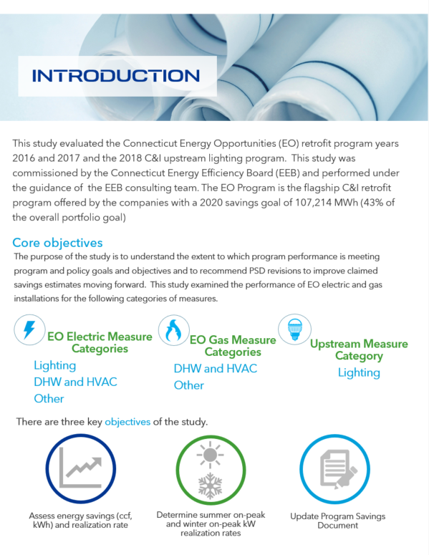
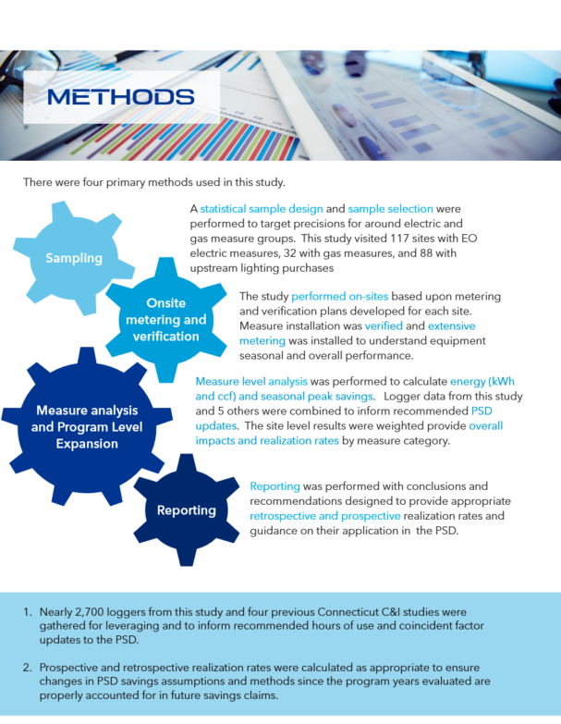
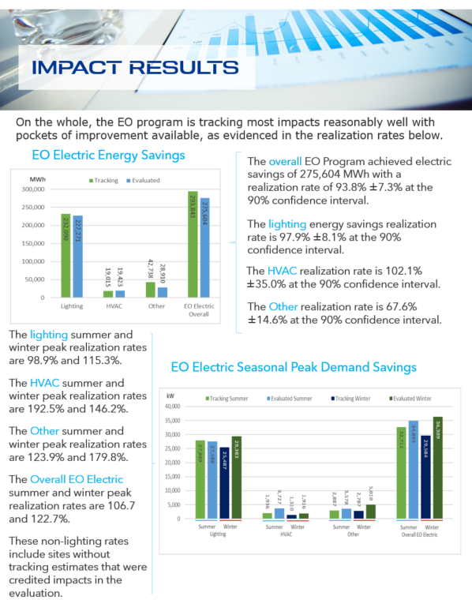
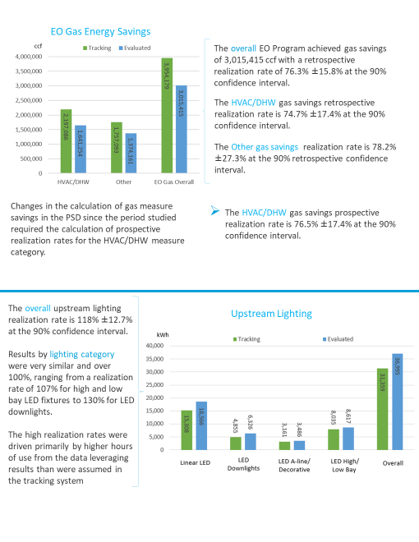
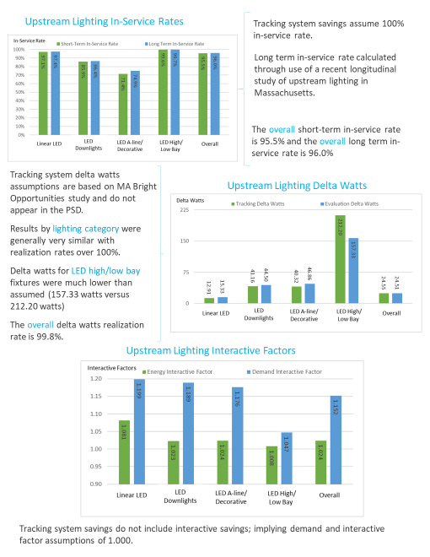
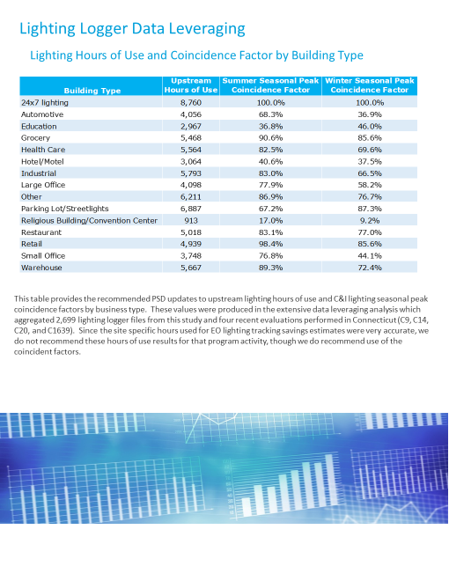
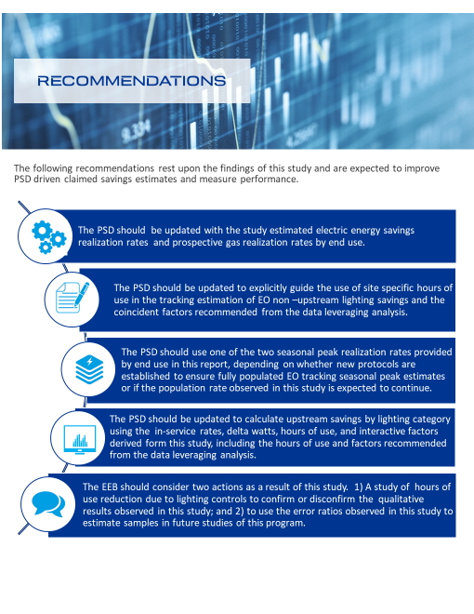

Introduction
This report presents the results from the C1635 Energy Opportunities (EO) Impact evaluation of the 2016 and 2017 program years. The EO Program is the flagship C&I retrofit program offered by the companies with a 2020 goal of 107,214 MWh in savings (roughly 43% of the overall portfolio goal of 250,394 MWh). This study is important due to the high contribution of EO Program savings relative to the portfolio and the duration since the previous study of this program (2014).
Consistent with the 2019-2021 C&LM plan and evaluation roadmap guidance, this study was performed through an independent process overseen by the Energy Efficiency Board. This study provides electric and natural gas retrospective and prospective realization rates as appropriate, recommend Program Savings Document (PSD) updates to refine future energy savings estimates, and verifies peak demand savings resources participating in ISO-NE’s FCM.

Study overview, purpose, and objectives
This impact evaluation of the EO Program was performed on program years 2016 and 2017. The EO program supports energy efficiency retrofit measures for C&I electric and gas customers of any size. The EO program includes a channel for upstream lighting purchases though the majority of electric energy savings (~90%) in the years studied came from traditional program activity characterized by prescriptive and custom measures delivered through incentives and technical assistance (for custom).
“EM&V guides program administrators, policy makers, and stakeholders in better understanding the extent to which program activities are successfully meeting the goals and objectives they were created to achieve.”
– 2019-2021 C&LM Plan Update
The purpose of the study is to understand the extent to which program performance is meeting program and policy goals and objectives, and to recommend PSD revisions to improve claimed savings estimates moving forward. This evaluation includes three overarching objectives.
- Determine ex-post evaluated energy and seasonal peak demand savings, and calculate retrospective and prospective realization rates for three electric end use groups and two gas end use groups.
- Evaluate the upstream lighting program portion of the EO program and savings.
- Recommend updates to the PSD realization rates and assumptions used to calculate program savings and for lighting hours of use and coincidence factors based on this study and four previous C&I impact studies. These studies include the 2014 C14 Connecticut EO evaluation, 2015 C20 Energy Conscious Blueprint, and 2014 C9 and 2017 C1639 SBEA studies.
The study performed the following activities to achieve these objectives.
- This study developed a statistically selected sample of participants with gas and electric efficiency measures for high rigor level M&V. This included an upstream lighting sample that received metering at a subset of sites with measure verification.
- This study performed engineering calculations to quantify ccf, kWh, and summer and winter seasonal peak kW savings as appropriate for measures installed at the sampled sites. When appropriate, alternative tracking savings were calculated based on updated PSD parameters to provide prospective realization rates. All realizations rates and key findings include associated precisions. All sites have individual reports detailing data gathered, analysis performed, and discussion of differences between tracking and evaluated estimates.
- This study compiled and analyzed its lighting logger data, hours of use, and coincident factor estimates with previous C&I Program studies performed in Connecticut and compared those results to the Massachusetts TRM at the building level and overall. Recommendations are provided to guide the incorporation of these results into the PSD.
- This study calculated retrospective realization rates with precisions for each measure group. Prospective realization rates are provided for measures where the PSD changed savings calculations since the years studied (i.e., 2016, 2017) or where a recommendation is made to change the PSD based on this study.
- This study calculated upstream results for key lighting savings parameters (installation rates, watt reduction, hours of use, interactive factors) for incorporation into the PSD.
- This study coordinated with the team performing the PSD update to review findings and planned recommendations to ensure seamless use of study outcomes.

Organization of report
The remainder of this report is organized as follows:
Section 4: Methodology and approach
Section 5: Analysis and Results
Section 6: Conclusions, recommendations, and considerations
Appendix A: Seasonal Peak Periods Definition
Appendix B: Detailed Population Summaries
Appendix C: Detailed Sample Summaries
Appendix D: Metering Equipment Used
Appendix E: Site Reports (Under Separate Cover)

Methodology and approach
This section describes the methodologies that DNV GL used to guide data collection and analysis for this impact evaluation. Primary tasks and their associated subtasks are presented below in Figure 4-1. The key phases of the evaluation effort included development of sample plans, project documentation review, and data collection. This was followed by a measure analysis with site reporting and expansion of sample results to estimate program level impacts. The flow of the evaluation effort was generally sequential in nature, proceeding from left to right as depicted in Figure 4-1. Each stage in the figure is presented with more detail in following subsections.
Figure 4-1. Summary of Key Evaluation Methods

Sample Design and Selection | File reviews and M&V Plans | On-Site Data Collection | Site and Aggregate Savings Analysis
Gather electric and gas account and measure level population data  Develop stratified sample designs by measure group and upstream lighting | Acquire files supporting savings claims for sampled sites  Perform file reviews with savings validation  Document planned M&V | On-site recruitment  Measure verification, operating condition, meter deployment  Gather historical lighting hours of use, coincidence | Measure level engineering estimates of ccf, kWh, and seasonal peak demand savings  Statistical expansion of results and realization rates with precisions

Sample design and selection
There were two sample tasks undertaken in this study. One was of EO 2016 and 2017 activity delivered through traditional program channels. The other was of 2018 “upstream” lighting activity. Each of these is discussed in turn, including why the program years studied differed among the EO and upstream components.

EO 2016/2017 Sample
The first step in the EO sampling process was to acquire 2016 and 2017 program year population data from each utility. Data cleaning was performed on this data, including checks for duplicate entries between and within datasets and negative savings values that might reflect product returns, removals or savings adjustment entries. An examination of a small sample of activity was also performed to ensure the savings estimates were gross (not net). The final cleaned population was checked against expected participant and savings levels in filed company reports before developing the final sample frame.
Table 4-1 presents 2016 and 2017 EO electric activity by end use. Energy and peak demand estimates are provided as well as the number of projects that installed each end use. Lighting dominated the total energy (79%) and summer (85%) and winter (86%) seasonal peak demand savings. HVAC, process and refrigeration activity comprises another 16% of energy savings, with 5% of activity spread among the remaining end uses. Note that overall participant totals in this table is less than the number of projects listed by end use as more than one project occurred at some sites. A detailed population summary by company (Eversource and Avangrid) are provided in APPENDIX B.
Table 4-1. Summary of 2016 and 2017 EO Electric Tracking Data by End Use
End Use | # Projects (N) | Energy |  | Summer Seasonal Peak Demand |  | Winter Seasonal Peak Demand
 |  | Annual MWh Savings | % | kW | % | kW | %
HVAC | 217 | 19,015 | 6.5% | 1,935.9 | 5.9% | 1,309.7 | 4.4%
Lighting | 2,572 | 232,090 | 79.0% | 27,889.0 | 85.3% | 25,486.4 | 86.2%
Motor | 75 | 7,223 | 2.5% | 565.4 | 1.7% | 554.3 | 1.9%
Process | 54 | 16,487 | 5.6% | 1,223.2 | 3.7% | 776.6 | 2.6%
Refrigeration | 101 | 12,092 | 4.1% | 612.6 | 1.9% | 1,143.7 | 3.9%
Other | 99 | 6,936 | 2.4% | 486.0 | 1.5% | 312.3 | 1.1%
Total | 2,743 | 293,843 | 100.0% | 32,712.1 | 100.0% | 29,583.0 | 100.0%
One of the goals of the sample design for the EO portion of the study was to develop three electric end-use categories. To accomplish this, we aggregated the end use savings presented in Table 4-1 into three electric categories (Lighting, HVAC, and Other). The purpose of creating these categories was to refine the application and use of study outcomes in the PSD.
Table 4-2 shows the EO electric sample design using these measure categories. Model-based statistical sampling (MBSS) techniques were used to develop the sample design using an error ratio of 0.48, consistent with that observed in the last Energy Opportunity study conducted in 2013-2014. Given the importance of lighting to overall program savings, sixty-five of the sample points were allocated to lighting measures, with the remainder divided evenly among the two remaining categories. These sizes offer precisions that target ±10% for lighting and at or better than ±15% for the others, with the precision around overall program savings at ±8.3%. Note that overall participant totals in these tables are less than the number of projects listed by end use as more than one project occurred at some sites. The final electric sample proportions by company (78% Eversource, 22% UI) are almost identical to the electric population proportions (79% Eversource, 21% UI). A detailed sample summary that includes strata cut points for each measure category and final cases weights is provided in APPENDIX C.
Table 4-2. Final EO Electric Sample Design
Measure Category | Population (N) | Total Annual Savings (MWh) | Sample Size | Expected Precision at 90% Confidence Interval
Lighting | 2,572 | 232,090 | 65 | ±10.0%
HVAC | 217 | 19,015 | 26 | ±14.8%
Other | 284 | 42,738 | 26 | ±15.0%
Statewide | 2,743 | 293,843 | 117 | ±8.3%
Table 4-3 presents 2016 and 2017 EO natural gas activity by end use. HVAC installations represent over half of all program savings. Process represents nearly 40% of savings. Note that overall participant totals in this table is less than the number of projects listed by end use as more than one project occurred at some sites. A detailed population summary by company (Eversource and Avangrid) are provided in APPENDIX B.
Table 4-3. Summary of 2016 and 2017 EO Gas Tracking Data by End Use
End Use | # Projects (N) | Energy
 |  | Annual ccf Savings | %
DHW | 14 | 38,964 | 1.0%
HVAC | 156 | 2,159,105 | 54.6%
Process | 26 | 1,554,898 | 39.3%
Other | 43 | 201,213 | 5.1%
Total | 208 | 3,954,180 | 100.0%
Like the electric sample design discussed above, one of the goals of the sample design was to develop two gas measure categories. To accomplish this, we aggregated the end use savings presented in Table 4-3 into two gas categories (HVAC/DHW, and Other). The purpose of creating these categories was to refine the application and use of study outcomes in the PSD.
Table 4-4 provides the EO gas sample design using an error ratio of 0.60, which is consistent with those observed in similar gas studies in Massachusetts. The sample sizes yield better than ±20% precision for each of the gas categories and are comprised of 20 sites among HVAC and DHW measures and 12 for all other measure types. This approach provides more site work for those measures producing most of the program savings (HVAC and DHW). This sample of 32 sites offers a portfolio precision of ±13.6%. Note that overall participant totals in this table is less than the number of projects listed by end use as more than one project occurred at some sites. The final gas sample proportions by company (59% Eversource, 41% UI) are similar to the gas population proportions (53% Eversource, 47% UI). A detailed sample summary that includes strata cut points for each measure category and final cases weights is provided in APPENDIX C.
Table 4-4. Final EO Gas Sample Design
Measure Category | Population (N) | Total Annual Savings (ccf) | Sample Size | Expected Relative Precision at 90% Confidence Interval
HVAC/DHW | 156 | 2,197,086 | 20 | ±18.9%
Other | 76 | 1,757,093 | 12 | ±19.4%
Statewide | 208 | 3,954,180 | 32 | ±13.6%

Upstream Lighting 2018 Sample
Table 4-5 summarizes the 2018 upstream lighting tracking data by lighting categories that are consistent with those used in Massachusetts for upstream lighting evaluations. Note that returns of purchases made in 2018 were netted out of this summary. In addition, returns from purchases made in previous years were removed from the population. Categories 1, 3, 4 and 7 account for over 97% of the savings. Note that overall participant totals in this table is less than the number of projects listed by category as products from more than one category were received by some sites.
Table 4-5. Summary of 2018 Upstream Lighting Tracking Data
MA Upstream Lighting Category | Lighting Category Description | # Accounts (N) | Annual MWh Savings | % of Total MWh
Category 1 | Linear LEDs | 2,800 | 15,308 | 47.5%
Category 2 | LED Stairwell Kits | 8 | 23 | 0.1%
Category 3 | LED Downlights | 1,157 | 4,855 | 15.1%
Category 4 | LED A-line/Deco | 493 | 3,161 | 9.8%
Category 5 | GU24 LEDs | 92 | 357 | 1.1%
Category 6 | LED Exterior Wall Packs | 161 | 340 | 1.1%
Category 7 | High/Low Bay LEDs | 467 | 8,035 | 25.0%
N/A | Linear Fluorescents | 96 | 116 | 0.4%
Total |  | 4, 272 | 32,195 | 100%
Unlike the EO samples, which were drawn from 2016 and 2017 program years, it was decided to evaluate the upstream lighting 2018 program year as the lighting measure mix underwent several changes, a new implementation vendor was hired for the 2018 program year, and program procedures were introduced to ensure measure installation after purchase. Product changes included discontinuing fluorescent products and introducing new LED products; including LED troffers, high bay fixtures, and exterior products. Increases in inspection rigor implemented in 2018 were undertaken to ensure in-service rates reflected these new processes.
Table 4-6 shows the upstream lighting sample design using an error ratio of 0.90, which is consistent with the ratio observed in the first Massachusetts upstream lighting study and within the range of measure level ratios observed in the second Massachusetts study (0.71 - 1.33). This table only focuses on the four measure categories that represent over 97% of program savings, as noted above. The error ratio and subsampling focus on kWh were informed by the last comprehensive impact evaluation of Massachusetts' C&I Upstream Lighting program, which focused on data collection to inform component parameters (delta watts, HOU, HVAC interaction, in-service rate or ISR) rather than a more expensive monitoring study to collect HOU for all sites. The sample design in this study was designed to perform 95 sites (where in-service rates, delta watts, and HVAC interaction were gathered) that targeted a precision of ±17.4% around demand savings and hours of use metering performed at a subset of those sites (36) that targeted a precision of ±28.7% around kWh.
This approach collected data on component savings parameters for all sites, while only monitoring a subset of sites to update hours of use assumptions. Our experience with upstream lighting evaluations in Massachusetts is that installation rates present the greatest uncertainty around savings estimates and should be a primary focus of research to ensure claimed savings accuracy. Although each site is selected into the sample for a given lighting category, other lighting categories and products present at the site were audited as part of each site visit, but not included in the expansion of results to the population (i.e., they carry a weight of one).
Ultimately, 88 total visits (where in-service rates, delta watts, and HVAC interaction were gathered); including 25 HOU visits were performed due to the cancellation of field work caused by the COVID-19 pandemic. Due to the reduction in HOU visits, the logger data from these 25 sites was integrated with the logger data from the data leveraging effort discussed later to provide evaluation HOU for upstream lighting. Note that overall participant totals in this table is less than the number of projects listed by category as products from more than one category were received by some sites. The final upstream lighting sample proportions by company (98% Eversource, 2% UI) are similar to the upstream lighting population proportions (91% Eversource, 9% UI). It is important to mention that UI suspended the operation of their Upstream lighting program from August 2018 through December 2018 due to budget restrictions.
Table 4-6. Upstream Lighting Sample Design
Measure Category | Population (N) | kW |  | kWh
 |  | Design kW/ISR Sample | Final kW/ISR Sample | Design kWh Sample | Final kWh Sample
Cat 1 LED Linear | 2,792 | 46 | 42 | 17 | 13
Cat 3 LED Downlights | 1,152 | 15 | 14 | 6 | 4
Cat 4 LED A-line/Deco | 491 | 10 | 8 | 4 | 2
Cat 7 LED High/Low Bay | 467 | 24 | 24 | 9 | 6
Statewide | 4, 272 | 95 | 88 | 36 | 25

Recruitment Disposition
The final response and refusal rates experienced for each of the three studies are provided in Table 4-7 below. Examining final dispositions of a sample in this way can help assess whether it might have non-response error and why. All unsuccessfully recruited sites were found to be in business at the time of outreach, meaning closed businesses were not observed in the primary or backup samples contacted.
The response rate calculated in the table below includes all customers that were in business and refused the on-site or were in business and were unable to be reached (non-contact). In developing this table, we have remained consistent with American Association for Public Opinion Research (AAPOR) definitions and calculation of Response and Refusal Rates. The response and refusal rates for all three evaluation efforts are comparable to those from similar recently performed studies.
Table 4-7. Final On-site Recruitment Response and Refusal Rates
Disposition description | EO Electric | EO Gas | Upstream Lighting | Overall
Complete | 117 | 32 | 88 | 237
Refused – In business | 9 | 0 | 20 | 29
Non-contact - In business | 31 | 11 | 25 | 67
Total Contacts | 157 | 43 | 133 | 333
Response Rate 1 | 74.5% | 74.4% | 66.2% | 71.2%
Refusal Rate 1 | 5.7% | 0.0% | 15.0% | 8.7%

Review project documents and draft M&V plans
Prior to data collection, the DNV GL team acquired detailed files for the sampled sites from the companies. The site engineers reviewed the project paperwork and conducted an initial assessment of the types and scope of measures installed. Using this project file information, project engineers performed preliminary recruitment to customer site contacts. During this initial outreach, the engineers discussed the purpose of the effort, the scope of measures installed, the availability of on-site trend data, and any other applicable parameters relevant to the evaluation. They also confirmed that the site contact would allow the visit. The M&V planning effort did not commence until the customer site contact indicated they would accommodate the on-site evaluation process. As noted earlier, backup site selection was needed to replace sites that refused a visit or that did not respond to recruitment efforts.
The study developed detailed site-specific M&V plans for all sites that went through the initial file review process and received preliminary approval for the M&V visit. These plans were submitted to the EA Consultant for comment and approval. Each site plan included the following:
Project description – A description of project type and measures implemented, along with how the project saves energy
Tracking savings – A short description of how the tracking savings were originally estimated, including:
- Analysis method used
- Key baseline assumptions
- Key proposed assumptions
- Evaluator assessment of tracking savings methods or assumptions
Project evaluation – A short description of the methods planned to evaluate the project, including but not limited to:
- How measure installation and current operation would be verified
- How building use and occupancy would be observed and/or assessed
- Identification of the tracking and expected evaluator baseline by measure
- The data to be collected by the DNV GL team, including any meter sampling planned within a site
- Any data available and expected to be provided by the site (e.g., EMS trends, production, pre-metering, etc.)
- The evaluation analysis method planned. In general, the study sought to use the same methodology used to estimate tracking savings to estimate evaluated savings.
- Key parameters gathered through the evaluation compared to those used in the original savings estimate
Planned data collection encompassed a variety of methods, including physical inspection and inventory, spot power measurements, interview with facility personnel, observation of site operating conditions and equipment, short-term metering of operation and power usage or other variables (such as temperature) that affect usage or runtime, and as EMS trend data. Senior engineers reviewed each M&V plan prior to their submission.

Data collection
At each successfully recruited site, engineers performed data collection and meter deployment as guided by the M&V plan. In general, each site visit consisted of the verification of installed equipment, a discussion with facility personnel regarding the baseline (e.g., pre-existing) characteristics of the measure, the installation of measurement equipment, the collection of available trend data, and the installation of metering equipment.
Site visits were scheduled to acquire metering data for a range of temperatures for HVAC and other equipment that are temperature dependent. For example, cooling HVAC equipment was examined and metered in the summer months with some shoulder month activity; some monitoring was extended into early winter to gather heating season use. EO HVAC sites were metered for an average of over seven months, EO Lighting and Other sites for an average of five months, and Upstream lighting sites for an average of over 2.5 months.
Figure 4-2 presents the number of sites with metering installed by month for each sampling category. Electric HVAC site metering occurred during the summer months and gas HVAC site metering occurred during the winter months to capture performance of equipment during the appropriate season.
Figure 4-2. Sites Metered by Month and Sampling Category
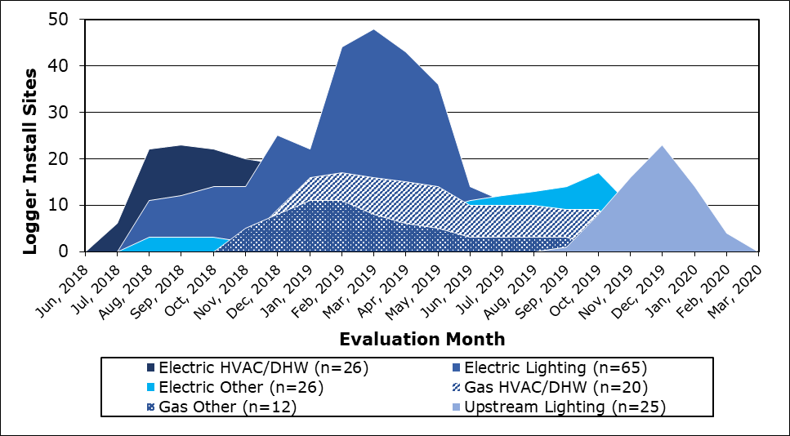

Metering equipment used
A summary of the metering devices used in this study is provided in APPENDIX D. This includes equipment used to monitor electric equipment, operating hours, proxy gas operation, and other dimensions needed to quantify the impacts of installed measures (e.g. temperature, humidity, etc.).
Each metering device used in this study receives routine battery checks and synchronization performed before being deployed and has documentation noting when, where, and how long each was installed. Site reports, provided as an appendix to this report under a separate cover, contains metering details for each site, including summaries of the data gathered and how the information was used to calculate energy savings seasonal peak use.

Savings analysis
There were three savings values calculated for each site in this study. These include energy savings (kWh for electric and ccf for gas) and summer and winter seasonal peak demand savings (kW).
Figure 4-3 presents the major measure categories that were evaluated in this evaluation, the metering equipment typically deployed to capture operation, and the key gross savings inputs gathered as either part of the metering or the onsite audit itself. Sites reports provided as an appendix contain the detailed measure level data collection, metering, and savings methods employed, including analysis results.
Figure 4-3. Technology Metering and Data Collection
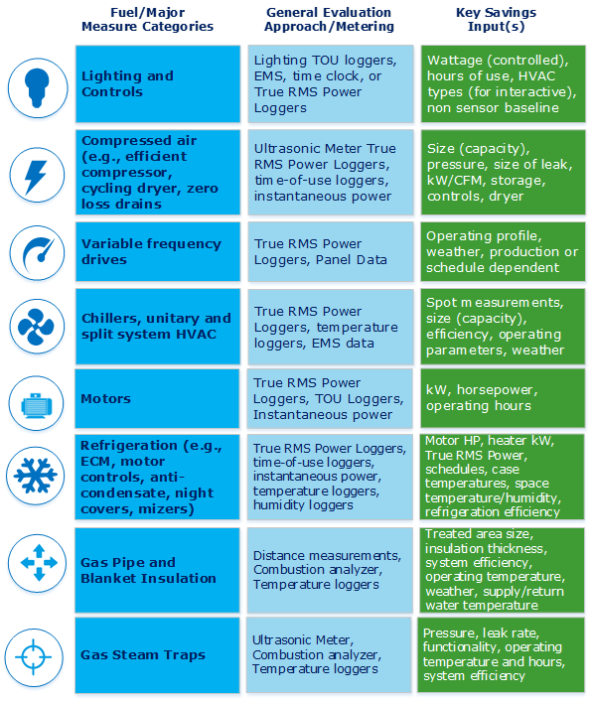
As part of reporting any changes in EO lighting savings from the tracking system estimate, the team used adjustment factors consistently across the sample to identify the cause of savings changes. These factors and their descriptions are provided in Figure 4-4 below and are used in the reporting of the evaluated lighting savings later in this report. These savings adjustments include out-of-business observations, administrative efforts, measure screening-related changes, and adjustments made based on on-site observations about the performance of installed equipment.
Figure 4-4. Lighting Savings Discrepancy Factors Discrepancy Factors
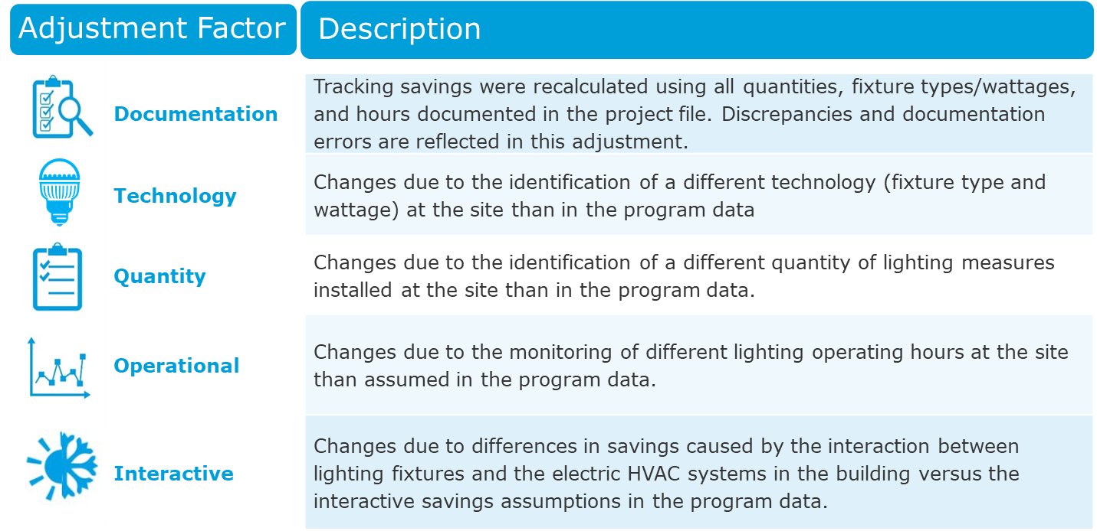

Seasonal Peak Savings
This study calculated demand impacts in summer and winter seasonal peak periods as defined by ISO New England. Seasonal demand performance hours are defined as hours when the real-time ISO-NE system load meets or exceeds 90% of the predicted Seasonal Peak from the most recent Capacity, Electricity, Load and Transmission (CELT) report. The study calculated the hours of interest as described in APPENDIX A. Based on those methods, the seasonal peak summer and winter hours are provided in Table 4-8 and Table 4-9 below.
Table 4-8. Summer Seasonal Peak Hours
Date | Hour Ending | Date | Hour Ending | Date | Hour Ending
7/10/2018 | 14 | 7/13/2018 | 15 | 7/25/2018 | 16
7/10/2018 | 15 | 7/24/2018 | 13 | 7/25/2018 | 17
7/11/2018 | 13 | 7/24/2018 | 14 | 7/25/2018 | 18
7/11/2018 | 14 | 7/24/2018 | 15 | 8/6/2018 | 13
7/11/2018 | 15 | 7/24/2018 | 16 | 8/6/2018 | 14
7/11/2018 | 17 | 7/24/2018 | 17 | 8/6/2018 | 15
7/12/2018 | 13 | 7/25/2018 | 13 | 8/6/2018 | 16
7/12/2018 | 14 | 7/25/2018 | 14 | 8/6/2018 | 17
7/12/2018 | 15 | 7/25/2018 | 15 | 8/6/2018 | 18

Table 4-9. Winter Seasonal Peak Hours
Date | Hour Ending | Date | Hour Ending | Date | Hour Ending | Date | Hour Ending
1/4/2018 | 8 | 1/30/2018 | 21 | 1/31/2018 | 22 | 12/14/2018 | 8
1/24/2018 | 21 | 1/30/2018 | 22 | 12/11/2018 | 8 | 12/14/2018 | 9
1/24/2018 | 22 | 1/31/2018 | 8 | 12/13/2018 | 8 | 12/14/2018 | 10
1/25/2018 | 8 | 1/31/2018 | 9 | 12/13/2018 | 9 | 12/14/2018 | 11
1/30/2018 | 8 | 1/31/2018 | 10 | 12/13/2018 | 10 | 12/14/2018 | 18
1/30/2018 | 9 | 1/31/2018 | 11 | 12/13/2018 | 11 | 12/14/2018 | 19
1/30/2018 | 10 | 1/31/2018 | 18 | 12/13/2018 | 19 | 12/14/2018 | 20
1/30/2018 | 18 | 1/31/2018 | 19 | 12/13/2018 | 20 | 12/14/2018 | 21
1/30/2018 | 19 | 1/31/2018 | 20 | 12/13/2018 | 21 | 12/14/2018 | 22
1/30/2018 | 20 | 1/31/2018 | 21 | 12/13/2018 | 22 | 12/21/2018 | 8

PSD review and prospective savings
One important element of this study was to provide retrospective and, as necessary, prospective realization rates. The need for a prospective realization rate that is different from a retrospective rate is triggered by changes in the PSD savings calculations between the evaluation program years (2016 and 2017) and the current program year (2020). When there are no changes in savings methods or assumptions the two realization rates are the same. When the savings method or assumptions change, the prospective realization rate uses the relationship between the evaluation savings estimates to what the tracking system savings estimates would have been for each site in the sample if this evaluation was based on the current 2020 program activity.
The assessment of the need for a prospective realization rate begins with the examination of PSD changes between the evaluation program years and the current PSD. This study went through all C&I retrofit measures in the PSD during this period and captured all changes in savings methods or assumptions observed. Many efficiency measures did not change savings methods during this period. Those that did change are summarized below. Whenever a measure was in the study sample and a change occurred, a new tracking savings was estimated to derive a prospective realization rate. In these instances, retrospective and prospective realization rate are provided. Otherwise, a single realization rate is offered for application.
- 2017 PSD: The 2017 PSD added a fan motor load factor assumption to the rooftop unit (RTU) variable frequency drive (VFD) savings calculation. One 2016 RTU VFD project is in the sample and it used a custom savings calculation. This PSD change has no effect on prospective savings.
- 2018 PSD: Updated the steam trap loss adjustment factors for leaking and failed traps. Two steam trap projects are in the sample and both used the updated factors. This PSD change has no effect on prospective savings.
- 2018 PSD: Updated energy savings factor for refrigerated beverage vending machines and glass front refrigerated cooler controls. There are no vending machine control sites are in the sample. This PSD change has no effect on prospective savings.
- 2019 PSD: Updated showerhead savings assumption (ccf saved/unit). Two showerhead sites are in the sample and neither used the updated savings assumption. This PSD change does affect gas HVAC/DHW prospective savings.

Lighting Logger Data Leveraging
Another important element of this study involved the use of lighting logger data from the current study, the last two CT Small Business Energy Advantage (SBEA) studies (C1639 and C9), the most recent CT Energy Conscious Blueprint (ECB) study (C20), and the previous CT EO study (C14) to update PSD savings input assumptions.
Table 4-10 provides the site and lighting logger sample sizes based on the data collected. Overall, data from 266 sites and nearly 2,700 loggers installed for an average of three months was used. The logger data was analyzed and weighted by connected kW to provide updates to the annual hours of use and seasonal peak coincidence factor assumptions provided in the PSD by building type.
Table 4-10. Lighting Logger Data Leveraging Sample
Lighting Logger Data Leveraging | Current CT EO Study | Current CT Upstream Study | 2014 CT SBEA Study | 2014 CT EO & 2015 CT ECB Studies | 2018 CT SBEA Study | Totals
Lighting Sites in Sample | 65 | 25 | 42 | 80 | 54 | 266
Lighting Loggers Installed | 755 | 79 | 370 | 1,223 | 272 | 2,699
Lighting Loggers/Site | 11.6 | 3.2 | 8.8 | 15.3 | 5.0 | 10.1
Average Lighting Logger Duration (months) | 4.6 | 2.7 | 5.6 | 1.0 | 2.0 | 3.0

Analysis and results
There are four subsections in this part of the report. They are results for EO electric, EO gas, upstream lighting, and PSD updates. These sections include scatter plots, realization rates, and impact estimates with precisions where appropriate.

EO Electric
As noted earlier, there are three EO electric measure categories that were examined in this study: lighting, HVAC, and other. Upstream lighting results are provided later in this report. The key energy savings results for each is presented in Table 5-1. Lighting and HVAC energy results have near 100% realization rates although the precision around the HVAC result is notably poorer at ±35%. The Other measure category experienced a lower realization rate of 67.6%. Details around these findings and their drivers are discussed below, in addition to summer and winter peak savings results.
Table 5-1. Summary of EO Electric Energy Results
Measure Category | Tracking Annual Energy Savings (MWh) | Evaluation Annual Energy Savings (MWh) | Realization Rate | Precision at 90% CI
Lighting | 232,090 | 227,271 | 97.9% | ±8.1%
HVAC | 19,015 | 19,423 | 102.1% | ±35.0%
Other | 42,738 | 28,910 | 67.6% | ±14.6%
Statewide | 293,843 | 275,604 | 93.8% | ±7.3%
As noted earlier, every sample point in each measure category received its own estimate of kWh and seasonal peak impacts. We compare the site level tracking versus evaluated sample results in scatterplots by measure category and savings dimension (energy, summer seasonal peak, winter seasonal peak) and provide savings estimates, realization rates and precisions below. The weighted sample results in these scatterplots produce the realization rates presented in Table 5-1.

Lighting
Figure 5-1 compares the tracking and evaluated annual energy savings for sites in the lighting sample (n=65). The diagonal dashed line indicates where each sample point would have plotted had the tracking estimates been 100% accurate. Note that there was one very large site in the sample in the upper right corner that was nearly 5 times the size of the next largest site. Refocusing this scatterplot on sites with tracking values less than 2,000 MWh shows most sample points trending near the dashed reference line, producing a gross realization rate of 97.9% with a precision of ±8.1% at the 90% confidence interval.
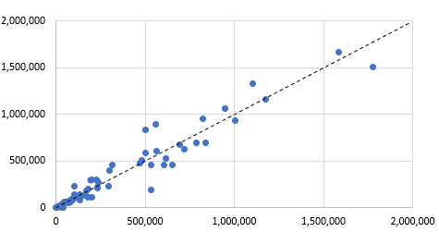
Figure 5-1. EO Electric Lighting Annual Energy Savings Scatterplot
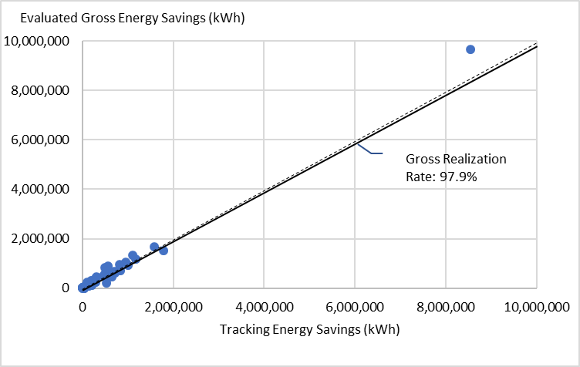
Figure 5-2 and Figure 5-3 show the relationship between the tracking and evaluated estimates of summer and winter peak demand savings in the lighting sample. The trending of these points in both summer and winter figures presents more variation around the 1:1 dashed reference line than the energy savings illustration above. This is due to an increased sensitivity in results from the narrowing of the performance period from a full year of operation (in the energy savings scatterplot) to a series of select hours of interest. This study estimates a seasonal summer peak savings of 27,588 kW with a realization rate of 98.9% and precision of ±10.6% at the 80% confidence interval. The winter seasonal peak savings estimate is 29,383 kW with a realization rate of 115.3% and precision of 7.6% at the 80% confidence interval. These results are further summarized below.
Figure 5-2. Lighting Summer Seasonal Peak kW Results Scatterplot
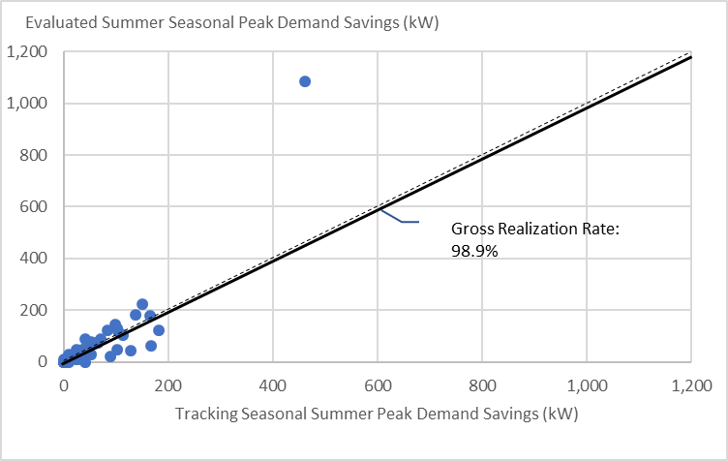
Figure 5-3. Lighting Winter Seasonal Peak kW Results Scatterplot
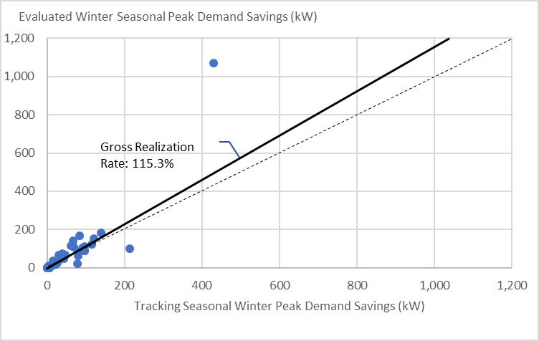

As noted earlier, lighting represents nearly 80% of program savings in the years examined. To examine this important program offering, Table 5-2 shows the influence of following adjustments made to develop the evaluated savings from the tracking estimate. It is important to note that the order in which these adjustments are provided matters since a site can have multiple adjustments. The realization rate in each row is the cumulative realization rate all adjustments made to that point (i.e., the technology realization rate includes both the documentation adjustment and the technology adjustment.
- Documentation: Tracking savings were recalculated using all quantities, fixture types/wattages, and hours documented in the project file. All tracking system discrepancies and documentation errors are reflected in this adjustment. For example, an error in the tracking system for one site caused savings to be entered that were 60% higher than was actually the case.
- Technology: Changes due to the identification of a different lighting technology (fixture type and wattage) at the site than in the program data system; provided that this technology was rebated by the program. For example, at one site, many of the program fixture wattages were found to be different that reported in the site documentation.
- Quantity: Changes due to the identification of a different quantity of lighting fixtures installed at the site than in the program data system. For example, at one site, none of the program fixtures were found to be installed and operating at the time of the site visit. The site contact at this site reported that the fixtures were received but was not sure when they would be installed.
- Operational: Changes due to the observation or monitoring of different lighting operating hours at the site than in the program tracking system. For example, lighting loggers at one site revealed that the program fixtures operated 4,308 hours per year, while the tracking system savings assumed that these fixtures operated 2,500 hours per year.
- Interactive: Changes due to interaction between lighting fixtures and the electric HVAC systems in the building. For example, the tracking system savings estimate at one site did not include interactive savings, but the program fixtures were found to be installed in a space served by a packaged DX cooling system.
It is clear that the information used to derive the EO lighting savings values are producing very stable estimates as evidenced by high realization rates among the various parameters studied (all in the 90% range).
Table 5-2: EO Lighting Savings Adjustments
Adjustment | Savings (kWh) | Change (kWh) | Realization Rate
Tracking System | 232,090 | N/A | N/A
Documentation | 228,261 | -3,829 | 98.4%
Technology | 229,288 | 1,027 | 98.8%
Quantity | 217,709 | -11,579 | 93.8%
Operational | 224,566 | 6,858 | 96.8%
Interactive | 227,271 | 2,705 | 97.9%
Table 5-3 summarizes the EO lighting savings results. The energy and summer seasonal peak realization rates are both near 100% at 97.9% and 98.9%, respectively. The winter seasonal peak realization rate is moderately higher at 115.3%. Precisions around these estimates are all fairly tight at ±8.1% around energy at the 90% confidence interval and ±10.6% and ±7.6% around the summer and winter seasonal peaks at the 80% confidence interval.
Table 5-3. Lighting Savings Summary
Category | Tracking Savings | Evaluation Savings | Realization Rate | Relative Precision
Energy (MWh) | 232,090 | 227,271 | 97.9% | ±8.1%*
Summer Seasonal Peak (kW) | 27,889 | 27,588 | 98.9% | ±10.6%^{Ŧ}
Winter Seasonal Peak (kW) | 25,487 | 29,383 | 115.3% | ±7.6%^{Ŧ}
* 90% Confidence Interval Ŧ 80% Confidence Interval

HVAC

Figure 5-4 compares the tracking and evaluated annual energy savings for sites in the electric HVAC measure category sample (n=26). As before, the diagonal dashed line provides a reference to illustrate differences between site level evaluated savings and their tracking counterpart. There were several sample points with savings either substantially higher or lower than their tracking estimate, which contributed to a higher precision rate for this measure category than seen above for lighting. This is most clearly seen when comparing performance in the focused pull out graphics where there is greater dispersion evident along the HVAC reference line than that seen in lighting. The final HVAC overall realization rate was just over 102% with a precision of ±35% at the 90% confidence interval.
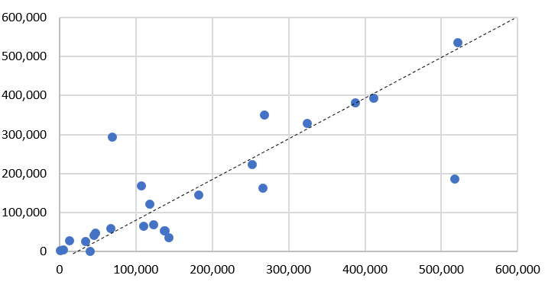
Figure 5-4. EO Electric HVAC Annual Energy Savings Scatterplot
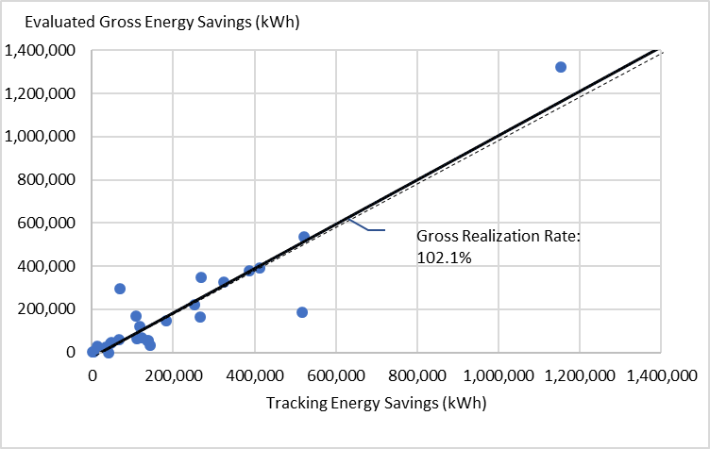

Figure 5-5 and Figure 5-6 show the relationship between the tracking and evaluated estimates of summer and winter peak demand savings in the HVAC sample. The realization rates accompanying these results are both well above 100%, with summer seasonal peak demand at 192.5% and winter seasonal peak demand at 146.2%. Precisions at the 80% confidence interval around the summer and winter realization rates are ±44.6% and ±31.7%, respectively.

Figure 5-5. HVAC Summer Seasonal Peak kW Results Scatterplot
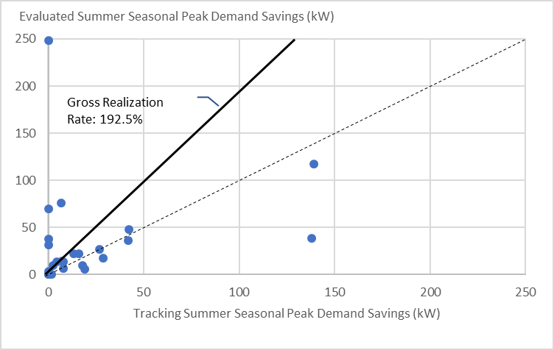
Figure 5-6. HVAC Winter Seasonal Peak kW Results Scatterplot
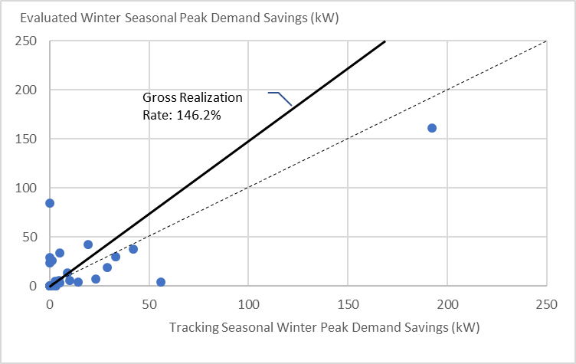
The key issue of note is that peak demand tracking savings are not being consistently estimated for all measures in this category, as evidenced in the vertical line of sites with zero savings on the Y-axis but not on the X-axis. There are six sites without summer seasonal peak demand tracking estimates that had evaluation savings, four of which also did not have winter seasonal peak demand tracking estimates that had evaluated savings. The measures installed at these sites included one site with setback thermostats, two with VFDs and three with EMSs.
The absence of seasonal summer and winter peak estimates in the tracking system for measures that are expected to have impacts (and, in fact, were credited with impacts in the evaluation), jeopardizes the applicability of these realization rates to future program years. Specifically, the future application risk is this realization rate will artificially increase claimed seasonal peak impacts if these tracking savings estimates are more fully populated in future years. To explore this further, this study developed alternative HVAC seasonal summer and winter realization rates by removing the sites with evaluated savings absent tracking savings. These results provide realization rates of 146.4% for summer seasonal peak (±47.0% at the 80% confidence interval), and a realization rate of 125.0% for winter seasonal peak (±31.1% at the 80% confidence interval).
Table 5-4 summarizes the HVAC savings results. The energy realization rate is near 100% with relative precision of ±35.0% at the 90% confidence interval. While this precision is poorer than expected, this study recommends the use of this realization rate for reasons discussed later in this report. The summer and winter seasonal peak realization rates are notably higher at 192.5% ±44.6% at the 80% confidence interval and 146.2% ±31.7% at the 80% confidence interval, respectively.
Table 5-4. HVAC Savings Summary
Category | Tracking Savings | Evaluation Savings | Realization Rate | Relative Precision
Energy (MWh) | 19,015 | 19,423 | 102.1% | ±35.0%*
Summer Seasonal Peak (kW) | 1,936 | 3,727 | 192.5% | ±44.6%^{Ŧ}
Winter Seasonal Peak (kW) | 1,310 | 1,916 | 146.2% | ±31.7%^{Ŧ}
* 90% Confidence Interval Ŧ 80% Confidence Interval

Other
Figure 5-7 compares the tracking and evaluated annual energy savings for sites in the Other sample (n=26). The diagonal dashed line indicates where each sample point would have plotted had the tracking estimates been 100% accurate. This sample produces a gross realization rate of 67.6% with a precision of ±14.6% at the 90% confidence interval. The two largest sites (shown in red) greatly influenced these results as each site had a realization rate below 50%.
The largest site (rightmost red point) had an evaluated energy savings estimate roughly 51% lower than its tracking counterpart. This was largely due to observed VFD staging and setpoints that produced a substantially different set savings conditions than assumed in the tracking estimate. The second red point had a series of measures installed that experienced baseline changes and/or differences in observed versus assumed operation that reduced its energy savings 54% from the tracking estimate.
Figure 5-7. EO Electric Other Annual Energy Savings Scatterplot
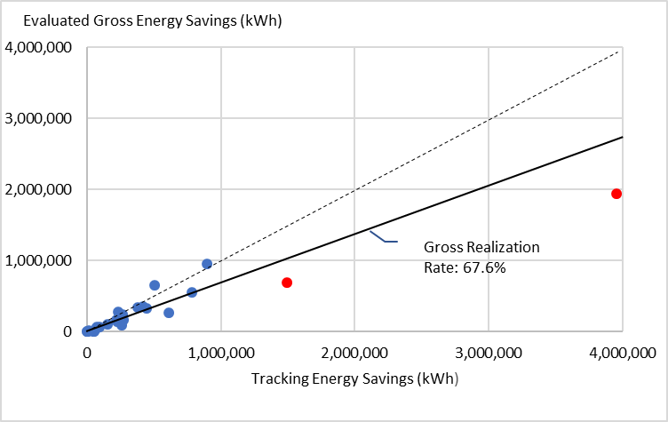
Figure 5-8 and Figure 5-9 show the relationship between the tracking and evaluated estimates of summer and winter peak demand savings in the other sample. This study estimates a seasonal summer peak savings of 3,578 kW with a realization rate of 123.9% and precision of ±15.4% at the 80% confidence interval. The winter seasonal peak savings estimate is 5,010 kW with a realization rate of 179.8% and precision of ±19.6% at the 80% confidence interval. These results are further summarized below.
Figure 5-8. Other Summer Seasonal Peak kW Results Scatterplot
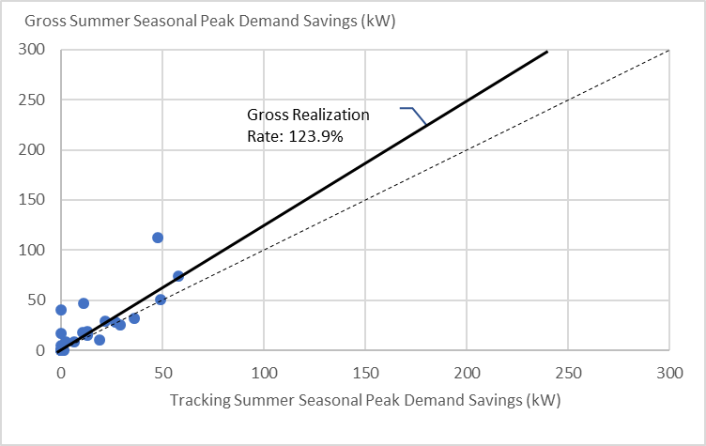
Figure 5-9. Other Winter Seasonal Peak kW Results Scatterplot
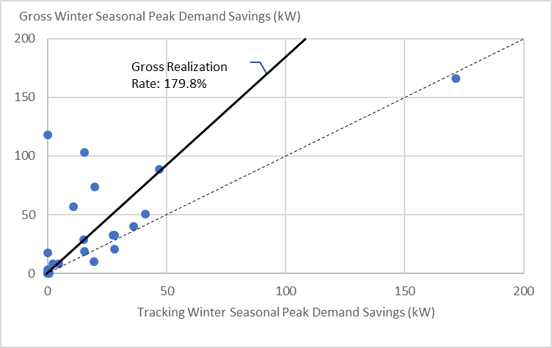

As was the case with the electric HVAC/DHW peak results, the key trend of note is that the Other seasonal peak demand tracking savings are not being consistently estimated for all measures, as evidenced in the vertical line of sites with savings on the Y-axis but not on the X-axis. There are three sites without summer or winter seasonal peak demand tracking estimates that had evaluation savings. The measures installed at these sites included one site with compressor leak repair and solenoid air valves, one with VFDs and one with VFDs, chiller plant optimization, and compressor air dryer controls.
Like the HVAC results above, this absence of the tracking system estimates for measures that are expected to have impacts (and, in fact, were credited with impacts in the evaluation) carries a risk of artificially increasing claimed seasonal peak impacts if these tracking savings estimates were to become more fully populated. To explore this further, alternative Other seasonal summer and winter realization rates were developed by removing the sites with evaluated savings absent tracking savings. These results provide realization rates of 114.7% for summer seasonal peak (±16.4% at the 80% confidence interval), and a realization rate of 162.1% for winter seasonal peak (±17.2% at the 80% confidence interval).
Table 5-5 summarizes the EO Electric Other savings results. The energy realization rate is 67.6%, while the summer and winter seasonal peak realization rates are much higher at 123.9% and 179.8%, respectively. Precisions around these estimates are all relatively tight at ±14.6% around energy at the 90% confidence interval and ±15.4% and ±19.6% around the summer and winter seasonal peaks at the 80% confidence interval.
Table 5-5. EO Electric Other Savings Summary
Category | Tracking Savings | Evaluation Savings | Realization Rate | Relative Precision
Energy (MWh) | 42,738 | 28,910 | 67.6% | ±14.6%*
Summer Seasonal Peak (kW) | 2,887 | 3,578 | 123.9% | ±15.4%^{Ŧ}
Winter Seasonal Peak (kW) | 2,787 | 5,010 | 179.8% | ±19.6%^{Ŧ}
* 90% Confidence Interval Ŧ 80% Confidence Interval

EO Gas
As noted earlier, there are two gas measure categories that were examined in this study: HVAC/DHW and Other. The key energy savings results for each is presented in Table 5-6. As noted in section 4.4.2, changes in PSD savings calculations between the program year(s) studied and the current PSD can trigger the need for prospective realization rates that complement the new savings analysis approach. There were two gas measures that experienced changes in their savings assumptions between the 2016 PSD (the program year from which part of this sample was drawn) and the 2020 PSD. These changes happened for steam traps in the 2018 and 2019 PSD and showerheads in the 2019 PSD. Due to these changes we provide a retrospective and prospective realization rate for this measure category that propagates to the overall realization rate also.
The overall EO gas realization rate is 76.3% with a precision of ±15.7% at the 90% confidence interval. The two measure category results were very similar with a HVAC/DHW measure category realization rate of 74.7% and Other realization rate of 78.2%%. The following two subsections compare the site level tracking versus evaluated savings results in scatterplots with discussions of primary drivers when appropriate. The weighted sample results in these scatterplots produce the realization rates presented in Table 5-6.
Table 5-6. Summary of EO Gas Energy Results
Measure Category | Tracking Annual Energy Savings (ccf) | Retrospective |  |  | Prospective
 |  | Evaluated Savings (ccf) | Realization Rate | Precision at 90% CI | Evaluated Savings (ccf) | Realization Rate | Precision at 90% CI
HVAC/DHW | 2,197,086 | 1,641,254 | 74.7% | ±17.4% | 1,641,254 | 76.5% | ±17.5%
Other | 1,757,093 | 1,374,161 | 78.2% | ±27.3% | 1,374,161 | 78.2% | ±27.3%
Statewide | 3,954,180 | 3,015,415 | 76.3% | ±15.8% | 3,015,415 | 77.3% | ±15.7%

HVAC/DHW

Figure 5-10 compares the retrospective tracking and evaluated annual energy savings for sites in the HVAC/DHW sample (n=20), with the two sites with measures (showerheads) that triggered the prospective realization rate shown as red points. The dashed reference line indicates where each sample point would have plotted had the tracking estimates been 100% accurate. This sample produces a gross realization rate of 74.7% with a precision of ±17.4% at the 90% confidence interval.
The largest site (shown as the blue point just past 300,000 ccf on the x-axis in Figure 5-10) had a realization rate of 62.4%. This was due to several measures performing lower than assumed in the tracking system for a variety of reasons. These included lower surface temperatures assumed in an insulation calculation and some duplication of measures in the tracking system that reduced savings when corrected.
Figure 5-10. EO Gas HVAC/DHW Retrospective Annual Energy Savings Scatterplot

As seen in the figure above, the two sites that triggered the need for a prospective gas HVAC/DHW realization rate were very small (shown as red dots). Figure 5-11 and Figure 5-12 presents a scatterplot of sites with under 10,000 ccf in tracking savings to show how these two sites impacted the prospective EO gas HVAC/DHW realization rate. In Figure 5-11 the two red points both fall below the dashed reference line while in Figure 5-12 one of these sites is above the reference line and the other close to it. The movement of these sample points closer to the reference line provides evidence the change in PSD savings approach for this measure is working. Since both sites are strata 1 sites which represent many other sites in the population, the improvement in the realization rate for these two sites results in a 1.8% increase in the overall HVAC/DHW realization rate.
Figure 5-11. Refocused EO Gas HVAC/DHW Retrospective Annual Energy Savings Scatterplot
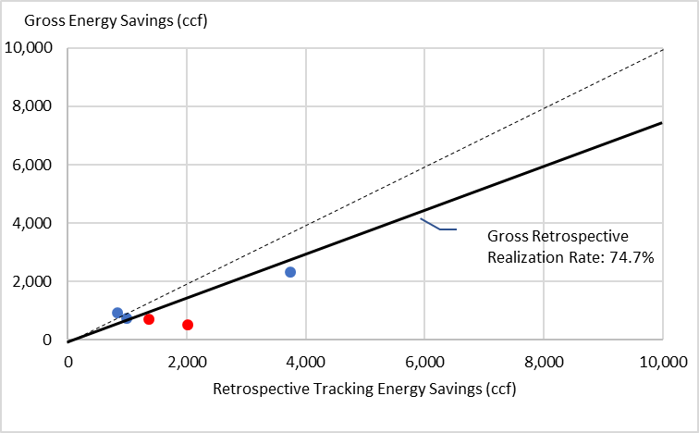
Figure 5-12. Refocused EO Gas HVAC/DHW Prospective Annual Energy Savings Scatterplot
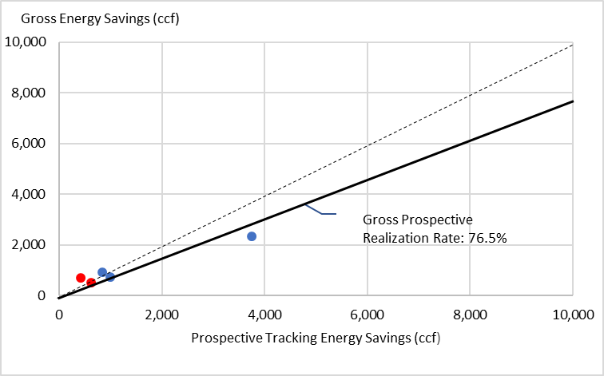

Table 5-7 summarizes the EO gas HVAC/DHW savings results. The retrospective energy realization rate is 74.7% with ±17.4% precision at the 90% confidence interval, while the prospective energy realization rate is 76.5% with ±17.5% precision at the 90% confidence interval.
Table 5-7. EO Gas HVAC/DHW Savings Summary
Category | Tracking Savings | Evaluation Savings | Realization Rate | Relative Precision at 90% CI
Retrospective Energy (ccf) | 2,197,086 | 1,641,254 | 74.7% | ±17.4%
Prospective Energy (ccf) | 2,145,240 | 1,641,254 | 76.5% | ±17.5%

Other

Figure 5-13 compares the tracking and evaluated annual energy savings for sites in the Other sample (n=12). The dashed reference line indicates where each sample point would have plotted had the tracking estimates been 100% accurate. The third largest site (shown as a red point in Figure 5-13) had a realization rate of 14.3% for the installation of pipe/blanket insulation primarily due to a calculation error.

Figure 5-13. EO Gas Other Annual Energy Savings Scatterplot
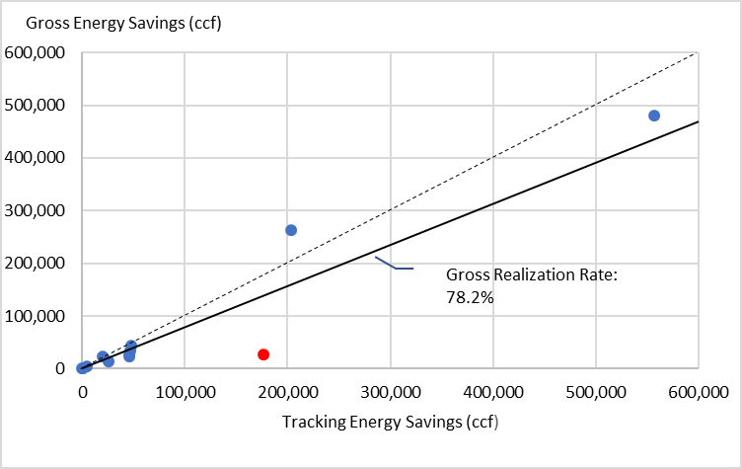

Table 5-8 summarizes the EO gas Other savings results. The energy realization rate is 78.2% with ±27.3% precision at the 90% confidence interval. The evaluated Other gas energy savings estimate is 1,374,161 ccf.
Table 5-8. EO Gas Other Savings Summary
Category | Tracking Savings | Evaluation Savings | Realization Rate | Relative Precision at 90% CI
Energy (ccf) | 1,757,093 | 1,374,161 | 78.2% | ±27.3%

Upstream Lighting
Table 5-9 provides the Upstream lighting energy savings results. The overall realization rate is 118.0% with a precision of ±12.7% at the 90% confidence interval. Recall, lighting loggers were retrieved from 25 of the 36 upstream sites with loggers due to the cancellation of field work caused by the COVID-19 pandemic. To calculate energy savings, hours of use from the lighting logger data leveraging effort (discussed later in this section) were used. The data leveraging study included data from the loggers that were retrieved from the 25 upstream sites. The key savings parameters for upstream lighting are provided in the remainder of this section.
Table 5-9: Summary of Upstream Lighting Energy Savings Results
Category | Tracking Annual Energy Savings (MWh) | Evaluation Annual Energy Savings (MWh) | Realization Rate | Precision at 90% CI
Upstream Lighting | 31,358 | 36,995 | 118.0% | ±12.7%
Table 5-10 summarizes the Upstream lighting in-service rate (ISR) results. As discussed earlier, the sample for the upstream study effort was of 2018 activity following the implementation of activities to ensure the installation of purchased lighting. The combination of higher installations rates associated with certain upstream measure types and the the companies’ activities in this area are producing a very high ISR compared to early studies of the recent MA Upstream lighting study. The short-term ISR is calculated by dividing the quantity of products found installed during the site visits by the total number of products listed as received according to the tracking system. The overall short-term ISR is 95.5% with a precision of ±2.5% at the 90% confidence interval.
Since the ISR rate is based on observations made within a year of purchase it is necessary to use factors from other studies to estimate the long-term ISR. To estimate a long-term upstream lighting ISR, the study used a multiplier of 117.5% from a two-stage study performed in Massachusetts that examined the installation rate of C&I upstream lighting over a year period. In applying this the quantity of products installed over the long term cannot exceed the sum of the products found installed and in storage during the site visit for each site visited. The overall long term ISR is 96.0% with ±2.4% precision at the 90% confidence interval.
Table 5-10. Upstream Lighting In-Service Rate Results
Category | Tracking System In-Service Rate | Evaluation Short-Term In-Service Rate | Precision at 90% CI | Evaluation Long Term In-Service Rate | Precision at 90% CI
Cat 1 LED Linear | 100.0% | 97.1% | ±1.9% | 97.4% | ±1.8%
Cat 3 LED Downlights | 100.0% | 85.9%* | ±22.5% | 86.4%* | ±22.3%
Cat 4 LED A-line/Deco | 100.0% | 71.4% | ±15.7% | 74.9% | ±13.8%
Cat 7 LED High/Low Bay | 100.0% | 99.6%* | ±0.6% | 99.7%* | ±0.5%
Total | 100.0% | 95.5%* | ±2.5% | 96.0%* | ±2.4%
*Results that are statistically different from the tracking system assumption at the 90% confidence interval.
Table 5-11 presents that Upstream lighting delta watts results. The overall delta watts realization rate is 99.8% with a precision of ±10.7% at the 90% confidence interval.
Table 5-11. Upstream Lighting Delta Watts Results
Category | Tracking Delta Watts | Evaluation Delta Watts | Realization Rate | Precision at 90% CI
Cat 1 LED Linear | 12.91 | 15.33* | 118.8% | ±8.9%
Cat 3 LED Downlights | 41.16 | 44.50 | 108.1% | ±17.0%
Cat 4 LED A-line/Deco | 40.32 | 46.86 | 116.2% | ±16.0%
Cat 7 LED High/Low Bay | 212.20 | 157.33* | 74.1% | ±30.4%
Overall | 24.55 | 24.51 | 99.8% | ±10.7%
*Results that are statistically different from the tracking system assumptions at the 90% confidence interval.
Table 5-12 shows the Upstream lighting connected demand savings results. The overall realization rate is 98.1% with a precision of ±8.3% at the 80% confidence interval. The poor realization rate for Category 7 LED High/Low Bay fixtures is due to a tracking savings weighted delta watts assumption of 212.2 watts, while the evaluation found the weighted average delta watts to be 157.3 watts for these products based on customer reports (as shown in Table 5-11).
Table 5-12. Upstream Lighting Connected Demand Savings Results
Category | Tracking Connected Demand Savings (kW) | Evaluation Connected Demand Savings (kW) | Realization Rate | Precision at 80% CI
Cat 1 LED Linear | 3,669 | 4,222 | 115.1%* | ±7.0%
Cat 3 LED Downlights | 1,277 | 1,254 | 98.2% | ±16.3%
Cat 4 LED A-line/Deco | 840 | 724 | 86.2% | ±11.6%
Cat 7 LED High/Low Bay | 2,144 | 1,580 | 73.7%* | ±23.7%
Total | 7,930 | 7,781 | 98.1% | ±8.3%
*Results that are statistically different from the tracking system assumption at the 90% confidence interval.
Table 5-13 provides the Upstream lighting energy interactive factor results, which are based on logger data from the 25 upstream lighting sites where loggers were installed and retrieved. The overall evaluation energy interactive factor is 1.024 with a precision of ±2.4% at the 90% confidence interval. This result is statistically the same as the tracking system assumption at the 90% confidence interval.
Table 5-13. Upstream Lighting Energy Interactive Factor Results
Category | Tracking Energy Interactive Factor | Evaluation Energy Interactive Factor | Precision at 90% CI
Cat 1 LED Linear | 1.000 | 1.081* | ±3.6%
Cat 3 LED Downlights | 1.000 | 1.023 | ±4.3%
Cat 4 LED A-line/Deco | 1.000 | 1.000 | ±0.0%
Cat 7 LED High/Low Bay | 1.000 | 1.008 | ±1.2%
Total | 1.000 | 1.024 | ±2.4%
*Results that are statistically different from the tracking system assumptions at the 90% confidence interval.
Table 5-14 provides the Upstream lighting energy savings results including interactive. The overall realization rate is 118.0% with a precision of ±12.7% at the 90% confidence interval. This evaluated energy savings estimate applied the leveraged hours of use results by business type as presented in the next section (Table 5-17 and Table 5-20). Seasonal peak demand realization rates for upstream lighting could not be provided since seasonal peak demand tracking savings estimates were not provided for most sites.
Table 5-14. Upstream Lighting Energy Savings Results
Category | Tracking Annual Energy Savings (MWh) | Evaluation Annual Energy Savings (MWh) | Realization Rate | Precision at 90% CI
Cat 1 LED Linear | 15,308 | 18,566 | 121.3% | ±11.5%
Cat 3 LED Downlights | 4,855 | 6,326 | 130.3% | ±24.4%
Cat 4 LED A-line/Deco | 3,161 | 3,486 | 110.3% | ±27.7%
Cat 7 LED High/Low Bay | 8,035 | 8,617 | 107.2% | ±33.4%
Total | 31,358 | 36,995 | 118.0% | ±12.7%
Table 5-15 summarizes the Upstream lighting demand interactive factor results, which are based on data gathered at all 88 upstream lighting site visits. The overall demand interactive factor is 1.152, which is statistically different from the tracking system assumption at the 90% confidence interval.
Table 5-15. Upstream Lighting Demand Interactive Factor Results
Category | Tracking Demand Interactive Factor | Evaluation Demand Interactive Factor | Precision at 90% CI
Cat 1 LED Linear | 1.000 | 1.199* | ±3.5%
Cat 3 LED Downlights | 1.000 | 1.189* | ±4.7%
Cat 4 LED A-line/Deco | 1.000 | 1.176* | ±7.1%
Cat 7 LED High/Low Bay | 1.000 | 1.047* | ±3.9%
Total | 1.000 | 1.152* | ±3.4%
*Results that are statistically different from the tracking system assumptions at the 90% confidence interval.

Lighting Data Leveraging
The study undertook a significant effort to pull together lighting logger data from this study and several other recently performed evaluations in Connecticut. This subsection of the report provides lighting parameters analyzed from the data by building type. The other evaluations where lighting logger information was gathered include the last two CT Small Business Energy Advantage (SBEA) studies (C1639 and C9), the most recent CT Energy Conscious Blueprint (ECB) study (C20), and the previous CT EO study (C14). Table 5-16 shows that this data leveraging effort compiled data from nearly 2,700 loggers installed at 266 sites for an average of three months.
Table 5-16. Lighting Logger Data Leveraging Sample
Lighting Logger Data Leveraging | Current CT EO Study | Current CT Upstream Study | 2014 CT SBEA Study | 2015 CT ECB & 2018 CT EO Studies | 2018 CT SBEA Study | Total
Lighting Sites in Sample | 65 | 25 | 42 | 80 | 54 | 266
Lighting Loggers Installed | 755 | 79 | 370 | 1,223 | 272 | 2,699
Lighting Loggers/Site | 11.6 | 3.2 | 8.8 | 15.3 | 5.0 | 10.1
Average Lighting Logger Duration (in months) | 4.6 | 2.7 | 5.6 | 1.0 | 2.0 | 3.0
Table 5-17 presents the weighted (by connected kW) interior fixture annual hours of use (HOU) results by building type with precisions at the 90% confidence interval. The rightmost two columns compare these results to the current PSD and MA Technical Reference Manual (TRM) upstream lighting assumptions. Since the study results are being compared to both the current PSD and current MA TRM assumptions, the identifiers that signify where statistical differences occur reside in those columns.
The tracking energy savings for interior fixtures at all but one lighting site in the EO sample were based on site-specific annual HOU assumptions. The PSD states that retrofit lighting calculations can use either site specific hours or assumed hours from the PSD for that building type. The Massachusetts TRM explicitly guides the use of site-specific hours for its direct install programs and hours by building type for upstream activity. The upstream lighting tracking savings for the majority interior spaces were based on the PSD annual HOU assumption for offices (3,748 hours), though some spaces used 70% of 8,760 (6,132 hours) for other interior spaces.
The overall weighted average of hours from the logger data gathering and leveraging is 5,550 hours per year. This is much higher than the estimate of 3,628 (derived when weighting the 2020 PSD assumed hours of use by the connected kW from the data leveraging by business type) but is slightly higher than the weighted estimate of 5,319 from the MA TRM assumed hours; although these results are not statistically different.
Table 5-17. Interior Fixture Hours of Use Results by Building Type
Building Type | Sites with Interior Systems Installed | Total Connected kW | Weighted Average Annual HOU | Precision at 90% Confidence Interval | 2020 PSD Assumption | MA TRM Upstream Assumption
24x7 lighting | 2 | 14.7 | 8,760 | ±0.0% | N/A | N/A
Automotive | 3 | 5.7 | 2,807 | ±46.1% | 4,056 | N/A
Education | 22 | 1,108.7 | 2,967 | ±14.0% | 2,187* | 2,788
Grocery | 14 | 194.6 | 7,698 | ±10.9% | 4,055* | 5,468*
Health Care | 15 | 249.9 | 5,564 | ±15.2% | 7,666* | 5,413
Hotel/Motel | 1 | 21.8 | 3,112 | N/A | 3,064 | 4,026
Industrial | 20 | 960.6 | 5,793 | ±13.3% | 4,730* | 4,988*
Large Office | 6 | 504.0 | 4,098 | ±8.0% | 3,748* | 4,181
Other | 25 | 706.9 | 6,211 | ±11.5% | N/A | 4,332*
Religious Building/ Convention Center | 6 | 8.3 | 913 | ±71.1% | 1,955* | N/A
Restaurant | 14 | 44.4 | 6,072 | ±12.3% | 4,182* | 5,018*
Retail | 30 | 665.7 | 6,318 | ±9.0% | 4,057* | 4,939*
Small Office | 30 | 169.0 | 3,595 | ±11.1% | 3,748 | 4,181*
Warehouse | 15 | 896.0 | 5,667 | ±19.9% | 2,602* | 6,512
Overall | 203 | 5,550.4 | 5,140 | ±5.2% | 3,628* | 5,319
*Results that are statistically different from the 2020 PSD or MA TRM Upstream lighting assumptions at the 90% confidence interval.
Table 5-18 provides the weighted (by connected kW) interior fixture summer seasonal coincidence factor (CF) results by building type with precisions at the 80% confidence interval. As above, the two columns on the right compares these results to the current PSD and MA Technical Reference Manual (TRM) on-peak assumptions. Similar to the hours of use summary above, the weighted average summer coincidence factor from the leveraged data is higher than that derived from the PSD using the same weights but is very similar to the overall weighted MA TRM value. The EO tracking summer seasonal peak savings were nearly always based on the PSD summer coincidence factor assumptions. Summer seasonal peak savings estimates were not provided in the Upstream lighting tracking data.
Table 5-18. Interior Fixture Summer Seasonal Coincidence Factor Results by Building Type
Building Type | # of Sites w/Interior Systems Installed | Total Connected kW | Weighted Average Summer Seasonal Peak CF | Precision at 80% Confidence Interval | 2020 PSD  Summer Seasonal Peak CF Assumption | MA TRM Summer On-peak Assumption
24x7 lighting | 2 | 14.7 | 100.0% | ±0.0% | N/A | 80.0%*
Automotive | 3 | 5.7 | 68.3% | ±33.7% | N/A | 80.0%
Education | 22 | 1,108.7 | 36.8% | ±22.0% | 59.9%* | 80.0%*
Grocery | 14 | 194.6 | 90.6% | ±9.3% | 90.4% | 80.0%*
Health Care | 15 | 249.9 | 82.5% | ±5.9% | 74.0%* | 80.0%
Hotel/Motel | 1 | 21.8 | 40.6% | N/A | N/A | 80.0%
Industrial | 20 | 960.6 | 83.0% | ±5.1% | 67.1%* | 80.0%
Large Office | 6 | 504.0 | 77.9% | ±12.4% | 70.2% | 80.0%
Other | 25 | 706.9 | 86.9% | ±9.0% | 47.6%* | 80.0%
Religious Building/ Convention Center | 6 | 8.3 | 17.0% | ±91.2% | N/A | 80.0%*
Restaurant | 14 | 44.4 | 83.1% | ±7.2% | 77.5% | 80.0%
Retail | 30 | 665.7 | 98.4% | ±3.8% | 79.5%* | 80.0%*
Small Office | 30 | 169.0 | 76.8% | ±8.0% | 70.2%* | 80.0%
Warehouse | 15 | 896.0 | 89.3% | ±9.2% | 72.7%* | 80.0%*
Overall | 203 | 5,550.4 | 76.4% | ±3.4% | 67.2%* | 80.0%*
*Results that are statistically different from the 2020 PSD or MA TRM Upstream lighting assumptions at the 80% confidence interval.
Table 5-19 summarizes the weighted (by connected kW) interior fixture winter seasonal coincidence factor results by building type with precisions at the 80% confidence interval and compares them to the current PSD and MA Technical Reference Manual (TRM) on-peak assumptions. The trend of the overall weighted leveraged results being substantially different than the current PSD but similar to the overall weighted MA TRM estimate remains here. The EO tracking winter seasonal peak savings were nearly always based on the PSD winter coincidence factor assumptions. Winter seasonal peak savings estimates were not provided in the Upstream lighting tracking data.

Table 5-19. Interior Fixture Winter Seasonal Coincidence Factor Results by Building Type
Building Type | # of Sites w/Interior Systems Installed | Total Connected kW | Weighted Average Winter Seasonal Peak CF | Precision at 80% Confidence Interval | 2020 PSD Winter Seasonal Peak CF Assumption | MA TRM Winter On-Peak Assumption
24x7 lighting | 2 | 14.7 | 100.0% | ±0.0% | N/A | 61.0%*
Automotive | 3 | 5.7 | 36.9% | ±48.1% | N/A | 61.0%*
Education | 22 | 1,108.7 | 46.0% | ±11.5% | 38.8%* | 61.0%*
Grocery | 14 | 194.6 | 85.6% | ±9.7% | 77.0%* | 61.0%*
Health Care | 15 | 249.9 | 69.6% | ±9.0% | 61.8%* | 61.0%*
Hotel/Motel | 1 | 21.8 | 37.5% | N/A | N/A | 61.0%
Industrial | 20 | 960.6 | 66.5% | ±12.9% | 43.2%* | 61.0%
Large Office | 6 | 504.0 | 58.2% | ±14.6% | 53.9% | 61.0%
Other | 25 | 706.9 | 76.7% | ±9.9% | 42.8%* | 61.0%*
Religious Building/ Convention Center | 6 | 8.3 | 9.2% | ±87.8% | N/A | 61.0%*
Restaurant | 14 | 44.4 | 77.0% | ±6.8% | 64.4%* | 61.0%*
Retail | 30 | 665.7 | 85.6% | ±9.5% | 64.7%* | 61.0%*
Small Office | 30 | 169.0 | 44.1% | ±14.0% | 53.9%* | 61.0%*
Warehouse | 15 | 896.0 | 72.4% | ±16.3% | 53.5%* | 61.0%
Overall | 203 | 5,550.4 | 66.2% | ±4.3% | 50.1%* | 61.0%*
*Results that are statistically different from the 2020 PSD or MA TRM Upstream lighting assumptions at the 80% confidence interval.
Table 5-20 presents the weighted (by connected kW) exterior fixture annual hours of use (HOU) and seasonal peak coincidence factor results. The two columns on the right compare these values to the current CT PSD and MA TRM assumptions. Asterisks identify results that are statistically different from the PSD assumption at the 90% confidence interval (CI) for HOU and at the 80% confidence interval for seasonal peak CFs.
The tracking energy savings for exterior fixtures in the EO sample were based on site-specific annual HOU assumptions, which is stated as an option in the PSD. Over 47% (or 319 kW) of the total connected exterior fixture kW in the data leveraging sample was due to parking garage lighting which operate 8,760 hours per year and have seasonal peak CFs of 100.0%. This heavily influenced the greater HOU estimate from this study (6,887) when compared to the current PSD assumption. The high presence of parking garages also drove up the summer and winter seasonal peak estimates.
Table 5-20. Exterior Fixture Results
Exterior: Parking Lot/streetlights | Sites w/Exterior Systems Installed | Total Connected kW | Weighted Average Result | Precision at 90% CI for HOU; at 80% CI for Seasonal Peak CFs | 2020 PSD Assumption | MA TRM  Assumption
Annual HOU | 66 | 677.0 | 6,887 | ±5.6% | 4,368* | N/A
Summer Seasonal Peak CF | 66 | 677.0 | 67.2% | ±7.4% | 1.5%* | 0.0%*
Winter Seasonal Peak CF | 66 | 677.0 | 87.3% | ±5.1% | 66.9%* | 100.0%*
*Results that are statistically different from the 2020 PSD and MA TRM assumptions at the 90% confidence interval for HOU and at the 80% confidence interval for Seasonal Peak CFs.
Table 5-21 presents the weighted (by connected kW) occupancy sensor summer seasonal peak coincidence factor results with precision at the 80% confidence interval. The overall baseline summer seasonal percent-on result for interior fixtures is from Table 5-18, while the overall occupancy sensor summer seasonal percent-on result is based on the logger data from 58 data leveraging sites. The summer seasonal occupancy sensor coincidence factor reduction is 22.1% with ±22.8% at the 80% confidence interval. This is statistically the same as the current PSD assumption of 20.5%.
Table 5-21. Occupancy Sensor Summer Seasonal Peak Coincidence Factor Result
Building Type | Sites | Weighted Average Summer Seasonal Peak CF | Precision at 80% Confidence Interval | 2020 PSD Assumption | MA TRM Assumption
Overall Baseline Percent-On | 203 | 76.4% | ±3.4% | 67.2%* | 80.0%*
Overall Occupancy Sensor Percent-On | 58 | 54.4% | ±7.9% | N/A | N/A
Occupancy Sensor Reduction | N/A | 22.1% | ±22.8% | 20.5% | 15.0%*
*Results that are statistically different from the 2020 PSD and MA TRM assumptions at the 80% confidence interval.
Table 5-22 provides the weighted (by connected kW) occupancy sensor winter seasonal peak coincidence factor result with precision at the 80% confidence interval. The overall baseline winter seasonal percent-on result for interior fixtures is from Table 5-19, while the overall occupancy sensor winter seasonal percent-on result is based on the logger data from 58 data leveraging sites. The winter seasonal occupancy sensor coincidence factor reduction is 14.3% with ±38.4% at the 80% confidence interval. This is statistically the same as the current PSD assumption of 18.9%.
Table 5-22. Occupancy Sensor Winter Seasonal Peak Coincidence Factor Result
Building Type | Site Count | Weighted Average Winter Seasonal Peak CF | Precision at 80% Confidence Interval | 2020 PSD Assumption | MA TRM Assumption
Overall Baseline Percent-On | 203 | 66.2% | ±4.3% | 50.1%* | 61.0%*
Overall Occupancy Sensor Percent-On | 58 | 51.8% | ±9.1% | N/A | N/A
Occupancy Sensor Reduction | N/A | 14.3% | ±38.4% | 18.9% | 13.0%
*Results that are statistically different from the 2020 PSD and MA TRM assumptions at the 80% confidence interval.

Study Error Ratios
Table 5-23 presents the final study energy error ratios by end use group for the EO portion of the study and for energy and connected demand for the upstream lighting of the study. With the exception of the electric HVAC error ratio, the study error ratios are all consistent with or better than those assumed in the sample design for each of the samples in this study. These final experienced error ratios can be used to inform future sample designs for similar studies of C&I retrofit programs in Connecticut.
Table 5-23. Study Error Ratios
End Use Group/Parameter | Error Ratio
EO Electric Lighting Energy | 0.37
EO Electric HVAC Energy | 0.83
EO Electric Other Energy | 0.47
EO Gas HVAC/DHW Energy | 0.48
EO Gas Other Energy | 0.43
Upstream Lighting Energy | 0.56
Upstream Lighting Connected Demand | 0.50

Study Realization Rates Compared to Those from Similar Programs
This section compares the energy realizations rates from this study to those from similar programs offered in other jurisdictions. Table 5-24 makes this comparison for electric energy realization rates and is sorted from the highest realization rate to the lowest with the results from this study in bold. Overall, the EO electric study results compare favorably to those from similar programs as the HVAC and Lighting realization rates are among the highest. While the Other realization rate is lower, the error ratio around it is relatively good compared to the error ratios around similar results in other jurisdictions. Custom study results are included in this comparison because the EO study also included custom measures though they were dispersed among the end uses reported.
Table 5-24: Electric Energy Realization Rates Compared to Those from Similar Program in Other Jurisdictions
Program Administrator | Program | State | Electric Realization Rate | Electric ER/CV
Consumers Custom | 2013 Custom C&I | MI | 1.088 | Not Provided
All MA Custom Electric Lighting | 2020 Custom Electric Program | MA | 1.067 | 0.26
Consumers Custom | 2012 Custom C&I²⁶ | MI | 1.024 | Not Provided
All CT EO HVAC | 2020 Energy Opportunities | CT | 1.021 | 0.83
All CT EO Lighting | 2020 Energy Opportunities | CT | 0.979 | 0.37
All NH Large C&I | 2015 Large Commercial and Industrial Retrofit Program | NH | 0.976 | 0.27
Efficiency Vermont | Efficiency Vermont 2017 Custom Program | VT | 0.966 | Not Provided
ComEd | 2019 Custom C&I | IL | 0.940 | Not Provided
All MA Custom Electric Lighting | 2019 Custom Electric Program | MA | 0.924 | 0.26
ComEd | 2018 Custom C&I³⁰ | IL | 0.910 | Not Provided
Energy Trust of Oregon | 2017 Existing Buildings Program | OR | 0.900 | 0.32
Efficiency Maine | 2014 -2015 Business Incentive Program | ME | 0.866 | Not Provided
NYSERDA | 2014–2017 Industrial and Process Efficiency Program | NY | 0.860 | 0.34
Consumers Custom | 2011 Custom C&I²⁶ | MI | 0.859 | Not Provided
PGE 2018 | Custom 2018 Commercial, Industrial, Agricultural | CA | 0.820 | Not Provided
All MA Custom Electric Non-Lighting | 2020 Custom Electric Program²⁷ | MA | 0.766 | 0.52
SCE 2018 | Custom 2018 Commercial, Industrial, Agricultural³⁵ | CA | 0.690 | Not Provided
All CT EO Other | 2020 Energy Opportunities | CT | 0.676 | 0.47
All MA Custom Electric Non-Lighting | 2019 Custom Electric Program³¹ | MA | 0.670 | 0.47
SDGE 2013-2015 | Custom 2013-2015, Industrial, Agricultural and Large Commercial | CA | 0.660 | 0.87
PGE 2013-2015 | Custom 2013-2015, Industrial, Agricultural and Large Commercial³⁶ | CA | 0.640 | 0.97
SDGE 2018 | Custom 2018 Commercial, Industrial, Agricultural³⁵ | CA | 0.530 | Not Provided
SCE&G 2013-2015 | Custom 2013-2015, Industrial, Agricultural and Large Commercial³⁶ | CA | 0.440 | 0.98
MCE 2018 | Custom 2018 Commercial, Industrial, Agricultural³⁵ | CA | 0.280 | Not Provided

Table 5-25 compares the gas energy realization rates from this study to those from similar programs in other jurisdictions. While the study realization rates are not among the highest, they are comparable to those experienced in MA and have associated error ratios that are similar to those from most of the other studies.
Table 5-25: Gas Energy Realization Rates Compared to Those from Similar Program in Other Jurisdictions
PA | State | Program | Gas Realization Rate | Gas ER/CV
Consumers Custom | MI | 2011 Custom C&I | 1.291 | Not Provided
Consumers Custom | MI | 2013 Custom C&I | 1.191 | Not Provided
Consumers Custom | MI | 2012 Custom C&I | 1.106 | Not Provided
All NH Large C&I | NH | 2015 Large Commercial and Industrial Retrofit Program | 0.917 | 0.16
Energy Trust of Oregon | OR | 2017 Existing Buildings Program | 0.870 | 0.41
All MA Custom Gas | MA | 2020 Custom Gas Program | 0.870 | 0.40
All MA Custom Gas | MA | 2019 Custom Gas Program | 0.820 | 0.49
All CT EO Other | CT | 2020 Energy Opportunities Program | 0.782 | 0.43
All CT EO HVAC/DHW | CT | 2020 Energy Opportunities Program | 0.747 | 0.48
PGE 2013-2015 | CA | Custom 2013-2015, Industrial, Agricultural and Large Commercial | 0.630 | 0.54
SCE&G 2013-2015 | CA | Custom 2013-2015, Industrial, Agricultural and Large Commercial | 0.550 | 0.92
SDGE 2013-2015 | CA | Custom 2013-2015, Industrial, Agricultural and Large Commercial | 0.500 | 1.31
Table 5-26 compares the upstream lighting energy realization rate to those from the upstream lighting program offered in Massachusetts. The realization rates compare very favorably to those from recent studies of the MA program as the current study results are among the highest and have better error ratios.
Table 5-26: Upstream Lighting Energy Realization Rates Compared to Those from Similar Program in MA
PA | State | Program | Electric Realization Rate | Electric ER/CV
All MA Upstream Lighting Category 1 (Linear LEDs) | MA | 2017 Upstream Lighting Program | 1.952 | 0.73
All CT Upstream Lighting Category 3 (LED Downlights) | CT | 2020 Upstream Lighting Program | 1.303 | 0.60
All CT Upstream Lighting Category 1 (Linear LEDs) | CT | 2020 Upstream Lighting Program | 1.213 | 0.43
All CT Upstream Lighting Category 4 (LED A-line/Deco) | CT | 2020 Upstream Lighting Program | 1.103 | 0.64
All CT Upstream Lighting Category 7 (LED High/Low Bay) | CT | 2020 Upstream Lighting Program | 1.072 | 0.68
All MA Upstream Lighting All LEDs | MA | 2014 Upstream Lighting Program | 1.019 | 0.90
All MA Upstream Lighting Category 3 (LED Downlights) | MA | 2017 Upstream Lighting Program³⁷ | 0.514 | 1.33
All MA Upstream Lighting Category 4 (LED A-line/Deco) | MA | 2017 Upstream Lighting Program³⁷ | 0.272 | 1.11

Conclusions, recommendations, and considerations
This section summarizes the conclusions and recommendations of this study based on the results presented above. EO electric energy, EO seasonal peak demand, and upstream lighting energy and connected demand savings results are favorable with very good realization rates. Poorer realization rates were found for EO gas energy savings estimates.

EO Electric Conclusions and Recommendations

Conclusion 1: The EO electric energy savings realization rates that can be used retrospectively and prospectively with accompanying precisions by sampling category are:
Table 6-1: EO Electric Energy Savings Realization Rate Results
Sampling Category | Realization Rate | Precision at 90% CI
HVAC | 102.1% | ±35.0%
Lighting | 97.9% | ±8.1%
Other | 67.6% | ±14.6%
Overall | 93.8% | ±7.3%
Recommendation 1: Update the EO electric energy savings realization rates by end use in the PSD so that they are consistent with the realization rates found in this study as follows. While the precision around the HVAC result is poorer than expected, after examining the sites which were the largest contributors, there are various drivers behind the site level results. The observed drivers are reasonably representative of what might be expected to occur within a sample of this nature (i.e., tracking system errors and differences in performance), and therefore support the application of this result despite the poor precision associated with it. Adjustments may be needed as program design changes.
Table 6-2: EO Electric Energy Savings Realization Rate Recommendations by End Use
End Use | 2020 Program Savings Document (PSD) Assumption | Recommended Realization Rate
Cooling | 101.0% | 102.1%
Heating | 101.0% | 102.1%
Lighting | 101.0% | 97.9%
Custom | 101.0% | 93.8%
EMS | 100.0% | 67.6%
Motors | 101.0% | 67.6%
Other | 101.0% | 67.6%
Process | 101.0% | 67.6%
Refrigeration | 101.0% | 67.6%
Conclusion 2: The EO lighting tracking energy savings estimates for all but one of the sites in the EO lighting sample (n=65) were based on the application of site-specific annual hours of use assumptions, which is stated as an option in the PSD and is consistent with the MA TRM for downstream lighting. The EO lighting realization rate using this method is very stable and near 100% overall.
Recommendation 2: Revise the PSD to explicitly call for the use of site-specific annual hours of use assumptions when calculating EO lighting energy savings and to use upstream lighting recommended annual hours of use by business type when site-specific assumptions do not exist.
Conclusion 3: This EO study sample included nine non-lighting sites (out of 52) that had evaluated summer seasonal peak savings results without a tracking counterpart. The table on the left shows the realization rate relative to the raw tracking savings (including zeros) while the table on the right provides a realization rate that approximates a realization rate had all tracking estimates of summer peak been populated (by removing sites with zero tracking savings with evaluated savings). The realization rate on the left is retrospective, while the result used as the prospective realization rate is dependent on any actions taken to improve the population of tracking values as noted in recommendation #3 below.
Table 6-3: EO Electric Summer Seasonal Peak Demand Realization Rate Results Relative to Tracking Savings (with Zero Tracking Estimates)  Sampling Category (n) Summer Seasonal Peak Realization Rate Precision at 80% CI  HVAC (n=26) 192.5% ±44.6%  Lighting (n=65) 98.9% ±10.6%  Other (n=26) 123.9% ±15.4%  Overall (n=117) 106.7% ±10.1% | Table 6-4: EO Electric Summer Seasonal Peak Demand Realization Rate Results (with Zero Tracking Estimates Removed)  Sampling Category (n) Summer Seasonal Peak Realization Rate Precision at 80% CI  HVAC (n=20) 146.4% ±47.0%  Lighting (n=65) 98.9% ±10.6%  Other (n=23) 114.7% ±16.4%  Overall (n=108) 103.1% ±10.2%
Recommendation 3: We recommend the PSD or companies either establish a new protocol to ensure fully populated seasonal summer peak tracking estimates and uses the realization rates in the rightmost column prospectively or use the realization rates in the second column prospectively in the event the rate of unpopulated/zero seasonal summer peak estimates is expected continue in future years.
Table 6-5: EO Electric Summer Seasonal Peak Demand Realization Rate Recommendations by End Use
End Use | Prospective realization rate if populated summer seasonal peak tracking estimates …
 | Remain similar to that observed in this study | Are fully populated moving forward
Cooling | 192.5% | 146.4%
Heating | 192.5% | 146.4%
Lighting | 98.9% | 98.9%
Custom | 106.7% | 103.1%
EMS | 123.9% | 114.7%
Motors | 123.9% | 114.7%
Other | 123.9% | 114.7%
Process | 123.9% | 114.7%
Refrigeration | 123.9% | 114.7%
Conclusion 4: The EO lighting tracking summer seasonal peak demand savings estimates are typically based on the application of the PSD summer seasonal coincidence factor assumptions by building type. The data leveraging summer seasonal coincidence factor results by building type are as follows. The weighted average of these results is 76.4%, which is higher than the current PSD average of 67.2% but very similar to the on peak MA TRM average of 80% when both are weighted the same way.
Table 6-6: EO Electric Summer Seasonal Peak Coincidence Factor Results by Building Type
Building Type | Summer Seasonal Peak CF | Building Type | Summer Seasonal Peak CF
24x7 lighting | 100.0%* | Other | 86.9%*
Automotive | 68.3%* | Parking Lot/Streetlights | 67.2%*
Education | 36.8%* | Religious bldg/Convention center | 17.0%*
Grocery | 90.6% | Restaurant | 83.1%
Health Care | 82.5%* | Retail | 98.4%*
Hotel/Motel | 40.6%* | Small Office | 76.8%*
Industrial | 83.0%* | Warehouse | 89.3%*
Large Office | 77.9%
*Results that are statistically different from the current PSD assumptions at the 80% CI or for which there are no current assumptions in the PSD.
Recommendation 4: Update the EO lighting summer seasonal peak coincidence factor assumptions by building type in the PSD so they are consistent with those that are statistically different from the current PSD assumption and retain the current PSD assumption for those results that are not statistically different from the current PSD assumption. These values are provided below. The MA TRM assumption did not influence these recommendations since it assumes a single coincidence factor (80.0%) for all building types.
Table 6-7: EO Electric Summer Seasonal Peak Coincidence Factor Recommendations by Building Type
Building Type | Summer Seasonal Peak CF | Building Type | Summer Seasonal Peak CF
24x7 lighting | 100.0% | Other | 86.9%
Automotive | 68.3% | Parking Lot/Streetlights | 67.2%
Education | 36.8% | Religious bldg/Convention center | 17.0%
Grocery | 90.4% | Restaurant | 77.5%
Health Care | 82.5% | Retail | 98.4%
Hotel/Motel | 40.6% | Small Office | 76.8%
Industrial | 83.0% | Warehouse | 89.3%
Large Office | 70.2%
Conclusion 5: This EO study sample included seven non-lighting sites (out of 52) that had evaluated winter seasonal peak savings results without a tracking counterpart. The table on the left shows the realization rate relative to the raw tracking savings (including zeros) while the table on the right provides a realization rate that approximates a realization rate had all tracking estimates of winter peak been populated (by removing sites with zero tracking savings with evaluated savings). The realization rate on the left is retrospective, while the result used as the prospective realization rate is dependent on any actions taken to improve the population of tracking values as noted in recommendation #5 below.
Table 6-8: EO Electric Winter Seasonal Peak Demand Realization Rate Results Relative to Tracking Savings (with Zero Tracking Estimates)  Sampling Category (n) Winter Seasonal Peak Realization Rate Precision at 80% CI  HVAC (n=26) 146.2% ±31.7%  Lighting (n=65) 115.3% ±7.6%  Other (n=26) 179.8% ±19.6%  Overall (n=117) 122.7% ±7.0% | Table 6-9: EO Electric Winter Seasonal Peak Demand Realization Rate Results (with Zero Tracking Estimates Removed)  Sampling Category (n) Winter Seasonal Peak Realization Rate Precision at 80% CI  HVAC (n=21) 125.0% ±31.1%  Lighting (n=65) 115.3% ±7.6%  Other (n=23) 162.1% ±17.2%  Overall (n=109) 120.1% ±7.0%
Recommendation 5: We recommend the PSD or companies either establish a new protocol to ensure fully populated seasonal winter peak tracking estimates and uses the realization rates in the rightmost column prospectively or use the realization rates in the second column prospectively in the event the rate of unpopulated seasonal summer peak estimates is expected to continue in future years.
Table 6-10: EO Electric Winter Seasonal Peak Demand Realization Rate Recommendations by End Use
End Use | Prospective realization rate if populated winter seasonal peak tracking estimates …
 | Remain similar to that observed in this study | Are fully populated moving forward
Cooling | 146.2% | 125.0%
Heating | 146.2% | 125.0%
Lighting | 115.3% | 115.3%
Custom | 122.7% | 120.1%
EMS | 179.8% | 162.1%
Motors | 179.8% | 162.1%
Other | 179.8% | 162.1%
Process | 179.8% | 162.1%
Refrigeration | 179.8% | 162.1%
Conclusion 6: The EO lighting tracking winter seasonal peak demand savings estimates are typically based on the application of the PSD winter seasonal coincidence factor assumptions by building type. The data leveraging winter seasonal coincidence factor results by building type are as follows. The weighted average of these results is 66.2%, which is higher than the current PSD average of 50.1% but very similar to the on peak MA TRM average of 61.0% when both are weighted the same way.
Table 6-11: EO Electric Winter Seasonal Peak Coincidence Factor Results by Building Type
Building Type | Winter Seasonal Peak CF | Building Type | Winter Seasonal Peak CF
24x7 lighting | 100.0%* | Other | 76.7%*
Automotive | 36.9%* | Parking Lot/Streetlights | 87.3%*
Education | 46.0%* | Religious bldg/Convention center | 9.2%*
Grocery | 85.6%* | Restaurant | 77.0%*
Health Care | 69.6%* | Retail | 85.6%*
Hotel/Motel | 37.5%* | Small Office | 44.1%*
Industrial | 66.5%* | Warehouse | 72.4%*
Large Office | 58.2%
*Results that are statistically different from the current PSD assumptions at the 80% CI or for which there are no current assumptions in the PSD.
Recommendation 6: Update the EO lighting winter seasonal peak coincidence factor assumptions by building type in the PSD so they are consistent with those that are statistically different from the current PSD assumption and retain the current PSD assumption for those results that are not statistically different from the current PSD assumption. These values are provided below. The MA TRM assumption did not influence these recommendations since it assumes a single coincidence factor (61.0%) for all building types.
Table 6-12: EO Electric Winter Seasonal Peak Coincidence Factor Recommendations by Building Type
Building Type | Winter Seasonal Peak CF | Building Type | Winter Seasonal Peak CF
24x7 lighting | 100.0% | Other | 76.7%
Automotive | 36.9% | Parking Lot/Streetlights | 87.3%
Education | 46.0% | Religious bldg/Convention center | 9.2%
Grocery | 85.6% | Restaurant | 77.0%
Health Care | 69.6% | Retail | 85.6%
Hotel/Motel | 37.5% | Small Office | 44.1%
Industrial | 66.5% | Warehouse | 72.4%
Large Office | 53.9%

EO Gas Conclusions and Recommendations
Conclusion 7: The retrospective and prospective EO gas energy savings realization rates by sampling category are below.
Table 6-13: EO Gas Energy Savings Realization Rate Results
Sampling Category | Retrospective |  | Prospective
 | Realization Rate | Precision at 90% CI | Realization Rate | Precision at 90% CI
HVAC/DHW | 74.7% | ±17.4% | 76.5% | ±17.5%
Other | 78.2% | ±27.3% | 78.2% | ±27.3%
Overall | 76.3% | ±15.8% | 77.3% | ±15.7%
Recommendation 7: Update the following gas energy savings realization rates by end use in the PSD so they are consistent with the prospective realization rates found in this study as provided in the rightmost two columns presents in conclusion 7 above.

Upstream Lighting Conclusions and Recommendations
Conclusion 8: The tracking system savings assume a 100% in-service rate for all products. The Upstream lighting short- and long-term in-service rates by sampling category are shown in the table below.
Table 6-14: Upstream Lighting In-Service Rate Results
Sampling Category | Short Term |  | Long Term
 | In-Service Rate | Precision at 90% CI | In-Service Rate | Precision at 90% CI
Category 1 LED Linear | 97.1% | ±1.9% | 97.4% | ±1.8%
Category 3 LED Downlights | 85.9% | ±22.5% | 86.4% | ±22.3%
Category 4 LED A-line/Deco | 71.4% | ±15.7% | 74.9% | ±13.8%
Category 7 LED High/Low Bay | 99.6% | ±0.6% | 99.7% | ±0.5%
Overall | 95.5% | ±2.5% | 96.0% | ±2.4%
Recommendation 8: Include Upstream lighting in-service rates in the PSD so that they are consistent with the results of this study as provided in conclusion 8 above.
Conclusion 9: The Upstream lighting delta watts and realization rates by sampling category are presented in the table below. Although the magnitude between the LED linear result (15.3 delta watts) is not large when compared to the average observed in the tracking data (12.9 watts), they are still statistically different at the 80% confidence interval. The result of 157.3 in the LED high and low bay category is substantially different than that observed in the tracking data (212.2 watts).
Table 6-15: Upstream Lighting Delta Watts Results
Sampling Category | Delta Watts | Realization Rate | Precision at 90% CI
Category 1 LED Linear | 15.33* | 118.8% | ±8.9%
Category 3 LED Downlights | 44.50 | 108.1% | ±17.0%
Category 4 LED A-line/Deco | 46.86 | 116.2% | ±16.0%
Category 7 LED High/Low Bay | 157.33* | 74.1% | ±30.4%
Overall | N/A | 99.8% | ±10.7%
*Results that are statistically different from the current tracking system savings assumptions at the 90% CI
Recommendation 9: Include delta watts assumptions in the PSD by product category so they are consistent with those that are statistically different from those used to calculate tracking savings and retain the delta watts assumptions used to calculate tracking savings for those results that are not statistically different.
Table 6-16: Upstream Lighting Delta Watts Recommendations
Sampling Category | Delta Watts
Category 1 LED Linear | 15.33
Category 3 LED Downlights | 41.16
Category 4 LED A-line/Deco | 40.32
Category 7 LED High/Low Bay | 157.33
Overall | N/A
Conclusion 10: The Upstream lighting tracking savings for the majority of interior spaces were based on the PSD annual HOU assumption for offices (3,748 hours), though some spaces used 70% of 8,760 (6,132 hours) for other interior spaces. The data leveraging annual hours of use results by building type are below.
Table 6-17: Data Leveraging Hours of Annual Hours of Use Results by Building Type
Building Type | Annual Hours of Use | Building Type | Annual Hours of Use
24x7 lighting | 8,760* | Other | 6,211*
Automotive | 2,807 | Parking Lot/Streetlights | 6,887*
Education | 2,967* | Religious bldg/Convention center | 913*
Grocery | 7,698* | Restaurant | 6,072*
Health Care | 5,564* | Retail | 6,318*
Hotel/Motel | 3,112 | Small Office | 3,595
Industrial | 5,793* | Warehouse | 5,667*
Large Office | 4,098*
*Results that are statistically different from the current PSD assumptions at the 90% CI or for which there are no current assumptions in the PSD.
Recommendation 10: Update the Upstream lighting annual hours of use assumptions by building type in the PSD so they are consistent with those reported in the table below. These recommendations have been made based on the statistical significance testing performed around the results as compared to both the current PSD assumptions and the current MA TRM assumptions. The recommendations have also been made after making judgements based on the data leveraging results and taking into consideration the sample size and precision around them.
Table 6-18: Upstream Lighting Annual Hours of Use Recommendations by Building Type
Building Type | Annual Hours of Use | Building Type | Annual Hours of Use
24x7 lighting | 8,760 | Other | 6,211
Automotive | 4,056 | Parking Lot/Streetlights | 6,887
Education | 2,967 | Religious bldg/Convention center | 913
Grocery | 5,468* | Restaurant | 5,018*
Health Care | 5,564 | Retail | 4,939*
Hotel/Motel | 3,064 | Small Office | 3,748
Industrial | 5,793 | Warehouse | 5,667
Large Office | 4,098
*Based on the MA TRM assumption since the data leveraging result assumes hours of operation which seem unreasonable for the average building of this type.
Conclusion 11: The tracking system savings do not account for interactive effects, implying an energy and demand interactive factor of 1.000. The Upstream lighting energy and summer demand interactive factors by sampling category are below.
Table 6-19: Upstream Lighting Interactive Factor Results
Sampling Category | Energy |  | Demand
 | Interactive Factor | Precision at 90% CI | Summer Interactive Factor | Precision at 90% CI
Category 1 LED Linear | 1.081* | ±3.6% | 1.199* | ±3.5%
Category 3 LED Downlights | 1.023 | ±4.3% | 1.189* | ±4.7%
Category 4 LED A-line/Deco | 1.000 | ±0.0% | 1.176* | ±7.1%
Category 7 LED High/Low Bay | 1.008 | ±1.2% | 1.047* | ±3.9%
Overall | 1.024 | ±2.4% | 1.152* | ±3.4%
*Results that are statistically different from the current tracking system savings assumptions at the 90% CI
Recommendation 12: Include the energy and demand interactive factors in the PSD as provided table in conclusion 7 above.

Considerations
Consideration 1: Only 13 sites in the EO lighting sample included the installation of occupancy sensors. The current PSD assumption is 0.3. Although not shown in this report, sensor performance at these sites suggest that there may be more reduction occurring. Due to the small sample size we do not make a recommendation on the use of the HOU reduction factor from this study. However, to the extent that lighting occupancy sensors become installed more prominently through the EO program and this factor becomes increasingly important, a more robust study or examination of existing studies may be needed to confirm or disconfirm the current PSD assumption.
Consideration 2: We suggest the EEB consider using the error ratios experienced in this study to size samples in future impact studies of the EO program. This will help ensure future sample sizes are planned in a way that is optimized based on the findings of this study.

Seasonal Peak Periods Methodology

In the ISO New England Forward Capacity Market, a participant may submit energy-efficiency “other demand resources” as one of three different types: On-Peak, Seasonal Peak, and Critical Peak. In Connecticut, Eversource and United Illuminating participates in FCM as a Seasonal Peak Demand Resource. The distinction is simply that the demand reduction value is computed as the average demand across the corresponding “Peak Hours” period. The following definitions are taken from ISO New England’s FERC Electric Tariff No. 3:
“Demand Resource On-Peak Hours are hours ending 1400 through 1700, Monday through Friday on non-holidays during the months of June, July, and August and hours ending 1800 through 1900, Monday through Friday on non-holidays during the months of December and January.
“Demand Resource Seasonal Peak Hours are those hours in which the actual, Real-Time hourly load for Monday through Friday on non-holidays, during the months of June, July, August, December, and January, as determined by the ISO, is equal to or greater than 90% of the most recent 50/50 system peal load forecast, as determined by the ISO, for the applicable summer or winter season.”
It is considerably more complex to assess coincidence relative to the Demand Resource Seasonal Peak Hours because they are conditional in nature and depend upon the relationship between real time system load and the most recent 50/50 system peak load forecast. The remainder of this section details DNV GL’s analytical approach to this challenge.
The calculation of the summer seasonal peak demand reduction was based on the performance hours that were used to evaluate the Demand Reduction Values (DRV). Seasonal demand performance hours for ISO-NE FCM are defined as hours when the real time ISO-NE system load meets or exceeds 90% of the predicted seasonal peak from the most recent Capacity, Electricity, Load and Transmission Report (CELT report). The peak load forecast for the summer 2018 season was 26,512 MW, and 90% of which was 23,861 MW. There were 30 hours during the summer 2018 season when the load exceeded 23,861 MW. The evaluation used Hartford, CT real weather data for the summer of 2018 to calculate the weighted Total Heat Index (THI) at each hour. The Total Heat Index is a forecast variable used by ISO-NE and it is calculated as follows;
THI = 0.5 x DBT + 0.3 x DPT + 15 Where,
THI = Total Heat Index
DBT = Dry Bulb Temperature (°F)
DPT = Dew Point Temperature (°F)
Table 6-1 provides the summer 2018 seasonal peak hours along with the system load, percent of CELT forecast peak and the Total Heat Index (THI) for Hartford, CT.
Table 6-20. 2018 Summer Seasonal Peak Hours and System Load
Date | Hour Ending | System Load (MW) | Percent of Peak | Hartford, CT THI
7/3/2018 | 17 | 23,992 | 90% | 82.1
7/3/2018 | 18 | 23,904 | 90% | 80.2
7/5/2018 | 17 | 23,992 | 90% | 81.8
7/5/2018 | 18 | 24,188 | 91% | 80.8
7/5/2018 | 19 | 23,966 | 90% | 80.1
8/6/2018 | 17 | 24,300 | 92% | 81.7
8/6/2018 | 18 | 24,685 | 93% | 81.0
8/6/2018 | 19 | 24,555 | 93% | 79.7
8/6/2018 | 20 | 23,983 | 90% | 78.5
8/7/2018 | 14 | 23,873 | 90% | 82.3
8/7/2018 | 15 | 24,236 | 91% | 82.2
8/7/2018 | 16 | 24,335 | 92% | 81.8
8/7/2018 | 17 | 24,334 | 92% | 81.4
8/7/2018 | 18 | 24,202 | 91% | 76.0
8/28/2018 | 15 | 24,311 | 92% | 83.6
8/28/2018 | 16 | 24,683 | 93% | 82.8
8/28/2018 | 17 | 25,086 | 95% | 82.3
8/28/2018 | 18 | 25,365 | 96% | 82.1
8/28/2018 | 19 | 25,125 | 95% | 80.9
8/28/2018 | 20 | 24,814 | 94% | 79.9
8/28/2018 | 21 | 24,289 | 92% | 79.4
8/29/2018 | 13 | 23,968 | 90% | 83.4
8/29/2018 | 14 | 24,720 | 93% | 83.0
8/29/2018 | 15 | 25,025 | 94% | 83.5
8/29/2018 | 16 | 25,232 | 95% | 83.5
8/29/2018 | 17 | 25,573 | 96% | 82.8
8/29/2018 | 18 | 25,763 | 97% | 81.5
8/29/2018 | 19 | 25,317 | 95% | 81.1
8/29/2018 | 20 | 24,931 | 94% | 79.3
8/29/2018 | 21 | 24,308 | 92% | 78.3

ISO-NE also uses a variable called a Weighted Heat Index (WHI) which is a three-day weighted average of the THI and is calculated as follows;
WHI = 0.59 x THI_{di hi} + 0.29 x THI_{d(i-1) hi} + 0.12 x THI_{d(i-2) hi} Where,
WHI = Weighted Heat Index
THI_{di hi}= Total Heat Index for the current day and hour
THI_{d(i-1) hi}= Total Heat Index for previous day and same hour
THI_{d(i-2) hi}= Total Heat Index for two days prior and same hour
The peak load data and the weighted THI and WHI data for 2018 were used to create linear regressions of peak system load as a function of THI and WHI. The analysis focused on non-holiday weekdays from June through August during hours ending 13 through 21. Evaluators used the time window of hours ending 13 to 21 based on the above observed peaks in the 2018 season.
The following THI & WHI cutoff points were the result of the regression analyses. These represent the selection points at which both the THI and WHI from a Hartford, CT TMY3 weather file must be greater than in order to trigger a summer seasonal peak hour.
THI Cutoff Point: 80.9
WHI Cutoff Point: 80.5
Table 6-2 provides a list of all hours from the Hartford, CT TMY3 weather file that met the above criteria of exceeding both the THI and WHI thresholds. There are a total of 27 TMY3 hours applied to the 2018 evaluation year that meet the criteria for being selected as a summer seasonal peak hour.
Table 6-21. Summary of Summer Seasonal Hours for Hartford, CT TMY3 File
Date | Hour Ending | THI | WHI
7/10/2018 | 14 | 82.2 | 81.0
7/10/2018 | 15 | 82.7 | 81.4
7/11/2018 | 13 | 81.3 | 81.4
7/11/2018 | 14 | 82.1 | 82.0
7/11/2018 | 15 | 82.1 | 82.2
7/11/2018 | 17 | 81.6 | 80.6
7/12/2018 | 13 | 81.4 | 81.3
7/12/2018 | 14 | 82.2 | 82.1
7/12/2018 | 15 | 81.4 | 81.7
7/13/2018 | 15 | 80.9 | 81.2
7/24/2018 | 13 | 82.9 | 81.3
7/24/2018 | 14 | 83.6 | 82.3
7/24/2018 | 15 | 83.6 | 82.3
7/24/2018 | 16 | 82.6 | 81.9
7/24/2018 | 17 | 82.2 | 81.4
7/25/2018 | 13 | 81.4 | 81.5
7/25/2018 | 14 | 82.5 | 82.6
7/25/2018 | 15 | 82.9 | 82.7
7/25/2018 | 16 | 82.1 | 82.0
7/25/2018 | 17 | 82.1 | 81.8
7/25/2018 | 18 | 80.9 | 80.7
8/6/2018 | 13 | 82.5 | 81.5
8/6/2018 | 14 | 82.4 | 82.1
8/6/2018 | 15 | 82.0 | 81.7
8/6/2018 | 16 | 81.5 | 81.5
8/6/2018 | 17 | 81.5 | 81.4
8/6/2018 | 18 | 81.3 | 80.6

The calculation of the winter seasonal peak demand reduction was based on the performance hours that were used to evaluate the Demand Reduction Values (DRV). Seasonal demand performance hours for ISO-NE FCM are defined as hours when the real time ISO-NE system load meets or exceeds 90% of the predicted seasonal peak from the most recent Capacity, Electricity, Load and Transmission Report (CELT report).
The peak load forecast for the winter 2017/2018 season was 20,714 MW, and 90% of which was 18,643 MW. There were a total of 54 hours during the winter 2017/2018 season when the load was 18,643 MW or greater. Table 6-3 provides a list of the winter seasonal peak hours along with the system load, the percentage of forecasted peak and the dry bulb temperature (DBT) for each hour for Hartford, CT.
Table 6-22. Winter 17/18 Seasonal Peak Hours and System Loads
Date | Hour Ending | System Load (MW) | Percent of Peak | Hartford, CT DBT |  | Date | Hour Ending | System Load (MW) | Percent of Peak | Hartford, CT DBT
12/13/2017 | 18 | 19,121 | 92% | 23 |  | 1/2/2018 | 17 | 19,568 | 94% | 21
12/13/2017 | 19 | 19,038 | 92% | 22 |  | 1/2/2018 | 18 | 20,629 | 100% | 20
12/13/2017 | 20 | 18,681 | 90% | 21 |  | 1/2/2018 | 19 | 20,639 | 100% | 19
12/14/2017 | 18 | 18,792 | 91% | 21 |  | 1/2/2018 | 20 | 20,266 | 98% | 16
12/14/2017 | 19 | 18,795 | 91% | 19 |  | 1/2/2018 | 21 | 19,601 | 95% | 15
12/15/2017 | 18 | 18,685 | 90% | 23 |  | 1/3/2018 | 18 | 19,446 | 94% | 22
12/27/2017 | 18 | 19,522 | 94% | 16 |  | 1/3/2018 | 19 | 19,539 | 94% | 22
12/27/2017 | 19 | 19,457 | 94% | 14 |  | 1/3/2018 | 20 | 19,238 | 93% | 19
12/27/2017 | 20 | 19,080 | 92% | 13 |  | 1/3/2018 | 21 | 18,729 | 90% | 19
12/28/2017 | 17 | 19,550 | 94% | 10 |  | 1/4/2018 | 12 | 18,773 | 91% | 21
12/28/2017 | 18 | 20,523 | 99% | 9 |  | 1/4/2018 | 13 | 18,696 | 90% | 23
12/28/2017 | 19 | 20,418 | 99% | 7 |  | 1/4/2018 | 17 | 18,674 | 90% | 24
12/28/2017 | 20 | 20,015 | 97% | 7 |  | 1/4/2018 | 18 | 19,450 | 94% | 23
12/28/2017 | 21 | 19,429 | 94% | 7 |  | 1/4/2018 | 19 | 19,156 | 92% | 23
12/29/2017 | 10 | 18,742 | 90% | 4 |  | 1/5/2018 | 16 | 18,746 | 91% | 12
12/29/2017 | 11 | 18,709 | 90% | 8 |  | 1/5/2018 | 17 | 19,631 | 95% | 10
12/29/2017 | 17 | 19,125 | 92% | 16 |  | 1/5/2018 | 18 | 20,663 | 100% | 8
12/29/2017 | 18 | 20,014 | 97% | 13 |  | 1/5/2018 | 19 | 20,607 | 99% | 7
12/29/2017 | 19 | 19,825 | 96% | 12 |  | 1/5/2018 | 20 | 20,185 | 97% | 7
12/29/2017 | 20 | 19,397 | 94% | 12 |  | 1/5/2018 | 21 | 19,648 | 95% | 7
12/29/2017 | 21 | 18,874 | 91% | 11 |  | 1/5/2018 | 22 | 18,874 | 91% | 7
1/2/2018 | 8 | 19,033 | 92% | 3 |  | 1/8/2018 | 18 | 19,209 | 93% | 27
1/2/2018 | 9 | 19,214 | 93% | 3 |  | 1/8/2018 | 19 | 19,104 | 92% | 26
1/2/2018 | 10 | 19,100 | 92% | 7 |  | 1/15/2018 | 17 | 19,040 | 92% | 21
1/2/2018 | 11 | 18,905 | 91% | 11 |  | 1/15/2018 | 18 | 19,831 | 96% | 21
1/2/2018 | 12 | 18,665 | 90% | 15 |  | 1/15/2018 | 19 | 19,592 | 95% | 21
1/2/2018 | 16 | 18,672 | 90% | 20 |  | 1/15/2018 | 20 | 19,021 | 92% | 21

The 2017/2018 peak load data and the Hartford, CT temperature data were used to create linear regressions of peak system load as a function of dry bulb temperature. The results of the regression were used to identify the seasonal peak hours using the Hartford, CT TMY3 weather data. The analysis focused on low temperature periods in December and January between hours ending 8 and 22. Evaluators included this hour range based on the observed peaks in the 2017/2018 season in the table above.
The following DBT cutoff point was the result of the regression analysis. This represents the selection point at which the DBT from the Hartford, CT TMY3 weather file must be less than in order to trigger a winter seasonal peak hour.
DBT Cutoff Point: 17.9°F
Table 6-4 provides a list of the winter seasonal peak hours from the Hartford, CT TMY3 that meet the criteria above. There is a total of 40 hours that qualify.
Table 6-23. Summary of Winter Seasonal Hours for Hartford, CT TMY3 File
Date | Hour Ending | DBT |  | Date | Hour Ending | DBT
1/4/2018 | 8 | 16 |  | 1/31/2018 | 22 | 16
1/24/2018 | 21 | 17 |  | 12/11/2018 | 8 | 16
1/24/2018 | 22 | 16 |  | 12/13/2018 | 8 | 8
1/25/2018 | 8 | 17 |  | 12/13/2018 | 9 | 14
1/30/2018 | 8 | 14 |  | 12/13/2018 | 10 | 15
1/30/2018 | 9 | 15 |  | 12/13/2018 | 11 | 17
1/30/2018 | 10 | 17 |  | 12/13/2018 | 19 | 17
1/30/2018 | 18 | 17 |  | 12/13/2018 | 20 | 15
1/30/2018 | 19 | 15 |  | 12/13/2018 | 21 | 13
1/30/2018 | 20 | 14 |  | 12/13/2018 | 22 | 12
1/30/2018 | 21 | 14 |  | 12/14/2018 | 8 | 3
1/30/2018 | 22 | 13 |  | 12/14/2018 | 9 | 8
1/31/2018 | 8 | 10 |  | 12/14/2018 | 10 | 11
1/31/2018 | 9 | 12 |  | 12/14/2018 | 11 | 15
1/31/2018 | 10 | 13 |  | 12/14/2018 | 18 | 15
1/31/2018 | 11 | 16 |  | 12/14/2018 | 19 | 14
1/31/2018 | 18 | 17 |  | 12/14/2018 | 20 | 15
1/31/2018 | 19 | 15 |  | 12/14/2018 | 21 | 12
1/31/2018 | 20 | 14 |  | 12/14/2018 | 22 | 13
1/31/2018 | 21 | 13 |  | 12/21/2018 | 8 | 15

Detailed population summaries
This appendix provides summaries of the EO 2016/2017 electric and gas sample frames and the 2018 upstream lighting sample frame used in this study. These breakdowns include energy and peak savings tracking activity by end use or sample end use category and utility.

Table 6-24. 2016-2017 Electric Savings by End Use and Utility
Measure | # Projects | Annual MWh | Summer Seasonal Peak kW | Winter Seasonal Peak kW
Eversource
Cooling | 155 | 13,283.0 | 1,647.9 | 806.6
Heating | 37 | 2,095.0 | 38.1 | 378.3
Lighting | 2,052 | 175,111.0 | 21,418.3 | 19,334.7
Motor | 68 | 7,073.0 | 565.4 | 554.3
Process | 43 | 9,375.5 | 891.0 | 577.6
Refrigeration | 83 | 11,239.0 | 591.3 | 1,108.2
Other | 52 | 3,643.6 | 358.1 | 229.9
Subtotal | 2,176 | 221,821.0 | 25,510.0 | 22,990.0
United Illuminating
Cooling | 7 | 1,310.0 | 17.3 | -
Heating | 4 | 68.5 | - | 5.1
HVAC | 37 | 2,258.0 | 232.6 | 119.7
Lighting | 519 | 56,979.0 | 6,470.7 | 6,151.7
VFD's | 7 | 150.2 | - | -
Process | 11 | 7,111.0 | 332.2 | 199.0
Refrigeration | 18 | 853.0 | 21.3 | 35.5
Custom | 47 | 3,292.0 | 127.9 | 82.4
Subtotal | 567 | 72,021.7 | 7,202.1 | 6,593.4
Grand Total | 2,743 | 293,842.7 | 32,712.0 | 29,583.4

Table 6-25. 2016-2017 Electric Savings by Measure Category and Utility
Measure Category | Accounts | Annual Savings (MWh) | Summer Seasonal Peak Savings (kW) | Winter Seasonal Peak Savings (kW)
Eversource
Lighting | 2,053 | 175,111 | 21,418 | 19,335
HVAC & DHW | 170 | 15,378 | 1,686 | 1,185
Everything Else | 209 | 31,331 | 2,406 | 2,470
Eversource Total | 2,176 | 221,821 | 25,510 | 22,990
United Illuminating
Lighting | 519 | 56,979 | 6,471 | 6,152
HVAC & DHW | 47 | 3,636 | 250 | 125
Everything Else | 75 | 11,406 | 481 | 317
Avangrid Total | 567 | 72,022 | 7,202 | 6,593
Statewide
Lighting | 2,572 | 232,090 | 27,889 | 25,487
HVAC & DHW | 217 | 19,015 | 1,936 | 1,310
Everything Else | 284 | 42,738 | 2,887 | 2,787
Statewide Total | 2,743 | 293,843 | 32,712 | 29,583

Table 6-26. 2016-2017 of Gas Savings by End Use and Utility
Measure | # Projects | CCF
Eversource
DHW | 7 | 37,982
Heating | 91 | 1,245,386
Other | 8 | 47,185
Process | 19 | 778,180
Subtotal | 112 | 2,108,733
AvanGrid
Custom | 35 | 154,028
DHW | 7 | 982
Heating | 43 | 376,495
HVAC | 23 | 537,224
Process | 7 | 776,718
Subtotal | 96 | 1,845,447
Grand Total | 208 | 3,954,180

Table 6-27. 2018 CT C&I Upstream Lighting program tracking savings summary by MA LED sample category
MA Upstream Lighting Category | Description | Eversource |  |  | UI |  |  | Total
 |  | Custom-ers | Qty | kWh Savings | Custom-ers | Qty | kWh Savings | Custom-ers | Qty | kWh Savings | % of Total
Category 1 | Linear LEDs | 2,525 | 237,767 | 13,210,894 | 275 | 40,792 | 2,097,431 | 2,800 | 278,559 | 15,308,325 | 47.5%
Category 2 | LED Stairwell Kits | 8 | 51 | 22,574 | 0 | 0 | 0 | 8 | 51 | 22,574 | 0.1%
Category 3 | LED Downlights | 1,068 | 25,519 | 4,299,059 | 89 | 4,234 | 555,528 | 1,157 | 29,753 | 4,854,587 | 15.1%
Category 4 | LED A-Line/Deco | 429 | 16,713 | 2,457,531 | 64 | 5,548 | 703,041 | 493 | 22,261 | 3,160,573 | 9.8%
Category 5 | GU24 LEDs | 86 | 5,993 | 304,839 | 6 | 1,096 | 52,580 | 92 | 7,089 | 357,419 | 1.1%
Category 6 | LED Exterior Wall-packs | 153 | 685 | 315,401 | 8 | 48 | 24,647 | 161 | 733 | 340,048 | 1.1%
Category 7 | High/Low Bay LEDs | 456 | 9,588 | 7,732,974 | 11 | 372 | 301,763 | 467 | 9,960 | 8,034,737 | 25.0%
N/A | Linear Fluorescents | 96 | 8,424 | 116,253 | 0 | 0 | 0 | 96 | 8,424 | 116,253 | 0.4%
Total |  | 3,907 | 304,740 | 28,459,526 | 365 | 52,090 | 3,734,990 | 4,272 | 356,830 | 32,194,516 | 100.0%

Detailed Sample summaries
This appendix provides summaries of the EO 2016/2017 electric and gas final sample and the 2018 upstream lighting final sample frame used in this study. These breakdowns show the various strata cut points used for each measure category and population, sample points in each, and case weights.

Table 6-28. Final EO Electric Sample by measure group and strata
Measure | Stratum | Maximum (kWh) | Population Count | Total Annual Savings (kWh) | Sample Size | Case Weight
Lighting | 1 | 51,118 | 1,742 | 27,652,204 | 13 | 134.0
 | 2 | 141,930 | 426 | 37,084,821 | 13 | 32.8
 | 3 | 269,468 | 229 | 43,090,036 | 13 | 17.6
 | 4 | 619,778 | 122 | 50,506,276 | 13 | 9.4
 | 5 | 4,927,788 | 52 | 65,210,000 | 12 | 4.3
 | 6 | 8,546,989 | 1 | 8,546,989 | 1 | 1.0
HVAC | 1 | 86,493 | 154 | 4,557,773 | 9 | 17.1
 | 2 | 204,727 | 43 | 5,835,312 | 8 | 5.4
 | 3 | 733,383 | 19 | 7,469,099 | 8 | 2.4
 | 4 | 1,152,514 | 1 | 1,152,514 | 1 | 1.0
Other | 1 | 153,098 | 203 | 9,774,119 | 9 | 22.6
 | 2 | 336,636 | 57 | 12,739,274 | 8 | 7.1
 | 3 | 1,543,121 | 23 | 16,264,766 | 8 | 2.9
 | 4 | 3,959,715 | 1 | 3,959,715 | 1 | 1.0

Table 6-29. EO Gas Sample by measure group and strata
End Use | Stratum | Maximum (CCF) | Population Count | Total Annual Savings (CCF) | Sample Size | Case Weight
HVAC/DHW | 1 | 8,263 | 98 | 236,292 | 6 | 16.3
 | 2 | 18,710 | 24 | 307,718 | 6 | 4.0
 | 3 | 29,522 | 14 | 360,684 | 6 | 2.3
 | 4 | 47,326 | 11 | 394,355 | 5 | 2.2
 | 5 | 72,582 | 7 | 443,267 | 5 | 1.4
 | 6 | 301,998 | 2 | 454,770 | 2 | 1.0
Other | 1 | 14,302 | 56 | 193,055 | 5 | 11.2
 | 2 | 45,462 | 11 | 271,508 | 4 | 2.8
 | 3 | 79,163 | 6 | 355,718 | 4 | 1.5
 | 4 | 557,029 | 3 | 936,812 | 3 | 1.0

Metering equipment used
This study used the metering devices itemized below. Individual reports developed for each site visited contain information on the meters deployed, the data gathered, and how it was used to develop the savings estimates.
DENT ELITEpro power loggers that monitor voltage, amperage, power factor, and kW over the monitoring period. The monitoring frequency was typically 15-minutes or less. ELITEpro power loggers were installed on variable load equipment including fans pumps, compressors, packaged equipment, lighting projects, and process equipment. The current transformers used with these loggers include:
- Split-core current transformers manufactured by DENT and Magnelab to measure current ranging from 5 amps to 600 amps nominally.
- Rogowski coil current transformers manufactured by DENT. These current transformers measure between 5 amps and 5,000 amps.
Continental Control Systems Wattnode Pulse energy meters that measure kWh. The monitoring period was typically 15-minutes or less. Wattnode loggers were installed in similar applications where DENT ELITEPro power loggers were installed. The data from these meters was typically logged in either a HOBO H-21-002 logger, or a HOBO UX-90-001 state data logger. The current transformers were split-core units manufactured by DENT or Magnelab.
Amprobe 220 power meters that spot measure voltage, amperage, power factor, and kW during a short period during the site visits. This meter data was used to measure power factor in situations where a DENT ELITEpro meter could not be installed.
HOBO H-21-002, H-22-001 data loggers that record amperage, kWh, temperature, humidity and pressure, depending on what sensors are connected. The monitoring frequency was 15-minutes or less. HOBO H-21-002 loggers are waterproof loggers and were used in applications where outdoor air temperature/humidity measurements were taken. HOBO H-22-001 loggers were used in indoor applications. The sensors that were typically installed with these loggers are as follows:
- Split-core current transformers manufactured by DENT and Magnelab to measure current ranging from 5 amps to 600 amps nominally.
- Wattnode energy meters that monitor kWh. These kWh meters used current transformers described above. Used for various types of projects.
- HOBO S-THB-M002 sensors to measure temperature/humidity. These measure air temperatures between -40 and 167°F, and humidity between 10% and 90% RH. Typically used for HVAC projects.
- HOBO S-TMB-M0xx sensors to measure temperature only. These measure temperatures between -40 and 212° F. Typically used for HVAC projects.
- Ashcroft G2 gauge pressure transducers. Gauges used include pressure 0-50 psig, 0-100 psig, and 0-200 psig. Typically used for pumping applications, especially involving VFDs.
- Veris differential air pressure transducer. Measures differential pressure from 0-0.1” W.C. to 0-10” W.C. Typically used for building shell weatherization projects.
DENT time of use (TOU) loggers measure the percent of time that equipment was on during the monitoring period, in increments as small as 1-minute to up to 1-day. The following DENT TOU loggers were used in this study.
- DENT TOUL-4G Lighting logger to measure the operating hours for lighting projects. This logger uses a photosensor to determine if lighting equipment is on.
- DENT TOUM-4G Motor logger to measure the operating hours of any motor-driven system. This logger responds to the electromagnetic field generated when a motor is on in motors that generate more than 40 mGauss of electric field
- DENT TOUCT-4G CT logger to measure the operating hours equipment for any electric system using more than 0.25 amps. These were used in smaller motor applications, such as evaporator fan motors in refrigeration systems.
HOBO UX-100-003 temperature/humidity loggers that monitor temperature and humidity. The monitoring frequency was typically 5-minutes. These loggers were installed to monitor supply, return, mixed, and exhaust temperatures in HVAC upgrade projects such as those involving scheduling upgrades, demand control ventilation, or temperature resets or setbacks.
HOBO UX120-014M and UX100-014M thermocouple temperature loggers. The monitoring frequency was typically 5-minutes. HOBO UX120-14M and UX100-014M loggers with type-K thermocouples were installed as a primary option to monitor high temperature surfaces in applications such as pipe/fitting insulation projects, and steam trap upgrade projects. The UX120-14M loggers are 4-channel loggers, whereas the UX100-014M loggers are 1-channel.
HOBO MX1102A CO₂, temperature and humidity loggers. The monitoring frequency was 15-minutes or less. These loggers were used in projects that involved demand-controlled ventilation.
Pace Scientific XR440 Pocket Logger. This logger was also used in applications where gauge pressure was being measured and logged, typically for pumping applications. Pace Scientific P1600 pressure transducers were used with this logger. These pressure transducers come in ranges of 0-50 psig, 0-100 psig, and 0-200 psig.
Etekcity Infrared Thermometer Lasergrip 749. This infrared thermometer was used to take spot measurements of hot surfaces, including the bare surface temperature of pipes and fittings that had insulation added, and the inlets and outlets of steam traps.
UE Systems ultrasonic probe that identifies ultrasonic frequencies from steam traps and air leaks for compressed air systems. The meter is used for spot measurements during a site visit. UE Systems Ultraprobe 9000 was used as a primary option to identify steam trap operation and detect air leaks in compressed air systems.
Testo 340 combustion analyzer that monitors combustion efficiency and combustion fuel ratios. The meter is used for spot measurements during a site visit. Testo 340 Combustion Analyzer was used as a primary option to evaluate combustion efficiency.

Site Reports (Under Separate Cover)

About DNV GL
Driven by our purpose of safeguarding life, property and the environment, DNV GL enables organizations to advance the safety and sustainability of their business. We provide classification and technical assurance along with software and independent expert advisory services to the maritime, oil and gas, and energy industries. We also provide certification services to customers across a wide range of industries. Operating in more than 100 countries, our 16,000 professionals are dedicated to helping our customers make the world safer, smarter, and greener.

2020 Plan Update to the 2019-2021 Conservation & Load Management, Submitted by: Eversource Energy, United Illuminating, Connecticut Natural Gas Corporation, and Southern Connecticut Gas, p 117.
Prospective realization rates were calculated by examining the changes that occurred in the PSD between the evaluation program years and the 2020 PSD. Whenever a measure that was in the sample experienced a PSD change during this timeframe, a new tracking savings estimate was calculated. Prospective realization rates were calculated using this new tracking savings estimate as the numerator.
Using lighting logger data from 266 sites and 2,699 loggers from the current study, the C14: 2014 CT EO evaluation, the C20: 2015 CT Energy Conscious Blueprint evaluation, and the 2014 and 2018 CT Small Business Energy Advantage studies (C9 and C1639, respectively).
Verification was performed at all 88 sites, while measurement was performed at 25 of these sites.
Recommended realization rates if tracking system estimates for some sites are 0.00 kW as found in the current study tracking population.
Recommended realization rates if tracking system estimates are fully populated with non-zero values moving forward.
2020 Plan Update to the 2019-2021 Conservation & Load Management, Submitted by: Eversource Energy, United Illuminating, Connecticut Natural Gas Corporation, and Southern Connecticut Gas, p 117.
Other (electric) includes process, refrigeration, motor and VFD measures.
C14: Evaluation of the Energy Opportunities Program: Program Year 2011, EMI Consulting, April 1, 2014, page 23, table 3-4.
Other (gas) includes steam trap, demand control ventilation, discharge air reset, and energy management system measures.
Impact Evaluation of PY2015 Massachusetts Commercial and Industrial Upstream Lighting Initiative, November 22, 2017. (http://ma-eeac.org/wordpress/wp-content/uploads/Upstream-Lighting-Initiative-Impact-Evaluation-PY2015.pdf)
https://www.aapor.org/Standards-Ethics/Standard-Definitions-(1).aspx
Most recent MA C&I Custom Electric Study experienced a response rate of 70.8% and a refusal rate of 3.1% (http://ma-eeac.org/wordpress/wp-content/uploads/MA_CIEC_Stage5_Report_C07_Custom_Electric_Impact_Evaluation_PY2017_18_FINAL-2020-06-01.pdf). Most recent MA C&I Custom Gas Study experienced a response rate of 77.5% and a refusal rate of 2.5% (http://ma-eeac.org/wordpress/wp-content/uploads/MA19C05-G-CUSTGAS_PY-2017-Custom-Gas-Report_Final_2020.03.16.pdf). Most recent MA Small Business Study experienced a response rate of 42.9% and a refusal rate of 21.4% (http://ma-eeac.org/wordpress/wp-content/uploads/Final-Report-MA19C03-E-SBIMPCT-03202020.pdf).
lighting, pipe insulation, duct insulation and sealing, setback thermostats, small business blower door, RTU speed control, kitchen hoods, custom measures, refrigeration night covers, evaporator fan motor replacement, refrigeration door heater controls and refrigeration case doors.
C1639: Impact Evaluation of the Connecticut Small Business Energy Advantage (SBEA) Program, 3/20/2018, Energy Resource Solutions (ERS) and C9: Impact Evaluation of the Connecticut Small Business Energy Advantage (SBEA) Program, April 2014, KEMA Inc.
C20 Impact Evaluation of Energy Conscious Blueprint Program Years 2012-2013, 11/6/2015, EMI Consulting.
C14: Evaluation of the Energy Opportunities Program: Program Year 2011, 4/1/2014, EMI Consulting.
Includes motor (i.e., VFDs), process (i.e., compressed air), refrigeration (i.e., door heater controls), and other (i.e., PC power management) measures.
http://ma-eeac.org/wordpress/wp-content/uploads/Upstream-Lighting-Initiative-Impact-Evaluation-PY2015.pdf, Table 1-2, page 7. Short-term ISRs ranged from 58.6% for category 3 products to 89.8% for category 1 products. Long-term ISRs ranged from 62.2% for category 3 products to 92.0% for category 1 products.
Ibid. Page D-3.
C1639: Impact Evaluation of the Connecticut Small Business Energy Advantage (SBEA) Program, 3/20/2018, Energy Resource Solutions (ERS) and C9: Impact Evaluation of the Connecticut Small Business Energy Advantage (SBEA) Program, April 2014, KEMA Inc.
C20 Impact Evaluation of Energy Conscious Blueprint Program Years 2012-2013, 11/6/2015, EMI Consulting.
C14: Evaluation of the Energy Opportunities Program: Program Year 2011, 4/1/2014, EMI Consulting.
The tracking savings for this education facility utilized the PSD annual HOU assumption (2,187 hours) for most spaces in the application and used a site-specific assumption (3,120 annual HOU) for the gym. and 4,380 annual HOU for exterior fixtures).
0.48 for EO electric, 0.60 for EO gas, and 0.90 for upstream lighting
https://www.michigan.gov/documents/mpsc/Consumers_Energy_CI_Evaluation_Highlights_Presentation_2014.09.16_468671_7.pdf.
http://ma-eeac.org/wordpress/wp-content/uploads/MA_CIEC_Stage5_Report_C07_Custom_Electric_Impact_Evaluation_PY2017_18_FINAL-2020-06-01.pdf.
https://www.puc.nh.gov/Electric/Monitoring%20and%20Evaluation%20Reports/New%20Hampshire%20Large%20C&I%20Program%20Impact%20Study%20Final%20Report.pdf.
https://publicservice.vermont.gov/sites/dps/files/documents/EVT%202017%20Savings%20Verification%20Report.pdf.
https://s3.amazonaws.com/ilsag/ComEd-Incentives-Custom-CY2019-Impact-Evaluation-Report-2020-04-10-Final.pdf.
http://ma-eeac.org/wordpress/wp-content/uploads/MA_CIEC_Stage5_Report_P80_Custom_Impact_Evaluation_PY2016_Final.pdf.
https://www.energytrust.org/wp-content/uploads/2019/10/2017_ExistingBuildings_Impact_Evaluation.pdf.
https://www.efficiencymaine.com/docs/EMT-BIP-Impact-Evaluation-Report-11_5_17.pdf.
https://www.nyserda.ny.gov/-/media/Files/Publications/PPSER/Program-Evaluation/2018-IPE-ConcurrentEvaluation-2017-18.pdf.
https://pda.energydataweb.com/#!/documents/2378/view
http://calmac.org/publications/PY2015_On-Bill_Finance_Impact_Evaluation_FINAL.pdf
http://ma-eeac.org/wordpress/wp-content/uploads/Upstream-Lighting-Initiative-Impact-Evaluation-PY2015.pdf.
http://ma-eeac.org/wordpress/wp-content/uploads/Upstream-Lighting-Impact-Evaluation-Final-Report.pdf
ISO New England, FERC Electric Tariff No. 3, General Terms and Conditions, Section I.2 – Rules of Construction; Definitions, Effective: January 24, 2010, Original Sheet No. 15L.
The MA Upstream Lighting Categories are based on the most recent impact evaluation work conducted in Massachusetts of the MA C&I Upstream Lighting Initiative.

