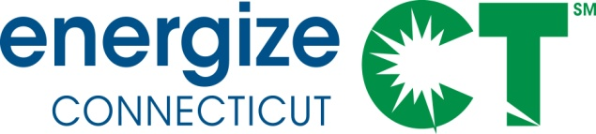

EEB Evaluation Committee Monthly Meeting

Monday April 11, 2016 – 10:00-11:30am

Department of Energy and Environmental Protection – Public Utilities Regulatory Authority, Commissioner's Conference Room, OCC, 10 Franklin Sq., New Britain, CT

Meeting Materials in Box folder: https://app.box.com/s/jr2crjop7rds8b99hou7up4oh4bgdy8o

NOTE: MEETING TO BE FOLLOWED BY RESIDENTIAL TECHNICAL MEETING 11:30-1 OR 1:30 (R4/R31/R46/R152)
Call-In Number: 712/432-1680 Code 624802#
WEBINAR ACCESS: www.join.me/SkumatzEconomics

DRAFT AGENDA

- Public Comment

- Discussion of Notes from previous meeting provided, interim calls, and e-votes. (not Approval of Minutes). Lisa provides notes with votes for information purposes only. 5 min

- Non-Project Updates and Issues: 15 min
  - Review Thursday report and highlights;
    - Schedule of reports to review & upcoming reports – Note also meeting following this one including Technical Presentation of R4+.
    - Review of interim votes and meetings and EEB / DEEP
  - Invoices from SERA – Discussion / votes for Feb / March (potential e-vote)
  - Select dates – NEI workshop (SERA Team) if desired; Remaining Technical meeting some time out – draft just becoming available (R113 Ductless Heat pump impact).
  - New Residential and Commercial Contracts Progress / Update
  - Duva – update on latest DEEP issues

- Discussion of Projects / Status (and data) – see Gantt & Project summaries 60 min
  - Walk-though of Projects / Monthly Status Report – focus on “changes” and status of new projects; update on results of call / meeting on “new” steps for projects
    - Scott’s Projects – focus on Gantt
    - Lori’s Projects – focus on next projects/ memo plus one-pagers / votes
    - Lisa’s Projects – focus on Gantt plus one pagers / votes

- Legislative report discussion 15 min

- Other items –

*** Supporting Materials in Box folder and attached, including:
- Updated Gantt Chart & Project Status Summary  - E-votes / call notes  - Invoices | - One pagers  - Latest Thursday report

