**R1963a Short-Term Residential Lighting Report**

**PUBLIC REVIEW DRAFT**

July 14, 2020

SUBMITTED TO:  
Connecticut Energy Efficiency Board Lisa Skumatz, Ralph Prahl, and Bob Wirtshafter, EEB Evaluation Administrators

SUBMITTED BY:  
Lisa Wilson-Wright and Shirley Pon, NMR Group, Inc.

Ethan Wilkes and Rob Carmichael, Cadeo

[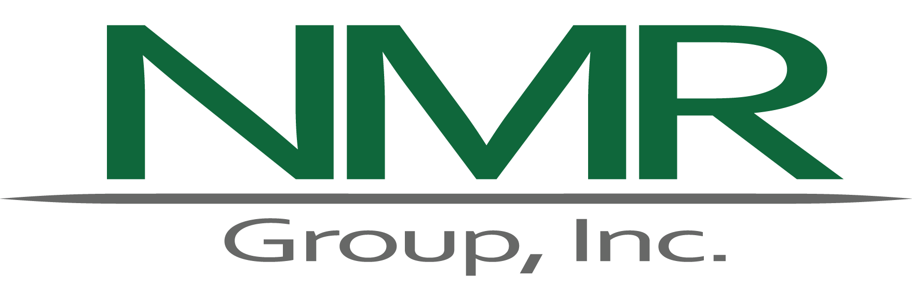](http://www.nmrgroupinc.com)

[INFOGRAPHIC TO BE PREPARED

WHILE DRAFT REPORT UNDER PUBLIC REVIEW]

# Abstract

The *R1963a Short-Term Residential Lighting Study* explored the current state and short-term future of the lighting market in Connecticut and other jurisdictions. The study offers two **recommendations:**

1. The Companies should remove all support for reflector light emitting diode (LED) bulbs in 2021.
2. The Companies should reduce the program resources going into the home improvement channel.

The study also includes **suggestions** touching on the current strategy to increase LED adoption among hard-to-reach consumers and preparing for a future in which lighting ceases to be a substantial part of the residential portfolio of program offerings.

To arrive at these recommendations and suggestion and the following key findings, the study analyzed: (1) program tracking data; (2) lighting sales data; and (3) in-depth interviews with suppliers, stakeholders, and program staff members.

* **LED sales – particularly reflector LEDs – are strong.** LEDs accounted for the majority of overall light bulb sales in Connecticut, other New England states, and even areas of the country lacking upstream lighting programs (non-program areas). In 2019, over 80% of reflector bulbs sold in Connecticut and all other jurisdictions were LEDs. LEDs make up about 50% of A-line, globe, and candelabra bulb sales in Connecticut and non-program areas. The growth in LED sales for globe and candelabra bulbs was particularly strong between 2018 and 2019 in all jurisdictions considered.
* **Program incentives still lift LED sales, but the impact on sales is waning**. The long-term engagement of the Companies in Connecticut’s residential retail market – through incentives, marketing, and education – paved the path for high LED market share. LED market share in Connecticut has mirrored program sales, and LED market share in Connecticut has historically exceeded that of non-program areas. However, LED market shares for all bulb shapes in non-program areas increased dramatically between 2017 and 2019, increasing 108% during that period, compared to 12% in Connecticut.
* **Sales are concentrated among retailers.** Programs have been particularly effective in ensuring that diverse retailers – including independent hardware stores and grocery stores – carry ENERGY STAR qualified LEDs, although program sales remain concentrated in *Big Box* stores, particularly home improvement.

Table of Contents

Abstract 3

Executive Summary 1

Methodology 1

Key Findings 1

Overall Sales Trends 2

Sales by Retail Channels 2

Sales by LED Bulb Shape 4

ENERGY STAR LEDs 5

Brightness 5

Price Trends 5

Recommendations and Considerations 6

Section 1 Introduction 7

1.1 Study Objectives 7

1.2 Report Organization 8

Section 2 Methodology 9

2.1 Program Tracking Data Review 9

2.2 Market Sales Data Analysis 10

2.3 Supplier and Stakeholder Interviews 11

Section 3 Findings 12

3.1 Overall Sales Trends: 2015 to 2019 12

3.1.1 Program Units Sales 12

3.1.2 Market Sales Shares 14

3.2 Program and Market Activity by Retail Channels 18

3.2.1 Diversity of Retail Partners and Program Sales 18

3.2.2 Market Sales Shares by Retail Channels 20

3.3 Sales Share by Bulb Shape 21

3.3.1 Program Sales Shares by Shape 21

3.3.2 Market Sales Shares by Shape 22

3.3.3 Predictions of LED Market Share and Dominance by Shape 24

3.4 ENERGY STAR, Brightness, and Price Trends 26

3.4.1 ENERGY STAR Qualification 27

3.4.2 Brightness: Sales Share by Wattage and Lumens 28

3.4.3 Bulb Price Trends 30

Appendix A Detailed Methodology 33

A.1 Sales Data Modeling Methodology 33

A.1.1 LightTracker Dataset 33

A.1.2 Program Activity 36

Appendix B Additional Findings 37

B.1 Demographic Distribution of Program Sales 37

B.2 Market by Shape and Channel 38

B.3 Supplier Market Share Estimates 38

B.4 Supplier Estimates of Market Dominance 40

B.5 LightTracker A-Line Sales by Lumen Bins 41

Appendix C R1963b Short-term Residential Lighting Results 43

# Executive Summary

This report presents the results from the *R1963a Short-term Residential Lighting* study. The study provided a depiction of current and future lighting program and market-level sales trends and resulted in recommendations for how the Energize Connecticut (Energize CT) upstream lighting program can best adapt in the coming years.

## Methodology

This study included three research tasks.

* **Program tracking data review.** This task involved an examination of the Connecticut Companies’ (Eversource and United Illuminating [UI]) program tracking data to assess program sales by product category and characteristics.
* **Market Sales data modeling.** The sales data modeling effort included an assessment of 2018 and 2019 LightTracker data, obtained from the Consortium for Residential Energy Efficiency Data (CREED),[1],[2] to assess market share in Connecticut, nearby states, nationwide, and in non-program states.
* **Supplier and Stakeholder in-depth interviews (IDIs).** The supplier and stakeholder interviews, conducted jointly with Massachusetts and New Hampshire, consisted of 17 IDIs with suppliers, two IDIs with representatives of lighting or environmental advocacy groups, and three IDIs (with eight individuals) with the Companies’ program staff and implementers.

## Key Findings

* Program sales and savings dropped in 2018 due to budget reductions, but appear to be rebounding with the restoration of funds.
* Stores carrying program bulbs concentrate in areas along key transportation corridors and in zip codes that are collectively home to 92% of the Connecticut population.
* The Connecticut light emitting diode (LED) market shows progress, but not to the extent of neighboring states.
* Program activity in Connecticut and other areas continues to boost LED sales, but the market shows strong progress towards LEDs regardless of program activity.
* The program has successfully diversified the retailers taking part in the program, but has had limited success at boosting sales in the discount, drug, grocery, and small hardware channels.
* Reflector market share and prices suggests that LEDs now serve as the dominant technology for that bulb shape.
* Decorative shapes showed large increases in LED market share between 2018 and 2019.

### Overall Sales Trends

Since 2017, LED bulbs have accounted for 97% or more of the **units sold and savings achieved** by the program, with compact fluorescent lamps (CFLs) and fixtures representing the remaining 3%. Standard LEDs (also known as A-lines and general service lamps; this report uses standard and A-line interchangeably) account for 60% of program sales, and specialty bulbs (reflectors, globes, and candelabras) account for 34% to 39% of program sales. At its height in 2017, the program sold about 6.3 million bulbs and fixtures and saved 180,400,000 kWh. Program sales and savings decreased by 36% from 2017 to 2018 due to program changes stemming from reduced Connecticut Energy Efficiency Fund (CEEF) support. Data for the first three quarters of 2019 signal a partial rebound of program sales and savings.

As reported in LightTracker, **market-level sales of LEDs** in Connecticut have increased from about 16% of all bulb sales in 2016 to 56% in 2019. The 2019 LED sales portion in Connecticut was about the same found in non-program states (i.e., states that do not have upstream retail LEDs programs): 56% in Connecticut compared to 54% in non-program states. Connecticut LED market share fell below those of Massachusetts, New Hampshire, and Rhode Island, which all had market shares of 60% or greater.

**Geographically,** Connecticut **program lighting sales** tended to be grouped around major population centers and interstates (Figure 1). More than three-fifths of the zip codes in Connecticut (180 of 284) – in which 92% of Connecticut residents live – contain stores that sold program offerings between 2017 and 2019. The analysis found no systematic demographic variations where program sales occurred.

### Sales by Retail Channels

The number of **retail stores partnering with the program** has increased over time, from 300 in 2015 to 730 in 2019 (Figure 2). Notably, the number of stores increased 66% in the past two years, which reflects the efforts of the implementation contractor to add new retail partners to the program in part to increase sales among hard-to-reach (HTR) customers (e.g., low-income, primarily non-English speaking, rural). Most program sales have occurred in the home improvement channel, accounting for more than one-half of bulb sales (52%) in 2019, down from a high of 59% in 2016. Sales in membership clubs decreased as a percentage of program units since 2017 – from 21% in 2017 to 14% in 2019. The discount channel gained the largest portion of sales, increasing from a share of 3% in 2016 to 11% in 2017, and remaining relatively steady in 2018 and 2019.

The LightTracker data suggests that **market-level LED sales shares** in discount, dollar, drug, grocery, mass merchandise, and some membership stores (the point-of-sale [POS] channels) lag those of hardware, home improvement, and the remaining membership stores (the non-POS channels). In Connecticut, the 2019 LED market share was 47% in POS channels and 59% in non-POS channels.

Figure 1: Geographic Distribution of Program LEDs, 2017 to 2019

(Source: Program Tracking Data, US Census Data)

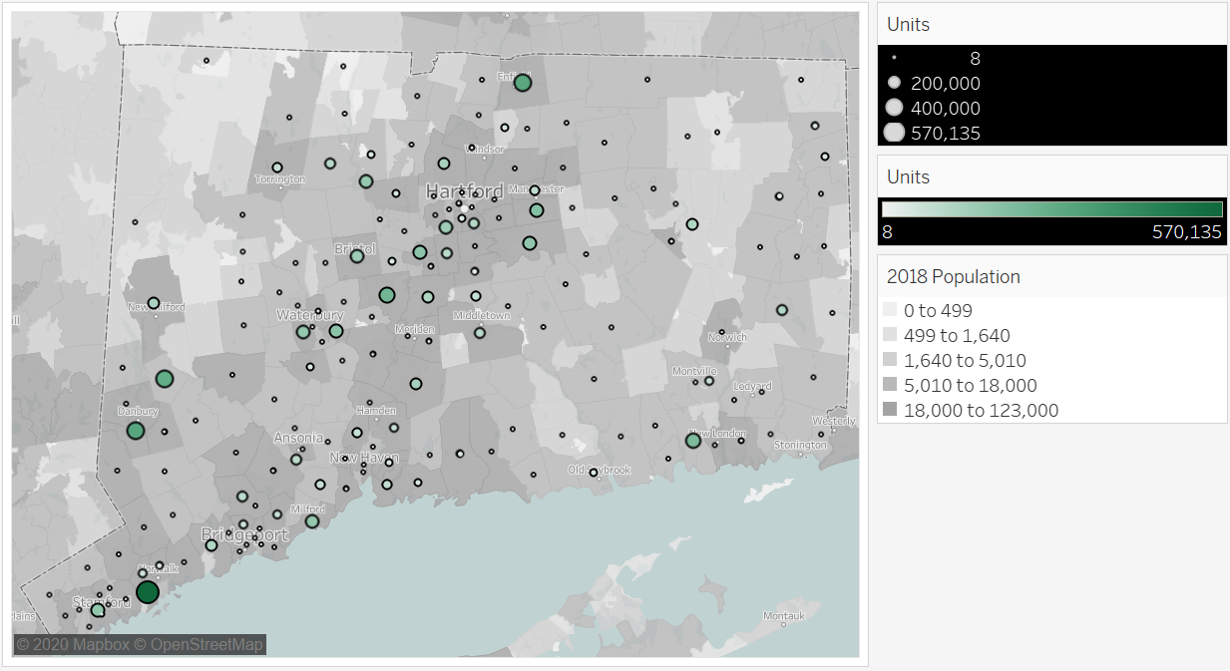

Figure 2: Number of Retail Stores by Channels

(Source: Program Tracking Data)

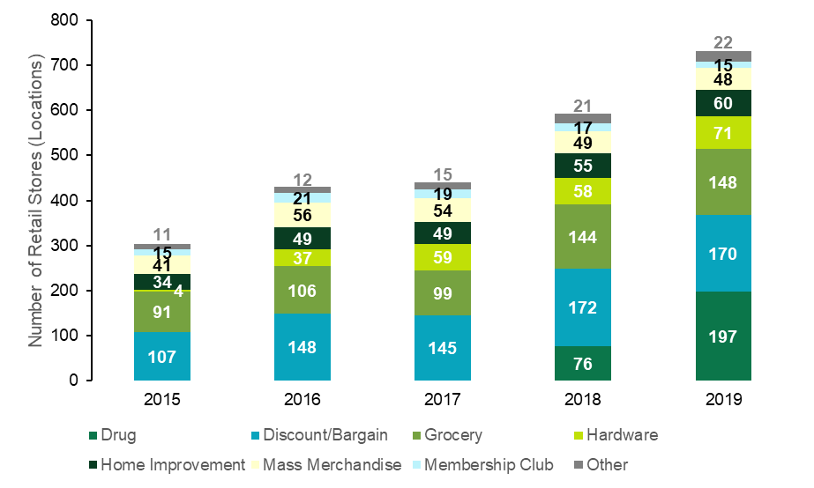

### Sales by LED Bulb Shape

In 2019, standard LEDs accounted for 63% **of program LED sales**, reflectors 18%, decorative 15%, and fixtures 4% (Figure 13). Over time, the share of standard LEDs have remained relatively constant between 2015 and 2019, the decorative bulb share more than doubled, and the shares of reflectors and downlight kits both decreased. Among decorative products, candelabra (flame-shaped) bulbs have garnered the largest program sales share (70% to 79% of decorative sales).

**LightTracker market share** data demonstrates growing LED shares for standard (A-line), reflector, globe, and candelabra bulbs (Figure 3). Reflector bulbs had high market share in Connecticut, the nation, and non-program areas in both 2018 and 2019. Globes and candelabras saw substantial market share increases in the same period. Market share for each bulb shape was higher in non-POS channels than in POS channels (Figure 23).

Figure 3: LED Market Shares by Shape, 2018 to 2019

(Source: LightTracker, All Retail Channels)

Suppliers predicted that the **dominant bulb in the market** for standard lamps would be LEDs in 2023, reflectors in 2025, and globes and candelabras in 2026. Most suppliers believed LEDs would be dominant when they accounted for 50% to 70% of market-level sales. The LightTracker data suggests that reflectors have surpassed the 70% threshold. The other bulb shapes have all reached 50% in Connecticut and nearly that in non-program areas. These results suggests that the Companies should exit the retail lighting market soon, although the exit timing remains uncertain.

### ENERGY STAR LEDs

The Companies only offer ENERGY STAR qualified lighting products in the program, a common practice for program administrators across the nation. According to **suppliers and the implementation contractor**, retailers stock similar numbers of LEDs in program and non-program areas. However, they carry a greater portion of ENERGY STAR qualified LEDs in Connecticut and other states with programs. Program incentives reduce the price of ENERGY STAR qualified models, making them a viable option for price-sensitive customers in program areas; non-ENERGY STAR qualified models serve the same purpose in areas without incentives.

LightTracker data analysis suggests that Connecticut’s **ENERGY STAR LED market share in POS channels** was 84% in 2019 compared to 66% in non-program areas, and about 90% in neighboring Massachusetts, New Hampshire, and Rhode Island. CREED estimates the portion of ENERGY STAR qualified LED sales using criteria that may overstate ENERGY STAR market share, but does this consistently across program and non-program states (Appendix A).

### Brightness

The program supports products with varying levels of brightness. Although the industry measures brightness in lumens, the **program tracking data** only listed wattages. The program sold LED bulbs ranging from less than three Watts to over 15 Watts. Decorative bulbs tended to be lower wattage, while standard and reflectors had the highest wattages. The largest concentration of standard bulb sales fell into the eight to nine wattage range, or a 60W incandescent equivalent bulb. Likewise, the **LightTracker POS-channel data** also indicates that the 750 to 1,049 lumen bin – equivalent to 60W incandescents – has the highest LED sales. In Connecticut, LEDs remain an unpopular choice in the lower (below 750) and highest (above 2,600) lumen bins, offering potential opportunities for program intervention.

### Price Trends

The **LightTracker market-level data** demonstrate that LED prices in both areas with and without programs continue to fall. Recognizing that LightTracker LED prices include program incentives, the average LED in Connecticut cost $2.46 in 2019 compared to $2.68 in non-program states. The price difference between LEDs and halogens in Connecticut was 66 cents in 2019 and $1.20 in non-program states. LightTracker analysis of **prices for** **LEDs by bulb shape for the POS channels** suggests that LED reflector prices in non-program states (meaning they lack incentives) fell below those of halogens in 2019, likely contributing to the high market share for LEDs. For other bulb shapes, LED prices at POS channels exceed those of halogens in non-program states.

## Recommendations and Considerations

The study offers two recommendations based on the results presented above and discussed in greater detail in the main body of the report.

1. The Companies should remove all support for reflector light emitting diode (LED) bulbs in 2021.
2. The Companies should reduce the program resources going into the home improvement channel.

The study also offers the following suggestions for the Companies to consider.

1. The current program strategy to increase LED adoption among of LEDs by HTR customers focuses on increasing the number of program supported LEDs in discount stores, independent hardware and grocery stores, and chain drug and grocery stores. The program has had greater success in diversified its retail partners than in diversifying sales. Therefore, the Companies should consider reviewing their current HTR strategy to determine its effectiveness in increasing LED adoption among HTR customers.
2. As the influence of program incentives on boosting LED market share wanes, the Companies should consider the best strategies for exiting the retail lighting market. They should explore a range of exit strategies, from ceasing program support for all light bulbs and fixtures in all channels at a single time to gradually removing support from products and channels over time in a phased process. Although not addressed in this report, the exit strategy should also consider the role of lighting in residential direct install programs.
3. Regardless of the exit strategy the Companies ultimately adopt, they should prepare for a future in which the residential program portfolio no longer offers residential light bulbs in retail-based or direct-install programs.

# Introduction

This report presents the results from the *R1963a Short-term Residential Lighting* study. The study presented a depiction of current and future lighting program and market-level sales trends and provided recommendations for how the Energize Connecticut (Energize CT) upstream lighting program can best adapt to the changing lighting market in the coming years. A companion study, *R1963b* will include a shelf-stocking study, which is being completed under separate cover.

The lighting market is at a critical juncture, and residential lighting programs, such as those of Energize CT, must decide whether they should continue to support light emitting diodes (LEDs). These programs also seek information to help inform program exit strategies, including how best to capture any remaining potential and reduce potential backsliding to inefficient bulb technologies (*i.e.,* halogens and incandescents).

Two key factors drive the need for this study:

* Some market information suggests the rapid adoption of LEDs[3] in Connecticut, nearby states, and even areas of the nation lacking lighting programs (i.e., non-program areas).
* In late 2019, the Department of Energy (DOE) rescinded an expanded general service lamp (GSL) definition from early 2017[4] and rejected the 45 lumens per watt (Lm/W) backstop of the Energy Independence and Security Act (EISA) that was slated to go into effect in January 2020.[5]

The first factor suggests that it may soon be time for programs to exit the residential retail lighting market. The second factor, however, allows a wide variety of inefficient bulbs to stay on store shelves. Consumers could backslide to these low-price alternative to LEDs if program incentives went away. This study seeks to untangle these two competing factors and provide guidance for the future of residential lighting programs in Connecticut.

## Study Objectives

Through a program tracking data review, a market sales data review, and supplier and stakeholder in-depth interviews (IDIs), the study accomplished several goals:

* Examine program tracking data to assess sales by product category and characteristics.
* Analyze third-party lighting market-level sales data to assess market share in Connecticut, nearby states, the US, and program and non-program states.
* Obtain predicted market share from lighting experts through 2023.
* Explore qualitative product and market trends and factors influencing the lighting market through interviews with lighting experts and document reviews.
* Identify and describe potential indicators of when to exit the market.
* Document program design and exit strategies suggested by lighting experts.

The EEB selected SCS Analytics, LLC (SCS) to conduct a shelf-stocking study and to track developments in federal regulations on residential lighting. [Brief discussion of R1963b will be included in final (just released under separate cover for review).]

## Report Organization

Table 1 outlines the structure of the report.

Table 1: Report Organization

|  |  |
| --- | --- |
| **Section** | **Purpose/Contents** |
| Section 1 | Introduction: Summarizes study goals and objectives |
| Section 2 | Methodology: Describes the data sources and analysis approaches |
| Section 3 | Findings: Presents detailed study findings |
| Appendix A | Detailed Methodology: Includes additional information on study approaches |
| Appendix B | Detailed Results: Includes additional information on study results |
| Appendix C | R1963 Short-term Residential Lighting Results |

# Methodology

This section provides a high-level summary of each research task. Appendix A offers additional methodological details.

## Program Tracking Data Review

The program tracking data analysis examined program sales trends from 2015 to 2019 to provide insight into past and current program performance. The Companies provided data reflecting product markdowns (incentives paid to manufacturers and retailers but passed onto customers as a lower sales price for eligible lighting products). Eversource also provided data generated from coupons that provided a rebate to consumers after they purchased the lighting products. The data encompasses sales from lighting vendors partnering with the program across all retail channels, including grocery stores, home improvement and hardware stores, and discount stores (see Figure 10 for store counts by all channel). The analysis of program shares highlights the trends in different lighting product types, shapes, and wattages (summarized in Table 2). The Companies could not provide lumen data, so the program sales data analysis relied on bulb wattage information as a substitute. Finally, because the data represent the population of program sales, the report does not include sampling statistics such as medians or quartiles.

Table 2: Summary of Program Share Analyses

|  |  |  |
| --- | --- | --- |
| **Type of Analysis** | **Equipment Addressed** | **Time Addressed** |
| Cross-sectional | All | 2018-Sept. 2019 |
| Time-series | All | 2015-Sept.2019 |
| by Technology | All | 2015-Sept.2019 |
| by Type | LED Lamps | 2015-Sept.2019 |
| by Type and Wattage | LED Lamps | 2018-Sept.2019 |
| by Shape | LED Decorative Lamps1 | 2015-Sept.2019 |
| by Retail Channel | All | 2015-Sept. 2019 |
| by Zip Code | All | 2018-Sept. 2019 |
| 1 Decorative lamps include globe and candelabra (flame-shaped) bulbs. | | |

## Market Sales Data Analysis

The market sales data analysis drew on screw-based light bulb sales data compiled by the LightTracker Initiative of the Consortium for Residential Energy Efficiency Data (CREED). [6],[7],[8],[9] The LightTracker data includes sales for four lighting technologies: LEDs, compact fluorescent lamps (CFLs), halogens, and incandescents.

CREED LightTracker sales data comprises two datasets obtained from IRI and Nielsen:

* Point-of-sale (POS) data, representing light bulb purchases scanned at the register for a *subset* of retail channels (see below); and
* National Consumer Panel (NCP) data, reflecting the light bulb purchases across *all* retail channels of households who volunteer for this panel.[10]

CREED combines the POS and NCP data into the full category lighting data (FCD). In doing so, the analysts adjust the data to avoid double counting sales from POS channels. Therefore, the final LightTracker dataset presents three groups of sales data: POS, non-POS, and the FCD. It is important to note that CREED aligns LED sales data with program data in a manner described in Appendix A. The upshot is that the adjustment may overstate LED market share as CREED only adjusts LED sales. Massachusetts and Rhode Island are among the states – and sometimes the only states – for which CREED makes this adjustment. The report presents critical results adjusted and unadjusted for these two states, and points out when the adjustment may affect comparisons across jurisdictions.

Table 3 provides a summary of the three groups of LightTracker data, including the retail channels each group covers, the percentage of the Connecticut market captured by those channels, and the market indicators available and of interest to this study. Most of the results describe the population of sales in a state, group of states, or the nation, so the report only presents sampling statistics for the analysis of LED market share by program spending.

Table 3: Summary of LightTracker Dataset

|  |  |  |  |
| --- | --- | --- | --- |
| **Data Group** | **Channels** | **% of CT Market** | **Indicators Analyzed** |
| POS | * Discount * Dollar * Drug * Grocery * Mass merchandise * Some membership | 31% | Market share:   * For All Screw-based bulbs * By Shape * ENERGY STAR qualification * By Lumen bins (A-line only)   Shelf price by shape |
| Non-POS | * Hardware * Home improvement * Remaining membership | 69% | Market share:   * For All Screw-based Bulbs * By Shape |
| FCD | * All of the above | 100% | Market share:   * For All Screw-based Bulbs * By Shape   Shelf price for All Screw-based Bulbs |

## Supplier and Stakeholder Interviews

The study methods included phone IDIs conducted from January to March 2020 with 14 manufacturers and three retailers, collectively referred to as *suppliers* in this report. These companies manufactured or sold lighting products that received upstream incentives from programs in Connecticut, Massachusetts, and/or New Hampshire in 2019. The study also included IDIs with a representative of an energy-efficiency advocacy organization and a consumer advocacy organization; both organizations had submitted comments on draft rulemakings on federal lighting standards.[11] The sample design was based on program sales in Massachusetts. The lighting suppliers accounted for 67% of total program sales for the first ten months of 2019 for that state. For Connecticut, program staff members at Eversource and UI, as well as their implementation contractor TRC (formerly Lockheed Martin), took part in IDIs. The report uses the term *suppliers* for responses from manufacturers and retailers and the term *stakeholders* for responses that also include advocacy groups, program staff, and implementation contractor staff.

The sample size reported for each analysis varies because some interviewees only answered certain questions. Likewise, four of the suppliers almost exclusively manufacture or sell LEDs. Because the LED focus could influence their knowledge of the market, some of the analyses refer to LED-focused suppliers and to mixed lighting suppliers (those who make or carry more than LEDs). The study presents unweighted results for all analyses due to the lack of adequate population data on market-level sales. See Appendix A for more details.

# Findings

This section presents the study findings. Additional details can be found in Appendix B.

## Overall Sales Trends: 2015 to 2019

* **Program Sales:** Since 2017, the program has primarily provided incentives on screw-based LED bulbs. While the number of units sold has varied, the mix of products has remained relatively stable.
* **Market Share:** Market-level sales data for Connecticut and other areas indicate rapid increases in the sales of LEDs. LED market share in Connecticut is similar to areas in the nation without programs and is behind that of neighboring states.

### Program Units Sales

Program sales reached a high of 6.3 million units in 2017, but decreased to about 4 million units in 2018. Program sales rebounded somewhat in the first three quarters of 2019.

Figure 4 shows total program units and savings by year, which are grouped into two categories for comparability: (1) the first three quarters and (2) the last quarter of each year. They are grouped this way because the data request for 2019 only included sales through September of that year. On average, UI supported about 885,000 units and Eversource supported about 3.6 million units annually. Program unit sales and savings decreased by 36% between 2017 and 2018, driven largely by program changes in response to state-induced budget cuts.[12] Through September 2019, program quantities were 45% higher than they were at the same time in 2018, but still 21% lower than January-September 2017.

Figure 4: Total Program Units and Savings

(Source: Program Tracking Data)



Standard LEDs account for most program units. The mix of standard and specialty bulbs has remained consistent since 2017.

Figure 5 highlights program unit shares by technology and equipment type. Standard LED lamps composed 59% of program units in January-September 2019, which is similar to the percentages in 2017 and 2018. Other LED bulbs (downlight kits, reflectors, and decorative bulbs) accounted for 39% of program units in 2019. LED fixtures made up the remaining 2% of program units. Despite changes in the volume of units, the proportion of sales by product type has been consistent since 2017. In that year, most CFLs lost ENERGY STAR qualification with a new specification change. Between 2015 and 2017, CFLs decreased in share from 43% of program units to a negligible number. Program savings shares (not shown) were similar in composition to program units.

Figure 5: Program Share by Technology

(Source: Program Tracking Data)



Although program sales are distributed throughout the state more sales occur around major metropolitan areas.

Figure 6 shows the distribution of program units in Connecticut by population. The size and color of the dots reflect the number of program units sold in each zip code. The figure shows zip code boundaries. Zip codes are colored based on population – darker zip codes are more populated.

Program sales tend to be grouped around the major population centers (in the center and southeast portions of the state) and interstates of Connecticut (I-84 running east and west, I-91 running north and south, and I-95 running along the coast). Generally, there are more, and darker, dots surrounding major metropolitan areas. Program sales occurred in 180 out of 284 zip codes in Connecticut, representing about 92% of the total population of Connecticut. The largest area that lacks program activity is the rural northwest corner of the state, but the eastern side of the state also has relatively few sales. The analysis showed no correlation between zip-code level program units and income, non-white percentage of total population, or Black percentage of total population. Appendix B presents a map of sales by income as an example.

Figure 6: Distribution of Program Units by Zip Code Population

(Source: Program Tracking Data, US Census Data)



### Market Sales Shares

LEDs make up the majority of light bulb sales in Connecticut, non-program areas, and all other areas examined in this study. However, Connecticut LED market share falls below that of neighboring areas.

The LightTracker market sales data suggests that the 2019 LED market share in Connecticut was 56%, slightly above the share for non-program states (54%) and below the share for New Hampshire (60%)(Figure 7). LEDs account for at least two-thirds of light bulbs sold in Massachusetts and Rhode Island – more with the CREED adjustment for program sales in place (see Appendix A). The implementation contractor noted that both Connecticut and New Hampshire have smaller budgets compared to Massachusetts and Rhode Island. This limits the depth of discounts suppliers can offer and the number of suppliers and channels that partner with the program. Suppliers will decline to participate if they cannot offer ENERGY STAR qualified LED products at a price point that is competitive with non-ENERGY STAR LEDs or inefficient bulb technologies.

Figure 7: 2019 LED Market Share by Study Area1,2

(Source: LightTracker, All Retail Channels)

1 CREED adjusts LED shares in program states if LightTracker estimated market sales volumes fall short of program sales. They made this adjustment for Massachusetts in 2017, 2018, and 2019 and in Rhode Island in 2017 and 2019. See Appendix A for more details.

2 The analysis groups sales volumes across the ten non-program states and 35 program states, treating them as a single population. Therefore, reporting the median, minimum, and maximum is not appropriate.

LED market share in Connecticut fell in 2018, coinciding with reduced program sales stemming from state-induced budget cuts. Connecticut’s LED market share rebounded in 2019, corresponding with the reinstatement of program funds.

Figure 8 presents market share for Connecticut, neighboring states, and non-program states from 2015 to 2019. The data show an increase in LED market share across areas, but Connecticut’s LED market share dipped from 50% in 2017 to 42% in 2018, when the program had to reduce sales due to budget cuts.[13] Connecticut consumers opted for halogens in 2018 at higher shares than in any other year. This finding supports the argument that program incentives still boosted sales as of 2018 and that reducing incentives may lead to backsliding. Yet, the market data show progress beyond program sales. Although Connecticut’s 2019 program sales had not fully recovered to 2017 levels (Figure 4), Connecticut’s 2019 LED market share (56%) exceeded 2017 (50%). Likewise, non-program areas showed rapid increases in LED market share – from 26% in 2017 to 54% in 2019. The Massachusetts and Rhode Island in Figure 8 include the CREED adjustment for program sales, so the results may overstate the LED shares in those two states.

Market share in 2019 was generally higher in states with moderate and high levels of lighting program funding.

Connecticut’s LED market share ranked lowest among the program states spending $5 or more per home on upstream lighting programs (Figure 9). Rhode Island and Massachusetts had among the highest LED market share, with or without the CREED adjustment for program sales. New Hampshire’s LED market share fell near the average across all reporting states. Seven of the ten non-program states had market shares that fell below those of Connecticut. Note that State 20 used to have programs but no longer offers them.

Figure 8: Market Share by Bulb Technology, 2015 to 20191

(Source: LightTracker, All Retail Channels)

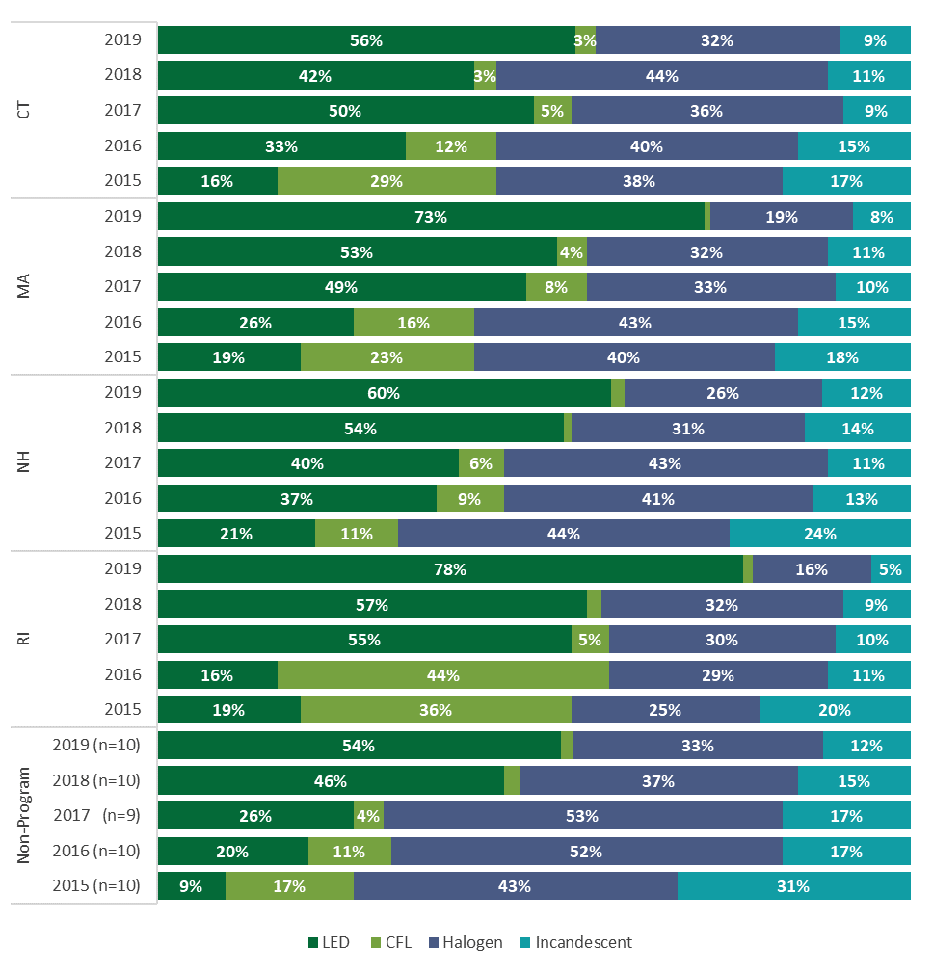

1 Massachusetts sales in 2017, 2018, and 2019 and Rhode Island sales in 2017 and 2019 may be overstated due to the CREED adjustment for program sales.

Figure 9: LED Market Share by Level of Program Spending, 2019

(Source: LightTracker, All Retail Channels)

1 Without the CREED adjustment for program sales, Massachusetts and Rhode Island would fall between states 7 and 8.

## Program and Market Activity by Retail Channels

* **Diversity of Retail Partners:** The program has increased the number and diversity of partnering stores, but home improvement still dominates program sales.
* **LED market share by Channel:** Home improvement and hardware stores sell a higher proportion of LEDs than discount, dollar, drug, grocery, mass merchandise, and membership stores.

### Diversity of Retail Partners and Program Sales

The number and diversity of retail stores partnering with the program increased substantially in the past two years. Program sales saw smaller shifts by channel.

According to staff members at both the Companies and the implementation contractor, one of the most critical changes for the 2019 to 2021 program cycle has been a concerted effort to diversify the geographic location and customer base of stores selling program supported products. This study analyzed program data to examine the success of this diversification effort. Specifically, the program directive was to diversify into both rural and urban markets and to reach more low-income, non-English speaking, and other hard to reach (HTR) populations. The program implementer has operationalized this plan by increasing the number of independent stores and franchises (e.g., hardware stores), grocery chains, discount stores, and small grocery and convenience stores selling program-supported products. According to one program staff member, this effort has been successful, explaining that the percentage of stores in the HTR category increased from 8% to 25% and program sales in these stores increased from 5% to about 12% or 14%.

Examination of the program data supports the staff member’s claim. Since the current implementer took over the program in 2018, the number of stores partnering with the program has increased 66%, rising even in 2018 as program sales fell due to the reduced budget (Figure 10). The implementer brought drug stores into the program and greatly increased the number of grocers by adding stores located in low-income neighborhoods or that target specific linguistic groups. Likewise, the implementer expanded grocery and hardware stores located in small towns. Collectively, the portion of drug, discount, grocery, and hardware stores increased from 70% of program stores to 81% of program stores.

Sales also diversified (Figure 11), although not to the same degree as retail locations. In fact, the *other* category in Figure 11 includes drug, grocery, and hardware stores because their sales portions were too small to call out on the graph individually. While home improvement stores still dominate sales, the portion in that channel was 52% in 2019, down from a high of 59% in 2016. In contrast, the discount channel (typically bargain stores and dollar stores) gained the largest portion of sales, increasing from a share of 3% in 2016 to 11% in 2017 and remaining relatively steady in 2018 and 2019. Sales in the *other* category, which includes many of the newly added stores, increased by 2% since 2017. The discrepancy between the great success at diversifying the retail partners but limited success in diversifying sales raises question about the adequacy of the program strategy designed to increase LED adoption among HTR customers.

Figure 10: Number of Retail Stores by Channel, 2015 to 2019

(Source: Program Tracking Data)

Figure 11: Sales by Retail Channels, 2015 to 2019

(Source: Program Tracking Data) 

1 Other includes drug, grocery, hardware, festivals, and lighting specialty stores. In 2019, the sales were 1%, 3%, 2%, 2%, and 2%, respectively (with some slight rounding error).

There are likely several reasons that sales by channel have not shifted as dramatically as the number of retailers, but the implementation contractor and suppliers cite sales volume and purchasing power as critical factors. As they explain it, Big Box stores thrive on large sales volumes. Their purchasing power allows them to negotiate lower prices with their suppliers, which, in turn, show up as lower shelf prices before the application of any incentives. Smaller retailers – even in large hardware, grocery, or drug chains – lack this purchasing power, so the pre-incentive shelf price remains higher than at their Big Box competitors. To bring an LED to a competitive price point, these smaller stores need to apply a deeper discount. Current program funding levels limit the discounts they can offer. This has two critical effects: First, the smaller retailers offer fewer products through the program because they cannot get the price point down to one that justifies carrying them on their shelves. Second, even with discounts, the prices of the products they do carry may remain too high for consumers to buy in large volumes. The fact that sales by channel have not shifted as dramatically as the number of retailers likely has numerous sources, but the implementation contractor and suppliers cite sales volume and purchasing power as critical. As they explain it, Big Box stores thrive on large sales volumes. Their purchasing power allows them to negotiate lower prices with their suppliers, which, in turn show up as lower shelf prices before the application of any incentives. Smaller retailers – even in large hardware, grocery, or drug chains – lack this purchasing power, so the pre-incentive shelf price remains higher than at their Big Box competitors. To bring an LED to a competitive price point, these smaller stores need to apply a deeper discount. Current program funding levels limit the discounts they can offer. This has two critical effects: first, the smaller retailers offer fewer products through the program because they cannot get the price point down to one that justifies carrying them on their shelves. Second, even with discounts, the prices of the products they do carry may remain too high for consumers to buy in large volumes.

Consumers shopping behavior also factors into the challenges of moving more program supported products through smaller retailers. Consumers have become accustomed to shopping at Big Box stores. Placing LEDs in a low-income or rural neighborhood certainly increases the likelihood of the purchase by a HTR customer, but those same HTR customers also likely shop for light bulbs and other products at Big Box Stores.

### Market Sales Shares by Retail Channels

LED market share was higher in home improvement and hardware stores than in other retail channels.

Similar to program sales, LED market share also varies by retail channel (Figure 12). As described above (Section 2.2), LightTracker is able to organize sales by two broad categories of retailers, with the most critical distinction being that POS channels excludes home improvement and hardware stores, while non-POS is primarily home improvement and hardware stores. In Connecticut, non-POS LED share is about 12% higher than POS LED sales shares. In all other areas examined, the difference exceeds 20%. Consumer shopping patterns, sales volumes, and the non-POS focus on home products largely explain these differences. Likewise, home improvement stores have embraced LEDs, stocking them in the most desirable locations, such as the middle shelves (Section 3.4 also addresses stocking).

Figure 12: LED Market Share by LightTracker Channels

(Source: LightTracker, By POS and non-POS)

## Sales Share by Bulb Shape

* **Program Sales by Shape:** Standard (A-line) bulbs accounted for just under two-thirds of program sales, with reflectors and decorative bulbs (globes and candelabras) making up most of the remainder. The program also sold a few downlight reflector kits.
* **Market Share by Shape:** Four out of five reflectors sold in Connecticut and non-program areas in 2019 were LEDs. In contrast, about one-half of standard, globes, and candelabras were LEDs.
* **When will LEDs be the Dominate Bulb Type**: Suppliers predicted that LED would become the dominant bulb technology in 2023, but LEDs would not become dominate until 2025 or later. Most suppliers felt dominance would occur when LED market share reached 50% to 70%, suggesting that reflectors may have achieved this status.

### Program Sales Shares by Shape

The program has offered a fairly consistent product mix since 2015, with standard A-line bulbs making up about 60% of sales and reflectors making up about 20% of sales.

The mix of decorative and downlight bulbs (mostly retrofit kits) changed when CFLs exited the market in 2017. At that time, downlight program share decreased to about 5% and decorative increased first to 9% and then to about 15% of program sales. Notably, LEDs tend to perform better in decorative applications because they have superior light quality, color rendition, and aesthetics compared to CFLs. This LED characteristic likely contributed to the greater decorative representation in the post-CFL program. Among decorative products, candelabra (flame-shaped) bulbs have garnered the largest program sales share (70% to 79% of decorative sales).

Figure 13: Program Sales by Shape, 2015 to 2019  
(Source: Program Tracking Data)



### Market Sales Shares by Shape

LED made up 80% or more of reflector sales and accounted for about one-half or more of 2019 bulbs sales by shape in Connecticut, non-program states, and the entire nation. Market share for globes and candelabras increased substantially between 2018 and 2019.

Figure 14 presents market share by bulb shape for Connecticut, non-program states, and the nation for all retail channels. Figure 23 in Appendix B also presents data for neighboring states broken out by POS and non-POS channels. The data indicate reflector share – already high in 2018 – continued to increase in 2019; at least four out of five reflectors sold in Connecticut and other areas are LEDs. Market share for globe and candelabra LEDs also increased substantially in 2019, more than doubling for candelabras. The popularity of filament style decorative bulbs likely contributed to the increased share of these bulb shapes. In contrast, while A-line LED market share also continued to increase, the growth was slower than for the other bulb shapes. Of course, A-line bulbs make up 78% of bulb sales in Connecticut and 75% of LED sales, so, despite slower growth, A-lines sales volumes remained high.

Halogens served as the most common alternative to LEDs for A-line bulbs, but incandescents were the most common alternative for globes and, especially, candelabras.

In both Connecticut (40%) and non-program states (42%), halogens made up nearly every non-LED A-line purchase, fewer globe non-LED globe purchases (14% in Connecticut and 19% in non-program states), and almost no non-LED candelabra purchases. Non-LED reflectors split almost evenly between incandescents and halogens.

Figure 14: LED Market Shares by Shape, 2018 to 2019

(Source: LightTracker, All Retail Channels)

Figure 15: LED Market Shares by Shape, 2018 to 2019

(Source: LightTracker, All Retail Channels)

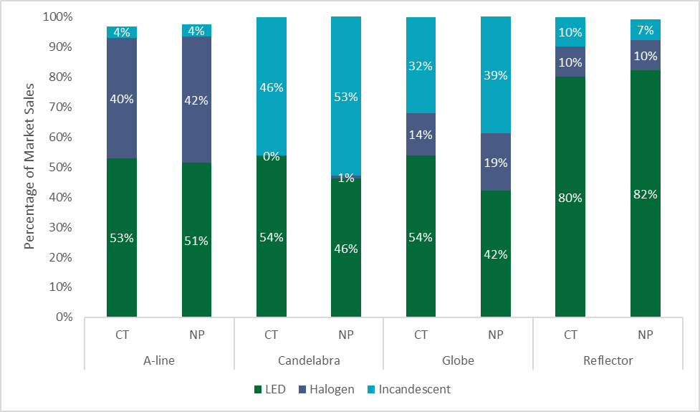

### Predictions of LED Market Share and Dominance by Shape

Suppliers predict moderate increases between 2019 and 2023 in LED market share in Connecticut and other areas across all bulb shapes.

Suppliers taking part in the IDI effort – some of whom primarily manufacturer LEDs – estimated that their companies’ LED 2019 market shares for A-line and reflector LEDs were about 90% in Connecticut and Massachusetts, 85% in New Hampshire, and 72% in non-program areas (Figure 16). They placed their companies’ 2019 combined LED market shares for decorative bulbs (globes and candelabras) market shares at 87% in Connecticut, 91% in Massachusetts, 79% in New Hampshire, and 66% in non-program areas. All of these shares are higher than LightTracker estimates (Figure 14) for 2019, which is most likely due to question wording that forced LED-focused suppliers to place their shares at 100% (Appendix A). Suppliers predicted modest increases in their companies’ market shares for all shapes and areas.[14] Predicted increases in non-program areas mirrored those for Connecticut and New Hampshire. Although most suppliers placed market share similarly for the three states, the two giving lower responses for New Hampshire cited the relatively young age of that state’s lighting program.

Figure 16: LED Market Share Estimate (2019) and Predictions (2021, 2023)

(Source: Supplier Interviews)

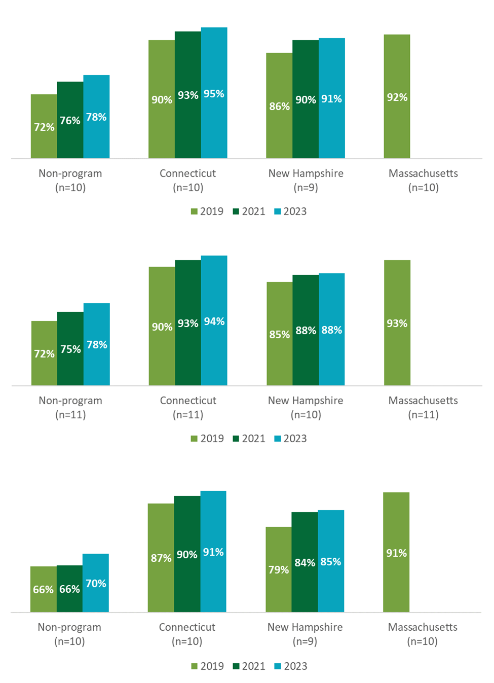

Suppliers predicted that LEDs would be the dominant bulb technology for standard A-lines in 2023, reflectors in 2025, and decorative bulbs in 2026. Most defined dominance as a specific threshold of market share, but others cited consumer recognition, shelf space, socket penetration, and price parity.

Figure 17 shows the timeline for supplier estimates for the year LEDs will become the dominant technology by lamp type.[15] Although these dates seem to run counter to the market share estimates described above, the dominance projections reflect perspectives on the entire market, while the market share estimates were specific to each respondent’s company. Appendix B includes more details on these predictions.

Figure 17: Predicted Year of LED Dominance

(Source: Supplier Interviews, n=11)

The definitions of dominance included the following (some respondents gave multiple answers):

* A minimum market share threshold is met (62%), typically between 50% and 70% (with 90% as an outlier)
* Consumer recognition and preference of LEDs (17%)
* Holds majority shelf space and product variety (11%)
* A minimum socket penetration threshold is met (6%)
* Price parity (or close to it) (6%)

## ENERGY STAR, Brightness, and Price Trends

* **ENERGY STAR Qualified LEDs:** Suppliers assert – and the LightTracker data support – that retailers stock and consumers buy more ENERGY STAR qualified LEDs in places with programs, as programs usually only support ENERGY STAR bulbs.
* **Brightness:** Program and market-level sales were highest in lumen bins (lumens are a measure of brightness) most closely associated with a 60W incandescent bulb. Sixty-eight percent of 60W equivalent A-line bulbs sold in Connecticut were LEDs compared to 62% in non-program areas. Connecticut also sold a larger share of LEDs in the 40W and 75W equivalent lumen bins.
* **Price Trends**: The price difference between LEDs and halogens in non-program states was $1.20 in 2019, but incentives in Connecticut and some neighboring states reduced that differences to 66 cents or less. Within the POS channels, prices for LED reflector bulbs fell below those of halogen reflectors in non-program states.

### ENERGY STAR Qualification

Suppliers assert that retailers across the nation generally stock similar numbers of LEDs, but program incentives increase the portion of LEDs qualified for the ENERGY STAR label. The LightTracker data suggest the same is true of LED sales.

Suppliers explain that, in program areas, ENERGY STAR qualified LEDs not only get more shelf space than their non-qualified counterparts, but ENERGY STAR models also enjoy coveted off-shelf placement, such as on end caps. Such off-shelf placement encourages impulse purchases and boosts market share. Non-ENERGY STAR models rarely get placed off-shelf, even in non-program areas.

Keeping in mind that CREED’s designation approach may overstate ENERGY STAR market share (see Appendix A), Figure 18 suggests two things: (1) market share for ENERGY STAR qualified LEDs in POS channels is higher in program areas, including Connecticut, and (2) market share for ENERGY STAR qualified LEDs in the POS channels has increased in all areas, including non-programs ones. The ENERGY STAR data are not subject to CREED’s adjustment for program sales in Massachusetts and Rhode Island.

Importantly, ENERGY STAR qualification does not affect first year energy savings, as both qualified and non-qualified models claim similar lumens per watt. However, ENERGY STAR qualified models also have to meet certain criteria about omnidirectionality. Manufacturers explain that they generally produce ENERGY STAR models to have superior measure lives, color rendition, and light quality. In contrast, they produce non-ENERGY STAR qualified models for price sensitive consumers, but remove some of the features of ENERGY STAR to keep those prices low.

Figure 18: ENERGY STAR Qualified LED Market Share

(Source: LightTracker, POS Channels only)

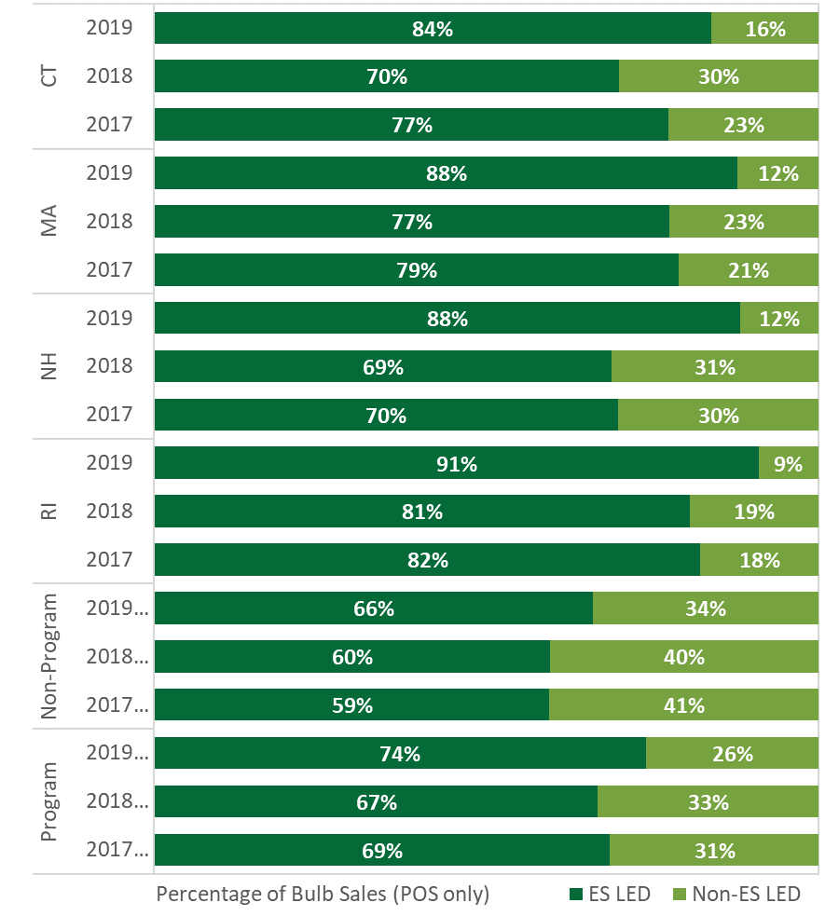

### Brightness: Sales Share by Wattage and Lumens

As expected, decorative lamps are primarily lower wattage compared with other lamp types. A-line lamps and reflectors have a wider distribution of wattages than decorative lamps and downlights.

Table 4 shows wattage distributions of program supported LEDs between 2015 and 2019 by bulb shape. The darker the shade of green, the greater the number of sales in that wattage, per shape. Decorative LED bulbs were primarily lower wattage – about 90% of decorative LED bulb sold through the program were between 3 and 6 watts (approximately a 40W incandescent equivalent). A-line bulbs had a wider distribution of wattages compared to other lamp types, although about two-thirds fell between 7 and 10 watts (approximately a 60W incandescent equivalent). Reflectors also display a wide distribution of wattages,

Table 4: LED Lamp Types by Wattage

(Source: Program Tracking Data)

|  |  |  |  |  |  |
| --- | --- | --- | --- | --- | --- |
| **Wattage** | **Incandescent Equivalent1** | **Decorative** | **A-Line** | **Downlights** | **Reflectors** |
| Three or Less | <40 | 9% | 0% | 0% | 0% |
| 3 to 4 | 40 | 44% | 0% | 1% | 1% |
| 4 to 5 | 40 | 25% | 4% | 0% | 0% |
| 5 to 6 | 40 | 20% | 6% | 0% | 1% |
| 6 to 7 | 60 | 2% | 6% | 2% | 9% |
| 7 to 8 | 60 | 0% | 13% | 1% | 10% |
| 8 to 9 | 60 | 0% | 36% | 49% | 19% |
| 9 to 10 | 60 | 0% | 18% | 29% | 24% |
| 10 to 12 | 75 | 0% | 4% | 16% | 15% |
| 12 to 15 | 75 | 0% | 7% | 2% | 17% |
| Greater than 15 | 100 or more | 0% | 6% | 0% | 4% |
| 1 Approximate for A-line, as wattage equivalence varies by shape, intended applications, and manufacturer | | | | | |

Market share of A-line LEDs in both Connecticut (68%) and non-program states (62%) was highest in the 750 to 1,049 lumen bin, equivalent to a 60W incandescent.

The 60W equivalent lumen bin accounted for 52% percent of market level A-line sales in Connecticut in 2019, and more than two-thirds of those were LEDs (Figure 19). While the 60W equivalent lumen bin accounted for only 43% of A-line sales in non-program areas, three out of five were LEDs.[16] Connecticut saw higher A-line LED market shares in the 40W and 75W equivalent lumen bins, which are also relatively high sales volume bins. Non-program areas demonstrate higher   
A-line LED market share in low volume bins, but this could reflect measurement error exacerbated by the small numbers of bulbs in these categories. Notably, incandescent bulbs exclusively serve as the alternative to LEDs in the very lowest and highest lumen bins, which are not subject to current federal efficiency standards put in place in the early 2010s.

Figure 19: A-line Market Share by Lumen Bin

(Source: LightTracker, POS Channels only)

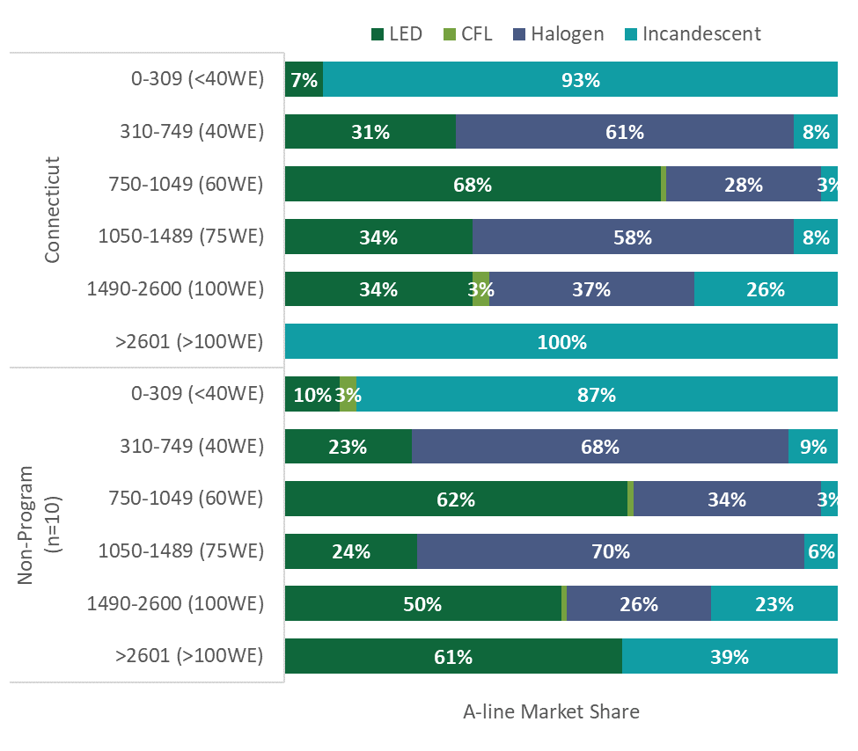

### Bulb Price Trends

LED prices in 2019 fell 66 cents of halogen prices in Connecticut, while the price difference in non-program states was $1.20. The average final shelf price of LEDs in Connecticut was $2.46 compared to $2.68 in non-program areas.

Average LED prices have fallen by at least $2 in Connecticut, neighboring states, and non-program areas between 2015 and 2019, while halogen prices have remained stable over the same time period. LED prices also appear to be stabilizing (Figure 20). [17] Notably, the LED prices are inclusive of ENERGY STAR and non-ENERGY STAR qualified models and include the application of program incentives in the program states. [18] Therefore, without program incentives, the prices for the LEDs sold in 2019 in program areas would be higher than observed in the data. The CREED adjustment for program sales does not impact price trends in Massachusetts and Rhode Island.

Figure 20: Market-level LED Price Trends

(Source: LightTracker, All Retail Channels)

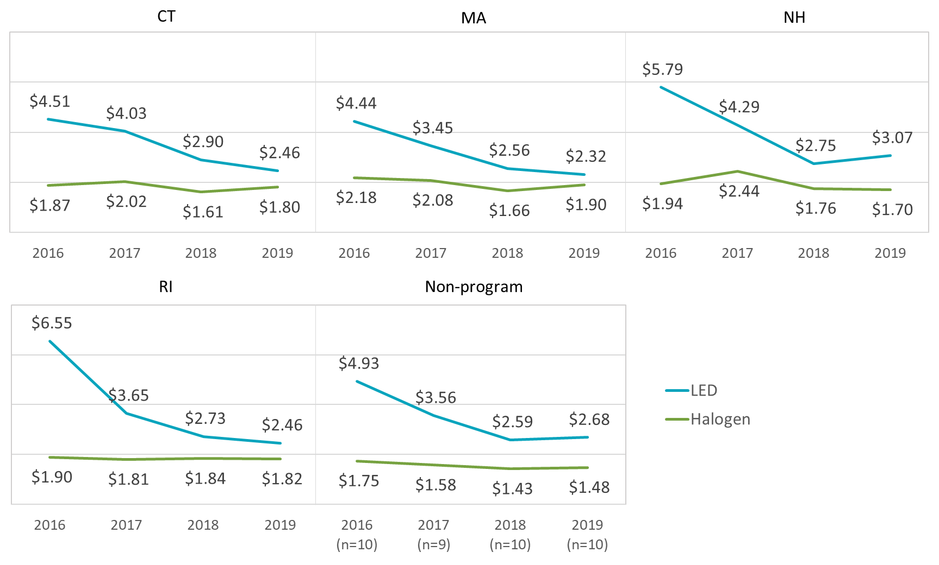

In non-program states, prices for reflector LEDs in the POS channels fell below those of halogen reflectors, likely contributing to high market share for this bulb shape.

Looking only at prices in non-program states, which do not have program incentives, the average price of an LED reflector was $3.99 compared to $4.63 for halogens and $3.18 for incandescents (Figure 21). Only reflectors showed lower LED prices across shapes. A-line and globe LED prices were about $1.00 more than halogens and candelabras about 50 cents higher.

Figure 21: Non-Program Area Bulb Prices by Shape and Technology

(Source: LightTracker, POS Channels only)

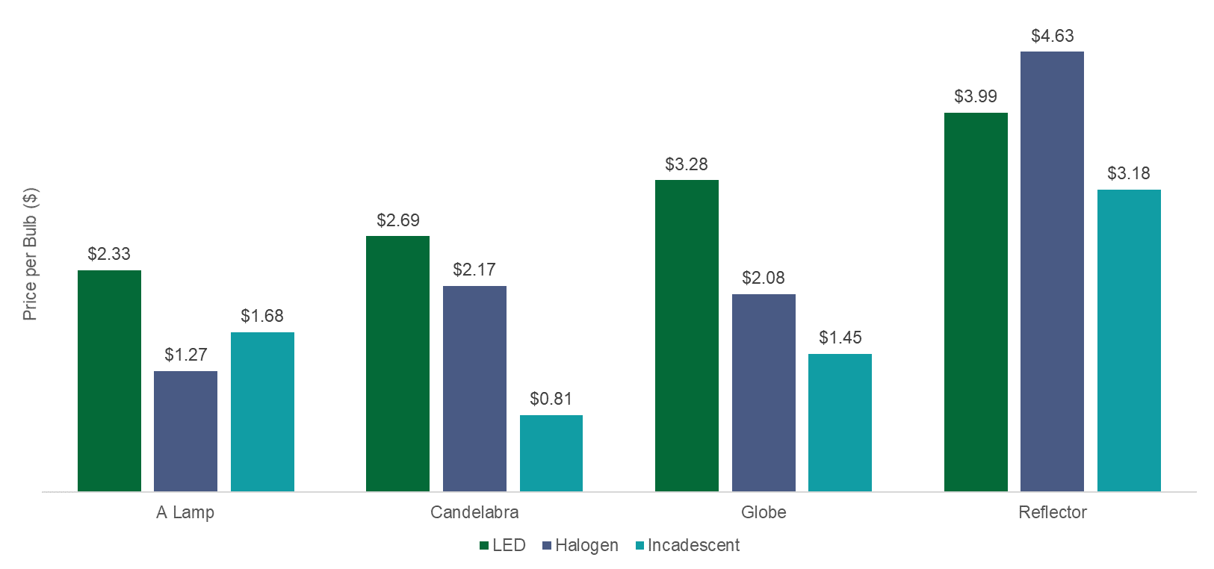

1. Detailed Methodology
   1. Sales Data Modeling Methodology

This section provides additional detail on the CREED LightTracker data and the process of determining a state’s level of program activity.

* + 1. LightTracker Dataset

The LightTracker Initiative represents a dataset compiled by CREED. These data fill a gap in the availability of market-level lighting sales data. While many program partners readily share program sales data, they are reluctant to share non-program sales data. Non-program retailers and manufacturers also rarely share sales data with PAs or evaluators. The LightTracker Initiative pools the resources of multiple PAs to make a new source of market level information available. CREED offers estimates of market-level sales for all retail channels and most states. LightTracker provides data for 45 of the 50 US States. Table 5 lists the 2019 program status for the 50 states. Note that in 2020, Delaware and Virginia instituted programs, while California has removed them since the state implemented EISA 2020 with the backstop provision and the expanded definition of a GSL.

Though the dataset CREED received included detailed records of lighting data purchases, the data required a considerable effort to ensure data integrity and inclusion of all the necessary bulb attributes. For example, some records did not have critical variables populated, such as bulb type, shape, or wattage. In addition, some records had clearly erroneous values (e.g., 60-watt LEDs). After thorough review and quality control of the dataset, CREED re-classified and standardized the data. CREED also populated missing records, created additional variables, and performed general enhancements to the data. To populate missing records, validate existing records, and include additional bulb attributes, CREED created a proprietary Universal Product Code (UPC) database with approximately 36,000 bulbs from the following five sources:

* Manufacturer product databases provided to LightTracker
* Product catalogs downloaded from manufacturer web sites via web scraping
* Product offerings downloaded from retailer web sites
* Automated lookups of online UPC databases, such as [www.upcitemdb.com](http://www.upcitemdb.com)
* ENERGY STAR databases available online at <https://www.energystar.gov/productfinder/product/certified-light-bulbs>

Table 5: Program Strength and Data Quality Confidence

|  |  |  |
| --- | --- | --- |
| **Program States** | **Non-program States** | **Unable to Categorize/ Excluded from LightTracker1** |
| Arizona | Alabama | Alaska |
| Arkansas | Delaware | Hawaii |
| California | Kansas | Iowa2 |
| Colorado | Kentucky | Montana |
| Connecticut | Mississippi | North Dakota |
| Florida | Nebraska |  |
| Georgia | Nevada |  |
| Idaho | Tennessee |  |
| Illinois | Virginia |  |
| Indiana | Wyoming |  |
| Louisiana |  |  |
| Maine |  |  |
| Maryland |  |  |
| Massachusetts |  |  |
| Michigan |  |  |
| Minnesota |  |  |
| Missouri |  |  |
| New Hampshire |  |  |
| New Jersey |  |  |
| New Mexico |  |  |
| New York |  |  |
| North Carolina |  |  |
| Ohio |  |  |
| Oklahoma |  |  |
| Oregon |  |  |
| Pennsylvania |  |  |
| Rhode Island |  |  |
| South Carolina |  |  |
| South Dakota |  |  |
| Texas |  |  |
| Utah |  |  |
| Vermont |  |  |
| Washington |  |  |
| West Virginia |  |  |
| Wisconsin |  |  |

1 LightTracker was unable to assign program status to these states or the states lacked sales data or LightTracker.

2 CREED was able to obtain program data for Iowa, but the state’s representation in the POS and NCP data used to create the LightTracker dataset is too small to allow for estimation of bulb sales and market share.

CREED then merged the bulb database with the POS/Panel data, populating fields based on a hierarchy of data sources believed to be most reliable. Prioritization was typically in the following order: manufacturer specifications, UPC lookups, and original data provider (IRI and Nielsen) database values. CREED analysts also conducted manual web lookups on individual bulbs to determine final assignments.

In addition, CREED investigated the bulb assignment and the quantity of bulbs per package by examining the average price per unit and by identifying outliers in terms of per bulb prices. This process helped identify misclassification of certain bulb types (e.g., bulbs that were flagged as low-cost LEDs but were really LED nightlights, so they needed to be moved under the *other* category) and misclassification of bulb counts that represented box shipments (e.g., a package identified as having 36 bulbs was really a six-pack of CFLs that was shipped with six packages per box).

As part of the data compilation effort, CREED compares the state-level volume of program LED sales to the LightTracker estimates of total LED sales in a given state. If CREED finds that the program claims sales that exceed LightTracker estimates of total LED sales, they adjust LED sales using the following assumptions: (1) the program(s) in a state supports no more than 90% of all LEDs sold in the state, and (2) the program is responsible for 90% of the ENERGY STAR sales. The end result is an LED sales volume in which 81% of the LEDs are program supported, based on program sales data provided by sponsors. CREED only adjusts LEDs, and does not adjust other bulb technologies, because adjusting all of them would lead to unreasonable numbers of bulb purchases per household in the adjusted states. In 2019, CREED applied this adjustment to both Massachusetts and Rhode Island; the report notes this when discussing the results. Table 6 lists the unadjusted and adjusted LED market shares for both states for 2017 to 2019.

Table : Unadjusted and Adjusted LED Market Share,   
Massachusetts and Rhode Island, 2017 to 2019

(Source: LightTracker, All Retail Channels)

|  |  |  |  |  |
| --- | --- | --- | --- | --- |
|  | **Massachusetts** | | **Rhode Island** | |
|  | **Unadjusted** | **Adjusted** | **Unadjusted** | **Adjusted** |
| 2017 | 36% | 49% | 42% | 55% |
| 2018 | 50% | 53% | 57% | N/A |
| 2019 | 67% | 73% | 68% | 78% |

Finally, CREED also designates bulbs in the POS dataset as ENERGY STAR qualified or not. They do so using a combination of stated qualification in the POS dataset, model-number look-ups, and rated measure life. For the last criterion, CREED considers bulbs with 15,000 hour rated measure life as ENERGY STAR qualified. CREED recognizes that some non-qualified bulbs also have this rated life, and it may overstate ENERGY STAR market share. Because CREED applies the criterion consistently across states, any error in the approach would affect program and non-program states in the same manner.

Key aspects of the final lighting dataset include the following:

* 2019 sales volume and pricing for CFLs, LEDs, halogens, and incandescent bulbs for all channels combined, and broken out by the POS and non-POS channels
* Data reporting by state (with 45 states included) and bulb type
* Inclusion of all bulb shapes (e.g., candelabra, globe, etc.) and controls (e.g., three-way, dimmers, etc.)
  + 1. Program Activity

To research program activity, CREED used internal resources and conducted a literature review of publicly available reports that analysts found on the internet or that PAs or their evaluators provided to CREED.[19] CREED analysts also contacted local utilities in each given area when reports with the relevant information were not available. Additionally, CREED accessed DSM Insights, an E Source product that provides a detailed breakdown of program-level spending, including incentives, marketing, and delivery for over 100 PAs around the country.[20]

CREED collected the following program data:

* Total number of claimed LED upstream program bulbs reported by each program
* Upstream LED incentives
* Total upstream program budget

Where available, CREED used actual program data. In other cases, it turned to DSM Insights, ENERGY STAR reported expenditures, or planning values as proxies.

All states with at least some program activity in 2018 were designated *program states; the* remaining states were designated *non-program states*, as shown above in Table 5.

1. Additional Findings

The sections that follow include additional findings that may be of interest to some reviewers.

* 1. Demographic Distribution of Program Sales

Figure 22 shows the distribution of per-capita program units in Connecticut by income level. The size of the dots reflect the number of units per person and the color of the dots reflect the number of program units sold in each zip code. The figure shows zip code boundaries. Zip codes are colored based on per-capita income – darker zip codes have higher income levels. The analysis removed three zip codes with per-person program units over 50 from the map to preserve the scale. Two of these zip codes have populations of less than 100 people, and the other one is a small zip code (by population) with a well-performing retailer. As noted in the main body of the report, the analysis showed no correlation between zip-code level program units and income, non-white percentage of total population, or Black percentage of total population.

Figure 22: Units per Person by Zip Code Per Capita Income

(Source: Program Tracking Data, US Census Data)

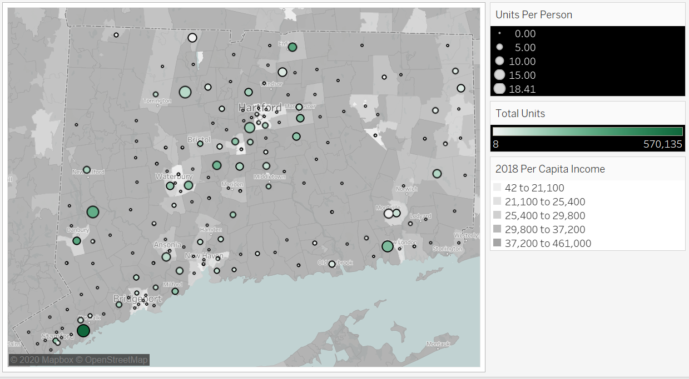

* 1. Market by Shape and Channel

Figure 23: 2019 LED Market Share by Bulb Shape, Channel, and Geography

(Source: LightTracker, All Retail Channels)

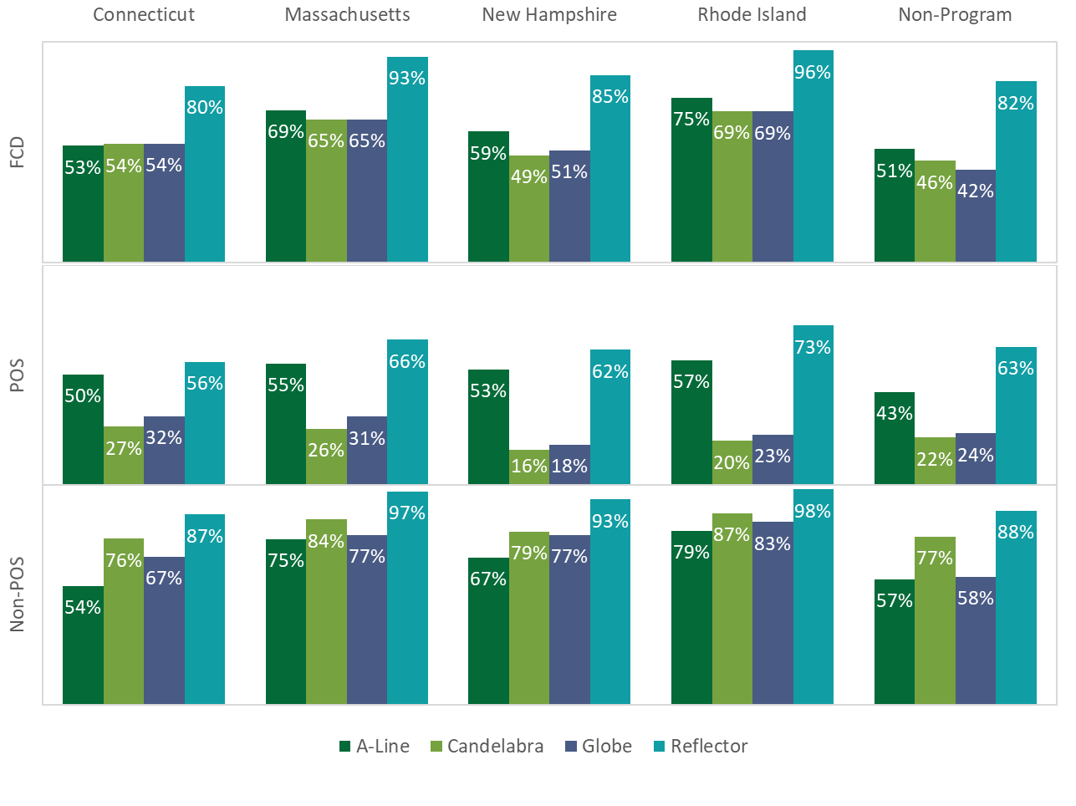

* 1. Supplier Market Share Estimates

The analysis of supplier predictions of LED market share yielded market shares in the 70% range for non-program areas and the 90% range for Connecticut and New Hampshire for all bulb shapes (Section 3.3.3). Question wording has likely biased the market share estimates upwards.

Table 7 compares the question wording and the market share predictions from a 2017 effort in Massachusetts and the current 2020 regional effort described in this report. *The 2017 study asked respondents to imagine what market share would be in Massachusetts if the program stopped incentives in 2017. The 2020 effort asks for market share for non-program areas for the respondent’s company.* The table only includes responses from the subset of suppliers who took part in both efforts and provided market share predictions in at least one them; all but one of the respondents are manufacturers.

*Importantly, every supplier makes or sells LEDs, and some of them only make or sell LEDs.* Therefore, when asked to speak to *your company’s* sales, three suppliers (in red, bolded font) had to say 100%, because their companies almost exclusively supplies LEDs. In contrast, in 2017, these same three suppliers had provided estimates well below 100%, even though they also primarily suppliers LEDs in 2017. Notably, each of the suppliers in the table provided higher estimates of LED market share in 2020 than they did in 2017. This almost certainly stems from the fact that the LED market took off more rapidly than predicted in 2017, but it also likely reflects that every respondent makes or sells LEDs.

Table 7: Comparison of Supplier Market Share Predictions Across Studies

|  |  |  |  |  |  |  |  |  |
| --- | --- | --- | --- | --- | --- | --- | --- | --- |
| Supplier | **2017 Study Predictions MA A-line LED Market Share, No Program Scenario** | | | | **2020 Study Predictions LED  Market Share, Non-program Areas** | | | |
| **I’d like you to predict the future market shares for A-Line Medium Screw Base Lamps for 2018, 2020, and 2022 under the assumption that the Massachusetts lighting program would end LED incentives in 2017.** | | | | **Thinking only about the areas of the US that do not have retail lighting programs [e.g., states like Kansas or Alabama, among others], what proportion of all of the A-Line lamps that your company sold in 2019 in these non-program areas were LEDs?** | | | |
| **2018** | **2020** | | **2022** | **2019** | **2021** | | **2023** |
| **A** | **40%** | **45%** | | **48%** | **100%** | **100%** | | **100%** |
| B | 27% | 27% | | 27% | 80% | 80% | | 80% |
| C | 25% | | 35% | | 39% | | Declined | |
| **D** | **40%** | **50%** | | **Declined** | **100%** | **100%** | | **100%** |
| E | 60% | 72% | | 78% | 60% | 70% | | 80% |
| F | 35% | 45% | | 59% | 90% | 85% | | 70% |
| **G** | **25%** | **30%** | | **35%** | **100%** | **95%** | | **85%** |
| H | 36% | 32% | | 31% | 45% | 60% | | 65% |
| I | 25% | 35% | | 50% | 50% | 50% | | 50% |
| J | 24% | 48% | | 95% | 53% | 57% | | 74% |

* 1. Supplier Estimates of Market Dominance

Section 3.3.3 presented suppliers’ predictions of when LEDs would become the dominant bulb type. This section of the appendix provides additional detail. Table 8 provides summary statistics for supplier predictions by lamp type, as well as the responses of a single program staff member and implementation contractor.

Table 8: Suppliers’ 2019 Weighted Year of Dominance Predictions: Standard Lamps (n=11 for suppliers)

|  |  |  |  |
| --- | --- | --- | --- |
| **Year of Dominance** | **Standard** | **Reflector** | **Specialty** |
| Supplier Mean | 2023 | 2025 | 2026 |
| Supplier Median | 2023 | 2025 | 2026 |
| Supplier Minimum | 2019 | 2020 | 2022 |
| Supplier Maximum | 2027 | 2030 | 2030 |
| Program Staff | 2022 | 2023 – 2025 | 2025+ |
| Implementation Staff | 2024 – 2025 | 2026 – 2027 | 2026 – 2027 |

Figure 24 lists the definitions of LED market dominance provided by suppliers (including those who focus on LEDs) and one of the stakeholders for how they defined LED market dominance. Figure 25 graphs the market share thresholds that would signal dominance as offered by 10 of the 11 respondents (the other declined to name a specific percentage). The mean response is 62% and the median is 62.5%. Removing the outlier who responded 90% moves the mean to 59% and the median to 60%.

Figure 24: Reported Supplier Definition of Dominance (n=18)

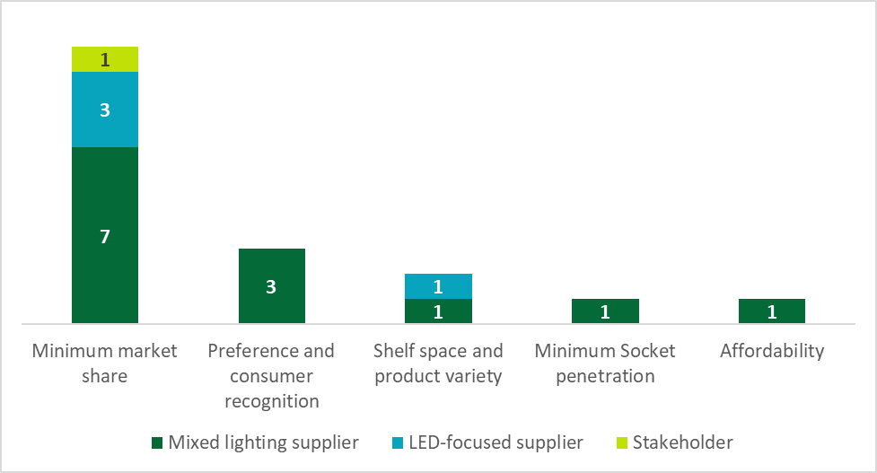

Figure 25: Definition of Dominance: Minimum Market Share (n=10)

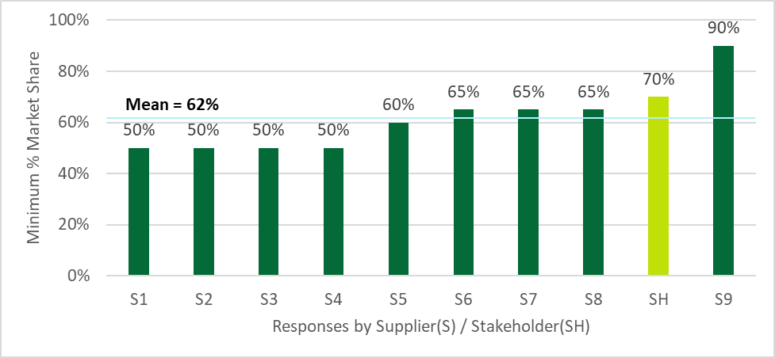

* 1. LightTracker A-Line Sales by Lumen Bins

Table 9 below lists the 2019 A-line sales by lumen bins for the POS channels in Connecticut, neighboring states, and non-program states. The table demonstrates that sales in 2019 concentrated in the mid-brightness bins most associated with 40W to 75W incandescents.

Table 9: POS A-line Sales by Lumen Bin by State

|  |  |  |  |  |  |
| --- | --- | --- | --- | --- | --- |
| **Lumen Bin** | **CT** | **MA** | **NH** | **RI** | **NP1** |
| 0-309 (<40WE) | 1% | 2% | 1% | 1% | 1% |
| 310-749 (40WE) | 23% | 24% | 23% | 23% | 30% |
| 750-1049 (60WE) | 52% | 53% | 53% | 56% | 43% |
| 1050-1489 (75WE) | 12% | 10% | 10% | 9% | 17% |
| 1490-2600 (100WE) | 11% | 10% | 8% | 7% | 8% |
| >2601 (>100WE) | 1% | 1% | 5% | 3% | 2% |
| 1 Non-program states |  |  |  |  |  |

1. R1963b Short-term Residential Lighting Results

1. The information contained herein is based in part on data reported by IRI through its Advantage service, as interpreted solely by LightTracker, Inc. Any opinions expressed herein reflect the judgement of LightTracker, Inc., and are subject to change. IRI disclaims liability of any kind arising from the use of this information.
2. Data presented include LightTracker calculations based in part on data reported by Nielsen through its Strategic Planner and Homescan Services for the lighting category for the 52-week period ending approximately on December 31, 2019, for the available state level markets and Expanded All Outlets Combined (xAOC) and Total Market Channels. Copyright © 2019, Nielsen.
3. NMR Group, Inc. 2019. *MA19R06-E Massachusetts Lighting Sales Data Analysis.* <http://ma-eeac.org/wordpress/wp-content/uploads/MA19R06-E-LtgSalesDataAnalysisReport_FINAL_2019.10.29.pdf>. Note that NMR has prepared a memo analyzing similar data for Connecticut (R1963a Task 3). This report updates the results from that earlier memo.
4. Department of Energy, Final determination, “Energy Conservation Program: Definition for General Service Lamps.” Federal Register 84, No. 172 (September 5, 2019) 46661. <https://www.federalregister.gov/documents/2019/09/05/2019-18940/energy-conservation-program-definition-for-general-service-lamps>.
5. Department of Energy, Final determination, “Energy Conservation Program: Energy Conservation Standards for General Service Incandescent Lamps.” Federal Register 84, No. 248 (December 27, 2019) 71626. <https://www.federalregister.gov/documents/2019/12/27/2019-27515/energy-conservation-program-energy-conservation-standards-for-general-service-incandescent-lamps>.
6. CREED serves as a consortium of program administrators, retailers, and manufacturers working together to collect the necessary data to better plan and evaluate energy- efficiency programs. CREED’s LightTracker Initiative seeks to acquire full category lighting data for all distribution channels in the entire United States. As a consortium, CREED speaks as one voice for program administrators nationwide as they request, collect, and report on the sales data needed by the energy- efficiency community (<https://www.creedlighttracker.com>).
7. CREED purchases data from IRI and Nielsen. IRI (<https://www.iriworldwide.com/en-us/Company/About-Us>) and Nielsen (<https://www.nielsen.com/us/en.html>) track and compile information on sales and purchases in numerous sectors of the economy. Nielsen is better known for its tracking of television-viewing habits.
8. The information contained herein is based in part on data reported by IRI through its Advantage service, as interpreted solely by LightTracker, Inc. Any opinions expressed herein reflect the judgement of LightTracker, Inc., and are subject to change. IRI disclaims liability of any kind arising from the use of this information.
9. Data presented include LightTracker calculations based in part on data reported by Nielsen through its Strategic Planner and Homescan Services for the lighting category for the 52-week period ending approximately on December 31, 2019, for the available state level markets and Expanded All Outlets Combined (xAOC) and Total Market Channels. Copyright © 2019, Nielsen.
10. NCP households agree to scan every purchase they make in a year, but compliance is voluntary.
11. One of the manufacturers serves on the board of an electrical manufacturers’ association, but the respondent provided answers as a representative of his employer, rather than on behalf of the association.
12. The remainder of the program tracking data analyses in this report focus on program unit sales for two reasons: (1) savings and sales mirror each other, so presenting both is redundant, and (2) the market share and supplier interview efforts focus on unit sales, not savings.
13. Rhode Island’s market share decreased by 3% between 2015 and 2016, but this could be due to measurement error stemming from the small population of the state coupled with small sales volumes of LEDs.
14. The study only asked about Massachusetts in 2019 at the request of the study sponsors in that state.
15. These questions about dominance provide some input into a potential timeline of when The Companies may consider ceasing program incentives for LEDs, also known as *exiting the market*. However, the primary purpose of these dominance questions was to inform discussions in Massachusetts about how long to claim program savings from bulbs sold in 2019 and 2020, or what that state calls the *adjusted measure life*.
16. Relative to the other areas, sales volumes in non-program areas were distributed more widely. See Table 8 in Appendix B.
17. CREED advises that pricing data, particularly in lower population states, are prone to abnormalities that the cannot always diagnose and repair; therefore the observed LED price increase in New Hampshire in 2019 could reflect an actual change, or it could reflect measurement error.
18. A recent sales data study conducted for Massachusetts found that halogen prices varied by cost-of-living so that prices of halogens in non-program areas, which tend to have lower costs-of-living fell below those of program states. This same pricing difference likely carries over to LEDs, complicating comparisons of prices and the impact of incentives on prices between the two groups of states. NMR Group, Inc. 2019. *MA19R06-E Massachusetts Lighting Sales Data Analysis.* <http://ma-eeac.org/wordpress/wp-content/uploads/MA19R06-E-LtgSalesDataAnalysisReport_FINAL_2019.10.29.pdf>.
19. Specifically, CREED began by searching the ENERGY STAR Summary of Lighting Programs website (<https://www.energystar.gov/ia/partners/downloads/2018%20ENERGY%20STAR%20Summary%20of%20Lighting%20Programs.pdf>) and referenced the Database of State Incentives for Renewables & Efficiency ([www.dsireusa.org](http://www.dsireusa.org)).
20. E Source. “DSM Insights.” April 2018.